**Abstract:**

Power quality is one of the major concerns in the era of power system. Power quality problem occurred due to nonstandard voltage, current or frequency, that result in a failure of end user equipment. To overcome this problem, Dynamic Voltage Restorer (DVR) is used, which eliminate voltage sag and swell in the distribution line, it is efficient and effective power electronic device. The size of DVR is small, cost is low and fast dynamic response to the disturbance. By injecting an appropriate voltage, the DVR restores a voltage waveform and ensures constant load voltage. The compensating signals are determined dynamically based on the difference between desired and measured values. The DVR is consisting of VSC, Booster transformer, Filter and Energy storage devices. This paper describe different compensation control technique used for compensate the voltage of the distribution line.

**CHAPTER 1 INTRODUCTION**

**1.1 OBJECTIVE OF THE PRESENT STUDY**

Nowadays, modern industrial devices are mostly based on electronic units such as programmable logic controllers and electronic drives. The electronic are very sensitive to disturbances and become less tolerant to power quality problems such as voltage sags, swells and harmonics. Voltage dips are considered to be one of the most severe disturbances to the industrial equipments.

Voltage support at a load can be achieved by reactive power injection at the load point of common coupling. The common method for this is to install mechanically switched shunt capacitors in the primary terminal of the distribution transformer. The mechanical switching may be on a schedule, via signals from a supervisory control and data acquisition (SCADA) system, with some timing schedule, or with no switching at all. The disadvantage is that, high speed transients cannot be compensated. Some sag is not corrected within the limited time frame of mechanical switching devices. Transformer taps may be used, but tap changing under load is costly.

Another power electronic solution to the voltage regulation is the use of a dynamic voltage restorer (DVR). DVRs are a class of custom power devices for providing reliable distribution power quality. They employ a series of voltage boost technology using solid state switches for compensating voltage sags/swells. The DVR applications are mainly for sensitive loads that may be drastically affected by fluctuations in system voltage.

**1.2 LITERATURE SURVEY**

C. Benachaiba and B. Ferdi [1] have proposed “**Power Quality Improvement Using DVR**”. This paper describes the voltage sags and swells in the medium and low voltage distribution network are considered to be the most frequent type of power quality problems based on recent studies. Their impact on sensitive loads is severe. The impact ranges from load disruptions to substantial economic losses up to millions of rupees. Different solutions have been developed to protect sensitive loads against such disturbances but the DVR is considered to be the most efficient and effective solution. Its appeal includes lower cost, smaller size and its dynamic response to the disturbance.

This research described DVR principles and voltage restoration methods for balanced and/or unbalanced voltage sags and swells in a distribution system. Simulation results were presented to illustrate and understand the performances of DVR under voltage sags/swells conditions. The DVR handled both balanced and unbalanced situations without any difficulties and injected the appropriate voltage component to correct rapidly any anomaly in the supply voltage to keep the load voltage balanced and constant at the nominal value. The efficiency and the effectiveness in voltage sags/swells compensation showed by the DVR makes it an interesting power quality device compared to other custom power devices.

ROSLI OMAR, NASRUDIN ABD RAHIM etc [2] have presented “**Modeling and Simulation for Voltage Sags/Swells Mitigation using Dynamic Voltage Restorer (DVR)**”. This paper analyses the issue of voltage sags and swells and its severe impact on non linear loads or sensitive loads. The dynamic voltage restorer (DVR) has become popular as a cost effective solution for the protection of sensitive loads from voltage sags and swells. The control of the compensation voltages in DVR based on dqo algorithm is discussed. The proposed control scheme is simple to design. Simulation results carried out by Matlab/Simulink verify the performance of the proposed method. The DVR handles both balanced and unbalanced situations without any difficulties and injects the appropriate voltage component to correct rapidly any anomaly in the supply voltage to keep the load voltage balanced and constant at the nominal value. The main advantage of this DVR is low cost and its control is simple. It can mitigate long duration voltage sags/swells efficiently.

They also presented “**Design Requirements for a Dynamic Series Compensator for Voltage Sags Mitigation in Low Voltage Distribution System”.** Power quality issues have become an increasing concern due to an increase of sensitive loads in distribution system. A dynamic series compensator or Dynamic Voltage Restorer (DVR) is a custom device that can be used to protect sensitive loads from various power quality problems from disturbed incoming supply. The dynamic voltage restorer (DVR) has become popular as a cost effective solution for the protection of sensitive loads from voltage sags. This paper highlights a series of discussion, analysis and studies performed on the active power injection requirements for a DVR under various system and load conditions, as well as for different types of fault in both single phase and three-phase fault. The analysis and experimental results validate the effectiveness of the DVR for mitigation voltage sag in low voltage distribution system. The DVR is an effective apparatus to protect sensitive loads from short duration voltage sags. The DVR can be inserted both at the low voltage and medium voltage level. It is shown that the active power requirements of a DVR depend on magnitude and phase-angle jump of the sag as well as on the power factor of the load.

They also presented “**Mitigation of Voltage Sags/Swells using Dynamic Voltage Restorer (DVR)**”. It describes the effectiveness of using dynamic voltage restorer (DVR) in order to mitigate voltage sags and swells in low voltage distribution systems. A dynamic voltage restorer based on the dqo algorithm is presented. The proposed control scheme is very effective to detect any disturbance in low voltage distribution systems. Simulation results using Matlab/Simulink are presented to verify the effectiveness of the proposed scheme. The main advantage of this DVR is low cost and its control is simple. It can mitigate long duration voltage sags/swells efficiently.

S.LEELA, S.S.DASH [3] have presented “**Control of Three Level Inverter Based Dynamic Voltage Restorer**”. This paper deals with modeling and digital simulation of three level inverter based Dynamic Voltage Restorer (DVR). The control of DVR that injects a voltage in series with a distribution feeder is presented. DVR is a power electronic controller that can protect sensitive loads from disturbances in supply system. It is observed that DVR can regulate the voltage at the load. Circuit model is developed and the same is used for simulation studies*.* This paper demonstrates the capability of DVR to improve the voltage quality. It is better to use a filter in the output of inverter to reduce heating. The simulation is based on the assumption of balanced load and single phase circuit model is considered.

H. Ezoji, A. Sheikholeslami, M. Tabasi, etc [5] have presented **“Simulation of Dynamic Voltage Restorer Using Hysteresis Voltage Control**”. Dynamic Voltage Restorer (DVR) is one of the custom power devices that are used as an effective solution for the protection of sensitive loads against voltage disturbances in power distribution system. The efficiency of the DVR depends on the performance of the efficiency control technique involved in switching the inverters. Unlike previous approaches, this paper presents a hysteresis voltage control technique of DVR based on bipolar and uni-polar Pulse Width Modulation (PWM).

The hysteresis voltage control has a very fast response, simple operation and variable switching frequency. To evaluate the quality of the load voltage during the operation of DVR, Total Harmonic Distortion (THD) is calculated with various Hysteresis Band (HB). The validity of proposed method and achievement of desired compensation are confirmed by the results of the simulation in MATLAB/ Simulink. The result simulation shows that effect of increasing the HB on THD of the load voltage under voltage swell is more than THD of the voltage sag. Therefore HB value has to be selected based on the voltage sag test. Also it is observed that that in both conditions, load voltage THD in hysteresis voltage control based on unipolar switching is less than bipolar. Move over can be seen that using HB1 less than 13 remains THD in standard region. We can say that hysteresis voltage control based on unipolar switching is more efficient and effective than bipolar switching. In conventional fixed band hysteresis controller, it is not impossible to determine hysteresis bandwidth and switching frequency according to system parameters.

Mehmet Tümay Ahmet Teke K. Çagatay Bayındır [6] is presented “**Simulation and Modeling of a Dynamic Voltage Restorer”.** This paper presents modeling and analysis of a Dynamic Voltage Restorer (DVR) with sinusoidal pulse width modulation (SPWM) based controller by using the Matlab /Simulink. The proposed control scheme is simple to design and allows flexibility in cost or robustness constraints. In addition, the performance of the designed DVR is examined under different sag conditions. The load side connected converter topology has capability of mitigating the long duration voltage sags on the line. The dynamic performance capability of DVR increases the number of sensitive equipments to use in the system.

Agileswari Ramasamy, Vigna Kumaran Ramachandaramurthy [7] is proposed “**Control of Dynamic Voltage Restorer using TMS320F2812”.** Dynamic Voltage Restorer (DVR) is a custom power device that is used to compensate voltage sag. The DVR generally consists of voltage source inverter (VSI), injection transformers, passive filters and energy storage (battery). The efficiency of the DVR depends on the efficiency of the control technique involved in switching the inverters. The inverters are switched using Space Vector Pulse Width Modulation pulses (SVPWM) to maximize the usage of DC link voltage. The control strategy that is used to generate the pulses will be illustrated in this paper.

The flow chart of the program and the modules involved in the implementation of the control algorithm using DSP board TMS320F2812 will be described in detail. The implementation of the control using TMS320F2812 is tested using a 3kVA lab prototype and the results are presented. This paper presented the detailed implementation of the DVR control algorithm using DSP board TMS320F2812. The operating principle of the DSP board and also the generation of the SVPWM pulses are discussed. A general overview of the DVR lab prototype is also presented. The experimental results clearly indicate the successful implementation of the control algorithm using TMS320F2812.

Ram Mohan Rao Errabelli, Y. Y. Kolhatkar [8] is proposed “**Experimental Investigation of DVR with Sliding Mode Control”.** Voltage sags and swells are vital power quality problems and the dynamic voltage restorer (DVR) is known as an effective device to mitigate voltage sags and swells. The paper deals with the sliding mode control of single phase DVR for voltage sag/swell correction. A sliding mode controller is designed and developed for a single phase DVR. Using sliding mode control to the DVR, additional sag/swell detection method is eliminated. This improves the dynamic response of the DVR and also DVR is able to compensate for any variation in source voltage. Usage of sliding mode control to DVR makes it multifunctional, such as compensation for voltage sag, swell, voltage flicker and voltage harmonics as well. The PCC voltage during sag and swell condition evidently shows good dynamic response of the DVR achieved through the sliding mode control. It can also be observed that usage of sliding mode control to DVR eliminates the additional sag/swell detection and makes the DVR multifunctional, such as the same control can be used to compensate any variation in the supply voltage.

Praveen.J, Bishnu P.Muni, etc [10] have presented “**Review of Dynamic Voltage Restorer for Power Quality Improvement”.**  Power qualify has always been important for customers, but with increasing applications of electronic loads and controllers sensitive to the power quality, the subject has attracted renewed interest in recent times. Power quality encompasses several aspects: harmonics, over voltage, flicker, voltage sags and swells, interruptions etc., lasting only a few cycles can cause significant damage for a manufacturing process and computer hardware installations. Voltage source converter based Dynamic voltage restorer (DVR) can be used effectively for mitigation of voltage sag and swells.

The present day industrial processes are automated with wide spread use of embedded controllers and industrial computers. Further, commercial establishments and software parks are also being affected by poor power quality as these establishments also depend on computer and communication related products for their operation. Poor power quality will *also* result in loss of data and failure of sensitive equipment. The use of DVR can help in reduction in financial losses associated with process shut down, failure of expensive electronic equipment and poor quality of products. Excellent performance of DVR is recorded at different industries round the globe. DVR is a cost effective solution for improvement of power quality.

Short-lived sags may not cause much harm other than cause a slight flickering of lights; temporary sag is bound to have a greater impact on the industrial customers. If the sags exceed two to three cycles, then manufacturing systems making use of sensitive electronic equipments are likely to be affected leading to major problems. It ultimately leads to wastage of resources (both material and human) as well as financial losses.

The increasing competition in the market and the declining profits has made it pertinent for the industries to realize the significance of high-power quality. This is possible only by ensuring that uninterrupted flow of power is maintained at proper voltage levels. Electric utilities are looking for solutions to ensure high quality power supply to their customers. The Dynamic Voltage Restorer appears to be an especially good solution in the current scenario.

The fundamental aspects of voltage sag production and their effects on power quality as well as enhancing this power quality in distribution network, using FACTS (Flexible AC Transmission System) Devices i.e. Dynamic Voltage Restorer (DVR). DVR is a powerful custom power device for short duration voltage compensation, which is connected in series with the load & hence it possesses some advantages.

Dynamic Voltage Restorer (DVR) and Static compensator (STATCOM) have been recently used as active solution for voltage sag mitigation. It is a device that injects a Dynamic controlled voltage in series to the bus voltage by means of a booster transformer. DVR installed in front of a critical load will appropriately provide correction to the load only.

The majority of voltage sags are within 40% of the nominal voltage. Therefore, by designing drives and other critical loads, capable of riding through sags, with magnitude of up to 40%, interruption of processes can be reduced significantly. The DVR can correct sags and swells resulting from faults in either the transmission or the distribution system.

**1.3 Organization of the Thesis**

The thesis is organized in to five chapters. The first chapter provides a brief review of some papers about Dynamic Voltage Restorer.

The second chapter gives the brief discussion about power quality and power quality problems like voltage sags, voltage swells, interruptions etc. Solutions for power quality problems also discussed in this chapter.

The third chapter introduces the Dynamic Voltage Restorer. This chapter also describes the basic operation, structure and the existing control technique etc…This chapter will give the reader a general idea about the Dynamic voltage restorer and its functionality.

The fourth chapter presents an ac chopper based DVR, which can be used to regulate the load side voltage and reduce the THD value. The control technique designed and developed by the author to maintain the constant voltage. The designed control technique was implemented and simulated using MATLAB.

In the fifth chapter the simulation results are outlined. The results are obtained by using the simulink and corresponding fast fourier transform analysis also presented.

**CHAPTER 2**

**POWER QUALITY**

**2.1 Power Quality in Present Day World**

The name power quality has become one of the most productive concepts in the power industry since late 1980s. Power Quality concept mainly deals with 3 factors namely Reliability, Quality of Supply and Customer service.

**2.2 Definitions of Power Quality**

Power quality may be defined as the *“Degree to which both the utilization and delivery of electric power affects the performance of electrical equipment.”*[14]

From a customer perspective, a power quality problem is defined as *“Any power problem manifested in voltage, current, or frequency deviations that results in power failure or disoperation of customer equipment.”*[13]

In a three-phase system, unbalanced voltages also are a power quality problem. Among them, two power quality problems have been identified to be of major concern to the customers are voltage sags and harmonics, but this project will be focusing on voltage sags. Figure 2.3[10] describe the demarcation of the various power quality issues defined by IEEE Std. 1159-1995.

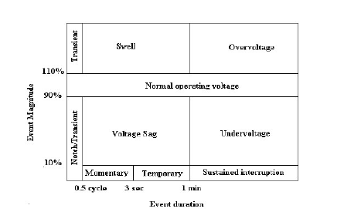

Figure 2.1 IEEE Standard 1159-1995[10]

**2.3 Effects of Poor Power Quality**

Some industries like Manufacturing Business machineries, Computers and Semiconductors are very sensitive to slightest change in the power supply. It is very important for them to take care of the frequently occurring power quality defects in order for production and revenue to not suffer. [15]

The five most common PQ defects defined by IEEE Std. 1159-1995[11] are:

1. Under Voltage: When the operating falls to a low value due to fault voltage.
2. Dips or Surges: Fluctuations leading to frequent increase and decrease in the magnitude of the supply.
3. Transient: A Spike in the sinusoidal voltage of the supply.
4. Harmonics: Voltage or Currents that are some integer multiple of operating specifications which cause distortion
5. Burnouts: Period of very low frequency voltage or sometimes even zero leading to reduced power delivery.

Power Quality problems happen when these ranges are crossed and this can occur in three ways:

1. Frequency events: change of the supply frequency outside of the normal range.
2. Voltage events: change of the voltage amplitude outside its normal range (may

occur for very short periods or be sustained.)

1. Waveform events: distortion of the voltage waveform outside the normal range.

These disturbances can degrade power quality by:

1. Interrupting supply, Trip out variable speed drives and cause annoying light flicker.
2. Cause damage to sensitive data processing, control and instrumentation equipment to malfunction.
3. Cause capacitors, transformers and induction motors to overheat.

**2.4 Voltage Sag and Swell Definitions**

Over the last fifteen years, based on how the power quality instruments measure voltage sags and swells the definitions have been developed. Power system communities state sags or dips as a reduction in voltage below a user- defined low limit for between one cycle and 2.55 seconds. Surges are now called as swells, except that the voltage exceeds a particular user-defined high limit. While different definitions pertaining to the amplitude and duration are still in use, the IEEE 1159-1995 Recommended Practice on Monitoring Electric Power Quality has defined them as follows:

Sag (dip) can be defined as, “*A decrease to between 0.1 and 0.9 pu in rms voltage or current at the power frequency for durations of 0.5 cycles to 1 minute*.”[11]

Swell can be defined as, “*An increase to between 1.1 pu and 1.8 pu in rms voltage or current at the power frequency durations from 0.5 to 1 minute*.”[11]

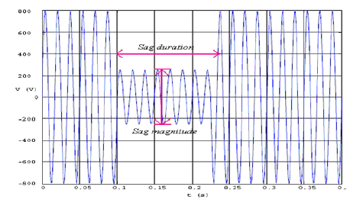

Figure 2.2 Voltage Sag Depiction [3]

With respect to an outage or interruption, sag is differentiated by the amplitude being greater than or equal to 0.1 per unit (of nominal voltage). The IEEE 1159 document further categorizes the duration values into: Instantaneous, momentary, and temporary, as illustrated in the following table2.

According to the IEEE Std. 1995-2009 a voltage sag is “*A decrease in rms voltage or current at the power frequency for duration of 0.5 cycle to 1 minute*”. [1]

IEC has the following definition for a dip (IEC 61000-2-1, 1990) “*A voltage dip is a sudden reduction of the voltage at a point in the electrical system, followed by a voltage recovery after a short period of time, from half a cycle to a few seconds*”.[1]

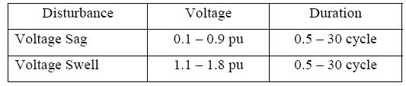

Table 2.1 IEEE definitions of Voltage Sags and Voltage Swells [11]

It is blatant from the previous definitions that both voltage sag and voltage dip relate to the same disturbance. Moreover, IEC states that “voltage sag is an alternative name for the phenomenon voltage dip” (IEC 61000-2-8, 2002).

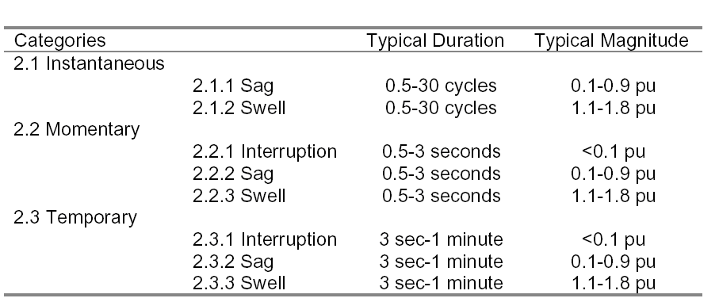

Table 2.2 Categories and Characteristics of Power Systems Electromagnetic Phenomena [12]

**2.5 Amplitude Limits of Voltage Sag**

The duration and amplitude value limits that are likely to cause problems with equipments are already defined by both the ANSI C84.1-1989 Utility Power Profile and the CBEMA (Computer and Business Equipment Manufacturers Association) curve. The smaller the amplitude of a sag or higher the value of a swell, the shorter the duration should be for equipment to follow through the disturbance, as in the following table derived from such. The typical industrial utility power after building line losses is in the range of +6%, -13% from the nominal value.

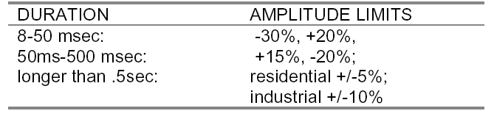

Table 2.3 Amplitude limits of Voltage Sag [12]

**2.6 Effects of Voltage Sag**

The prime interest about voltage sags is their effect on sensitive electrical devices, such as personal computers, adjustable speed drives, programmable logic controllers, and other power electronic equipment. The least sensitive loads failed when the voltage dropped to 30 % of the specified voltage. On the other hand, the most sensitive components failed when the voltage dropped to 80-86 % of rated value. From the test results, the calculated sag threshold to affect production at the utility PCC - point of common coupling was 87 % of the nominal voltage for more than 8.3 ms.

Voltage Sag Classification based on type of Sag, duration and magnitude as shown in Table 2.4

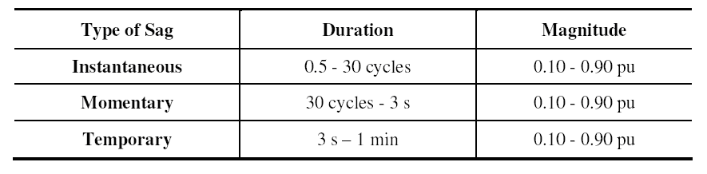

Table 2.4 Classification of Voltage Sags according to IEEE 1159 [11]

The power system voltage can be given by a sine wave. A reduction in the amplitude of the waveform indicates a Voltage Sag. Figure 3.3 shows the voltage waveform during voltage sag. The sag magnitude is characterized by the amplitude of the instantaneous voltage.

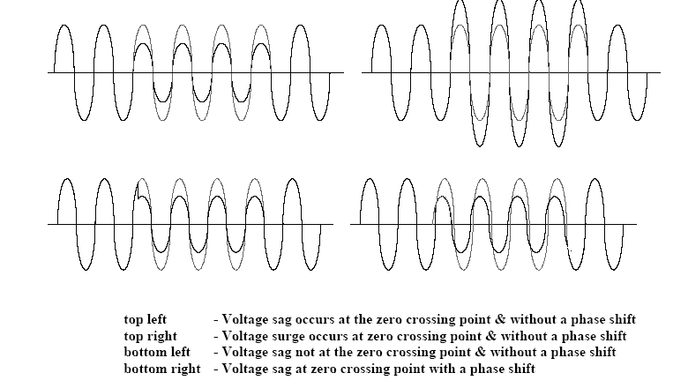

Figure 2.3 Classification of Voltage Sags [13]

**2.6.1 A Typical Voltage Sag Waveform**

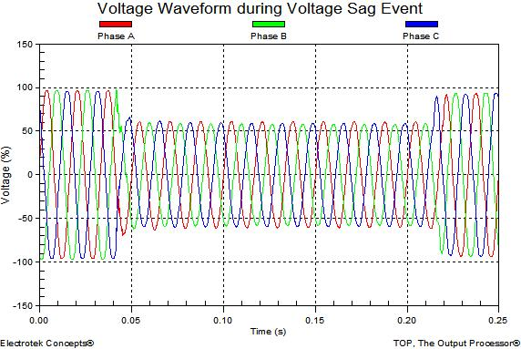

Figure 2.4 A Typical Voltage Sag Waveform [8]

**2.7 General Causes and Effects of Voltage Sags**

There are various causes of voltage sags in a power system. Voltage sags can be caused by lightning faults on the transmission or distribution system or by switching of loads with large amounts of initial starting or inrush current such as motors, transformers, and large dc power supply.

**2.7.1 Voltage Sags Due to Faults**

One of the major factors critical to the operation of the power plant is voltage sags due to faults. The magnitudes of the voltage sags can be equal in each phase or unequal depending on the types of the fault such as symmetrical or unsymmetrical, respectively. For faults in the transmission system, customers do not experience interruption since transmission systems are looped or networked.

At a certain point in the system parameters affecting the sag magnitude due to faults are:

i. Distance to the fault

ii Fault impedance

iii. Type of fault

iv. Pre-sag voltage level

v. System configuration, System impedance and Transformer connections.

**2.8 Multi-Phase Sags and Single Phase Sags**

**2.8.1 Single Phase Sags**

The frequently occurring voltage sags are single phase events which are basically due to a phase to ground fault occurring somewhere on the system. On other feeders from the same substation this phase to ground fault appears as single phase voltage sag. Typical causes are lightning strikes, tree branches, animal contact etc. It is common to see single phase voltage sags to 30% of nominal voltage or less in industrial plants.

**2.8.2 Phase to Phase Sags**

The 2 Phase or Phase to phase sags may be caused by tree branches, adverse weather, animals or vehicle collision with utility poles. These types of sags typically appear on other feeders from the same substation.

**2.8.3 Three Phase Sags**

These are caused by switching or tripping of a 3 phase circuit breaker, switch or recloser which will create three phase voltage sag on other lines fed from the same substation. Symmetrical 3 phase sags arise from starting large motors and they account for less than 20% of all sag events and are usually confined to an industrial plant or its immediate neighbors.

**2.9 Classification of Equipments used for Voltage Sag Mitigations**

A greater awareness of voltage quality has been created with the recent growth in the use of digital computers and PWM adjustable speed drives. Voltage dips and its associated phase angle jumps can cause equipment to fail or malfunction which in turn can lead to production downtime. Since a very long time interval is needed to restart industrial processes, these effects can be greatly expensive for the clients/customers who are continuously seeking for cost effective sag mitigation techniques. These interests have resulted in the development of power electronics based devices with sag mitigation capability. These devices can be classified into two classes, namely Custom Power Devices and Power Line conditioners.

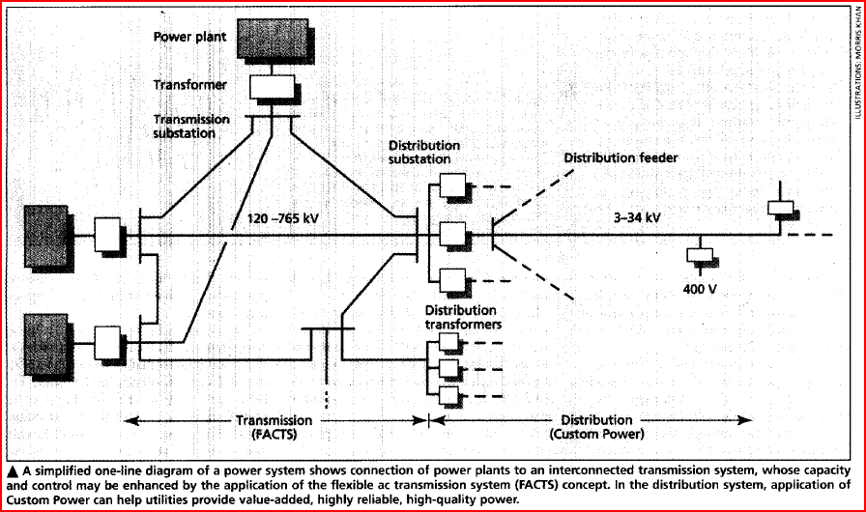

Figure 2.5 Custom Power Distribution System [16]

N G Hingorani put forward the idea of custom power devices in 1995 as shown in the figure above. Like Flexible AC Transmission Systems (FACTS), the term custom power devices relates to the use of power electronics controllers in a distribution system, to deal with various power quality problems. Just as FACTS improves the power transfer capabilities and stability margins, custom power devices ascertain that customers get pre-specified quality and reliability of supply. Without significant effect on the terminal voltages this pre-specified quality may contain a combination of the following, low phase unbalance, no power interruptions, low flicker at the load voltage, low harmonics distortion in load voltage, magnitude and duration of over voltages and under voltages within specified limits, acceptance of fluctuations and poor power factor loads.

Custom Power Devices are recently being developed under the Custom Power Program initiated by the Electric Power Research Institute (EPRI). Typical custom power applications include the Dynamic Voltage Restorer (DVR), Distribution Static Compensator (D-STATCOM), Solid State Fault Current Limiter (SSFCL). These devices are also known as source side solutions.

There are many types of Custom power devices like those listed below:

1. Active Power filters(APF)
2. Battery Energy storage systems(BESS)
3. Distributed Static Compensators(DSTATCOM)
4. Distribution series Capacitors(DSC)
5. Dynamic Voltage Restorer(DVR)
6. Super conducting Magnetic Energy systems(SEMES)
7. Static Electronics Tap Changers(SETC)
8. Solid State Transfer Switches (SSTS)
9. Solid state Fault Current Limiters(SSSFCL)
10. Static VAR Compensators(SVC)
11. Thyristor Switched Capacitors(TSC)
12. Uninterruptible Power Supplies (UPS)[2]

The conventional approach is adding Power Line Conditioners to the distribution systems as a form of load side solution. These devices work by providing voltage sag ride through capability to critical loads. Examples of these devices include motor-generator sets (M-G sets) uninterruptible power supplies (UPSs), magnetic synthesisers and super conducting storage devices (SSDs).

Uninterruptible Power Supplies (UPS), Dynamic Voltage Restorers (DVR) and Active Power Filters (APF) with voltage sag compensation facility are the most common custom power devices to compensate for the voltage sags and swells. UPS is ubiquitous whereas DVR and APF are less popular due to the fact that they are still in the developing stage, even though they are highly efficient and cost effective than UPSs. Due to the rapid ongoing development in the power electronic industry, low cost power devices like DVR and APF will become much popular among the industries in the near future.

DVR and APF are normally used to eliminate two different types of abnormalities that affect the power quality. They are discussed based on two different load situations namely linear loads and non-linear loads. The load is considered to be a linear when both the dependent variable and the independent variable show linear changes to each other. Example: Resistors. The non-linear load on the other hand does not show a linear change. Example: Capacitors and inductors.

1. When the supply voltage/current consists of abnormalities, with a linear load

Here, the custom power device together with the defected supply should be capable of supplying a defect free voltage/current to the load. In other words, the device should be able to supply the missing voltage/current component of the source. A reliable device that can be used for the above case (for voltage abnormalities) is the DVR. It compensates for voltage sags/swells either by injecting or absorbing real and reactive power.

ii. When the Power supplied is in normal condition with a non linear load

In this case, when non-linear loads are connected to the system, the supply current also becomes non-linear and this will cause harmonic problems in the supply waveform. In such a situation, a shunt APF is connected to inject/absorb the current to make the supply current sinusoidal. So, the supply treats both the non-linear load and the APF as a single load, which draws a fundamental sinusoidal current.

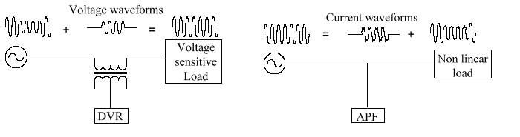

Fig 2.6 Basic Operation of DVR (left) and APF (right)

It is clear from Figure2.6 that the DVR is series connected to the power line, while APF is shunt connected. Among the custom power devices, UPS and DVR can be qualified as the devices that inject a voltage waveform to the distribution line. The UPS is always supplying the full voltage to the load irrespective of whether the wave form is distorted or not unlike DVR. This property of the UPS leaves it always operating at its full power whereas the DVR injects only the difference between the pre-sag and the sagged voltage and that also only during the sagged period. Therefore as compared to UPS, DVR operating losses and the required power rating are very low. Hence DVR is considered as a power efficient device compared to the UPS. [17][18][19]

**2.10 Propitious choice of DVR**

There are numerous reasons why DVR is preferred over other devices:

1. Although, SVC predominates the DVR but the latter is still preferred because the SVC has no ability to control active power flow.
2. DVR is less expensive compared to the UPS.
3. UPS also needs high level of maintenance because it has problem of battery leak and have to be replace as often as five years.
4. DVR has a relatively higher energy capacity and costs less compared to SMES device.
5. DVR is smaller in size and costs less compared to DSTATCOM
6. DVR is power efficient device compared to the UPS.

**CHAPTER 3**

**DYNAMIC VOLTAGE RESTORER (DVR)**

**3.1 INTRODUCTION**

The technological advancements have proven a path to the modern industries to extract and develop the innovative technologies within the limits of their industries for the fulfillment of industrial goals. And their ultimate objective is to optimize the production while minimizing the production cost and their by achieving maximized profits while ensuring continuous production through the period.

As such stable supply of un-interruptible power has to be guaranteed during the production process. The reason for demanding high quality power is basically the modern manufacturing and process equipment, which operates at high efficiency, requires high quality defect free power supply for the successful operation of their machines. More precisely most of those machine components are designed to be very sensitive for the power supply variations. Adjustable speed drives, automation devices, power electronic components and examples for such equipments.

Failure to provide the required quality power output may sometimes cause complete shutdown of the industries which will make a major financial loss to the industry concerned. Thus the industries always demand for high quality power from the supplier or the utility but the blame due to degraded quality cannot be solely put on the hands of the utility itself. It has been found out most of the conditions that can disrupt the process are generated within the industry itself. For examples, most of the non-linear loads within the industries cause transients which can affect the reliability of the power supply. Following shows some abnormal electrical conditions cased both in the utility end and customer end that can disrupt a process.

1. Voltage sags
2. Voltage swells
3. Phase outages
4. Transients due to lightning loads, capacitor switching, non-linear loads etc.
5. Harmonics

As a result of above abnormalities the industries may undergo burned-out motors, lost data on volatile memories, erroneous motion of robotics, unnecessary downtime, increased maintenance costs and burning core materials especially in plastic industries, paper mills and semiconductor plants.

As the power quality problems originated from utility and customer side, the solutions come from both and are named as utility based solutions and customer based solutions respectively. The best examples of both two types of solutions are FACTS devices (Flexible AC Transmission Systems) and custom power devices. FACTS devices are those controlled by utility, where as the custom power devices are operated, maintained and controlled by customer itself and installed at the customer premises. Both the custom power devices and FACTS devices are based on the solid state power electronic components. As the new technologies emerged, the manufacturing cost and reliability of those solid state devices are improved; hence the protection devices which incorporate such solid state devices can be purchased at a reasonable price with better performance than the other electrical or pneumatic devices available in the market. Uninterruptible power supplies (UPS), Dynamic voltage restorer (DVR), and Active power filters (APF) are examples of commonly used custom power devices. Among those APF is used to mitigate harmonic problems occurring due to non-linear loading conditions, where as UPS and DVR are used to compensate Voltage sags and sells conditions. A new control technique to maintain the constant the load voltage for a single phase DVR was developed and simulated using MATLAB software.

Voltage Sag (Fig. 3.1) is a momentary decrease in the root mean square voltage between 0.1 to 0.9 per unit, with a duration ranging from half cycle up to 1 min .In other word it is defined as a sudden reduction of supply voltage down 90% to10% of nominal and followed by a recovery after short period of time. A normal duration of sag according to standards is, 10 ms to 1 minute. It is considered as the most serious problem of power quality. It is caused by fault in power system or by starting of large induction motor.

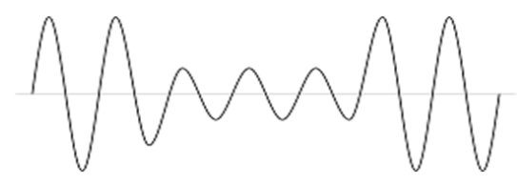

**Fig. 3.1 Sag or dip**

It can interrupts or malfunction any electronic or electrical equipment which is sensitive to load. Therefore huge losses result, due to voltage sag problem at customer load end.

Voltage swell (Fig. 3.2) is an increase between 1.1 and 1.8pu in rms voltage (or) current at the power frequency for durations of 0.5 cycles to 2 secs. Voltage swells are caused by system fault conditions, switching off large loads or energizing a large capacitor bank.

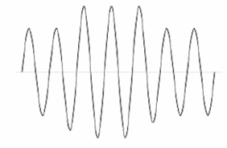

**Fig. 3.2 Swell**

DVR (Fig. 3.3) is designed to mitigate voltage sags and voltage swells on lines feeding sensitive equipment. A viable alternative to uninterruptible power systems (UPS's) and other utilization voltage solutions to the voltage sag problem, the DVR is specifically designed for large loads (2 MVA and up) served at distribution voltage. A DVR is expected to be a lower cost alternative to UPS for applications at distribution voltage. A DVR typically requires less than one-third the nominal power rating of the UPS. Also, the DVR can be used to mitigate troublesome harmonic voltages on the distribution system. The DVR is available in 2 MVA increment sizes up to 10 MVA.

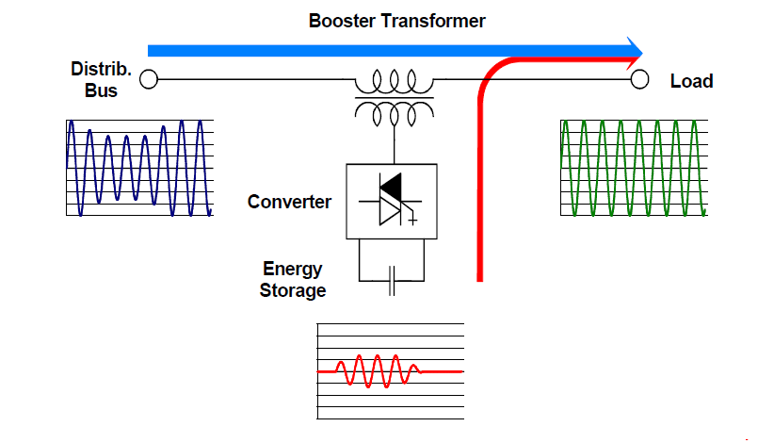

**Fig. 3.3 Schematic diagram DVR system**

A Dynamic Voltage Restorer (DVR) is a custom power device that is used to compensate voltage sag and voltage swells. The DVR generally consists of voltage source inverter (VSI), injection transformers, passive filters and energy storage (battery). The efficiency of the DVR depends on the efficiency of the control technique involved in switching the inverters. The inverters are switched using Space Vector Pulse Width Modulation pulses (SVPWM) to maximize the usage of DC link voltage. During normal operation supply voltage is provided by the network to the load at rated value.

**3.2 NEED FOR DVR**

Dynamic Voltage Restorer (DVR) was introduced commercially only in 1994. The primary function of DVR is to minimize the voltage sags on lines that cater to sensitive equipment. It controls voltage applied to the load by injecting a voltage of compensating amplitude, frequency and phase angle to the distribution line. The voltage turns to the desired magnitude in case of any disturbances. The device functions as a filter between the transmission line and the facility, thus enabling the facility to continuously receive clean power. The DVR is primarily responsible for restoring the quality of voltage delivered to the end user when the voltage from the source is not appropriate to be used for sensitive loads. Usage of DVR enables consumers to isolate and protect themselves from transients and disturbances caused by sags and swells on the transmission lines or distribution network.

**3.3 BENEFITS OF DVR**

DVRs offer a wide range of benefits to industrial and commercial end users, some of them being:

* A large part of the industrial machinery makes use of sophisticated electronics that are quite sensitive to power disturbances. DVR plays a key role in ensuring the smooth functioning of such equipments.
* Power disturbances can lead to irregularities or in a worst-case scenario, stoppage of production processes. Whenever any kind of aberration in power is detected, DVRs reduce the potential shutdown time for equipment within facilities that ultimately saves a lot of time and money.
* DVRs can also be used to tackle the problem of harmonics caused by non-linear load machinery in manufacturing facilities. If not corrected in time, the harmonic voltages can spill over to the office power and cut into the productivity.
* The insulation wear on transformers, motors and drivers caused by power irregularities can also be reduced by DVR.

**3.3.1 The major industries that are likely to benefit the most from DVRs are:**

* Utilities (transmission and distribution companies)
* Process industries (semiconductor plants, paper mills, plastic manufacturers)
* Automotive manufacturers
* Chemical plants
* Electronics (consumer electronic and computer manufacturers)
* Mining industry
* Steel plants

**3.4 MERITS OF DVR OVER DEVICES LIKE D-STATCOM**

1. Cost is less
2. Small in size
3. High energy capability
4. To maintain load voltage is constant
5. Effective custom power device to mitigate Sag and Swell
6. It provides best effective solution for its size and capabilities
7. Dynamic response towards disturbance
8. DVR can mitigate for long period of Sag and Swell effectively

**3.5 DEMERITS OF D-STATCOM**

1. Complicated in structure and control
2. High in cost
3. Reduced Security
4. Possibility of improper compensation
5. Large in size

**3.6 MODES OF DVR**

The DVR has two modes of operation which are:

-Standby mode and

-Boost mode.

**Standby mode:** In this mode (*VDVR=*0), the booster transformer’s low voltage winding is shorted through the converter. No switching of semiconductors occurs in this mode of operation. Therefore, only the comparatively low conduction losses of the semiconductors in this current loop contribute to the losses. The DVR will be most of the time in this mode.

**Boost mode:** In this mode (*VDVR>*0), the DVR is injecting a compensation voltage through the booster transformer due to a detection of a supply voltage disturbance.

**3.6.1 Equivalent Circuit:**

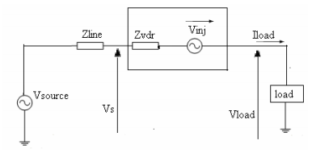

**Fig. 3.4 Equivalent Circuit of DVR**

Figure shows the equivalent circuit of the DVR, when the source voltage is drop or increase, the DVR injects a series voltage V injected through the injection transformer so that the desired load voltage magnitude VL can be maintained. The series injected voltage of the DVR can be written as

**V injected =VL – V Supply­**

Where,

VL is the desired load voltage magnitude

V Supply is the source voltage during sags/swells condition

The load current IL is given by,

**IL = ((PL ± j QL)/ VL)**

**3.7 VOLTAGE INJECTION METHODS OF DVR**

Voltage injection or compensation methods by means of a DVR depend upon the limiting factors such as; DVR power ratings, various conditions of load, and different types of voltage sags. Some loads are sensitive towards phase angel jump and some are sensitive towards change in magnitude and others are tolerant to these. Therefore the control strategies depend upon the type of load characteristics.

There are four different methods of DVR voltage injection which are

i. Pre-sag compensation method

ii. In-phase compensation method

iii. In-phase advanced compensation method

iv. Voltage tolerance method with minimum energy injection

**3.7.1 Pre-sag/dip compensation method:**

The pre-sag method tracks the supply voltage continuously and if it detects any disturbances in supply voltage it will inject the difference voltage between the sag or voltage at PCC and pre-fault condition, so that the load voltage can be restored back to the pre-fault condition. Compensation of voltage sags in the both phase angle and amplitude sensitive loads would be achieved by pre-sag compensation method. In this method the injected active power cannot be controlled and it is determined by external conditions such as the type of faults and load conditions

VDVR = V pre-fault – V sag

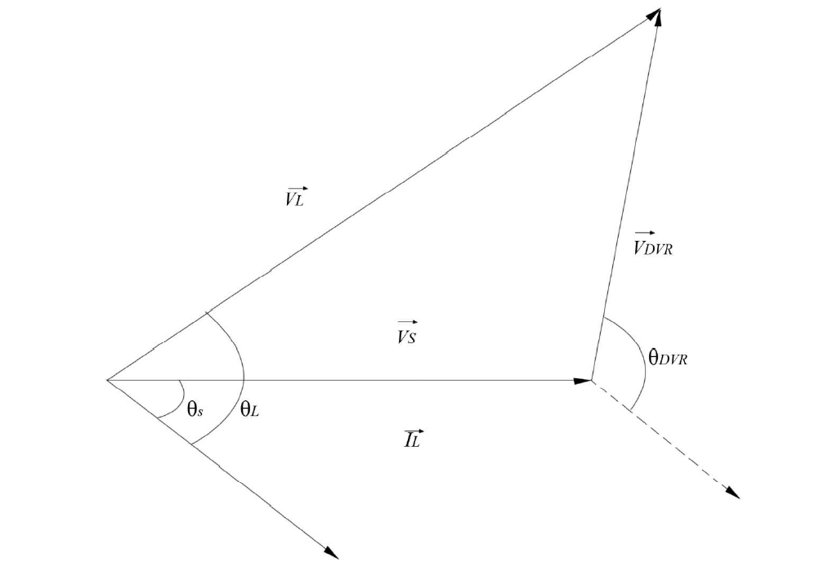

**Fig. 3.5 Pre-sag compensation method**

**3.7.2 In-phase compensation method:**

This is the most straight forward method. In this method the injected voltage is in phase with the supply side voltage irrespective of the load current and pre-fault voltage. The phase angles of the pre-sag and load voltage are different but the most important criteria for power quality that is the constant magnitude of load voltage are satisfied.

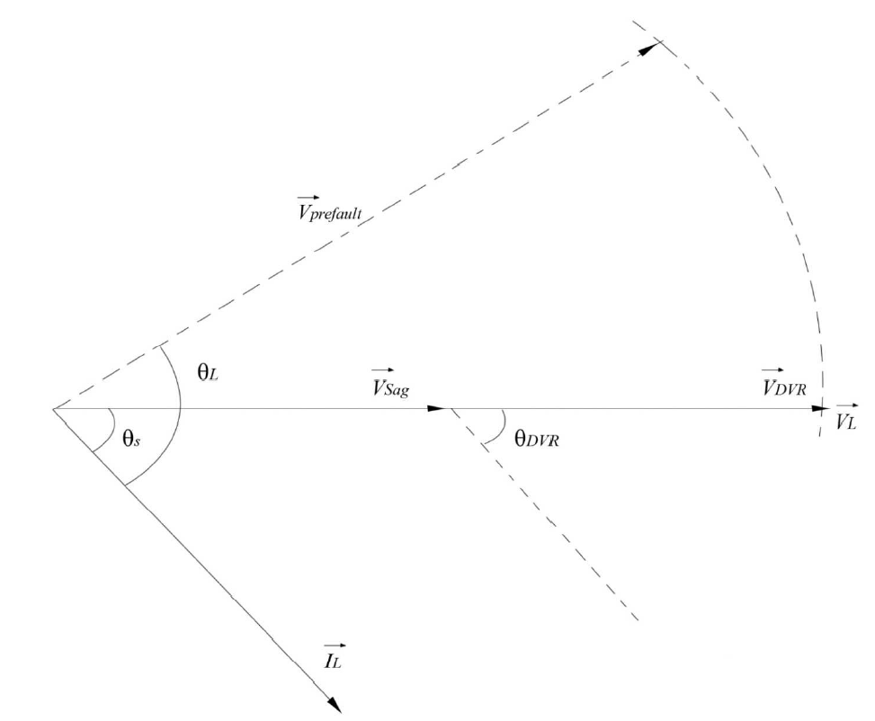

**Fig. 3.6 In-phase compensation method**

|VL|=|V pre-fault|

One of the advantages of this method is that the amplitude of DVR injection voltage is minimum for certain voltage sag in comparison with other strategies. Practical application of this method is in non-sensitive loads to phase angle jump.

**3.7.3 In-phase advanced compensation method:**

In this method the real power spent by the DVR is decreased by minimizing the power angle between the sag voltage and load current. In case of pre-sag and in-phase compensation method the active power is injected into the system during disturbances. The active power supply is limited stored energy in the DC links and this part is one of the most expensive parts of DVR. The minimization of injected energy is achieved by making the active power component zero by having the injection voltage phasor perpendicular to the load current phasor.

In this method the values of load current and voltage are fixed in the system so we can change only the phase of the sag voltage. IPAC method uses only reactive power and unfortunately, not al1 the sags can be mitigated without real power, as a consequence, this method is only suitable for a limited range of sags.

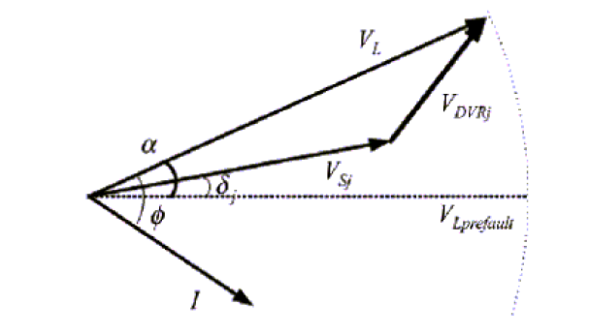

**Fig. 3.7 In-phase advanced compensation method**

**3.7.4 Voltage tolerance method with minimum energy injection:**

A small drop in voltage and small jump in phase angle can be tolerated by the load itself. If the voltage magnitude lies between 90%-110% of nominal voltage and 5%-10% of nominal state that will not disturb the operation characteristics of loads. Both magnitude and phase are the control parameter for this method which can be achieved by small energy injection.

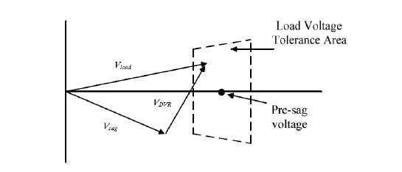

**Fig. 3.8 Voltage tolerance method with minimum energy injection**

**3.8 DIFFERENCES BETWEEN VOLTAGE REGULATORS AND DVRS**

Both are used to mitigate the effects of voltage dips. Dips are characterized by the depth - the retained voltage - and the duration. Short and deep dips are best served by a DVR while long and shallow dips are the province of the voltage regulator.

A voltage regulator has no energy store. It has a transformer secondary winding in series with the supply. When the input voltage moves outside the tolerance band the primary of that transformer is driven to boost, or in anti-phase to reduce, the voltage appropriately. Because the load voltage is kept constant, the power to the load is constant so, when the input voltage falls, the input current increases. The current capability of the supply and the device itself limits the working range to about +/-30 % of nominal voltage.

A DVR has an energy store, so requires no additional input power (in the short term) to boost the voltage during a dip. A DVR can correct a dip to 0 % retained voltage. But the DVR has a limited energy store and so is suitable for short-term effects only - it cannot correct for long term under voltage, for example. Also, the store has to be recharged between events so it is not suitable multiple dips are expected frequently. Typically, DVRs use super capacitors, large secondary batteries or high-speed flywheels as energy stores. Unsurprisingly, DVRs are more expensive than voltage regulators.

**CHAPTER 4**

**OPERATION AND TOPOLOGIES OF MULTILEVEL CONVERTERS**

**4.1 DIODE-CLAMPED MULTILEVEL INVERTER**

The most commonly used multilevel topology is the diode clamped inverter, in which the diode is used as the clamping device to clamp the dc bus voltage so as to achieve steps in the output voltage. Figure 3.1 shows the circuit for a diode clamped inverter for a three-level and a four-level inverter. The key difference between the two-level inverter and the three-level inverter are the diodes D1a and D2a. These two devices clamp the switch voltage to half the level of the dc-bus voltage. In general the voltage across each capacitor for an N level diode clamped inverter at steady state is Vdc/n-1. Although each active switching device is only required to block Vdc/n-1, the clamping devices have different ratings. The diode-clamped inverter provides multiple voltage levels through connection of the phases to a series of capacitors. According to the original invention, the concept can be extended to any number of levels by increasing the number of capacitors. Early descriptions of this topology were limited to three-levels where two capacitors are connected across the dc bus resulting in one additional level. The additional level was the neutral point of the dc bus, so the terminology neutral point clamped (NPC) inverter was introduced. However, with an even number of voltage levels, the neutral point is not accessible, and the term multiple point clamped (MPC) is sometimes applied Due to capacitor voltage balancing issues, the diode-clamped inverter implementation has been limited to the three level. Because of industrial developments over the past several years, the three level inverter is now used extensively in industry applications. Although most applications are medium-voltage, a three-level inverter for 480V is on the market.

In general for a N level diode clamped inverter, for each leg 2 (N-1) switching devices, (N-1) * (N-2) clamping diodes and (N-1) dc link capacitors are required. When N is sufficiently high, the number of diodes and the number of switching devices will increase and make the system impracticable to implement. If the inverter runs under pulse width modulation (PWM), the diode reverse recovery of these clamping diodes becomes the major design challenge



Figure 4.1: Topology of the diode-clamped inverter (I) two-level inverter, (II) three-level inverter, (III) four-level inverter.

Though the structure is more complicated than the two-level inverter, the operation is straightforward and well known . In summary, each phase node (a, b, or c) can be connected to any node in the capacitor bank (V3, V2, V1). Connection of the a-phase to positive node, V3 occurs when S1ap and S2ap are turned on and to the neutral point voltage, when S2ap and S1an are turned on and the negative node V1 is connected when S1an and S2an are turned on. There are some complementary switches and in a practical implementation, some dead time is inserted between the gating signals and their complements meaning that both switches in a complementary pair may be switched off for a small amount of time during a transition. However, for the discussion herein, the dead time will be ignored. From Figure 4.1 (II), it can be seen that, with this switching state, the a-phase current Ia will flow into the junction through diode D1a if the current is negative or out of the junction through diode D2a if the current is positive. The dc currents I3, I2, and I1 are the node currents of the inverter.

Extending the diode-clamped concept to four levels results in the topology shown in Figure 4.1 (III). A pair of diodes is added in each phase for each of the two junctions. The operation is similar to the three-level. For practical implementation, the switching state needs to be converted into transistor signals. Once the transistor signals are established, general expressions for the a-phase line-to-ground voltage and the a-phase component of the dc currents can be written as



The node currents for the N level inverter are given by



The above relationships may be programmed into a simulation software to form a block that simulates one phase of a diode-clamped inverter. A number of blocks can be connected together for a multiphase system. For more simulation details, the transistor and diode KVL and KCL equations may be implemented. This allows inclusion of the device voltage drops (as well as conduction losses) and also the individual device voltages and currents. To express this relationship, consider the general N-level diode-clamped structure. Therein, only the upper half of the inverter is considered since the lower half contains complementary transistors and may be analyzed in a similar way. Through the clamping action of the diodes, the blocking voltage of each transistor is the corresponding capacitor voltage in the series bank.

The inner diodes of the multilevel inverter must block a higher voltage. For example, in the four-level topology the inner diodes must block two-thirds of the dc voltage while the outer diodes block one-third. This is a well-known disadvantage of the diode-clamped topology. For this reason, some authors represent the higher voltage diodes with lower voltage diodes in series [6] or alter the structure of the topology so that each diode blocks the same voltage [7].

Finally, the capacitor junction currents may be expressed as the difference of two clamping diode currents. In case of a three-level inverter, the expression reduces to



**4.2 FLYING CAPACITOR STRUCTURE**

The capacitor clamped inverter alternatively known as flying capacitor was proposed by Meynard and Foch. This is one of the alternative topology for the diode clamped inverter. The flying capacitor involves series connection of capacitor clamped switching cells [8]. Figure 3.2 shows the three-level and the four level capacitor clamped inverter. This topology has several unique and attractive features when compared to the diode-clamped inverter. One feature is that added clamping diodes are not needed. Furthermore, the flying capacitor inverter has switching redundancy within the phase, which can be used to balance the flying capacitors so that only one dc source is needed. Figure 3.2 shows the three-level flying capacitor inverter. The general concept of operation is that each flying capacitor is charged to one-half of the dc voltage and can be connected in series with the phase to add or to subtract this voltage. The major advantage is that the required number of voltage levels can be achieved without the use of the transformer. This assists in reducing the cost of the converter and again reduces power loss. Unlike the diode clamped structure where the series string of capacitors share the same voltage, in the capacitor-clamped voltage source converter the capacitors within a phase leg are charged to different voltage levels. To synthesize the phase voltage waveforms the various switches within the phase leg are switched on to combine the various capacitor voltage levels with the constraint that no capacitor is short-circuited and current continuity with the DC link is maintained for each capacitor.

Similar to the diode clamped inverter, the capacitor clamping requires a large number of bulk capacitors to clamp the voltage. Provided that the voltage rating of each capacitor used is the same as that of the main power switch, a N level converter will require a total of (N-1) * (N-2) / 2 clamping capacitors per phase in addition to the N-1 main dc bus capacitors.

The topology also has several disadvantages that have limited its use. First one being the converter initialization i.e., before the converter can be modulated by any modulation scheme the capacitors must be set up with the required voltage level as the initial charge. This complicates the modulation process and becomes a hindrance to the operation of the converter. The capacitor voltages must also be regulated under normal operation in a similar way to the capacitors of a diode clamped converter. Another major drawback of the topology is the rating of the capacitors, since the capacitors have large fractions of the dc bus voltage across them.



Figure 4.2: Schematic of Capacitor Clamped inverter (I) three-level inverter (II) four-level inverter.

In the operation of the converter, each phase node (a, b, or c) can be connected to any node in the capacitor bank (V3, V2, V1). Connection of the a-phase to positive node V3 occurs when S1ap and S2ap are turned on and to the neutral point voltage when S2ap and S1an are turned and the negative node V1 is connected when S1an and S2an are turned on. The clamped capacitor C1 is charged when S1ap and S1an are turned on and is discharged when S2ap and S2an are turned on. The charge of the capacitor can be balanced by proper selection of the zero states. In comparison to the three-level diode-clamped inverter, an extra switching state is possible. In particular, there are two transistor states, which make up the level V3. Considering the direction of the a-phase flying capacitor current Ia for the redundant states, a decision can be made to charge or discharge the capacitor and therefore, the capacitor voltage can be regulated to its desired value by switching within the phase. As with the three-level flying capacitor inverter, the highest and lowest switching states do not change the charge of the capacitors. The two intermediate voltage levels contain enough redundant states so that both capacitors can be regulated to their ideal voltages.

**4.3 SERIES H-BRIDGE MULTILEVEL INVERTER**

One more alternative for a multilevel inverter is the Series H-bridge inverter. The series H-bridge inverter appeared in 1975 [7], but several recent patents have been obtained for this topology as well. A series of single-phase full bridges makes up a phase for the inverter. Each full bridge can switch between +Vdc, 0, -Vdc. Since this topology consists of series power conversion cells, the voltage and power level may be easily scaled. The dc link supply for each full bridge converter is provided separately, and this is typically achieved using diode rectifiers fed from isolated secondary windings of a three-phase transformer. An apparent disadvantage of this topology is the large number of isolated voltages required to supply each cell. However, phase-shifted transformers can supply the cells in medium-voltage systems in order to provide high power quality at the utility connection.

There are several advantages for this topology that have made the application of the converter interesting. The main advantage is the regulation of the DC buses described, while the other is concerning the modularity of control that can be achieved. Unlike the diode clamped and capacitor clamped inverter where the individual phase legs must be modulated by a central controller, the full-bridge inverters of a cascaded structure can be modulated separately. Communication between the full-bridges is required to achieve the synchronization of reference and the carrier waveforms.

A two-cell series H-bridge inverter is as shown in Figure 3.3. The inverter consists of familiar H-bridge (sometimes referred to as full-bridge) cells in a cascade connection. Since each cell can provide three voltage levels (zero, positive dc voltage, and negative dc voltage), the cells are themselves multilevel inverters. Since the H-bridge cells can supply both positive and negative voltages contributing to the line-to-ground voltage, a switching state is defined for H-bridge cells that have negative values.



Figure 4.3: Schematic of series H-bridge inverter.

**CHAPTER 5**

**SIMULATION RESUTS**



**Simulation Circuit**

Harmonic Compensation:

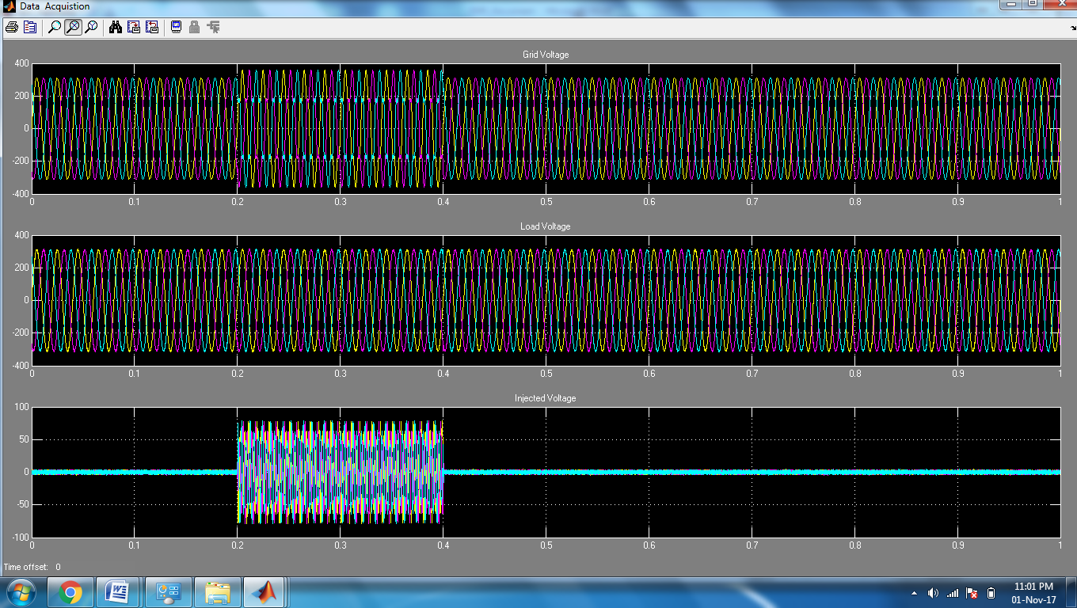

Fig: Harmonic Compensation during 0.2 to 0.4 sec

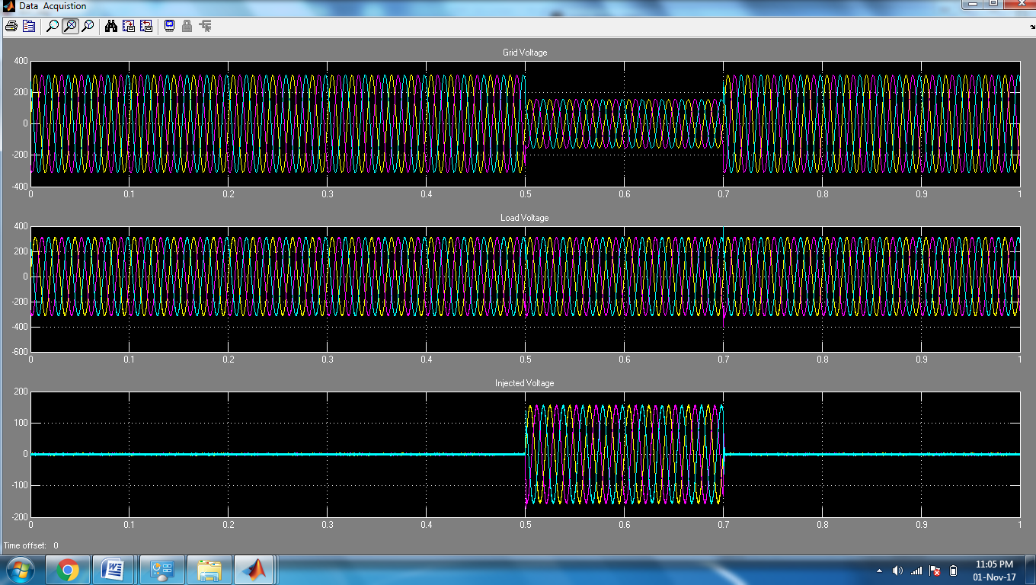

Fig: Voltage Sag Compensation during 0.5 to 0.7 sec

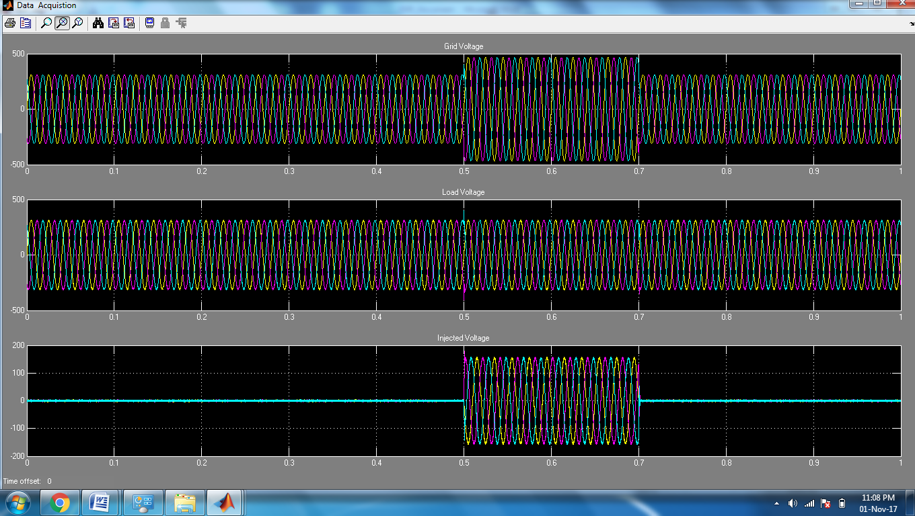

Fig: Voltage Swell Compensation during 0.5 to 0.7 sec

**CONCLUSION**

The Dynamic Voltage Restorer (DVR) is an effective device for power quality enhancement due to its quick response and high reliability. The conclusion is that it is an effective apparatus to protect sensitive load from short duration of voltage dips. Compensation technique for the DVR was presented in this paper. The effectiveness of the DVR depends upon rating of energy storage device and loads

**REFERENCES**

[1] Tarek I El-Shennawy, Abdel-Mon’em Moussa, Mahmoud A El-Gammal and Amr Y Abou-Ghazala “A Dynamic Voltage Restorer for Voltage Sag Mitigation in a Refinery with Induction Motors Loads” 2010 Science

[2] Chellali Benchaiba,Brahim Ferdi “Voltage Quality Improvement Using DVR” Electrical Power Quality and Utilization,Journal Vol.XIV no.1,2008

[3] Shairul Wizmar Wahab and Alia Mohd Yusof “Voltage Sag and mitigation Using Dynamic Voltage Restorer (DVR) System” Faculty of Electrical Engg,University Of Malaysia

[4] Brice J Quirl,Brain K Johnsom,Senior member IEEE “ Mitigation of voltage sags with phase jump using Dynami Voltage Restorer”

[5] Paosan Boonchaiam and Nadarajah Mothulananthan “Understanding Dynamic Voltage Restorers through MATLAB simulation” Electrical Power system Management ,enerfy Field of Studey,Asian Institute of Technology,Thailand

[6] B H Lai,S S Choi D M Vilathgamuwa “A New Control Strategy for Energy-Saving Dynamic Voltage Restoration”School of Electrical and Electronic Engg. Nanyan Technological University Singapore 639798.

[7] Mehmet Tumay ,Ahmet Teke , K Cagatay Baymdr and M Ugras Cuma “Simuation and Modelling of a Dynamic Voltage Restorer” Departmetn of Electrical and Electronics Engg. Turkey available from

http://www.emo.org.tr/ekler/ee5605917626676_ek.pdf

[8] ELECTROTEK Concepts, Voltage Sag Studies Date : 10/03/2009

http://www.electrotek.com/voltsag.htm.

[9] C S Chang, Y.S. Ho, P.C. Lo “Voltage Quality Enhancement with Power Electronics Based Devices.

[10] Glanny M Ch Mangindaan, M Ashari Mauridhi HP “Control of Dynamic Voltage Restorer For Voltage Sag Mitigation” ICTS 2008 available from

http://ieeexplore.ieee.org/ebooks/5270869/5271123.pdf

[11] IEEE Standard 1159-1995 “IEEE Recommended Practice for Monitoring Electric

Power Quality.Published 1995.

[12] Richard P. Bingham “Sags and Swells” available from

http://www.dranetz-bmi.com/pdf/sags-swells.pdf

[13] Nita R. Patne, Krishna L. Thakre “Factor Affecting Characteristics Of Voltage Sag Due to Fault in the Power System” Vol. 5, No.1, May2008, 171-182, Serbian Journal Of Electrical engineering.

[14] Alexander Eigels Emanuel, John A. McNeill “Electric Power Quality”. Annu. Rev. Energy Environ 1997.22:263-303.

[15] Mohd Izhwan Muhammad, Norman Mariun, Mohd Amran Mohd Radzi “ Effects Of Power Quality to the Industries” 11-12 December 2007, Malaysia

[16] Narain G. Hingorani, “Introducing custom power” IEEE spectrum, June 1995 pg.41-48.

[17] C. Zhan, V.K. Ramachandramurthy, A.Arulampalam, C.Fitzzer, M.Barnes, N.Jenkins, “Control of a battery supported dynamic voltage restorer”, IEEE proceedings on Transmission and Distribution, Vol.149 (No.5), Sep. 2002, pg.533-542.

[18] P.T. Nguyen, Tapan K. Saha, “Dynamic Voltage Restorer against balanced and unbalanced voltage sags: Modelling and simulation”. IEEE transactions on Power Delivery, 2004, pg1-6.

[19] G. Ramtharan, S.G. Abeyratne, A.Atputharajah,”Constant frequency control of an active power filter”, National Science Foundation, Sri Lanka, 2006,34(1)pg.21-28

[20] Kasuni Perera, Arualpalam Atputharajah, Sanath Alahakoon, Daniel Salomonsson “Automated Control Technique for a Single Phase Dynamic Voltage Restorer” December 15-17, 2006, Colombo, Sri-Lanka.

[21] W. Raithmayr, P. Daehler, M. Eichler, G. Lochner, EricJohn, Kevin Chan “Customer Reliability Improvement with a DVR or a DUPS” ABB Industires AG