Lab5-Morphological Image Processing

CIS694/EEC693 Image Processing and Learning Methods-2021 Spring

By Hongkai Yu, [h.yu19@csuohio.edu](mailto:h.yu19@csuohio.edu)

Cleveland State University

In this in-class lab, we will practice the Lab5-Morphological Image Processing algorithms. The image named “demo.tif” is a binary image with 1 channel.

1. Please make up for the file *DIP.m* to complete the function *DIP.LabelObjects() to generate the following visualization output*:

% sample call:

DIP.LabelObjects('demo.tif', 50);

It will show as follow:

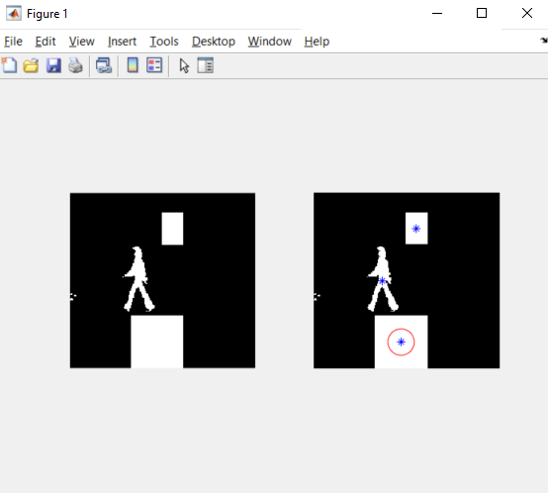

Hints: For a binary image, find connected components, ignore small ones (area < an input threshold), then draw blue star for each center, then draw a large red circle for the center of the largest connected component.

2. Please make up for the file *DIP.m* to complete the function *DIP.RemoveSmall() to generate the following visualization output*:

% sample call:

DIP.RemoveSmall('demo.tif', 50);

It will show as follow:

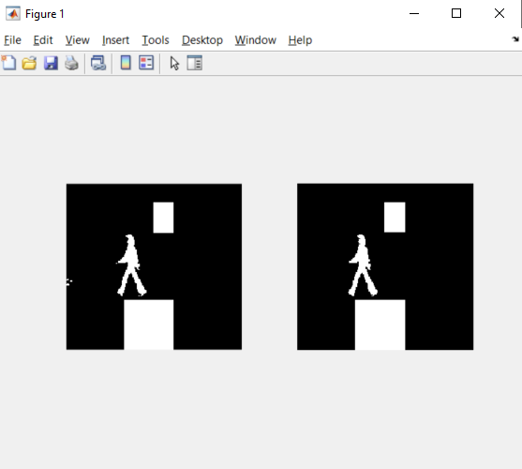

Hints: For a binary image, find connected components, remove small ones (area < an input threshold).

3. Please make up for the file *DIP.m* to complete the function *DIP.LabelObjectsBBX () to generate the following visualization output*:

% sample call:

DIP.LabelObjectsBBX('demo.tif', 50);

It will show as follow:

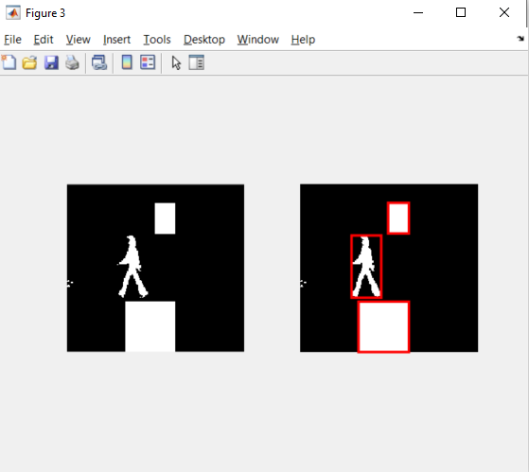

Hints: For a binary image, find connected components, ignore small ones (area < an input threshold), then draw a tight bounding box for each connected component.