Lab7-Linear Regression

CIS694/EEC693 Image Processing and Learning Methods-2021 Spring

By Hongkai Yu, [h.yu19@csuohio.edu](mailto:h.yu19@csuohio.edu)

Cleveland State University

**In this in-class lab, we will practice the Linear Regression technique for machine learning.**

1. Please fill the code “LinearRegressionOneVariable.m” for linear regression with one single variable:

f(x)=theta0+theta1*x

Suppose the ground-truth data is generated by gt=10+3*x with some [-5, 5] random noises. After filling the code, if you run it, you will see the following output in the command window with the following two figures:

epoch: 1, loss:16779.873034

epoch: 2, loss:7353.328047

epoch: 3, loss:3227.508267

epoch: 4, loss:1421.715089

epoch: 5, loss:631.353426

epoch: 6, loss:285.426824

epoch: 7, loss:134.020995

epoch: 8, loss:67.753208

epoch: 9, loss:38.748723

epoch: 10, loss:26.053677

…

epoch: 45, loss:16.152112

epoch: 46, loss:16.151517

epoch: 47, loss:16.150922

epoch: 48, loss:16.150328

epoch: 49, loss:16.149733

epoch: 50, loss:16.149138

Linear regression result-> theta0: 0.059176, theta1:3.146987

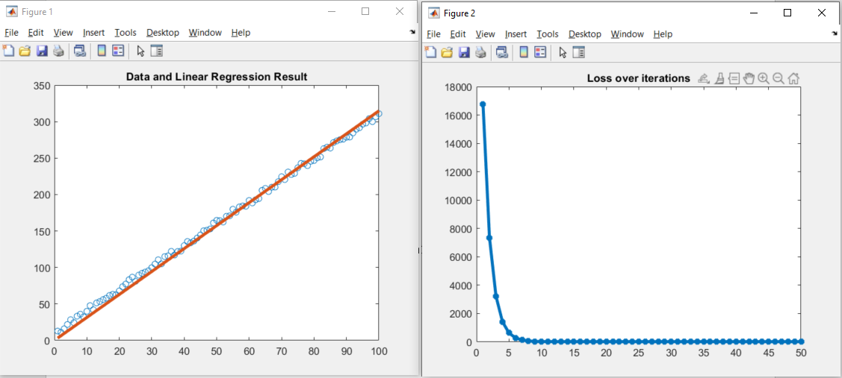

2. Please fill the code “LinearRegressionMultipleVariables.m” for linear regression with multiple variables:

f(x) = theta_0*1 + theta_1*x_1 + theta_2*x_2 +...+ theta_n*x_n, where n=3 in this example. Suppose the ground-truth data is generated by the ground-truth theta= [20, 1, 10, -2] as follow:

gt= 20*1 + 1*x(2,:) + 10*x(3,:) - 2*x(4,:);

After filling the code, if you run it, you will see the following output in the Command Window with the following figure:

epoch: 1, loss:12791.173701

epoch: 2, loss:7505.894055

epoch: 3, loss:4438.424634

epoch: 4, loss:2658.025772

epoch: 5, loss:1624.570724

epoch: 6, loss:1024.608227

epoch: 7, loss:676.230337

epoch: 8, loss:473.866921

epoch: 9, loss:356.249271

epoch: 10, loss:287.818750

…

epoch: 490, loss:75.008048

epoch: 491, loss:74.859974

epoch: 492, loss:74.712191

epoch: 493, loss:74.564701

epoch: 494, loss:74.417502

epoch: 495, loss:74.270593

epoch: 496, loss:74.123974

epoch: 497, loss:73.977645

epoch: 498, loss:73.831604

epoch: 499, loss:73.685852

epoch: 500, loss:73.540388

theta =

7.8085

0.9402

10.0140

-2.0714

test =

1

5

13

4

gt =

147

predict =

134.4062

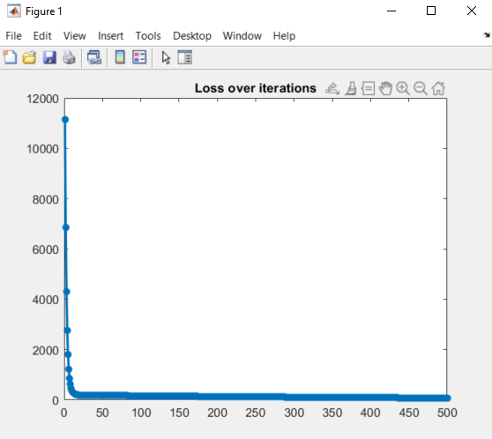

**Brainstorm: The prediction result of Question2 looks not accurate enough. What changes can we make to improve it?**