A Mini Project Report on

THE ENGAGEMENT TRAP
Accuracy, Diversity and Feedback Loops in Movie Recommendation

Submitted by
Panini Shah C169 60004240248
Raj Panchali C149 60004240012

Under the guidance of
Prof. Ruhina Karani
TABLE OF CONTENTS
Abstract 5
1. Introduction 6
1.1 Background 6
1.2 Problem Statement 6
1.3 Objectives 6
2. Literature Survey 7
2.1 Collaborative Filtering and Matrix Factorisation 7
2.2 Accuracy Metrics versus Top-N Recommendation 7
2.3 Diversity in Recommendation 7
2.4 Popularity Bias and Feedback Loops 7
2.5 Proxy Optimisation and Goodhart's Law 7
2.6 Clustering 8
2.7 Summary and Research Gap 8
3. Dataset Description 9
3.1 Source 9
3.2 Files and Attributes 9
3.3 Statistics 9
3.4 Characteristics Relevant to the Study 10
4. Proposed Methodology 11
4.1 Overview 11
4.2 Evaluation Protocol 11
4.3 Evaluation Metrics 11
5. Data Preprocessing and Feature Engineering 13
5.1 Data Quality Checks 13
5.2 Filtering Rarely-Rated Movies 13
5.3 Re-indexing 13
5.4 Feature Engineering 13
6. Algorithms Implemented 14
6.1 Popularity (Reference Line) 14
6.2 Linear Regression – Bias Model (Exp 1) 14
6.3 Item-based K-Nearest Neighbours (Exp 8) 14
6.4 Singular Value Decomposition (Exp 6) 15
6.5 Content-Based Filtering with PCA (Exp 5) 15
6.6 Ranking 15
7. Proposed Minor Novelty / Improvement 16
7.1 Diversity-Aware Re-ranking with MMR 16
7.2 Cluster Caps with K-Means and DBSCAN (Exp 10) 16
7.3 Choosing the Operating Point 16
7.4 Feedback-Loop Simulation 16
7.5 Design Decision: Avoiding a Circular Simulation 17
8. Implementation 18
8.1 Environment 18
8.2 Code Organisation 18
8.3 Running the Experiments 18
8.4 Web Prototype 19
9. Experimental Results 21
9.1 Baseline Comparison 21
9.2 Model Selection 22
9.3 Diversity-Aware Re-ranking 23
9.4 K-Means versus DBSCAN 24
9.5 Hidden User Model 25
9.6 Feedback-Loop Simulation 25
10. Comparison and Discussion 27
10.1 Which Model Is Best? 27
10.2 Accuracy and Popularity 27
10.3 The Accuracy–Diversity Trade-off 27
10.4 K-Means versus DBSCAN 28
10.5 What the Simulation Shows 28
10.6 Practical Applicability 29
10.7 Limitations 29
11. Conclusion 30
12. Future Scope 31
References 32
Appendix – Source Code, Additional Results and Screenshots 33
A. Source Code 33
B. Additional Results 34

Abstract
Recommender systems are trained to predict what a user will click or rate highly. That prediction is a proxy for the real goal, which is helping people find items they enjoy across the whole catalogue. This project, The Engagement Trap, studies what an accuracy-driven recommender, and the click metric used to judge it, can and cannot see.
Using the MovieLens ml-latest-small dataset (610 users; 3,650 movies with at least five ratings; 90,274 ratings), four algorithms from the laboratory syllabus were implemented and compared: a Linear Regression bias model, item-based K-Nearest Neighbours, Singular Value Decomposition (SVD) and a content-based model on PCA-compressed genre and decade features. Each was tuned on a validation split and evaluated on held-out data over three random seeds, using both rating-accuracy metrics (RMSE, MAE) and ranking metrics (Precision, Recall and NDCG at 10), together with catalogue coverage, exposure Gini, genre diversity and average popularity.
As the novelty, the SVD recommender was extended with diversity-aware re-ranking: Maximal Marginal Relevance (MMR) and per-cluster caps using K-Means and DBSCAN clusters of the SVD movie embeddings. A 30-round feedback-loop simulation was also built, in which the recommender retrains on clicks it caused. Those clicks are generated by a hidden Logistic Regression model of user taste that shares no parameters with the recommender (held-out AUC 0.78–0.79).
The model with the lowest rating error (ItemKNN, RMSE 0.880) produced almost useless top-10 lists (NDCG@10 0.022), while SVD produced the best lists on test (NDCG@10 0.167). MMR offered a smooth accuracy–diversity trade-off; DBSCAN found no usable cluster structure in the embeddings. In the simulation, plain SVD exposed only 5.6% of the catalogue over 30 rounds, compared with 10.8% for MMR, while click rate and simulated satisfaction were statistically indistinguishable. The click metric is therefore blind to how narrow a recommender is, and exposure has to be measured separately. A static web prototype lets a visitor compare accuracy-only and diversity-aware recommendations live.
Keywords: recommender systems, collaborative filtering, matrix factorisation, diversity, MMR, popularity bias, feedback loops, Goodhart's law, MovieLens.

1. Introduction

1.1 Background
Recommender systems decide much of what people see on streaming services, online shops and social media. Most are built by learning from past behaviour, such as ratings, clicks and purchases, to predict what a user will engage with next, and are judged by how accurately they make that prediction. Accuracy is easy to measure, but it is only a proxy for the outcome that matters: users discovering things they value, and the whole catalogue having a fair chance of being seen.
Two properties make this proxy risky. First, popularity is highly concentrated: a small share of items receives most of the attention, so a model that predicts engagement well can do so largely by recommending popular items. Second, deployed recommenders are retrained on data they helped to create. Items that are shown get clicked; items that get clicked are shown more. This feedback loop can lock exposure into a narrow part of the catalogue.
In AI-safety terms this is an instance of Goodhart's law: when a measure becomes a target, it ceases to be a good measure. A system optimised for a proxy can look successful by that proxy while drifting away from the true goal, and the proxy may give no warning that this is happening.

1.2 Problem Statement
To build and compare movie recommenders from the laboratory syllabus on a public dataset, and to investigate whether (a) the model that predicts ratings best also recommends best, (b) diversity-aware re-ranking can widen recommendations at an acceptable cost in accuracy, and (c) a click-based metric can detect how concentrated a recommender's exposure is when the system retrains on its own output.

1.3 Objectives
- Pre-process and explore the MovieLens dataset, with particular attention to the long tail of movie popularity.
- Implement and compare four recommendation algorithms (Linear Regression, KNN, SVD and a PCA-based content model) with a popularity reference line, using a leakage-free tuning and evaluation protocol.
- Measure recommendations with both accuracy metrics and beyond-accuracy metrics (coverage, exposure inequality, genre diversity and popularity).
- Propose and evaluate diversity-aware re-ranking (MMR and cluster caps), comparing K-Means and DBSCAN clustering.
- Simulate a recommendation feedback loop with a hidden user model and compare policies by click rate, true utility and catalogue exposure.
- Build a working web prototype that demonstrates the accuracy–diversity trade-off live.

2. Literature Survey

2.1 Collaborative Filtering and Matrix Factorisation
Sarwar et al. [2] introduced item-based collaborative filtering, which predicts a user's rating of an item from that user's ratings of similar items. Similarity is computed between items rather than users, which proved both more accurate and more scalable than user-based approaches. This is the basis of the KNN model in this project.
Koren, Bell and Volinsky [3] described the matrix factorisation techniques that were central to the Netflix Prize. Users and items are mapped to a shared low-dimensional space of latent factors, so that a rating is approximated by the dot product of the two vectors, together with user and item bias terms. The SVD model and the Linear Regression bias model in this project are simplified forms of these ideas.

2.2 Accuracy Metrics versus Top-N Recommendation
Cremonesi, Koren and Turrin [4] showed that algorithms tuned for rating error (RMSE) are not necessarily the best at producing top-N recommendation lists. A simple SVD of the imputed rating matrix ("PureSVD") performed strongly on top-N tasks, and results were heavily influenced by a small set of popular items. This project reproduces that pattern. NDCG, the ranking metric used here, comes from Järvelin and Kekäläinen [5].

2.3 Diversity in Recommendation
Carbonell and Goldstein [6] proposed Maximal Marginal Relevance (MMR) for re-ranking retrieved documents so that each new result is both relevant and different from those already selected. Ziegler et al. [7] introduced topic diversification and the intra-list similarity measure for recommendation lists, and found in a user study that more diverse lists could increase user satisfaction even when accuracy fell. This project uses MMR for re-ranking and an intra-list diversity (ILD) measure on genres.

2.4 Popularity Bias and Feedback Loops
Abdollahpouri, Burke and Mobasher [8] examined popularity bias in learning-to-rank recommenders and proposed a regularisation method to control it. Chaney, Stewart and Engelhardt [9] used simulation to show that when recommenders are trained on data generated under earlier recommendations ("algorithmic confounding"), user behaviour becomes more homogeneous and utility can fall. Jiang et al. [10] analysed "degenerate feedback loops" theoretically and showed how exploration can slow them. The simulation in this project follows the same idea at laboratory scale.

2.5 Proxy Optimisation and Goodhart's Law
Manheim and Garrabrant [11] categorised the ways in which optimising a proxy measure can fail, building on Goodhart's law. The click-rate metric of a recommender is a natural example of such a proxy, and the framing of this project is drawn from this line of work.

2.6 Clustering
K-Means [12] partitions data into k clusters by minimising within-cluster squared distance, so every point belongs to some cluster. DBSCAN [13] instead groups points into dense regions and labels points in sparse regions as noise, so the number of clusters does not need to be fixed in advance. Silhouette analysis [14] is used here to choose the number of clusters and the DBSCAN radius.

2.7 Summary and Research Gap
Table 2.1: Summary of the literature used
Ref. | Work | Key idea | Use in this project
[2] | Sarwar et al., 2001 | Item-based collaborative filtering | ItemKNN baseline
[3] | Koren et al., 2009 | Latent-factor matrix factorisation with biases | SVD and bias model
[4] | Cremonesi et al., 2010 | RMSE winners are not top-N winners; PureSVD | Explains the RMSE/NDCG reversal
[5] | Järvelin & Kekäläinen, 2002 | Cumulated gain (NDCG) | Ranking metric
[6] | Carbonell & Goldstein, 1998 | Maximal Marginal Relevance | Re-ranking method
[7] | Ziegler et al., 2005 | Topic diversification, intra-list similarity | ILD metric
[8] | Abdollahpouri et al., 2017 | Controlling popularity bias | Motivation, coverage metrics
[9] | Chaney et al., 2018 | Simulated feedback loops increase homogeneity | Simulation design
[10] | Jiang et al., 2019 | Degenerate feedback loops | Simulation design
[11] | Manheim & Garrabrant, 2018 | Variants of Goodhart's law | Framing
[12–14] | MacQueen; Ester et al.; Rousseeuw | K-Means, DBSCAN, silhouette | Clustering for cluster caps

Gap addressed. Accuracy comparisons, diversity re-ranking and feedback-loop simulation are usually studied separately and with complex models. This project brings them together at a scale a student can reproduce on a free CPU, using only syllabus algorithms. It asks a specific question: can the click metric itself detect how concentrated a recommender's exposure is?

3. Dataset Description

3.1 Source
The project uses the MovieLens ml-latest-small dataset published by GroupLens Research, University of Minnesota [1]. It contains explicit 5-star ratings (in half-star steps from 0.5 to 5.0) and free-text tags collected on the MovieLens website between March 1996 and September 2018. Users were selected at random among those who had rated at least 20 movies, and no demographic information is included. The licence permits non-commercial research use with citation, and redistribution under the same terms.

3.2 Files and Attributes
Table 3.1: Files in the dataset
File | Attributes | Used for
ratings.csv | userId, movieId, rating (0.5–5.0), timestamp | All models; targets
movies.csv | movieId, title (with release year), genres (pipe-separated) | Content features, genre diversity, oracle
tags.csv | userId, movieId, tag, timestamp | Not used
links.csv | movieId, imdbId, tmdbId | Not used

3.3 Statistics
Table 3.2: Dataset statistics (from notebook 01)
Quantity | Value
Raw ratings / rated movies / users | 100,836 / 9,724 / 610
Movies with exactly one rating (raw) | 3,446 (35%)
Share of ratings received by the top 10% of movies (raw) | 60.0%
Gini coefficient of ratings per movie: raw → after filtering | 0.716 → 0.529
After filtering (movies with ≥ 5 ratings): users / movies / ratings | 610 / 3,650 / 90,274
Sparsity of the filtered user–movie matrix | 95.9%
Median ratings per user / per movie (filtered) | 68 / 13
Minimum ratings per user (filtered) | 12
Mean rating; share of ratings ≥ 4.0 | 3.54; 49.6%
Correlation of log(popularity) with mean rating | 0.27
Release years | 1902 – 2018
Genres | 20 (incl. IMAX and "(no genres listed)")

The 20 genre labels are: Action, Adventure, Animation, Children, Comedy, Crime, Documentary, Drama, Fantasy, Film-Noir, Horror, IMAX, Musical, Mystery, Romance, Sci-Fi, Thriller, War, Western and "(no genres listed)".

3.4 Characteristics Relevant to the Study
Movie popularity follows a steep long tail: the top tenth of movies receives six in ten ratings, and over a third of rated movies were rated only once. Popular movies are also rated slightly higher on average (correlation 0.27 with log popularity), so an accuracy-optimised recommender has a genuine statistical reason to favour them. That is why accuracy alone cannot reveal whether popularity bias is a problem.
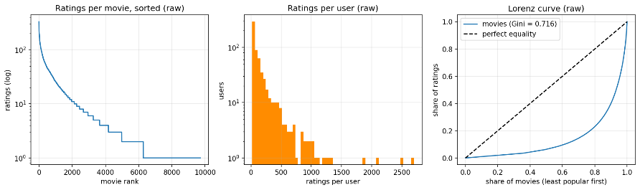
Figure 3.1: Ratings per movie (log scale), ratings per user, and the Lorenz curve of movie popularity (raw data)
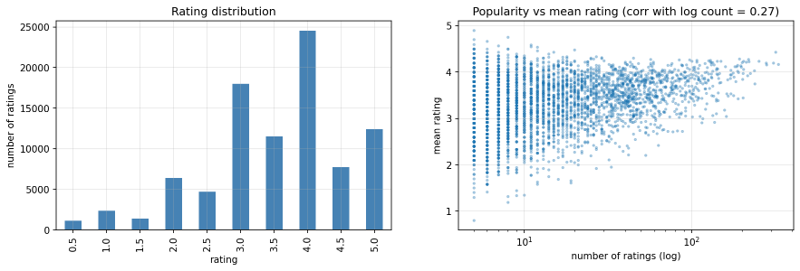
Figure 3.2: Rating distribution and popularity versus mean rating
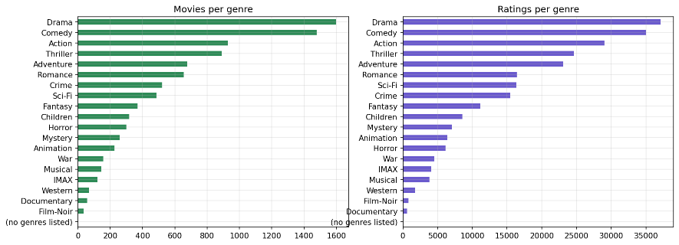
Figure 3.3: Movies and ratings per genre
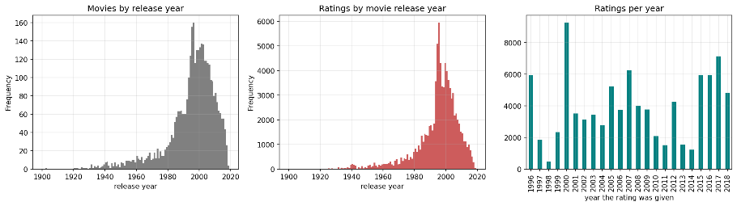
Figure 3.4: Movies and ratings by release year, and ratings given per year

4. Proposed Methodology

4.1 Overview
The work is organised as a pipeline of four Kaggle notebooks sharing one Python library, followed by a static web prototype:
- Exploration and preprocessing (notebook 01): load, check, filter and explore the data; build features; verify the data split.
- Baseline comparison (notebook 02): tune and evaluate four algorithms and a popularity reference over three seeds.
- Diversity-aware re-ranking (notebook 03): re-rank SVD's recommendations with MMR and cluster caps; compare K-Means and DBSCAN; choose settings on validation data.
- Feedback-loop simulation (notebook 04): simulate 30 rounds of recommendation, clicking and retraining under a hidden user model, for four policies.
- Prototype: export model parameters and results as JSON and build an interactive web page.

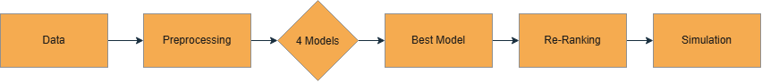
Figure 4.1: Overall pipeline of the project

4.2 Evaluation Protocol
Splitting. For each user, a random 20% of their ratings forms the test set and the rest forms the training set. From the training set, another 20% per user is held out as a validation set; the remainder is the fitting set. Every user has at least 12 ratings after filtering, so every user appears in all parts.
Tuning without leakage. For each model, every hyperparameter setting is fitted on the fitting set and scored on the validation set. The best setting by validation NDCG@10 is refitted on the full training set and evaluated once on the test set. The test set is never used to choose anything.
Repetition. The whole procedure is repeated with seeds 0, 1 and 2 (validation seeds 100, 101 and 102). Results are reported as mean ± standard deviation over the three seeds.
Top-N lists. Each user receives a list of K = 10 movies, excluding movies they rated in the training data. A test movie is relevant if the user rated it 4.0 or higher.

4.3 Evaluation Metrics
Let r̂ be a predicted rating, r the true rating, and n the number of test ratings.
RMSE = √( (1/n) Σ (r − r̂)² ) MAE = (1/n) Σ |r − r̂|
For a user with relevant test set Rel and top-10 list L:
Precision@10 = |L ∩ Rel| / 10 Recall@10 = |L ∩ Rel| / |Rel|
DCG@10 = Σ_{p=1..10} rel_p / log₂(p + 1) NDCG@10 = DCG@10 / IDCG@10
where rel_p is 1 if the movie at position p is relevant and IDCG is the DCG of a perfect list. Ranking metrics are averaged over users with at least one relevant test movie. Beyond accuracy:
- Coverage: the fraction of the catalogue that appears in at least one user's list.
- Exposure Gini: the Gini coefficient of how often each movie is recommended (0 = perfectly equal exposure, values near 1 = exposure concentrated on very few movies):
G = ( n + 1 − 2 · Σᵢ Cᵢ / Cₙ ) / n, with exposures sorted ascending and Cᵢ their cumulative sum
- ILD (intra-list diversity): the mean of (1 − cosine similarity) between the genre vectors of every pair of movies in a list.
- AvgPop: the mean number of training ratings of the recommended movies.

5. Data Preprocessing and Feature Engineering

5.1 Data Quality Checks
The ratings contain no missing values and no duplicate (user, movie) pairs. Rating values are the ten half-star steps from 0.5 to 5.0. Every rated movie appears in movies.csv. Release years are parsed from the title; after filtering, every movie has a year and at least one genre label.

5.2 Filtering Rarely-Rated Movies
Movies with fewer than five ratings were removed before modelling. A movie rated once or twice has no reliable similarity to other movies and no reliable latent vector, and cannot be evaluated meaningfully. The filter keeps 3,650 of the 9,724 rated movies and 90,274 of the 100,836 ratings (about 90%). All 610 users remain, each with at least 12 ratings. The long tail is still steep after filtering (Gini 0.529), so the phenomenon under study is preserved. The exploratory analysis of the long tail was carried out on the unfiltered data.

5.3 Re-indexing
User and movie identifiers were mapped to consecutive integers starting at 0 so that they can index the rows and columns of a matrix directly. The original movieId is kept for reference.

5.4 Feature Engineering
- Rating matrix R: a sparse 610 × 3,650 matrix of ratings, used by the Linear Regression, KNN and SVD models.
- User-mean centring: for KNN and SVD, each user's mean rating is subtracted from their ratings, removing differences in how generously users rate.
- Genre matrix G: a 3,650 × 20 binary matrix, one column per genre, used for diversity measurement and by the simulation's user model.
- Release decade: parsed from the title and one-hot encoded (11 decades from the 1900s to the 2010s).
- Content features F: the 20 genre flags plus the 11 decade indicators (31 features), compressed with PCA for the content-based model.
- Popularity: the number of ratings per movie, always computed on the training split only.
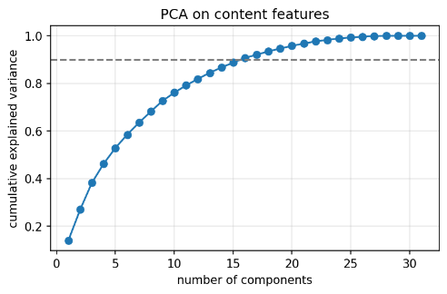
Figure 5.1: Cumulative explained variance of PCA on the content features

6. Algorithms Implemented
Table 6.1 maps every algorithm used in the project to the corresponding laboratory experiment. The four compared recommenders are described in this chapter; MMR, the cluster caps and the simulation are described in Chapter 7.
Table 6.1: Algorithms and the corresponding laboratory experiments
Algorithm | Lab experiment | Role in the project
Linear Regression (ridge) | Exp 1 – Linear Regression | Baseline recommender (bias model)
Logistic Regression | Exp 2 – Logistic Regression | Hidden user model in the simulation
PCA | Exp 5 – PCA | Content-based recommender
SVD | Exp 6 – SVD | Baseline recommender; embeddings
K-Nearest Neighbours | Exp 8 – KNN | Item-based collaborative filtering
K-Means vs DBSCAN | Exp 10 – DBSCAN vs K-Means | Movie clusters for cluster caps

6.1 Popularity (Reference Line)
Every user is recommended the most-rated movies they have not yet rated. For rating prediction, the reference uses each movie's mean rating, shrunk towards the global mean with a prior weight of 10 ratings. This is not one of the four compared algorithms, but any personalised model should beat it.

6.2 Linear Regression – Bias Model (Exp 1)
Each rating is modelled as a global intercept plus a user bias and a movie bias:
r̂(u, i) = b₀ + b_u + b_i
Each training rating becomes one row of a sparse design matrix with a one-hot column for its user and one for its movie, and the coefficients are fitted with ridge regression (scikit-learn Ridge with an intercept and the sparse conjugate-gradient solver). The L2 penalty α shrinks the biases of rarely-rated movies towards zero. A user bias shifts all of that user's scores equally, so this model gives every user essentially the same ranking. Grid: α ∈ {10, 25, 50, 100, 250, 500}.

6.3 Item-based K-Nearest Neighbours (Exp 8)
Ratings are centred by each user's mean. The similarity between two movies is the cosine similarity of their centred rating columns, multiplied by a shrinkage factor n/(n + 25), where n is the number of users who rated both; this distrusts similarities based on few common users. Only positive similarities are kept. A rating is predicted from the k most similar movies the user has rated:
r̂(u, i) = μ_u + Σ_{j ∈ N_k(i; u)} s_ij (r_uj − μ_u) / Σ_{j ∈ N_k(i; u)} s_ij
Grid: k ∈ {5, 10, 20, 40, 80}.

6.4 Singular Value Decomposition (Exp 6)
The user-mean-centred rating matrix (missing entries equal to zero, i.e. the user's mean) is factorised with a truncated SVD, keeping the k largest singular values (scipy.sparse.linalg.svds):
R_c ≈ U_k Σ_k V_kᵀ, r̂(u, i) = μ_u + (U_k Σ_k)_u · (V_k)_i
The rows of VkΣk serve as movie embeddings for re-ranking, clustering and the web prototype. Grid: k ∈ {5, 10, 20, 40, 60}.

6.5 Content-Based Filtering with PCA (Exp 5)
The 31 content features of each movie are compressed by PCA to c components. Each user then has their own ridge regression from those components to their centred ratings, i.e. a learned "taste profile" w_u:
w_u = (Z_uᵀ Z_u + α I)⁻¹ Z_uᵀ (r_u − μ_u), r̂(u, i) = μ_u + z_i · w_u
where Z_u holds the PCA components of the movies user u rated. Grid: (c, α) ∈ {(4, 1), (8, 1), (12, 1), (8, 10), (12, 10)}.

6.6 Ranking
All four models rank movies by their predicted rating; the popularity reference ranks by number of ratings. Top-10 lists exclude movies the user rated in the training data.

7. Proposed Minor Novelty / Improvement
The novelty has two parts. The first changes which ten movies are shown, without changing the underlying SVD model. The second studies what happens over time when a recommender retrains on its own output.

7.1 Diversity-Aware Re-ranking with MMR
For each user, the 100 highest-scoring unseen movies from SVD form a candidate pool. MMR builds the list one movie at a time, each time choosing the candidate that maximises
λ · rel(i) − (1 − λ) · max_{j ∈ S} sim(i, j)
where rel(i) is the SVD score min–max scaled to [0, 1] within the pool, S is the set of movies already chosen, and sim is the cosine similarity of the SVD movie embeddings. λ = 1 reproduces the plain SVD list; smaller λ favours variety. Diversity is measured with genre vectors (ILD), whereas MMR uses SVD embeddings, so MMR does not directly optimise the metric it is judged by. Grid: λ ∈ {1.0, 0.9, 0.8, 0.7, 0.6, 0.5, 0.4, 0.3}.

7.2 Cluster Caps with K-Means and DBSCAN (Exp 10)
The SVD movie embeddings are clustered, and the ranked pool is walked from the top, skipping any movie whose cluster already has "cap" movies in the list. If the pool runs out, the list is filled in rank order. Two clustering algorithms are compared:
- K-Means on L2-normalised embeddings, with k ∈ {5, 10, 20, 30, 40, 50} chosen by silhouette score (cosine distance) and 10 initialisations.
- DBSCAN with cosine distance and min_samples = 5. The radius ε ∈ {0.05, 0.10, …, 0.60} is chosen by silhouette score on non-noise points, among settings with at least two clusters and at most 50% noise. Noise points are never capped.
Grid: cap ∈ {1, 2, 3} movies per cluster.

7.3 Choosing the Operating Point
For each method, the chosen setting is the most diverse one (highest validation ILD) that keeps at least 95% of plain SVD's validation NDCG@10. If no setting qualifies, the least restrictive setting is used. This rule was fixed before looking at test results.

7.4 Feedback-Loop Simulation
Hidden user model (Exp 2). A Logistic Regression predicts the probability that a user likes a movie (rating ≥ 4.0) from:
- the user's affinity for each genre (their average centred rating of movies in that genre, shrunk towards zero) multiplied by the movie's genre flags, giving 20 features;
- the user's mean rating, the movie's damped mean rating and the log of its popularity.
It is fitted on the training split, its AUC is measured on the held-out test split, and it is never shown to the recommender. Because the model is linear in its features, the full 610 × 3,650 probability matrix Ptrue is computed with a few matrix products. In the notebook this was checked to match scikit-learn's predictproba exactly.
Loop. Each user starts with 10 random movies from their real training history as their click log. Then, in each of 30 rounds:
- An SVD (k = 20) is fitted to the binary user × movie click matrix.
- Each user is shown 10 movies they have not clicked, chosen by one of four policies from the top 50 candidates: plain SVD, MMR (λ from notebook 03), K-Means cap and DBSCAN cap (caps from notebook 03; clusters computed once from the round-0 embeddings).
- The user clicks the movie at position p with probability P_true(u, i) / log₂(p + 2), a standard position-bias model.
- Clicks are added to the log, and the next round retrains on them.
Measured each round: click-through rate (CTR, the proxy); TrueUtility (mean P_true of the shown movies); Discovery (the share of each user's 50 best-matching movies, according to the hidden model, that have ever been shown); cumulative catalogue coverage; exposure Gini; ILD; and average popularity. All four policies share the same random numbers within a seed, so they are compared on equal terms.

7.5 Design Decision: Avoiding a Circular Simulation
An earlier design built the hidden user model from the same SVD factors as the SVD recommender. That would give the recommender the "true" structure of the world for free and make the experiment circular. The final hidden model uses no latent factors, and its accuracy is reported on held-out data. Because it rewards staying within a user's favourite genres, it if anything works against the diversity policies, so any benefit they show is conservative.

8. Implementation

8.1 Environment
Table 8.1: Tools and libraries
Component | Tool
Compute | Kaggle Notebooks, CPU only (no GPU)
Language | Python 3
Data handling | NumPy, pandas, SciPy sparse matrices
Models and metrics | scikit-learn [15] (Ridge, LogisticRegression, PCA, KMeans, DBSCAN, silhouettescore, rocauc_score), SciPy svds
Plots | Matplotlib
Prototype | HTML, CSS, JavaScript, Chart.js; hosted on GitHub Pages
Version control | Git and GitHub

8.2 Code Organisation
All reusable code lives in one module, etlib.py, so that each notebook reads as an experiment rather than a library. The repository is organised as follows:
Table 8.2: Repository structure
Path | Contents
notebooks/etlib.py | Data loading and filtering, splitting, the four models, metrics, MMR, cluster caps, clustering selection, the Logistic Regression oracle and the simulator
notebooks/01edapreprocessing.ipynb | Data checks, EDA, features, split check; exports movies.json
notebooks/02_baselines.ipynb | Tuning and evaluation of the four models; exports baselines.json
notebooks/03diversityrerank.ipynb | Clustering comparison, re-ranking, trade-off curves; exports embeddings and clusters
notebooks/04feedbackloop.ipynb | Oracle, simulation, plots; exports simulation.json
kaggle_outputs/ | Figures, result tables and JSON from the final Kaggle run, with a written summary
docs/ | The web prototype (index.html, style.css, app.js, data/)
Every model exposes the same interface: fit(R) on a sparse rating matrix, predictall() returning a full matrix of predicted ratings, and rankall() returning the scores used for top-N lists. Evaluation, re-ranking and the notebooks are therefore model-agnostic.

8.3 Running the Experiments
The library was uploaded to Kaggle as a private dataset and attached to each notebook together with the MovieLens dataset. Each notebook was run with Save & Run All (Commit), which executes it top to bottom and stores the outputs. Notebook 04 reads the λ and caps chosen by notebook 03 from its attached output, so the simulation uses settings chosen on validation data. All randomness is seeded, and rows that did not depend on changed code reproduced exactly between runs.

8.4 Web Prototype
The prototype is a static web page with no server: the SVD movie embeddings, cluster labels and result tables exported by the notebooks are loaded as JSON files, and all computation happens in the visitor's browser.
- Fold-in. A visitor picks movies they like. The browser finds the user vector p that best explains liking those movies, by solving a small ridge regression on their 40-dimensional embeddings QJ: p = (QJᵀ QJ + λI)⁻¹ QJᵀ 1. Every other movie's score is q_i · p.
- Side-by-side lists. The plain top-10 (accuracy only) is shown next to a re-ranked top-10. The re-ranking uses either MMR with a λ slider or a K-Means cap with a cap selector, implemented exactly as in the notebooks. Movies not in the plain list are tagged as new.
- Live measures. Under each list the page shows average popularity, the number of distinct K-Means taste groups, the number of genres covered, and the model's own predicted appeal relative to the plain list.
- Results. The simulation curves, model comparison table and trade-off chart are drawn from the exported results.
The demo opens on a strong setting (at most one movie per taste group) so that the difference is immediately visible, and states this on the page. One click switches to the setting chosen on validation data (MMR, λ = 0.70).

Figure 8.2: Web prototype – accuracy-only and diversity-aware lists side by side
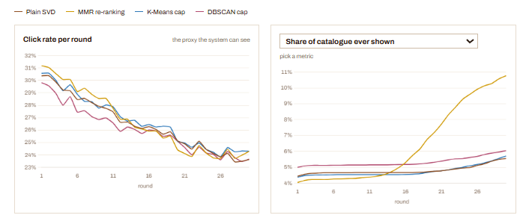
Figure 8.3: Web prototype – simulation results
Site link: https://paninishah.github.io/engagement-trap

9. Experimental Results
All values are on the test split, as mean ± standard deviation over three seeds, unless stated otherwise.

9.1 Baseline Comparison
Table 9.1: Rating and ranking accuracy of the baselines
Model | RMSE ↓ | MAE ↓ | Precision@10 | Recall@10 | NDCG@10
Popularity (reference) | 0.9532 ± 0.0121 | 0.7430 ± 0.0069 | 0.1199 ± 0.0047 | 0.1053 ± 0.0036 | 0.1602 ± 0.0038
Linear Regression | 0.9713 ± 0.0107 | 0.7702 ± 0.0070 | 0.1184 ± 0.0042 | 0.0990 ± 0.0031 | 0.1567 ± 0.0065
ItemKNN | 0.8802 ± 0.0102 | 0.6602 ± 0.0074 | 0.0205 ± 0.0002 | 0.0091 ± 0.0005 | 0.0219 ± 0.0003
SVD | 0.9170 ± 0.0077 | 0.7088 ± 0.0051 | 0.1207 ± 0.0038 | 0.1109 ± 0.0014 | 0.1671 ± 0.0014
ContentPCA | 0.9044 ± 0.0080 | 0.6998 ± 0.0048 | 0.0067 ± 0.0011 | 0.0048 ± 0.0009 | 0.0077 ± 0.0013
Table 9.2: Beyond-accuracy measures of the baselines
Model | Coverage | Exposure Gini ↓ | ILD | AvgPop | Chosen setting
Popularity (reference) | 0.0146 ± 0.0004 | 0.9952 | 0.7016 ± 0.0178 | 195.6 ± 1.4 | —
Linear Regression | 0.0132 ± 0.0007 | 0.9953 | 0.6810 ± 0.0027 | 186.0 ± 0.6 | α = 500
ItemKNN | 0.6511 ± 0.0051 | 0.6173 | 0.7141 ± 0.0056 | 19.7 ± 0.3 | k = 5
SVD | 0.1503 ± 0.0042 | 0.9554 | 0.7099 ± 0.0038 | 123.6 ± 0.9 | k = 40
ContentPCA | 0.3435 ± 0.0430 | 0.8362 | 0.2548 ± 0.0188 | 21.1 ± 0.4 | c = 8 or 12, α = 10

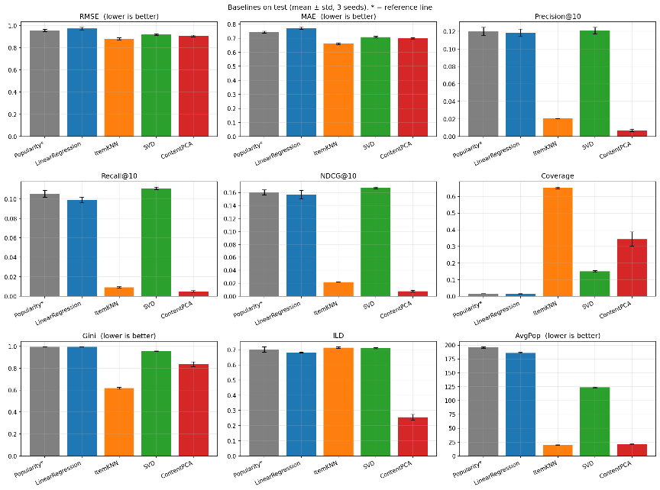
Figure 9.1: All metrics per model with error bars over three seeds
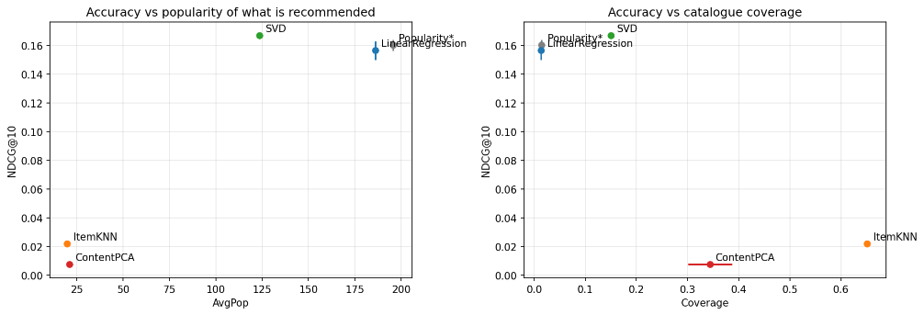
Figure 9.2: NDCG@10 against average popularity and against coverage

9.2 Model Selection
Table 9.3: Validation score used for selection versus test score
Model | Mean validation NDCG@10 | Test NDCG@10
Linear Regression | 0.1206 | 0.1567
SVD | 0.1140 | 0.1671

By the rule fixed in advance (highest mean validation NDCG@10), the selected model is Linear Regression. On the test set, SVD is the best model, and Linear Regression scores below the popularity reference. Both outcomes are reported; the rule was not changed after seeing the test results. This is discussed in Section 10.1.

9.3 Diversity-Aware Re-ranking
Table 9.4: Settings chosen on validation data
Seed | SVD k | MMR λ | K-Means cap | DBSCAN cap
0 | 40 | 0.7 | 3* | 1
1 | 40 | 0.7 | 3* | 1
2 | 40 | 0.8 | 3* | 2
* No K-Means cap kept 95% of plain SVD's validation NDCG@10 (cap 3 kept 93%), so the least restrictive cap was used as a fallback.
Table 9.5: Re-ranking results at the chosen settings
Policy | Precision@10 | NDCG@10 | Coverage ↑ | Gini ↓ | ILD ↑ | AvgPop ↓
SVD (plain) | 0.1207 ± 0.0038 | 0.1671 ± 0.0014 | 0.1503 ± 0.0042 | 0.9554 ± 0.0008 | 0.7099 ± 0.0038 | 123.6 ± 0.9
MMR | 0.1139 ± 0.0066 | 0.1596 ± 0.0024 | 0.1611 ± 0.0046 | 0.9493 ± 0.0022 | 0.7208 ± 0.0077 | 118.3 ± 1.5
K-Means cap | 0.1063 ± 0.0023 | 0.1545 ± 0.0056 | 0.1655 ± 0.0086 | 0.9455 ± 0.0043 | 0.7177 ± 0.0064 | 110.3 ± 6.5
DBSCAN cap | 0.1038 ± 0.0189 | 0.1498 ± 0.0149 | 0.1132 ± 0.0327 | 0.9633 ± 0.0067 | 0.7162 ± 0.0094 | 115.6 ± 9.3
Popularity (ref.) | 0.1199 ± 0.0047 | 0.1602 ± 0.0038 | 0.0146 ± 0.0004 | 0.9952 | 0.7016 ± 0.0178 | 195.6 ± 1.4
Table 9.6: The MMR trade-off curve (test, mean of three seeds)
λ | NDCG@10 | Coverage | AvgPop | ILD
1.0 (plain SVD) | 0.1671 | 0.150 | 123.6 | 0.710
0.9 | 0.1651 | 0.151 | 122.5 | 0.713
0.8 | 0.1621 | 0.155 | 120.6 | 0.717
0.7 | 0.1578 | 0.164 | 117.4 | 0.723
0.6 | 0.1501 | 0.178 | 111.9 | 0.730
0.5 | 0.1380 | 0.198 | 104.0 | 0.736
0.4 | 0.1243 | 0.225 | 94.0 | 0.740
0.3 | 0.1084 | 0.249 | 84.1 | 0.743

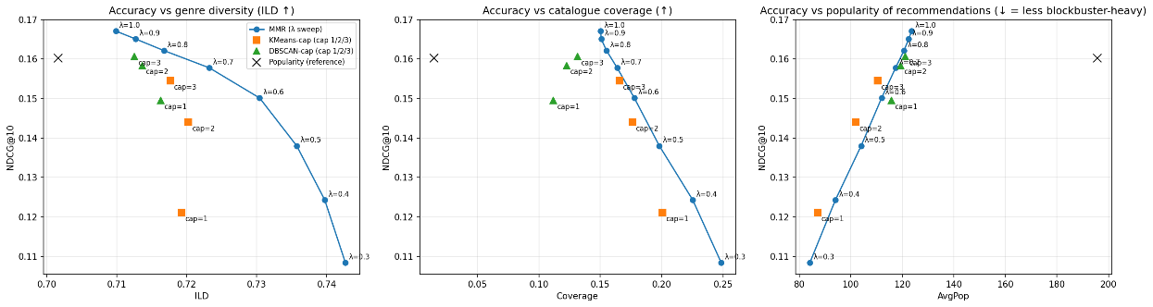
Figure 9.3: Accuracy against ILD, coverage and average popularity for every re-ranking setting

9.4 K-Means versus DBSCAN
Table 9.7: K-Means – silhouette score by number of clusters (seed 0)
k | 5 | 10 | 20 | 30 | 40 | 50
Silhouette (cosine) | 0.126 | 0.183 | 0.243 | 0.292 | 0.303 | 0.283
Table 9.8: DBSCAN – clusters, noise and silhouette by radius ε (seed 0)
ε | Clusters | Noise share | Silhouette
0.05 | 33 | 86% | 0.754
0.10 | 41 | 67% | 0.231
0.15 | 21 | 49% | −0.128
0.20 | 16 | 30% | −0.256
0.25 (chosen) | 2 | 14% | 0.002
≥ 0.30 | 1 | ≤ 4% | —

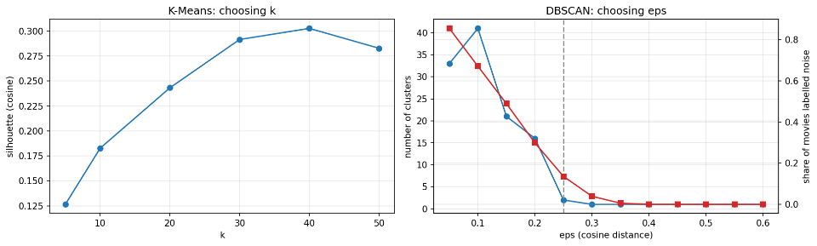
Figure 9.4: Choosing k for K-Means and ε for DBSCAN
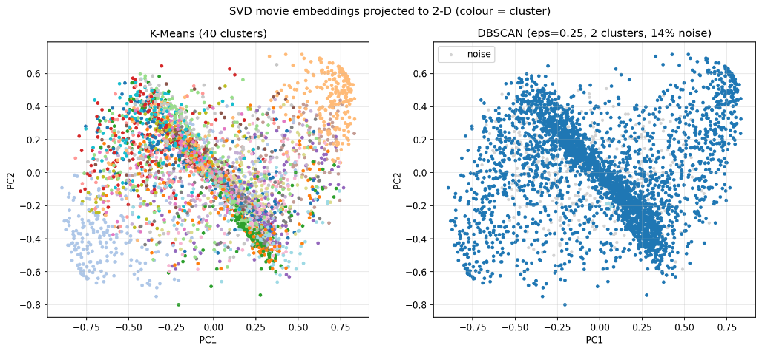
Figure 9.5: SVD movie embeddings projected to two dimensions, coloured by K-Means and DBSCAN clusters

9.5 Hidden User Model
Table 9.9: AUC of the Logistic Regression user model
Seed | AUC on training split | AUC on held-out test split
0 | 0.824 | 0.786
1 | 0.824 | 0.782
2 | 0.823 | 0.788
The model is well calibrated on held-out data. Its largest coefficients are user–genre affinity terms and the movie's mean rating, while the direct weight on log popularity is close to zero.
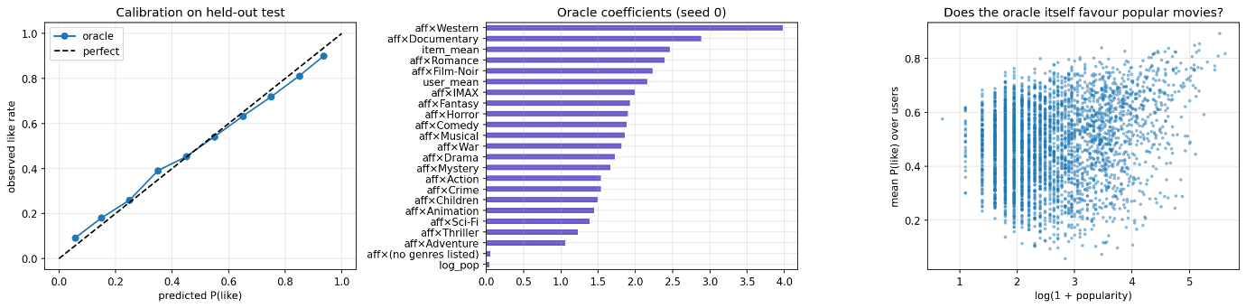
Figure 9.6: Calibration, coefficients and popularity relationship of the hidden user model

9.6 Feedback-Loop Simulation
Table 9.10: Simulation after 30 rounds (mean ± std over three seeds)
Policy | CTR | True utility | Discovery | Cum. coverage | Exposure Gini | AvgPop
Plain SVD | 0.2363 ± 0.0088 | 0.5233 ± 0.0111 | 0.2972 ± 0.0165 | 0.0556 ± 0.0019 | 0.9727 ± 0.0005 | 92.3 ± 2.5
MMR | 0.2430 ± 0.0059 | 0.5326 ± 0.0198 | 0.2982 ± 0.0077 | 0.1077 ± 0.0024 | 0.9725 ± 0.0003 | 86.2 ± 0.4
K-Means cap | 0.2431 ± 0.0031 | 0.5346 ± 0.0128 | 0.2930 ± 0.0113 | 0.0571 ± 0.0018 | 0.9732 ± 0.0007 | 91.9 ± 1.3
DBSCAN cap | 0.2366 ± 0.0234 | 0.5241 ± 0.0432 | 0.2432 ± 0.0443 | 0.0605 ± 0.0019 | 0.9752 ± 0.0015 | 83.1 ± 15.0
Table 9.11: Change from round 1 to round 30 (mean of three seeds)
Policy | CTR | True utility | Cum. coverage | AvgPop
Plain SVD | 0.304 → 0.236 | 0.656 → 0.523 | 0.044 → 0.056 | 135.7 → 92.3
MMR | 0.312 → 0.243 | 0.671 → 0.533 | 0.041 → 0.108 | 143.6 → 86.2
K-Means cap | 0.306 → 0.243 | 0.663 → 0.535 | 0.044 → 0.057 | 137.8 → 91.9
DBSCAN cap | 0.298 → 0.237 | 0.639 → 0.524 | 0.050 → 0.061 | 124.4 → 83.1

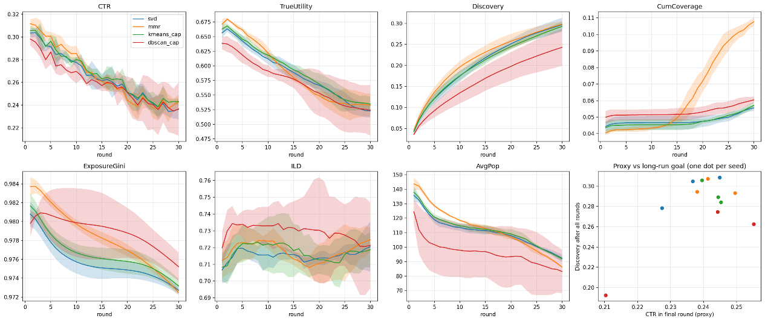
Figure 9.7: All simulation metrics over 30 rounds (bands = ±1 std over seeds) and click rate against discovery

10. Comparison and Discussion

10.1 Which Model Is Best?
The answer depends on the yardstick, and that is itself the first finding. ItemKNN predicts ratings most accurately (RMSE 0.880) but produces almost useless top-10 lists (NDCG@10 0.022). ContentPCA has the second-best RMSE and the worst lists. SVD has mediocre RMSE but the best lists on test (NDCG@10 0.167). This matches the observation of Cremonesi et al. [4] that rating accuracy and top-N quality are different objectives.
The cause is visible in the beyond-accuracy measures. KNN and ContentPCA rank movies by predicted rating, and for movies with few ratings that prediction is extreme and noisy. Such movies (average popularity about 20 ratings) fill the top of the list, yet they rarely appear in users' test sets. Their high coverage is a side effect of this noise, not useful diversity.
The validation rule selected Linear Regression, which then performed below the popularity reference on test. With α = 500, the ridge penalty shrinks the biases of rarely-rated movies to zero, and the model becomes almost a popularity ranker (coverage 1.3%, average popularity 186). Its validation score was still rising slowly at the edge of the grid (0.1194 at α = 250, 0.1206 at α = 500), approaching the popularity ranking rather than a better optimum. Validation is also built from less data than the final training set (64% versus 80% of each user's ratings), where popularity-style ranking does relatively better. The rule was not changed after seeing test results, because that would amount to tuning on the test set. The re-ranking and simulation build on SVD for a design reason: they need personalised scores and movie embeddings, which the Linear Regression bias model does not provide.

10.2 Accuracy and Popularity
Recommending the ten most-rated movies to everyone reaches NDCG@10 0.160, only 4% below SVD, while exposing just 1.5% of the catalogue (about 53 movies) with an exposure Gini of 0.995. SVD's movies average 124 training ratings each, against a median of 13 ratings per movie in the filtered data, and only 15% of the catalogue is ever recommended. Offline accuracy therefore rewards popularity heavily, partly because the evaluation can only credit movies a user actually rated.

10.3 The Accuracy–Diversity Trade-off
MMR provides a smooth, tunable dial. Between λ = 1.0 and 0.8, NDCG@10 falls by only 0.005, and it falls quickly below λ ≈ 0.6. At the chosen λ = 0.7, MMR loses 4.5% NDCG, gains 7% coverage and lowers average popularity by 4%. At that point it still ranks about as well as the popularity reference (0.158 against 0.160) while covering eleven times more of the catalogue.
Genre diversity (ILD) changes little, from 0.710 to 0.743 even at λ = 0.3. Re-ranking in SVD-embedding space mainly changes how popular the recommended movies are, not their genres. Because ILD is measured on genres while MMR works on embeddings, this result is not self-fulfilling.
The K-Means cap pushes harder against popularity than MMR at a similar accuracy (cap 3: NDCG 0.155 with average popularity 110; MMR at λ = 0.7: NDCG 0.158 with average popularity 117). For the same coverage, however, it costs slightly more accuracy, and it never met the 95% accuracy rule.

10.4 K-Means versus DBSCAN
This comparison (Experiment 10) gave a clear and instructive result. Every DBSCAN radius either labelled most movies as noise (ε ≤ 0.15) or merged almost all of them into one cluster (ε ≥ 0.25). The only high silhouette score (0.754 at ε = 0.05) came with 86% noise. The SVD embeddings form a single continuous cloud without dense, separated groups, which is precisely the structure DBSCAN assumes. Capping one giant cluster mostly lets in the same few hundred noise movies for everyone, so coverage fell and results varied widely between seeds (NDCG standard deviation 0.015, about ten times that of SVD).
K-Means always partitions the space, so it remained usable, with its silhouette peaking at k = 40 inside the search range. DBSCAN's strengths, detecting noise and arbitrary shapes, do not help when the data has no density structure.

10.5 What the Simulation Shows
Exposure stays stuck. Over 30 rounds (183,000 impressions per run), plain SVD showed only 5.6% of the catalogue in total, up from 4.4% after the first round, with exposure Gini 0.97. Cumulative coverage was almost flat for the first twenty rounds: the system kept showing the same few hundred movies.
MMR roughly doubles exposure at no measurable cost. With MMR, 10.8% of the catalogue was shown, and this held in every seed. MMR's click rate (0.243 against 0.236) and true utility (0.533 against 0.523) were within seed-to-seed variation; MMR was higher on both in two of the three seeds. A plausible explanation for MMR's coverage rising mainly after round 15 is that, once users have clicked the most popular movies, their candidate pools contain more distinct movies for MMR to spread across. This was not tested directly.
The proxy is blind. The click metric cannot distinguish a system that keeps showing 5.6% of the catalogue from one that shows 10.8%. This is the Goodhart point the data supports: the quantity being optimised gives no warning about how narrow the system is, so exposure has to be measured separately.
What the data does not show. Click rate and true utility did not diverge; both fell over the rounds for every policy, because users click their best matches early and clicked movies are never shown again. Popularity concentration did not grow over time; average popularity and Gini drifted slightly downwards for the same reason. Showing more of the catalogue did not raise Discovery: the extra movies MMR showed were mostly not among users' 50 best matches according to the hidden model. The appropriate description is therefore stagnation, not collapse. The K-Means cap behaved almost like plain SVD in the loop, while the DBSCAN cap had the lowest Discovery and the largest variation between seeds, repeating the finding of Section 10.4.

10.6 Practical Applicability
- A recommender team that monitors only click metrics would not notice that its system shows a very small part of the catalogue. Coverage and exposure inequality should be tracked as separate dashboard metrics.
- MMR is cheap (it re-orders a candidate pool), easy to tune with a single parameter, and in this study widened exposure without a measurable cost in simulated engagement. That makes it a reasonable default safeguard.
- Before using clusters for business rules, check that the clustering actually finds structure; here DBSCAN's clusters made recommendations worse.

10.7 Limitations
- Three seeds give means and spreads but not formal significance tests; differences within about two standard deviations are treated as comparable.
- Offline evaluation only rewards movies a user happened to rate, which structurally favours popular movies and penalises diversity.
- The validation rule selected a model that under-performed on test; a larger or repeated validation scheme would make selection more reliable.
- The simulation is a model, not real users. P(like) is learned only from movies people chose to rate (selection bias), tastes are fixed, users always return, the position-bias curve is assumed, clicked movies are never re-shown, and clusters are fixed at round 0. Click rate and true utility are linked by construction.
- The hidden user model is based on genre affinity, which rewards staying within favourite genres and therefore works against diversity policies.
- ml-latest-small is a development dataset whose contents may change between releases, and filtering removed the extreme tail of movies with fewer than five ratings.

11. Conclusion
This project built and compared four syllabus algorithms as movie recommenders on MovieLens, added diversity-aware re-ranking as a novelty, and simulated a recommender retraining on its own clicks. Three conclusions follow.
- Rating accuracy is not recommendation quality. The model with the lowest rating error (ItemKNN) produced the weakest lists, while SVD produced the best lists on test. A popularity ranking was a strong baseline, showing how much offline accuracy rewards recommending popular movies.
- Diversity can be bought cheaply and controllably. MMR re-ranking widened the catalogue reached by recommendations with a small, adjustable accuracy cost. K-Means clusters supported a usable cap, while DBSCAN found no cluster structure in the movie embeddings and made concentration worse.
- Click metrics are blind to narrowness. In a 30-round feedback loop, plain SVD exposed 5.6% of the catalogue and MMR 10.8%, with indistinguishable click rates and simulated satisfaction. Exposure stayed stuck rather than collapsing, and more variety did not help users reach more of their best matches. The proxy simply gave no signal about the difference.
The practical lesson echoes Goodhart's law: optimising and monitoring only the engagement proxy leaves an important property of the system invisible, so it must be measured directly. A web prototype makes this concrete by letting anyone compare accuracy-only and diversity-aware recommendations for their own picks.

12. Future Scope
- Scale up to MovieLens 20M or 25M with sparse or sampled methods, to test whether the findings hold with more users and items.
- Pre-declared simulation variants: users who return less often after poor recommendations, tastes that drift over time, social herding effects on clicks, and re-watching. These should be stated before the runs to avoid fishing for results.
- Exploration-based policies, such as epsilon-greedy or Thompson sampling, as an alternative to re-ranking for escaping feedback loops [10].
- Learned objectives that combine accuracy and exposure directly in training, for example popularity-bias regularisation [8], instead of re-ranking after the fact.
- Calibrated recommendations that match the genre mix of a user's own history.
- User studies with the web prototype, to measure whether people actually prefer the diversity-aware lists.
- More seeds and significance tests (for example paired tests across seeds) for stronger statistical conclusions.

References
[1] F. M. Harper and J. A. Konstan, "The MovieLens Datasets: History and Context," ACM Transactions on Interactive Intelligent Systems, vol. 5, no. 4, Art. 19, 2015.
[2] B. Sarwar, G. Karypis, J. Konstan and J. Riedl, "Item-based collaborative filtering recommendation algorithms," in Proc. 10th International World Wide Web Conference (WWW), 2001, pp. 285–295.
[3] Y. Koren, R. Bell and C. Volinsky, "Matrix factorization techniques for recommender systems," Computer, vol. 42, no. 8, pp. 30–37, 2009.
[4] P. Cremonesi, Y. Koren and R. Turrin, "Performance of recommender algorithms on top-N recommendation tasks," in Proc. 4th ACM Conference on Recommender Systems (RecSys), 2010, pp. 39–46.
[5] K. Järvelin and J. Kekäläinen, "Cumulated gain-based evaluation of IR techniques," ACM Transactions on Information Systems, vol. 20, no. 4, pp. 422–446, 2002.
[6] J. Carbonell and J. Goldstein, "The use of MMR, diversity-based reranking for reordering documents and producing summaries," in Proc. 21st ACM SIGIR Conference, 1998, pp. 335–336.
[7] C.-N. Ziegler, S. M. McNee, J. A. Konstan and G. Lausen, "Improving recommendation lists through topic diversification," in Proc. 14th International World Wide Web Conference (WWW), 2005, pp. 22–32.
[8] H. Abdollahpouri, R. Burke and B. Mobasher, "Controlling popularity bias in learning-to-rank recommendation," in Proc. 11th ACM Conference on Recommender Systems (RecSys), 2017, pp. 42–46.
[9] A. J. B. Chaney, B. M. Stewart and B. E. Engelhardt, "How algorithmic confounding in recommendation systems increases homogeneity and decreases utility," in Proc. 12th ACM Conference on Recommender Systems (RecSys), 2018, pp. 224–232.
[10] R. Jiang, S. Chiappa, T. Lattimore, A. György and P. Kohli, "Degenerate feedback loops in recommender systems," in Proc. AAAI/ACM Conference on AI, Ethics, and Society (AIES), 2019, pp. 383–390.
[11] D. Manheim and S. Garrabrant, "Categorizing variants of Goodhart's law," arXiv:1803.04585, 2018.
[12] J. MacQueen, "Some methods for classification and analysis of multivariate observations," in Proc. 5th Berkeley Symposium on Mathematical Statistics and Probability, vol. 1, 1967, pp. 281–297.
[13] M. Ester, H.-P. Kriegel, J. Sander and X. Xu, "A density-based algorithm for discovering clusters in large spatial databases with noise," in Proc. 2nd International Conference on Knowledge Discovery and Data Mining (KDD), 1996, pp. 226–231.
[14] P. J. Rousseeuw, "Silhouettes: a graphical aid to the interpretation and validation of cluster analysis," Journal of Computational and Applied Mathematics, vol. 20, pp. 53–65, 1987.
[15] F. Pedregosa et al., "Scikit-learn: Machine learning in Python," Journal of Machine Learning Research, vol. 12, pp. 2825–2830, 2011.

Appendix – Source Code, Additional Results and Screenshots

A. Source Code
The complete source code, notebooks and result files are available at:
https://github.com/paninishah/engagement-trap
Key excerpts from notebooks/etlib.py are reproduced below.

A.1 Maximal Marginal Relevance re-ranking
def mmr(pool, relevance, item_vecs_norm, lam, k=10):
rel = (relevance - relevance.min()) / (relevance.max() - relevance.min() + 1e-12)
V = item_vecs_norm[pool]
sim = V @ V.T
picked = []
max_sim = np.zeros(len(pool))
available = np.ones(len(pool), dtype=bool)
for _ in range(k):
score = np.where(available, lam * rel - (1 - lam) * max_sim, -np.inf)
j = int(np.argmax(score))
picked.append(j)
available[j] = False
max_sim = np.maximum(max_sim, sim[j])
return pool[picked]

A.2 SVD recommender
class SVDRec(Recommender):
def fit(self, R):
Rc, self.mu = center_rows(R)
U, s, Vt = svds(Rc, k=self.k, random_state=self.seed)
order = np.argsort(-s) # svds returns singular values in ascending order
self.U, self.s, self.Vt = U[:, order], s[order], Vt[order]
return self

def predict_all(self):
return self.mu[:, None] + (self.U * self.s) @ self.Vt

A.3 One round of the feedback loop (inside simulate)
scores, item_vecs = implicit_svd(log, svd_k, seed)
pool, pool_scores = candidate_pool(scores, log, pool_size)
recs = ... # plain top-k, MMR or cluster cap, depending on the policy
clicks = rng.random(recs.shape) < P_true[rows, recs] * position_bias
log[np.broadcast_to(rows, recs.shape)[clicks], recs[clicks]] = True

B. Additional Results
Table B.1: Mean validation scores across the hyperparameter grids (notebook 02)
Model | Setting | Val. RMSE | Val. NDCG@10 | Val. coverage
Linear Regression | α = 10 | 0.8619 | 0.0686 | 0.0085
Linear Regression | α = 25 | 0.8781 | 0.0957 | 0.0090
Linear Regression | α = 50 | 0.8958 | 0.1104 | 0.0088
Linear Regression | α = 100 | 0.9172 | 0.1156 | 0.0091
Linear Regression | α = 250 | 0.9484 | 0.1194 | 0.0093
Linear Regression | α = 500 | 0.9715 | 0.1206 | 0.0092
ItemKNN | k = 5 | 0.8876 | 0.0135 | 0.6173
ItemKNN | k = 10 | 0.8608 | 0.0113 | 0.5242
ItemKNN | k = 20 | 0.8510 | 0.0097 | 0.4679
ItemKNN | k = 40 | 0.8489 | 0.0070 | 0.4205
ItemKNN | k = 80 | 0.8503 | 0.0039 | 0.3940
The full tuning tables for all models are in kaggleoutputs/02baselines/results/02tuningvalidation.csv.

