Chapter 6: Three-Phase Alternating Current Circuits (Comprehensive Mastery Guide)
Course: Fundamental Electrical Engineering (FunE) • Faculty of Engineering, Khon Kaen University
Instructor: Assoc. Prof. Dr. Nararat Ruangchaijatupon

📌 Introduction: Why Three-Phase AC Power? (Intuition from First Principles)
Before memorizing formulas and subscripts, let us understand the physical and economic intuition:
- Single-Phase Power ($1ϕ$): The standard household supply ($230\text{ V}$) is like “pedaling a bicycle with only one leg”. When the crank reaches the top and bottom dead centers, instantaneous power drops to zero ($p(t)$ pulsates at twice the supply frequency, $2ω$). Consequently, large single-phase motors vibrate, run unevenly, and lack inherent starting torque.
- Three-Phase Power ($3ϕ$): Three identical coils positioned ${120}^{∘}$ apart in space inside an electrical alternator. It acts like a “three-cylinder engine firing sequentially in perfect balance”:
  - Constant Instantaneous Power ($p(t)=\text{Constant}$): In a balanced three-phase system, the total instantaneous power delivered to the load never drops to zero. Large motors operate smoothly without mechanical vibrations and produce self-starting rotating magnetic fields.
  - Massive Conductor Material Savings: Delivering a given amount of power over a transmission line requires $25\%−50\%$ less copper or aluminum in a three-phase system compared to a single-phase system carrying the same power at equivalent losses.
  - Two Distinct Voltage Levels from a Single System: A standard 3-phase 4-wire system provides both $230\text{ V}$ (Phase Voltage, line-to-neutral for lights and appliances) and $400\text{ V}$ (Line Voltage, line-to-line for heavy machinery and industrial motors).
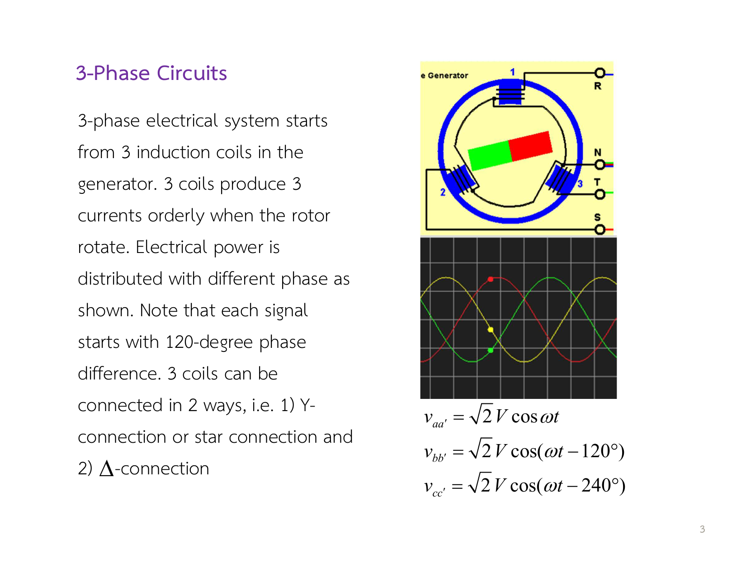 Figure 1: Generation of 3-phase voltages from three coils displaced by ${120}^{∘}$ in the generator stator, producing three equal sinusoidal waveforms phase-shifted by ${120}^{∘}$ (From Slide 3).
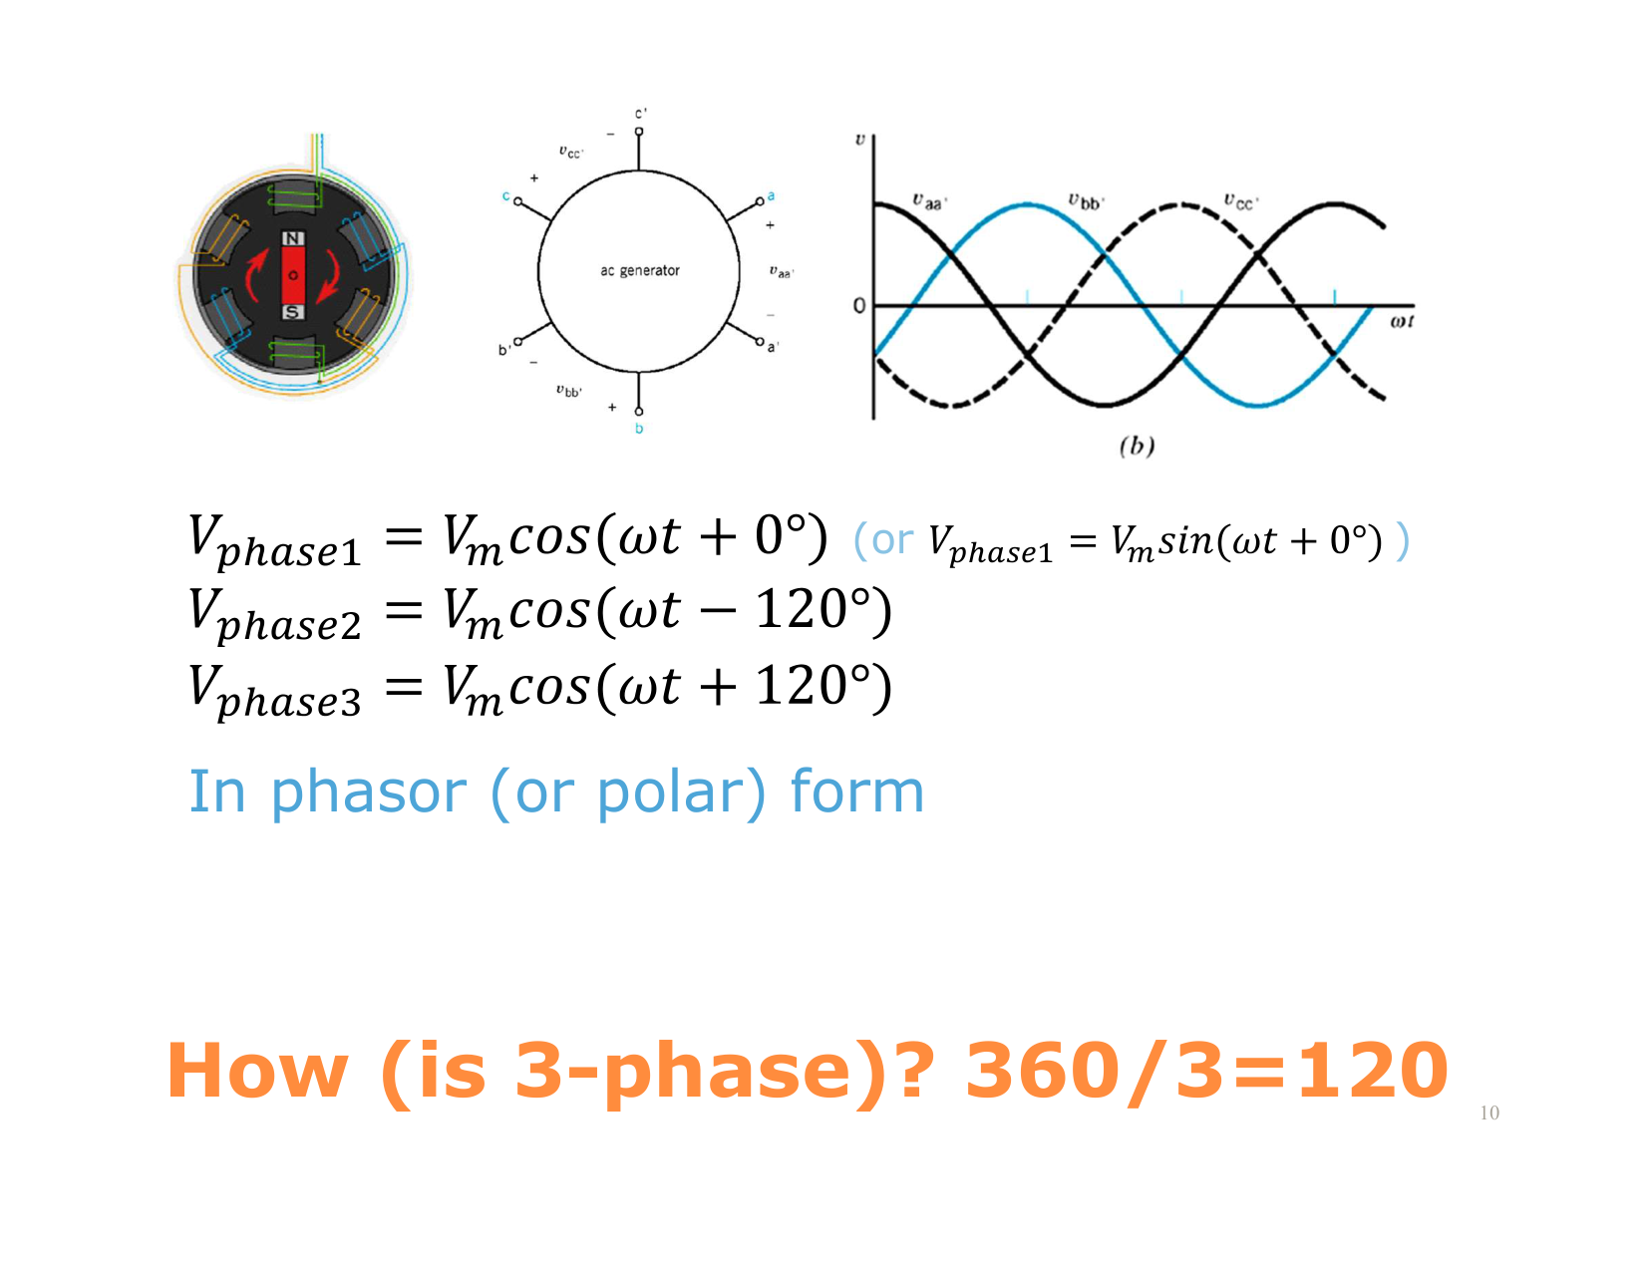 Figure 2: The three sinusoidal waveforms ($v_{a},v_{b},v_{c}$) with period $T={360}^{∘}$, each shifted by ${360}^{∘}/3={120}^{∘}$ (From Slide 10).

🔤 Complete Subscript & Notation Decoder (Variables Decoded)
The primary reason students struggle with three-phase circuits is confusing subscripts. Let us clarify them permanently:
flowchart LR
subgraph Source["Source / Generator Side"]
A_src["Terminal a"]
B_src["Terminal b"]
C_src["Terminal c"]
N_src["Neutral n"]
end
subgraph Transmission["Transmission Lines"]
L_A["Line A (Z_line)"]
L_B["Line B (Z_line)"]
L_C["Line C (Z_line)"]
L_N["Neutral Line (Z_nN)"]
end
subgraph Load["Load Side"]
A_ld["Terminal A"]
B_ld["Terminal B"]
C_ld["Terminal C"]
N_ld["Neutral N"]
end
A_src --> L_A --> A_ld
B_src --> L_B --> B_ld
C_src --> L_C --> C_ld
N_src -.-> L_N -.-> N_ld

1. Meaning of Subscript Letters
- Lowercase Letters ($a,b,c,n$): Represent the Source / Generator side, where $n$ is the source neutral point.
- Uppercase Letters ($A,B,C,N$): Represent the Load / Receiver side, where $N$ is the load neutral point.
- Double Subscripts Represent Potential Difference:
  - $V_{an}=V_{a}−V_{n}$ : Voltage from source terminal $a$ to source neutral $n$ (Source Phase Voltage).
  - $V_{AN}=V_{A}−V_{N}$ : Voltage across load phase $A$ to load neutral $N$ (Load Phase Voltage).
  - $V_{ab}=V_{a}−V_{b}$ : Voltage between transmission line $a$ and line $b$ (Line-to-Line Voltage or Line Voltage).
  - $V_{Nn}=V_{N}−V_{n}$ : Voltage difference between load neutral and source neutral (Neutral Shift Voltage).

2. Line vs. Phase Quantities Comparison Table
Quantity | Symbol | Physical Definition | In Star / Wye ($Y$) Circuit | In Delta ($Δ$) Circuit
Phase Voltage | $V_{p}$ or $V_{\text{phase}}$ | Voltage dropped across one single coil/branch | Measured from phase terminal to neutral ($V_{an}$) | Measured across individual delta branch ($V_{ab}$)
Line Voltage | $V_{L}$ or $V_{\text{line}}$ | Voltage measured between any two transmission lines | Measured line-to-line, e.g. $V_{ab},V_{bc},V_{ca}$ | Measured line-to-line, e.g. $V_{ab},V_{bc},V_{ca}$
Phase Current | $I_{p}$ or $I_{\text{phase}}$ | Current flowing through the internal coil winding | Current through single phase arm ($I_{p}=I_{L}$) | Current circulating in delta branch ($I_{ab}$)
Line Current | $I_{L}$ or $I_{\text{line}}$ | Current travelling along the external transmission line wire | Current in transmission line ($I_{aA},I_{bB},I_{cC}$) | Current in transmission line ($I_{a},I_{b},I_{c}$)

🧭 Phase Sequence: Positive ($abc$) vs. Negative ($acb$)
In a balanced system, all three phase voltages have equal magnitude ($V_{p}$) and are displaced by ${120}^{∘}$:

1. Positive Sequence ($abc$ Sequence) — Standard in 95% of Problems
The phasor rotates counter-clockwise. Phase $a$ passes the reference axis first, followed by phase $b$, then phase $c$:
$$V_{an}=V_{p}∠0^{∘}$$
$$V_{bn}=V_{p}∠−{120}^{∘}$$
$$V_{cn}=V_{p}∠−{240}^{∘}=V_{p}∠+{120}^{∘}$$

2. Negative Sequence ($acb$ Sequence) — Used in Exam Trap Questions
Phase $a$ passes first, followed by phase $c$, then phase $b$:
$$V_{an}=V_{p}∠0^{∘}$$
$$V_{bn}=V_{p}∠+{120}^{∘}$$
$$V_{cn}=V_{p}∠−{120}^{∘}$$
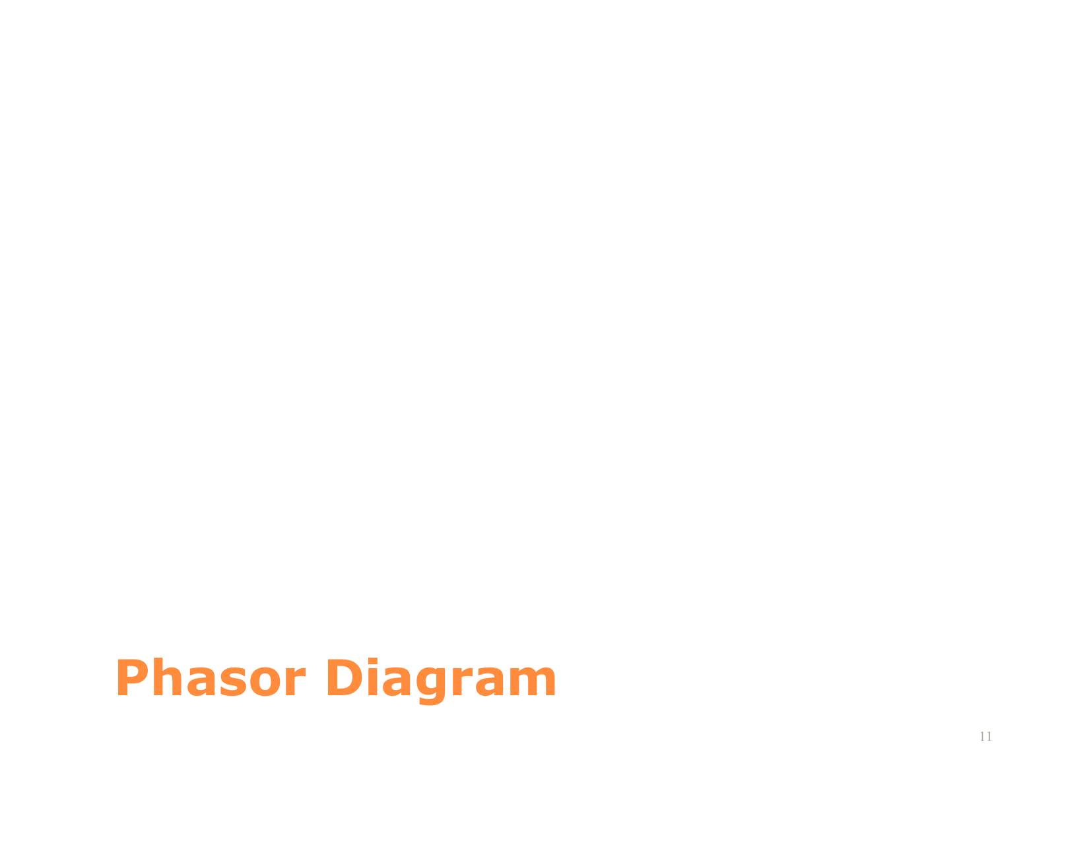 Figure 3: Phasor diagrams of positive ($abc$) vs negative ($acb$) phase sequences (From Slide 11).

🔗 The 4 Interconnection Topologies (Source-to-Load)
Both source and load can be connected in either Star ($Y$) or Delta ($Δ$). This yields four possible topologies:
graph TD
Sources["Source Types:<br/>- Wye (Y)<br/>- Delta (Δ)"] --> Topo["4 Circuit Topologies"]
Topo --> YY["1. Y - Y Connection (Most Common)"]
Topo --> YD["2. Y - Δ Connection (High Power)"]
Topo --> DY["3. Δ - Y Connection"]
Topo --> DD["4. Δ - Δ Connection"]
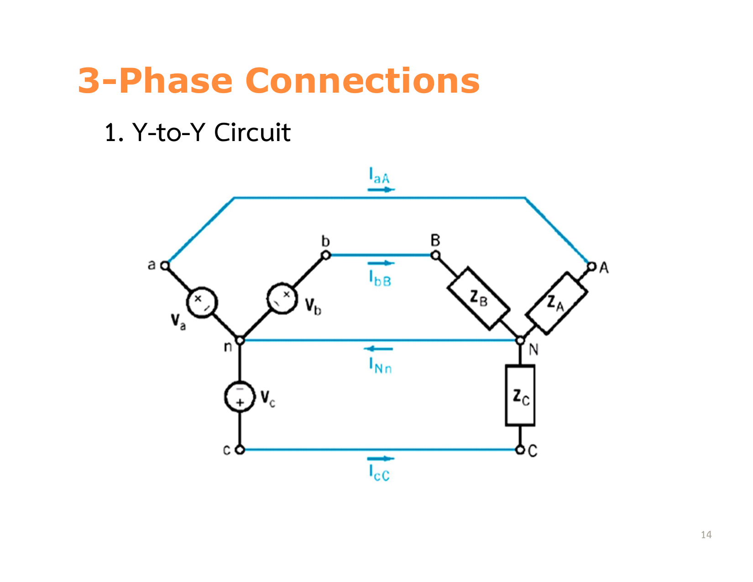 Figure 4: A 3-phase 4-wire Y-Y connected system showing source, line impedance, and star-connected load (From Slide 14).

1. Mathematical Proof of Wye ($Y$) System: $V_{L}=\sqrt{3}V_{p}∠+{30}^{∘}$
In a Wye-connected source, applying Kirchhoff’s Voltage Law (KVL) between terminal $a$ and terminal $b$:
$$V_{ab}=V_{an}−V_{bn}$$
For positive sequence with $V_{an}=V_{p}∠0^{∘}$ and $V_{bn}=V_{p}∠−{120}^{∘}$:
$$V_{ab}=V_{p}(1+j0)−V_{p}\left(−\frac{1}{2}−j\frac{\sqrt{3}}{2}\right)=V_{p}\left(\frac{3}{2}+j\frac{\sqrt{3}}{2}\right)$$
Converting to polar form:
$$|V_{ab}|=V_{p}\sqrt{{\left(\frac{3}{2}\right)}^{2}+{\left(\frac{\sqrt{3}}{2}\right)}^{2}}=V_{p}\sqrt{\frac{9+3}{4}}=V_{p}\sqrt{3}=\sqrt{3}V_{p}$$
$$θ=arctan\left(\frac{\sqrt{3}/2}{3/2}\right)=arctan\left(\frac{1}{\sqrt{3}}\right)={30}^{∘}$$
$$V_{ab}=\sqrt{3}V_{p}∠+{30}^{∘}$$
$$V_{bc}=\sqrt{3}V_{p}∠−{90}^{∘}$$
$$V_{ca}=\sqrt{3}V_{p}∠+{150}^{∘}$$
[!IMPORTANT] Summary for Wye ($Y$) Connection: * Line Voltage leads Phase Voltage by ${30}^{∘}$: $V_{L}=\sqrt{3}V_{p}∠+{30}^{∘}$ * Line Current equals Phase Current: $I_{L}=I_{p}$
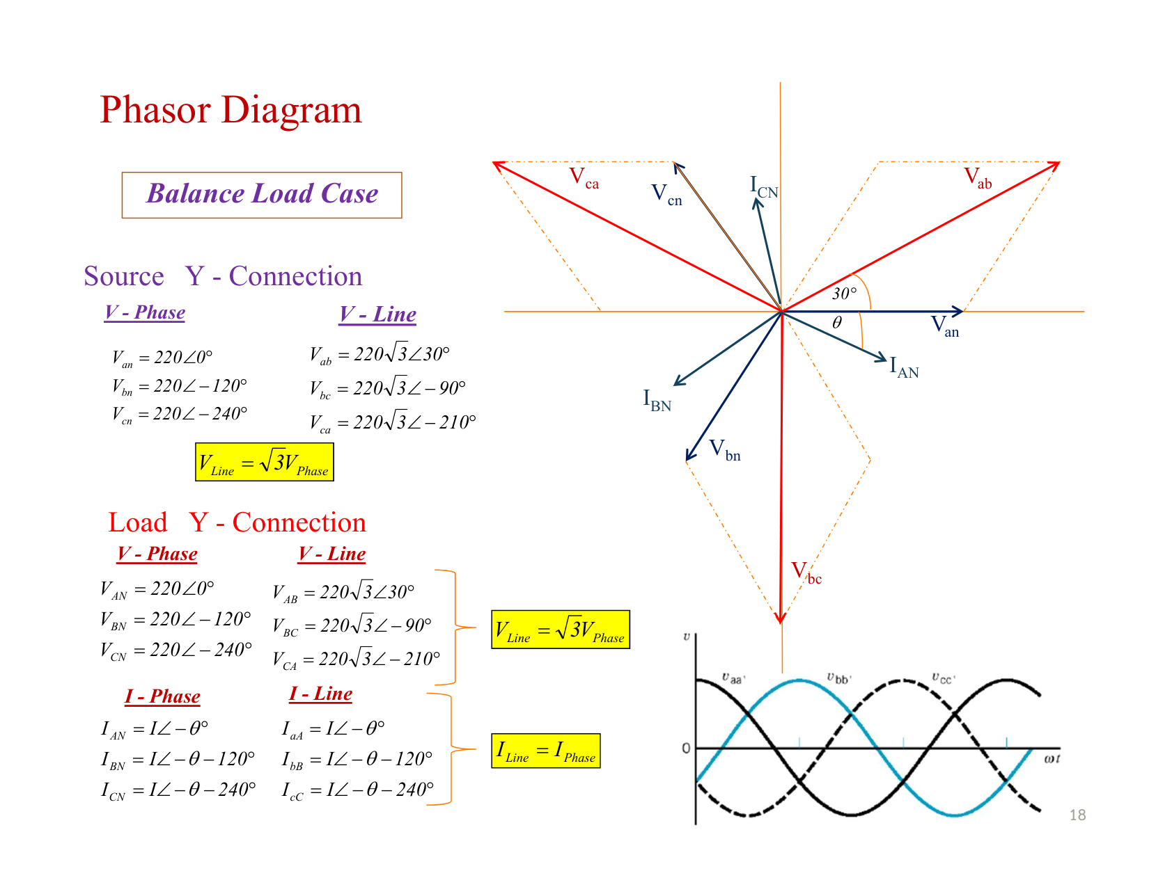 Figure 5: Graphical phasor proof showing $V_{ab}=V_{an}−V_{bn}=\sqrt{3}V_{p}∠{30}^{∘}$ (From Slide 18).

2. Mathematical Proof of Delta ($Δ$) System: $I_{L}=\sqrt{3}I_{p}∠−{30}^{∘}$
In a Delta connection, the phase branches are connected directly between the line conductors:
$$V_{L}=V_{p}$$
Applying Kirchhoff’s Current Law (KCL) at terminal node $A$:
$$I_{a}=I_{AB}−I_{CA}$$
Assuming balanced positive sequence currents $I_{AB}=I_{p}∠0^{∘}$ and $I_{CA}=I_{p}∠+{120}^{∘}$:
$$I_{a}=I_{p}(1+j0)−I_{p}\left(−\frac{1}{2}+j\frac{\sqrt{3}}{2}\right)=I_{p}\left(\frac{3}{2}−j\frac{\sqrt{3}}{2}\right)=\sqrt{3}I_{p}∠−{30}^{∘}$$
[!IMPORTANT] Summary for Delta ($Δ$) Connection: * Line Voltage equals Phase Voltage: $V_{L}=V_{p}$ * Line Current lags Phase Current by ${30}^{∘}$: $I_{L}=\sqrt{3}I_{p}∠−{30}^{∘}$
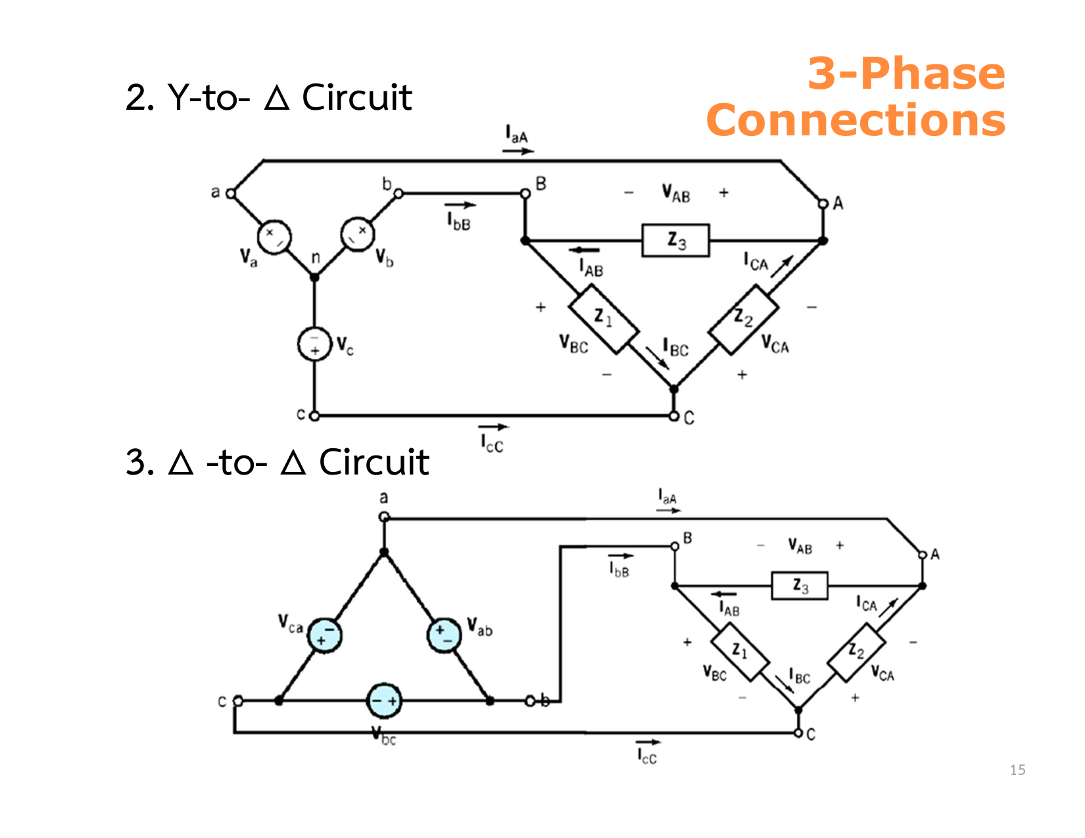 Figure 6: Wye source supplying a Delta-connected load (From Slide 15).
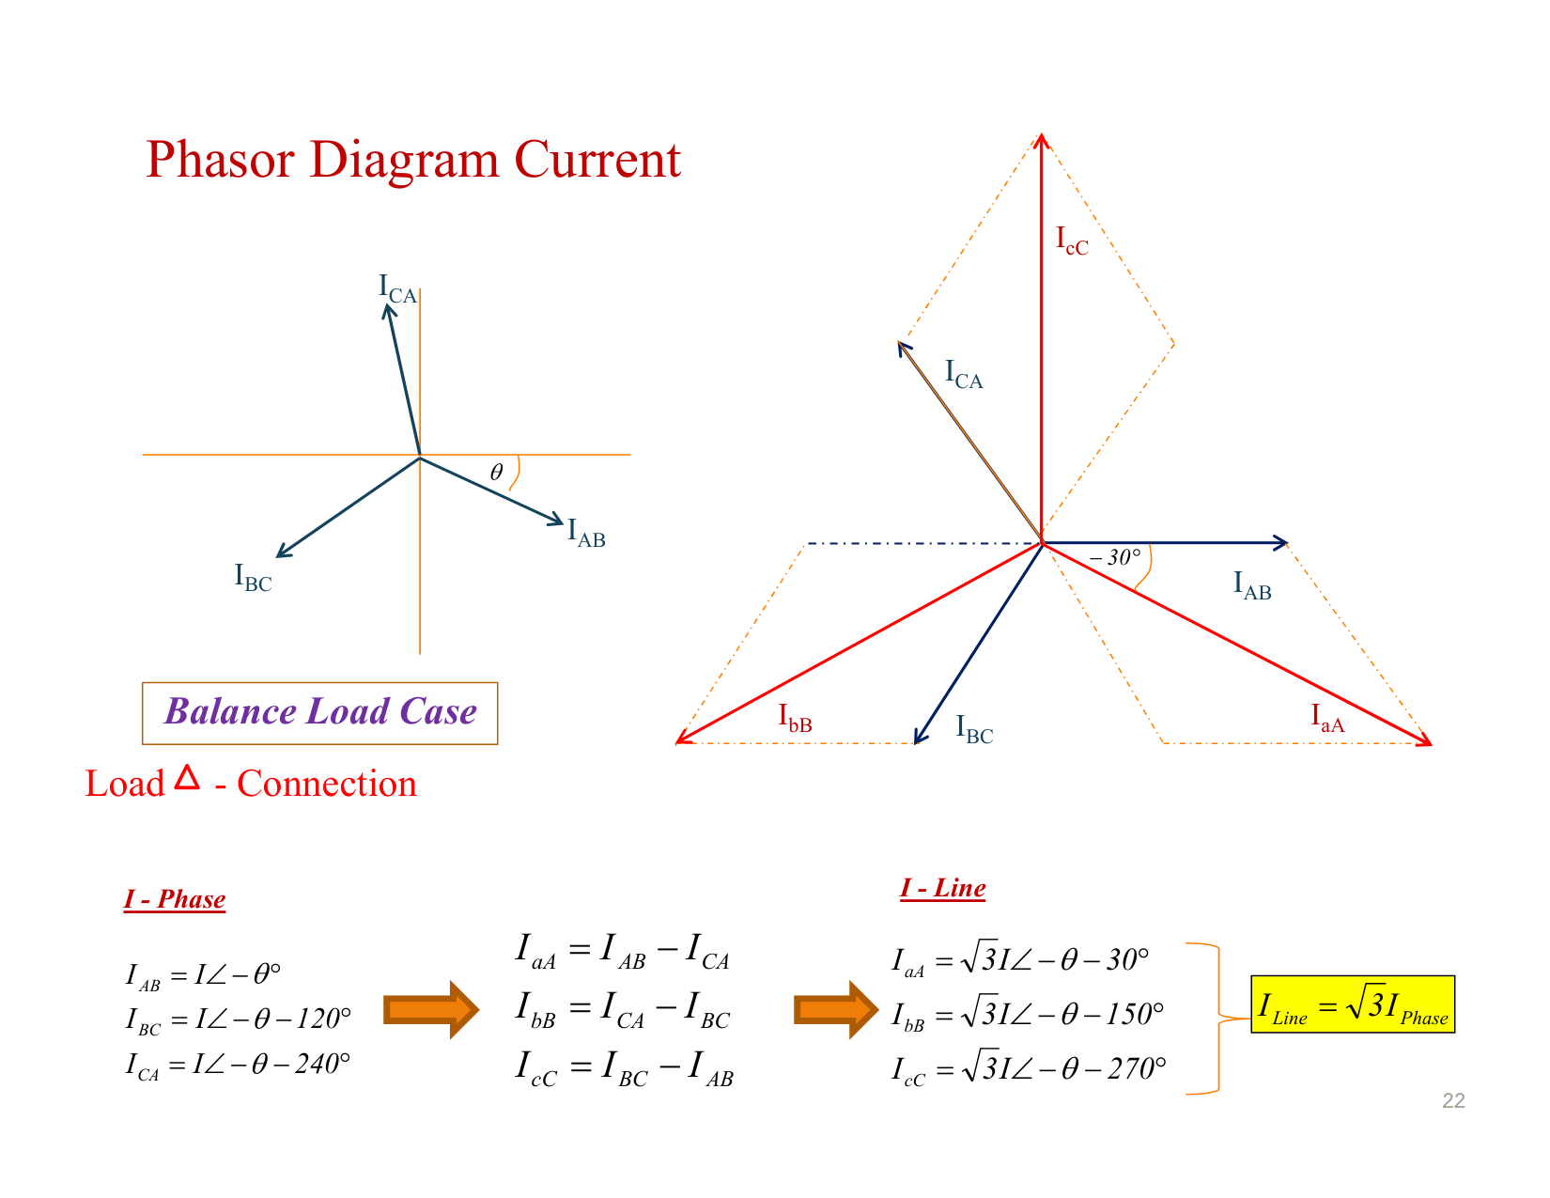 Figure 7: Phasor relationship showing $I_{a}=\sqrt{3}I_{AB}∠−{30}^{∘}$ (From Slide 22).
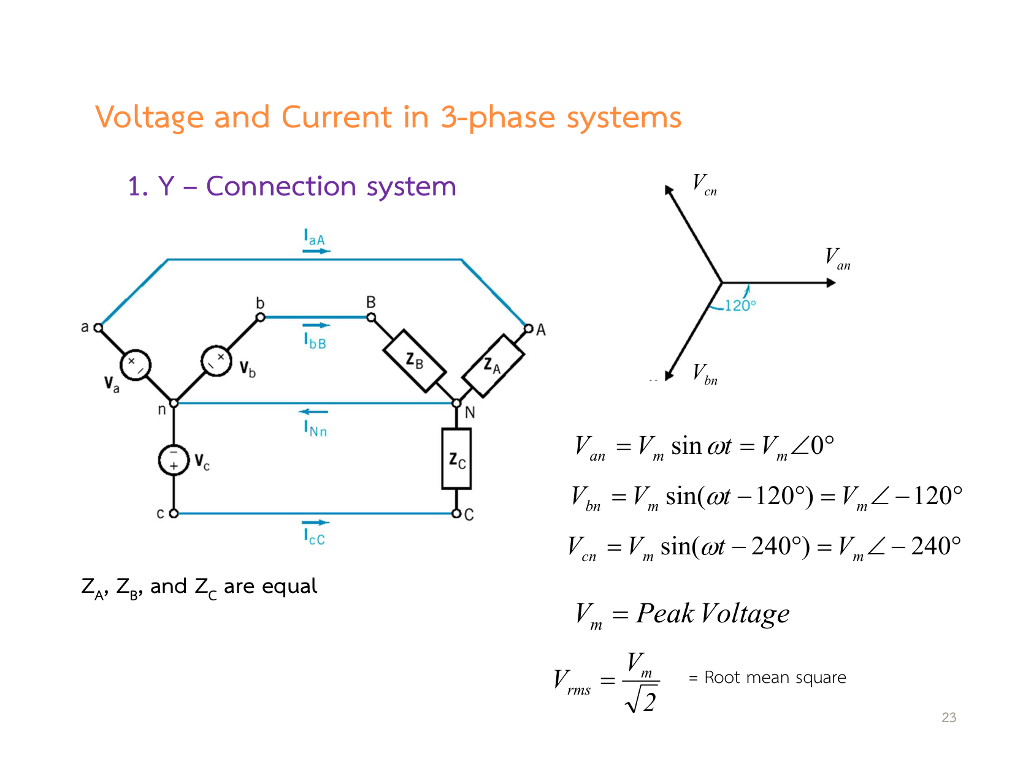 Figure 8: Comprehensive summary table of Line vs Phase quantities for Wye and Delta connections (From Slide 23).

3. Delta-Wye Impedance Transformation ($Δ↔Y$)
When solving balanced circuits containing Delta loads, transform the Delta load into an equivalent Wye load to solve on a Per-Phase Equivalent basis:
$$Z_{Y}=\frac{Z_{Δ}}{3}⇔Z_{Δ}=3Z_{Y}$$
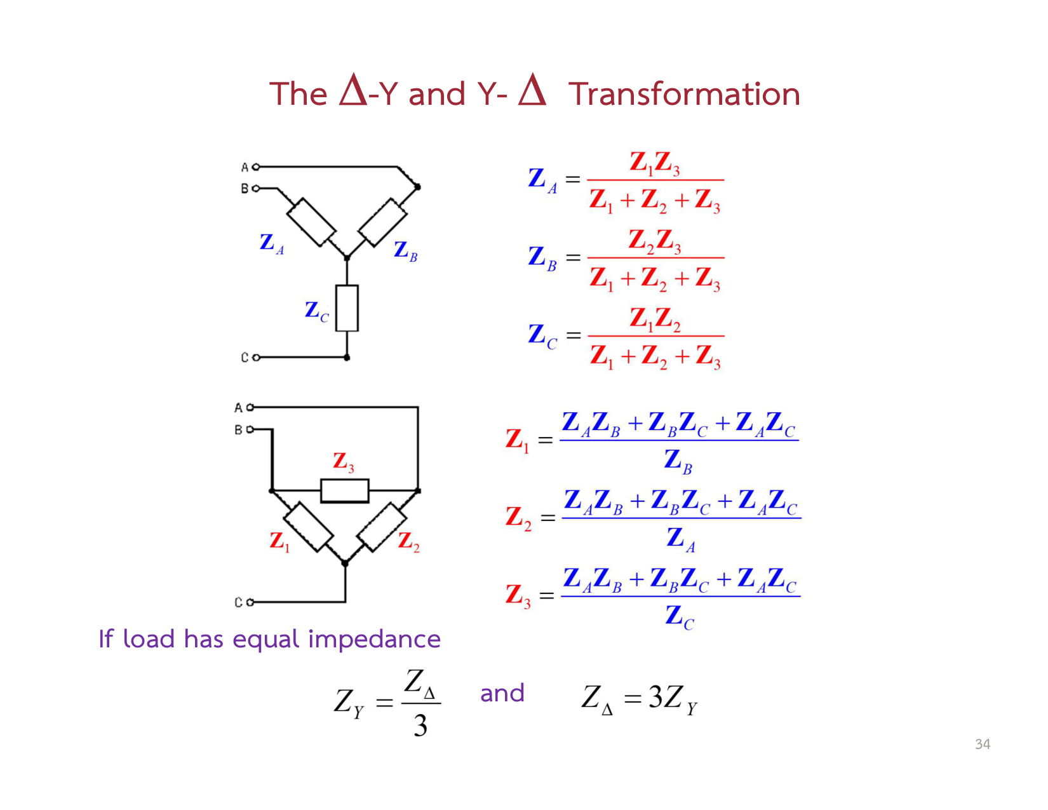 Figure 9: Transforming a balanced Delta load to an equivalent Wye load $Z_{Y}=Z_{Δ}/3$ (From Slide 34).

⚡ Power in Three-Phase Circuits
The total power consumed by a balanced three-phase load (whether connected in Wye or Delta) is three times the single-phase power:

1. Complex, Real, and Reactive Power Formulas
$$S_{3ϕ}=3S_{1ϕ}=3V_{p}I_{p}^{*}=\sqrt{3}V_{L}I_{L}∠θ$$
$$P_{3ϕ}=3V_{p}I_{p}cosθ=\sqrt{3}V_{L}I_{L}cosθ [\text{Watts, W}]$$
$$Q_{3ϕ}=3V_{p}I_{p}sinθ=\sqrt{3}V_{L}I_{L}sinθ [\text{Volt-Amperes Reactive, VAR}]$$
$$S_{3ϕ}=\sqrt{P_{3ϕ}^{2}+Q_{3ϕ}^{2}}=\sqrt{3}V_{L}I_{L} [\text{Volt-Amperes, VA}]$$
[!CAUTION] In the formula $\sqrt{3}V_{L}I_{L}cosθ$, the angle $θ$ is the phase angle of the load impedance ($θ=θ_{v}−θ_{i}$ of individual phase branch), NOT the angle between line voltage and line current!
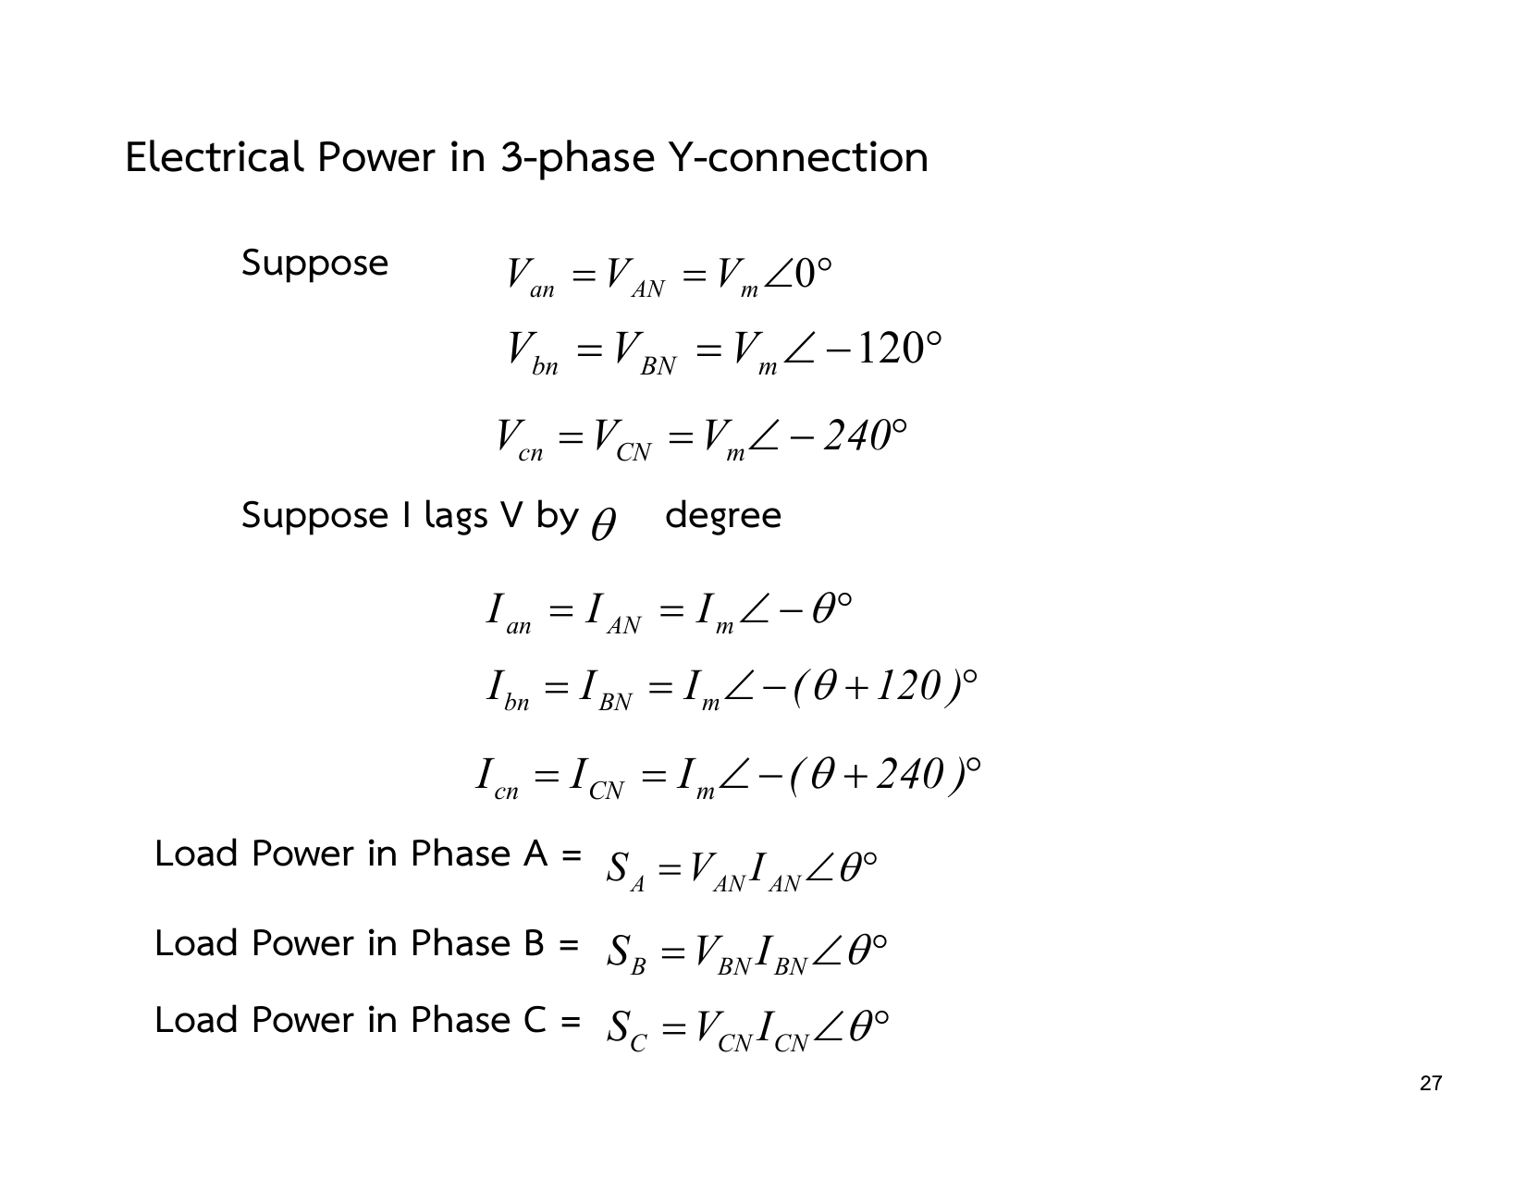 Figure 10: Real, reactive, and apparent power formulas for balanced three-phase systems (From Slide 27).

📊 Two-Wattmeter Method for Power Measurement
The two-wattmeter method measures the total real and reactive power of a three-phase three-wire system (balanced or unbalanced) using only two wattmeters:
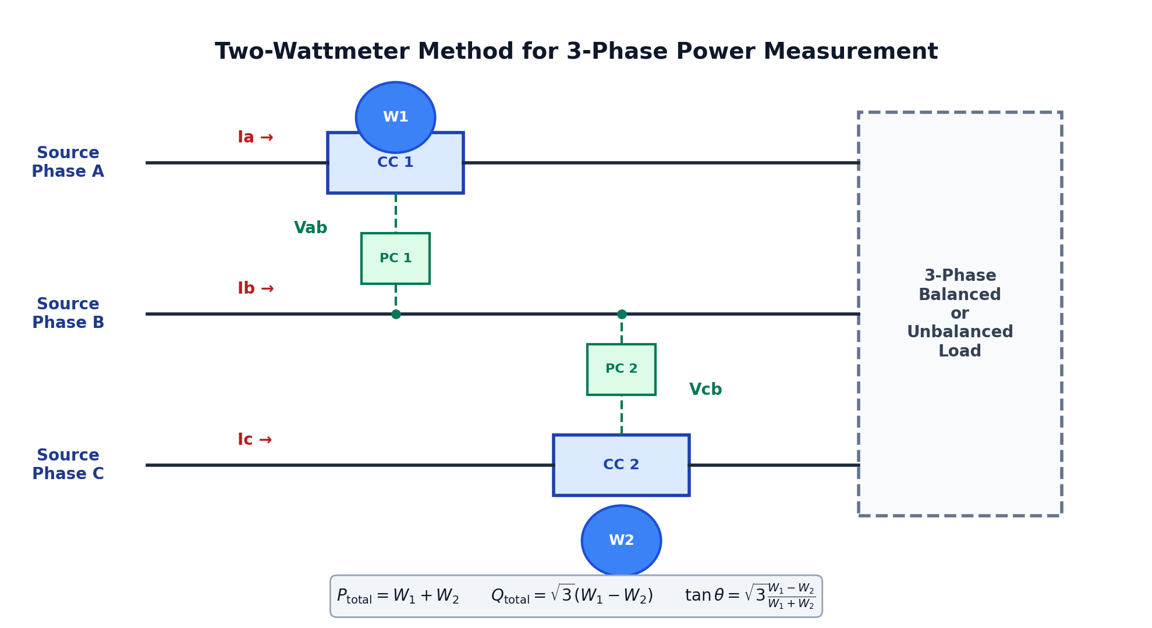 Figure 11: Circuit diagram of the Two-Wattmeter Method with Current Coils (CC) in lines A and C, and Potential Coils (PC) connected across common line B.
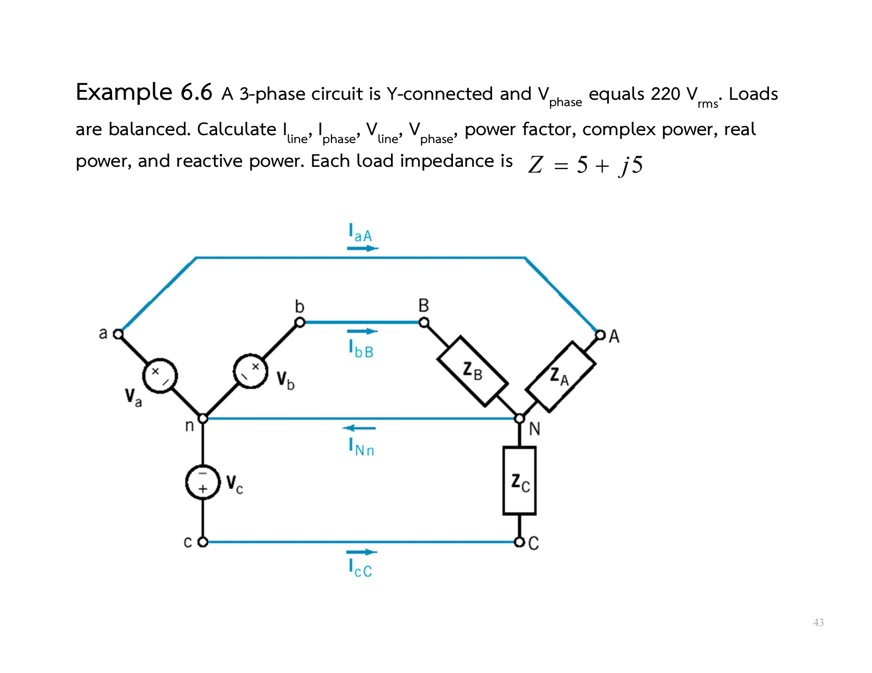 Figure 12: Derivation and vector angles of individual wattmeter readings (From Slide 43).

1. Wattmeter Reading Equations (Balanced Load, Phase Sequence $abc$)
- Wattmeter 1 measures line current $I_{a}$ and voltage $V_{ab}$:
$$W_{1}=V_{ab}I_{a}cos(∠V_{ab}−∠I_{a})=V_{L}I_{L}cos({30}^{∘}−θ)$$
- Wattmeter 2 measures line current $I_{c}$ and voltage $V_{cb}$:
$$W_{2}=V_{cb}I_{c}cos(∠V_{cb}−∠I_{c})=V_{L}I_{L}cos({30}^{∘}+θ)$$

2. Master Formulas Derived from $W_{1}$ and $W_{2}$
- Total Real Power ($P_{\text{total}}$):
$$P_{\text{total}}=W_{1}+W_{2}$$
- Total Reactive Power ($Q_{\text{total}}$):
$$Q_{\text{total}}=\sqrt{3}(W_{1}−W_{2})$$
- Power Factor Angle ($θ$):
$$tanθ=\sqrt{3}\frac{W_{1}−W_{2}}{W_{1}+W_{2}}⟹\text{pf}=cosθ$$
Load Power Factor ($\text{pf}=cosθ$) | Load Angle ($θ$) | Wattmeter 1 Reading ($W_{1}$) | Wattmeter 2 Reading ($W_{2}$) | Special Phenomenon
$\text{pf}=1.0$ (Purely Resistive) | $θ=0^{∘}$ | $W_{1}=W_{2}>0$ | $W_{1}=W_{2}>0$ | Both wattmeters read identical positive values.
$\text{pf}=0.5$ (Lagging) | $θ=+{60}^{∘}$ | $W_{1}>0$ | $W_{2}=0$ | Wattmeter 2 reads exactly ZERO!
$0≤\text{pf}<0.5$ (Lagging) | $θ>{60}^{∘}$ | $W_{1}>0$ | $W_{2}<0$ (Negative!) | Wattmeter 2 deflects backwards! Reverse CC terminals to read.
$\text{pf}=0$ (Purely Reactive) | $θ={90}^{∘}$ | $W_{1}=−W_{2}$ | $W_{2}=−W_{1}$ | $W_{1}+W_{2}=0$ (Zero total real power).

⚙️ Power Factor Correction with Delta Capacitor Banks
Most industrial loads are inductive (induction motors, transformers) operating at lagging power factors. Installing a parallel capacitor bank supplies the required reactive power locally, unloading transmission lines:
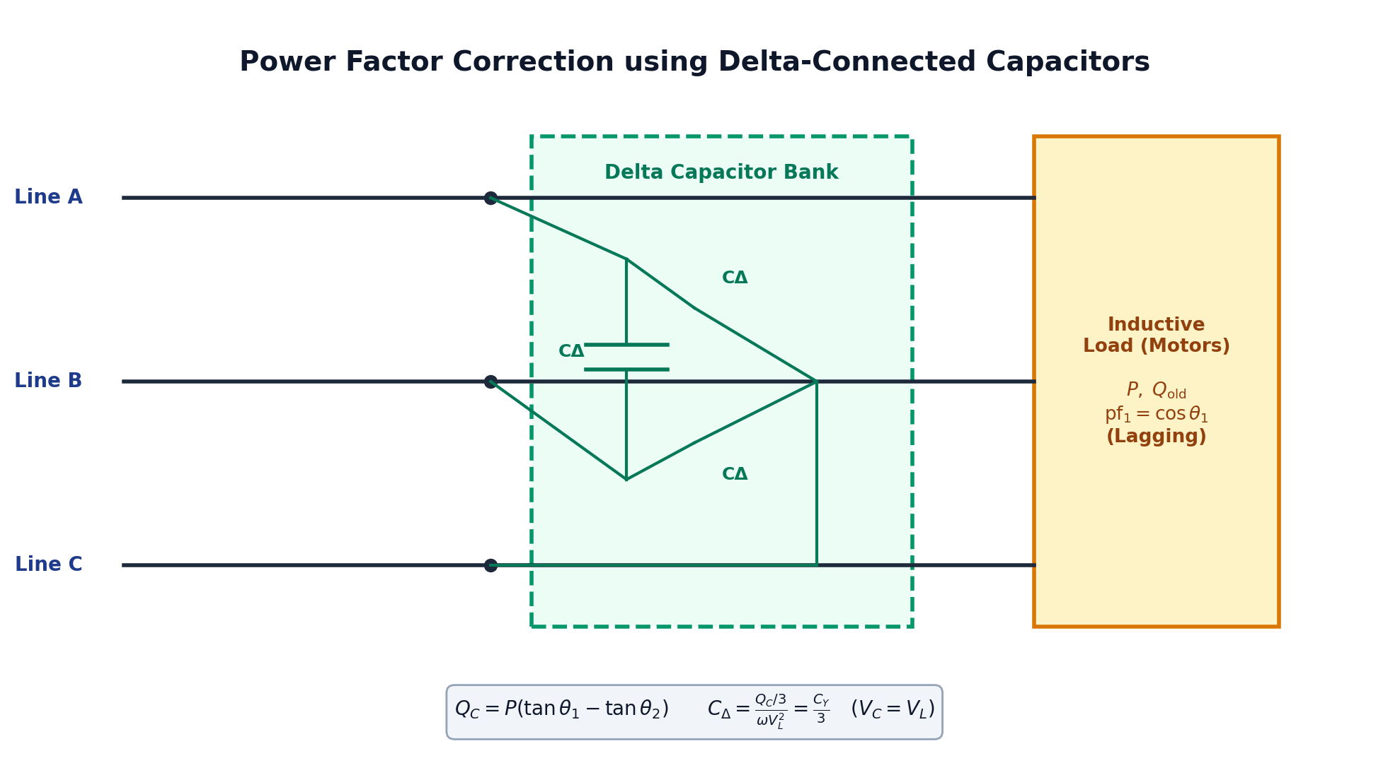 Figure 13: Schematic of a three-phase inductive motor load corrected by a parallel Delta-connected capacitor bank.

1. Step-by-Step Design Formula
- Calculate the required total reactive power compensation:
$$Q_{C}=P(tanθ_{1}−tanθ_{2})$$
- In a Delta-connected capacitor bank, each capacitor sees the full line-to-line voltage ($V_{C}=V_{L}$):
$$Q_{C,\text{per phase}}=\frac{Q_{C}}{3}=ωC_{Δ}V_{L}^{2}⟹C_{Δ}=\frac{Q_{C}}{3ωV_{L}^{2}}$$
- If connected in Wye ($Y$), the voltage across each capacitor is only $V_{p}=V_{L}/\sqrt{3}$:
$$C_{Y}=\frac{Q_{C}}{ωV_{L}^{2}}=3C_{Δ}$$
[!TIP] Why Delta is Universally Preferred in Industry: A Delta-connected capacitor bank requires $3×$ smaller capacitance than a Wye bank ($C_{Δ}=\frac{1}{3}C_{Y}$) to provide identical reactive VARs. Smaller capacitance means smaller physical size, lighter weight, and lower equipment cost!

📝 5 Authentic Exam Problems with Full Step-by-Step Solutions

🔴 Problem 1 (Level 1: Fundamentals of Phase Sequence & Line Voltages)
Problem Statement:
A balanced three-phase Wye-connected source has a positive sequence ($abc$) with phase voltage $V_{an}=120∠{10}^{∘}\text{ V rms}$.
Find: 1. The remaining phase voltages $V_{bn}$ and $V_{cn}$. 2. All three line-to-line voltages $V_{ab},V_{bc},V_{ca}$.

💡 Step-by-Step Model Solution:
Step 1: Determine Phase Voltages
In positive sequence, each phase lags by ${120}^{∘}$:
$$V_{an}=120∠{10}^{∘}\text{ V}$$
$$V_{bn}=120∠({10}^{∘}−{120}^{∘})=120∠−{110}^{∘}\text{ V}$$
$$V_{cn}=120∠({10}^{∘}+{120}^{∘})=120∠+{130}^{∘}\text{ V}$$
Step 2: Calculate Line Voltages
Line voltage magnitude is $V_{L}=\sqrt{3}V_{p}=\sqrt{3}×120≈207.85\text{ V}$, leading phase voltage by ${30}^{∘}$:
$$V_{ab}=\sqrt{3}×120∠({10}^{∘}+{30}^{∘})=207.85∠{40}^{∘}\text{ V}$$
$$V_{bc}=207.85∠({40}^{∘}−{120}^{∘})=207.85∠−{80}^{∘}\text{ V}$$
$$V_{ca}=207.85∠({40}^{∘}+{120}^{∘})=207.85∠{160}^{∘}\text{ V}$$

🔴 Problem 2 (Level 2: Balanced Y-Y System with Line Impedance - Homework 6 Prob. 1)
Problem Statement:
A balanced 3-phase 4-wire Y-Y system has: * Source: $V_{an}=110∠0^{∘}\text{ V rms}$, $abc$ sequence. * Line impedance: $Z_{\text{line}}=5−j2 Ω$ per phase. * Load impedance: $Z_{Y}=10+j8 Ω$ per phase. * Neutral wire impedance: $Z_{n}=0 Ω$.
Find: 1. The line currents $I_{aA},I_{bB},I_{cC}$. 2. The phase voltages at the load terminals $V_{AN},V_{BN},V_{CN}$. 3. The total complex power $S_{\text{total}}$ delivered to the load.
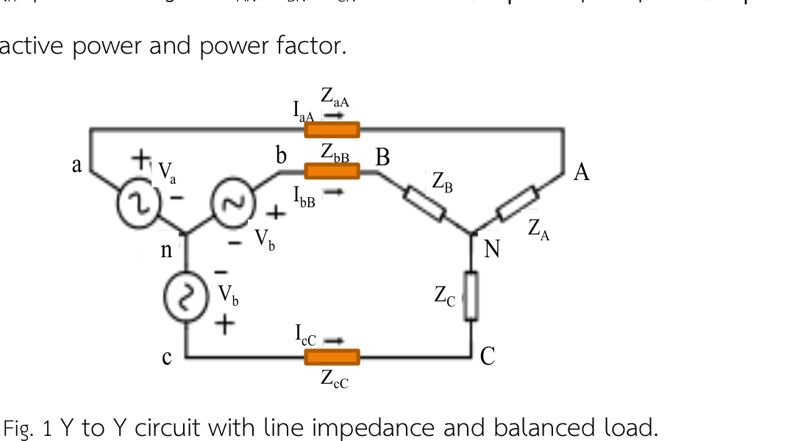 Figure 14: Balanced Y-Y system with line impedance (Homework 6 Problem 1).

💡 Step-by-Step Model Solution:
Step 1: Single-Phase Equivalent Circuit Analysis
Total impedance per phase:
$$Z_{\text{total}}=Z_{\text{line}}+Z_{Y}=(5−j2)+(10+j8)=15+j6 Ω$$
$$Z_{\text{total}}=\sqrt{{15}^{2}+6^{2}}∠arctan(6/15)=\sqrt{225+36}∠{21.8}^{∘}=16.16∠{21.8}^{∘} Ω$$
Step 2: Line Current Calculation
$$I_{aA}=\frac{V_{an}}{Z_{\text{total}}}=\frac{110∠0^{∘}}{16.16∠{21.8}^{∘}}=6.81∠−{21.8}^{∘}\text{ A}$$
$$I_{bB}=6.81∠(−{21.8}^{∘}−{120}^{∘})=6.81∠−{141.8}^{∘}\text{ A}$$
$$I_{cC}=6.81∠(−{21.8}^{∘}+{120}^{∘})=6.81∠{98.2}^{∘}\text{ A}$$
$$I_{n}=−(I_{aA}+I_{bB}+I_{cC})=0\text{ A (Balanced!)}$$
Step 3: Load Phase Voltages
$$V_{AN}=I_{aA}Z_{Y}=(6.81∠−{21.8}^{∘})×(10+j8)$$
$$10+j8=\sqrt{100+64}∠arctan(8/10)=12.81∠{38.66}^{∘} Ω$$
$$V_{AN}=6.81×12.81∠(−{21.8}^{∘}+{38.66}^{∘})=87.24∠{16.86}^{∘}\text{ V}$$
$$V_{BN}=87.24∠({16.86}^{∘}−{120}^{∘})=87.24∠−{103.14}^{∘}\text{ V}$$
$$V_{CN}=87.24∠({16.86}^{∘}+{120}^{∘})=87.24∠{136.86}^{∘}\text{ V}$$
Step 4: Total Complex Power Delivered to the Load
$$S_{3ϕ}=3×|I_{aA}|^{2}×Z_{Y}=3×(6.81)^{2}×(10+j8)=3×46.38×(10+j8)$$
$$S_{3ϕ}=1,391.4+j1,113.1\text{ VA}=1.39\text{ kW}+j1.11\text{ kVAR}$$

🔴 Problem 3 (Level 3: Balanced Y-Δ System with Line Impedance)
Problem Statement:
A balanced three-phase system has: * Source: Wye-connected, line-to-line voltage $V_{L}=208\text{ V rms}$, $abc$ sequence, taking $V_{ab}$ as reference ($208∠0^{∘}\text{ V}$). * Line impedance: $Z_{\text{line}}=1+j1 Ω$. * Load: Delta-connected with branch impedance $Z_{Δ}=12+j9 Ω$.
Find: 1. The line currents $I_{a},I_{b},I_{c}$. 2. The phase currents circulating inside the Delta load $I_{AB},I_{BC},I_{CA}$.

💡 Step-by-Step Model Solution:
Step 1: Transform Delta Load to Equivalent Wye Load
$$Z_{Y}=\frac{Z_{Δ}}{3}=\frac{12+j9}{3}=4+j3 Ω$$
Step 2: Determine Source Phase Voltage Since $V_{ab}=208∠0^{∘}\text{ V}$ and $V_{ab}=\sqrt{3}V_{an}∠+{30}^{∘}$:
$$V_{an}=\frac{208}{\sqrt{3}}∠(0^{∘}−{30}^{∘})=120.09∠−{30}^{∘}\text{ V}$$
Step 3: Total Impedance and Line Current
$$Z_{\text{total}}=Z_{\text{line}}+Z_{Y}=(1+j1)+(4+j3)=5+j4=6.403∠{38.66}^{∘} Ω$$
$$I_{a}=\frac{V_{an}}{Z_{\text{total}}}=\frac{120.09∠−{30}^{∘}}{6.403∠{38.66}^{∘}}=18.755∠−{68.66}^{∘}\text{ A}$$
$$I_{b}=18.755∠(−{68.66}^{∘}−{120}^{∘})=18.755∠−{188.66}^{∘}\text{ A}=18.755∠{171.34}^{∘}\text{ A}$$
$$I_{c}=18.755∠(−{68.66}^{∘}+{120}^{∘})=18.755∠{51.34}^{∘}\text{ A}$$
Step 4: Calculate Delta Phase Currents Phase current magnitude is $I_{p}=I_{L}/\sqrt{3}=18.755/\sqrt{3}=10.828\text{ A}$, leading line current by ${30}^{∘}$:
$$I_{AB}=\frac{18.755}{\sqrt{3}}∠(−{68.66}^{∘}+{30}^{∘})=10.83∠−{38.66}^{∘}\text{ A}$$
$$I_{BC}=10.83∠(−{38.66}^{∘}−{120}^{∘})=10.83∠−{158.66}^{∘}\text{ A}$$
$$I_{CA}=10.83∠(−{38.66}^{∘}+{120}^{∘})=10.83∠{81.34}^{∘}\text{ A}$$

🔴 Problem 4 (Level 4: Unbalanced Y-Y System & Neutral Shift - Homework 6 Prob. 2)
Problem Statement:
An unbalanced 3-phase 3-wire Y-Y system (NO neutral wire, $Z_{n}=∞$) has: * Source: $V_{an}=100∠0^{∘}\text{ V}$, $V_{bn}=100∠−{120}^{∘}\text{ V}$, $V_{cn}=100∠{120}^{∘}\text{ V}$. * Line impedance: $Z_{\text{line}}=0 Ω$. * Unbalanced load: $Z_{A}=10 Ω$, $Z_{B}=j10 Ω$, $Z_{C}=−j10 Ω$.
Find: 1. The Neutral Shift Voltage ($V_{Nn}=V_{N}−V_{n}$). 2. The load phase voltages $V_{AN},V_{BN},V_{CN}$. 3. The line currents $I_{aA},I_{bB},I_{cC}$.
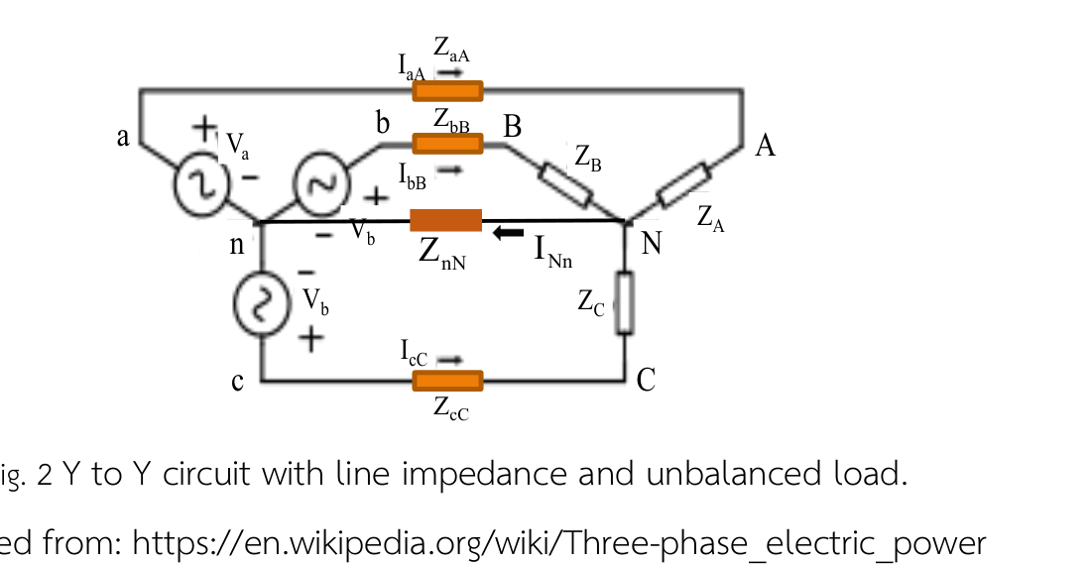 Figure 15: Unbalanced Y-Y load with disconnected neutral wire (Homework 6 Problem 2).

💡 Step-by-Step Model Solution:
Step 1: Calculate Load Admittances
$$Y_{A}=\frac{1}{10}=0.1 \text{S}$$
$$Y_{B}=\frac{1}{j10}=−j0.1 \text{S}$$
$$Y_{C}=\frac{1}{−j10}=+j0.1 \text{S}$$
Sum of admittances:
$$∑Y=Y_{A}+Y_{B}+Y_{C}=0.1−j0.1+j0.1=0.1 \text{S}$$
Step 2: Calculate Neutral Shift Voltage using Millman’s Theorem / KCL
$$V_{Nn}=\frac{V_{an}Y_{A}+V_{bn}Y_{B}+V_{cn}Y_{C}}{∑Y}$$
Numerator:
$$V_{an}Y_{A}=(100∠0^{∘})(0.1)=10$$
$$V_{bn}Y_{B}=(100∠−{120}^{∘})(−j0.1)=(100∠−{120}^{∘})(0.1∠−{90}^{∘})=10∠−{210}^{∘}=10∠{150}^{∘}=−8.66+j5$$
$$V_{cn}Y_{C}=(100∠{120}^{∘})(+j0.1)=(100∠{120}^{∘})(0.1∠{90}^{∘})=10∠{210}^{∘}=−8.66−j5$$
Summing the terms:
$$\text{Numerator}=10+(−8.66+j5)+(−8.66−j5)=10−17.32=−7.32\text{ V}$$
$$V_{Nn}=\frac{−7.32}{0.1}=−73.2∠0^{∘}=73.2∠{180}^{∘}\text{ V}$$
Step 3: Calculate Load Phase Voltages
$$V_{AN}=V_{an}−V_{Nn}=100−(−73.2)=173.2∠0^{∘}\text{ V}$$
$$V_{BN}=V_{bn}−V_{Nn}=(−50−j86.6)−(−73.2)=23.2−j86.6=89.65∠−{75}^{∘}\text{ V}$$
$$V_{CN}=V_{cn}−V_{Nn}=(−50+j86.6)−(−73.2)=23.2+j86.6=89.65∠{75}^{∘}\text{ V}$$
Step 4: Calculate Line Currents
$$I_{aA}=\frac{V_{AN}}{Z_{A}}=\frac{173.2∠0^{∘}}{10}=17.32∠0^{∘}\text{ A}$$
$$I_{bB}=\frac{V_{BN}}{Z_{B}}=\frac{89.65∠−{75}^{∘}}{10∠{90}^{∘}}=8.965∠−{165}^{∘}\text{ A}$$
$$I_{cC}=\frac{V_{CN}}{Z_{C}}=\frac{89.65∠{75}^{∘}}{10∠−{90}^{∘}}=8.965∠{165}^{∘}\text{ A}$$
(Verification: $I_{aA}+I_{bB}+I_{cC}=17.32+2(−8.66)=0\text{ A}$. Perfect KCL match!)

🔴 Problem 5 (Level 5: Two-Wattmeter Method & Power Factor Correction Exam Problem)
Problem Statement:
A three-phase, $400\text{ V rms},50\text{ Hz}$ supply feeds a balanced inductive load. Two wattmeters connected to measure total input power read:
$$W_{1}=12.5\text{ kW} \text{and} W_{2}=4.5\text{ kW}$$
1. Find the total real power $P_{\text{total}}$, reactive power $Q_{\text{total}}$, apparent power $S_{\text{total}}$, and the power factor. 2. Determine the line current $I_{L}$. 3. Calculate the required capacitance per phase ($C_{Δ}$) of a Delta-connected capacitor bank to improve the overall power factor to $0.95\text{ lagging}$.

💡 Step-by-Step Model Solution:
Step 1: Calculate Total Powers from Wattmeter Readings
$$P_{\text{total}}=W_{1}+W_{2}=12.5+4.5=17.0\text{ kW}$$
$$Q_{\text{total}}=\sqrt{3}(W_{1}−W_{2})=\sqrt{3}(12.5−4.5)=\sqrt{3}×8.0≈13.856\text{ kVAR}$$
$$S_{\text{total}}=\sqrt{P^{2}+Q^{2}}=\sqrt{{17.0}^{2}+{13.856}^{2}}=\sqrt{289+192}=\sqrt{481}≈21.93\text{ kVA}$$
$${\text{pf}}_{1}=cosθ_{1}=\frac{P_{\text{total}}}{S_{\text{total}}}=\frac{17.0}{21.93}≈0.775\text{ lagging}$$
$$θ_{1}=arccos(0.775)≈{39.18}^{∘}$$
Step 2: Line Current Before Compensation
$$I_{L}=\frac{P_{\text{total}}}{\sqrt{3}V_{L}cosθ_{1}}=\frac{17,000}{\sqrt{3}×400×0.775}=\frac{17,000}{536.94}≈31.66\text{ A}$$
Step 3: Capacitor Bank Sizing for ${\text{pf}}_{2}=0.95\text{ lagging}$
$$θ_{2}=arccos(0.95)≈{18.19}^{∘}$$
$$tanθ_{1}=tan({39.18}^{∘})=0.815$$
$$tanθ_{2}=tan({18.19}^{∘})=0.329$$
Required reactive power compensation:
$$Q_{C}=P_{\text{total}}(tanθ_{1}−tanθ_{2})=17.0×(0.815−0.329)=17.0×0.486=8.262\text{ kVAR}$$
For a Delta-connected capacitor bank ($V_{C}=V_{L}=400\text{ V}$):
$$C_{Δ}=\frac{Q_{C}/3}{ωV_{L}^{2}}=\frac{8,262/3}{2π×50×{400}^{2}}=\frac{2,754}{2π×50×160,000}=\frac{2,754}{50,265,482}≈5.48×{10}^{−5}\text{ F}=54.8 μ\text{F}$$

🎯 Final Exam Key Formulas & Cheat Sheet
- Wye ($Y$) Relationships:
  - $V_{L}=\sqrt{3}V_{p}∠+{30}^{∘}$
  - $I_{L}=I_{p}$
- Delta ($Δ$) Relationships:
  - $V_{L}=V_{p}$
  - $I_{L}=\sqrt{3}I_{p}∠−{30}^{∘}$
- $Δ↔Y$ Impedance Transformation:
  - $Z_{Y}=\frac{Z_{Δ}}{3}⇔Z_{Δ}=3Z_{Y}$
- Three-Phase Power:
  - $P=\sqrt{3}V_{L}I_{L}cosθ=3V_{p}I_{p}cosθ$
  - $Q=\sqrt{3}V_{L}I_{L}sinθ=3V_{p}I_{p}sinθ$
- Two-Wattmeter Method:
  - $P_{\text{total}}=W_{1}+W_{2}$
  - $Q_{\text{total}}=\sqrt{3}(W_{1}−W_{2})$
  - $tanθ=\sqrt{3}\frac{W_{1}−W_{2}}{W_{1}+W_{2}}$
- Capacitor Sizing:
  - $Q_{C}=P(tanθ_{1}−tanθ_{2})$
  - $C_{Δ}=\frac{Q_{C}/3}{ωV_{L}^{2}}=\frac{C_{Y}}{3}$

