# Customer Segmentation Analysis Report

## 1. Executive Summary (Top-Level Takeaway)

This report provides a detailed analysis of customer segmentation conducted using clustering techniques to identify distinct customer groups based on demographic and behavioural data. Four customer segments were identified: Budget-Conscious Customers, Young Explorers, High-Value Loyalists, and New or Inactive Users. The segmentation highlights clear variations in income, spending behaviour, and tenure. High-income and long tenure customers contribute significantly to total revenue, whereas low-income and low engagement customers represent potential growth through targeted marketing and retention initiatives. These insights serve as a foundation for developing data-driven strategies that enhance customer retention, optimize marketing investments, and boost overall profitability.

## 2. Objective / Business Question

The primary objective of this project is to segment customers into meaningful clusters using demographic and behavioural variables. The analysis aims to uncover hidden patterns in purchasing and engagement behaviour that can guide strategic decision-making. By understanding these segments, the business can tailor its marketing and communication strategies to better meet the needs of each customer group.

## 3. Key Metrics / KPIs

The segmentation analysis utilized the following key metrics to uncover actionable insights:

* Age – Captures generational differences in customer preferences and spending habits.
* Annual Income – Indicates purchasing capacity and financial stability of customers.
* Spending Score – Reflects the level of customer engagement and expenditure behavior.
* Tenure – Represents the duration of customer association with the business.
* Customer Lifetime Value (CLV) – Estimates total expected revenue from each customer over their lifecycle.

## 4. Insights & Findings

* Cluster 0 – Budget-Conscious Customers

What we found: These customers typically have low to moderate annual income and moderate spending scores.

Why it matters: They are highly price-sensitive and driven by value-for-money offers.

Recommendation: Introduce time-bound discounts and referral campaigns to encourage repeat purchases.

* Cluster 1 – Young Explorers

What we found: Comprising younger individuals with moderate income but varying spending levels.

Why it matters: This group is highly responsive to digital engagement and experiential marketing.

Recommendation: Use influencer marketing, loyalty programs, and gamified reward systems to boost engagement.

* Cluster 2 – High-Value Loyalists

What we found: Customers with high income, high spending, and longer tenure.

Why it matters: They represent the most profitable segment with strong brand loyalty.

Recommendation: Offer premium benefits, early product access, and personalized rewards to sustain loyalty.

* Cluster 3 – New or Inactive Users

What we found: This cluster consists of customers with short tenure and inconsistent spending behaviour.

Why it matters: They are at a higher risk of churn due to limited brand engagement.

Recommendation: Deploy onboarding communications, welcome offers, and retention driven campaigns to increase engagement.

## 5. Supporting Visuals

Visuals such as PCA plots and pairwise scatterplots were created during analysis to show how customers are distributed across clusters and to reveal relationships between key variables like Age, Annual Income, and Spending Score. These visuals highlighted the separation among clusters and validated the consistency of segmentation patterns.

**Dataset Shape: (50, 6)**

|  |  |  |  |  |  |  |
| --- | --- | --- | --- | --- | --- | --- |
| |  | | --- | | ID Age Gender Annual Income Spending Score Tenure | | 01 56 Female 78704 23 1 | | 12 46 Male 54099 15 10 | | 23 32 Female 23571 43 4 | | 34 60 Male 53044 29 12 | | 45 25 Female 66214 36 14 | |

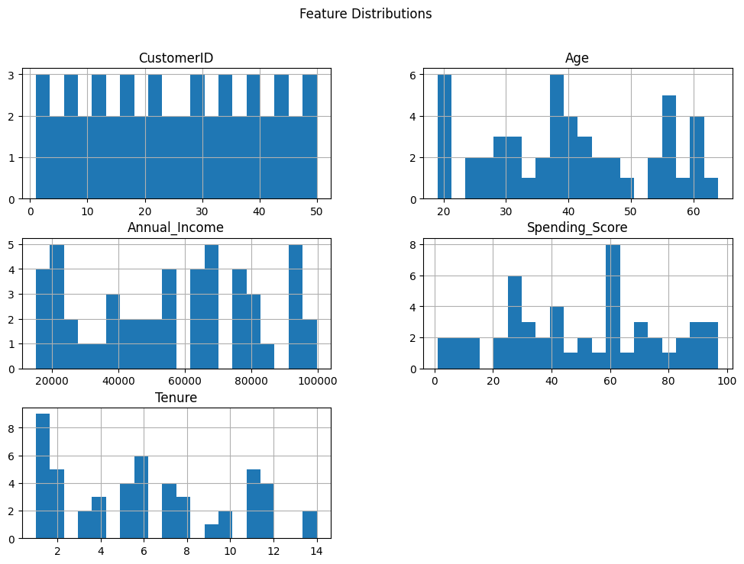

## 6. Limitations

The analysis is limited by the available dataset, which may lack psychographic or qualitative variables such as preferences and satisfaction. Additionally, customer behaviour can evolve over time, meaning that periodic re-segmentation may be necessary to maintain accuracy. External factors like seasonality or macroeconomic changes were not considered in this model.

## 7. Next Steps / Recommendations

* Personalize marketing campaigns based on segment-specific preferences and behaviours.
* Conduct regular updates of the segmentation model to reflect changes in customer data.
* Introduce predictive modelling to anticipate churn and identify high-value leads.
* Integrate additional customer feedback and satisfaction data for richer segmentation.
* Measure campaign ROI within each segment to refine future targeting efforts.