FormalLayout.html
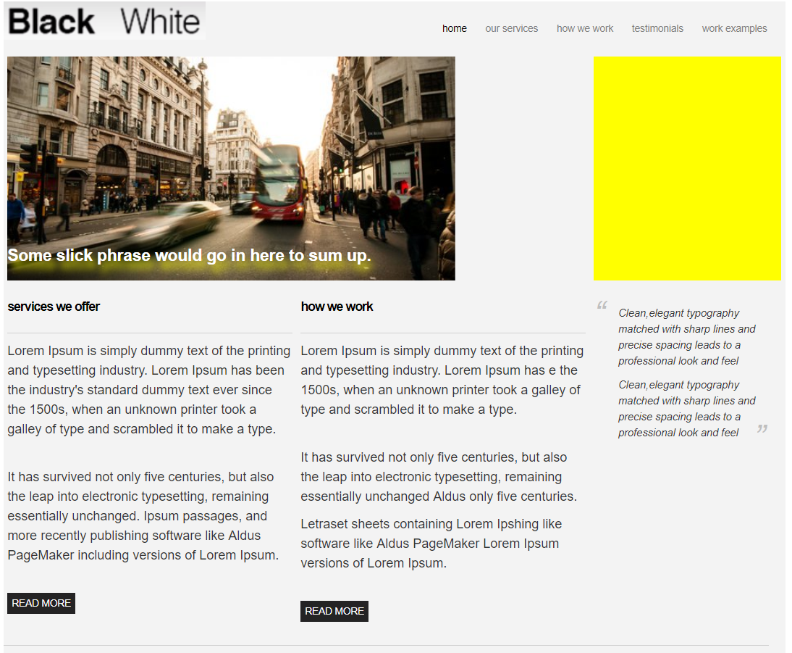

From the navigation bar on the top, the anchor tag ‘work examples’, the page can jump to work.html, which is shown in next page.

work.html
