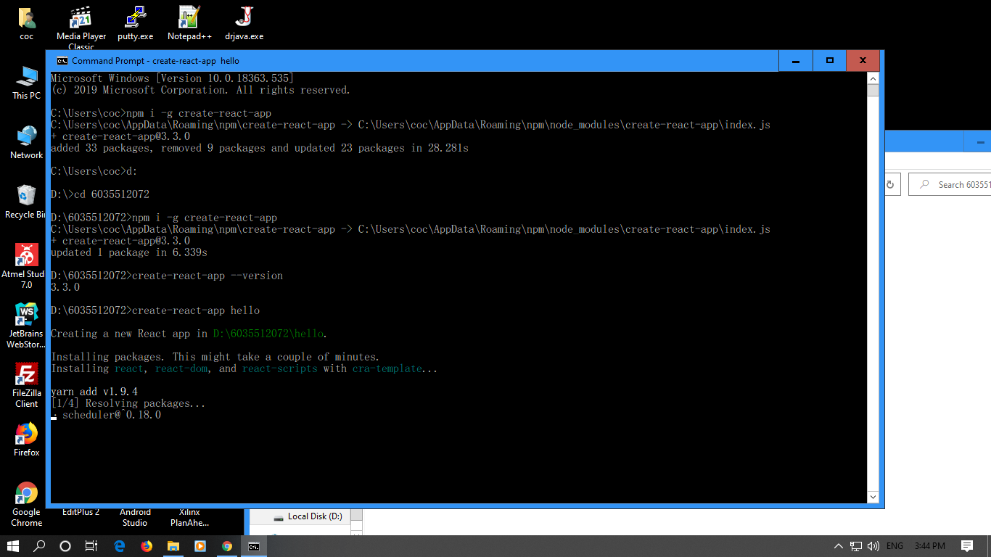

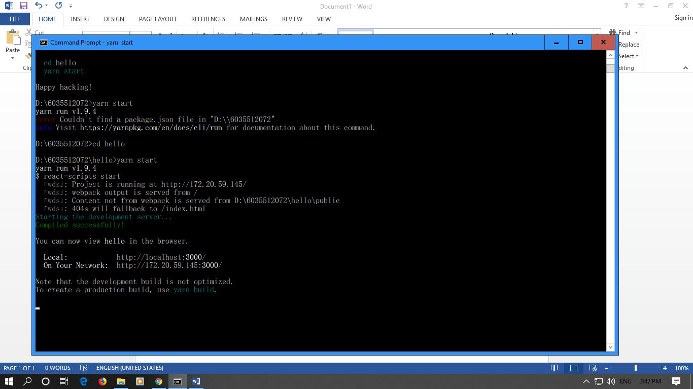

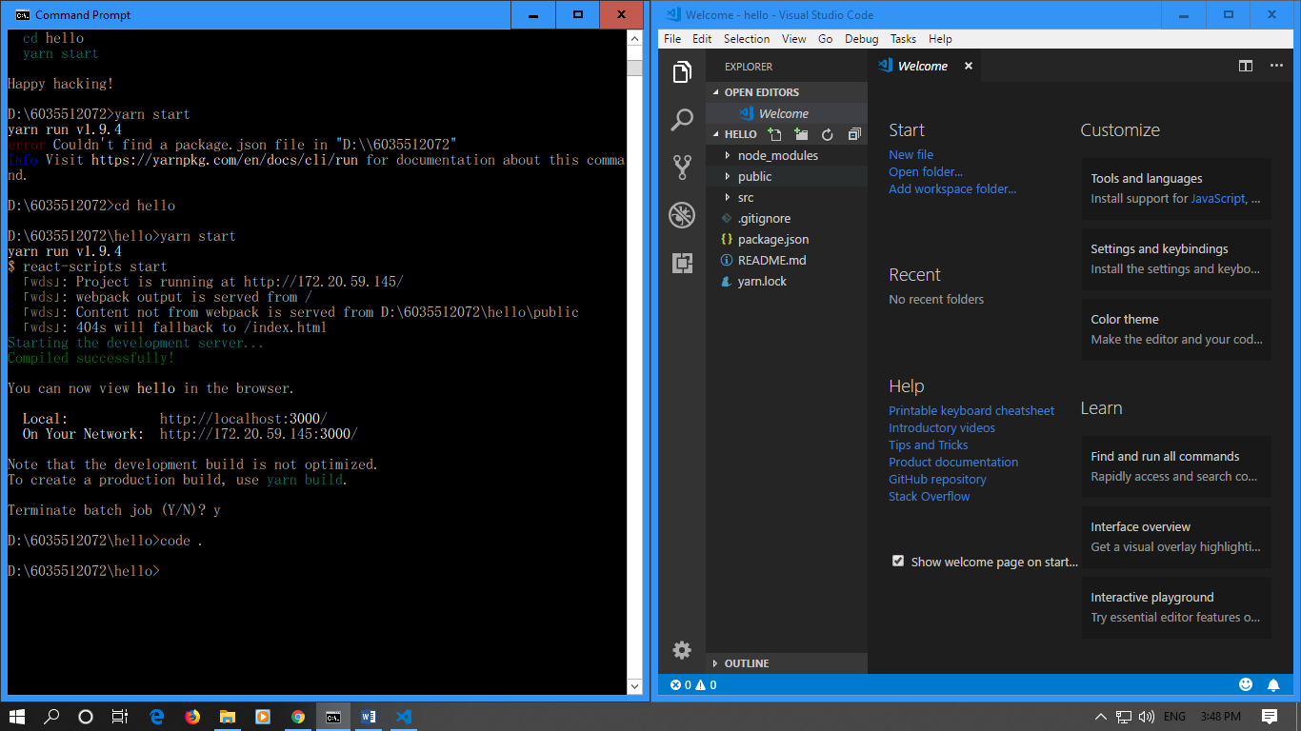เปิดใน vs

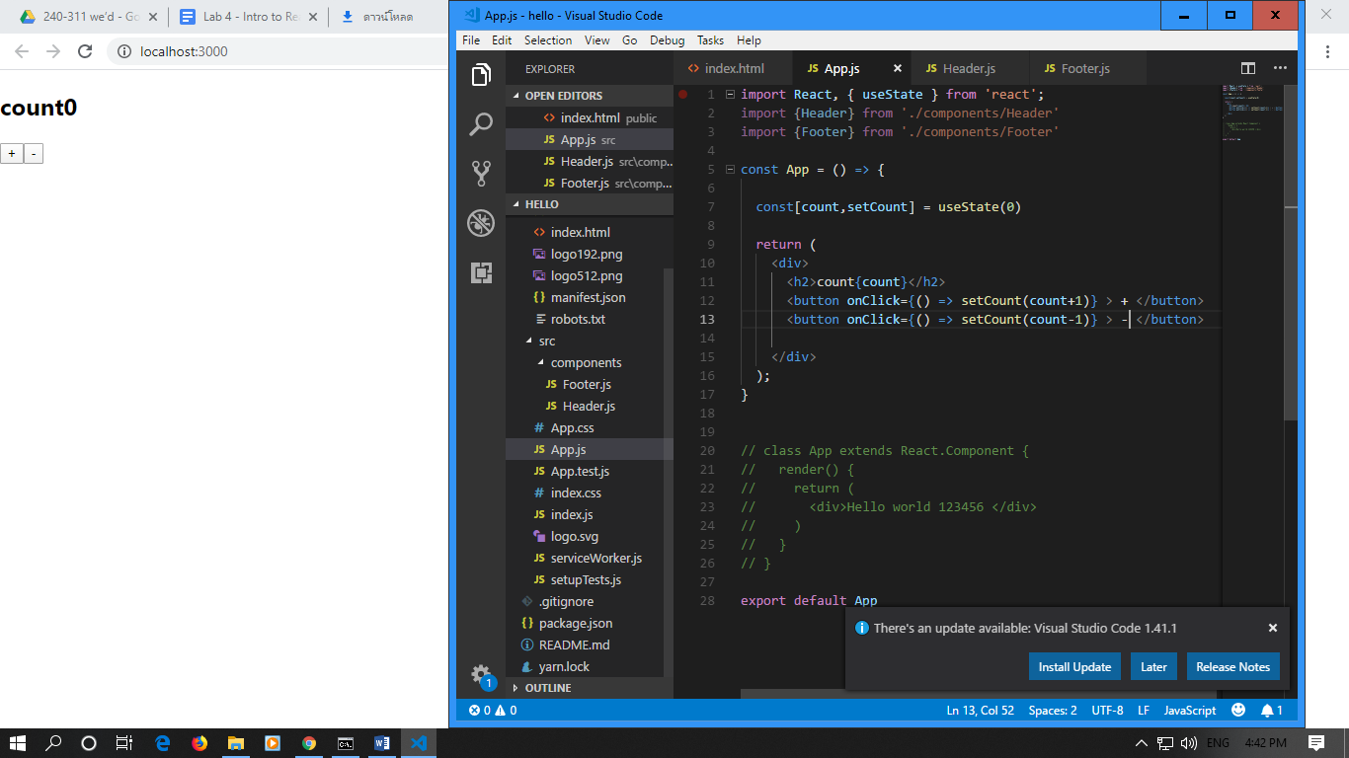

import React, { useState } from 'react';

import {Header} from './components/Header'

import {Footer} from './components/Footer'

const App = () => {

const[count,setCount] = useState(0)

return (

<div>

<h2>count{count}</h2>

<button onClick={() => setCount(count+1)} > + </button>

<button onClick={() => setCount(count-1)} > - </button>

</div>

);

}

// class App extends React.Component {

// render() {

// return (

// <div>Hello world 123456 </div>

// )

// }

// }

export default App

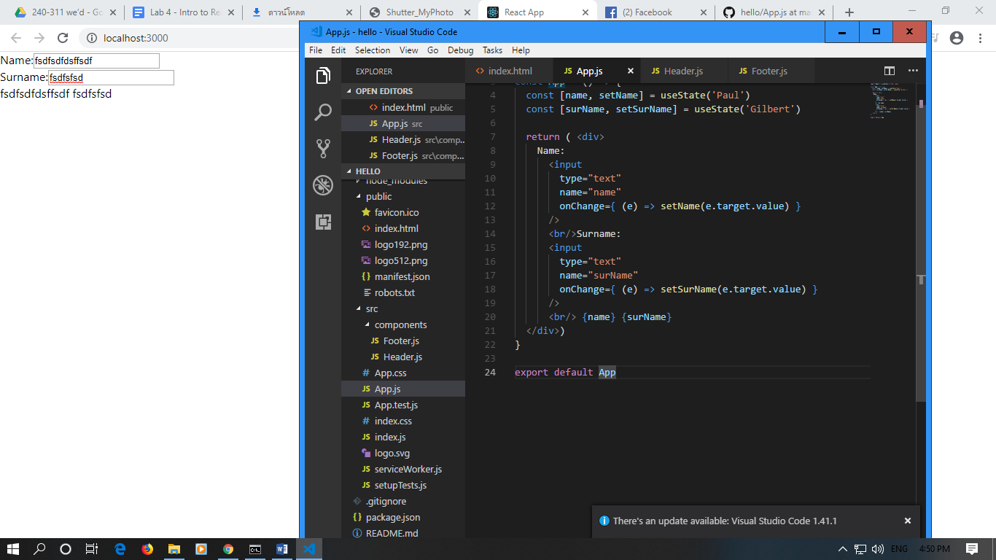

import React, { useState } from 'react'

const App = () => {

const [name, setName] = useState('Paul')

const [surName, setSurName] = useState('Gilbert')

return ( <div>

Name:

<input

type="text"

name="name"

onChange={ (e) => setName(e.target.value) }

/>

<br/>Surname:

<input

type="text"

name="surName"

onChange={ (e) => setSurName(e.target.value) }

/>

<br/> {name} {surName}

</div>)

}

export default App

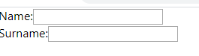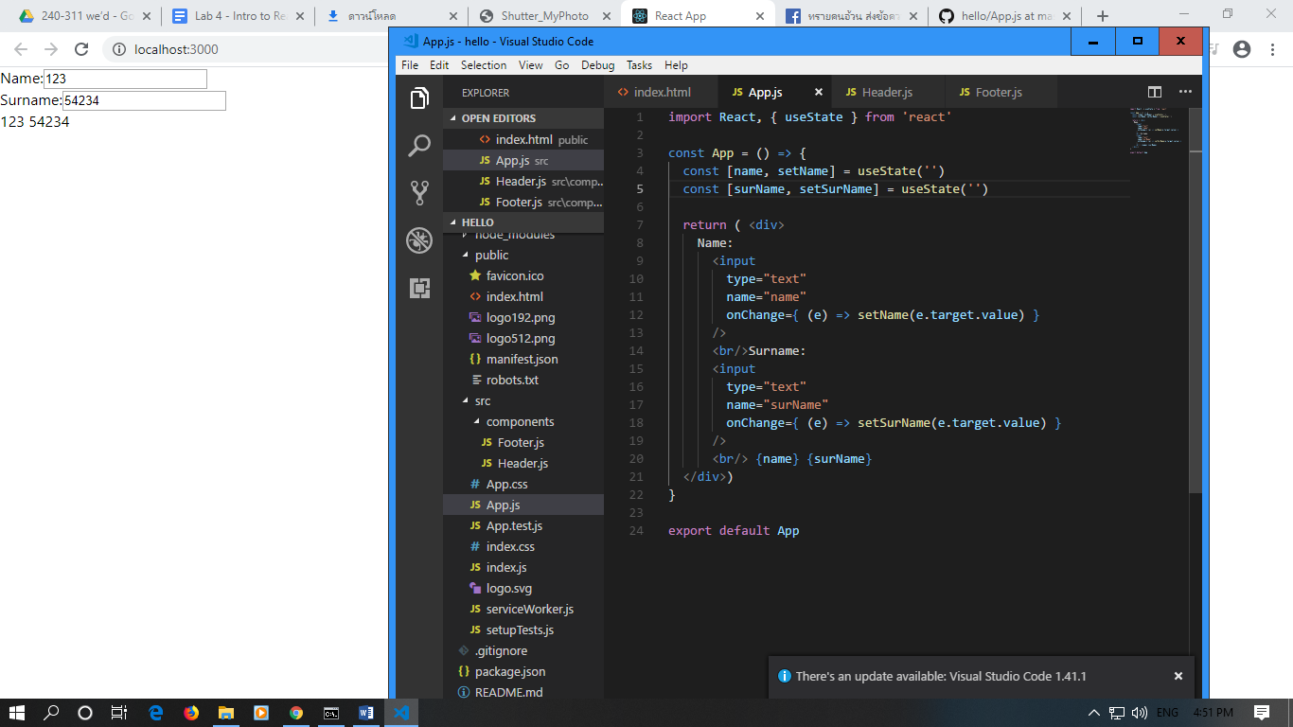

ไม่มีค่าเริ่มต้นนั้นแหละ