Team Cronus - Meeting Reports

* Karthik Palaniappan(karth295)
* Ki Yeung(kyeungk)
* Linsen Wu(linsenwu)
* Tiffany Lin(lintiff)
* Micaela Tolliver(mictol42)
* Panji Wisesa(panjiw)
* Tsz Fung Cheung(tfcheung)

**Figure 1. Login View**

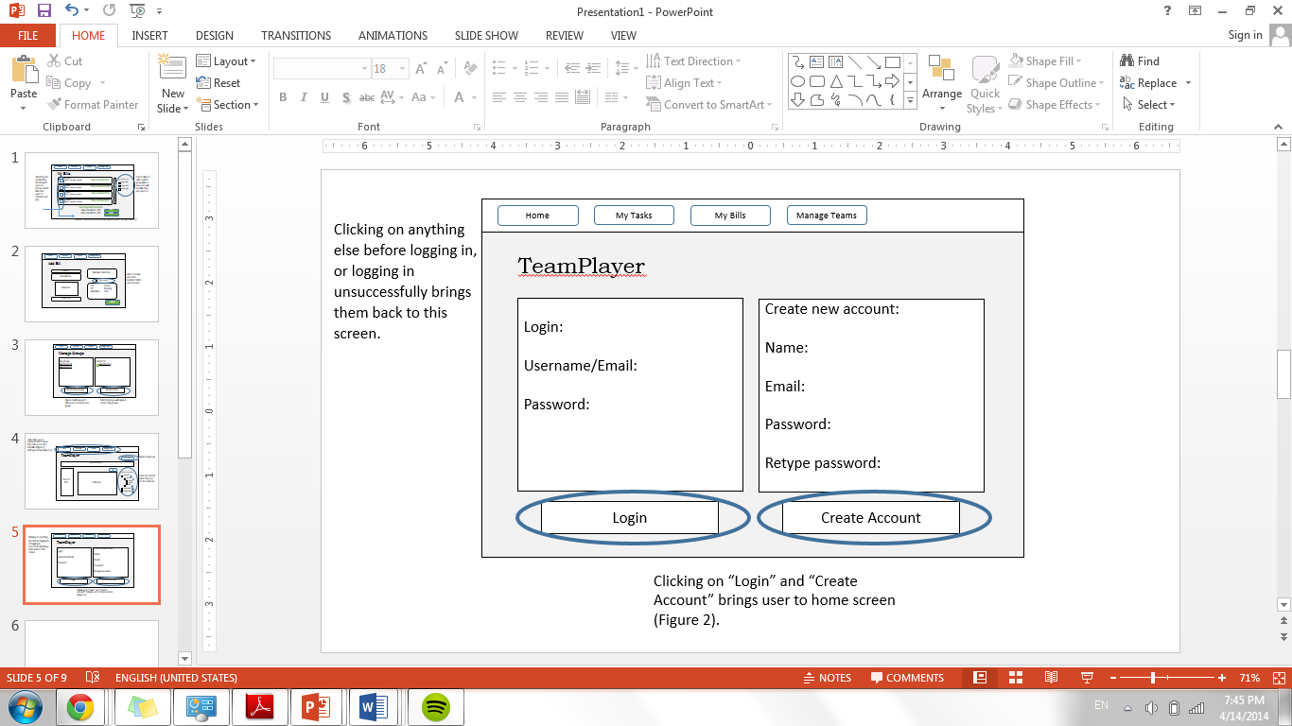

**Figure 2. Home View**

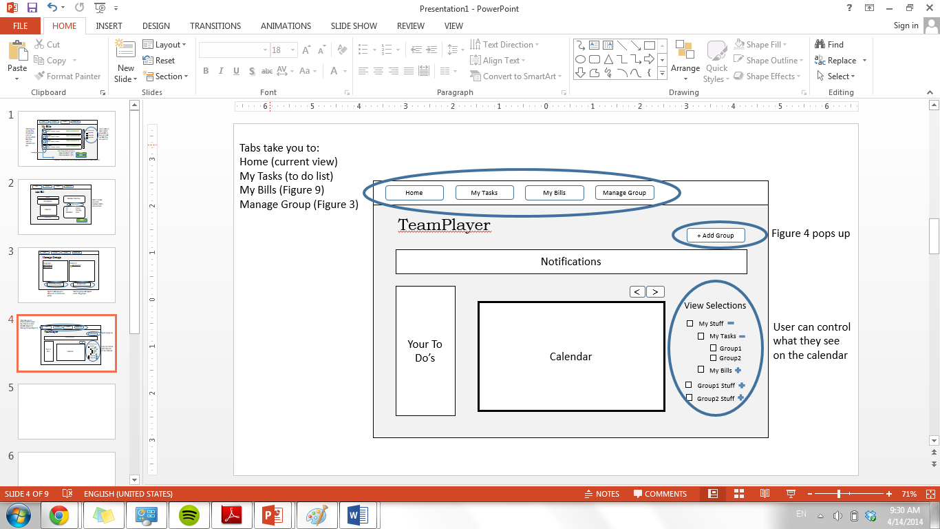

**Figure 3. Group Management View**

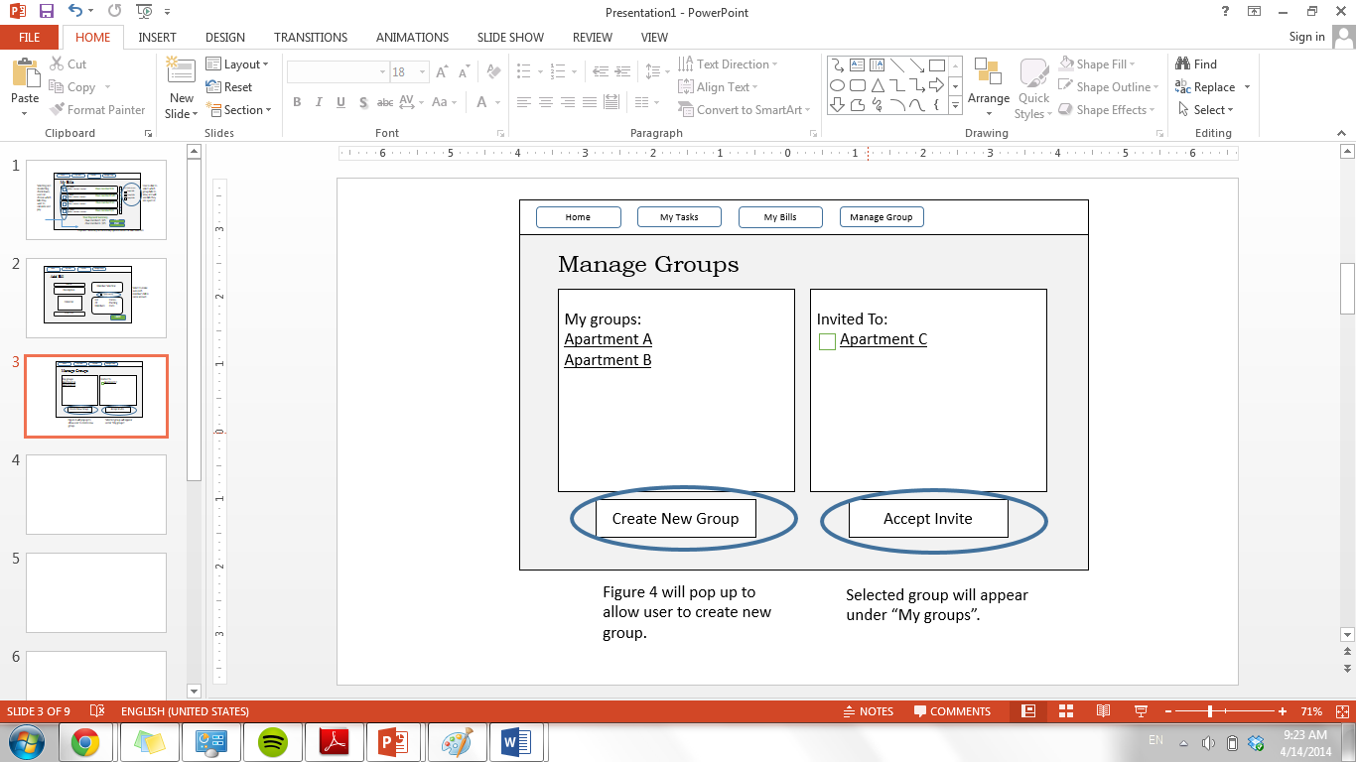

**Figure 4. Group Creation View**

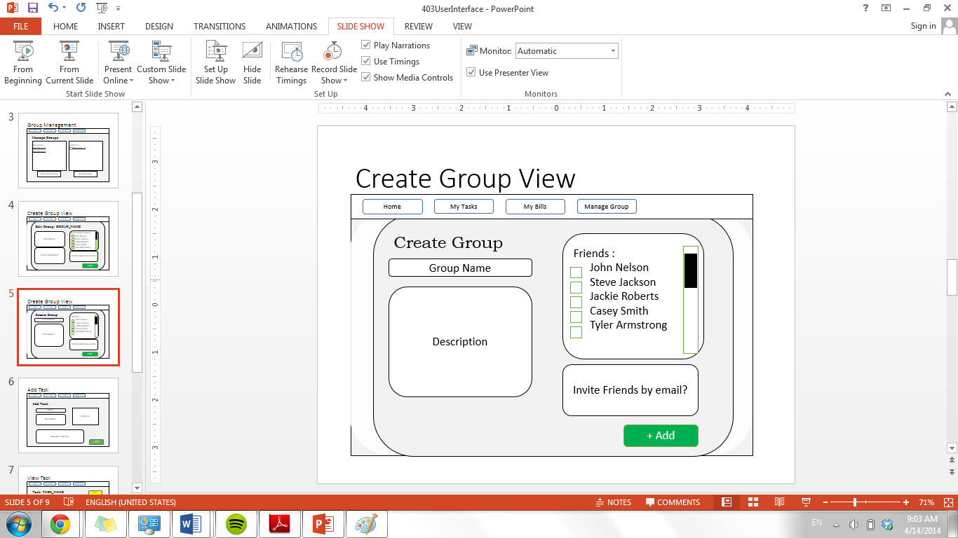

**Figure 5. Group Edit View**

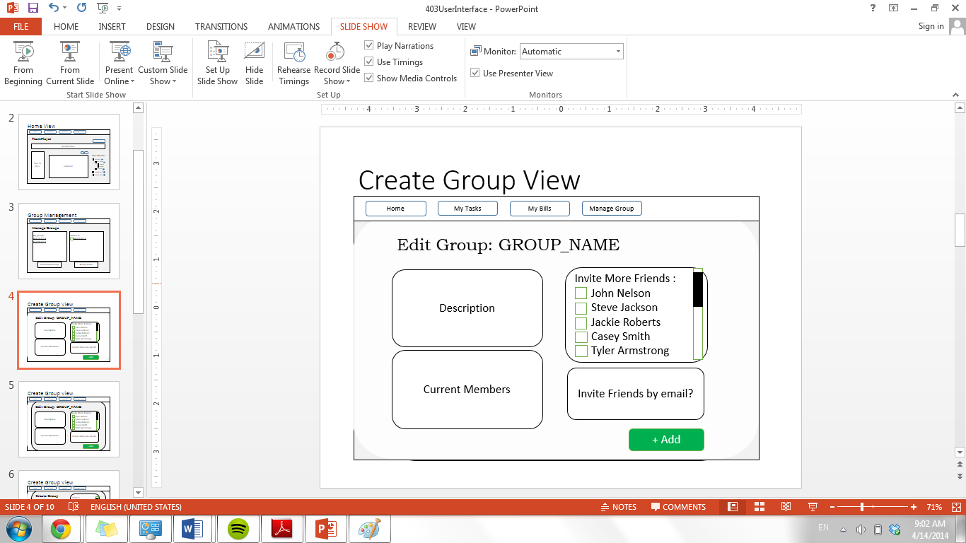

**Figure 6. Task Addition View**

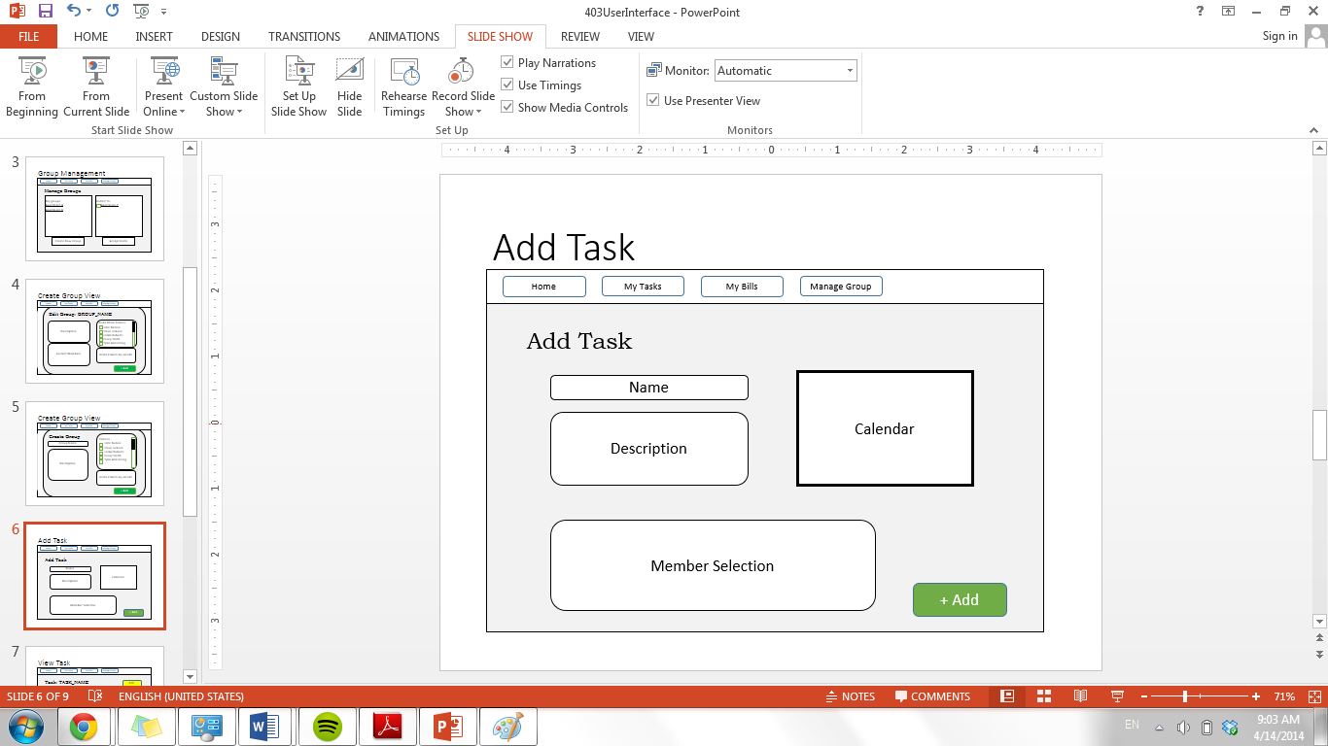

**Figure 7. Task Summary View**

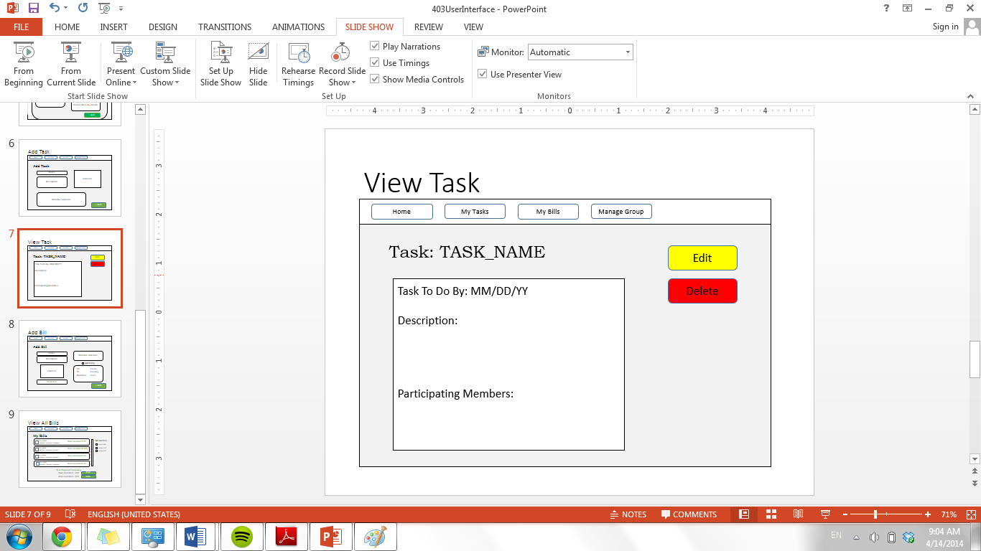

**Figure 8. Bill Input View**

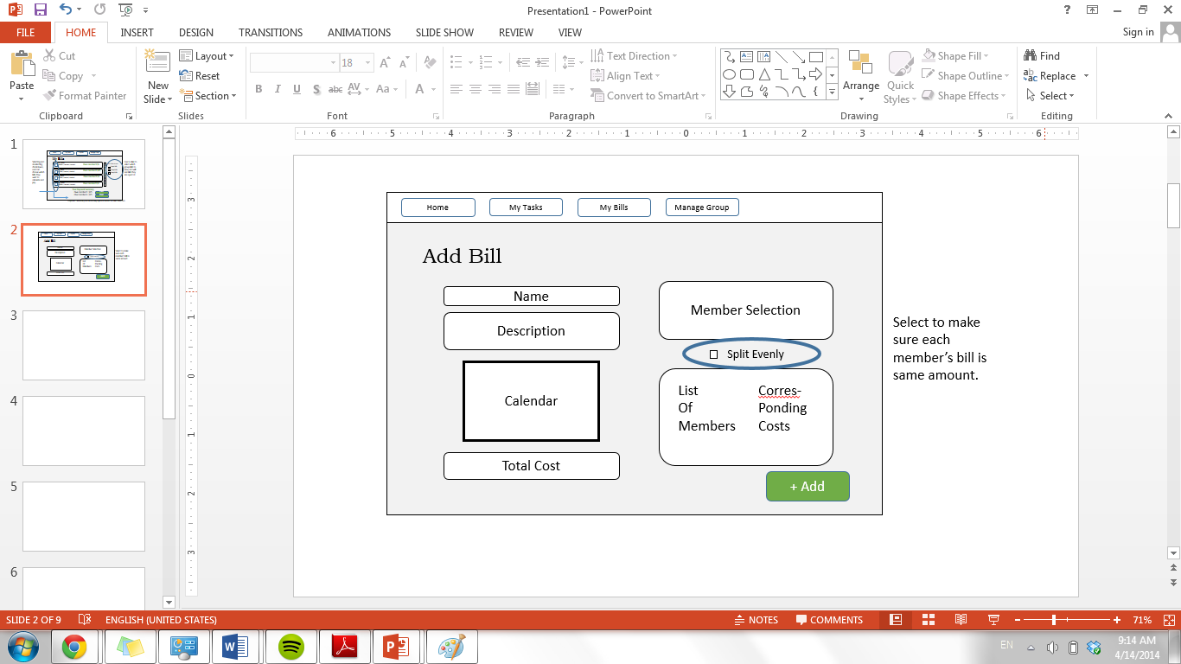

**Figure 9. User Bills View**

