Contents

1 Introduction 2

1.1 Purpose of the document 2

2 FedEx Single Sign On Screen 2

2.1 Fedex Single Sign On Functionality 2

3 PeopleSoft Home Screen 3

4 Entity Screen 4

4.1 When user select ‘Entity & Distribution’ option from document distribution menu item the above screen will be displayed. 4

4.2 Add New Entity 5

4.2.2 After selecting ‘Add’ from entity screen the above add new entity screen shown 5

5 Creation New Entity Screen 6

5.1 After Clicking Add button from entity screen the above new entity Creation Screen will come. 7

6 Document Distribution 8

6.1 Document Distribution Details 8

6.1.1 After selecting Document Distribution tab the documents details is shown. 8

7 Adjustment Number Screen 9

7.1 When user select ‘Adjustment Number’ tab the above screen will be displayed. 9

8 Bill to Country 10

8.1 When user select ‘Bill to country’ tab the above screen will be displayed. 10

9 Entity Name and Mapping Screen 11

9.1 The above screen will come when user select ‘Map Entity Name’ from Document Distribution menu item. 12

Here user can see all entity and respective mapping. 12

10 Customer Distribution UI 13

10.1 The above screen will come when user select ‘Customer Distribution’ from Document Distribution menu item. 13

# Introduction

## Purpose of the document

This document details the migration of existing PeopleSoft application. The migration is required to facilitate use of new functionalities. The Document contains all related screens of PeopleSoft application and there details.

# FedEx Single Sign On Screen

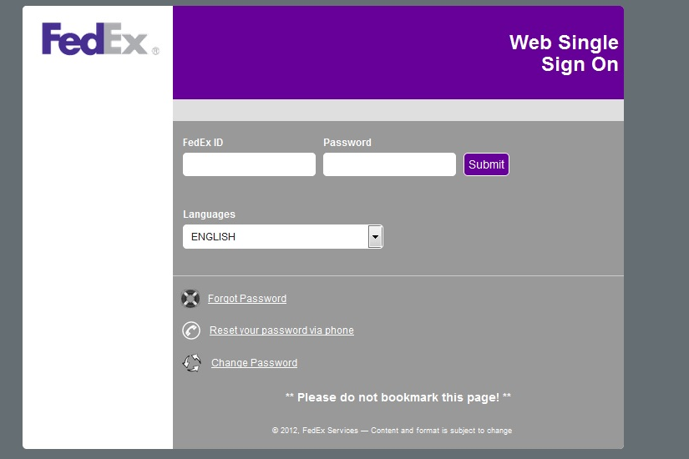

## FedEx Single Sign On Functionality

The FedEx sign on screen is for authentication before accessing PeopleSoft. The FedEx ID and password are required for login into FedEx applications.

* There is a web-service call which fetch user detail for single sign on.
* The Single sign on is provided such that user don’t have to login in each application.

# PeopleSoft Home Screen

|  |  |
| --- | --- |
| |  | | --- | |  | |

3.1 After login to FedEx application the PeopleSoft home screen will look like above.

User can navigate to all PeopleSoft functionality from main menu screen.

# Entity Screen

|  |  |  |
| --- | --- | --- |
| |  |  | | --- | --- | |  |  | |

## When user select ‘Entity & Distribution’ option from document distribution menu item the above screen will be displayed.

Here User can add new entity, search existing entity and delete.

* If user click on ‘Search’ Button after selecting entity & description field then the related entity details screen will come.
* If user click on ‘Add’, Button then add new entity screen will be displayed.
* Delete button is to delete any existing entity.
* The Clear button is for clearing the text entered in Entity & Description fields.
* User can save search criteria by selecting ‘save search criteria’

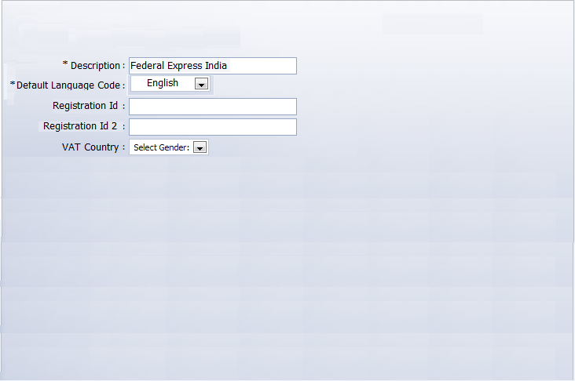

## Add New Entity

4.2.1 Add new entity screen

|  |
| --- |
|  |

### After selecting ‘Add’ from entity screen the above add new entity screen shown

Here User can add new entity by entering value in entity textbox.

* User can add new entity by entering new entity name in ‘Entity’ text box.
* ‘Add’ button used for adding new entity.
* If User click on add button after entering text in entity textbox a new entity details screen will be displayed where user have to enter all details for entity like description,address,name,default bank etc.

# Creation New Entity Screen

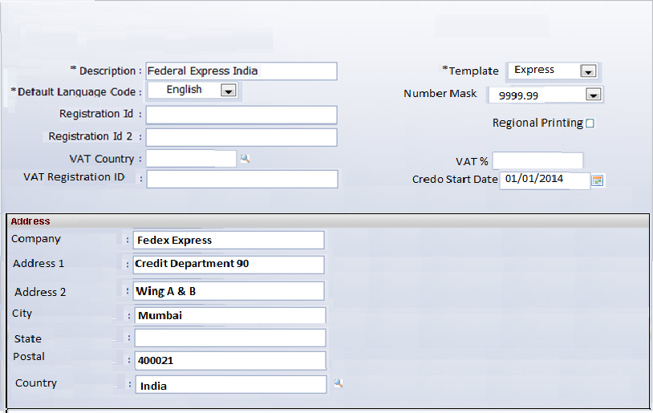

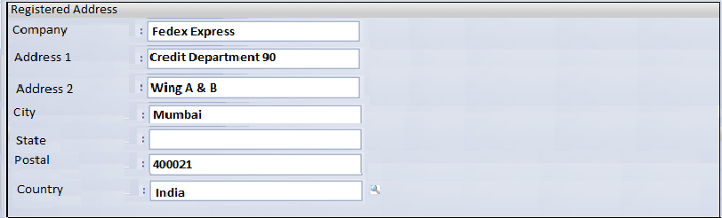

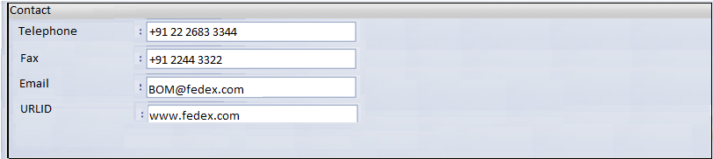

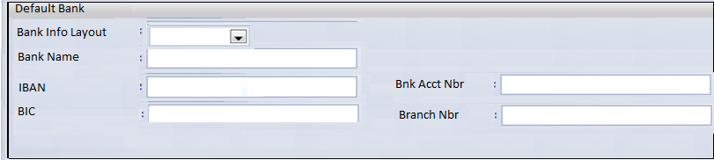

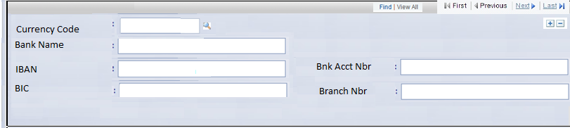



## After Clicking Add button from entity screen the above new entity Creation Screen will come.

Here user have to enter all details of entity to create a new entity.

* The detail of entity contains Entity Name, Type , Default Language, Registration Id, address, registered address, Contact, Default bank etc.
* ‘Save’ Button for saving new entity.
* ‘Return to Search’ button is for searching entity.
* ‘add’ button for adding entity

# Document Distribution

## Document Distribution Details

|  |  |  |  |  |  |  |  |
| --- | --- | --- | --- | --- | --- | --- | --- |
| |  |  |  |  |  |  |  | | --- | --- | --- | --- | --- | --- | --- | | Entity |  | Document Distribution |  | Adjustment Number |  | Bill to Country |   **Entity** INT Federal Access India |

### After selecting Document Distribution tab the documents details is shown.

* The above screen list documents and there details.
* The documents displayed are Credit Note External, Credit Note Internal, Debit Note External ,Debit note Internal.
* User can select any options to Print, E-mail, FBO, EDI, Copy, Mail
* The Search option is provided to search email, process ID.
* User can navigate to different screen by selecting first & last at top frame.
* The +, - sign at end of each document distribution provided to add, delete documents.

# Adjustment Number Screen

|  |  |  |  |  |  |  |  |  |
| --- | --- | --- | --- | --- | --- | --- | --- | --- |
| |  |  |  |  |  |  |  | | --- | --- | --- | --- | --- | --- | --- | | Entity |  | Document Distribution |  | Adjustment Number |  | Bill to Country |   **Entity** INT Federal Access India   |  | | --- | |  | |

## When user select ‘Adjustment Number’ tab the above screen will be displayed.

* ‘Save’ Button for saving updated details
* ‘Return to Search’ button is for searching entity.
* ‘Add’ button for adding new entry.
* User can navigate to different screen by selecting first & last at top frame.

# Bill to Country

|  |  |  |  |  |  |  |  |  |
| --- | --- | --- | --- | --- | --- | --- | --- | --- |
| |  |  |  |  |  |  |  | | --- | --- | --- | --- | --- | --- | --- | | Entity |  | Document Distribution |  | Adjustment Number |  | Bill to Country |   **Entity** INT Federal Access India   |  | | --- | |  | |

## When user select ‘Bill to country’ tab the above screen will be displayed.

* ‘Save’ Button for saving updated details
* ‘Return to Search’ button is for searching entity.
* ‘Add’ button for adding new entry.
* User can navigate to next and previous screen by selecting first & last at top frame.

# Entity Name and Mapping Screen

|  |  |  |  |  |  |  |  |  |  |  |  |  |  |  |  |  |  |  |  |  |  |  |  |  |  |  |  |  |  |  |  |  |  |  |  |  |  |  |  |  |  |  |  |  |  |  |  |  |  |  |  |  |  |  |  |  |  |  |  |  |  |  |  |  |  |  |  |  |  |  |  |  |  |  |  |  |  |  |  |  |  |  |  |  |  |  |  |  |  |  |  |  |  |  |  |  |  |  |  |  |  |  |
| --- | --- | --- | --- | --- | --- | --- | --- | --- | --- | --- | --- | --- | --- | --- | --- | --- | --- | --- | --- | --- | --- | --- | --- | --- | --- | --- | --- | --- | --- | --- | --- | --- | --- | --- | --- | --- | --- | --- | --- | --- | --- | --- | --- | --- | --- | --- | --- | --- | --- | --- | --- | --- | --- | --- | --- | --- | --- | --- | --- | --- | --- | --- | --- | --- | --- | --- | --- | --- | --- | --- | --- | --- | --- | --- | --- | --- | --- | --- | --- | --- | --- | --- | --- | --- | --- | --- | --- | --- | --- | --- | --- | --- | --- | --- | --- | --- | --- | --- | --- | --- | --- | --- |
| |  | | --- | | Map Entity Name |      |  |  |  |  |  |  |  |  |  |  |  |  |  |  |  |  |  |  |  |  |  |  |  |  |  |  |  |  |  |  |  |  |  |  |  |  |  |  |  |  |  |  |  |  |  |  |  |  |  |  |  |  |  |  |  |  |  |  |  |  |  |  |  |  |  |  |  |  |  |  |  |  |  |  |  |  |  |  |  |  |  |  |  |  |  |  |  |  |  |  |  |  |  |  |  |  |  |  |  |  |  | | --- | --- | --- | --- | --- | --- | --- | --- | --- | --- | --- | --- | --- | --- | --- | --- | --- | --- | --- | --- | --- | --- | --- | --- | --- | --- | --- | --- | --- | --- | --- | --- | --- | --- | --- | --- | --- | --- | --- | --- | --- | --- | --- | --- | --- | --- | --- | --- | --- | --- | --- | --- | --- | --- | --- | --- | --- | --- | --- | --- | --- | --- | --- | --- | --- | --- | --- | --- | --- | --- | --- | --- | --- | --- | --- | --- | --- | --- | --- | --- | --- | --- | --- | --- | --- | --- | --- | --- | --- | --- | --- | --- | --- | --- | --- | --- | --- | --- | --- | --- | --- | | Map Entity Name with Entity  Entity Name Entity   |  |  |  |  |  | | --- | --- | --- | --- | --- | | Federal Express Botswana |  |  | BWA |  | | Federal Express Agencia en Chile |  |  | CHI |  | | Federal Express Austria |  |  | AUR |  | | Federal Express Bahrain |  |  | BHR |  | | Federal Express Belgium |  |  | BEL |  | | Federal Express Belgium BEA |  |  | BEA |  | | Federal Express Belgium BEE |  |  | BEE |  | | Federal Express Czech Republic |  |  | CZT |  | | Federal Express Denmark |  |  | DKT |  | | Federal Express Egypt |  |  | EGY |  | | Federal Express Estonia |  |  | EET |  | | Federal Express Finland |  |  | FIT |  | | Federal Express France |  |  | FRA |  | | Federal Express GB Domestic |  |  | GBD |  | | Federal Express Germany |  |  | DEU |  | | Federal Express Great Britain |  |  | GBR |  | | Federal Express Hungary |  |  | HUT |  | | Federal Express India |  |  | INT |  | | Federal Express SUB CONT |  |  | ISC |  | | Federal Express Ireland |  |  | IES |  | | |

## The above screen will come when user select ‘Map Entity Name’ from Document Distribution menu item.

## Here user can see all entity and respective mapping.

* Entity name textbox display the name of entity.
* Entity mapping name is front of entity name textbox.
* User can navigate to next and previous screen by selecting first & last at top frame.
* The +, - sign at end of each entity provided to add, delete.

# Customer Distribution UI

|  |  |  |  |  |
| --- | --- | --- | --- | --- |
| |  |  |  | | --- | --- | --- | | Find an Existing Value |  | Add a New Value |   Enter any Information you have and click Search. Leave fields blank for a list of all values.   |  | | --- | |  | |

## The above screen will come when user select ‘Customer Distribution’ from Document Distribution menu item.

* If user selects ‘Search’ Button after selecting customer ID or other fields then the related customer details screen will come.
* The Clear button is for clearing the text entered in Entity & Description fields.
* User can save search criteria by selecting ‘save search criteria’

# Setup UI

|  |  |
| --- | --- |
| |  | | --- | |  | |

## The above screen will come when user select ‘Setup’ from Document Distribution menu item.

* There are some more submenu items in setup menu like Mailing Country and Region, region mapping, entity region settings, customer E-mail etc.
* When user select any of sub menu item a new screen will displayed related to that menu item.

# Mailing country and region

|  |  |  |  |  |  |  |  |  |  |  |  |  |  |  |  |  |  |  |  |  |  |  |  |  |  |  |  |  |  |  |  |  |  |  |  |  |  |  |  |  |  |  |  |  |  |  |  |  |  |
| --- | --- | --- | --- | --- | --- | --- | --- | --- | --- | --- | --- | --- | --- | --- | --- | --- | --- | --- | --- | --- | --- | --- | --- | --- | --- | --- | --- | --- | --- | --- | --- | --- | --- | --- | --- | --- | --- | --- | --- | --- | --- | --- | --- | --- | --- | --- | --- | --- | --- |
| |  |  |  | | --- | --- | --- | | Mailing Country |  | Mailing Reason |  |  |  |  | | --- | --- | --- | | Mailing Country |  |  | | *Country Description Print Vendor Country ID * Postal Position   |  |  |  |  |  | | --- | --- | --- | --- | --- | | AD | Andorra | 99 | Postal before City |  |  |  |  |  |  |  | | --- | --- | --- | --- | --- | | AE | United Arab | 99 | Postal After City |  |  |  |  |  |  |  | | --- | --- | --- | --- | --- | | AL | Albania | 99 | Postal before City |  |  |  |  |  |  |  | | --- | --- | --- | --- | --- | | AM | Armenia | 99 | Postal before City |  |  |  |  |  |  |  | | --- | --- | --- | --- | --- | | AO | Angola | 99 | Postal before City |  |  |  |  |  |  |  | | --- | --- | --- | --- | --- | | AT | Austria | 99 | Postal before City |  |  |  |  |  |  |  | | --- | --- | --- | --- | --- | | AZ | Azerbaijan | 99 | Postal before City |  |  |  |  |  |  |  | | --- | --- | --- | --- | --- | | BE | Belgium | 99 | Postal before City |  | | | | |

## The above screen will come when user select ‘Mailing country and region’ from setup menu bar.

* Here user will see country, Country description, Print vendor country ID, Postal position.
* The +, - sign at end of each country provided to add, delete.