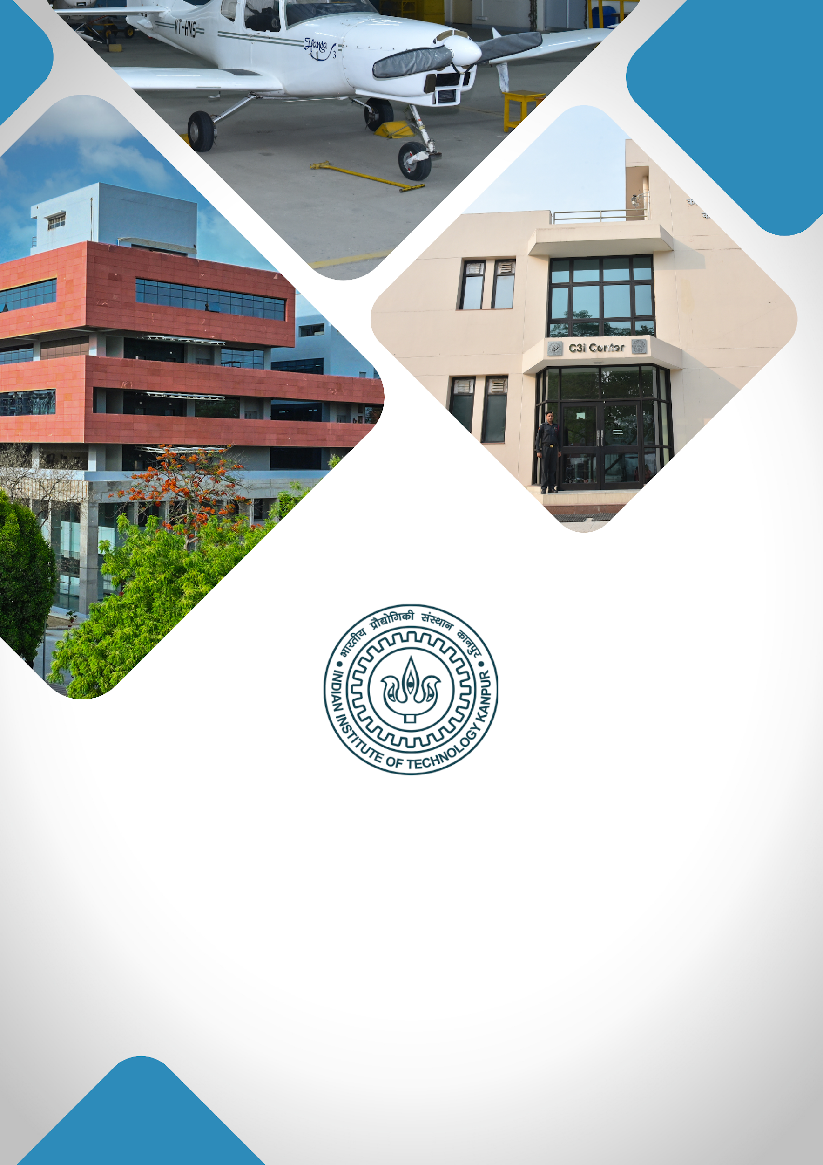



**TABLE OF CONTENTS**

1. **About IIT Kanpur**
2. **Institutional Vision**
3. **Project Title**
4. **Executive Summary**
5. **Background & Rationale / Motivation**
6. **Project Objectives**
7. **Expected Outcomes**
8. **Expected Impact**
9. **Milestones & Implementation Timeline**
10. **Financial Budget**
11. **Team Involved / Key Faculty Members**

**ABOUT IIT KANPUR**

**Indian Institute of Technology Kanpur**, established in 1959, is one of the premier institutions established by the Government of India. The aim of the Institute is to provide meaningful education, conduct original research of the highest standard, and provide leadership in technological innovation. The Institute has gained a legendary reputation in the country through its academic, social, and economic contributions. The combined record of its past and present faculty and students along with the alumni spread across the world is awe-inspiring.

From the start, the students have been provided education with a strong emphasis on the fundamentals of science and engineering and their application in the field of study. Subsequently, programs in humanities, management, and several interdisciplinary programs like design, environmental engineering and management, material sciences, nuclear engineering and technology, and photonic sciences and engineering programs were started. The education imparted to the students has stood by them even as they acquired new skills and knowledge during their professional careers.

IIT Kanpur continues to be a much sought-after destination for UG and PG studies. In the 65 years of its existence, over 43,000 students have graduated from the Institute. The alumni of IIT Kanpur have made their alma mater proud through their achievements and contributions in diverse fields like engineering, academia, business, entrepreneurship, and public service.

The Institute today has close to 600 full-time faculty members and all of them have earned their degrees from the top universities in the world. The Institute faculty members have often been bestowed with prestigious national honours as listed below:

| Padma Shri |
| --- |
| Infosys Prize (Infosys Science Foundation) |
| J C Bose Fellowship |
| Shanti Swarup Bhatnagar Prize for Science & Technology |
| Fellow, Indian National Science Academy (INSA), New Delhi |
| Fellow, Indian Academy of Sciences (IAS), Bangalore |
| Fellow, Indian National Academy of Engineering (INAE), New Delhi |
| Fellow, The National Academy of Sciences, India (NASI), Allahabad |
| Fellow, The World Academy of Sciences (TWAS), Italy |
| Humboldt Research Award |
| TWAS Prize |
| Wellcome Trust/India Alliance Early Career/Intermediate/Senior Fellowship |
| Tata Innovation Fellowship |

The Institute has a large pool of academic resources spanning 19 departments, 25 centers, and 3 Interdisciplinary programs in all engineering, science, design, humanities, and management disciplines. It has a student strength of more than 9000 across all programs.

IIT Kanpur has always laid strong emphasis on new academic initiatives that will allow the Institute to broaden its academic repertory and create an impact in academia and society. Some of these initiatives include the Department of Sustainable Energy Engineering and the Department of Cognitive Science which were established in the year 2020.

**INSTITUTIONAL VISION**

***"To create, disseminate, and translate knowledge in science, engineering, and allied disciplines that will best serve society."***

1. **Developing Technologies that Solve Real-World Problems:** Prioritising research and development that address critical societal challenges, translating innovations into solutions with high-TRL (Technology Readiness Level) technologies. The goal is to establish an Office of Translational Research within the Directorate for strategic guidance, funding support, industry connections, and information on government and industry needs.

**Major focus areas:**

* **Large-Scale AI Deployment**: Implementing AI solutions on a wide scale, focusing on impactful applications for government and industry sectors, including public grievance redressal and fraud detection.
* **MedTech:** Making healthcare accessible and affordable through cutting-edge research, device innovation, and medical training with the **Mehta Family Center**, **MedTech IITK**, and the **Gangwal School of Medical Sciences & Technology**.
* **Cybersecurity:** With **C3iHub**, focused on developing advanced solutions, supporting startups, and offering specialised training for critical cybersecurity needs.
* **Unmanned Aerial Vehicle (UAV) Technology**: Advancing UAV technology with a focus on defence, humanitarian, and disaster relief applications, and providing affordable testing facilities to promote industry growth.
* **Sustainability:** Positioning IIT Kanpur as a leader in sustainable development through technologies and initiatives led by the **Kotak School of Sustainability**, the **Chandrakanta Kesavan Centre** **for Energy Policy and Climate Solutions**, and the **Department of Sustainable Energy Engineering**.

1. **Elevating R&D Excellence:** Focus on recruiting top talent, creating state-of-the-art facilities, securing substantial research grants, and maintaining a balance between research quality and quantity.
2. **Enhancing Teaching Quality:** Achieving leadership inhigh-quality education by establishing a Centre for Teaching Excellence, developing courses in soft skills and technical writing, and introducing faculty career paths that focus on research, translational projects, or teaching.
3. **Enhancing Student Life and Campus Infrastructure:** Upgrading existing hostels and constructing new ones to accommodate growing student numbers. Developing state-of-the-art infrastructure within the campus.

**PROJECT TITLE**

**Centre for Advanced Computing and Artificial Intelligence**

**EXECUTIVE SUMMARY**

In today's rapidly evolving science and technology landscape, the demand for advanced computing and artificial intelligence (AI) is skyrocketing across academia, research, industry, and society. These technologies have become indispensable tools across various scientific and engineering domains, requiring continuous access to high-end computing resources, particularly GPU-based systems. Moreover, interdisciplinary expertise spanning numerical methods, programming, and high-performance computing is essential for addressing complex problems with industrial and biomedical implications.

We propose the establishment of a cutting-edge Centre for Artificial Intelligence and Advanced Computing (CAIAC) to address these growing needs:

* A hub for training and research in advanced computing across all disciplines, catering to scientists and industry professionals.
* Offering comprehensive Master's and Ph.D. programs.
* Introducing specialized interdisciplinary courses for students at IIT Kanpur and industry professionals through an innovative e-Masters program.

The center will host state-of-the-art computing facilities and will conduct ongoing training programs in advanced computing and AI. Collaborations with the Gangwal School of Medical Science and Technology and Kotak School of Sustainability will focus on applying these technologies to medicine, materials science, and climate change.

Targeted initiatives will encompass medicine, drug discovery, materials innovation, weather modeling, and the advancement of large language models. Exposure to interdisciplinary knowledge in advanced computing will empower researchers to develop novel computational methodologies and tools for complex simulations and data analysis.

*Collaborating with startups and established industries will facilitate innovation and drive impactful solutions. CAIAC aims to cultivate a culture of innovation, forge strong industry partnerships, and foster international collaborations, positioning itself as a global leader in advanced computing and AI research and education.*

**BACKGROUND & RATIONALE / MOTIVATION**

Distinguished for its pioneering spirit and unwavering commitment to innovation, the Indian Institute of Technology Kanpur stands as a beacon of excellence in India's academic landscape. With a rich legacy deeply rooted in cutting-edge research, IIT Kanpur has consistently prioritized advanced computing across its diverse disciplines since its inception. The institute's unwavering dedication to fostering excellence is exemplified by its robust infrastructure, including stellar high-performance computing facilities, which have catalyzed groundbreaking research and development endeavors.

In today's dynamic landscape, the significance of advanced computing in science and engineering continues to ascend, with artificial intelligence emerging as a pivotal tool driving innovation across research and industry domains. Against this backdrop, the imperative for a platform to nurture the next generation of researchers in advanced computing and AI has become increasingly apparent. Despite the burgeoning demand for interdisciplinary collaboration, the pace of knowledge dissemination across traditional disciplines remains sluggish. The absence of a unified platform impedes the seamless exchange of insights, resulting in delays in adopting cutting-edge technologies across diverse fields.

It is within this context that the proposition for a new center is in the spotlight—a visionary endeavor poised to bridge disciplinary divides and galvanize collaborative initiatives. Through comprehensive (full-time and part-time) PhD/Master programs, joint research endeavors, seminars, workshops, and coursework, this center will serve as a vibrant hub, fostering synergistic interactions and propelling innovation.

Moreover, as industries increasingly embrace AI and advanced computing, the need to equip their executives with multifaceted expertise poses a formidable challenge. Tailored e-Masters programs, workshops, and training initiatives offered by IIT Kanpur will not only address this pressing need but also serve as conduits for industry-academia collaboration. By imparting contemporary insights and applications of computing in diverse domains such as medicine, drug discovery, climate modelling, and quantum computing, this center will drive transformative advancements, nurturing a thriving ecosystem of startups and bolstering the nation's economy.

In response to the burgeoning demand for interdisciplinary education, IIT Kanpur seeks to expand its repertoire of courses, transcending conventional subject-specific boundaries. By convening esteemed academicians and industry stalwarts, this center will curate an array of interdisciplinary courses, fostering a culture of cross-pollination and equipping learners with holistic computational proficiency.

**PROJECT OBJECTIVES**

**Moto**: COLLABORATE. COMPUTE. CHANGE.

**A new centre for AI & AC is poised to achieve the following aspirational objectives with precision and strategic vision:**

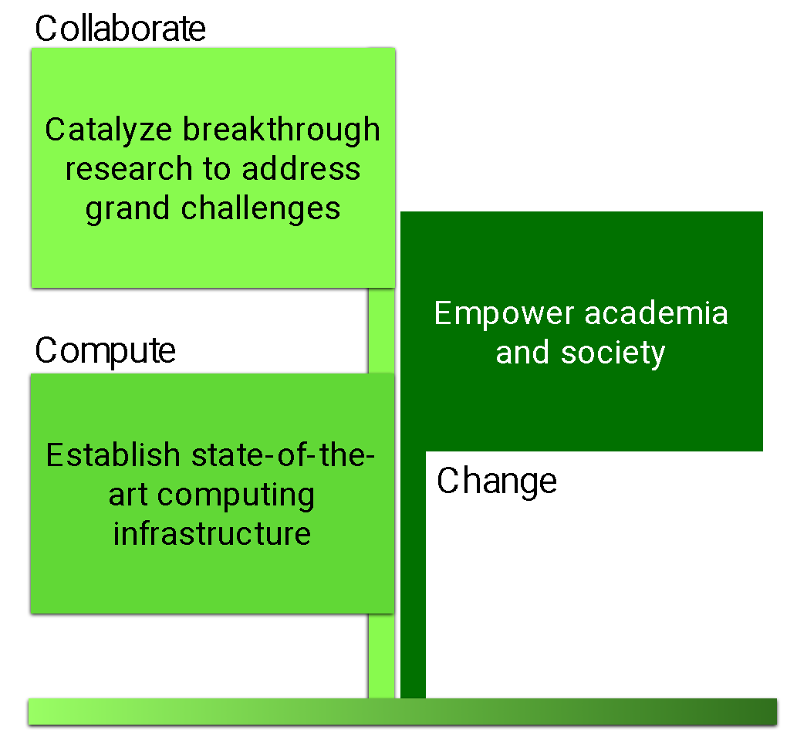

A. **Catalyze Breakthrough Research to Address Grand Challenges:**

* Foster interdisciplinary synergy to surmount formidable grand challenges in healthcare, material innovation, weather forecasting, and beyond.
* Quantify impact through metrics such as research project initiation, collaborative endeavors, and paradigm-shifting discoveries.
* Enhance adaptability by harnessing cross-disciplinary insights to propel innovation in AI & AC.

B. **Empower Academia and Society:**

* Innovate and implement cutting-edge interdisciplinary courses and degree programs tailored for IIT Kanpur students and industry leaders.
* Measure success through increased enrollment rates and the effectiveness of workshops and outreach initiatives.
* Gauge impact by tracking participant engagement and the dissemination of knowledge in the rapidly evolving AI & AC landscape.
* Introduction and implementation of the new e-Masters program in Advanced Computing and Artificial Intelligence through rigorous assessment mechanisms.

C. **Establish State-of-the-Art Data Computing Infrastructure:**

* Forge ahead with the establishment and maintenance of a world-class data center and high-performance computing resources.
* Quantify investment in infrastructure development and upkeep.
* Assess resource utilization and efficiency using metrics such as uptime, processing capacity, and user satisfaction.

**EXPECTED OUTCOMES**

**A. Mastery of Evolving Methodologies in AI and AC:**

• Equipping students, researchers, and industry executives with cutting-edge techniques and strategies in the dynamic realms of AI and AC. Fostering a culture of continuous learning and adaptability to stay abreast of the latest advancements in these pivotal fields.

**B. Facilitated Interdisciplinary Collaboration and Funding Opportunities:**

* Cultivating a vibrant ecosystem where researchers and students from diverse disciplines converge, fostering unprecedented levels of interaction and collaboration.
* Establishment of Centers of Excellence (COEs) to catalyze innovation and attract diverse funding streams, bolstered by quarterly presentations and brainstorming sessions to fuel collaboration.

**C. Proactive Industry Problem Solving through AI and AC:**

• Undertaking industry challenges with proactive vigor, leveraging AI and AC to offer agile solutions for both short-term and long-term objectives. Positioning the center as a premier destination for industry partnerships, serving as a centralized hub for swift and effective problem resolution.

**D. Provision of Cutting-Edge High Performance Computing Resources:**

• Offering state-of-the-art computing infrastructure to support advanced research endeavors, enabling complex simulations and data-intensive analyses.

**E. An Integral Industry Nexus:**

* Establishing robust industry partnerships, wherein companies can readily access a diverse pool of experts spanning multiple disciplines to address their challenges efficiently.
* Serving as a one-stop solution provider, the center offers streamlined problem-solving processes, eliminating the need for the industry to seek expertise elsewhere.

**F. Strategic Workshops and Training Initiatives:**

• Host regular workshops and training programs catering to both industry and academia, nurturing a skilled workforce adept in the latest AI and AC methodologies.

**G. Contribute to Governance:**

• The center will enable the development of technologies that will empower society (e.g., LLMs, legal AI, accessible AI, AI+Governance, etc.).

**H. Distinguishing Features and Global Recognition:**

Setting itself apart from existing centers like CDAC and NIC, the proposed center boasts a cadre of highly esteemed and forward-thinking researchers, ensuring unparalleled expertise and innovation.

* Unique in encompassing both AI and AC, the center positions itself as a trailblazer on the national stage, distinct from specialized AI-focused centers like those at IIT Kharagpur and IIT Jammu.
* Drawing inspiration from esteemed institutions abroad, such as
  + ▪  **Boston University** Faculty of Computing & Data Sciences
  + ▪  **MIT Schwarzman College** of Computing
  + ▪  **Pacific Northwest National Laboratory** Center for AI

The center aspires to attract top-tier faculty and forge robust international collaborations, cementing its status as a global frontrunner in AI and AC research and education.

**PROPOSED IMPACT** (SOCIAL / SCIENTIFIC)

* The center will attract public and private sector funding and collaborations for solving some of the challenging problems.
* Training students to address challenges in the areas of engineering and sciences
* Attract top-class faculty members and students
* This center will bring global recognition to IIT Kanpur
* Contribute to healthcare and governance in the country

**MILESTONES & IMPLEMENTATION TIMELINE**

| **DELIVERABLES/MILESTONE** | **Y1** | **Y2** | **Y3** |
| --- | --- | --- | --- |
| Manpower hiring | √ |  |  |
| Program/course approvals | √ |  |  |
| Building construction starts | √ |  |  |
| Launching outreach activities-I | √ |  |  |
| Industry-connect activities-I | √ |  |  |
| Launching academic programs | √ |  |  |
| Launching HPC facility – Phase 1 |  | √ |  |
| Outreach and academic activities - II |  | √ |  |
| Industry-connect activities - II |  | √ |  |
| Inauguration of the building |  |  | √ |
| Launching of HPC facility – Phase 2 |  |  | √ |
| Outreach and academic activities – III |  |  | √ |
| Industry-connect activities - III |  |  | √ |

**BUDGET**

Any other information you may like to give in support of this proposal that may help

evaluate it. (e.g.- High-resolution photographs, videos 1-2 min)

| Budget Head | Amount in  (₹ Crore) |
| --- | --- |
| Capital Expenditure (CAPEX) | |
| Building Cost | 30 |
| Civil Construction | 10 |
| Equipment & Furniture *(including substation/chiller plant upgradation)* | 20 |
| Digital Infrastructure (HPC facility – 2 x faces) | 200 |
| Operational Expenditure (OpEX) | |
| Services and Consultancy | 5 |
| People Cost | 5 |
| Other Expenses | |
| Contingency | 10 |
| TOTAL | **280** |

**KEY FACULTY MEMBERS** (











