NATIONAL INSTITUTE OF TECHNOLOGY DELHI



DBMS PROJECT REPORT ON:
ONLINE QUIZ CONTEST


PROJECT MEMBERS:
Pankaj (141100033)
Anupam Kumar(141100049)
Sahil Bajaj(141100056)

Submitted to: Jaya Thomas

TABLE OF CONTENTS:

1) Problem Statement

2) Project Objectives

3) Functional Requirements

4) Front End & Back End

5) ER – Diagram

6) Relational Tables

7) Constraints

8) DML Statements

9) Comments

PROJECT OBJECTIVE:

- Objective of ONLINE QUIZ CONTEST (TESTO) is to provide an online platform for taking quizzes related to various programming languages.
- The users can also host their own quizzes through this platform .The valid quizzes will be considered.
- The project focuses to provide a platform where users can excel in different topics
of computer science by having a good practice of question solving .

PROBLEM STATEMENT:

- To create a database for hosting an online quiz contest website.
- New users need to sign in & already registered users can login through their registered accounts(We have also provided third party login as facebook).
- The better the UI ,the more users it will attract.
- Fun & challenging.
- User can get to know where he stands checking the leader board.

FUNCTIONAL REQUIREMENTS:

Upload Quiz:
1.User can create quiz after getting logged in!
2. User can select topic and can enter question with its options and answer at the time
of creating quiz.
3. 10 Question for each quiz required to be entered.
Take Quiz:
1. Can take quiz according to their interest by just one click.
2. After completing all questions, result will be displayed on the LeaderBoard.
3. Ranks will be displayed according to their score in topics.

FRONT END & BACK END:

Front End:
1) HTML
2) CSS
3) JS

Back End:
1) PHP ,
2) Ajax
3) SQL
Connections:
1) PHP

ER – DIAGRAM:

email
password
topic_id
topic_name
user_id
name

user_details
topics
has

Participates
in
has

opt_three
correct_opt
opt_four
has
question
contests

contest_id
que_id
que
contest_id
contest_name
opt_one
opt_two
topic_id
leaderboard

user_id
topic_id
score

RELATIONAL TABLES:

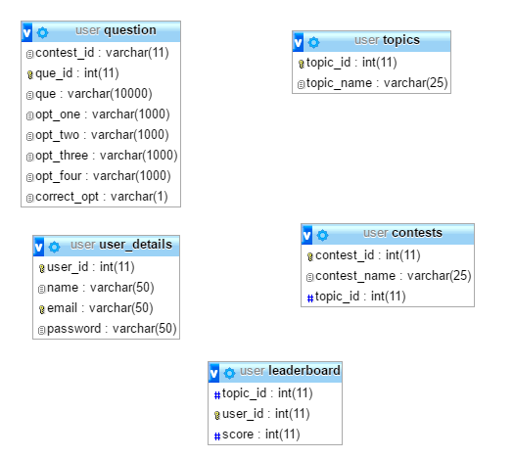

CONTRAINTS USED:

- NOT NULL : question( que , opt_one , opt_two , opt_three , opt_four , correct_opt)
- UNIQUE : user_details(email)
- PRIMARY KEY : user_details(user_id) , topics(topic_id) , question(que_id) , leaderboard(user_id , topic_id) , contests(contest_id)
- FOREIGN KEY : user_id,contest_id,topic_id
- DEFAULT : NOT NULL

DML STATEMENTS:

1) Select Query :
"SELECT topic_name from topics where topic_id=$topic_id";
"SELECT * from contests where topic_id=$topic_id";
"SELECT topic_name from topics where topic_id=$topic_id";

2) Insert Query :
"INSERT INTO question (contest_id,que,opt_one,opt_two,opt_three,opt_four,correct_opt) VALUES
('$contest_id', '$que1','$opt1a','$opt1b','$opt1c','$opt1d','$corr1' )";

3) View Query :
CREATE VIEW V AS
(SELECT leaderborad.user_id , leaderboard.topic_id,user_details.name,leaderboard.score from
leaderboard INNER JOIN user_details ON leaderboard.user_id=user_details.user_id);

SCREENSHOTS:
1) Login Page :
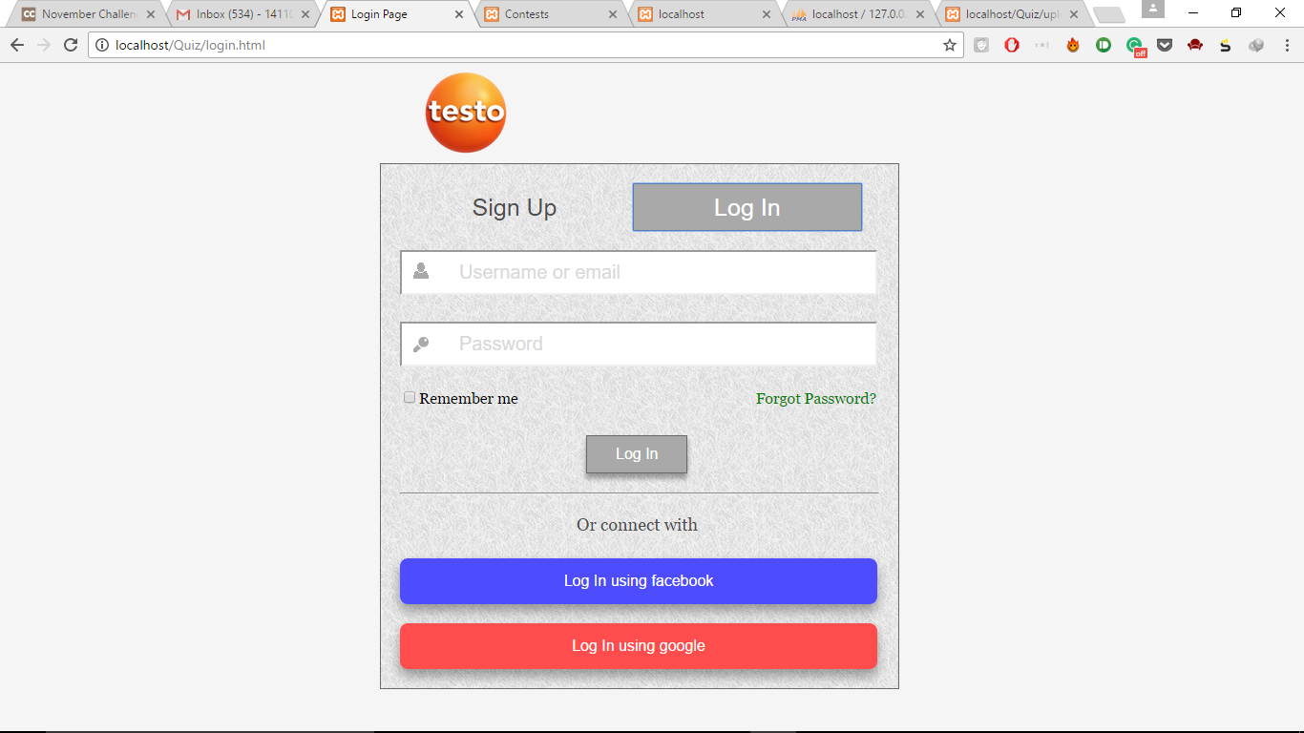
2) Signup page :
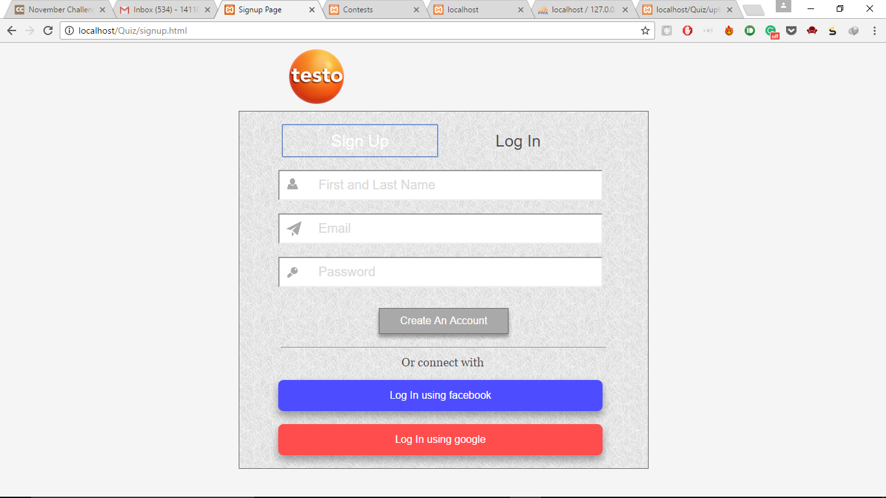

3) Contest Page :
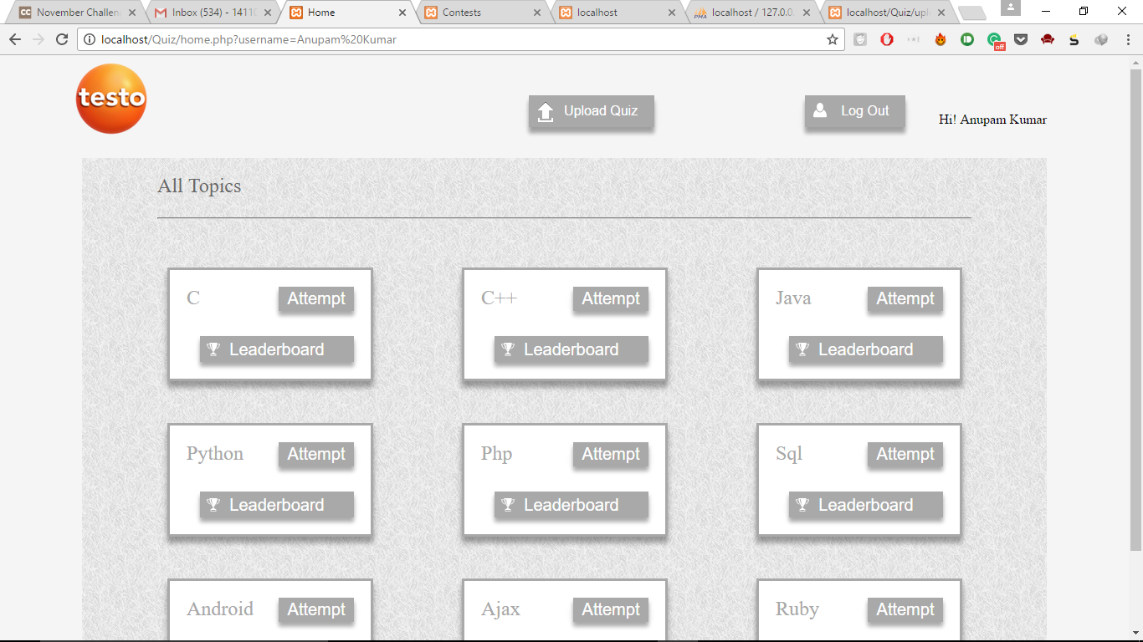
4) Quiz Page :
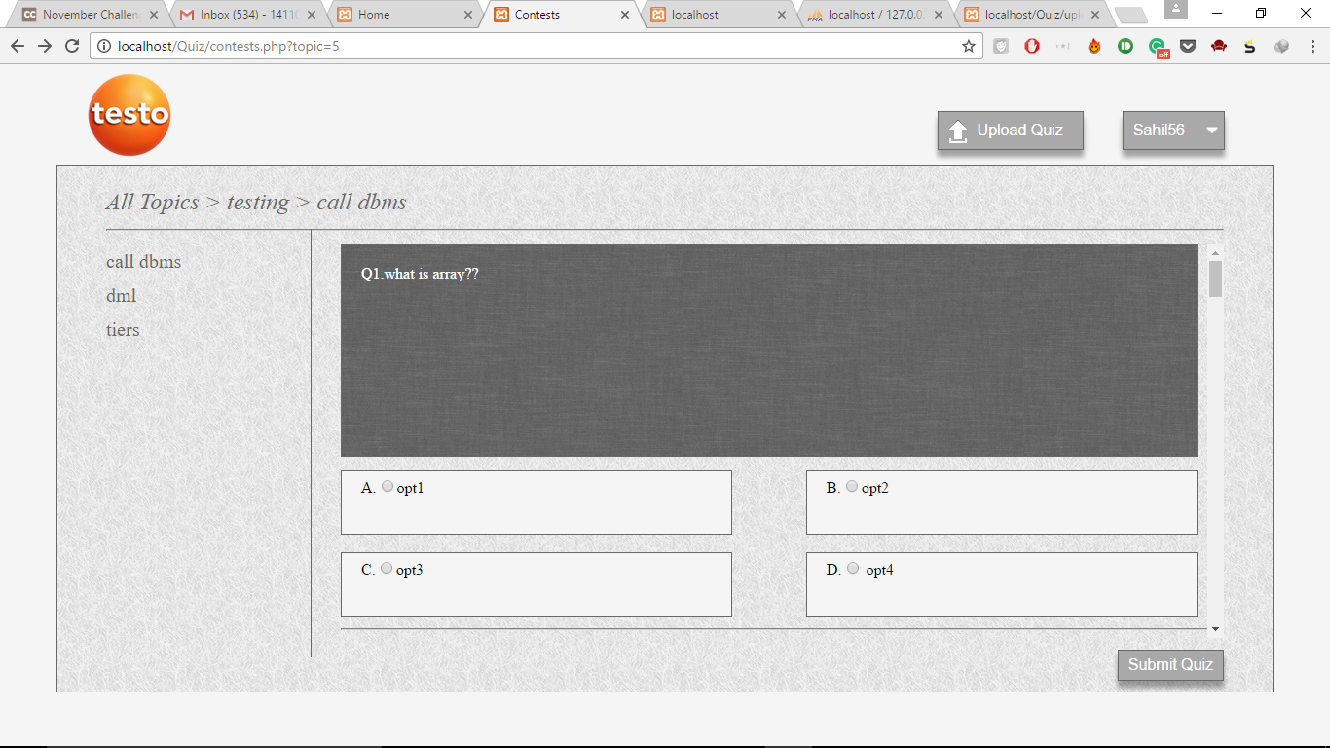

5) Leaderboard Page :

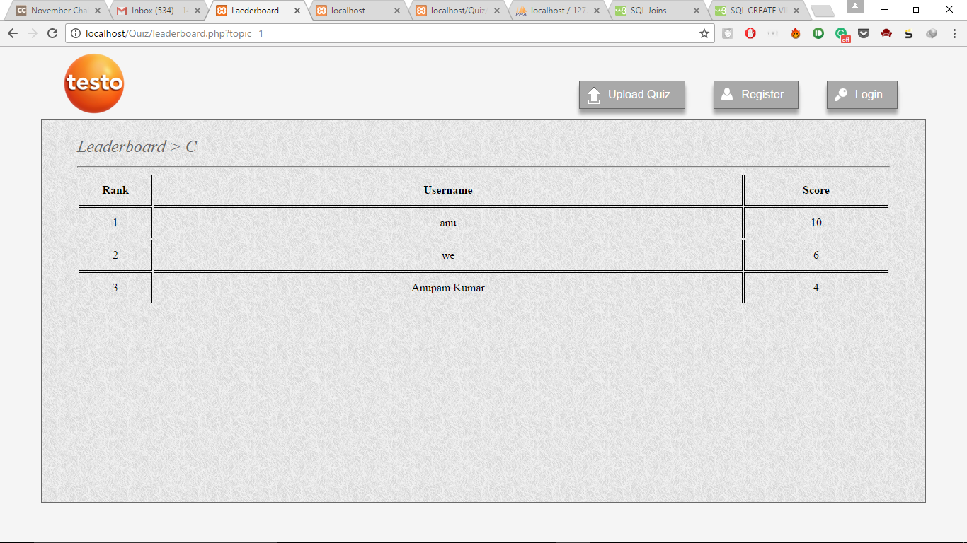
6) Upload Page :
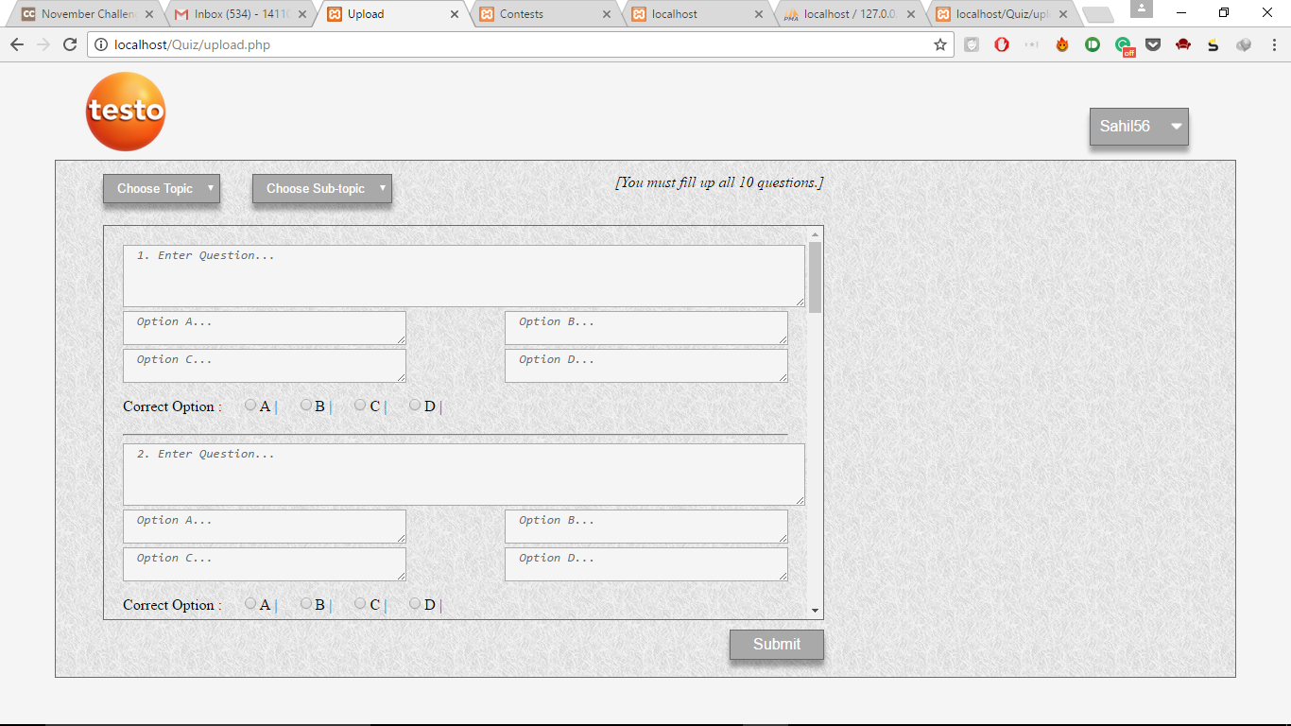

COMMENTS:

The website needs to extended in terms of providing more languages to choose from.
A global leaderboard still needs to be implemented .
A timer has to be implemented while taking a test.

