Beyond security, a Strategy!

AI powered Risk Prioritization and Remediation platform

Discover, assess, prioritize, and patch critical vulnerabilities and reduce cybersecurity risk in real time across your global hybrid Cloud, IT, OT, and IoT landscape — all from a single platform

**SECURE&** platform offers key features that set them apart from competitors, providing unique solutions to address real-time challenges faced by enterprises of all sizes, from small businesses to large corporations.

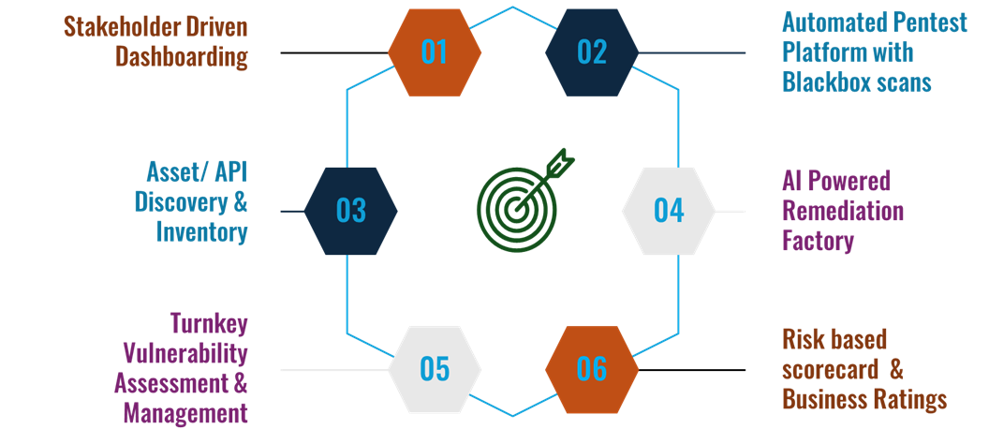

Next Generation AI powered solution that helps organizations identify, manage, analyse, prioritize, and eliminate vulnerabilities with ease:

* **Discovery**: Identification of assets, systems, and applications/ APIs to scan and monitor.
* **Assessment**: Schedule and perform Regular vulnerability assessments using automated tools and manual testing (if necessary).
* **AI penetration test platform**: work with AI powered penetration test platform to perform exploitations with ease and high accuracy.
* **Prioritization**: Risk-based prioritization of vulnerabilities based on criticality and business impact.
* **Remediation**: Determine AI based remediation insights, identify implementation plans for fixes such as patches, updates, or configuration changes.
* **Verification**: Ensuring that the applied fixes have addressed the vulnerabilities.
* **Monitoring**: Continuous surveillance of the environment for new vulnerabilities or threat
* **Management Scorecard**: Determine Risk based scorecard for each application, API or infrastructure item with Industry built Business Ratings

**Integration with ITSM and CMDB accelerates risk reduction across the enterprise**

**Secure&** integrates seamlessly with IT Service Management (ITSM) systems and configuration management databases (CMDB), enabling rapid discovery, prioritization, and remediation of vulnerabilities at scale to mitigate risk. Its close integration with ITSM platforms like ServiceNow and Jira streamlines and automates vulnerability management, ensuring smooth collaboration between IT and Security teams across the enterprise.

With **Secure&**, you get a risk-based vulnerability management solution that prioritizes vulnerabilities, misconfigurations, assets, and groups of assets based on risk, reduces risk by providing technology specific AI based remediations to help fix vulnerabilities at scale, and helps organizations measure security program effectiveness by tracking risk reduction over time.

**Automates workflows to reduce risks at scale**

**Secure&** brings together all the key elements of an effective vulnerability management program into a single service unified by powerful no-code orchestration workflows out of the box. From asset discovery to risk-based assessment to prioritize and remediate, **Secure&** automates the entire process and significantly accelerates an organization’s ability to respond to threats, thus preventing possible exploitation.

