Services in angular 2

Ng g s log

What is dependency injection ?

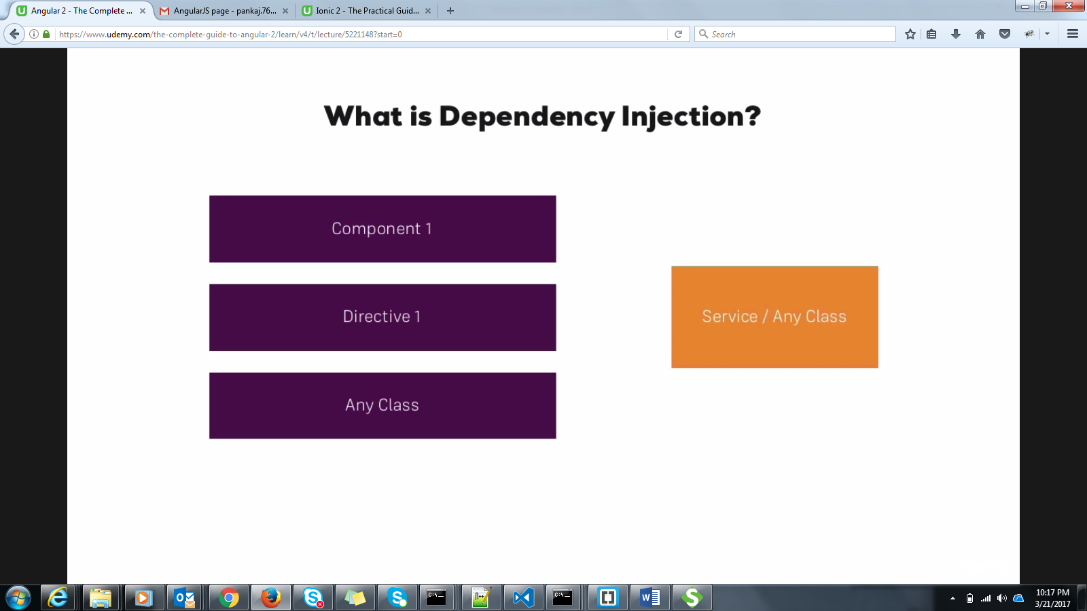

Making The service/class available to another component/Directive/Class.

constructor(argument : Service){}

It can be done by using provide metadata.

**provide : [Service]**

**bootstrap(AppComponent,[Service])**

**q1)Write a service with anme Calculator and create functions for add(),subtract(),multiply(),divide()**

**q1)Write a service for passing side of three side of triangle and find the area.Display it on span.**

Ref : inside the pankaj_git\angular1\nath_angular2\myApplication. Service name is : **triangle.service.ts , app.component.ts**

**Q2)Write a service for taking an product array and make 2 service functions putData() and getData(). Populate the table with this array. Display the List on the table using the bootstrap css.**

Ref : inside the pankaj_git\angular1\nath_angular2\myApplication. Service name is : **productlist.service.ts , product.ts , app.component.ts**

**Injecting service inside the service.**

Injectable is required.

Use Injectable()

import { Injectable } from '@angular/core';

import { CalculateService } from './calculate.service';

@Injectable()

export class TriangleService {

private area : number = 0;

private s : number;

constructor(private calculateService : CalculateService)

{}

sideArea(a : number,b : number, c : number)

{

this.s = this.calculateService.perimeter(a,b,c);

this.area = Math.sqrt(this.s*(this.s-a)*(this.s-b)*(this.s-c));

return this.area;

}

}

Also , declare the service in providers in app.module.ts.

import { CalculateService } from './calculate.service';

providers: [LogService,DataService,CalculateService],

**q3)Write a service for passing side of three side of triangle and find the area.Display it on span. Also use Calculare service inside the Triangle service.**