**Ref 1 :** [**https://www.lynda.com/AngularJS-tutorials/How-AngularJS-form-validation-works/438886/445593-4.html**](https://www.lynda.com/AngularJS-tutorials/How-AngularJS-form-validation-works/438886/445593-4.html)

**Ref 2 :** [**https://www.lynda.com/Angular-tutorials/Working-AngularJS-validation/560052/571705-4.html**](https://www.lynda.com/Angular-tutorials/Working-AngularJS-validation/560052/571705-4.html)

**Notes :**

**1)Pattern validation tutor required**

**2)**

**---------------------------------------------------------------------------------**

ng-required , ng-minlength , ng-maxlength

Properties / classes :

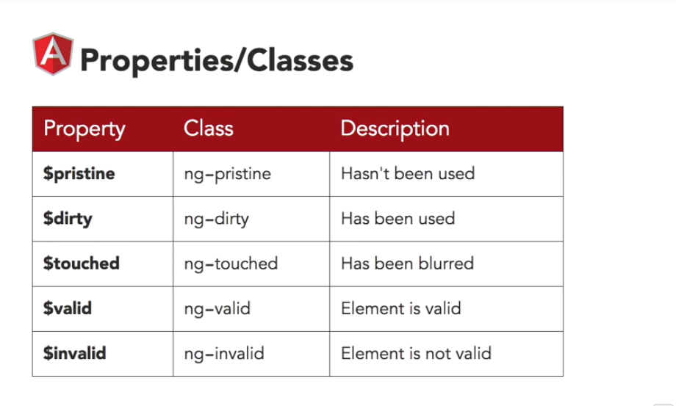

1)Create a form with first_name(required), last_name (required), email (email validation) and password (Minimum 6 length). Then right click on the first_name and inspect it to show change of states for ng-prestine , ng-dirty , ng-touched , ng-valid , ng-invalid

2)Now apply the class for different field state like for ng-valid , ng-invalid , ng-dirty

Hint :

input.ng-invalid.ng-touched {

border : 1px solid red;

}

input.ng-valid.ng-touched {

border : 1px solid green;

}

.ng-invalid .btn {

background : gray

}

Note : If the form is invalid and then any button inside it will be gray color.

For text color apply :

.error {

color : red;

padding-bottom : 10px;

}

[Building Custom HTML5 Video Playback with AngularJS 1](https://www.lynda.com/AngularJS-tutorials/Building-Custom-HTML5-Video-Playback-AngularJS/383036-2.html) : https://www.lynda.com/AngularJS-tutorials/Welcome/383036/423752-4.html