Isolate scope in anularJs

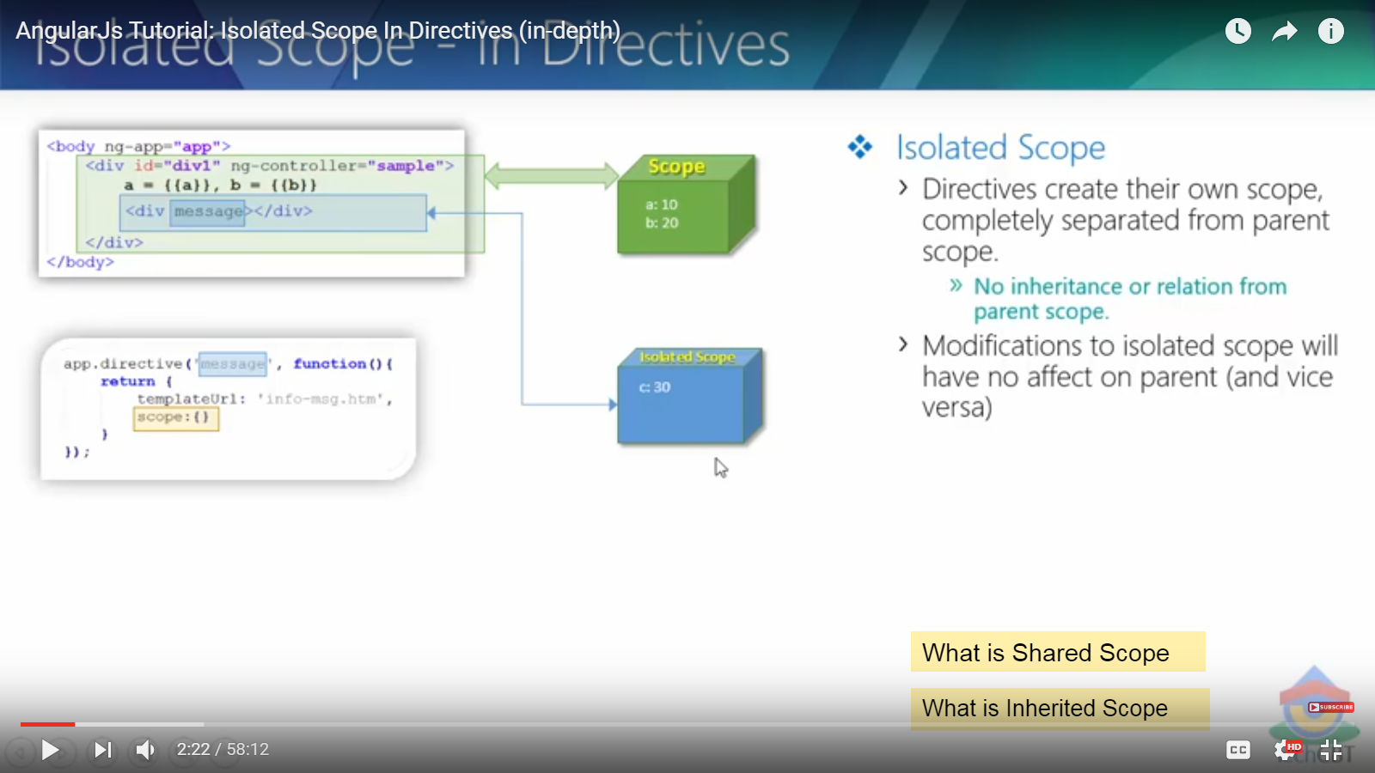

a and b are the part of sample controller. When we apply {} in the directive it means they have created an isolated scope here. controller scope does not know about the directive scope and vice versa.