<http://ionicframework.com/docs/>

let us open the link and we can see below page there .

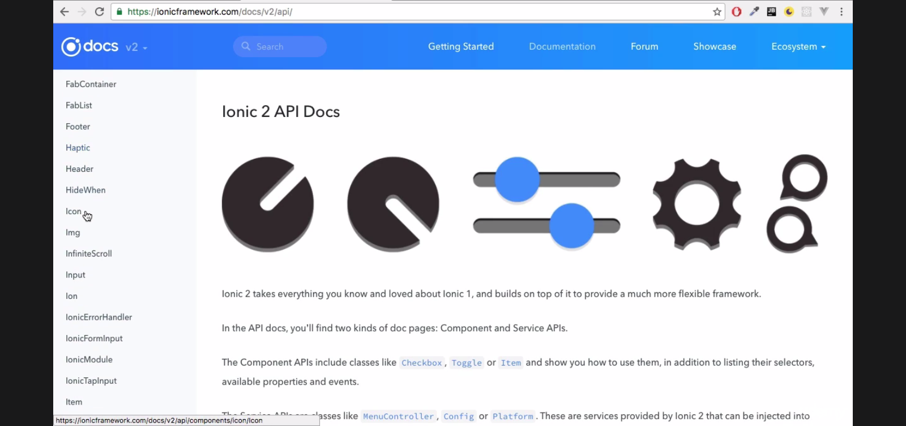

Let us click on the **Api** link on the left hand side.

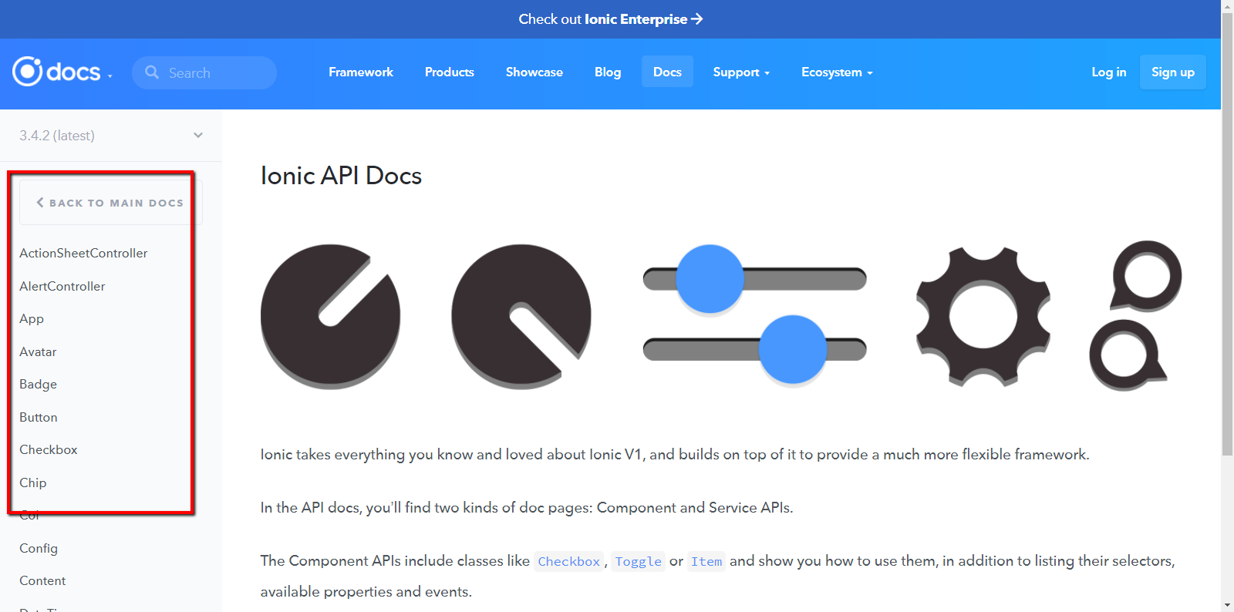

Here we can see alist of classes that comes along with the ionic 2. We can use any of them.

One more important link is for the **components.**

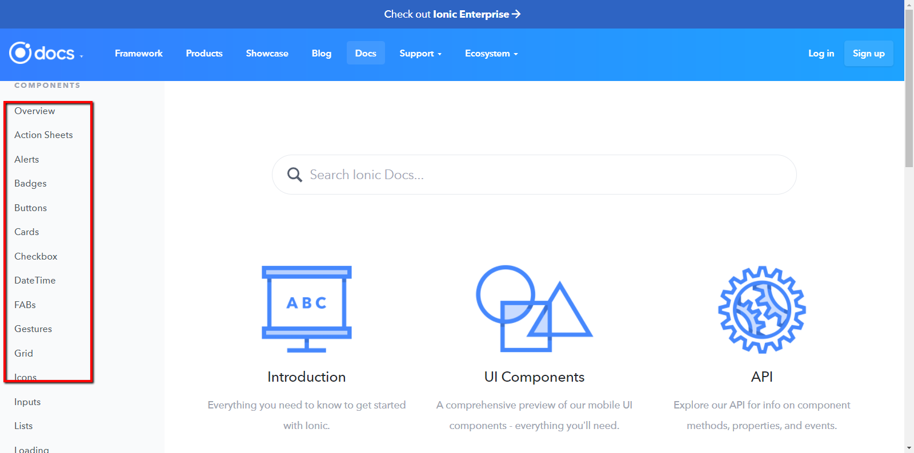

Here we can find a lot of classes for Alerts , Badges , cards etc..