Practical File
of
Operating System and
Linux Fundamentals
(25CSE0104)


Submitted To: Submitted By:
Dr. Meena Rani Name : PANKAJ SHARMA
Roll No.: 2510993147
Sem/Batch: 2nd -AIML
Group: 2G4

CHITKARA UNIVERSITY, PUNJAB
JUNE 2026

Operating System and Linux Fundamentals(25CSE0104)
INDEX

Sr. No. | Practical Name | Page No. | Teacher Sign
1-3 | Install or access a Linux environment and perform basic terminal operations. Navigate the Linux directory structure using commands such as pwd, ls, cd, and understand the role of directories in the Linux file system hierarchy. | 4-5
4-5 | Create, copy, move, and delete files and directories using Linux commands. Display and inspect file contents using appropriate file viewing utilities to understand file manipulation at the operating system level. | 6-7
6-7 | Modify file permissions and ownership using Linux access control commands. Create and analyse hard links and soft links to understand inode-based file referencing and protection mechanisms. | 8-11
8-9 | Observe running processes using Linux monitoring commands. Control process execution by changing priorities and terminating processes, and analyse how the operating system manages multiple active programs. | 12-15
10-13 | Write C programs to create and manage processes using system calls such as fork(), exec(), wait(). Study parent-child relationships and process lifecycle behaviour in Linux. | 16-19
14-17 | Simulate CPU scheduling algorithms including FCFS, SJF, Priority, and Round Robin. Analyse scheduling decisions based on waiting time, turnaround time, and response time. | 20-24
18-19 | Implement inter-process communication using pipes and demonstrate the need for synchronization. Conceptually analyse critical section problems and illustrate the use of mutexes or semaphores. | 25-28
20-21 | Create a deadlock scenario by simulating multiple processes competing for shared resources. Implement Banker’s Algorithm to demonstrate deadlock avoidance and analyse system safety. | 29-33
22-23 | Monitor system memory usage using Linux commands such as free, vmstat, /proc/meminfo. Analyze how memory is allocated and utilized by running processes. | 34-38
24-27 | Simulate paging and page replacement algorithms such as FIFO, LRU. Compare their performance and understand the role of virtual memory in optimizing system performance. | 39-43
28-31 | Write programs using file system system-calls (open, read, write, close, lseek) and analyse disk usage using Linux storage commands. Understand file access and secondary storage management. | 44-47
32-40 | Perform a comprehensive system-level analysis by integrating process management, memory usage, and file system behaviour. Prepare a brief report and present findings during viva-voce. | 48-51

Operating System and Linux Fundamentals(25CSE0104)
Experiment: 1-3
Install or access a Linux environment and perform basic terminal operations. Navigate the Linux directory structure using commands such as pwd, ls, and cd, and understand the role of directories in the Linux file system hierarchy
Theory:
Linux is freely available operating system that lets users interact with the system using commands through a terminal. Instead of relying only on graphical interfaces, users can directly control system operations using the command line, which is fast and efficient.
Some commonly used commands are:
- pwd → shows the current working directory
- ls → displays files and folders in a directory
- cd → is used to move from one directory to another
Understanding these commands is essential for navigating and managing the Linux file system.
Procedure:
- Install Linux (such as Ubuntu) or set it up using a virtual machine.
- Open the terminal window.
- Enter pwd to check the current directory.
- Use ls to view the list of files and folders.
- Change directories using cd directory_name.
- Explore different system folders like /home, /etc, and /usr.Download VirtualBox from the official website: https://www.virtualbox.org/

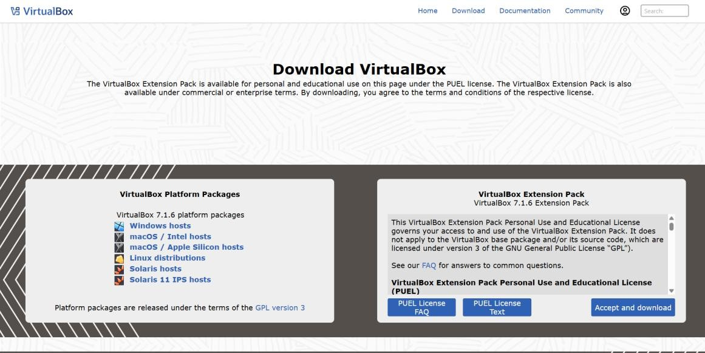
Operating System and Linux Fundamentals(25CSE0104)

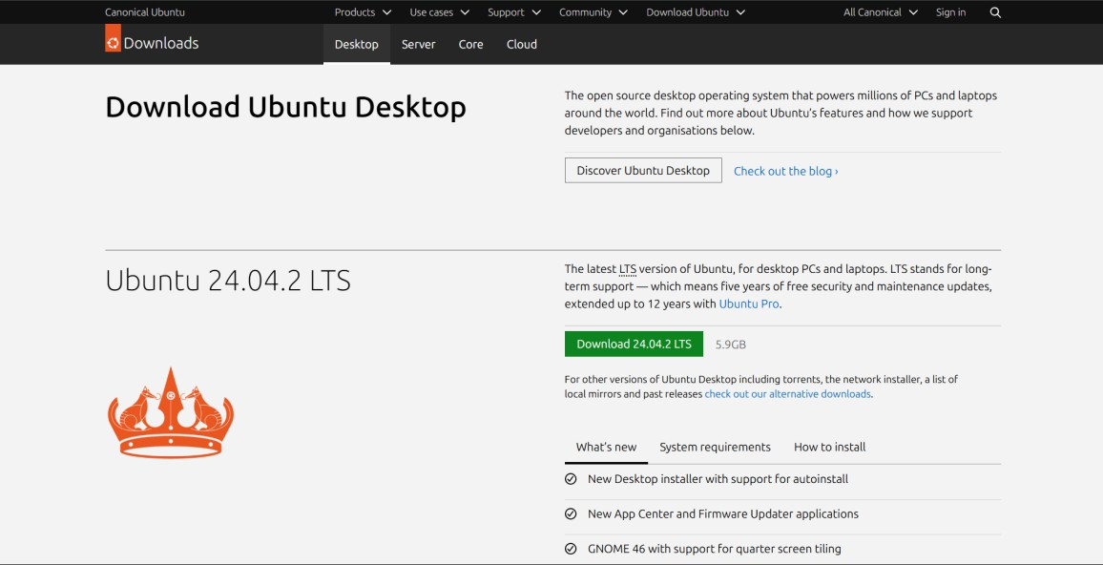
Result:
The Linux environment was set up successfully. Basic terminal commands were executed, and navigation through different directories was performed without any issues.

Operating System and Linux Fundamentals(25CSE0104)
Experiment: 4-5
Create, copy, move, and delete files and directories using Linux commands. Display and inspect file
contents using appropriate file viewing utilities to understand file manipulation at the operating
system level.
Theory:
Linux offers a set of simple commands that allow users to handle files and directories easily. These
commands make it possible to create, organize, modify, and remove data within the system.
Some commonly used commands are:
Procedure:
- touch → used to create a new file

- mkdir → used to create a new directory

- cp → used to copy files from one location to another

- mv → used to move or rename files

- rm → used to delete files

Operating System and Linux Fundamentals(25CSE0104)

- Delete the file using rm file2.txt.
- Remove the directory using rmdir testdir.

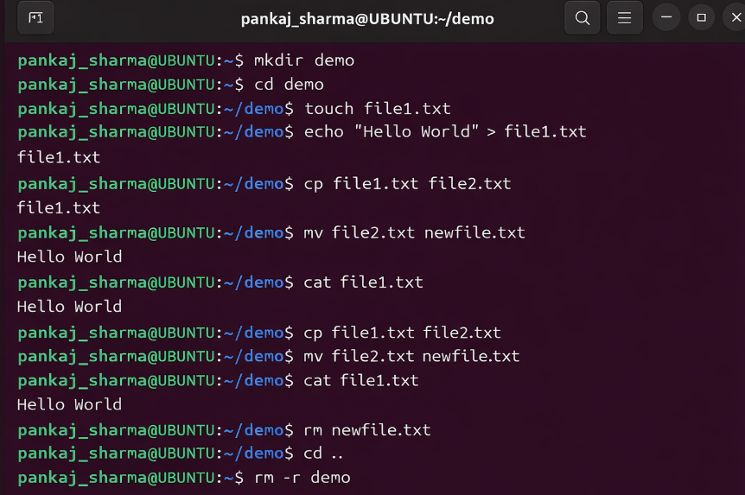

Result:
All file and directory operations were performed successfully. Files were created, copied, renamed, and deleted, and directories

Operating System and Linux Fundamentals(25CSE0104)
Experiment: 6-7
Modify file permissions and ownership using Linux access control commands. Create and analyse
hard links and soft links to understand inode -based file referencing and protection mechanisms.
Objective:

The aim of this experiment is to learn how file permissions and ownership work in Linux and how
they can be modified to control access. It helps in understanding how files can be protected using the
permission system.
Theory:
Linux is designed as a multi-user operating system, which means several users can work on the same

system at the same time. To ensure security and proper access, Linux uses a permission mechanism

that decides who can access or modify files and directories.

Every file in Linux is associated with three types of permissions:

- Read (r) → allows a user to view the contents of a file
- Write (w) → allows making changes to the file
- Execute (x) → allows running the file as a program

Operating System and Linux Fundamentals(25CSE0104)
Permissions & Commands
- Owner (user) → the person who created or owns the file
- Group → a set of users who share similar access rights
- Others → all remaining users on the system
To manage these permissions and ownership, the following commands are used:
- chmod → used to modify file permissions
- chown → used to change the ownership of a file

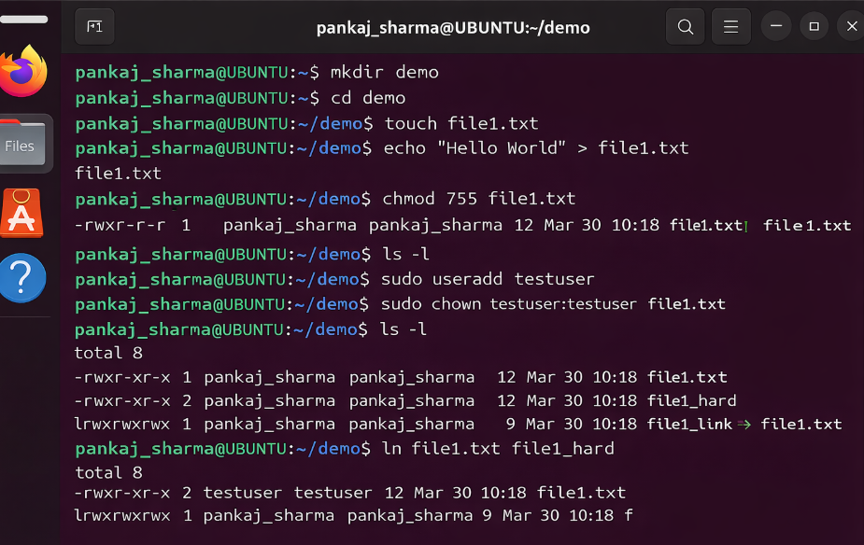
Operating System and Linux Fundamentals(25CSE0104)
Procedure:
- Open the terminal window.
- Create a file by typing touch sample.txt.
- View the current permissions using ls -l.
- Change permissions using the command:
chmod 755 sample.txt
- Update permissions using symbolic notation:
chmod u+x sample.txt
- Change the file owner using:
chown user sample.txt
- Confirm the changes again with ls -l.
Observations:
- The initial permissions of the file were displayed using ls -l.

- Permission values were successfully updated using the chmod command.

Operating System and Linux Fundamentals(25CSE0104)
- The ownership of the file was changed successfully using the chown command.

- Proper access control was achieved by applying different permission settings.

Result:

File permissions and ownership were modified successfully using the Linux commands, ensuring controlled and secure way to access to the file.

Operating System and Linux Fundamentals(25CSE0104)
Experiment: 8-9
Observe running processes using Linux monitoring commands. Control process execution by changing
priorities and terminating processes, and analyse how the operating system manages multiple active
programs.

Objective:
The aim of this experiment is to monitor and study active processes in a Linux system using different
commands. It also focuses on learning how to manage processes by adjusting their priority and
stopping them when required, along with understanding how the operating system handles multiple
programs at the same time.

Theory:

A process refers to a program that is currently running. In an operating system like Linux,
many processes can run at the same time, which is known as multitasking. The operating system
manages these processes using scheduling methods so that CPU resources are used effectively.
Each process is given a unique identification number called a Process ID (PID). A process can be
in different states such as running, waiting, or completed. The Linux kernel keeps track of all
processes and controls their execution.

ps: Displays a snapshot of current processes

Operating System and Linux Fundamentals(25CSE0104)

- top → displays running processes in real time along with CPU and memory usage
- htop → an advanced and interactive version of top (if available)
- renice → used to adjust the priority of a process that is already running
Procedure:
- Open the Linux terminal.

- Type ps and press Enter to see currently active processes.

- Use ps -aux to view detailed information about all running processes.

- Execute the top command to monitor processes in real time.

- Observe details such as Process ID (PID), CPU usage, and memory usage.

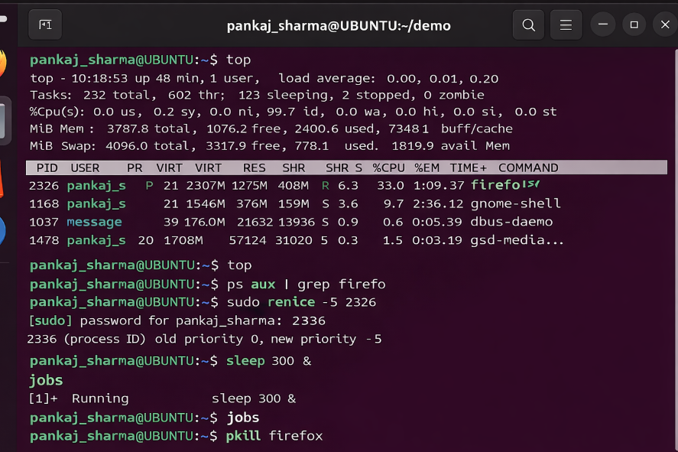

Operating System and Linux Fundamentals(25CSE0104)
- Start a new process with a specific priority using:
nice -n 10 command_name

- Modify the priority of an already running process using:
- renice -n 5 -p PID

- Stop a process normally with:
- kill PID

- Forcefully stop a process using:
- kill -9 PID

- Observe how the system updates process details in real time after these actions.

Observations:

- The ps command was used to view active processes along with their process IDs.

- The top command provided a live view of CPU and memory usage.

- Different processes were running with varying priority levels.

- Changing the priority influenced how CPU time was allocated.

- Processes were terminated successfully using the kill command.

Operating System and Linux Fundamentals(25CSE0104)
Result:
Running processes in Linux were successfully observed and monitored. Process priorities were

adjusted, and selected processes were terminated when needed. This experiment helped in

understanding how process management works in the operating system.

Operating System and Linux Fundamentals(25CSE0104)
Experiment: 10-13
Write C programs to create and manage processes using system calls such as a fork(), exec(), and

wait(). Study parent–child relationships and process lifecycle behaviour in Linux.

Objective:
The aim of this experiment is to learn how processes are created and managed in Linux using C programming. It focuses on using system calls such as fork(), exec(), and wait() to create processes, run programs, and coordinate their execution. It also helps in understanding how parent and child processes are related and how a process behaves during its lifecycle.
Theory:
In Linux, a process is a program that is currently being executed. The operating system handles processes through different system calls, which help in creating, managing, and controlling them. Process creation is an important concept because it allows multiple tasks to run at the same time.
Some key system calls used in process management are:
- fork() → This function is used to create a new process. The newly created process is known as the child process, while the process that creates it is called the parent process. After the fork() call, both parent and child processes continue execution separately.

Operating System and Linux Fundamentals(25CSE0104)
exec() → This system call is used to load and run a new program in place of the current

process. After calling exec(), the previous program is replaced, and the process starts executing

the new one.

wait() → This function is used by the parent process to pause its execution until the child

process completes. It ensures proper coordination between processes and helps avoid issues

like zombie processes.

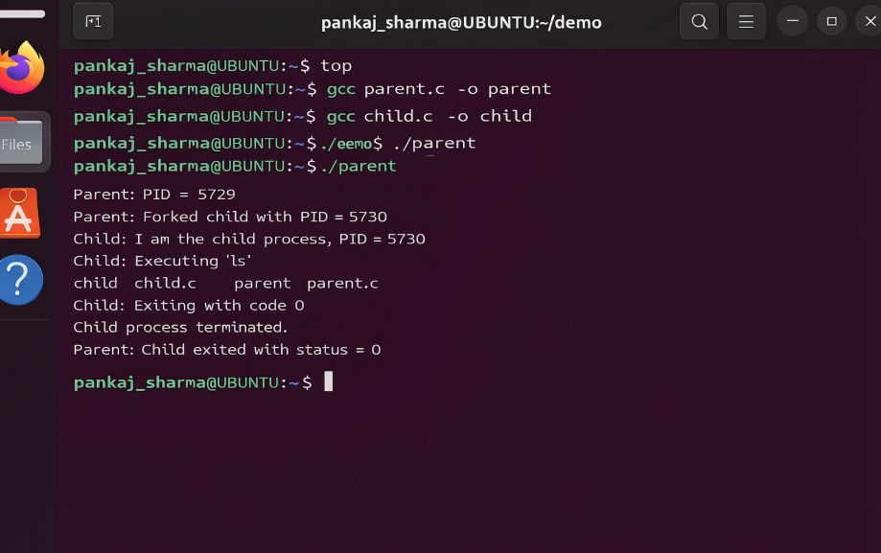

Operating System and Linux Fundamentals(25CSE0104)
- Open the Linux terminal.
- Create a C source file by typing:
nano process.c
- Write a program that uses fork() to generate a child process.
- Compile the program using:
gcc process.c -o process
- Run the compiled program with:
./process
- Check the output to see the process IDs of both parent and child.
- Update the program to include wait() for proper synchronization.
- Create another program that uses exec() to execute a different command.
- Compile and run the updated program.
- Observe the changes in how processes execute and behave.

Operating System and Linux Fundamentals(25CSE0104)
Observations:
- The fork() call successfully generated a separate child process.

- The parent and child processes ran independently after creation.

- Using wait() ensured that the parent process paused until the child finished execution.

- The exec() call replaced the current process with a new program.

- The parent and child processes had different process IDs (PIDs).

Result:

Processes were successfully created and managed using fork(), exec(), and wait() system calls. The

relationship between parent and child processes, along with the process lifecycle, was clearly

understood.

Operating System and Linux Fundamentals(25CSE0104)
Experiment: 14-17
Simulate CPU scheduling algorithms including FCFS, SJF, Priority, and Round Robin. Analyse scheduling decisions based on waiting time, turnaround time, and response time.
Objective:
The aim of this experiment is to understand and simulate different CPU scheduling techniques such as

FCFS, SJF, Priority, and Round Robin. It also focuses on comparing their performance using factors

like waiting time, turnaround time, and response time.

Theory:

CPU scheduling is an important task of an operating system that decides which process should get

CPU time from the ready queue. Proper scheduling helps improve system efficiency, faster response,

and better use of resources.

Different algorithms are used depending on system needs:

1. First Come First Serve (FCFS):

- In this method, processes are executed in the same order in which they arrive.

- It is a non-preemptive scheduling technique, meaning once a process starts execution, it runs until completion.

Operating System and Linux Fundamentals(25CSE0104)
- Its Simple to implement but may cause lead to long waiting times in process and called (convoy effect).
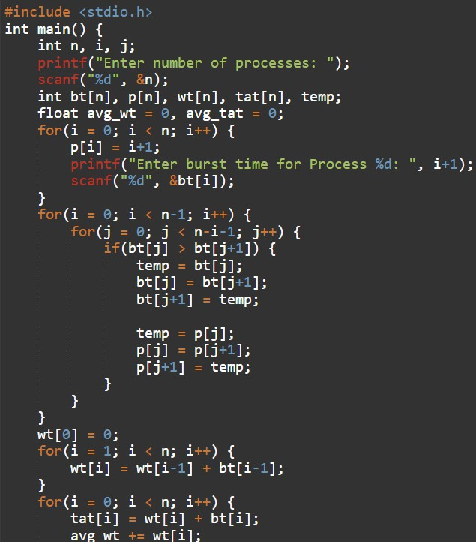
2. Shortest Job First (SJF):
- The process with the smallest execution time is selected first.

- Can be preemptive (Shortest Remaining Time First) or non-preemptive.

- Provides minimum average waiting time.

- Difficult to predict exact burst time in real systems.

3. Priority Scheduling:
- Each process is assigned a priority.

- CPU is allocated to the highest priority process.

- This scheduling method can work in both preemptive and non-preemptive modes.

- It may could cause starvation, where low-priority processes wait for a long time, but this issue can be reduced using a technique called aging.

4. Round Robin Scheduling:
- In this approach, each process is given a fixed time slice (time quantum).
- Processes are executed one by one in a circular order, ensuring fair CPU sharing.
Operating System and Linux Fundamentals(25CSE0104)
- If the time quantum is too small, the number of context switches increases, which can reduce efficiency.
- If the time quantum is too large, the algorithm starts behaving like FCFS scheduling.
Scheduling Parameters:

- Waiting Time (WT)
The total time a process remains in the ready queue before getting CPU time.
- Turnaround Time (TAT)
The total time taken for a process from submission to completion.
Formula: TAT = Completion Time – Arrival Time

- Response Time (RT)
- The time taken from when a process is submitted until it gets its first response.

Efficient scheduling aims to:

- Reduce waiting time as much as possible

- Reduce turnaround time

- Reduce response time

- Improve overall CPU utilization

Operating System and Linux Fundamentals(25CSE0104)
- Reduce turnaround time

- Reduce response time

- Improve CPU utilization

Procedure:

- Define a set of processes along with their arrival time and burst time.

- Apply the FCFS algorithm and compute waiting time and turnaround time.

- Implement the SJF algorithm and compare the results with FCFS.

- Use Priority Scheduling based on assigned priorities.

- Perform Round Robin scheduling using a fixed time quantum.

- Note the order of execution using a Gantt chart.

- Calculate waiting time (WT), turnaround time (TAT), and response time (RT) for each process.

- Compare the performance of all scheduling techniques.
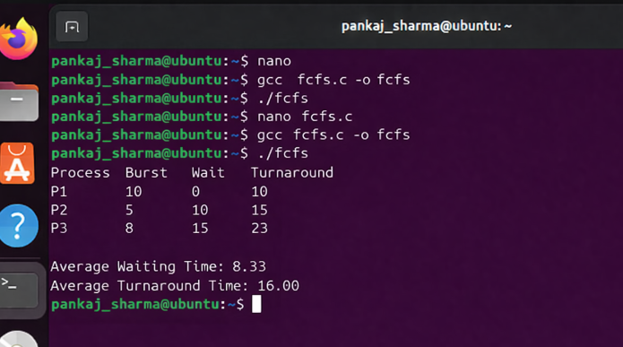
Operating System and Linux Fundamentals(25CSE0104)
Observations:
- FCFS is easy to use but can be inefficient when long processes are executed first.

- SJF generally provides the lowest waiting time among the algorithms.

- Priority scheduling can lead to starvation for processes with lower priority.

- Round Robin distributes CPU time fairly among all processes.
- The choice of time quantum plays a major role in the performance of Round Robin scheduling.
.
Result:
Different CPU scheduling algorithms were successfully implemented and analyzed. Waiting time,

turnaround time, and response time were calculated, and the comparison highlighted the performance

differences between the algorithms.

Operating System and Linux Fundamentals(25CSE0104)
Experiment: 18-19
Implement inter-process communication using pipes and demonstrate the need for synchronization.

Conceptually analyse critical section problems and illustrate the use of mutexes or semaphores.

Objective:

The purpose of this experiment is to understand how processes communicate with each other using

pipes in Linux. It also focuses on the importance of synchronization, explains the critical section

problem, and introduces methods like mutexes and semaphores to avoid conflicts during shared

resource access.

Theory:

In a multitasking system, several processes run at the same time and often need to share data. Inter-

process communication (IPC) provides a way for these processes to exchange information efficiently.

Pipes in Linux (Rewritten)

A pipe is a communication method that allows data to flow from one process to another. It works in

one direction, where the output of one process becomes the input of another.

Types of pipes:

- Unnamed pipes → used between related processes (such as parent and child)
- Named pipes (FIFO) → used between unrelated processes

A pipe uses two ends:

- One end is used for reading data
- The other end is used for writing data

Operating System and Linux Fundamentals(25CSE0104)

- One for writing

Need for Synchronization:

When multiple processes try to access shared data at the same time, it can lead to incorrect or

unpredictable results. This situation is known as a race condition.

To prevent this, synchronization techniques are used so that only one process can access shared

resources at a time.

Critical Section Problem:

A critical section is a part of the program where shared resources are accessed.
Requirements for solving critical section problem:

- Mutual Exclusion → only one process can access the critical section at a time

- Progress → processes should not be forced to wait unnecessarily

- Bounded Waiting → there should be a limit on how long a process waits

Synchronization Tools:

1. Mutex (Mutual Exclusion Lock):

Ensures that only one process can access a resource at a time
Simple locking mechanism to protect critical sections

2. Semaphore:

- A variable used to control access to resources

- Two types:

  - Binary semaphore (0 or 1)

  - Counting semaphore

Operating System and Linux Fundamentals(25CSE0104)

Procedure:

- Open the Linux terminal.

- Create a C file by typing:
nano pipe.c

- Write a program that uses the pipe() system call.

- Use fork() to generate a child process.

- Transfer data from the parent process to the child process through the pipe.

- Compile the program using:
gcc pipe.c -o pipe

- Run the program with:
./pipe

- Observe how data is passed between the processes.

- Demonstrate synchronization using a shared variable example.

- Study the occurrence of race conditions and understand how mutexes or semaphores can be used to avoid them (conceptually).Analyze race condition and apply mutex/semaphore concept theoretically.

Observations:
- Data transfer between parent and child processes was performed successfully.
- Pipes allowed communication between processes effectively.
- It was observed that without proper synchronization, shared data may produce incorrect results.

Operating System and Linux Fundamentals(25CSE0104)
Result:
Inter-process communication using pipes was successfully carried out. The importance of
synchronization was clearly demonstrated, and the concepts of critical section, mutex, and semaphores
were properly understood
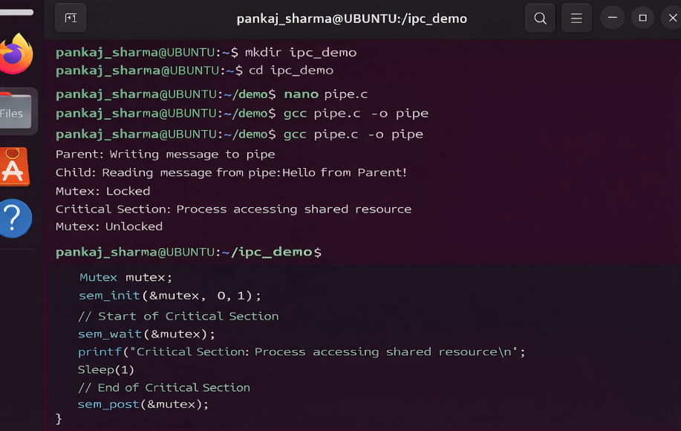

Operating System and Linux Fundamentals(25CSE0104)
Experiment: 20-21
Create a deadlock scenario by simulating multiple processes competing for shared resources.

Implement Banker’s Algorithm to demonstrate deadlock avoidance and analyse system safety.

Objective:

The aim of this experiment is to understand deadlock by creating a situation where multiple processes

compete for limited resources. It also focuses on using Banker’s Algorithm to prevent deadlock and to

check whether the system is in a safe or unsafe state.

Theory:

Deadlock is a situation where a set of processes cannot continue execution because each process is

waiting for a resource that is held by another. As a result, none of the processes can proceed, and they

remain stuck..

Necessary Conditions for Deadlock occuring:

Deadlock happens only when all of the following conditions are present:
- Mutual Exclusion:
A resource can be used by only one process at a time

- Hold and Wait:
A process holding some resources is waiting for additional resources.

Operating System and Linux Fundamentals(25CSE0104)
- No Preemption:
Resources cannot be taken away from a process forcefully..
- Circular Wait:
A group of processes form a cycle, where each process waits for a resource held by another process in the chain..
Deadlock Example:
Let assume two processes P1 and P2:
- Process P1 holds resource R1 and is waiting for R2
- Process P2 holds resource R2 and is waiting for R1
This creates a cycle where both processes are waiting for each other, resulting in deadlock.
Deadlock Avoidance:
Deadlock can be prevented by ensuring that at least one of the necessary conditions does not occur. One commonly used method for avoiding deadlock is Banker’s Algorithm.
Banker’s Algorithm:

Operating System and Linux Fundamentals(25CSE0104)
Banker’s Algorithm is used to check whether allocating resources to a process will keep the system in
a safe state.

A system is considered safe if there exists an order (safe sequence) in which all processes can

complete their execution without causing deadlock.

Important Terms:

- Available → resources currently free in the system

- Max → maximum resources a process may require

- Allocation → resources already assigned to a process

- Need → remaining resources required (Need = Max – Allocation)

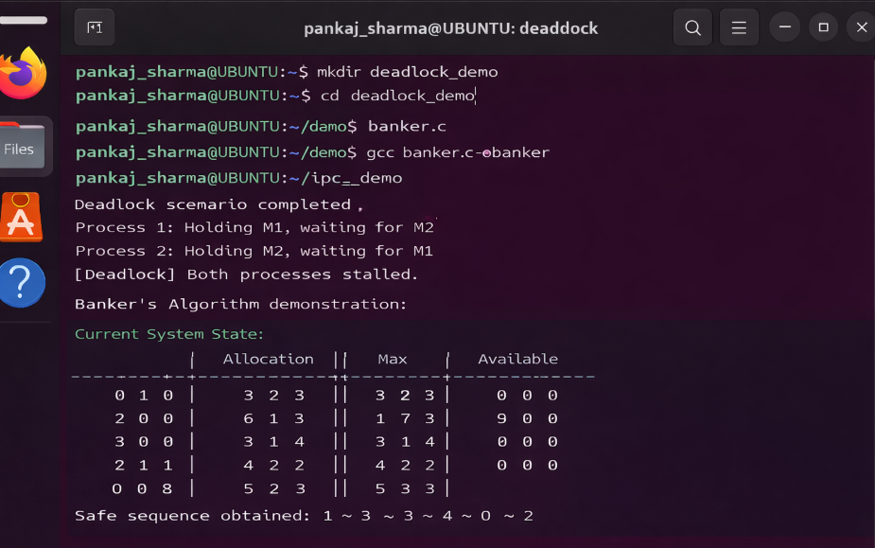
Operating System and Linux Fundamentals(25CSE0104)

Procedure:

- Specify the number of processes and resources.

- Enter the Allocation matrix.

- Enter the Maximum (Max) matrix.

- Provide the Available resources.

- Calculate the Need matrix using:
Need = Max – Allocation

- Apply Banker’s Algorithm to determine a safe sequence.

- If a safe sequence exists, the system is in a safe state.

- If no safe sequence is found, the system is unsafe (deadlock may occur).

- Analyze and interpret the results.
Observations:
- Deadlock occurs when processes keep waiting for resources indefinitely.
- Banker’s Algorithm checks whether the system will remain safe before allocating resources.
- The presence of a safe sequence ensures that all processes can complete execution.
.

Operating System and Linux Fundamentals(25CS0104)
- If no safe sequence is found, the system is considered unsafe

Result:

Successfully simulated a deadlock scenario and implemented Banker’s Algorithm. The system

safety was analyzed, and a safe sequence was determined

Operating System and Linux Fundamentals(25CSE0104)
Experiment: 22-23
Monitor system memory usage using Linux commands such as free, vmstat, and /proc/meminfo.

Analyze how memory is allocated and utilized by running processes.

Objective:

The aim of this experiment is to observe and study how memory is used in a Linux system using

commands such as free, vmstat, and /proc/meminfo. It also helps in understanding how memory is

assigned to processes and how efficiently it is managed by the operating system.

Theory:

Memory management is an important responsibility of an operating system. It ensures that all running

processes get the required memory while maintaining overall system performance. Linux improves

memory usage through methods like virtual memory, paging, and caching.

Types of Memory in Linux:

- Physical Memory (RAM) → the actual hardware memory available in the system

- Virtual Memory → uses disk space to extend available memory

- Swap Space → a portion of disk used when RAM is fully utilized

Operating System and Linux Fundamentals(25CSE0104)

- Cache Memory → stores frequently used data to improve access speed
Memory Usage Parameters:
- Total Memory → total RAM installed in the system
- Used Memory → memory currently occupied by running processes
- Free Memory → memory that is not in use
- Available Memory → memory that can be allocated to new processes
- Buffers/Cache → memory used for temporary storage and faster access
Procedure:
- • Open the Linux terminal.
- • Run the command free -h to view total, used, and free memory.
- • Execute vmstat to check system performance statistics.

Operating System and Linux Fundamentals(25CSE0104)

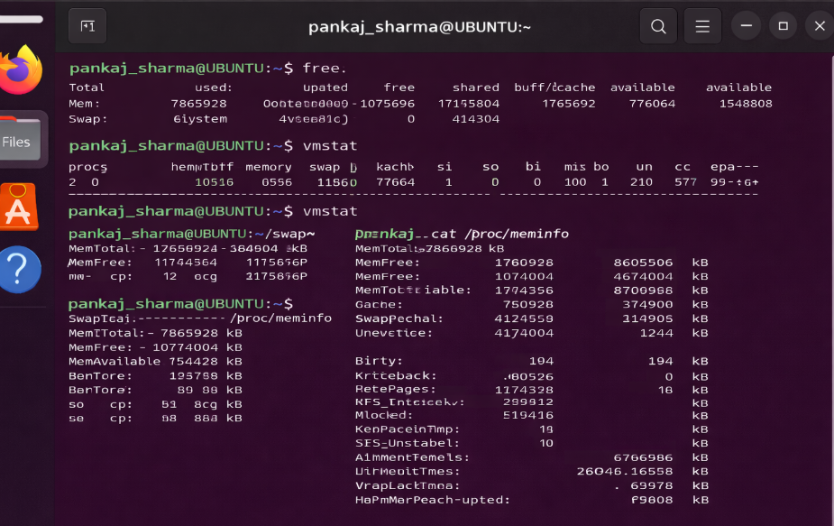

Operating System and Linux Fundamentals(25CSE0104)

- Run vmstat 2 to observe memory updates at regular intervals.

- Display detailed memory information using cat /proc/meminfo.

- Open multiple applications to increase memory usage.

- Observe how memory values change during execution.

- Compare memory statistics before and after running processes.

Observations:

- The free command clearly displayed memory distribution.

- The vmstat command provided system performance details.

- /proc/meminfo showed detailed internal memory information.

- Memory usage increased when more applications were opened.

- Cache memory was actively utilized to enhance system performance.

Operating System and Linux Fundamentals(25CSE0104)

Result:
System memory usage was successfully monitored and analyzed using Linux commands. The
experiment helped in understanding how memory is allocated and utilized by running processes.

Operating System and Linux Fundamentals(25CSE0104)
Experiment: 24-27

Simulate paging and page replacement algorithms such as FIFO and LRU. Compare their performance

and understand the role of virtual memory in optimizing system performance.

Objective:

The aim of this experiment is to understand how paging works in memory management and to

simulate page replacement techniques such as FIFO and LRU. It also focuses on comparing their

performance and understanding how virtual memory improves overall system efficiency.
.

Theory:

Memory management is an essential function of an operating system. When the available RAM is not

enough, the system uses virtual memory, which utilizes disk space to support the execution of larger

programs.

Paging:

Paging is a technique used to manage memory efficiently by dividing it into fixed sizes:
- Physical memory is divided into blocks called frames
- Logical memory is divided into blocks called pages

Operating System and Linux Fundamentals(25CSE0104)
Pages are loaded into frames whenever required. This method helps in better memory utilization and avoids external fragmentation.
Page Fault:

A page fault occurs when a program tries to access a page that is not currently available in the main

memory. In such cases, the operating system loads the required page from secondary storage.

Frequent page faults can slow down system performance.

Page Replacement Algorithms:

When memory is full and a new page needs to be loaded, the system must decide which existing page

to remove. This is handled using page replacement algorithms.

1. FIFO (First-In-First-Out):

- Removes the page that was loaded first

- Easy to implement

- Does not consider how often a page is used

- Can sometimes give poor performance (known as Belady’s anomaly)

Operating System and Linux Fundamentals(25CSE0104)
2. LRU (Least Recently Used):

- Removes the page that has not been used for the longest time

- Usually performs better than FIFO

- Based on the idea that recently used pages are likely to be used again

- Requires extra effort to track page usage

Virtual Memory:

Virtual memory allows programs to run even if they require more memory than what is physically available.

Advantages:

- Better utilization of memory

- Supports multitasking

- Faster program execution

- Provides separation between processes

Operating System and Linux Fundamentals(25CSE0104)
However, excessive use of virtual memory can cause thrashing, where the system spends more time
swapping pages than executing tasks.
Procedure:
- Define a sequence of page references.

- Set the number of memory frames available.

- Apply the FIFO page replacement method.

- Count the number of page faults generated.

- Apply the LRU algorithm on the same reference string.

- Count the number of page faults again.

- Compare the results of both algorithms.

- Analyze which method performs better.

Operating System and Linux Fundamentals(25CSE0104)
Observations:
- FIFO replaces pages based only on their order of entry.

- LRU considers recent usage of pages before replacing them.

- LRU generally produces fewer page faults compared to FIFO.

- Increasing the number of frames reduces the number of page faults.

- Virtual memory helps in running large programs efficiently.

Result:

Paging and page replacement algorithms (FIFO and LRU) were successfully implemented. The

comparison showed that LRU generally performs better than FIFO by reducing the number of page

faults.

Operating System and Linux Fundamentals(25CSE0104)
Experiment: 28-31
Write programs using file system system-calls (open, read, write, close, lseek) and analyse disk usage

using Linux storage commands. Understand file access and secondary storage management.

Objective:

The aim of this experiment is to learn how files are handled in Linux using system calls and to

examine disk usage using storage-related commands. It also helps in understanding different file

access methods and how secondary storage is managed.

Theory:

A file system is responsible for organizing and managing data in an operating system. In Linux, low-

level file operations are performed using system calls such as open, read, write, close, and lseek.

- open() → used to open an existing file or create a new one

- read() → used to retrieve data from a file

- write() → used to store data into a file

- close() → used to close an opened file

- lseek() → used to move the file pointer for accessing data at different positions

Operating System and Linux Fundamentals(25CSE0104)
Each opened file is assigned a unique number called a file descriptor, which is used to identify it during operations.

File Access Methods:
- Sequential Access → data is read or written in a fixed order from beginning to end
- Direct Access → data can be accessed from any location using functions like lseek()
Disk Usage Commands:
- df → displays total disk space and available space
- du → shows disk usage of directories and files
- ls -lh → lists files along with their sizes in a readable format
Secondary Storage:
Secondary storage devices such as hard disks or SSDs are used to store data permanently. The
operating system manages how data is stored, tracks free space, and ensures efficient access to files.

Operating System and Linux Fundamentals(25CSE0104)

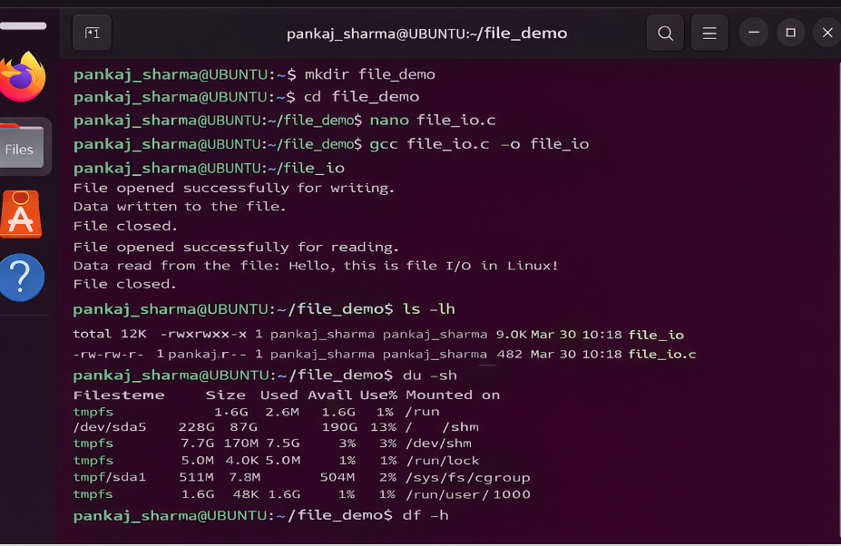

Procedure
- Open the terminal.

- Study the working of file system calls.

- Perform file creation and modification operations.

- Use the df command to check overall disk space.

- Use the du command to examine directory-wise storage usage.

Operating System and Linux Fundamentals(25CSE0104)

- Observe changes in disk usage after creating or modifying files.

Observations:
- File operations using system calls were carried out successfully.

- Disk usage increased as new files were created.

Commands like df and du clearly displayed storage details
Result:
File system calls were successfully used to handle files, and disk usage was analyzed using Linux

commands. The experiment provided a clear understanding of file access methods and storage

management.

Operating System and Linux Fundamentals(25CSE0104)
Experiment: 32-40

Perform a comprehensive system-level analysis by integrating process management, memory usage,

and file system behaviour. Prepare a brief report and present findings during viva-voce

Objective:
The aim of this experiment is to analyze the overall performance of a Linux system by studying

process management, memory usage, and file system behavior. It focuses on understanding how these

components work together to ensure efficient system operation.

Theory:

An operating system manages all hardware and software resources of a computer. The major

components that affect system performance are CPU (process handling), memory, and storage. Proper

coordination among these components is necessary for smooth system functioning.
.

Process Management:

Process management involves creating, running, and terminating processes. In a multitasking system

like Linux, multiple processes run simultaneously, and the CPU allocates time to each process using

scheduling techniques.

Linux provides commands such as ps, top, and htop to monitor processes. These tools display details

like process ID (PID), CPU usage, memory usage, and process state. Efficient scheduling ensures fair

CPU distribution among all processes.

Operating System and Linux Fundamentals(25CSE0104)
Memory Management:

Memory management ensures that processes receive the required memory for execution. Linux uses

concepts like virtual memory, paging, and caching to optimize memory usage.

- Virtual memory allows execution of programs larger than RAM by using disk space
- Cache memory stores frequently used data for faster access
- Swap memory is used when physical RAM becomes full

Commands like free and vmstat help monitor memory usage and system performance.

File System Behaviour:

The file system controls how data is stored, accessed, and organized on storage devices such as HDDs

and SSDs. It manages file creation, deletion, and retrieval operations.

Commands like df and du are used to check disk usage and analyze storage distribution. Proper file

system management ensures efficient storage utilization and quick data access.

System Integration:

All components of the operating system are interconnected:

Operating System and Linux Fundamentals(25CSE0104)
- Processes require memory to execute

- Memory temporarily holds process data

- The file system stores data permanently

When system load increases, CPU usage rises, memory consumption increases, and disk activity also

changes. The operating system balances these resources to maintain stability and performance.

Procedure:

- Open the Linux terminal.

- Use ps and top to monitor running processes.

- Observe CPU usage and process states.

- Use free and vmstat to check memory usage.

- Run multiple applications to increase system load.

- Use df to check disk space usage.

- Use du to analyze directory-wise storage usage.

- Observe system behavior under different load conditions.

- Record and analyze all observations.

Operating System and Linux Fundamentals(25CSE0104)

Observations:

- CPU usage increased as more processes were executed.

- Memory consumption increased with running applications.

- Swap memory was used when RAM became insufficient.

- Disk usage changed when files were created or modified.

- All system components worked together to maintain stability.

Result:

A complete system-level analysis was successfully performed. The interaction between process

management, memory usage, and file system behavior was clearly observed and understood..

