Vid2Log
Technical Documentation and Project Report
Turning screen recordings into structured activity logs
Cloud Web Application and Offline Desktop Application
Field | Detail
Project | Vid2Log, an automated video to action log platform
Deliverables | 1. Cloud web application (Next.js, FastAPI, Google Cloud Run)  2. Offline desktop application (Flutter with an embedded Python engine, macOS and Windows)
Core capability | CNN and OCR hybrid frame classification, unsupervised action discovery, sequence mining analytics
Document type | Technical reference and project report
Version | 1.0
Date | September 2026
Context | IIT Bombay, research and learning platform video analysis

Table of Contents
1. Introduction 5
1.1 Purpose and Scope 5
1.2 Background 5
1.3 Terminology 6
1.4 Conventions 6
2. System Overview 7
2.1 What the System Does 7
2.2 The Two Products 8
2.3 Web Architecture 8
2.4 Desktop Architecture 9
2.5 Technology Stack 10
3. Feature Catalogue 11
3.1 Identity and Access Control 11
3.2 Recording Processing 11
3.3 Action Discovery 12
3.4 Detector Training 12
3.5 Detector Registry 13
3.6 Activity Logs 13
3.7 Analytics 14
3.8 Administration 16
3.9 Supporting Features 16
4. Machine Learning Pipeline 17
4.1 Frame Sampling 17
4.2 Image Preprocessing 17
4.3 The Image Classifier 17
4.3.1 Data Splitting 18
4.4 Text Extraction 18
4.5 The Hybrid Classifier 19
4.5.1 Tier 1, Keyword Rules 20
4.5.2 Tier 2, Text Classifier and Fusion 20
4.5.3 Choosing the Fusion Weight 20
4.5.4 Per-Action Routing 20
4.5.5 Tier 3, Fallback 21
4.6 Scene Segmentation 21
4.6.1 Two-Tier Evaluation 22
4.6.2 Hysteresis 23
4.6.3 Confidence Floor 23
4.6.4 Despiking 23
4.6.5 Scene Record 23
4.7 Evaluation Metrics 23
4.8 Unsupervised Action Discovery 24
4.8.1 Sampling and Embedding 24
4.8.2 Normalisation and Clustering 25
4.8.3 Noise Reassignment 25
4.8.4 Choosing Representatives 25
5. Analytics Engine 26
5.1 Building Sequences 26
5.2 Sequential Pattern Mining 26
5.2.1 Two Kinds of Support 26
5.2.2 Counting Instances 27
5.2.3 Gap and Window Limits 27
5.2.4 Termination Safeguards 27
5.2.5 Parameters and Output 28
5.3 Differential Sequence Mining 28
5.3.1 Procedure 28
5.3.2 Available Tests 29
5.4 Reading the Results 30
6. Web Application 31
6.1 Frontend 31
6.2 API Reference 32
6.2.1 Uploads and Jobs 32
6.2.2 Logs 32
6.2.3 Training and Detectors 32
6.2.4 Actions and Datasets 33
6.2.5 Analytics, Users and Administration 33
6.3 Data Model 34
6.4 Storage Lifecycle 34
6.5 Background Processing 35
6.6 Security 35
7. Desktop Application 37
7.1 Why It Exists 37
7.2 Architecture 37
7.3 Local Data Model 38
7.4 Parity and Differences 38
7.5 Startup Reliability 39
7.6 Packaging and Distribution 40
8. Data Formats 41
8.1 Activity Log CSV 41
8.2 Import Rules 41
9. Deployment and Operations 42
9.1 Cloud Infrastructure 42
9.2 Cost Optimisation 43
9.3 Configuration 43
9.4 Deployment Steps 44
9.5 Local Development 44
10. Tuning Reference 46
11. Engineering Challenges 47
11.1 Keras Serialisation 47
11.2 Double Normalisation 47
11.3 Weights Versus Routing 47
11.4 Unbounded Mining 47
11.5 Frozen Bundle Analysis 47
11.6 A Silent Packaged Crash 47
11.7 Timeline Colours 48
12. Status, Limitations and Future Work 49
12.1 Current Status 49
12.2 Known Limitations 49
12.3 Future Work 49
12.4 Conclusion 49
Appendix A. Repository Layout 50
Appendix B. Feature Availability by Platform 50

1. Introduction

1.1 Purpose and Scope
This document is the technical reference for Vid2Log. It covers the system's purpose, architecture, features, machine learning pipeline, analytics algorithms, data formats and deployment, for both products the project ships: a cloud web application and an offline desktop application.
It serves three readers. A reviewer can read Sections 1 to 3 and understand what the system does and why. An engineer can read Sections 4 to 9 and understand how each part works, including exact parameters and formulas. An operator can work from Sections 9 and 10 alone.
Everything here is taken from the current implementation rather than from design intent. Where a value is a tunable constant, the constant is named so the claim can be checked against the code.

1.2 Background
Producing a structured log of a screen recording is normally manual work. An analyst scrubs the timeline and types rows into a spreadsheet. The cost grows with every recording, which makes any study of more than a handful of sessions impractical.
The earlier version of this work was a Streamlit prototype. It handled one video at a time on a single machine, using a model trained outside the tool in Google Teachable Machine. It had no persistence, no users, no test set evaluation, and no analysis beyond printing the log. Its accuracy was assumed rather than measured, and adding an action meant leaving the tool, retraining elsewhere, and re-exporting.
Vid2Log was rebuilt around three goals. First, bring training inside the application and report real held-out metrics, so classifier quality is measured rather than assumed. Second, replace the single user script with an authenticated multi-user service that can process many recordings at once, and add analytics that turn logs into findings. Third, once the cloud product was stable, ship an offline desktop version with the same behaviour for users whose recordings cannot leave their machine.
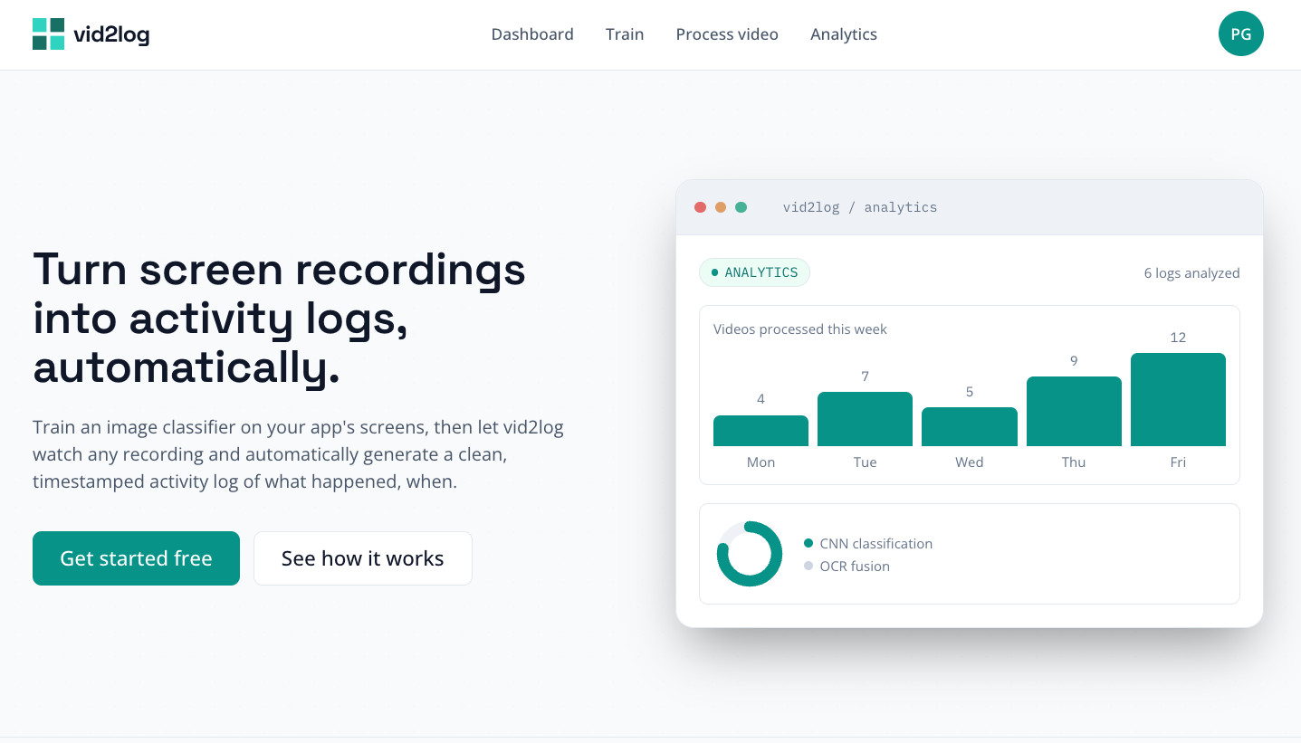
Figure 1. The Vid2Log landing page.

1.3 Terminology
Term | Meaning
Action, or class | One label the classifier can assign to a frame, such as "GameWorkspace". Called an action in the interface and a class in the machine learning layer. They are the same thing.
Scene | A continuous stretch of time assigned to one action. Scenes are the rows of an activity log.
Activity log | The ordered list of scenes from one recording, with start time, end time, duration, action, confidence and source.
Detector, or model | A trained classifier: a CNN, optionally a text classifier, keyword rules, and the fusion settings that combine them. Called a detector in the interface.
Action set, or dataset | A reviewed collection of example images grouped by action, reusable as training input.
Job | One unit of background work: processing a video, training a detector, or running action discovery.
Sidecar | The local Python process the desktop application starts and talks to over the loopback interface.
Sequence | One activity log reduced to its ordered action labels, with timing dropped. The input to pattern mining.
S-support | Sequence support: the share of recordings in which a pattern occurs at least once.
I-support | Instance support: the average number of non-overlapping occurrences of a pattern per recording.
Table 1. Terminology used in this document.

1.4 Conventions
- Identifiers taken from the source, such as file paths, endpoints and constants, are written exactly as they appear in the code.
- Numerical defaults are the values the code actually uses. The defining constant is named so the claim is checkable.
- Figure placeholders are a blank line followed by a numbered caption. Screenshots go in the blank line above each caption.
- "The web application" means the browser based cloud product. "The desktop application" means the installable macOS and Windows product. "Both applications" means the behaviour is the same in each.

2. System Overview

2.1 What the System Does
Vid2Log turns screen recordings into timestamped activity logs and then analyses them. There are four stages, each a full feature rather than a hidden step:
- Define the actions to recognise, either by letting the system discover them from a demonstration recording or by assembling example images by hand.
- Train a detector on those actions and read its measured performance on a held-out test set.
- Process any number of recordings with that detector, producing one activity log each.
- Analyse the logs, individually as timelines and collectively through pattern mining.
The loop is closed. Discovery feeds training, training feeds processing, and processing feeds analytics, without the user leaving the application or handling an intermediate file.
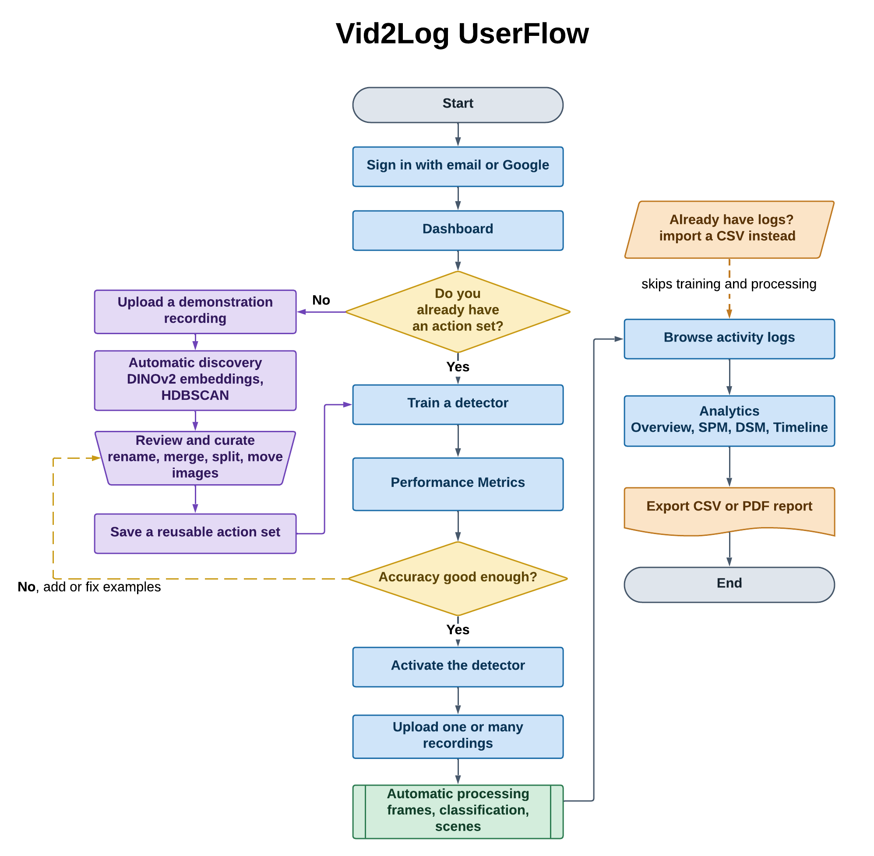
Figure 2. Vid2Log end to end user flow, from sign in through to exported analytics.

2.2 The Two Products
Vid2Log ships as two applications that share the same machine learning behaviour. They are not a client and a server. Each is complete on its own.
- The cloud web application. A Next.js frontend and a FastAPI backend on Google Cloud Run, backed by Firebase Authentication, Firestore, a Google Cloud Storage bucket and a Redis job queue. Built for several users at once, each with their own recordings, detectors and action sets, and for processing many jobs in parallel.
- The offline desktop application. A Flutter shell for macOS and Windows that starts a local Python FastAPI process, the sidecar, bound only to the loopback interface. Every cloud dependency has a local equivalent: SQLite for Firestore, the local filesystem for Cloud Storage, direct execution for the queue, and no login at all, since there is one local user. After installation it needs no network access.
The shared parts are the ones that decide what the system produces: the classifier, scene segmentation, the training pipeline and its metrics, action discovery, and the mining engine. The parts that differ are the ones that decide how it is run: identity, storage and scheduling.

2.3 Web Architecture
The frontend never talks to Firestore or Cloud Storage directly. Every read and write goes through the backend, with one exception: file bytes. Videos and training images upload straight from the browser to Cloud Storage using short lived signed URLs, so media never passes through the API server.
Next.js frontend ────────────► Firebase Authentication (sign-in, ID token)
│
│ REST over HTTPS, Authorization: Bearer <Firebase ID token>
▼
FastAPI backend ─────────────► Firestore (jobs, models, datasets, users)
│
├──────────────────────► Cloud Storage
│ signed PUT uploads (temporary media)
│ model files under models/{model_id}/
│
└──► Redis ──► RQ workers
├─ video_processing CNN and OCR, produces a scene log
├─ training trains a detector, reports metrics
└─ action_discovery DINOv2 embeddings, HDBSCAN
The API process stays lightweight and never imports TensorFlow, PyTorch or any other heavy dependency. Jobs are queued by string reference to the function that will run them, not by importing it, so the request process never loads the worker's dependency tree just to schedule work.
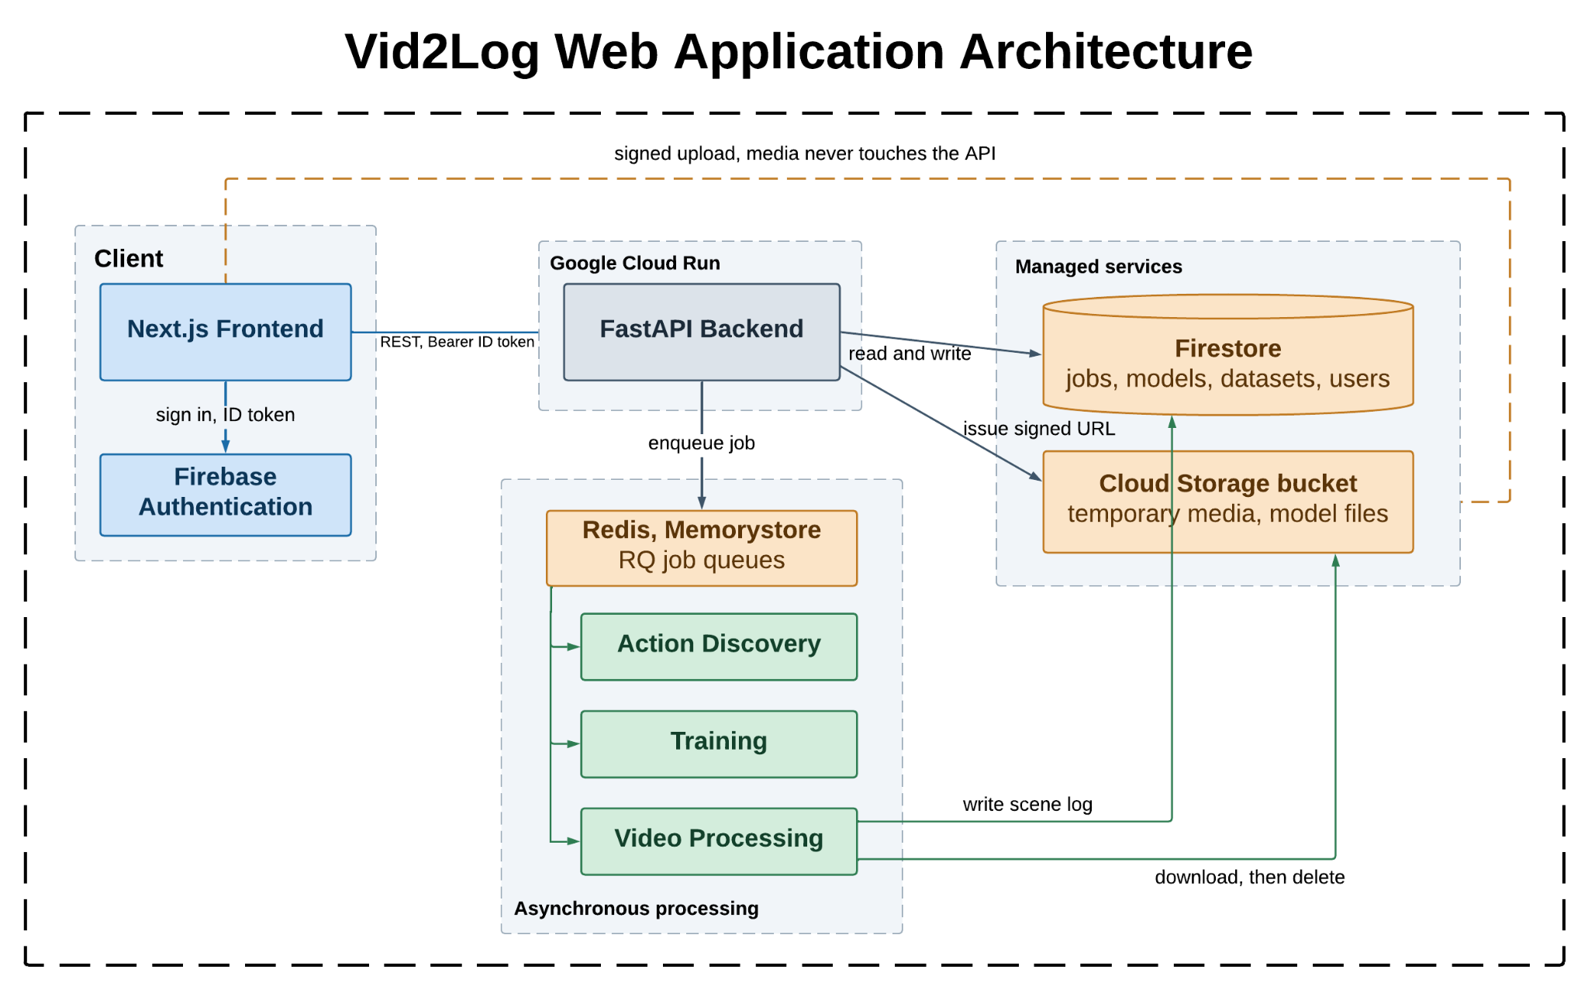
Figure 3. Overall architecture of the cloud web application.

2.4 Desktop Architecture
The desktop application mirrors the same shape locally. There is no queue because there is no contention, and no signed URL step because there is no network boundary. The sidecar reads the user's files where they already are.
Flutter shell (macOS / Windows)
│ starts it as a child process; HTTP over 127.0.0.1 only
▼
Local Python sidecar (FastAPI) ──► SQLite
│ jobs, models, discovery_jobs,
│ training_jobs, action_datasets
│
└──► ~/.vid2log/ trained models, saved action sets,
discovery temporary files, sidecar.log
State is written under the user's home directory, outside the installed bundle, so reinstalling or upgrading never destroys trained detectors or saved action sets.
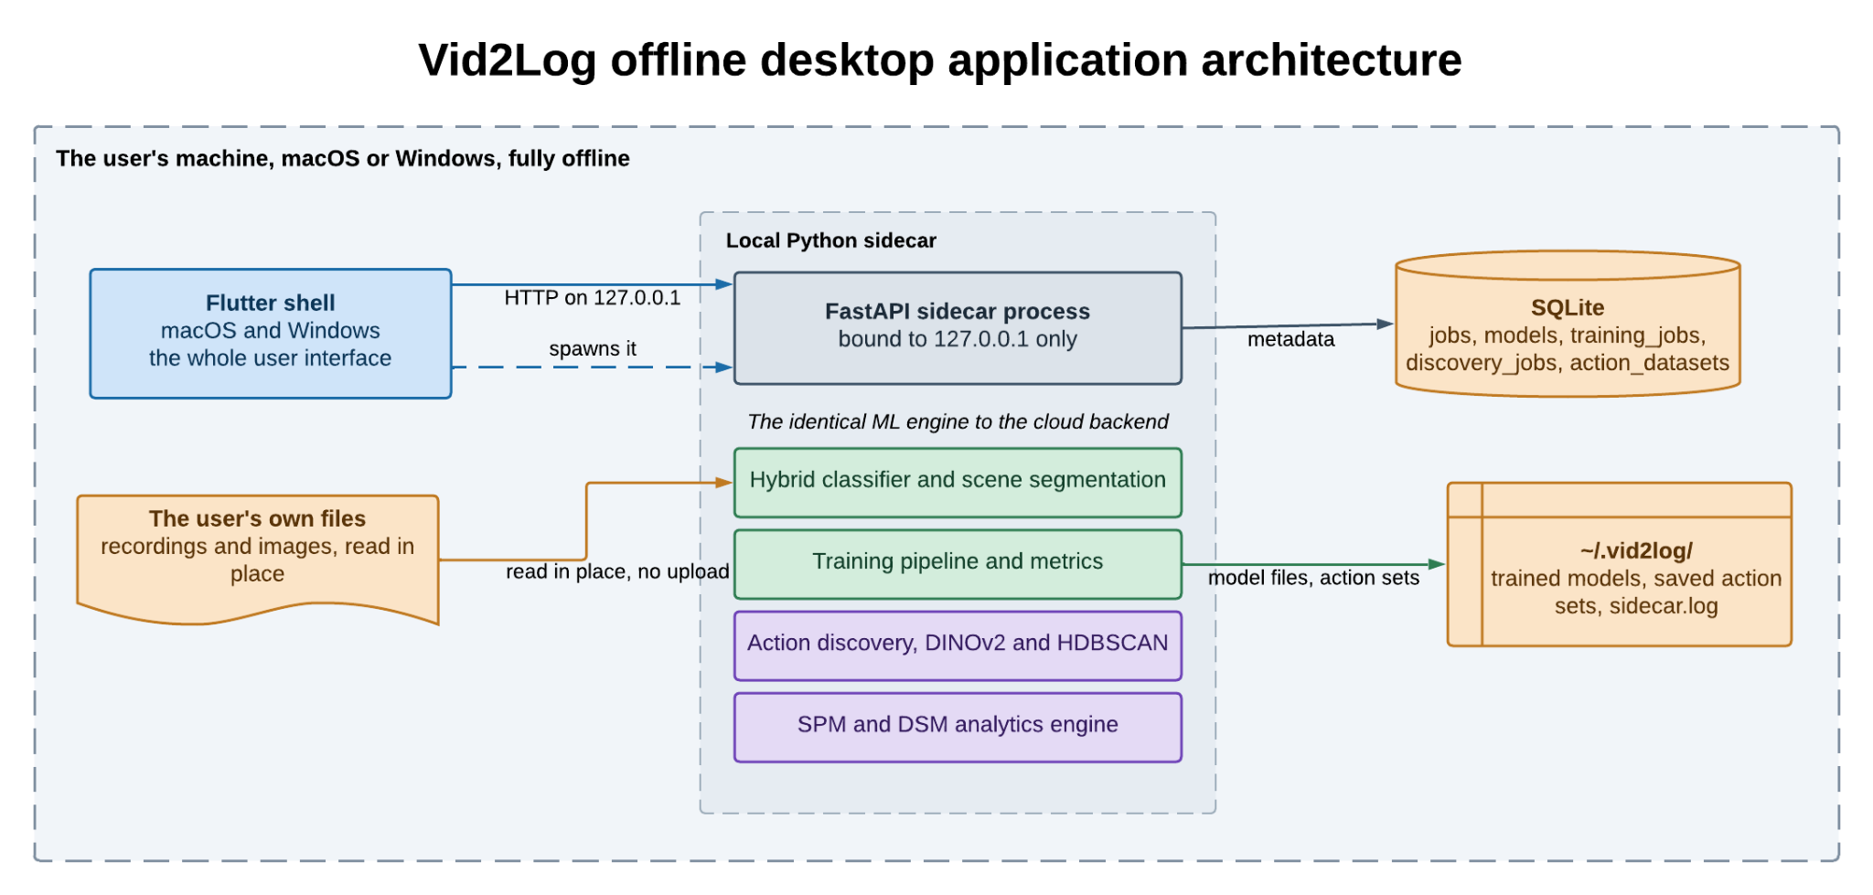
Figure 4. Architecture of the offline desktop application, with every cloud dependency replaced by a local equivalent.

2.5 Technology Stack
Layer | Web application | Desktop application
Interface | Next.js 16 (App Router), React 19, TypeScript, Tailwind CSS v4 | Flutter (macOS, Windows)
Identity | Firebase Authentication (email and password, Google) | None, single local user
API | FastAPI (Python) | FastAPI (Python), bound to 127.0.0.1
Database | Firestore | SQLite
File storage | Google Cloud Storage bucket | Local filesystem under ~/.vid2log/
Scheduling | Redis and RQ, three named queues | Direct in-process execution
Image classification | TensorFlow and tf-keras, MobileNetV2 transfer learning | Same
Text extraction | Tesseract through pytesseract | Same, with Tesseract bundled in the installer
Text classification | scikit-learn TF-IDF and Logistic Regression | Same
Action discovery | PyTorch, Transformers (DINOv2), HDBSCAN | Same
Analytics | Custom PrefixSpan style miner, SciPy tests | Same
Reporting | jsPDF for PDF, CSV export | CSV export
Packaging | Docker images, Cloud Run services and jobs | PyInstaller sidecar, .dmg and Inno Setup .exe
Table 2. Technology stack for each product.

3. Feature Catalogue
This section lists the full feature set. Unless stated otherwise, a feature is present in both applications.

3.1 Identity and Access Control
- Email and Google sign-in. Handled by Firebase Authentication. Every API request carries the user's ID token.
- Server side verification. The backend verifies the token on every request. No client supplied identity is trusted.
- Per-user isolation. Every job, detector and action set records an owner. Handlers compare that owner against the caller and reject mismatches, so isolation is enforced per record, not only by query filtering.
- Roles. A server side role system (bootstrap, user, admin) gates administrative endpoints separately from Firebase.
- Desktop. Not applicable. One local user, no login, no roles.

3.2 Recording Processing
- Direct upload. The browser requests a short lived signed URL scoped to the caller's own storage path, then uploads the video straight to Cloud Storage.
- Sampling rate. How many frames are examined per second of video is configurable, default 2.
- Detector choice. A job can name a detector or leave it unset to use whichever is active.
- Parallel batches. Any number of recordings can be queued and processed by independent workers.
- Live status. Jobs move through queued, processing, done and failed. The error message is kept on failure and shown in the interface.
- History, renaming, deletion. Completed jobs are listed with an editable display name that overrides the filename.
- Videos are not kept. Once the log is saved, both the worker's temporary copy and the stored blob are deleted. Only the log remains.
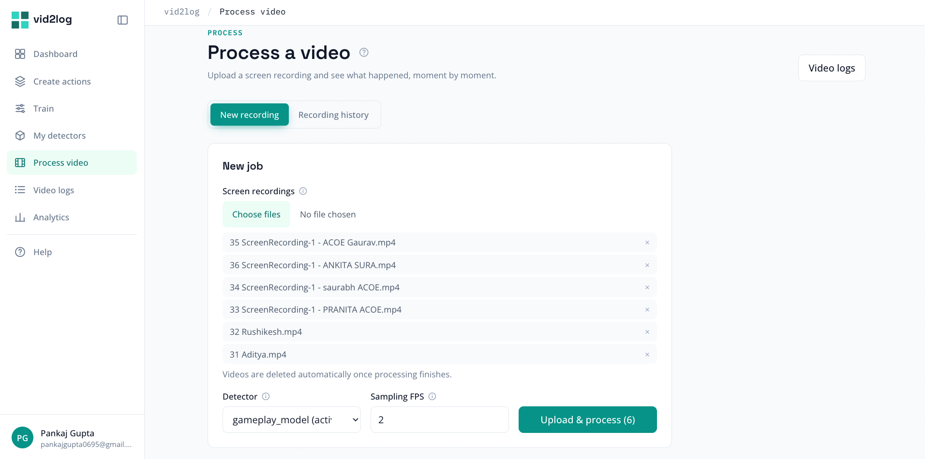
Figure 5. Submitting a recording, with sampling rate and detector selection.

3.3 Action Discovery
- Automatic discovery. Uploading one demonstration recording produces a set of proposed actions, with no labelling from the user.
- Diverse review sets. The example images offered for review are spread out in embedding space rather than being near duplicates of one static screen.
- Curation. Proposed actions can be renamed, merged, split and deleted. Images can be viewed full size and dragged between actions.
- Manual definition. An action set can also be built by hand without running discovery.
- Reusable sets. A reviewed set is saved under a name and reused for any number of training runs, edited later, or copied as a starting point.
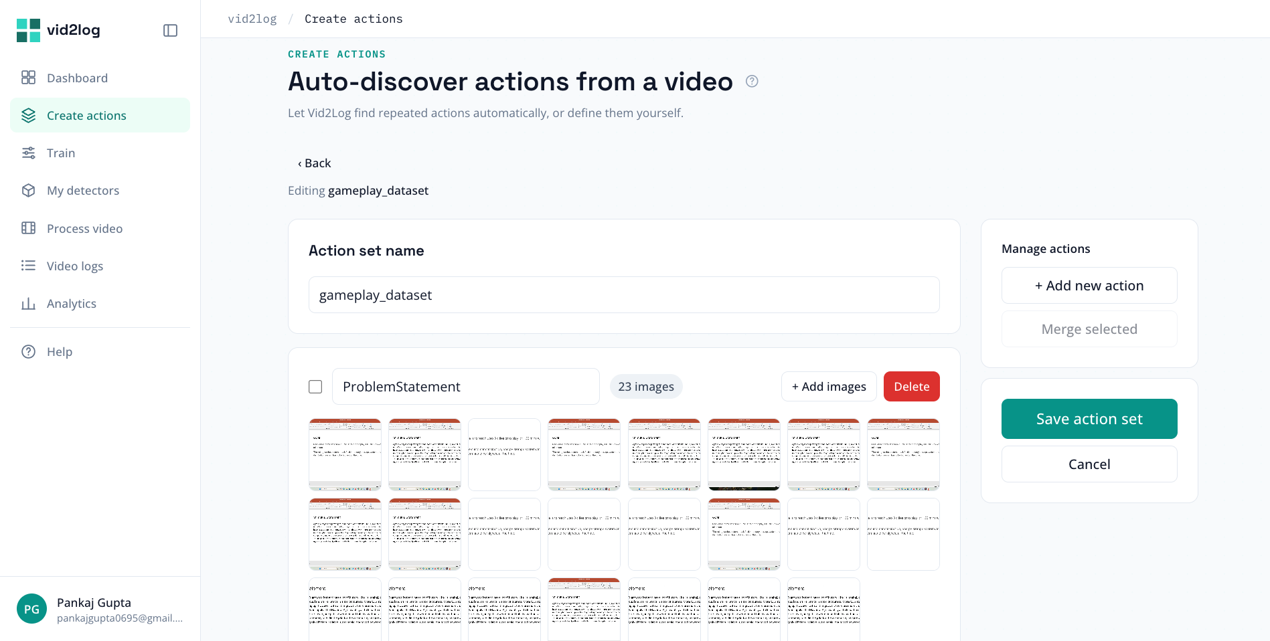
Figure 6. The Create Actions screen, with proposed clusters awaiting review.

3.4 Detector Training
- Training in the application. No external tool is involved at any point.
- Real held-out evaluation. The dataset is split into training, validation and test parts, stratified per class. Reported metrics come from the test part, which is used neither for fitting nor for tuning.
- Three reports side by side. Every run reports test metrics for the image classifier alone, the text classifier alone, and the two fused, so the benefit of fusion is visible rather than assumed.
- Per-action detail. Precision, recall, F1 and support for every action, plus overall accuracy and a confusion matrix.
- Configurable settings. Epochs, batch size, learning rate and split ratios are all adjustable, with server side bounds.
- Live progress. The current stage is reported, and during fitting the current epoch with running accuracy and loss.
- Retry without re-upload. A failed run keeps its images so it can be re-run on exactly the same dataset.
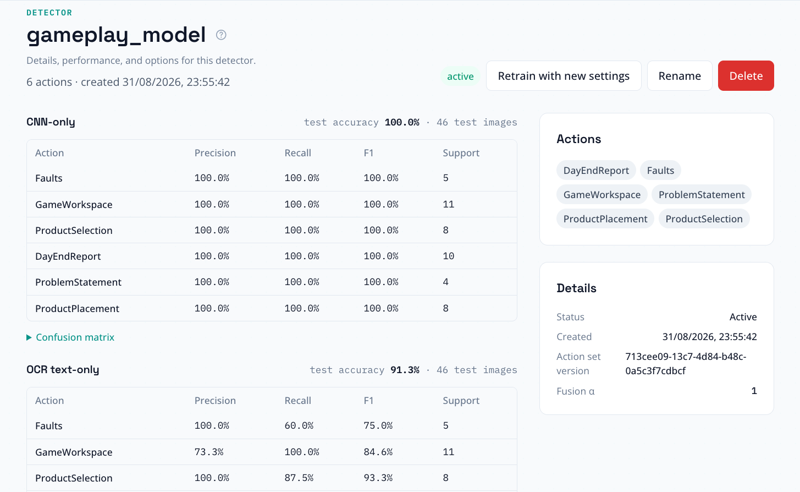
Figure 7. A finished training run showing accuracy, per-action metrics and the confusion matrix.

3.5 Detector Registry
- Versioned detectors. Each detector is stored with its labels, metrics, fusion settings and the training run that produced it.
- Activation and rollback. One detector can be active at a time. Switching is immediate and needs no retraining.
- Comparison and detail. Detectors can be compared in a list and inspected individually with the full evaluation report.
- Editable keyword rules. The per-action keyword list used by the first classifier tier can be changed at any time and applies immediately.
- Rename and delete.

3.6 Activity Logs
- Scene by scene view. Each log is shown as an ordered list of scenes with start time, end time, duration, action, confidence, and which classifier tier decided the label.
- CSV export. Any single log can be exported.
- Combined export. Several logs can be exported as one file with a column identifying each source recording, ready for external statistical tools.
- CSV import. A log produced elsewhere can be imported instead of processing a recording, so the analytics work against existing data. The importer is tolerant of real files: column order and letter case are ignored, extra columns are reported rather than rejected, times may be HH:MM:SS, MM:SS or a plain number of seconds, and any two of start time, end time and duration are enough because the third is derived.
- Clear import errors. Every problem in a file is reported at once, with line number and offending value, so a whole file can be fixed in one pass.
- Template. A minimal correctly shaped CSV is available as a starting point.
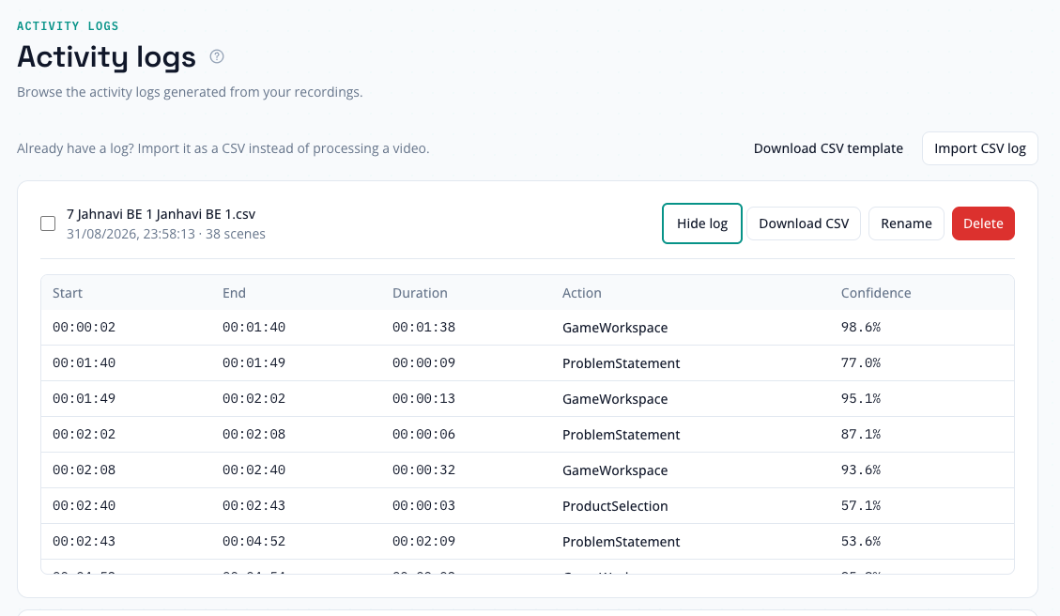
Figure 8. An activity log shown scene by scene, with per-scene confidence.

3.7 Analytics
Analytics has four tabs.
- Overview. Aggregate figures across the selected recordings: scene counts and time per action, distribution by classification source, and scene counts per recording.
- Sequential Pattern Mining. Repeated action sequences across a set of recordings, with both sequence support and instance support, under configurable gap and window limits.
- Differential Sequence Mining. A statistical comparison of two groups of recordings, showing only patterns whose frequency differs significantly, under a selectable test and threshold.
- Video Timeline. A proportional colour coded timeline per recording. Colours are keyed to the action name and shared across every timeline on screen, so one action is one colour everywhere and recordings can be compared directly.
- Export. Mining results export to CSV, and the Overview tab produces a combined PDF and CSV report.
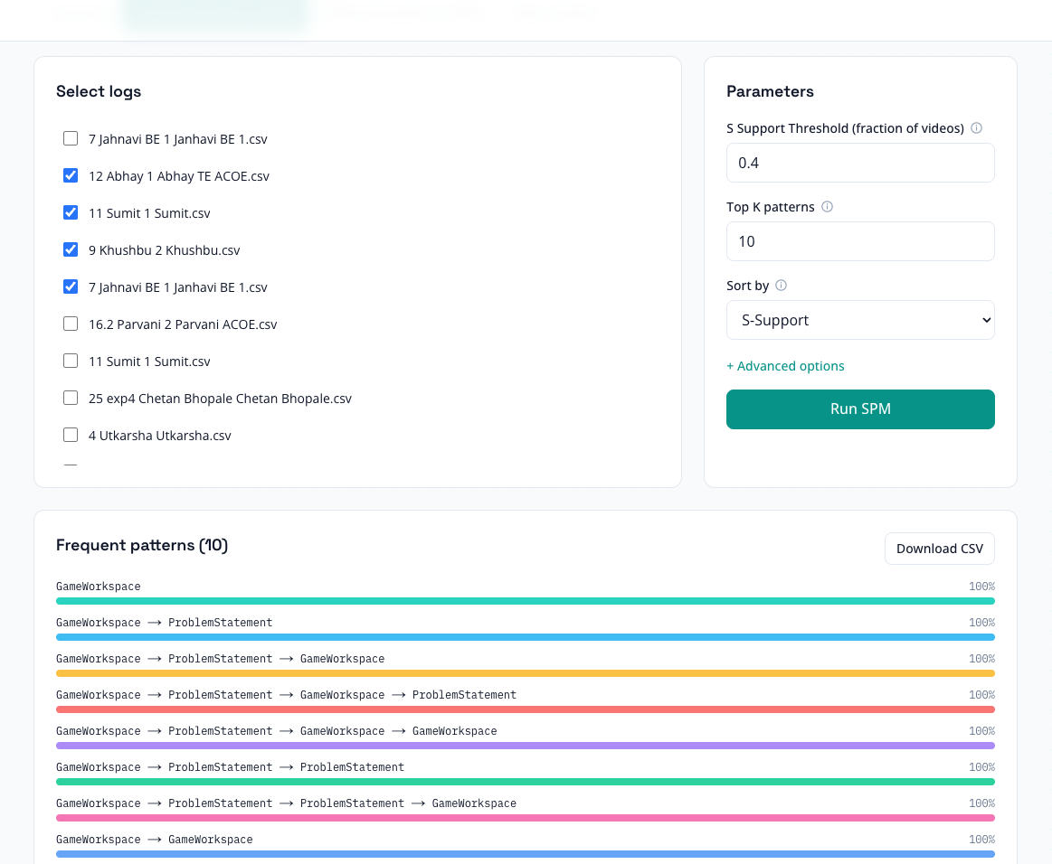
Figure 9. Sequential Pattern Mining results with advanced gap and window options.
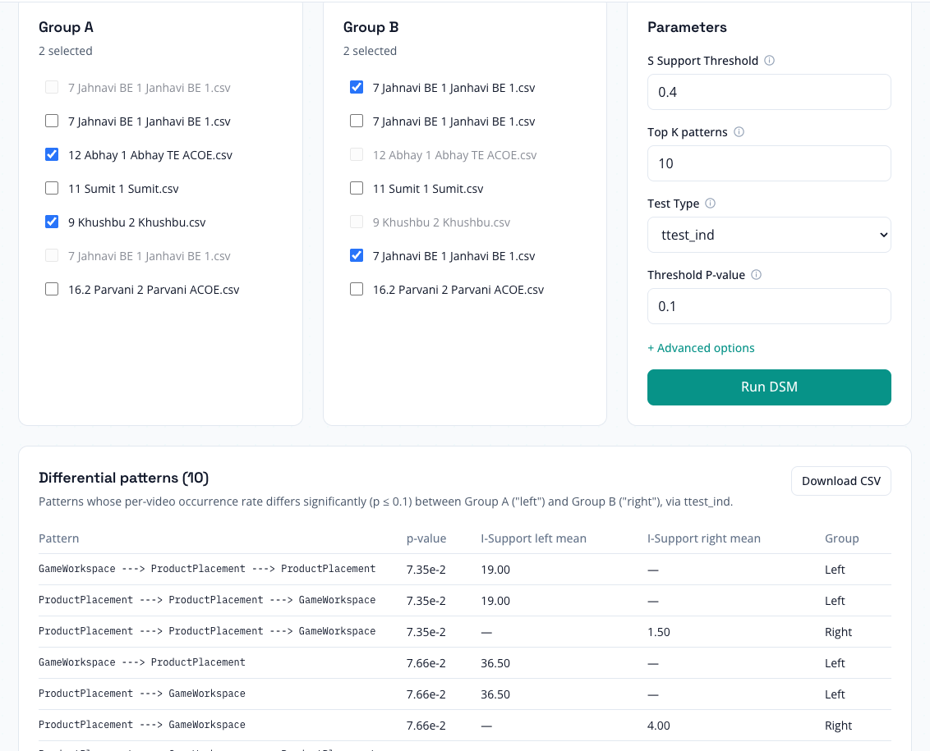
Figure 10. Differential Sequence Mining comparing two groups of recordings.
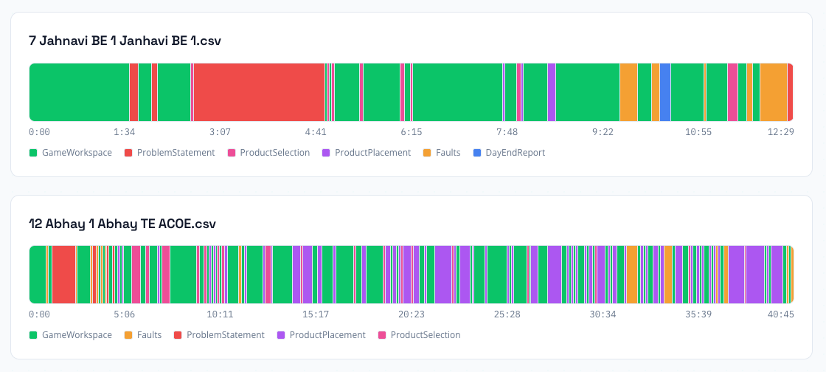
Figure 11. The Video Timeline tab, with one action holding one colour across all recordings.

3.8 Administration
- Users and roles. Administrators can list users and change roles.
- Statistics. Aggregate counts across the deployment.
- Maintenance. Cleanup routines remove stale uploaded videos and orphaned discovery previews, suitable for scheduled runs.
- Web application only.

3.9 Supporting Features
- In-application help. A help section documents every part of the product, with per-page links from a help icon in each page header.
- Tooltips. Attached to navigation, tabs, form fields and primary actions throughout.
- Light and dark themes. Applied consistently, including charts and timelines.
- Responsive layout. The web interface adapts from wide desktop down to narrow screens.
- Search metadata. Public routes carry Open Graph, Twitter card and JSON-LD metadata with a generated sitemap. Signed-in routes are excluded from indexing.
- Product analytics. Page views, sign-in events and key funnel events are instrumented in the web application.

4. Machine Learning Pipeline
This section follows a frame through the pipeline in order. The same pipeline and the same constants run in both applications.

4.1 Frame Sampling
Video is decoded in order and sampled at a fixed rate rather than classified frame by frame. Given a source frame rate fs and a target rate fd (default 2), the pipeline keeps every nth frame:
n = max(1, round(f_s / f_d))
Sampling twice per second places a scene boundary to within about half a second, far finer than any activity worth logging, while cutting forward passes by roughly ten times against a 25 to 30 fps source. Each frame's timestamp comes from the decoder's own position rather than from the frame index, so recordings with a variable frame rate stay correctly timed.

4.2 Image Preprocessing
Frames are letterboxed, not stretched, to the 224 by 224 input. Aspect ratio is kept and the rest is padded black. For a frame of width W and height H, with target side S = 224:
s = min(S / W, S / H), W′ = floor(sW), H′ = floor(sH)
The resized image is pasted centred using Lanczos resampling, then pixels are scaled to the range MobileNetV2 expects:
x′ = x / 127.5 − 1, x in [0, 255] gives x′ in [−1, 1]
Keeping the aspect ratio matters more here than in general image work. Screen recordings vary widely in resolution, and stretching would make the same interface element look different depending on the capture device. The identical transform runs at training time and at inference time, which is what makes the reported test metrics predict live behaviour.
One consequence is worth noting. The model holds no preprocessing layer of its own; every caller normalises before the tensor reaches the network. This matches the bundled default model, which is a plain graph with no such layer, and it must stay that way. Adding a preprocessing layer inside the model would normalise twice, squeezing the whole input range into a narrow band near minus one and destroying most of the signal.

4.3 The Image Classifier
The classifier is a transfer learning model on a MobileNetV2 backbone pretrained on ImageNet, with global average pooling and no classification head. The backbone is frozen and only the head is trained.
Input(224, 224, 3)
└─ MobileNetV2(weights='imagenet', include_top=False, pooling='avg') [frozen]
└─ Dense(128, activation='relu')
└─ Dropout(0.2)
└─ Dense(num_classes, activation='softmax')
optimizer Adam(learning_rate=1e-3)
loss sparse_categorical_crossentropy
metrics accuracy
Freezing the backbone is what makes the product's core promise practical. Only the head is trainable, so a typical dataset of 20 to 25 images per action trains in under a minute on CPU with no GPU needed. It also resists overfitting on datasets that small, which a fully fine-tuned network would not.
The softmax output is a probability vector over the actions. The fusion stage uses that whole vector, not just the top label.
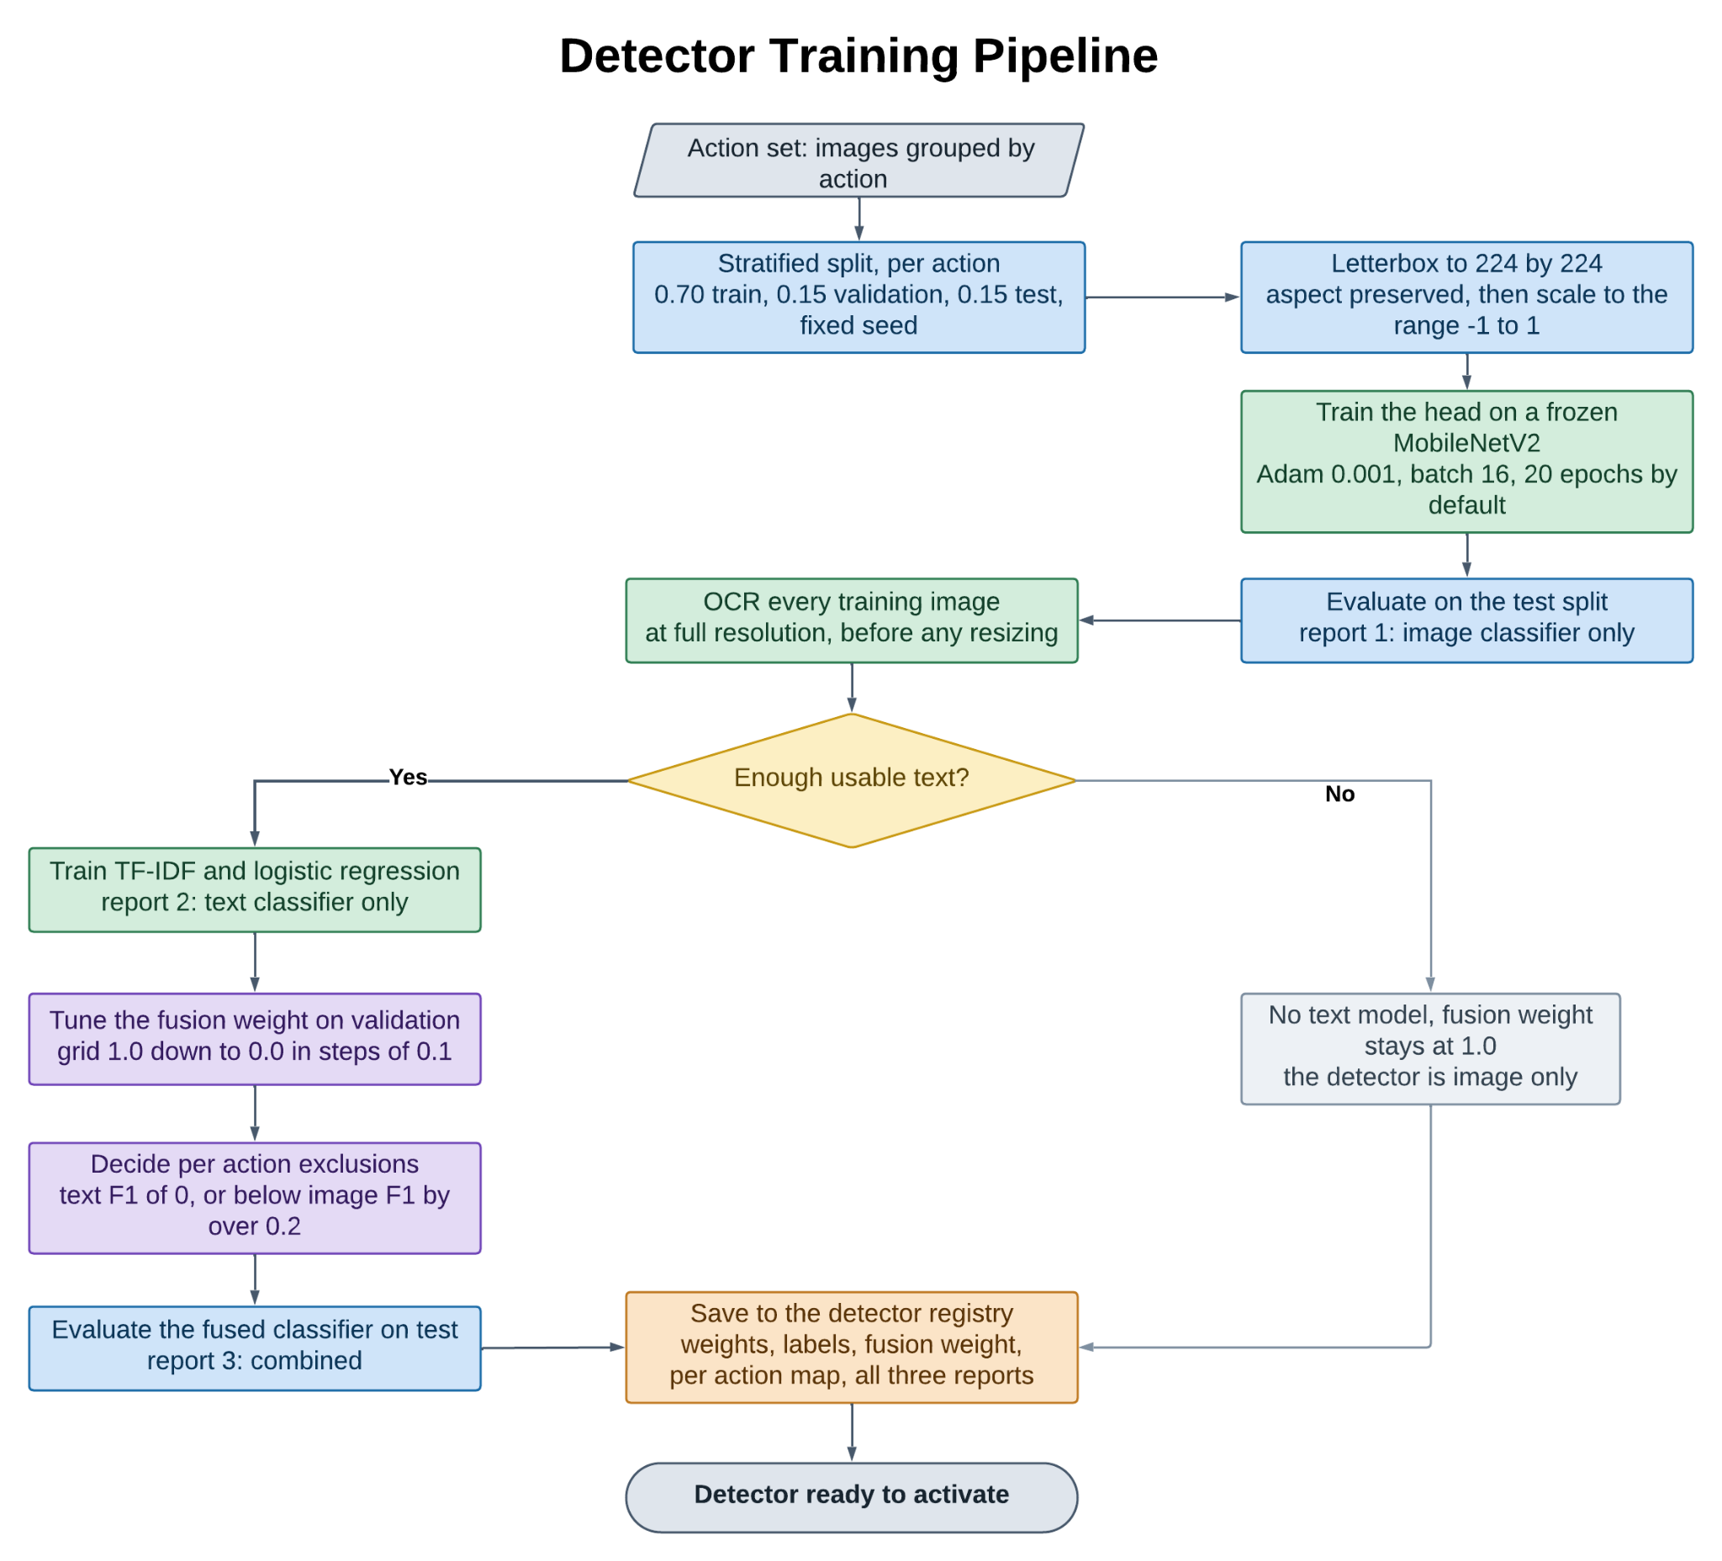
Figure 12. The detector training pipeline, from action set through to the registry.

4.3.1 Data Splitting
The dataset is split per class, so every action appears in every part in proportion to its size. Defaults are 0.70 training, 0.15 validation and 0.15 test, with a fixed random seed so runs are reproducible.
Splitting happens in two steps per class. The training part is taken first, then the rest is divided between validation and test in the ratio v / (v + t). If a class has fewer than two images left after the training split, everything remaining goes to validation and that class contributes no test images. That case is visible in the per-class support figures rather than hidden.

4.4 Text Extraction
An image classifier reduces a frame to texture and layout. In screen recordings, two genuinely different states often share almost all of their visual structure and differ only in their text: a heading, a label, a title. That is exactly where a CNN is weakest and OCR is strongest, which is the reason for combining them.
Text extraction runs Tesseract with this preparation, in order: optional cropping to a per-detector region of interest, upscaling by two with Lanczos resampling, conversion to greyscale, and automatic contrast normalisation. Tesseract runs in single uniform block mode.
Two details matter. OCR always runs on the original resolution frame, before any resize toward 224 by 224, because shrinking first destroys small interface text before Tesseract sees it. And extraction is best effort: any Tesseract failure returns an empty string instead of raising, so one unreadable frame falls back to image only classification instead of failing the job.
Setting a region of interest is worth it whenever the distinguishing text sits in a fixed place on screen. Cropping is both faster and more accurate than reading the whole frame, because graphics elsewhere act as noise.

4.5 The Hybrid Classifier
A frame is resolved in three tiers, ordered from most confident and cheapest to least. The first tier that produces an answer wins.
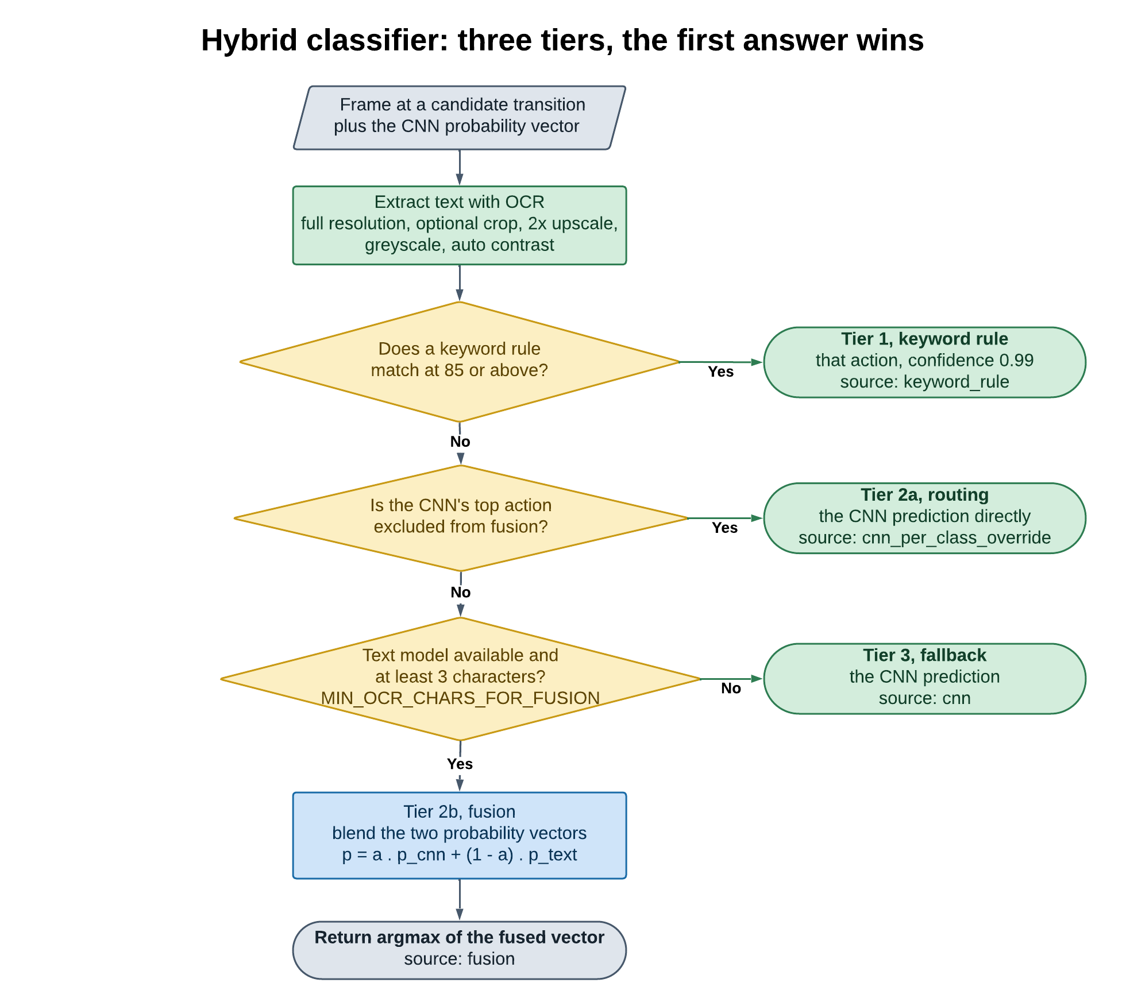
Figure 13. The hybrid classifier: three tiers evaluated in order, the first answer winning.

4.5.1 Tier 1, Keyword Rules
Each action can carry a list of keywords. Extracted text is compared against every keyword with a partial ratio fuzzy match, which scores a keyword against the best matching part of the text and so tolerates the surrounding text OCR also picks up. The best scoring action is accepted if it reaches 85 out of 100, set by DEFAULT_MATCH_THRESHOLD. Otherwise this tier abstains.
A rule match reports a confidence of 0.99, because it is a definite assertion rather than an estimate. This tier is deliberately simple. It answers the question "does the on-screen text separate these actions at all?" before any investment in a trained text model, and it stays useful afterwards, for example for a new action that has a known fixed heading but no training data yet. Rules live on the detector and are editable in the interface, so changes apply immediately with no retraining.

4.5.2 Tier 2, Text Classifier and Fusion
Where there is enough text, a small text classifier trained alongside the CNN gives a second opinion. It is a TF-IDF vectoriser over single words and word pairs feeding a logistic regression. Interface text has a small, formulaic vocabulary, so a linear model over sparse features is normally enough, trains in seconds, and needs far less data than a deep text model.
The text model's probability vector is realigned to the detector's canonical class order, with zero for any action it never saw, so it can be combined element by element with the CNN output. The two are blended by a single weight α:
p_combined = α · p_cnn + (1 − α) · p_text, α in [0, 1]
ŷ = argmax_c p_combined[c]
An α of 1 is image only and 0 is text only. The blend stays a valid probability distribution because it is a convex combination of two distributions. Fusion is attempted only when the extracted text is at least three characters, set by MIN_OCR_CHARS_FOR_FUSION. Below that the text is noise and the frame falls to tier 3.

4.5.3 Choosing the Fusion Weight
α is not set by hand. It is tuned on the validation part by searching the grid 0.0, 0.1 up to 1.0, set by FUSION_ALPHA_GRID, for the value that maximises validation accuracy:
α* = argmax_α (1/|V|) · Σ_{i in V} 1[ argmax_c ( α·p_cnn^(i) + (1−α)·p_text^(i) )[c] = y_i ]
The search order is deliberate. The grid runs from 1.0 downward, and a candidate replaces the current best only on a strict improvement, so ties settle on the highest α tried, meaning toward the image classifier. This is not cosmetic. On the small datasets this product targets, validation accuracy moves in steps of one over the validation set size, so exact ties across many α values are common, and a naive search would land on α of 0, discarding the CNN entirely, only because zero happened to be tested last.

4.5.4 Per-Action Routing
A single shared α is the right level for the blend, but it cannot express the case where OCR actively hurts one action while helping elsewhere. That case is handled by routing instead of weighting. After evaluation, an action is excluded from fusion if its text F1 is zero, or falls below its image F1 by more than PER_CLASS_OCR_EXCLUDE_MARGIN, which is 0.2:
c is excluded if and only if F1_text(c) = 0 or F1_text(c) < F1_cnn(c) − 0.2
At inference, if the CNN's own top prediction is an excluded action, that prediction is returned directly and the text model does not compete. The excluded actions and the tuned α are stored on the detector as a per-action weight map, so the values behind the reported metrics are the values used in production.
It is worth recording why this is routing and not a per-action weight vector, since the latter is the intuitive design and it is wrong. Blending an excluded action at α of 1 while every other action keeps the shared α produces an argmax over numbers computed on different bases: the excluded action carries a raw CNN probability while its competitors carry blended scores that the text model may dominate. A confidently wrong text score for another action can then beat a correct CNN prediction. Routing avoids this by never comparing scores computed on different bases. The same routing runs during tuning, final evaluation and inference, so all three agree.

4.5.5 Tier 3, Fallback
If no rule matched, no text model exists, or the text was too short to trust, the CNN's own prediction and confidence are returned unchanged. Every frame gets a label; there is no abstain path.
Tier | Mechanism | Reported source | Confidence
1 | Fuzzy keyword rule match of 85 or above | keyword_rule | 0.99 fixed
2a | Per-action routing to the CNN | cnn_per_class_override | CNN probability
2b | Weighted fusion of CNN and text | fusion | Fused probability
3 | CNN alone | cnn | CNN probability
Table 3. Classification tiers in evaluation order. The source is recorded per scene and exported in the CSV.

4.6 Scene Segmentation
A per-frame classifier does not produce a log, it produces a label per sample. Turning that into scenes is where most of the practical accuracy is won or lost, because any classifier has frames near a decision boundary where the top label is nearly a tie. Without temporal reasoning those frames make the log flip between two actions on every sample instead of holding one action for a meaningful stretch.
This was measured, not assumed. Against a manually corrected reference log, 76 percent of transitions in a real recording were spurious flips between two visually similar actions. Three independent mechanisms address it, none of which involve retraining.
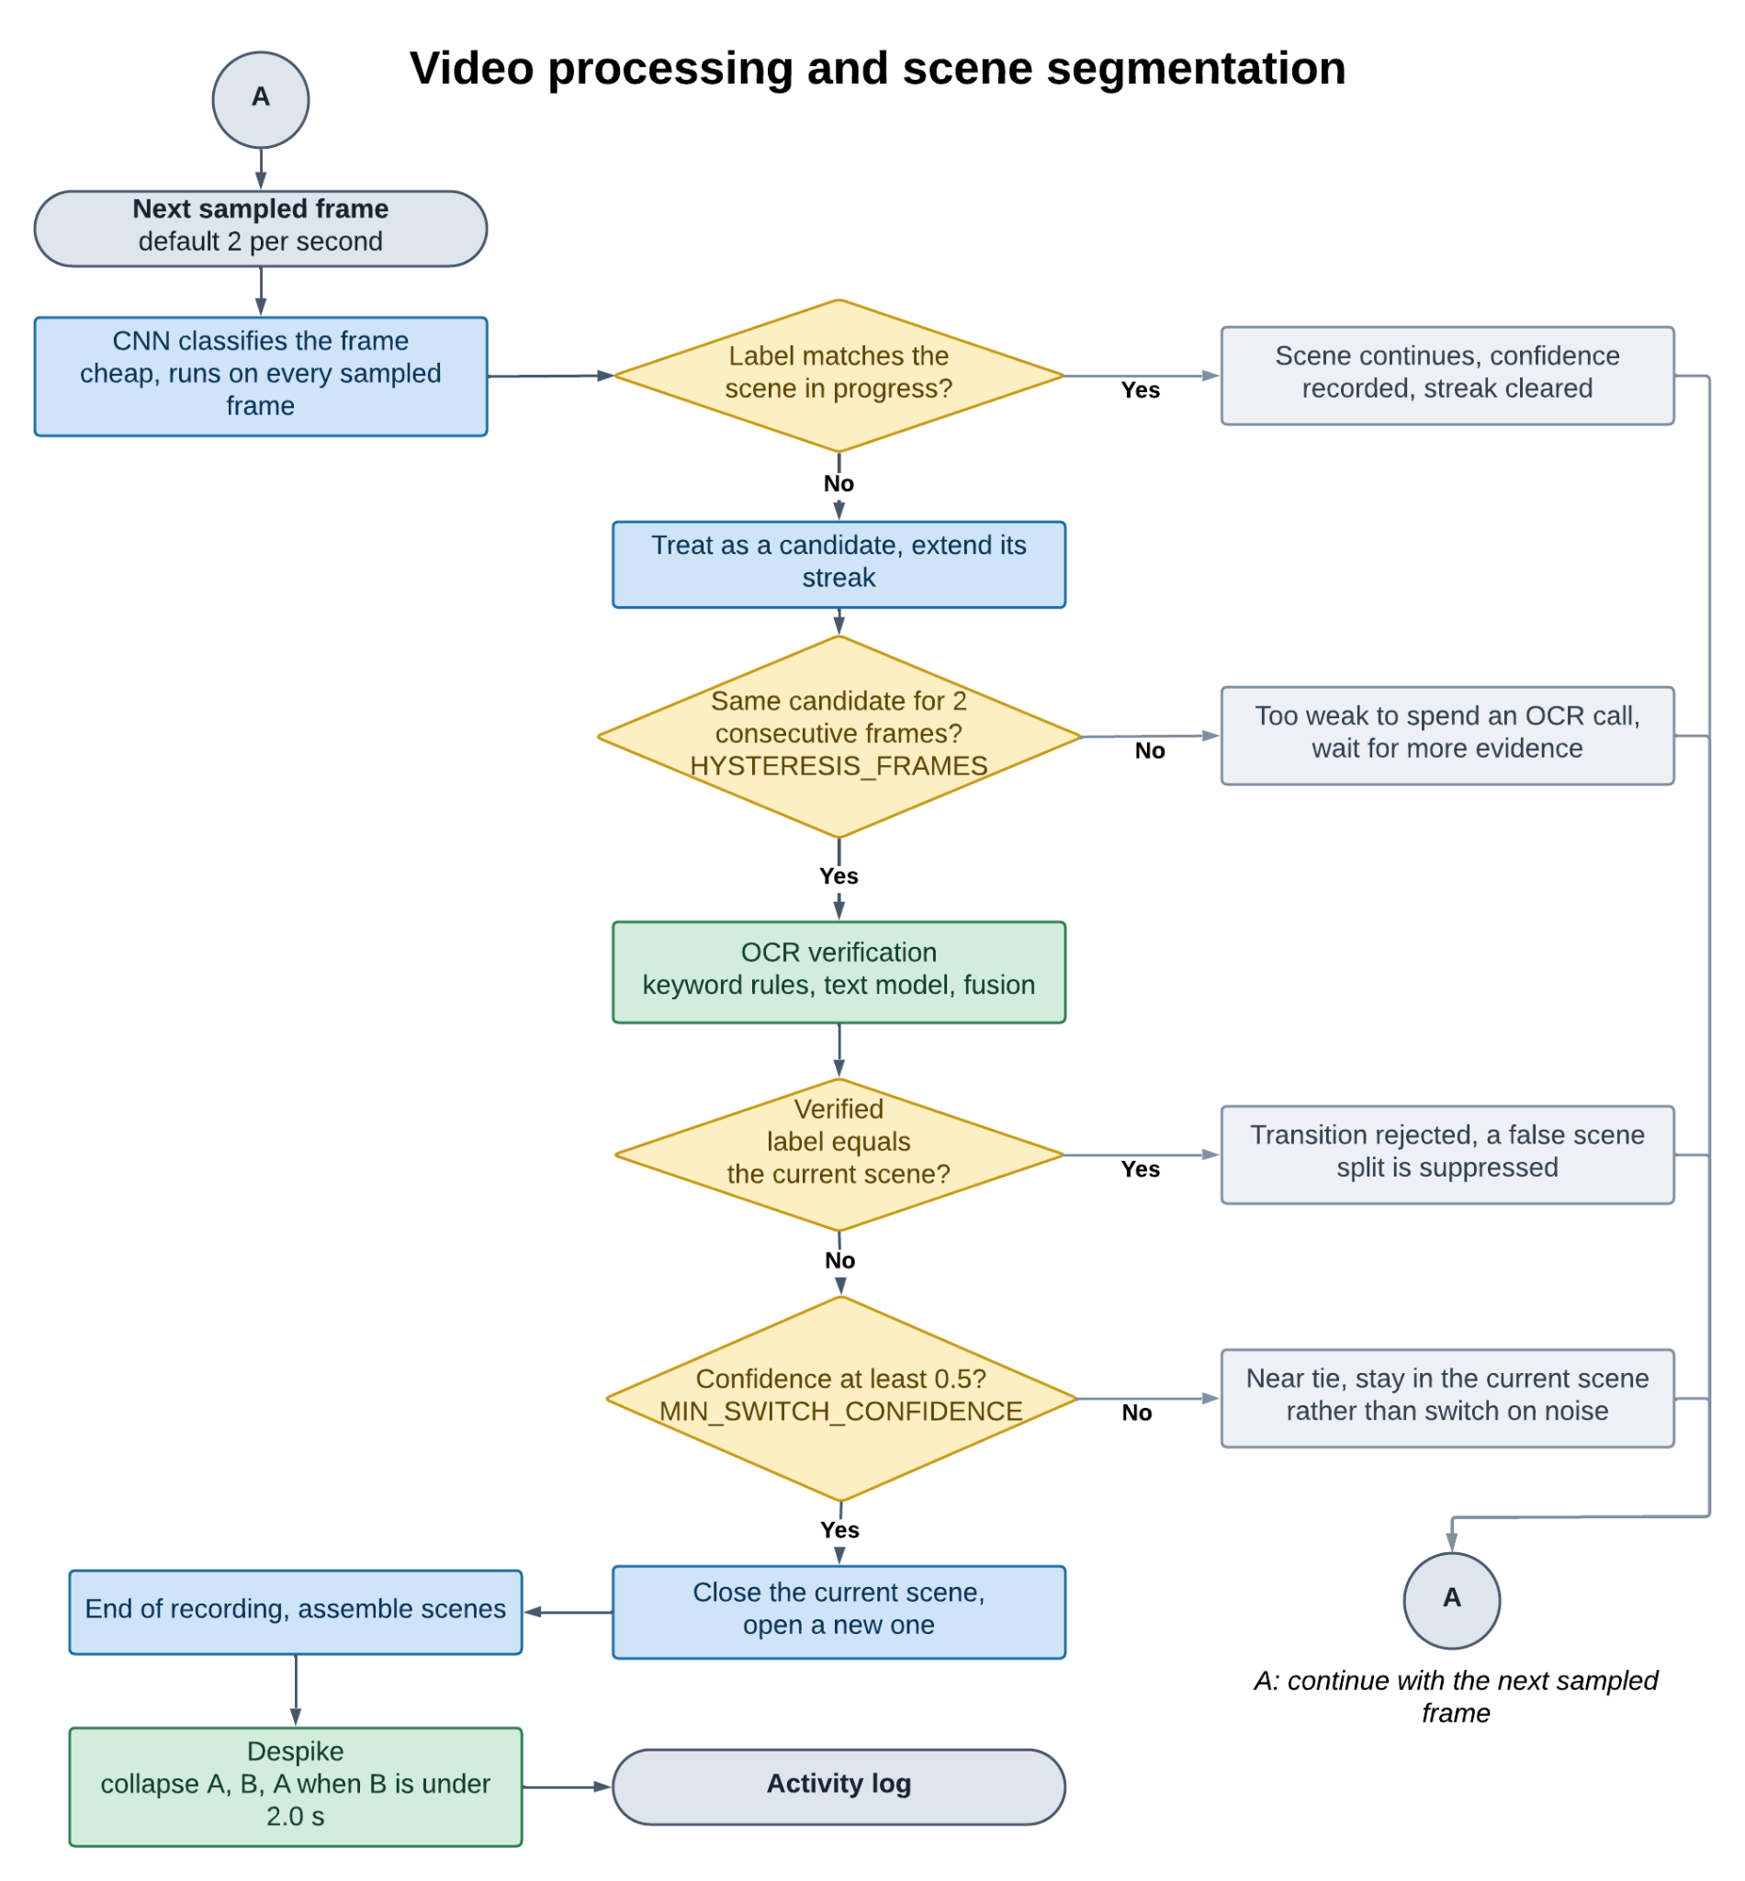
Figure 14. Video processing and scene segmentation, including hysteresis, the confidence floor and despiking.

4.6.1 Two-Tier Evaluation
The CNN runs on every sampled frame because it is cheap. OCR and fusion run only when the CNN's label differs from the scene in progress and that disagreement has persisted, which is to say only at candidate transitions. OCR is roughly ten to a hundred times more expensive than a CNN pass, so this is the difference between a pipeline that works across many concurrent recordings and one that does not:
OCR calls = O(number of scenes) instead of O(number of sampled frames)
There is a second benefit beyond cost. Because verification can also decide the frame belongs to the scene already in progress, it can reject a transition outright, suppressing a false scene split rather than just relabelling it.

4.6.2 Hysteresis
A label that differs from the current scene becomes a candidate. It must stay the CNN's top prediction for HYSTERESIS_FRAMES, which is 2 consecutive sampled frames or about one second at the default rate, before verification is attempted at all. A different competing label restarts the streak, and any frame agreeing with the current scene clears it. A single flickering frame therefore never reaches the transition decision.

4.6.3 Confidence Floor
Even after a candidate survives hysteresis and is verified, the switch is committed only if the verified confidence reaches MIN_SWITCH_CONFIDENCE, which is 0.5. A near tie leaves the current scene alone. When a switch is refused on these grounds the current scene's recorded confidence is left untouched, so a weak off-class reading does not overwrite its last good measurement.

4.6.4 Despiking
After scenes are built, a final pass removes what is left. A scene shorter than MIN_SCENE_DURATION_S, which is 2.0 seconds, whose neighbours on both sides are the same action, is absorbed into that action, collapsing three scenes into one:
A then B then A, with duration(B) < 2.0 s, becomes a single A
The pass repeats until no spike is found, which also unwinds longer alternating chains, since removing one spike can expose another. It is deliberately careful: a short scene between two different actions is left alone, because that is a real boundary or a genuinely brief event, not a blip to erase.
These constants were tuned against a manually corrected log. A stricter earlier setting of three confirmation frames and a 0.6 floor did remove the flicker, but it also missed genuinely brief events, cutting one action's true share of the recording to about a twentieth. The current values are the loosest that still suppress flicker.

4.6.5 Scene Record
Each committed scene stores its start time, end time, duration, action, the confidence of the reading that set it, and the tier that decided it. The last scene closes at the final sampled timestamp.

4.7 Evaluation Metrics
All reported figures come from the test part. Let N be the number of test images, yi the true action and ŷi the predicted one.
Accuracy = (1/N) · Σ_i 1[ ŷ_i = y_i ]
For each action c, with TP, FP and FN counted one against the rest:
Precision(c) = TP_c / (TP_c + FP_c)
Recall(c) = TP_c / (TP_c + FN_c)
F1(c) = 2 · Precision(c) · Recall(c) / (Precision(c) + Recall(c))
Support(c) = number of test images whose true action is c
Division by zero gives zero rather than an error, so an action with no test images reports zero instead of failing the run. A confusion matrix is also produced, indexed in the detector's canonical action order, which makes systematic confusions between specific pairs visible instead of merely lowering the headline accuracy.
This full report is produced three times per run, for the image classifier alone, the text classifier alone, and the two fused. That is what lets the benefit of fusion be read off the report rather than taken on trust.

4.8 Unsupervised Action Discovery
Requiring users to list and label every action before the system is useful is a real barrier. Discovery removes it: from one demonstration recording the system proposes candidate actions for review.
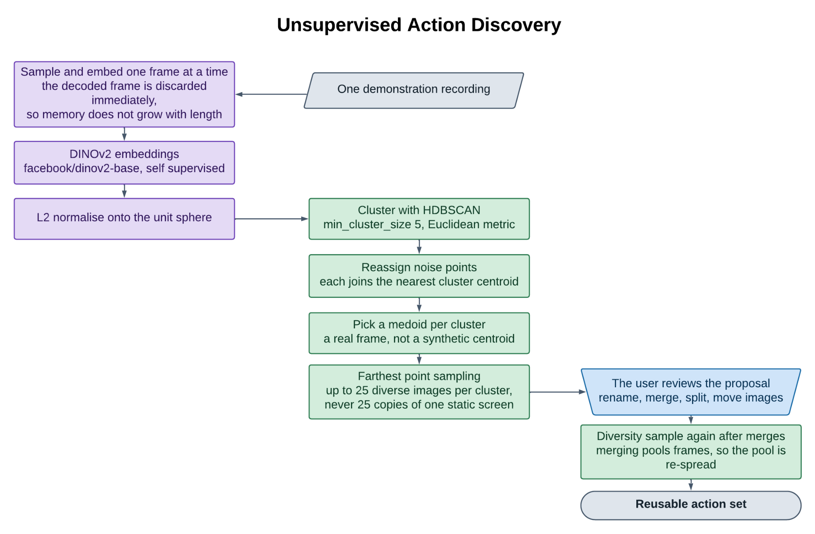
Figure 15. Unsupervised action discovery, from demonstration recording to reusable action set.

4.8.1 Sampling and Embedding
Frames are sampled at the configured rate and embedded one at a time, with the decoded frame discarded as soon as its embedding and a JPEG preview exist. This matters in practice: holding every sampled frame of a long recording as a raw array at once is what exhausts memory. Peak memory therefore scales with the number of embeddings and previews, not with the length of the recording.
Embeddings come from DINOv2 (facebook/dinov2-base), a self-supervised vision transformer. A self-supervised model is right here precisely because the task has no labels. DINOv2 is trained without class supervision, so its features reflect general visual and semantic similarity rather than similarity with respect to one particular label set.

4.8.2 Normalisation and Clustering
Embeddings are L2 normalised onto the unit sphere before clustering with HDBSCAN under a Euclidean metric. This pairing is deliberate, because on the unit sphere squared Euclidean distance is an exact monotone function of cosine similarity:
||a − b||² = ||a||² + ||b||² − 2 (a · b) = 2 (1 − cos θ) when ||a|| = ||b|| = 1
Clustering by Euclidean distance on normalised vectors is therefore the same as clustering by cosine distance, while still using the efficient Euclidean implementation. Cosine geometry is the right similarity for high dimensional embeddings, where vector length mostly reflects feature intensity rather than meaning.
HDBSCAN is chosen over k-means for two reasons that both matter here. It does not need the number of clusters in advance, which is the whole point since the number of distinct actions is exactly what is unknown. And it finds clusters of differing density, which matters because a long static screen and a brief transition occupy very different amounts of embedding space. Its one meaningful setting, the minimum cluster size, defaults to 5 and is exposed to the user.

4.8.3 Noise Reassignment
HDBSCAN deliberately refuses to assign ambiguous points, labelling them noise. That is correct for general clustering but wrong here, because every sampled frame is a real moment from the demonstration and belongs to some action. Each noise point is folded into the cluster with the nearest centroid:
label(i) = argmin_{c in C} || e_i − μ_c || , μ_c = (1/|c|) Σ_{j in c} e_j
C is the set of real clusters, and centroids are computed only over confidently assigned members.

4.8.4 Choosing Representatives
Two selections are made per cluster. The medoid, the member nearest its own centroid, becomes the cluster's representative image:
medoid(c) = argmin_{i in c} || e_i − μ_c ||
The medoid is used rather than the centroid because the centroid is a synthetic point with no matching frame, while the medoid is a real frame the user can recognise.
Separately, the review set for each cluster is chosen by greedy farthest point sampling, which repeatedly adds whichever remaining frame is furthest from everything already picked:
next = argmax over i not in S of min_{j in S} || e_i − e_j ||
This is what stops the review set being twenty-five near identical frames of one static screen. The number kept per cluster is capped at MAX_PREVIEW_IMAGES_PER_CLUSTER, which is 25, matching the guidance the training page gives for examples per action. Diversity sampling runs a second time when the set is saved, because merging two proposed actions pools their frames and the pool needs re-diversifying.

5. Analytics Engine

5.1 Building Sequences
Each finished activity log is reduced to the ordered list of its action labels, with timing dropped. One recording becomes one sequence of symbols:
["ProblemStatement", "GameWorkspace", "ProductSelection", "GameWorkspace", ...]
Dropping duration is what makes recordings of different lengths comparable, and it fits the question pattern mining answers, which is about order rather than pace. Scenes are already stored in order, so no sorting is needed. Every referenced job is checked for ownership and completion before its sequence is read. A job owned by another user, or one not yet finished, is rejected rather than quietly skipped.
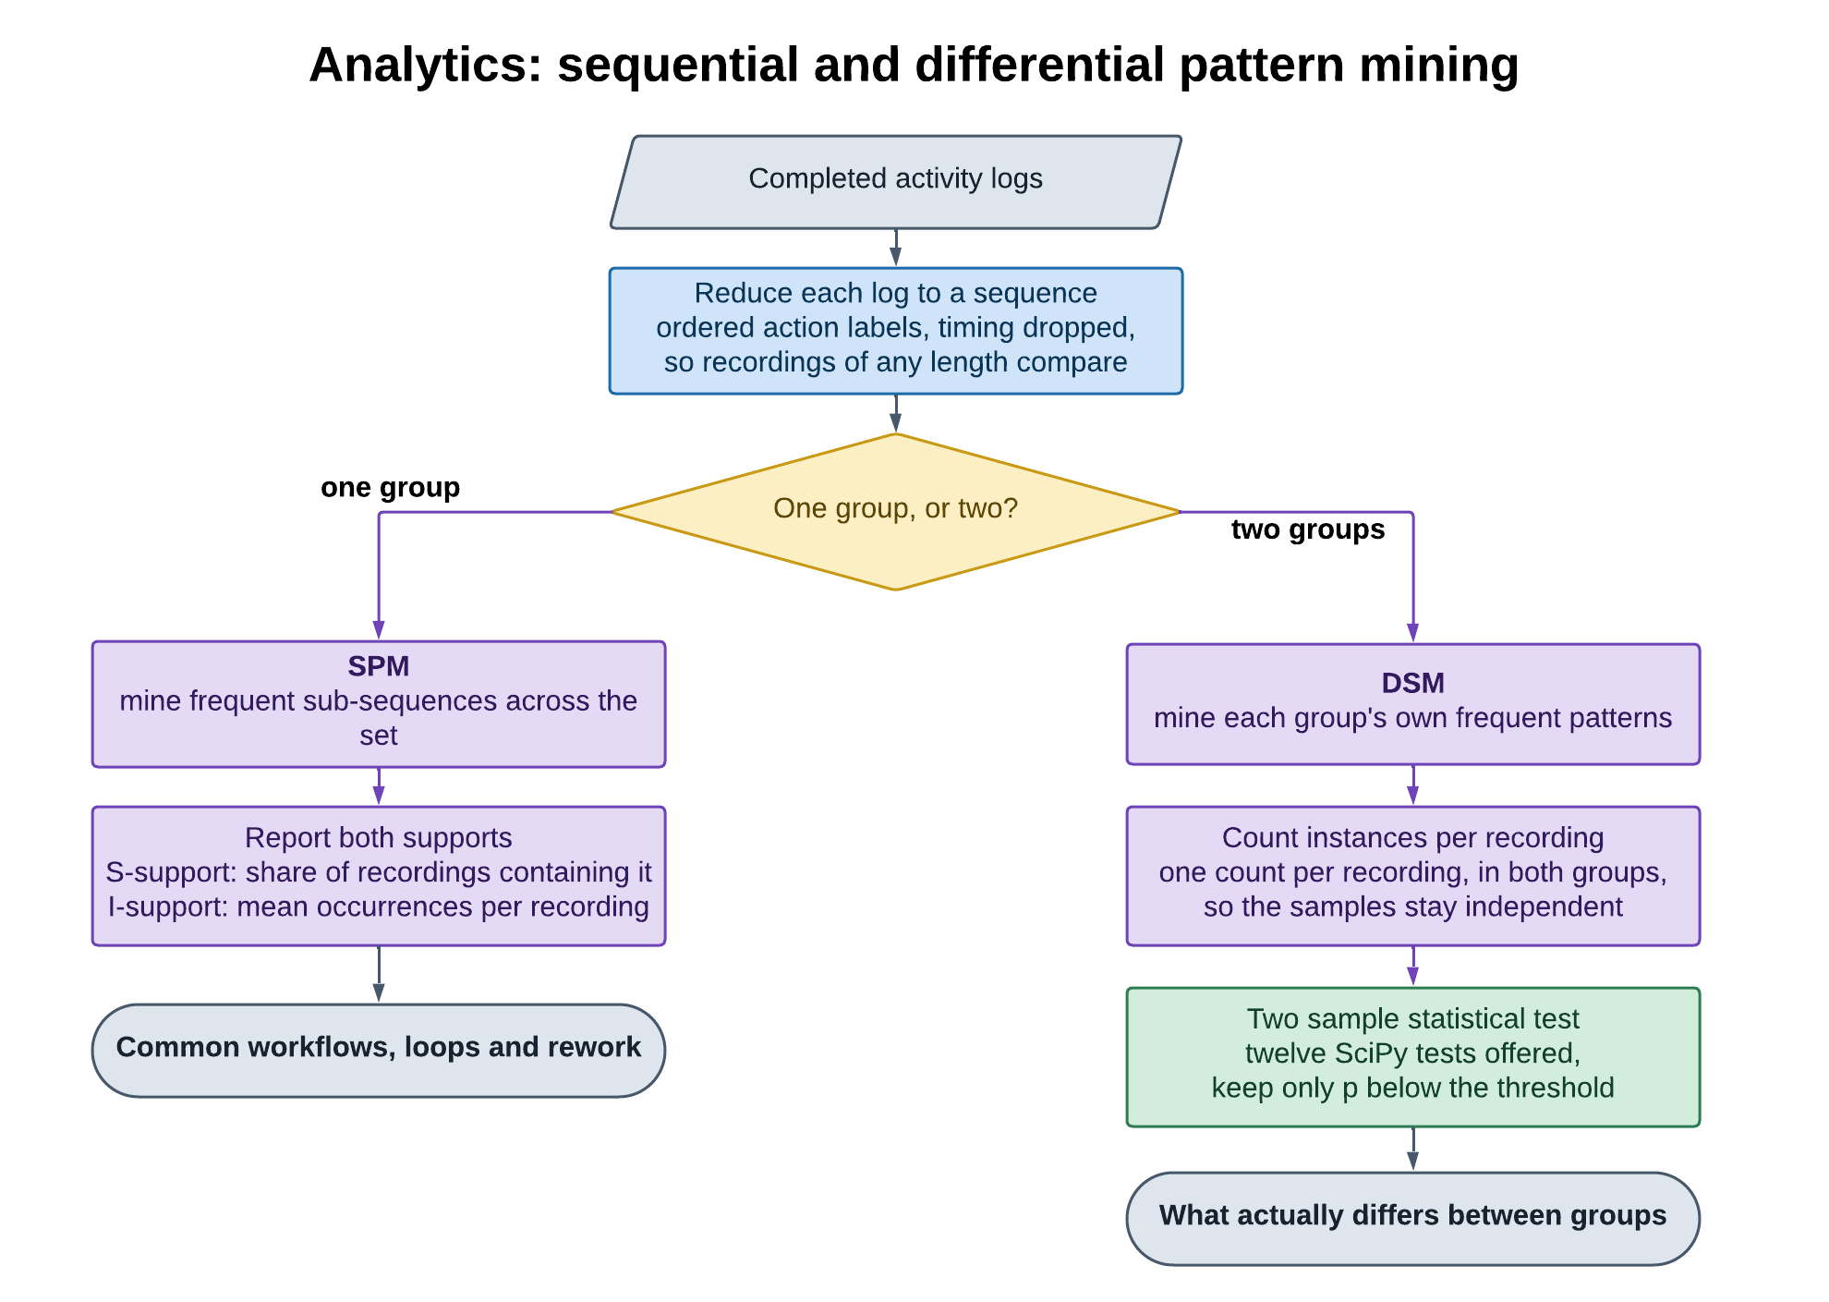
Figure 16. The analytics engine: sequence construction, then either sequential or differential mining.

5.2 Sequential Pattern Mining
SPM finds sub-sequences that recur across a set of recordings, surfacing common workflows, loops and rework. The implementation is a custom PrefixSpan style recursive projection algorithm with no external dependency. The obvious library pins packages more than a decade out of date and fails to install on current Python, and the algorithm is short enough that carrying that risk is not worth it.

5.2.1 Two Kinds of Support
Both support measures from the literature are reported, because they answer different questions and a pattern can score well on one and badly on the other. Let n be the number of sequences and P a candidate pattern.
Sequence support (S-support): in how many recordings does this pattern occur at all?
S-frequency(P) = |{ i : P occurs in sequence i at least once }|
S-support(P) = S-frequency(P) / n
Instance support (I-support): how often does it happen, per recording?
I-frequency(P) = Σ_i count_i(P)
I-support_mean(P) = I-frequency(P) / n
I-support_sd(P) = sqrt( (1/n) Σ_i ( count_i(P) − I-support_mean(P) )² )
Here count_i(P) is the number of non-overlapping occurrences of P inside sequence i. Both averages are taken over all sequences, including those where the pattern never occurs, so a pattern appearing many times in one recording and nowhere else is not flattered. The standard deviation is the population form, consistent with that. A pattern occurring once in every recording and one occurring ten times in a tenth of them have the same S-support and very different I-support. Reporting both is what separates a universal step from a local loop.

5.2.2 Counting Instances
Instance counting uses greedy leftmost matching. The earliest valid match is found and counted, then the search resumes just after where it ended, so no position is reused across two counted instances. If a match attempt fails partway, the search restarts just after where that attempt's first element matched, rather than abandoning the sequence, because a later occurrence of the first element may still match.

5.2.3 Gap and Window Limits
Plain PrefixSpan treats a pattern as a subsequence with no limit on what comes between, which in practice returns patterns whose elements are minutes of unrelated activity apart. The engine therefore supports gap limits on how many other events may fall between consecutive pattern elements. Having matched an element at position q, the next must be found in the half-open window:
[ q + 1 + min_gap , q + 1 + max_gap + 1 )
The window runs to the end of the sequence when no maximum is set. The limit applies at every level of the recursion, so it holds for every consecutive pair, not just the first. Setting min_gap to 0 and leaving max_gap unset reproduces unconstrained PrefixSpan exactly. Pattern length is limited separately by a sliding window with its own minimum and maximum.
The two limits answer different questions. The gap limit says how directly one step must follow another to count as the same workflow. The window limit says how many steps make a workflow worth reporting.

5.2.4 Termination Safeguards
Frequent pattern mining is exponential in the worst case, and this domain reaches that case easily. A frame level classifier naturally produces many short scenes alternating among a few actions, and once the support threshold stops pruning, the number of frequent sub-sequences explodes. In practice this showed up not as an error but as a request that never returned.
Two safeguards bound it. Pattern length is capped at MAX_PATTERN_LEN, which is 8, whatever window was requested, on the reasoning that eight steps already exceeds what anyone reads as one workflow. And the minimum support count is computed as:
min_support_count = max( 1, ceil( s_threshold × n ) )
The ceiling stops a fractional threshold on a small set of recordings rounding down to a count that prunes nothing.

5.2.5 Parameters and Output
Parameter | Default | Meaning
min_support | 0.4 | S-support threshold, the share of recordings a pattern must appear in
min_instance_support | 0.0 | I-support threshold, the minimum average instances per recording
sliding_window_min | 1 | Shortest pattern length considered, 1 to 20
sliding_window_max | 4 | Longest pattern length considered, 1 to 20, capped at 8 on the server
min_gap | 0 | Fewest events allowed between consecutive pattern elements
max_gap | unset | Most events allowed; unset means unlimited
sort_by | s_support | Ranking measure, s_support or i_support
top_k | 10 | Number of patterns returned
Table 4. Sequential Pattern Mining parameters.
Each returned pattern carries its elements, S-frequency, S-support, I-frequency, I-support mean and I-support standard deviation. Results are ranked by the chosen measure and cut to the requested count.

5.3 Differential Sequence Mining
DSM answers a comparison. Given two groups of recordings, such as high against low performing sessions or novices against experts, which patterns actually separate them? Simply subtracting support fractions cannot tell a real difference from sampling noise, especially with the small groups typical here. DSM applies a significance test instead.

5.3.1 Procedure
- Mine each group on its own for its frequent patterns, using the same gap and window limited engine as SPM, applying both thresholds within that group alone.
- For each such pattern, count its non-overlapping instances in every recording of both groups, giving two samples of counts.
- Run the chosen two-sample statistical test on those samples to get a p-value.
- Drop any pattern whose p-value exceeds the threshold, or for which the test could not be computed.
- Rank the rest by ascending p-value and return the requested number.
The unit of observation is the recording, not the scene, so each recording contributes exactly one count to its group's sample and the tests' independence assumption holds. A pattern frequent in both groups produces two rows, one per home group, each reporting that group's own mean, which keeps the output comparable with the reference tool this analysis follows.

5.3.2 Available Tests
Twelve two-sample tests from SciPy are offered. The choice is left to the analyst rather than imposed, since the right test depends on the assumptions the analyst is willing to make, and some options test spread rather than location.
Test | Family | Notes
ttest_ind | Parametric, location | Default. Assumes group means are roughly normal.
poisson_means_test | Parametric, rate | Compares two event rates. Called with total counts and group sizes rather than raw samples, so k over n is exactly the I-support mean.
mannwhitneyu | Non-parametric, location | Rank based, assumes no normality.
ranksums | Non-parametric, location | Wilcoxon rank sum.
brunnermunzel | Non-parametric, location | Does not assume equal variances.
bws_test | Non-parametric, general | Baumgartner, Weiss and Schindler.
mood | Non-parametric, scale | Tests spread, not location.
ansari | Non-parametric, scale | Tests spread, not location.
ks_2samp | Non-parametric, distribution | Kolmogorov and Smirnov, two sample.
kstest | Non-parametric, distribution | Kolmogorov and Smirnov, general form.
cramervonmises_2samp | Non-parametric, distribution | Cramer and von Mises.
epps_singleton_2samp | Non-parametric, distribution | Epps and Singleton, handles discrete data.
Table 5. Statistical tests available for differential mining.
A test that cannot be computed for a pair of samples, through too few observations or constant data in a scale test, causes the pattern to be dropped rather than reported with a meaningless p-value. The threshold defaults to 0.1, which is deliberately permissive for exploring small groups, and is adjustable.

5.4 Reading the Results
- High S-support with low I-support mean marks a step nearly every session performs once, usually a required stage of the workflow.
- Moderate S-support with high I-support mean and a large standard deviation marks a loop concentrated in a minority of sessions, often rework or repeated correction.
- A DSM result shows a difference in frequency between groups, not a cause. Group membership is assigned by the analyst, and the usual caution about multiple comparisons applies: many patterns are tested at once, so a few results under a permissive threshold are expected by chance.

6. Web Application

6.1 Frontend
The frontend is a TypeScript Next.js application on the App Router. Charts are hand-built SVG rather than a charting library, which keeps the bundle small and removes a dependency that would otherwise have to track the design system's theming. A persistent sidebar and topbar wrap the routes below.
Route | Purpose
/ | Public landing page with full search metadata
/login, /signup | Authentication
/dashboard | Overview of recordings, detectors and recent activity
/process | Submit a recording; job history
/video-logs | Browse, export, import and combine activity logs
/train | Train a detector; training history
/detectors | Detector registry
/detectors/[id] | Detector detail: metrics, keyword rules, activation, retraining
/create-actions | Action discovery and manual curation
/analytics | Overview, SPM, DSM and Video Timeline tabs
/admin | User and role administration
/help | In-application documentation, linked per page
Table 6. Web application routes.
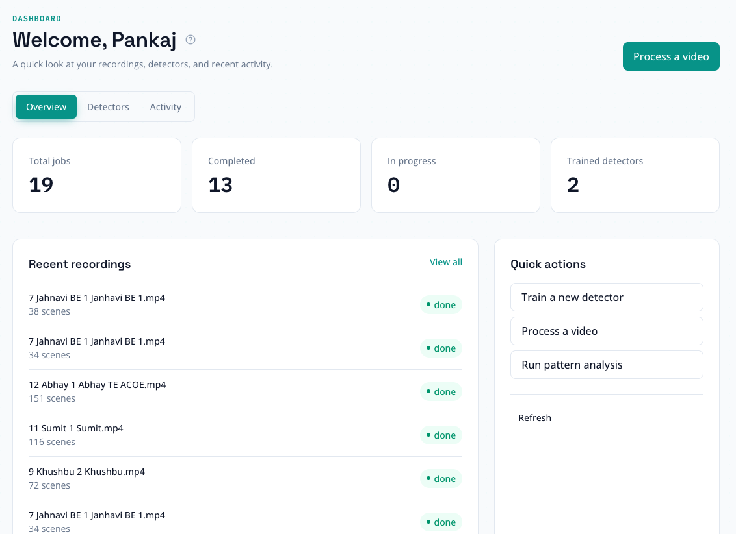
Figure 17. The dashboard: recordings, detectors and recent activity.

6.2 API Reference

6.2.1 Uploads and Jobs
Method and path | Purpose
POST /uploads/signed-url | Issue a short lived V4 signed PUT URL scoped to the caller's own storage path
POST /jobs | Create a processing job for an already uploaded video
GET /jobs | List the caller's jobs
GET /jobs/{job_id} | Retrieve one job
PATCH /jobs/{job_id} | Update a job, for example its display name
DELETE /jobs/{job_id} | Delete a job and its log
Table 7. Upload and job endpoints.

6.2.2 Logs
Method and path | Purpose
GET /logs/{job_id} | Retrieve one activity log
GET /logs/{job_id}/csv | Export one log as CSV
POST /logs/import | Create a job from an uploaded CSV log instead of a recording
POST /logs/combine | Export several logs as one CSV with a per-recording identifier column
Table 8. Log endpoints.

6.2.3 Training and Detectors
Method and path | Purpose
POST /train | Start a training run
GET /train | List training runs
GET /train/{training_job_id} | Retrieve one run with live progress and final metrics
POST /train/{training_job_id}/retry | Re-run a failed job on its kept dataset
GET /models | List detectors
GET /models/{model_id} | Retrieve one detector
POST /models | Register a detector
PATCH /models/{model_id}/activate | Mark a detector active
PATCH /models/{model_id}/rename | Rename a detector
PATCH /models/{model_id}/keyword-rules | Replace keyword rules without retraining
DELETE /models/{model_id} | Delete a detector
Table 9. Training and detector endpoints.

6.2.4 Actions and Datasets
Method and path | Purpose
POST /actions/discover | Start discovery over a demonstration recording
GET /actions/discover | List discovery runs
GET /actions/discover/{job_id} | Retrieve one run with its proposed clusters
GET /actions/discover/{job_id}/frames/{cluster_id}/{frame_id} | Fetch one proposed preview frame
POST /actions/discover/{job_id}/save | Save a reviewed run as a reusable action set
DELETE /actions/discover/{job_id} | Delete a run and its previews
GET /actions/datasets | List action sets
GET /actions/datasets/{dataset_id} | Retrieve one action set
GET /actions/datasets/{dataset_id}/classes/{class_index}/images/{image_index} | Fetch one image from an action set
PUT /actions/datasets/{dataset_id} | Update an action set
DELETE /actions/datasets/{dataset_id} | Delete an action set
POST /actions/datasets/{dataset_id}/copy-for-training | Prepare an action set as training input
Table 10. Action discovery and action set endpoints.

6.2.5 Analytics, Users and Administration
Method and path | Purpose
POST /analytics/spm | Sequential Pattern Mining across a set of recordings
POST /analytics/dsm | Differential Sequence Mining between two groups
POST /users/bootstrap | Create the caller's profile on first sign-in
GET /users/me | Retrieve the caller's profile and role
GET /admin/users | List all users, administrators only
PATCH /admin/users/{uid}/role | Change a user's role, administrators only
GET /admin/stats | Platform statistics, administrators only
POST /admin/cleanup-stale-videos | Remove orphaned uploaded videos
POST /admin/cleanup-stale-action-previews | Remove orphaned discovery previews
Table 11. Analytics, user and administration endpoints.

6.3 Data Model
Collection | Contents
jobs | One document per processing job: status, source reference, sampling rate, detector, the scene list, timestamps and any error
training_jobs | One per training run: dataset references, settings, split ratios, live progress and the three metric reports
discovery_jobs | One per discovery run: source reference, clustering settings, proposed clusters and progress
models | Detector registry: labels, metrics, fusion weight and per-action map, keyword rules, storage paths, active flag and the training run behind it
action_datasets | Saved action sets: name and per-action image counts, with images in object storage
users | Profiles and server side roles
Table 12. Firestore collections.

6.4 Storage Lifecycle
Object storage is a standalone Google Cloud Storage bucket rather than Firebase Storage, for a billing reason: Firebase Storage requires the whole project to be on the paid plan, a plain bucket does not. An uploaded video has a deliberately short life:
- The browser requests a signed PUT URL scoped to the caller's own path.
- The browser uploads the video straight to Cloud Storage. The API never sees the bytes.
- The job is created, referencing the storage path.
- A worker downloads the blob to temporary local storage and processes it.
- The scene log is written to the database. This is the durable output.
- The worker's temporary copy is deleted, including on failure.
- The stored blob is deleted once the log is safely saved.
Recordings are never stored permanently. Only two things persist: activity logs in the database, and detector files in object storage. Training images follow the same pattern with one exception: a failed training run keeps its images so a retry can reuse the same dataset without asking the user to upload again.
Signing a URL needs a private key, and a Cloud Run service's attached credentials have none. The service account is therefore granted Token Creator on itself, so it can sign by impersonating itself through the IAM SignBlob API.
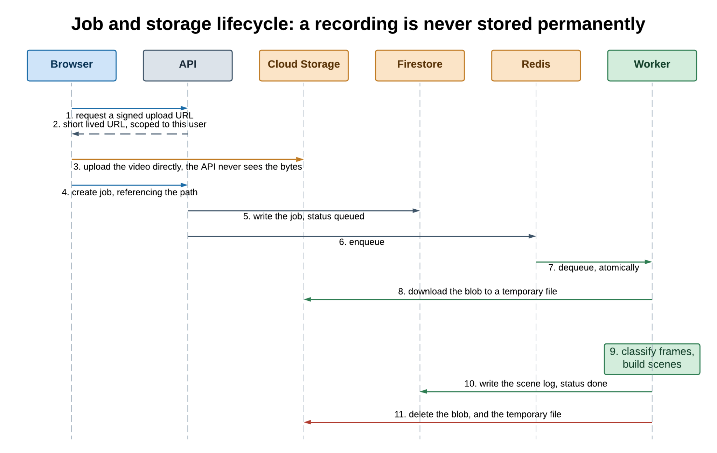
Figure 18. Job and storage lifecycle, showing why a recording is never stored permanently.

6.5 Background Processing
Queue | Work | Timeout
video_processing | Classifying one recording into a scene log | 30 minutes
training | One training run, including evaluation and fusion tuning | 2 hours
action_discovery | Embedding and clustering one demonstration recording | 30 minutes
Table 13. Background queues.
Each queue retries at most three times, at 15, 60 and 180 second intervals. That is enough to absorb brief network or DNS failures but narrow enough not to hide a real defect behind repeated retries.
Database writes at the start of a job use a shortened deadline, so a transient failure appears within seconds as a visible, retryable failed job instead of leaving the job stalled with nothing written back.

6.6 Security
- Every request is authenticated by verifying the Firebase ID token on the server. No client supplied identity is trusted.
- Authorisation is enforced per record by comparing the stored owner against the caller, not only by filtering queries.
- Signed upload URLs are short lived and scoped to the caller's own path, so a leaked URL grants neither broad nor lasting access.
- Media never passes through the API server.
- Administrative access is governed by a server side role independent of the authentication provider.
- Cross-origin access is limited to a configured allow-list.
- Recordings are deleted from storage as soon as their log is saved, so source material exists at rest for as little time as possible.

7. Desktop Application

7.1 Why It Exists
The desktop application serves users who cannot send recordings to a third party cloud, whether for regulatory reasons, sensitive material, poor connectivity, or a preference for local ownership, while still getting the same classification, training and analytics. It is a peer of the web application, not a cut down client.

7.2 Architecture
A Flutter shell hosts the interface and starts a Python FastAPI process as a child. All communication is HTTP over the loopback interface, and no external network access is needed once installed. Each cloud dependency has a local counterpart.
Web application | Desktop equivalent | Consequence
Firestore | SQLite | Same document shapes, stored as JSON columns
Cloud Storage | Local filesystem under ~/.vid2log/ | No upload step; the sidecar reads files in place
Redis and RQ | Direct in-process execution | No queue needed for one user
Firebase Authentication | None | One local user, no login
Signed upload URLs | Direct file paths | No network boundary to cross
Table 14. Cloud dependencies and their local equivalents.
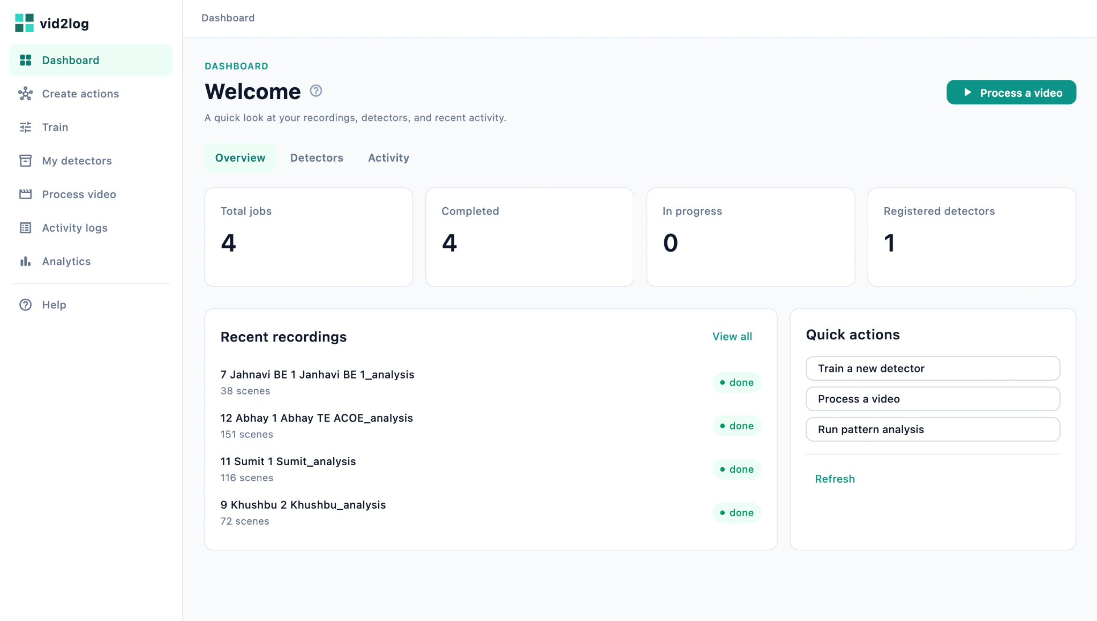
Figure 19. The desktop application's home screen and navigation.

7.3 Local Data Model
The sidecar's SQLite schema mirrors the cloud collections.
Table | Key columns
jobs | job_id, status, video_path, original_filename, display_name, model_id, fps, scene_count, scenes_json, error, created_at, started_at, completed_at
models | model_id, name, labels_json, fusion_alpha, fusion_alpha_per_class_json, metrics_json, is_active, dataset_version, created_at
discovery_jobs | discovery_job_id, status, video_path, fps, min_cluster_size, clusters_json, progress_json, error, timestamps
training_jobs | training_job_id, status, model_name, dataset_json, epochs, batch_size, learning_rate, split_json, progress_json
action_datasets | dataset_id, name, action_counts_json, created_at
Table 15. SQLite schema in the desktop sidecar.
Only metadata lives in the database. Model weights sit on disk under the models directory, and action set images in a folder per action, matching how the cloud version uses object storage. All of it is under the user's home directory rather than inside the installed bundle, so upgrading or reinstalling never destroys trained detectors or saved action sets.

7.4 Parity and Differences
The desktop application implements the full core workflow: processing with scene logs, training with real held-out metrics, a local registry, the complete discovery and curation experience including full size preview and drag and drop between actions, CSV import and export, and all four analytics tabs. The differences below are deliberate.
- No authentication, roles or administration. There is one local user.
- Direct processing. Jobs run on local compute as they are submitted, rather than going to a worker pool.
- No upload step. Files are read in place from the user's own filesystem.
- No PDF report. CSV export is available; the combined PDF report is web only.
- Colours are assigned differently. Both applications guarantee that one action holds one colour across every chart and timeline on screen, and that no two actions collide. The desktop version does this by index over a sorted label list; the web version hashes the action name and resolves collisions across the set on screen. So an action will not necessarily get the same colour in both applications, although within either one it is consistent everywhere.
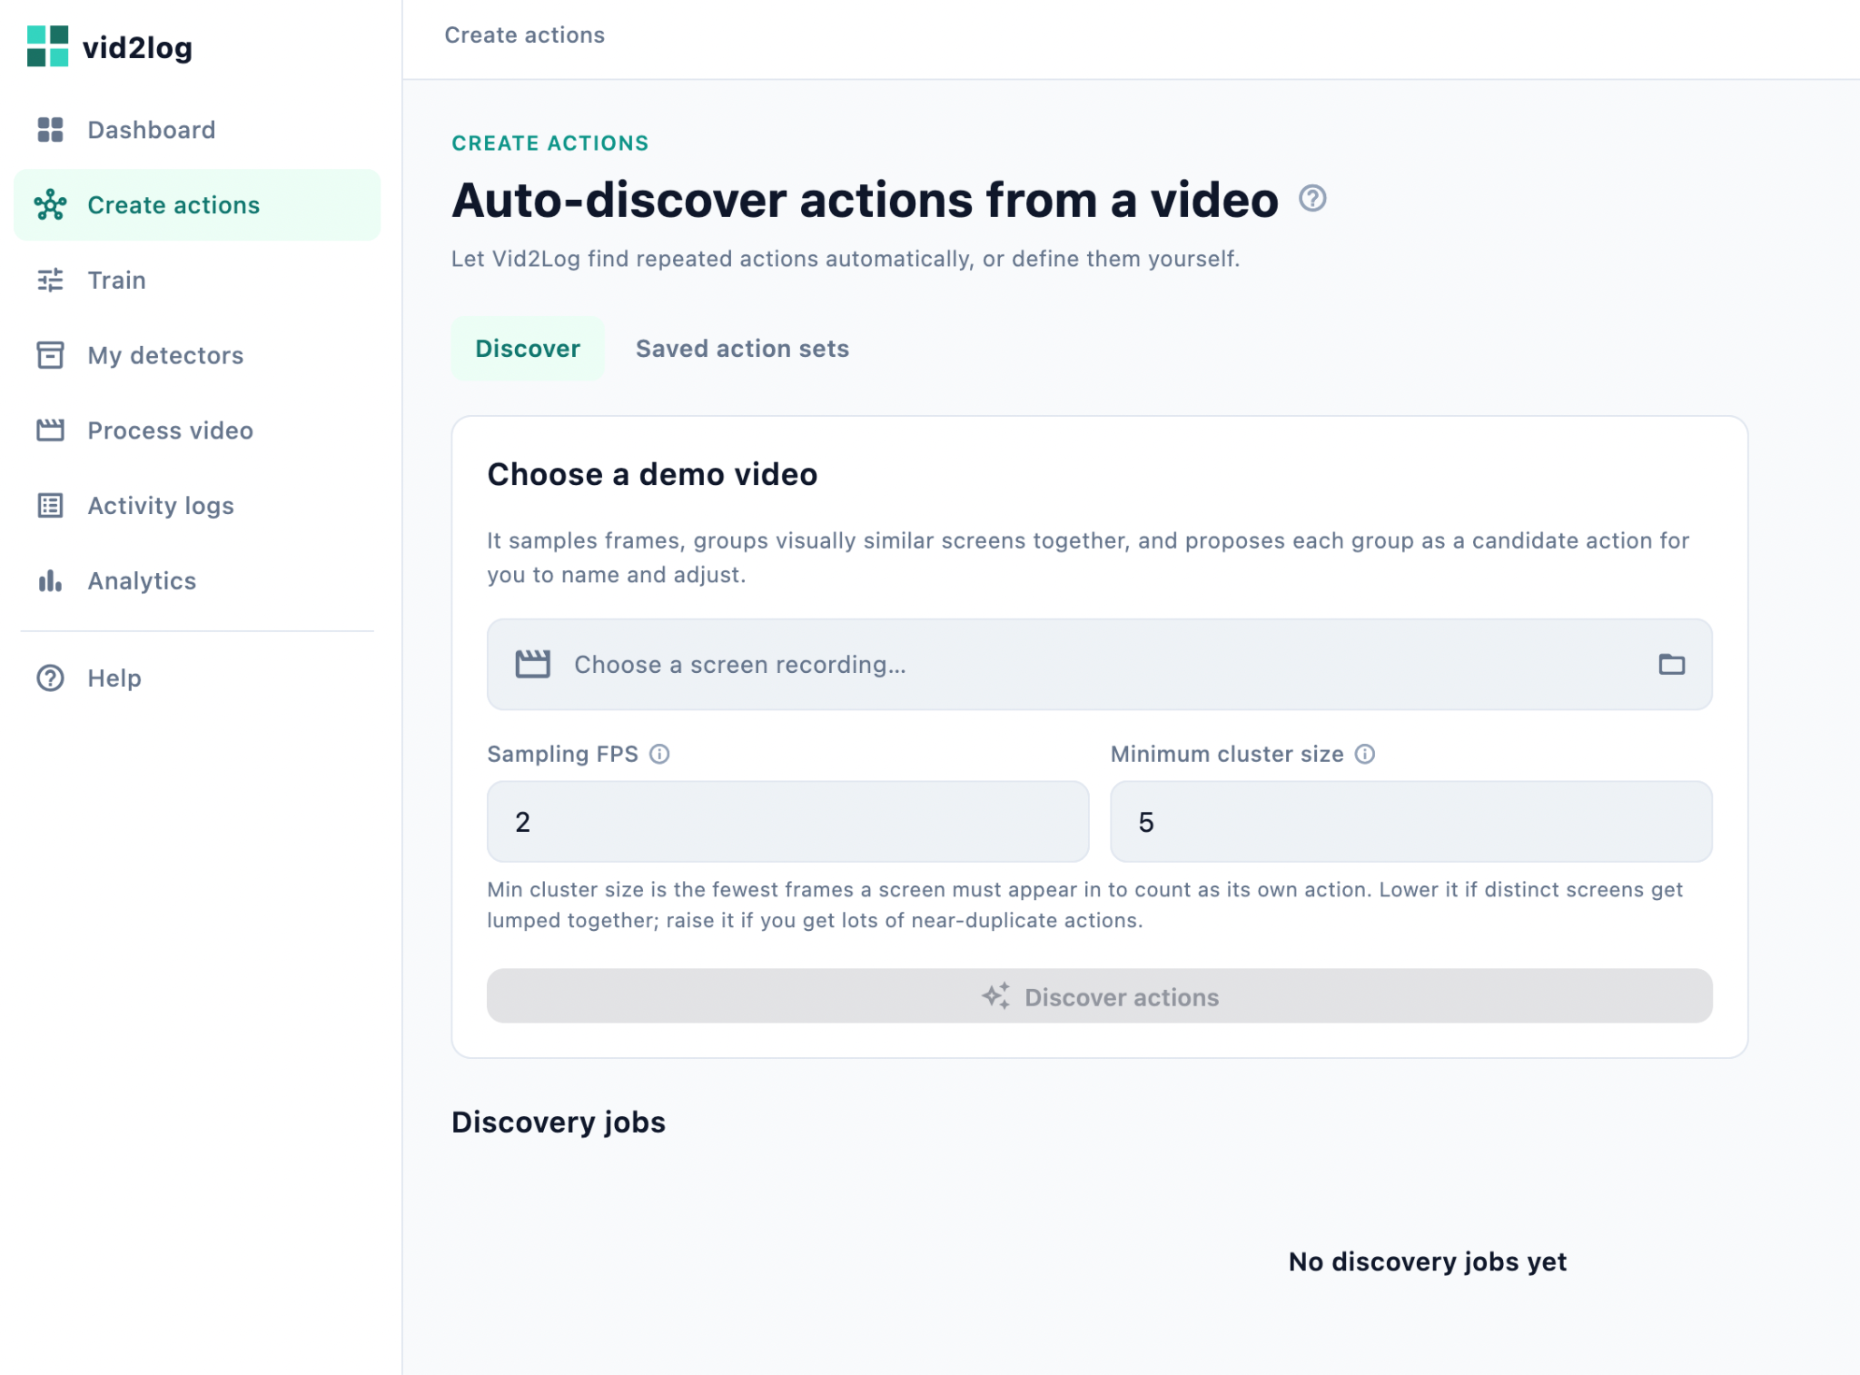
Figure 20. The desktop Create Actions screen, with clusters, preview panel and controls.
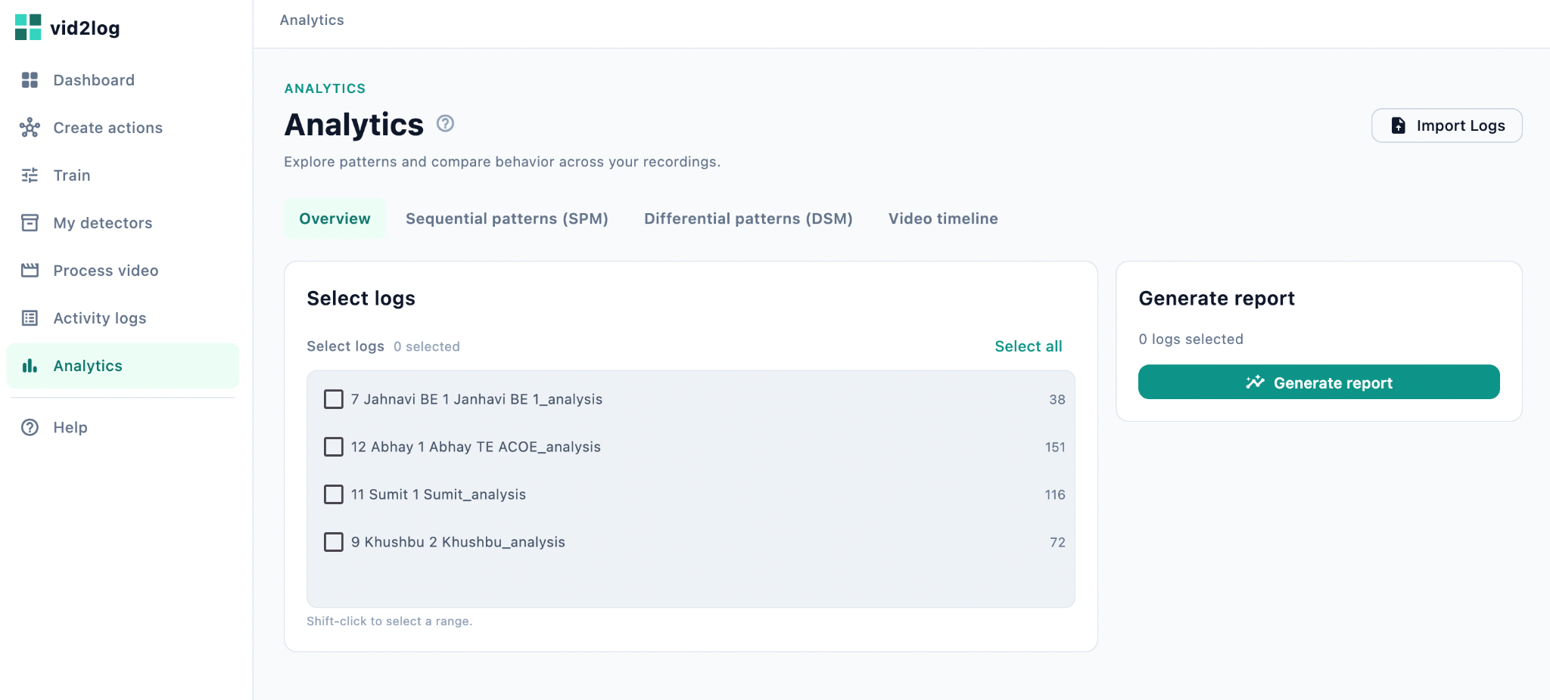
Figure 21. The desktop analytics screen.

7.5 Startup Reliability
Importing TensorFlow dominates the sidecar's startup, taking several seconds. An early version had a race: any screen whose first request fired before the sidecar was ready showed a raw connection error, even though the application worked once the user had moved between a few pages. This is fixed by a readiness gate on the Flutter side that completes only when the sidecar's health check succeeds, and which every screen's first request waits on.
A related failure was a sidecar unable to bind its port because a previous process still held it. The application now checks for and adopts an already healthy sidecar instead of starting a duplicate, which fixes the symptom and makes the condition self correcting.

7.6 Packaging and Distribution
Shipping the desktop application means freezing a full Python, TensorFlow, OpenCV, scikit-learn and Tesseract environment into something a user with no Python toolchain can install. This uses PyInstaller in one-directory mode rather than one-file mode, to avoid the slow re-extraction on every launch that a single file bundle this size would cause.
A resource resolution module finds the default model, the bundled Tesseract binary and its language data the same way whether the code runs from source in development or from inside a frozen bundle, so nothing else in the codebase needs to know which it is.
- Freeze the sidecar with PyInstaller, bundling the default model and Tesseract.
- Build the Flutter application for the target platform.
- Copy the frozen sidecar into the bundle: the resources directory on macOS, beside the executable on Windows. The shell prefers this copy over any development virtual environment it finds.
- Package the result as a disk image on macOS, or an Inno Setup installer on Windows, falling back to a portable archive if Inno Setup is not available.
Neither PyInstaller nor Flutter's desktop tooling supports cross-compilation, so each platform must be built on that platform.
Distribution beyond a few colleagues needs code signing. On macOS an unsigned application is reported by Gatekeeper as "damaged", a misleading message that really means unsigned; clearing it needs a paid Apple Developer account and notarisation. On Windows an unsigned installer triggers a SmartScreen warning, avoidable only with a paid certificate. Neither has been judged worth the cost for internal research use so far.
The installed application takes roughly 1.5 to 2.5 GB, almost all of it TensorFlow. This is accepted as the price of shipping a local machine learning runtime rather than making the user install a multi-gigabyte dependency tree.

8. Data Formats

8.1 Activity Log CSV
Column | Type | Description
start_time | HH:MM:SS | Offset from the start of the recording where the scene begins
end_time | HH:MM:SS | Offset where the scene ends
duration | HH:MM:SS | end_time minus start_time
action | text | The action assigned to the scene
confidence | number, 0 to 1 | Confidence of the reading that set the scene
source | text | Which tier decided the label: keyword_rule, fusion, cnn_per_class_override, cnn, or csv_import
Table 16. Activity log CSV columns.
A combined export adds an identifying column in front. Two variants exist, and the difference matters when reading a file back. The application's own combined export writes user_id holding each log's display name, which is what makes such a file re-importable as separate, recognisable logs. The server endpoint writes video_id holding the job identifier, which is stable but not readable. The importer accepts either, treating video_id as a legacy name, and splits the file into one log per distinct value.

8.2 Import Rules
The server side import format is strict and needs all five core columns. Rather than force that on the user, the client repairs a tolerant input into the strict shape before submitting. The rules are:
- Column names are matched ignoring case and order. Extra columns are reported as notices, not errors.
- Times are accepted as HH:MM:SS, MM:SS, or a plain number of seconds.
- Any two of start_time, end_time and duration are enough; the third is derived.
- Quoted fields containing commas, byte order marks and both line ending styles are handled.
- A confidence of 1.0 is filled in where the column is missing, on the reasoning that a hand written log states a fact rather than estimating one. The import says when it has done this.
- Source is recorded as csv_import unless the file says otherwise, so imported logs stay distinguishable from generated ones.
- Every problem in the file is collected and reported together, by line number and offending value, instead of failing at the first error.
Only action, plus any two of the three timing columns, are genuinely required. One consequence is that imported scenes carry a filled-in confidence, so average confidence over a set mixing imported and generated logs should be read with that in mind.

9. Deployment and Operations

9.1 Cloud Infrastructure
Component | Resource | Role
vid2log-api | Cloud Run service | FastAPI backend, scales to zero when idle
vid2log-frontend | Cloud Run service | Next.js production build
Worker | Cloud Run job | Runs queued processing, training and discovery work
Memorystore | Redis instance | Queue broker, reachable only inside the project network
Artifact Registry | Container repository | Holds both container images
Firebase | Authentication, Firestore | Identity and application data
Cloud Storage | Bucket | Temporary media and durable detector files
Service account | IAM identity | Shared by API and worker, least privilege
Table 17. Cloud Run deployment topology.
The shared service account holds three bindings: read and write on Firestore, object administration on the application's bucket, and Token Creator on itself so it can produce signed upload URLs by impersonating itself.
Memorystore is reachable only inside the project network, and Cloud Run resources are not on that network by default. Connectivity is arranged two ways: the API service uses a Serverless VPC Access connector, and the worker uses direct network egress, because the job resource type does not support the connector.
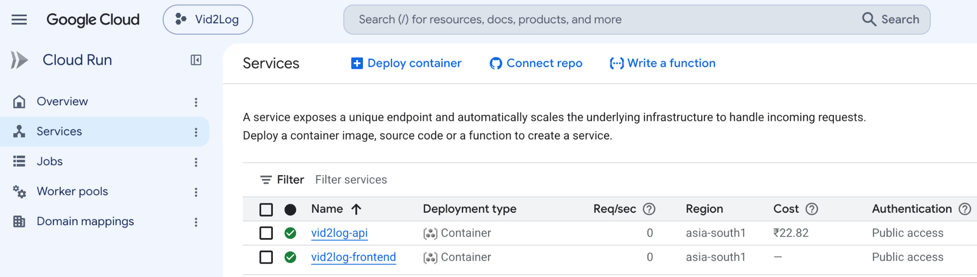
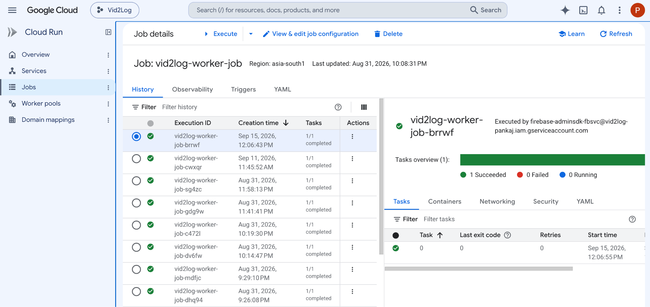
Figure 22. The Cloud Run console showing the deployed services and worker job.

9.2 Cost Optimisation
The worker was first deployed as a Cloud Run worker pool, the resource type meant for long running non-HTTP processes, which a queue worker blocking on Redis is. Worker pools do not scale to zero, because with no instance running nothing would notice new work. So the worker billed continuously whether or not anything was being processed: a fair trade for constant load, a poor one for occasional use.
It was redesigned around Cloud Run jobs, which run to completion and have no such floor. The worker gained a burst mode that drains everything currently queued and then exits cleanly instead of blocking. Every enqueue also fires a request to the Cloud Run Admin API to start a fresh execution of the worker job.
Correctness under concurrency comes free from the queue library's atomic dequeue: two executions racing to drain the same queues cannot both claim the same job. The worker now bills close to zero on idle days, and gains natural parallelism when several jobs arrive together, since each enqueue starts its own execution rather than competing for a fixed pool.
The trade-off is a cold start on the first job after an idle period, which is acceptable for work already measured in minutes.

9.3 Configuration
Setting | Purpose
firebase_project_id | Firebase project used for token verification and Firestore
gcs_bucket_name | Cloud Storage bucket for media and detector files
google_application_credentials | Service account credentials path, for local development
redis_url | Queue broker connection string
cors_origins | Comma separated list of permitted frontend origins
app_env | Deployment environment marker
cloud_run_job_name | Worker job to trigger on enqueue; empty for local development
cloud_run_region | Region of the worker job
gcp_project_id | Project containing the worker job
Table 18. Backend configuration keys. Environment variables are matched ignoring case.

9.4 Deployment Steps
- Enable the required APIs: Cloud Run, Artifact Registry, Memorystore, Serverless VPC Access, IAM, Cloud Build, Firestore and Cloud Storage.
- Create the Artifact Registry repository.
- Create the Redis instance and its network connector.
- Grant the shared service account its three role bindings.
- Build and push both container images with Cloud Build, which targets linux/amd64 by default and so avoids the architecture mismatch local builds hit on Apple Silicon.
- Deploy the API and frontend as Cloud Run services.
- Deploy the worker as a Cloud Run job and let the API's service account trigger its executions.
- Update the API's cross-origin allow-list once the frontend URL is known.
- Optionally attach a custom domain and schedule the maintenance endpoints.

9.5 Local Development
You need Node.js 20 or later, Python 3.11, Redis, Tesseract, a Firebase project and a Cloud Storage bucket.
# Backend
cd backend
python3.11 -m venv .venv && source .venv/bin/activate
pip install -r requirements.txt
cp .env.example .env # fill in Firebase, storage and Redis settings
python -m uvicorn app.main:app --reload --port 8000
python -m app.worker # separate terminal; run more for more parallelism
# Frontend
cd frontend
npm install
cp .env.local.example .env.local
npm run dev # http://localhost:3000
The desktop application needs no Firebase, Cloud Storage or Redis. Its sidecar environment is created once, after which the Flutter shell starts the sidecar itself:
cd vid2log/python_sidecar
python3.11 -m venv .venv && source .venv/bin/activate
pip install -r requirements.txt
cd ..
flutter pub get
flutter run -d macos # or: flutter run -d windows

10. Tuning Reference
Every constant that materially affects output quality, named as it appears in the source.
Constant | Value | Effect of increasing it
fps (per job) | 2 | Finer scene boundaries, proportionally more computation
IMG_SIZE | 224 by 224 | Fixed by the backbone
BATCH_SIZE | 16 | Faster training, more memory, fewer updates per epoch
epochs | 20 | More fitting, more risk of overfitting on small datasets
learning_rate | 0.001 | Faster convergence, more risk of instability
split | 0.70 / 0.15 / 0.15 | More training data, less reliable evaluation
HYSTERESIS_FRAMES | 2 | Fewer false transitions, brief real events missed
MIN_SWITCH_CONFIDENCE | 0.5 | Fewer low confidence switches, real changes suppressed
MIN_SCENE_DURATION_S | 2.0 | More aggressive despiking, short real scenes absorbed
MIN_OCR_CHARS_FOR_FUSION | 3 | Text must be longer before it is trusted
DEFAULT_MATCH_THRESHOLD | 85 | Stricter keyword matching, fewer rule matches
FUSION_ALPHA_GRID | 0.0 to 1.0, step 0.1 | Finer weight search, longer tuning
PER_CLASS_OCR_EXCLUDE_MARGIN | 0.2 | Fewer actions excluded from fusion
min_cluster_size | 5 | Fewer, larger proposed actions
MAX_PREVIEW_IMAGES_PER_CLUSTER | 25 | More images to review per proposed action
MAX_PATTERN_LEN | 8 | Longer patterns, exponentially more mining work
min_support (SPM, DSM) | 0.4 | Fewer, more universal patterns
threshold_p_value (DSM) | 0.1 | More permissive significance filtering
Table 19. Tunable constants affecting output quality.

11. Engineering Challenges
Several non-obvious problems shaped the final architecture and are recorded here.

11.1 Keras Serialisation
TensorFlow 2.16 and later ship Keras 3 and point the standard namespace at it, while the classifier deliberately loads through the legacy Keras 2 package for compatibility with older exported models. Left alone, newly trained detectors were saved in a format the loader could not read, appearing as an unrecognised argument error the first time a recording used a fresh detector. The fix forces legacy behaviour at the earliest point in process startup for future saves, plus a fallback loader that catches the specific error and retries under the newer API. Detectors trained before the fix still load, so nobody has to retrain.

11.2 Double Normalisation
The training graph originally included a preprocessing layer while every caller already normalised beforehand, so images were normalised twice. That collapses the whole input range into a narrow band near minus one and destroys most of the signal. It degraded live classification and every training time evaluation at once, including fusion tuning and the routing decision, which is why the combined report's per-action numbers looked wrong even after the routing logic itself was corrected. The fix removes the layer so exactly one normalisation runs everywhere, in both training and inference.

11.3 Weights Versus Routing
The first attempt at handling actions where OCR is unreliable used a per-action weight vector. As Section 4.5.4 describes, that produces an argmax over numbers computed on different bases and lets a confidently wrong text prediction beat a correct image prediction. Replacing weighting with routing fixed it, and the same routing now runs in tuning, evaluation and inference so all three agree by construction.

11.4 Unbounded Mining
Mining over logs with many short alternating scenes produced an effectively unbounded search whenever the support threshold stopped pruning. The symptom was a request that never returned, not an error. Two bounds fixed it: a hard cap on pattern length, and a ceiling rather than a floor when turning a fractional support threshold into a minimum count.

11.5 Frozen Bundle Analysis
Freezing the sidecar first failed because the server was started by passing its target as a string, resolved at runtime and so invisible to the bundler's static analysis, which left the entire application package out. Passing the application object directly fixed it. A second failure came from excluding a numeric submodule to save space, without realising a scientific dependency walks every attribute of that package at runtime; the exclusion was reverted. Both failures appeared only when the bundle ran, never at build time.

11.6 A Silent Packaged Crash
An application launched from the desktop has no terminal, so a traceback in the sidecar was invisible and the shell could report only an exit code. The fix captures the sidecar's output into a persistent log file and shows a rolling tail in the error banner, making the failure readable without a terminal.

11.7 Timeline Colours
Timeline colours were originally assigned by position within each log, so the same action appeared in different colours in different recordings, defeating the point of comparing them. Assignment is now made once across every timeline on screen and keyed by action name, guaranteeing both that one action holds one colour everywhere and that no two actions collide. Because people can reliably tell apart only about ten categorical colours, larger sets reuse hues with both a brightness shift and a fill pattern, so reused colours differ in more than one way.

12. Status, Limitations and Future Work

12.1 Current Status
Both applications work end to end. The web application is deployed on Google Cloud Platform with signed URL uploads, scale to zero background processing, role based administration and the full analytics suite. The desktop application has been built and verified as an installable disk image on macOS. The Windows build path is fully scripted and documented, pending verification on physical Windows hardware.

12.2 Known Limitations
- Frozen backbone. Only the head is trained. That is the right trade for small datasets and fast CPU training, but it caps accuracy where actions differ in ways ImageNet features do not capture.
- Some confusions are a data problem. Where two actions look genuinely alike and share no distinguishing text, no amount of tuning the segmentation constants separates them. The fix is better training data for that pair.
- OCR depends on language and font. Quality varies with interface typography, and the text tiers contribute little on mostly graphical interfaces.
- Imported logs carry filled-in confidence. Average confidence over mixed sets should be read accordingly.
- Statistical caution. Many patterns are tested at once with no correction for multiple comparisons, and the default threshold is permissive. Results are exploratory, not confirmatory.
- Desktop size. Roughly 1.5 to 2.5 GB, mostly the machine learning runtime.
- Unsigned distribution. Both platforms warn on first run without paid signing certificates.

12.3 Future Work
- Evaluate GPU backed job execution for faster training on larger datasets.
- Verify the Windows installer on physical hardware.
- Obtain code signing certificates for both desktop platforms.
- Investigate a lighter inference engine for the desktop build to cut the installed size.
- Offer optional backbone fine-tuning for users with large enough datasets.
- Add multiple comparison correction as an option in differential mining.

12.4 Conclusion
Vid2Log shows that one carefully layered pipeline, covering image classification, OCR text fusion, unsupervised action discovery and sequence mining, can serve two very different deployment targets without diverging in behaviour. What makes this possible is that every cloud specific dependency sits behind a boundary with a straightforward local equivalent: a document database for a file, object storage for a filesystem, a distributed queue for direct execution, and a federated identity provider for no identity at all. What stays on the shared side of that boundary is exactly the part that decides what the system produces, which is why a detector trained through one application behaves predictably in the other.

Appendix A. Repository Layout
vid2log/
├── frontend/ Next.js web application
│ ├── app/ Routes (App Router)
│ ├── components/ UI, charts, analytics, help
│ └── lib/ API client, CSV normaliser, colours, copy
├── backend/ FastAPI service, workers and ML pipelines
│ └── app/
│ ├── ml/ classifier, hybrid_classifier, ocr,
│ │ text_classifier, text_rules, preprocessing
│ ├── routers/ jobs, logs, train, models, actions,
│ │ analytics, uploads, users, admin
│ └── services/ video_pipeline, training_pipeline,
│ action_discovery_pipeline, sequence_mining,
│ queue_service, gcs_service, firebase_service
├── vid2log/ Flutter desktop application
│ ├── lib/ Screens, widgets, services, theme
│ ├── python_sidecar/ Local FastAPI engine, SQLite, same ML pipeline
│ └── scripts/ Build scripts and installer definition
└── streamlit_application/ The original single video prototype

Appendix B. Feature Availability by Platform
Feature | Web | Desktop
Authentication and multi-user isolation | Yes | Not applicable
Role based administration | Yes | No
Recording processing and scene logs | Yes | Yes
Parallel batch processing | Yes | One at a time
Training with test metrics | Yes | Yes
Three way metric comparison | Yes | Yes
Detector registry and activation | Yes | Yes
Keyword rules editable without retraining | Yes | Yes
Unsupervised action discovery | Yes | Yes
Manual action set curation | Yes | Yes
CSV export and tolerant import | Yes | Yes
Combined multi-log export | Yes | Yes
Analytics: Overview, SPM, DSM, Timeline | Yes | Yes
Combined PDF report | Yes | No
In-application help | Yes | Yes
Light and dark themes | Yes | Yes
Fully offline operation | No | Yes
Table 20. Feature availability across the two products.

