Assignment-1 Report
Pankaj Ghimire,2501550
Concept and Technologies of AI
2025-01-09

Introduction

Overview
The Human Development Index (HDI) is a composite metric created by the United Nations to measure a nation’s average performance in three basic aspects of human development: life expectancy, education and gross national income per capita. It is a summary measure of average achievement in key areas of human development.

Objective
- To explore and clean the dataset for the latest year
- To analyze multi-year HDI trends
- To do comparative regional analysis

Scope
The analysis focuses on the data of year 2020-2022. The scope includes data cleaning, single-year exploration, multi-year trend analysis, and a comparative regional analysis.

The Problem 1A analysis started by loading the dataset of the global Human Development Index (HDI) into a pandas Data Frame. In order to focus on the latest observations, the Data Frame was then filtered, which left behind a subset of only entries that were made in the year 2022. A detailed data-cleaning procedure was henceforth carried out on this subset. This was done in phases, the first of which involved quantifying the percentage of missing values in every column to gauge the completeness of the data, the second involved determining numeric measurements that were held as text strings and converting them to numeric formats accurately, the third involved standardizing the country names to a unified nomenclature, which reduced the chances of duplicated records and the fourth involved deleting any duplicate rows within the entire observation set.
Rows where there were missing values in the columns that were to be considered in future analysis were cut so that the integrity of the consequent calculations could be kept intact.
A new category attribute- HDI-Category was also engineered in the last phase of data preparation. This property was obtained by employing a classification function which had given the HDI value of each country to one of the four categories of the United Nations Development Programme (UNDP) the following categories being Low, Medium, High, and Very High based on pre-determined threshold values.
After cleaning, the 2022 dataset contained 182 unique country records. The key findings are summarized below.
Mean HDI (2022): 0.7331768707482993
Median HDI (2022): 0.76
Standard Deviation of HDI (2022): 0.1601509861520783

From the findings, country with highest HDI in 2022 is Switzerland with HDI 0.967 and Somalia is with the lowest HDI with HDI score 0.38.

The 2022 data demonstrates that there is a strong heterogeneity of human development all over the world. Countries with the largest Gross National Income (GNI) per capita, especially Liechtenstein and Singapore, are always ranked in the Very High category of human development. This strong correlation between high income rates and high levels of Human Development Index (HDI) is expected, based on the fact that wealth enables one to invest in the main factors that determine the Human Development Index; health and education. The data cleaning processes enforced cannot have been done without to maintain the integrity of these rankings, hence eradicating any form of distortions caused by the lack of data quality.

In Problem 1B, the original data were filtered to form a multi-year data frame of data and observations in the calendar years of 2020, 2021, and 2022 to conduct the temporal analysis. This subset was then subjected to the same stringent cleaning procedure as in Problem 1A to make sure that the data is quality and consistent over the years; cleaning procedures involved dealing with missing values, data type conversion, standardization of country names, and data duplication. In order to plot country-level trends, a sample of five countries (Nepal, India, Norway, Bhutan and China) has been taken. The methodology consisted of the sub setting of the cleaned multi-year data on these particular countries and then plotting their values of the Human Development Index versus the years in one line graph using the matplotlib package and thus allowing the direct visual comparison of their development trends across the three years.

Key Results
HDI shows the steady improvement in most countries. But some countries shows declining trend due to covid-19.
Figures:
- Figure 2: HDI boxplot 2020–2022
- Figure 3: Scatter plot of HDI vs GNI per capita

Interpretation:
- Most countries show positive HDI trends.
- Outliers highlight unusual deviations between income and development.

Visualizations
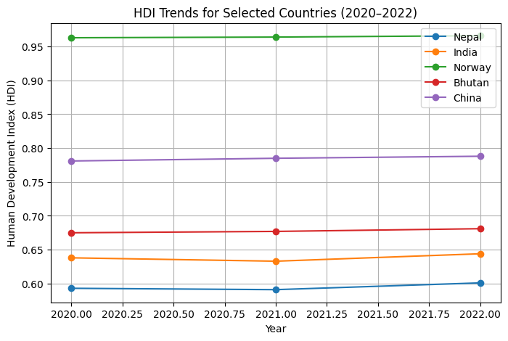

This chart displays the HDI progression for five selected countries. It illustrates that most countries experienced a dip or stagnation in their HDI around 2021, with a slight recovery in 2022. Norway consistently maintains a much higher HDI than the selected Asian nations.

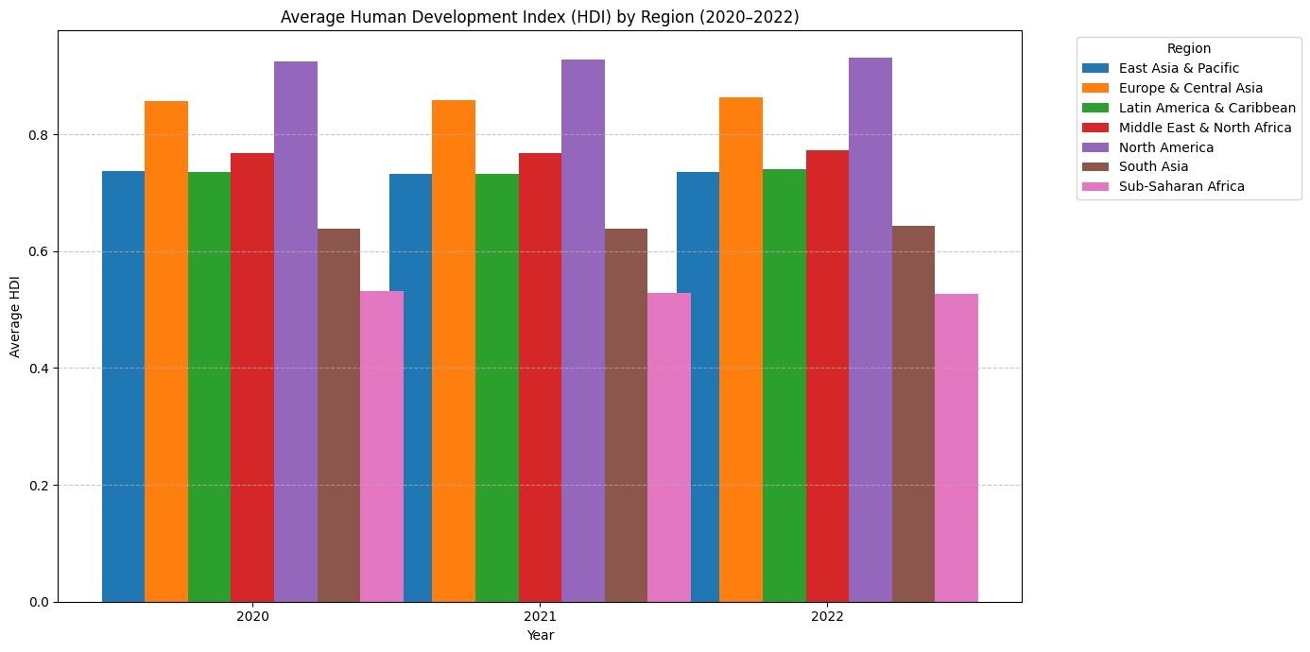

4. Problem 2 - Advanced HDI Exploration.

Methods / Approach:

The countries included in the analysis were filtered to include those in South Asia. In order to determine a composite indicator, the following formula was used: Composite Score = 0.3 × Life Expectancy Index + 0.3 × GNI per Capita Index. Countries were then ranked by their Composite Score and the ranking was compared to the official Human Development Index (HDI) ranking in order to determine concordance. The 1.5 x interquartile range (IQR) criterion was used to determine possible outliers. Correlation tests were conducted to test the relationships between HDI and Life Expectancy Index and Gender Development Index (GDI). Besides, a gap analysis was conducted to compare GNI per Capita and HDI values.

Key Results & Figures:

Figure 4: The leading 5 South Asian countries on Composite Score.
Figure 5: The outlier scatter diagram that shows HDI against the Life Expectancy Index.
Figure 6: Correlation scatter plots to show the relationship between HDI and life expectancy and between HDI and GDI.
Figure 7: List of the three largest positive and the three largest negative GNIHDI gaps.

Interpretation / Discussion:

Composite Score ranking shows that the fit to HDI is significant, but it puts huge emphasis on countries in which the allocation of economic performance and longevity is skewed. The outlier identification indicated that there are some countries with low values of HDI compared to the high levels of GNI per Capita and the opposite also. The correlation analysis shows that Life Expectancy Index has a stronger linear relationship with HDI as compared to the Gender Development Index. Lastly, the analysis of the GNI and HDI gap highlights the fact that not all countries in the region are achieving the same results of higher human development due to economic prosperity.

5. Problem 3 South Asia vs Middle East Comparative Regional Analysis.

Methods / Approach:

South Asia and the Middle East were divided into separate subsets where descriptive statistics (mean, standard deviation, range, and coefficient of variation) of important indicators were calculated. Countries became classified as those with high performance or low performance as per HDI. Comparative analysis was done on the following measures, Gender Development Index, Life Expectancy Index, and GNI per Capita Index. Correlations, and outlier detection processes, were applied in a systematic way using the combined dataset.

Key Results & Figures:

Figure 8: 3 leading and 3 bottom countries in the region in terms of HDI.
Figure 9: Grouped bar chart on the comparison of Gender Development Index, Life Expectancy Index and GNI per Capita Index in the two regions.
Figure 10: Scatter plots of HDI and the Life Expectancy Index in each area.
Figure 11: Scatter plots of the regions outliers.

Interpretation / Discussion:

The mean HDI is higher in the Middle East region as compared to South Asia with the difference in GNI per Capita perhaps coming out as the most striking difference among individuals. The positive correlation between life expectancy and HDI in the two regions is strong. The presence of outlier patterns indicates that some countries are significantly behind in development, which represents an uneven development in each of the regions. Besides, the South Asia region has a higher coefficient of variation in HDI, which shows an increased range of inequalities in the human development outputs in the member states.

6. Conclusion

South Asia has a rising pattern in the human development index; the index is still at a low level of position compared to the Middle East.

The most formidable factor of human development index is life expectancy.

The composite score serves as a major instrument in identifying countries that have unbalanced patterns of development.

The outlier and gap analyses provide sharp information that can be applicable in developing specific policy interventions.

This creates limitations due to the absence of some data or data inconsistency, let alone that the human development index alone cannot reflect the entire range of developmental dimensions.

