Date: 18/08/2003
Name: Pankaj Agarwal
Roll no: 65
Class: TE COMP -1

ASSIGNMENT 1 IOTES

Understanding the connectivity of Raspberry-Pi. Write an application to detect obstacle and notify user using LEDs.

A Raspberry Pi is a small, affordable, credit-card-sized computer that was originally developed to promote the teaching of basic computer science in schools and developing countries. It is designed to be a versatile platform for learning, experimenting, and creating a wide range of projects involving computing and electronics. Despite its small size and low cost, the Raspberry Pi offers impressive capabilities and can be used for a variety of tasks, from basic programming and web browsing to complex robotics and home automation.

he Raspberry Pi's versatility and affordability have led to a wide range of applications and uses across various fields. Here are some of the most common and notable applications:

- Education:
  - Teaching programming, electronics, and computer science in schools.
  - Building hands-on projects to enhance STEM (Science, Technology, Engineering, and Mathematics) education.
  - Providing an accessible platform for learning about hardware and software development.
- Home Automation and IoT (Internet of Things):
  - Creating smart home systems to control lights, thermostats, cameras, and more.
  - Designing IoT devices that collect and transmit data, such as weather stations and home security systems.
  - Automating tasks using sensors and actuators.
- Media Centers and Entertainment:
  - Building media centers using software like Kodi or Plex for streaming movies, TV shows, and music.
  - Retro gaming consoles that emulate classic video game systems.
  - Creating digital signage for businesses or public spaces.
- Robotics and Automation:
  - Designing and programming robots for educational purposes or hobbyist projects.
  - Building automated systems for tasks such as plant watering, pet feeding, and more.
- Programming and Software Development:
  - Learning and practicing programming languages, from Python to C++.
  - Developing software applications, web servers, and databases.
  - Experimenting with software development tools and frameworks.

- Network Services and Web Hosting:
  - Running web servers, hosting personal websites, or blogs.
  - Setting up network services like DNS servers, file servers, and VPNs.
- Artificial Intelligence and Machine Learning:
  - Training and deploying machine learning models for image recognition, natural language processing, and more.
  - Experimenting with AI algorithms and frameworks.
- Education and Research Projects:
  - Conducting scientific experiments and data analysis.
  - Creating educational tools and simulators.
  - Developing prototypes for research projects.
- DIY Electronics and Prototyping:
  - Building custom electronics projects using sensors, actuators, and displays.
  - Prototyping and testing new hardware concepts.
- Remote Monitoring and Control:
  - Monitoring and controlling devices remotely, such as security cameras, environmental sensors, and home appliances.
  - Developing remote control systems for various applications.
- Network Security and Penetration Testing:
  - Learning about network security by setting up penetration testing labs.
  - Experimenting with ethical hacking techniques and tools.
- Art and Creative Projects:
  - Creating interactive art installations and displays.
  - Designing musical instruments and sound generation systems.
- Learning and Tinkering:
  - Exploring electronics and hardware by experimenting with various components and circuits.
  - Learning about how computers and devices work at a low level.

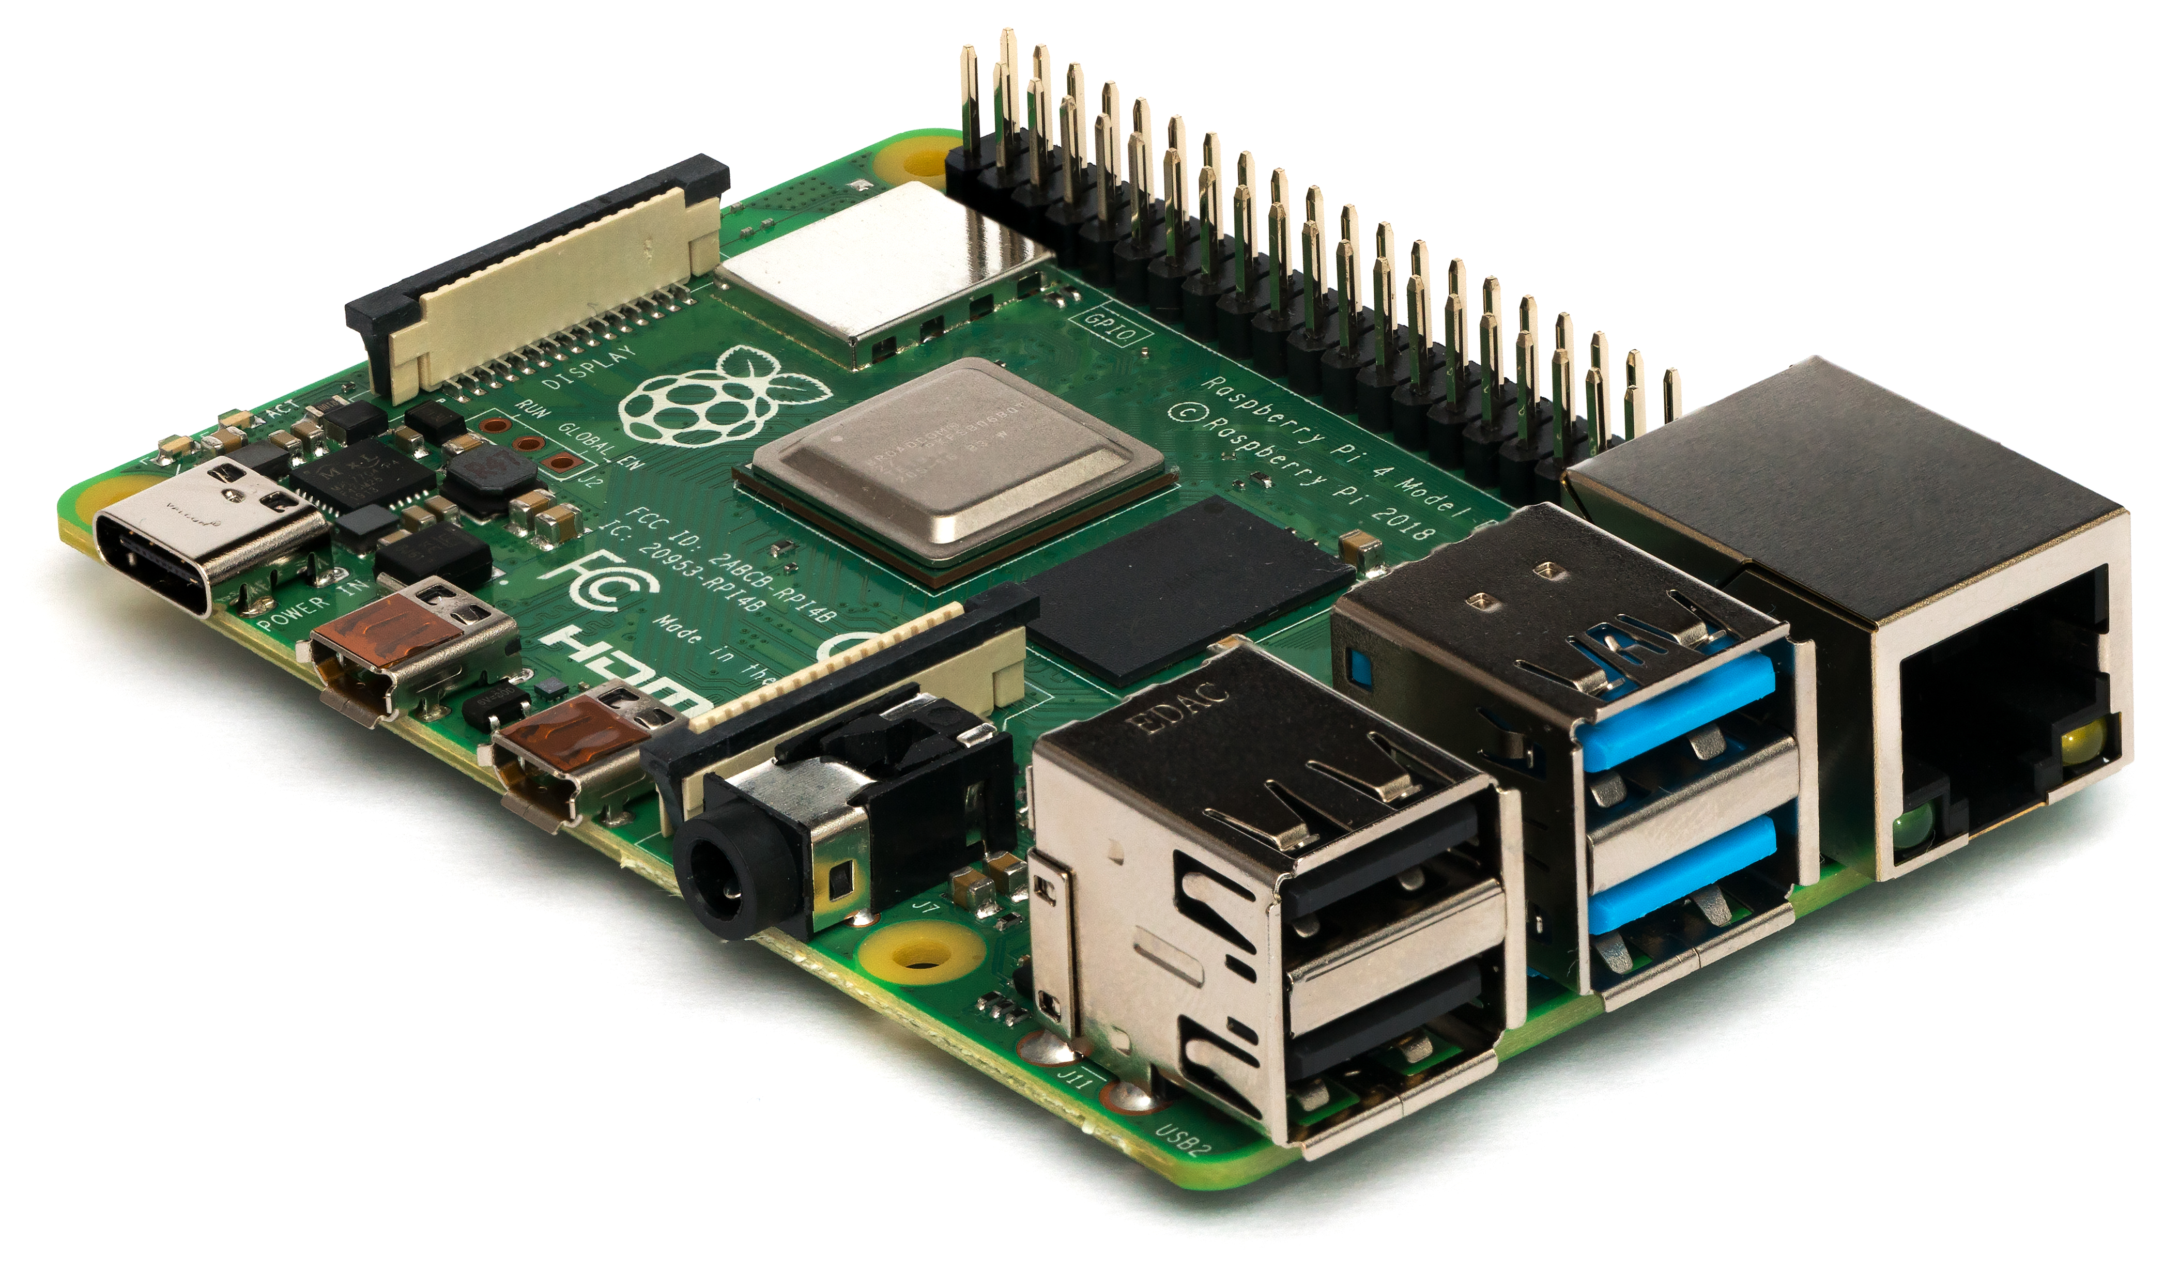
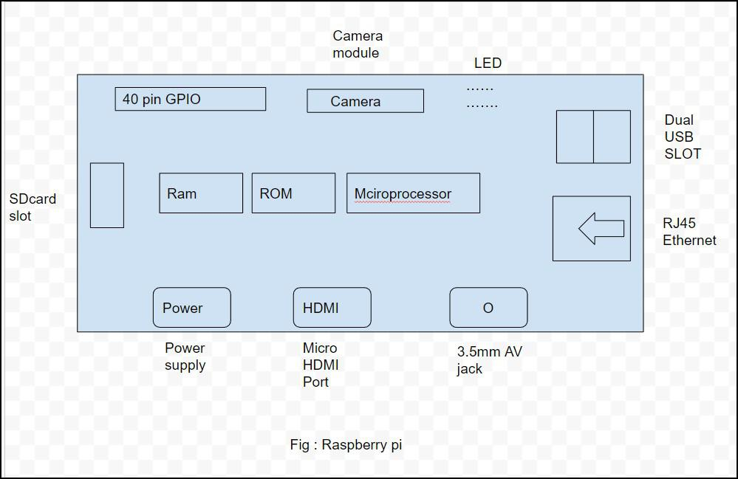

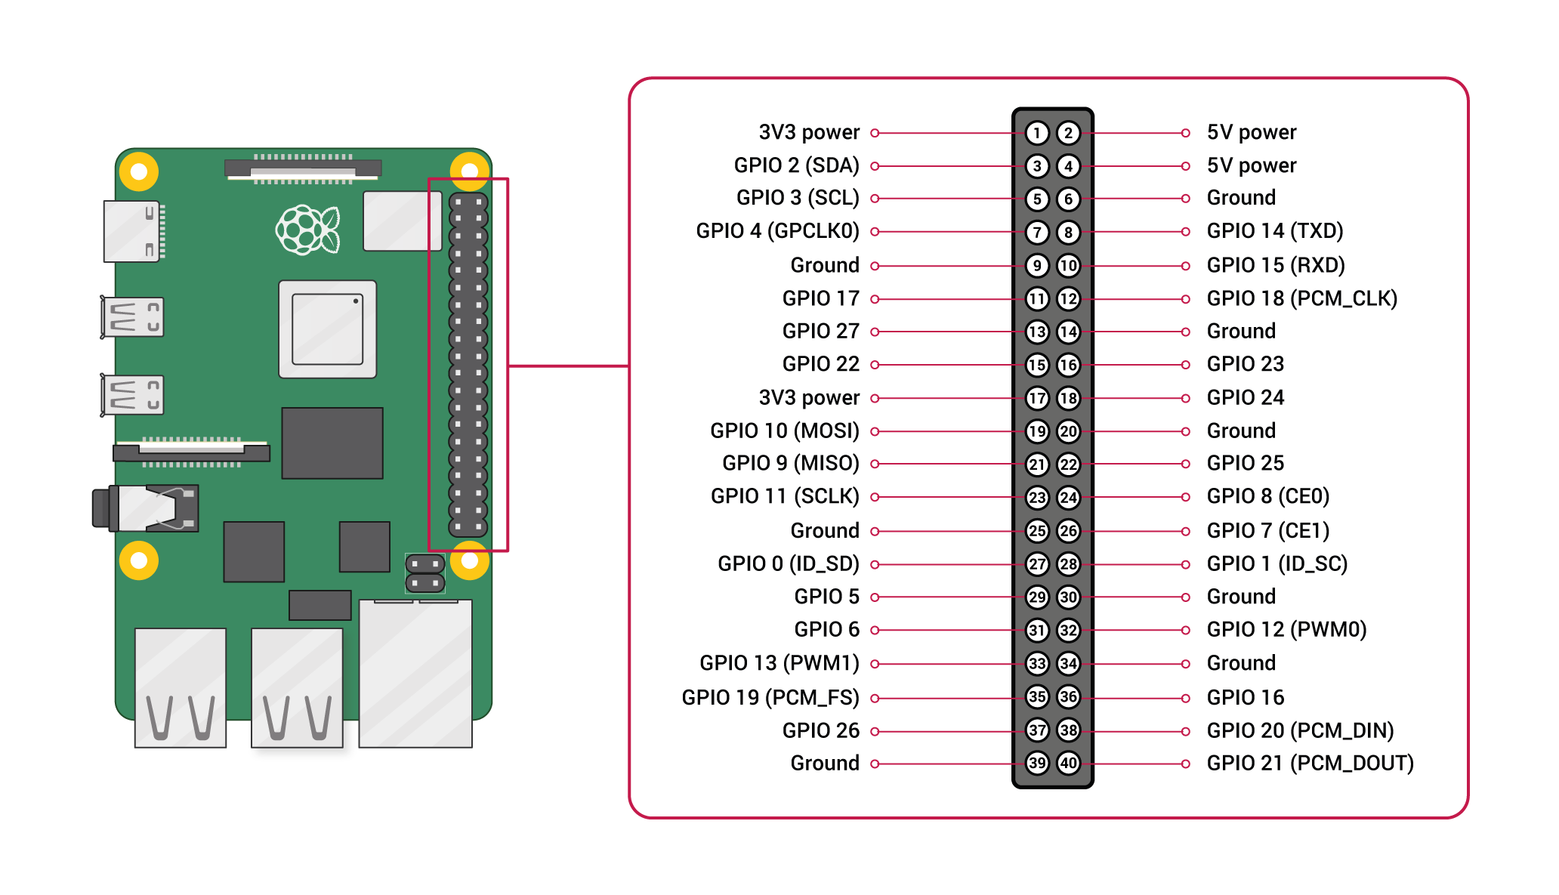

Certainly, here are some advantages and disadvantages of using Raspberry Pi:
Advantages:
- Affordability: Raspberry Pi boards are very affordable, making them accessible to a wide range of users, including students, hobbyists, and professionals.
- Versatility: Raspberry Pi can be used for a wide variety of applications, from programming and electronics projects to web servers and IoT devices.
- Educational Tool: Raspberry Pi is an excellent platform for learning about programming, electronics, and computer science, and it's widely used in educational settings.
- Small Size: The compact size of the Raspberry Pi makes it easy to integrate into projects with limited space.
- GPIO Pins: The GPIO pins allow users to interface with external hardware, sensors, and actuators, enabling the creation of custom electronics projects.
- Active Community: Raspberry Pi has a large and supportive community of users and developers who share tutorials, projects, and troubleshooting tips.
- Open Source: Both the hardware and software aspects of Raspberry Pi are open source, encouraging collaboration and innovation.
- Energy Efficient: Raspberry Pi boards consume very little power, making them suitable for projects that require low energy consumption.
- Availability of Accessories: There is a wide range of compatible accessories and add-ons available, such as cases, cameras, displays, and HATs (Hardware Attached on Top).
- Customizability: Raspberry Pi can be customized and configured according to specific project requirements, allowing for flexibility in implementation.
Disadvantages:
- Limited Processing Power: Raspberry Pi's processing power is limited compared to traditional desktop computers, which might affect performance in certain resource-intensive tasks.
- Limited RAM: While newer models have more RAM, it's still limited compared to higher-end computers, which can impact multitasking and memory-intensive applications.
- Limited Storage: Raspberry Pi usually relies on microSD cards for storage, which can have limited capacity and may wear out over time.
- Not Suitable for Heavy Workloads: Raspberry Pi is not suitable for tasks requiring high computational power, such as complex simulations or 3D rendering.
- Limited Graphics Performance: The graphics capabilities of Raspberry Pi might not be sufficient for demanding graphical applications or gaming.
- Software Compatibility: Some software and applications might not be fully compatible with the ARM-based architecture of Raspberry Pi.
- Learning Curve: While Raspberry Pi is beginner-friendly, there can still be a learning curve, especially for individuals new to programming and electronics.
- Potential Hardware Issues: Raspberry Pi components are generally reliable, but there can be occasional hardware-related issues or compatibility challenges with certain accessories.
- Limited Connectivity: Some models have limited USB ports and network connectivity options, which can restrict the number of peripherals that can be connected simultaneously.
- Lack of Official Technical Support: Raspberry Pi Foundation provides community support, but there's no official customer support like you might find with commercial products.

