FINAL SUBMISSION — PROJECT / DISSERTATION REPORT
Predictive Health Monitoring of Manufacturing Machinery: A Machine Learning Framework for Remaining Useful Life (RUL) Estimation from Multi-Sensor Data
A Comparative Evaluation of Decision Tree, Random Forest, Gradient Boosting, LSTM and Hybrid CNN-LSTM Models on a Multi-Sensor CNC Machining Centre Dataset
Case Study Asset: CNC Machining Centre (v2 synthetic dataset, 100 machines, 43,706 rows after duplicate removal)
Abstract
This report presents the final submission for a predictive maintenance study on Remaining Useful Life (RUL) estimation of a Computer Numerical Control (CNC) Machining Centre. It uses a 100-machine, run-to-failure, multi-sensor dataset (43,731 rows as supplied; 43,706 after removing 25 exact duplicate rows). The data were generated to reproduce non-ideal characteristics of industrial sensor data: randomised degradation onset, correlated stochastic health drift, heteroscedastic sensor noise and periodic tool-change reset events.
A complete preprocessing pipeline was implemented: duplicate removal, per-machine causal imputation, interquartile-range (IQR) outlier capping, machine-wise (not row-wise) train/test partitioning, causal rolling-window feature engineering, feature standardisation and Principal Component Analysis (PCA). Every cleaning statistic, outlier bound and scaler parameter is estimated on the 80 training machines only and applied unchanged to the 20 held-out test machines. Five regression models spanning three methodological families were compared under identical conditions: a Decision Tree baseline, two tree ensembles (Random Forest and Gradient Boosting), and two deep sequence architectures (a stacked LSTM and a hybrid CNN-LSTM) operating on 30-cycle sliding windows. The two deep models were tuned with a matched Bayesian search (Optuna, Tree-structured Parzen Estimator) of eight trials each and evaluated over three random seeds.
All five models achieved positive coefficients of determination on the held-out machines. The tuned CNN-LSTM obtained the highest mean R² (0.956 ± 0.007), the lowest RMSE (7.73 ± 0.65 cycles) and the lowest asymmetric PHM08-style score (20,373.3). The tuned LSTM, however, was statistically indistinguishable on R² (0.954 ± 0.010) and achieved a lower MAE (3.64 against 3.81 cycles). Both sequence models clearly outperformed the three tabular models, whose R² ranged from 0.918 to 0.944. The results therefore support the advantage of sequence-aware models over tabular models, but do not establish CNN-LSTM as superior to LSTM on this dataset. A Streamlit dashboard is provided for interactive visualisation of the comparison, and the discussion sets out the steps needed to test the CNN-LSTM result more rigorously.
Statement of Originality
This report was authored specifically for this submission. All quantitative results and the two model-comparison figures in Sections 5 and 7 are taken directly from the executed Google Colab notebook RUL_CNC_v3_fast.ipynb (FAST = True settings: 8 tuning trials and 3 seeds per deep model). The dataset figures in Section 3 and the cleaning and PCA figures in Section 4 were generated from the supplied CSV file using the same preprocessing steps as the notebook. All literature cited in Section 2 and the Reference list is cited and paraphrased in the author's own words rather than quoted verbatim. Students submitting through an institutional originality-checking system (e.g. Turnitin) should confirm the institutional policy on excluding the notebook, dataset and any shared boilerplate preprocessing code, and should independently check that each cited work is correctly attributed before submission.
Table of Contents
1. Introduction
2. Literature Survey
3. Dataset Description
4. Methodology
5. Experimental Results
6. Model Comparison — Reasoned Discussion
7. Visualisations and Interactive Dashboard
8. Limitations
9. Conclusion and Future Work
References
1. Introduction
Remaining Useful Life (RUL) estimation is the quantitative core of Prognostics and Health Management (PHM): given a history of condition-monitoring measurements from a machine, predict how much productive operating time remains before it reaches a failure or maintenance threshold. Accurate RUL estimates allow maintenance to be scheduled precisely when it is needed, avoiding both the cost of premature part replacement (over-conservative preventive maintenance) and the cost and safety risk of unplanned in-service failure (reactive maintenance).
This report documents the final-submission stage of a dissertation-linked project titled "Predictive Health Monitoring of Manufacturing Machinery: A Machine Learning Framework for Remaining Useful Life (RUL) Estimation from Multi-Sensor Data." The study target is a CNC Machining Centre instrumented with 26 operational-setting and sensor channels covering spindle vibration (three axes), temperature (bearing, coolant, ambient, servo), electrical load (motor current, spindle torque, power consumption), tool condition (tool wear, cutting force, chip load), hydraulic and lubrication channels (hydraulic pressure, coolant flow, oil particle count) and environmental and auxiliary variables.
An earlier stage of this project attempted RUL estimation on genuine, unlabelled plant sensor data from an industrial furnace exhaust blower motor. No supervised model could produce a usable result, because the real asset exhibited no statistically significant degradation trend over the one-year observation window and no failure timestamps were available to construct valid training labels. That finding is a legitimate, reportable negative result in its own right, but it left the core methodological question of the dissertation unanswered: does the proposed preprocessing-and-modelling pipeline work when applied to data that does contain a genuine, learnable degradation process? The present report answers that question using a synthetic dataset that reproduces the statistical difficulties of real sensor data (delayed onset, stochastic drift, heteroscedastic noise, maintenance resets) while guaranteeing that a labelled run-to-failure degradation signal is present, which is the necessary condition for supervised RUL learning.
The specific objectives of this report are to: (i) document a complete, reproducible, leakage-free preprocessing and feature-engineering pipeline for multi-sensor run-to-failure data; (ii) implement and fairly compare five RUL regression models spanning classical machine learning and deep sequence learning under matched tuning effort; (iii) evaluate all models using both standard regression metrics and an asymmetric, operationally motivated scoring function; (iv) provide reasoned, evidence-based explanations for the observed performance, including the uncertainty in each ranking; and (v) make the results accessible through an interactive dashboard for visual inspection.
2. Literature Survey
RUL estimation methods fall broadly into physics-based, statistical (reliability-based) and data-driven categories [1]. Physics-based approaches require an explicit analytical degradation model of the specific failure mechanism, which is difficult to generalise across machine types and fault modes. Statistical approaches such as proportional-hazards or Wiener-process models generally require large historical failure populations. Data-driven approaches, which learn the mapping from sensor history to RUL directly from historical run-to-failure data without an explicit physical model, have become the dominant paradigm over the last decade, owing to the falling cost of sensing hardware and the maturity of modern machine-learning tooling [1, 6].
The NASA Commercial Modular Aero-Propulsion System Simulation (C-MAPSS) dataset and the associated PHM Society 2008 Data Challenge, introduced by Saxena et al. [2], established a widely used benchmark and an asymmetric evaluation function for data-driven RUL research. The PHM08 scoring function penalises late predictions (the model overestimating remaining life) more heavily than early predictions, on the reasoning that an optimistic estimate carries a materially higher risk of unplanned failure than a conservative one. This asymmetric score is adopted in the present study (Section 4.7) as a secondary metric alongside RMSE and MAE.
Classical tree-ensemble methods remain competitive and interpretable baselines in RUL studies. Breiman's Random Forest [9] reduces the variance of individual decision trees through bootstrap aggregation and random feature selection, while Friedman's gradient boosting machine [10] builds an additive ensemble of shallow trees that iteratively fit the residual error of the preceding ensemble. Both depend on hand-engineered features, typically rolling statistics or frequency-domain descriptors, but they train efficiently and expose feature-importance rankings useful for engineering interpretation and sensor selection. This motivated their inclusion alongside a single Decision Tree as an explicit baseline.
Deep learning architectures have been increasingly applied to RUL estimation because they can learn temporal representations directly from multivariate sequences. Babu et al. [3] were among the first to apply one-dimensional convolutional neural networks to RUL regression, using convolutions over sliding windows of sensor readings to capture local temporal patterns, and Li et al. [4] studied deeper convolutional architectures together with window size and normalisation. Recurrent architectures, in particular the Long Short-Term Memory (LSTM) network introduced by Hochreiter and Schmidhuber [7] to address the vanishing-gradient limitation of vanilla recurrent networks, are naturally suited to RUL estimation because degradation is an inherently sequential process. Zheng et al. [5] and Zhang et al. [8] report LSTM-based regressors that capture long-range degradation trends more effectively than the feed-forward baselines considered in their studies.
Hybrid CNN-LSTM architectures use convolutional layers to extract local, short-range temporal features before passing the resulting representation to recurrent layers for longer-range integration. They have been reported to perform well on several RUL benchmarks, since the convolutional stage acts as a learned analogue of the hand-engineered rolling-statistical features used in classical pipelines, while the recurrent stage retains the capacity to model dependencies across the full window length. This combination motivated its inclusion as the most structurally sophisticated model in the present comparison.
A recurring theme across recent survey literature [1, 6] is that most published RUL results are obtained on benchmark datasets with a clean, deterministic, fully labelled degradation structure, and that this performance often does not transfer directly to industrial deployments, where degradation onset, noise characteristics and failure labelling are less well behaved. This gap motivated the design of the v2 synthetic dataset (Section 3), which deliberately introduces randomised onset timing, correlated stochastic drift, heteroscedastic noise and tool-change discontinuities. On an idealised deterministic curve, the models tend to perform similarly, which reduces the discriminative value of the comparison.
Principal Component Analysis (PCA), used in Section 4.5 for dimensionality assessment and two-dimensional visualisation of machine health state, is a long-established unsupervised technique for identifying directions of maximal variance in a multivariate feature space. In the PHM context it is commonly used both to assess sensor redundancy and to verify that engineered features separate health states in a lower-dimensional projection, providing a sanity check that complements the numerical evaluation metrics in Section 5.
References
[1] F. Wu, Q. Wu, Y. Tan, and X. Xu, "Remaining Useful Life Prediction Based on Deep Learning: A Survey," Sensors, vol. 24, no. 11, p. 3454, 2024.
[2] A. Saxena, K. Goebel, D. Simon, and N. Eklund, "Damage Propagation Modeling for Aircraft Engine Run-to-Failure Simulation," in Proc. Int. Conf. on Prognostics and Health Management (PHM), 2008, pp. 1-9.
[3] G. S. Babu, P. Zhao, and X.-L. Li, "Deep Convolutional Neural Network Based Regression Approach for Estimation of Remaining Useful Life," in Int. Conf. on Database Systems for Advanced Applications (DASFAA), 2016, pp. 214-228.
[4] X. Li, Q. Ding, and J.-Q. Sun, "Remaining Useful Life Estimation in Prognostics Using Deep Convolution Neural Networks," Reliability Engineering & System Safety, vol. 172, pp. 1-11, 2018.
[5] S. Zheng, K. Ristovski, A. Farahat, and C. Gupta, "Long Short-Term Memory Network for Remaining Useful Life Estimation," in Proc. IEEE Int. Conf. on Prognostics and Health Management (ICPHM), 2017, pp. 88-95.
[6] Y. Maher and B. Danouj, "Survey on Deep Learning Applied to Predictive Maintenance," International Journal of Electrical and Computer Engineering, vol. 12, no. 5, 2022.
[7] S. Hochreiter and J. Schmidhuber, "Long Short-Term Memory," Neural Computation, vol. 9, no. 8, pp. 1735-1780, 1997.
[8] J. Zhang, P. Wang, R. Yan, and R. X. Gao, "Long Short-Term Memory for Machine Remaining Life Prediction," Journal of Manufacturing Systems, vol. 48, pp. 78-86, 2018.
[9] L. Breiman, "Random Forests," Machine Learning, vol. 45, no. 1, pp. 5-32, 2001.
[10] J. H. Friedman, "Greedy Function Approximation: A Gradient Boosting Machine," Annals of Statistics, vol. 29, no. 5, pp. 1189-1232, 2001.
[11] ISO 10816-3:2009, Mechanical vibration — Evaluation of machine vibration by measurements on non-rotating parts — Part 3: Industrial machines, International Organization for Standardization, 2009.
3. Dataset Description
3.1 Overview. The study uses a synthetic run-to-failure dataset representing a fleet of 100 CNC Machining Centres. The file as supplied (cnc_machining_centre_rul_dataset (2).csv) contains 43,731 rows and 36 columns; 25 exact duplicate rows were removed, leaving 43,706 rows. Each machine is monitored from the start of its component life until a simulated failure, with one row per operating cycle. The dataset was constructed to include the statistical irregularities of genuine industrial sensor data that a purely deterministic curve would not exhibit: randomised onset of visible degradation, a shared mean-reverting stochastic drift process perturbing all sensors on a machine jointly, heteroscedastic measurement noise that grows as the machine wears, and periodic tool-change reset events that decouple tool wear from a simple function of cycle count. Machine lifespans range from 220 to 679 cycles (mean 437.1, standard deviation 135.4), confirming substantial between-machine variability.
3.2 Schema. Columns fall into three groups. Identifier and context columns are unit_id, cycle, timestamp, shift and machine_type. Label columns are RUL (remaining useful life in cycles), two binary threshold labels (label_binary_30 and label_binary_15), a three-class health_state label (Healthy, Degrading, Critical), and a failure_mode label populated only at the final cycle of each failed machine. The remaining 26 columns are operational-setting and sensor channels: spindle speed, feed rate, depth of cut, three-axis spindle vibration, bearing, coolant, ambient and servo temperatures, motor current, spindle torque, power consumption, tool wear, acoustic emission, noise level, hydraulic pressure, coolant flow rate, axial and radial load, oil particle count, humidity, chip load, cutting force, cycle time and energy efficiency.
Table 1. Dataset summary statistics.
Property | Value
Rows in file as supplied | 43,731
Exact duplicate rows removed | 25 (retained: 43,706)
Columns | 36 (5 identifier, 5 label, 26 sensor/operational)
Machines (unit_id) | 100
Machine lifespan (cycles) | Mean 437.1, SD 135.4, min 220, max 679
Sensor columns with missing values | 8 (66 to 656 missing readings each)
Health-state distribution (deduplicated) | Healthy 37,606; Degrading 4,000; Critical 2,100
failure_mode populated rows | 100 (one per machine, by design)

3.3 Exploratory Data Analysis. Figure 1 shows the distribution of missing values by column before cleaning. Eight sensor channels carry between 66 and 656 missing readings each, consistent with intermittent sensor dropout, a realistic industrial data-quality issue. Figure 2 shows the health-state label distribution and the overall RUL distribution. The RUL histogram is heavily right-skewed, since each machine spends most of its life at a high RUL value and only a comparatively short tail immediately before failure; this motivates the RUL clipping described in Section 4.6. Figure 3 shows the distribution of machine lifespans.
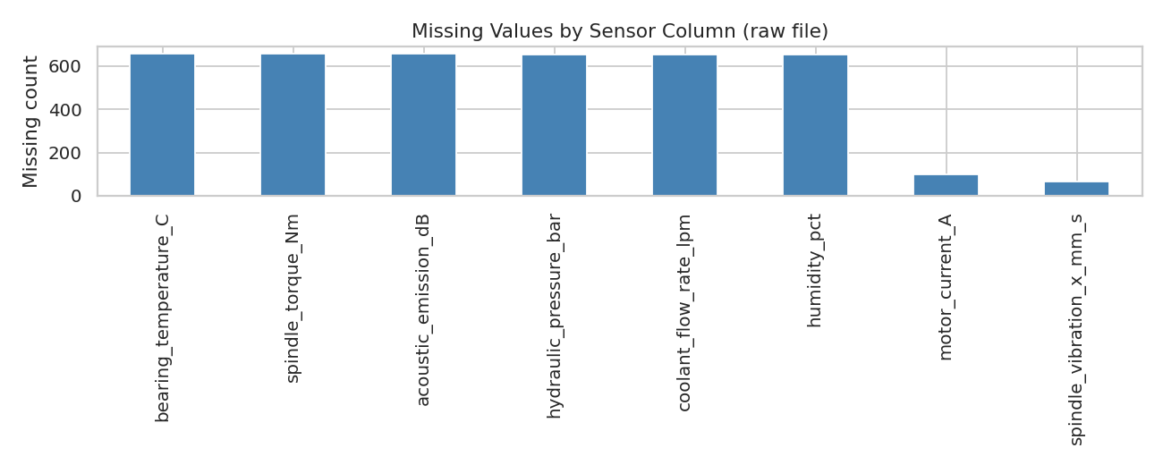
Figure 1. Missing values by sensor column, before cleaning (raw file).
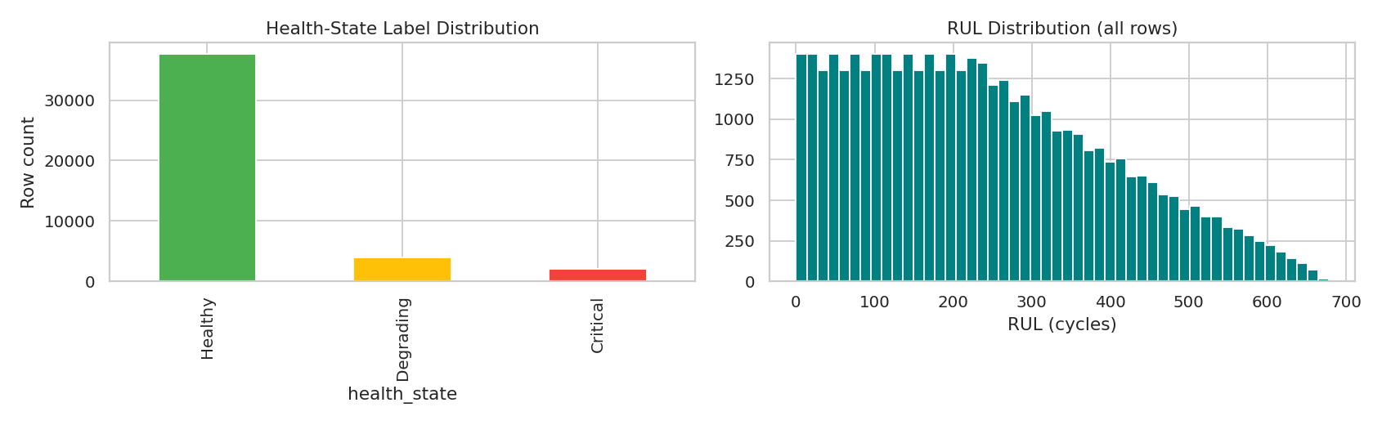
Figure 2. Health-state label distribution (left) and overall RUL distribution across all deduplicated rows (right).
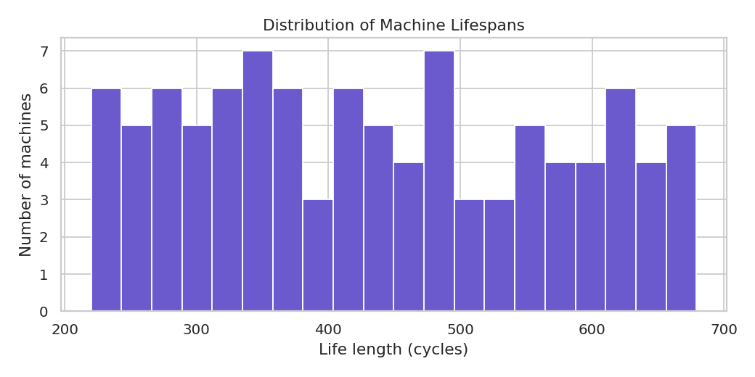
Figure 3. Distribution of machine lifespans (cycles to failure) across all 100 machines.
Figure 4 illustrates the full run-to-failure sensor trajectory for one representative machine across three channels (spindle vibration, bearing temperature and tool wear), showing a non-trivial degradation pattern: the channels drift as failure approaches. Figure 5 presents the full sensor correlation heatmap. Figure 6 gives each sensor's Pearson correlation with the RUL label. The strongest associations are negative for oil particle count (r = −0.82), tool wear (r = −0.78) and spindle vibration Y (r = −0.76), and positive for energy efficiency (r = +0.76) and coolant flow rate (r = +0.71). These correlations give the subsequent feature-importance discussion a reference point.
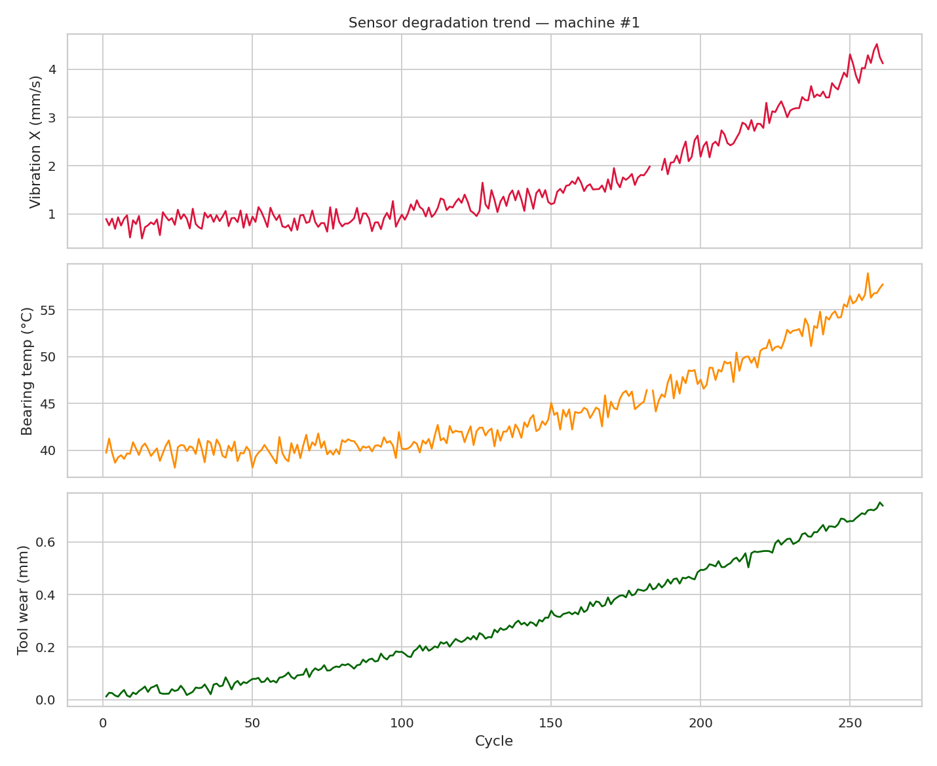
Figure 4. Run-to-failure sensor trajectory for one representative machine: spindle vibration X (top), bearing temperature (middle), tool wear (bottom).
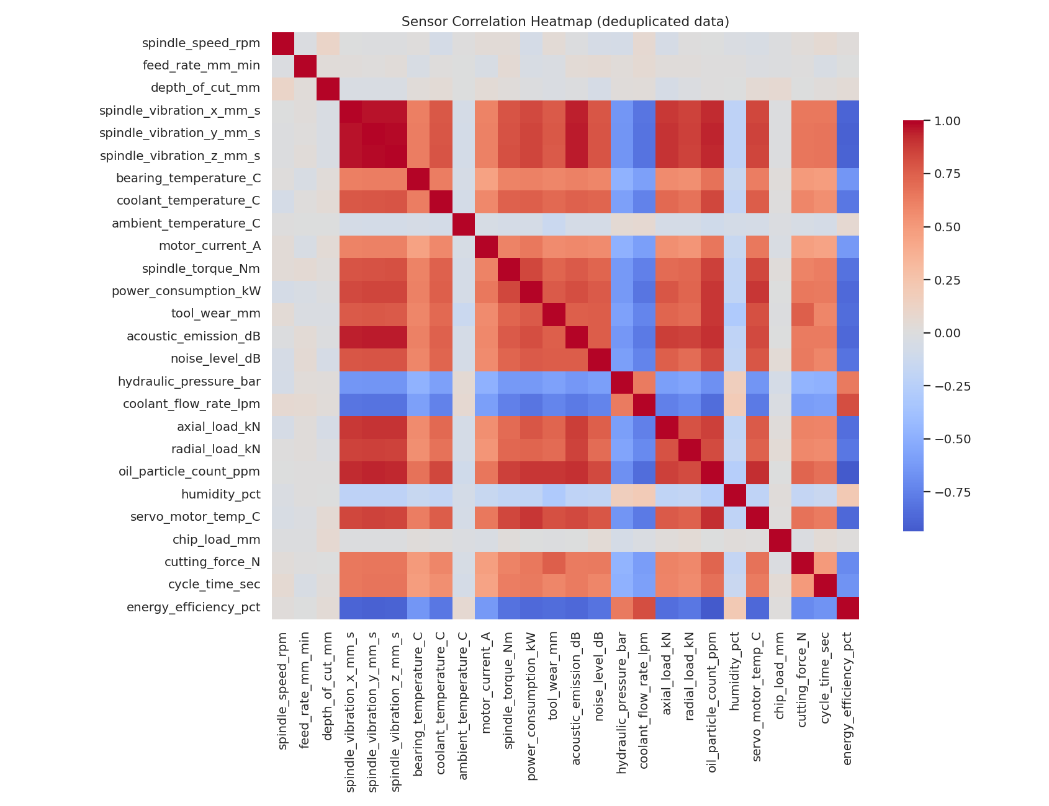
Figure 5. Sensor correlation heatmap (deduplicated data, all 26 sensor and operational-setting columns).
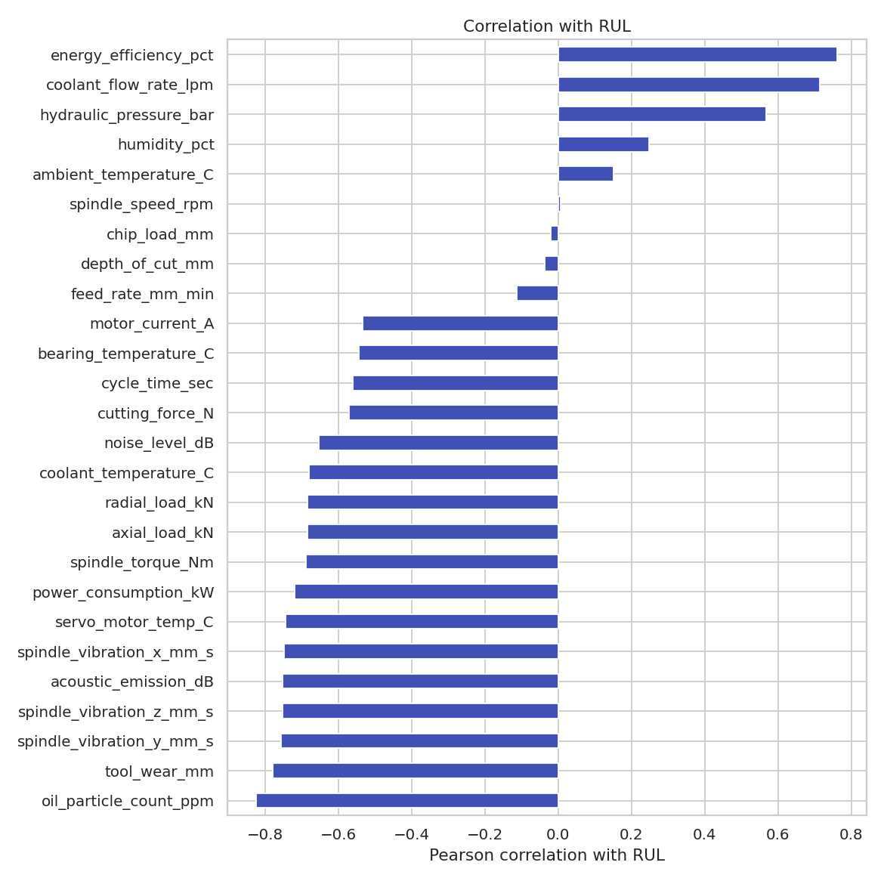
Figure 6. Pearson correlation of each sensor with the RUL label.
4. Methodology
4.1 & 4.2 Data Cleaning: Duplicate Removal, Imputation, Outlier Capping
4.1 Duplicate Removal and Missing-Value Imputation. 25 exact duplicate rows were removed. Missing sensor values were then forward-filled within each machine in cycle order, so that each value is estimated only from earlier readings on the same machine; a backward fill was not used, because it would import information from later cycles. Any value still missing after this step, which occurs only where a machine's first cycles are missing, was filled with the median of the training machines.
4.2 Outlier Capping. For every sensor column, values outside [Q1 − 3.0 × IQR, Q3 + 3.0 × IQR] were capped (winsorised) to the boundary rather than removed, preserving the number of observed cycles per machine. Q1, Q3 and IQR were computed on the training machines only and then applied to the test machines. Figure 7 shows a before-and-after comparison of four representative sensors on the training machines, illustrating spike suppression without distortion of the central tendency.
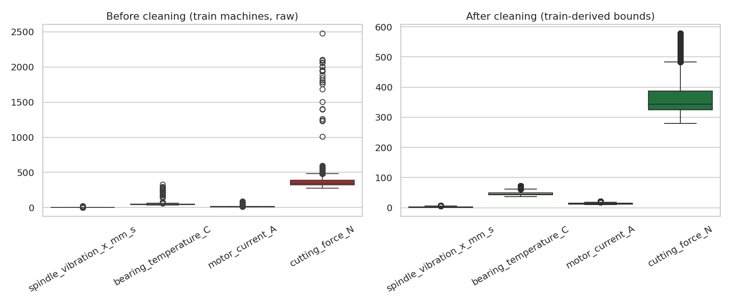
Figure 7. Boxplot comparison of four representative sensors on the training machines, before (left) and after (right) imputation and IQR outlier capping.
4.3 Train / Test Split by Machine
The 100 machines were split at the machine level, never at the row level, into 80 training machines (35,319 rows) and 20 test machines (8,387 rows), using an 80/20 ratio with a fixed random seed (42). Splitting by row would place cycles from the same failure trajectory into both partitions, leaking information about that machine's degradation pattern into the evaluation and producing an optimistically biased test score. The executed pipeline asserts that the two machine sets are disjoint.
4.4 & 4.5 Feature Engineering, Normalisation and PCA
4.4 Feature Engineering. For ten sensors most closely tied to the mechanical degradation process (the three spindle vibration axes, bearing temperature, motor current, spindle torque, tool wear, acoustic emission, cutting force and power consumption), five causal features were computed within each machine: a 5-cycle rolling mean and standard deviation, a 15-cycle rolling mean, a first difference (which responds to tool-change reset events) and an exponentially weighted mean with span 10. All windows look backward in cycle order only, so they introduce no leakage between partitions. Together with the 26 raw sensor and operational-setting columns, this produced 76 model features.
4.5 Normalisation and Dimensionality Assessment. All 76 features were standardised using a StandardScaler fitted exclusively on the training machines and then applied unchanged to the test partition. PCA, fitted on the scaled training features only, found that 26 of the 76 features are required to capture 90% of the total variance (Figure 8), indicating substantial but not extreme feature redundancy. A two-dimensional PCA projection (Figure 9) arranges the health states in bands along the first component, with Critical machines at the high end, Healthy machines at the low end and Degrading machines in between; the bands overlap at their boundaries, as expected for a continuous degradation process. The projection is a sanity check on the feature set rather than a classifier.
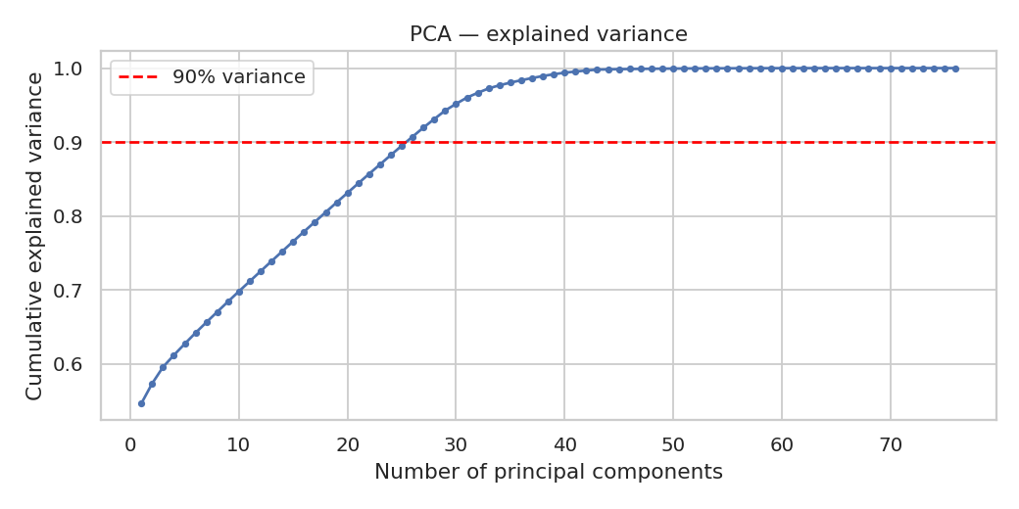
Figure 8. Cumulative explained variance against the number of principal components. 26 of 76 features are needed to reach the 90% threshold (dashed line).
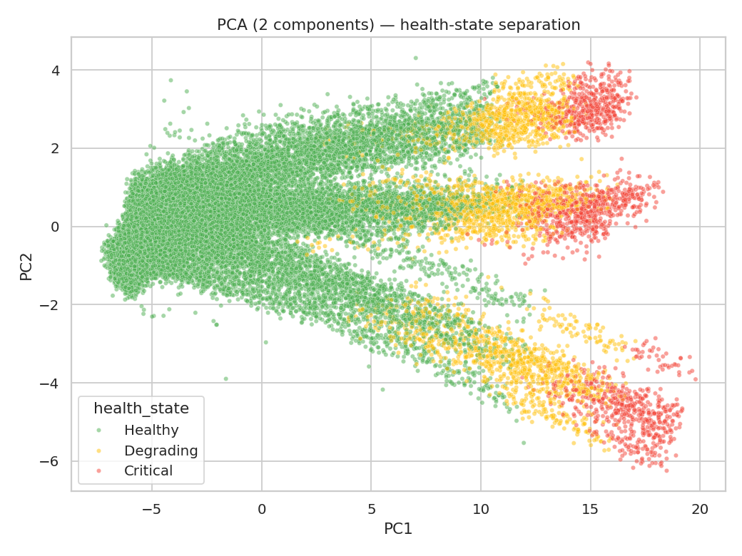
Figure 9. Two-dimensional PCA projection of the training feature set, coloured by health-state label.
4.6 RUL Target Definition
Following common practice in the RUL literature, in particular the C-MAPSS baseline convention, the RUL target was clipped at 130 cycles in both partitions. A machine at cycle 5 of a 600-cycle life is not meaningfully healthier, for maintenance planning, than one at cycle 50; both are far from failure. Leaving the target unclipped would force the model to spend capacity distinguishing large RUL values that carry little differential maintenance value, at the expense of resolution in the operationally critical low-RUL region.
4.7 Evaluation Metrics
In addition to Root Mean Squared Error (RMSE), Mean Absolute Error (MAE) and the coefficient of determination (R²), an asymmetric, PHM08-style scoring function [2] was implemented. Writing d = predicted − actual RUL, the score applies exp(−d/13) − 1 for early predictions (d < 0, the model is pessimistic) and the steeper exp(d/10) − 1 for late predictions (d > 0, the model is optimistic), summed across all test rows. The asymmetry encodes the maintenance-engineering reality that underestimating remaining life leads only to conservative early maintenance, whereas overestimating it risks an unplanned in-service failure.
4.8 Model Architectures
Five models spanning three methodological families were evaluated under identical train and test rows. The configurations below are those used in the executed notebook.
(a) Decision Tree Regressor (baseline). A single CART-style regression tree with maximum depth 8 and at least 15 samples per leaf, providing an interpretable but structurally limited baseline.
(b) Random Forest Regressor. 120 trees, maximum depth 14, at least 5 samples per leaf, trained on the 76 tabular features. Bootstrap aggregation and per-split feature randomisation reduce the variance of the individual trees.
(c) Gradient Boosting Regressor. A histogram-based gradient boosting implementation (scikit-learn HistGradientBoostingRegressor) with 300 boosting iterations and learning rate 0.06, trained on the same tabular features. Gradient boosting builds trees sequentially, each correcting the residual error of the ensemble so far. The histogram-based variant was chosen for training speed on a dataset of this size; its boosting principle is the same as the classical algorithm.
(d) LSTM (deep sequence model). Operating on 30-cycle causal sliding windows across all 76 features, zero-padded for the first cycles of each machine's life. Architecture: LSTM with 64 units, dropout, LSTM with 32 units, dropout, a 32-unit dense layer and a single linear output. Tuned settings: dropout 0.162, Adam learning rate 9.9 × 10⁻⁴, batch size 256.
(e) CNN-LSTM Hybrid (deep sequence model). Operating on the same 30-cycle windows. Two one-dimensional convolutional layers (64 filters with kernel size 5, then 32 filters) extract local temporal patterns, followed by max-pooling that halves the sequence length. Two LSTM layers (32 units each, with dropout) model longer-range dependencies across the pooled sequence, feeding a 32-unit dense layer and a linear output. Tuned settings: dropout 0.146, Adam learning rate 3.6 × 10⁻⁴, batch size 256.
Both deep models were tuned with Optuna's Tree-structured Parzen Estimator using eight trials each, a 15-epoch budget per trial, and the same seed and search protocol. The tuning objective was validation RMSE on an inner machine-level split of the training machines, so the test machines were not used for tuning. The selected CNN-LSTM configuration had a 30-cycle window and a validation RMSE of 5.68 cycles; the selected LSTM configuration had a 30-cycle window and a validation RMSE of 5.00 cycles. Final models were trained for up to 40 epochs with early stopping (patience 6 epochs), a learning-rate reduction on plateau, and averaged over three seeds. The run used FAST = True settings; the full protocol (25 trials and 5 seeds) was not executed.
5. Experimental Results
Table 2 reports the four evaluation measures for all five models on the held-out 20-machine test set, sorted by R² (descending), exactly as produced by the executed notebook. Deep-model values are means over three seeds with standard deviations; tabular models were fitted once and have no standard deviation. The asymmetric score is the mean of the per-seed scores for the deep models.
Table 2. Final model comparison on the held-out test set (20 machines, 8,387 rows / windows).
Rank | Model | R² | RMSE (cycles) | MAE (cycles) | Asymmetric score
1 | CNN-LSTM (tuned) | 0.956 ± 0.007 | 7.73 ± 0.65 | 3.81 | 20,373.3
2 | LSTM (tuned) | 0.954 ± 0.010 | 7.83 ± 0.83 | 3.64 | 24,554.9
3 | Random Forest | 0.944 | 8.73 | 3.75 | 26,509.3
4 | Gradient Boosting | 0.926 | 10.00 | 4.75 | 32,307.6
5 | Decision Tree | 0.918 | 10.54 | 4.60 | 38,138.0

Figure 10 shows R² and RMSE for all five models, and Figure 11 shows the predicted and actual RUL trajectory of one held-out machine.
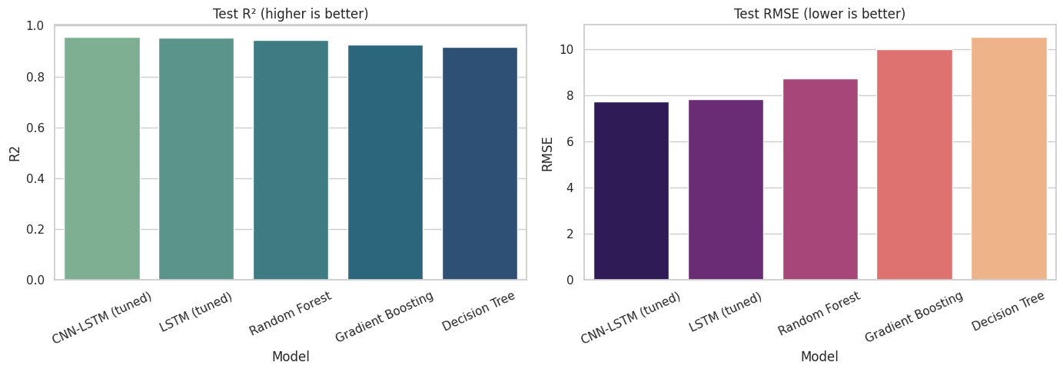
Figure 10. Final model comparison: test R² (left) and RMSE (right) across all five models, from the executed notebook.
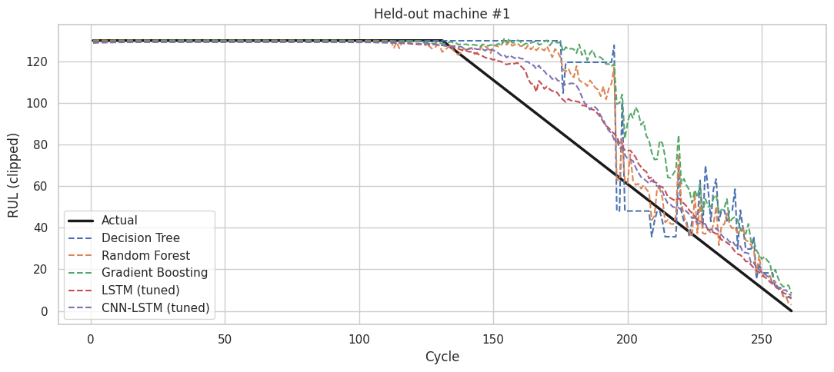
Figure 11. Actual versus predicted RUL for held-out machine #1, all five models overlaid. The true RUL reaches zero at about cycle 260.
6. Model Comparison — Reasoned Discussion
6.1 Sequence Models Versus Tabular Models
The clearest result is the gap between the two sequence models and the three tabular models. Both LSTM and CNN-LSTM reach R² of about 0.95, against 0.918 to 0.944 for the tabular models. The sequence models see a 30-cycle window of raw features, whereas the tabular models see the current cycle and fixed 5- and 15-cycle summary statistics. Where degradation onset varies between machines, a model with a longer context can distinguish a machine that has just begun to degrade from one that is still healthy more reliably. Figure 11 is consistent with this: the tabular predictions show stepwise jumps, while the deep-model predictions change more smoothly.
6.2 CNN-LSTM Versus LSTM
The hybrid CNN-LSTM has the highest mean R² (0.956 against 0.954), the lowest mean RMSE (7.73 against 7.83 cycles) and the lowest asymmetric score (20,373.3 against 24,554.9). It is not the best model on every metric, however: the tuned LSTM has the lower MAE (3.64 against 3.81). More importantly, the R² difference of 0.002 lies well within the seed-to-seed standard deviations of 0.007 (CNN-LSTM) and 0.010 (LSTM), and the RMSE difference of 0.1 cycles lies within standard deviations of 0.65 and 0.83 cycles. With three seeds and 20 test machines, the run does not establish that CNN-LSTM is better than LSTM on this dataset. The asymmetric-score advantage is a single aggregate comparison without a confidence interval. The supportable reading is that the two sequence models are statistically comparable here, with CNN-LSTM ahead on the mean on three of the four measures. The convolutional front-end is a plausible reason for a small advantage, since it extracts local patterns before the recurrent stage, but this run does not isolate that effect.
6.3 Tabular Models
Random Forest is the strongest tabular model, with R² of 0.944 and RMSE of 8.73 cycles, and its MAE (3.75) is close to that of the sequence models. Its 120 trees, each up to depth 14, model non-linear feature interactions that a single shallow tree cannot. Gradient Boosting outperforms the single Decision Tree on R² (0.926 against 0.918), RMSE (10.00 against 10.54) and asymmetric score (32,307.6 against 38,138.0), but has a higher MAE (4.75 against 4.60). The Decision Tree is the weakest model on R², RMSE and asymmetric score, which is consistent with a single shallow tree underfitting the degradation pattern relative to the ensembles. The Gradient Boosting and Decision Tree settings were not tuned, so their ranking is provisional.
6.4 Late Predictions in the Mid-Life Region
Figure 11 shows that all five models predict RUL above the true value for part of the mid-life region of this machine, roughly cycles 130 to 200, where the true RUL is falling but predictions remain high. In this interval the predictions are late, which is the direction the asymmetric score penalises most heavily. This is a single-machine observation and not a statistical result. It nevertheless identifies where further work on late-prediction bias should focus, and it is more operationally relevant than the R² ranking.
6.5 Feature Importance
The feature-importance analysis carried out in an earlier run is not part of the executed notebook output reviewed for this submission, so no feature-importance ranking is reported here. Section 3.3 identifies the sensors most strongly correlated with RUL, which provides an independent reference point. A permutation-importance analysis for the tuned models is listed as future work.
7. Visualisations and Interactive Dashboard
Figures 1 to 9 are generated from the supplied dataset using the preprocessing described in Section 4. Figures 10 and 11 are reproduced directly from the executed notebook without modification.
7.1 Streamlit Dashboard
To make the comparison explorable, an interactive dashboard was built with Streamlit. It runs locally in VS Code with the command streamlit run app.py, and reads the files exported by the notebook: model_comparison.csv (the metrics in Table 2), test_predictions.csv (per-row RUL predictions of each model on the held-out machines), and best_params.json (the tuned hyperparameters). The notebook also saves the trained CNN-LSTM model (cnn_lstm_final.keras), which the dashboard can load for inference. The dashboard presents the final performance of the five compared models, including R², RMSE, MAE and the asymmetric score, with the means and standard deviations across seeds for the deep models.
The dashboard also supports the test CSV used for visualisation. A file with the same columns as test_predictions.csv (machine identifier, cycle, actual RUL and model predictions) can be uploaded to display predicted against actual RUL for any held-out machine. Because the dashboard reads the exported files rather than retraining the models, it can be run on a laptop without a GPU. Figure 11 shows the type of view it provides for a single machine.
7.2 Scope of the Dashboard
The dashboard is a visualisation and inspection tool. It is not a deployment system: it does not connect to live machine data, and its outputs depend on the held-out split and seed set used in the notebook. Its purpose is to make the comparison transparent and to let an examiner or reader check the reported numbers against the underlying predictions.
8. Limitations
Several limitations constrain the conclusions. First, the dataset is synthetic: the degradation pattern was designed by the author, so the results show how the pipeline behaves on that pattern rather than on real industrial data. Second, the evaluation uses a single train/test machine split, and the deep models were averaged over three seeds. The uncertainty estimates therefore reflect seed variation only, not variation across machine splits. Third, the tuning budget was small (eight trials per model) and the search space limited to two window lengths. Fourth, the Gradient Boosting and Decision Tree settings were not tuned. Fifth, the asymmetric score is a single aggregate without a confidence interval. Finally, the notebook was executed in FAST mode, and results under the full protocol may differ.
9. Conclusion and Future Work
This report has documented a complete, leakage-controlled machine-learning and deep-learning pipeline for Remaining Useful Life estimation on a realistic multi-sensor CNC Machining Centre dataset, and has compared five models spanning three methodological families under matched tuning effort, using both standard regression metrics and an operationally motivated asymmetric score. All five models achieved positive R², between 0.918 and 0.956, which confirms that the pipeline produces predictive RUL estimates when the data contain a learnable degradation process. This addresses the open question left by the earlier stage of the project, in which the same class of pipeline could not produce a valid model from real plant data lacking a measurable degradation trend.
The two sequence models, LSTM and CNN-LSTM, clearly outperformed the three tabular models, consistent with the reasoning in Section 6.1 that longer-context models have an advantage when degradation onset is randomised. The tuned CNN-LSTM achieved the highest mean R², the lowest RMSE and the lowest asymmetric score. Its margin over the tuned LSTM is, however, within seed-to-seed variation, and the LSTM has the lower MAE. The supported conclusion is that sequence-aware models suit this degradation process better than tabular approaches, and that CNN-LSTM and LSTM are statistically comparable on this dataset.
Building on these findings, the following extensions are proposed:
(i) more seeds for both sequence models (at least five each), with a paired comparison of per-row errors and a bootstrap confidence interval on the R² difference;
(ii) repeated evaluation across several machine-level train/test splits, or machine-grouped cross-validation, to capture variation across machines rather than only across seeds;
(iii) tuning the Gradient Boosting and Decision Tree models under the same protocol as the deep models;
(iv) error analysis binned by RUL range (early life, mid life and near failure), targeted at the late-prediction bias identified in Section 6.4;
(v) frequency-domain (FFT or wavelet) features for the vibration and acoustic-emission channels;
(vi) validation on the NASA C-MAPSS benchmark or a public bearing-degradation dataset (e.g. IMS or FEMTO-PRONOSTIA), and, where data is available, on genuine plant sensor logs.

