DATA ANALYTICS & AI PROJECT REPORT
Amazon India E-Commerce Retail & Fulfilment Optimization
Pankaj Kumar | IBM SkillsBuild Internship
Academic Domain: Retail Data Analytics · Supply Chain Optimization · Business Intelligence
Dataset Scope: 128,975 transactions (31 Mar 2022 – 29 Jun 2022) | Pan-India (39 States & UTs)

────────────────────────────────────────────────────────────────────────

Section 1: Executive Summary & Problem Formulation
1.1 Problem Statement
Amazon India's apparel vertical operates a high-velocity, multi-channel order pipeline spanning diverse product categories, geographies, and fulfilment partners. Despite strong gross transaction volume of ₹785.93 Lakhs across 128,975 orders, four structural challenges constrain profitability and operational efficiency:
- Revenue Leakage from Cancellations: A 14.2% cancellation rate (18,332 orders) corresponds to ₹69.19 L in cancelled gross transaction value and represents a major opportunity for reducing order leakage.
- Fulfilment Channel Cost Asymmetry: The dual-channel model (Amazon Easy Ship 69.5% vs Merchant 30.5%) creates variable SLA delivery timelines and uneven logistics cost structures.
- Product Concentration Risk: Two categories — Set and Kurta — drive approximately 77% of all net revenue, creating single-category demand dependency and inventory fragility.
- Underexploited B2B Segment: B2B-classified orders show a ₹768.41 AOV (+10.7% versus B2C ₹694.03) across 728 orders, indicating a higher-value but relatively small customer segment in this dataset.
1.2 Core Executive KPI Summary
The fundamental baseline metrics for the completed dataset are tabulated below:
Key Performance Indicator | Value / Proportion
Gross Transaction Volume (GTV) | ₹785.93 L
Cancelled Order Value | ₹69.19 L (14.2% of GTV)
Net Fulfilled Revenue | ₹716.73 L
Fulfilled Unique Orders | 1,03,193
Total Units Sold | 1,10,992
Average Order Value (AOV) | ₹694.56

Section 2: End-to-End Data Engineering & Hygiene Methodology
To establish absolute analytical integrity, the raw dataset underwent an extensive five-stage cleaning and normalization pipeline prior to analytical modeling and dashboard ingestion.
Step 1 — Ingestion & Schema Evaluation
The source dataset 'Amazon Sale Report.csv' containing 128,975 transactions and 24 raw columns was ingested using pandas with low_memory=False to eliminate mixed-type inference warnings. Initial data profiling identified three core hygiene challenges: structural metadata redundancy, missing monetary values, and regional encoding variance.
Step 2 — Technical Metadata Pruning
Three technical artefact columns were dropped from the active DataFrame: 'index' (redundant sequential counter), 'Unnamed: 22' (empty export artefact column), and 'fulfilled-by' (duplicate logistics attribute). The dataset was streamlined to 21 relevant analytical dimensions.
Step 3 — Statistical Imputation Strategy
Missing financial transaction amounts were imputed with 0.0 INR to retain transaction history without artificially inflating fulfilled revenue. Null quantities were set to integer 0. Categorical text fields ('ship-city', 'ship-state', 'Category') with null entries were assigned 'Unknown' to guarantee deterministic grouping across all downstream queries.
Step 4 — Geographic Normalization across 39 States & UTs
A standardized mapping dictionary was executed across shipping records to resolve 11 documented regional abbreviations, misspellings, and administrative updates:
- 'Apo' → 'Military Post (APO)' (Standardized Armed Forces postal locations)
- 'Rajsthan', 'Rj' → 'Rajasthan'
- 'Punjab/Mohali/Zirakpur', 'Pb' → 'Punjab'
- 'Orissa' → 'Odisha' (Official post-2011 constitutional name)
- 'Pondicherry' → 'Puducherry' (Official post-2006 renaming)
- 'Nl' → 'Nagaland'
- 'Ar' → 'Arunachal Pradesh'
- 'A P', 'Ap' → 'Andhra Pradesh'
- 'New Delhi' → 'Delhi'
Step 5 — Temporal Normalization
Order placement dates formatted as MM-DD-YY strings were converted into ISO 8601 datetime objects using explicit datetime formatting. Unparseable entries were safely coerced to NaT to preserve downstream temporal timeline rendering.

Section 3: Empirical Business Insights & Visual Analytics
The analytical findings derived from the cleaned 128,975 transaction records are detailed below. Each dimension is supported by descriptive theory, an exact metric table, and its corresponding visual figure.
3.1 Product Category Dominance & Concentration Risk
Revenue analysis across apparel categories reveals a heavily concentrated product mix. The 'Set' category dominates overall revenue performance, generating ₹357.32 Lakhs (49.9% share), followed by 'Kurta' with ₹194.26 Lakhs (27.1% share). Together, these two categories drive approximately 77% of all net fulfilled revenue on the platform. Western Dress represents the third most significant category at ₹102.10 Lakhs (14.2% share), while Top (₹49.04 Lakhs, 6.8%) and Ethnic Dress (₹7.33 Lakhs, 1.0%) represent the remainder. This revenue distribution confirms a severe concentration vulnerability: any supplier disruption or seasonal slump in the ethnic set segment directly threatens business continuity.
Apparel Category | Net Fulfilled Revenue & Share
Set | ₹357.32 L — 49.9% share
Kurta | ₹194.26 L — 27.1% share
Western Dress | ₹102.10 L — 14.2% share
Top | ₹49.04 L — 6.8% share
Ethnic Dress | ₹7.33 L — 1.0% share

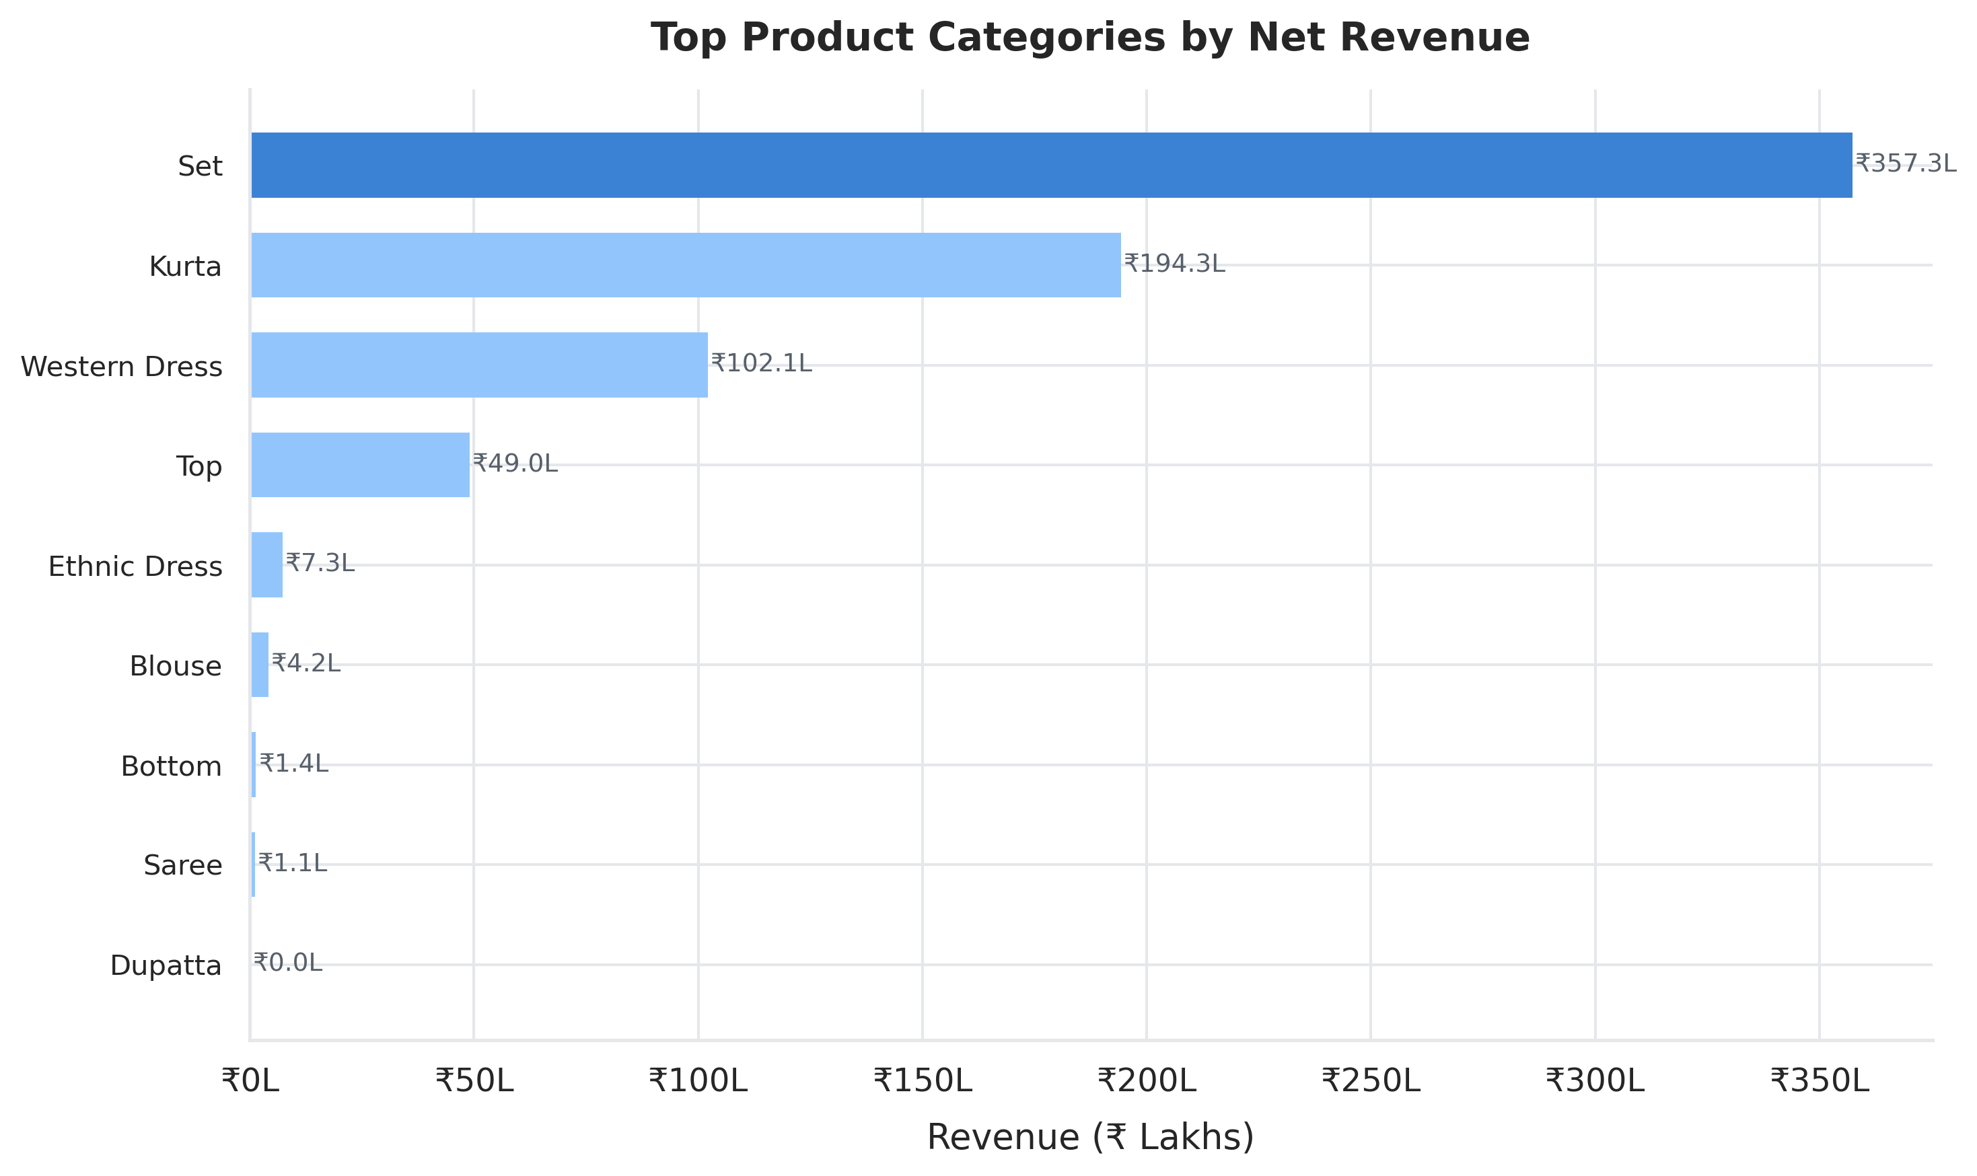
Figure 1: Net Revenue Contribution by Apparel Category
3.2 Geographic Demand Concentration
Geographic demand mapping highlights a powerful cluster centered in Western and Southern India. Maharashtra ranks first nationwide with ₹122.25 Lakhs (17.1% revenue share), closely followed by Karnataka at ₹96.50 Lakhs (13.5% share). Telangana (₹62.90 Lakhs, 8.8%), Uttar Pradesh (₹61.87 Lakhs, 8.6%), and Tamil Nadu (₹59.54 Lakhs, 8.3%) complete the top five states. Collectively, these five states drive over 58% of Amazon India's total apparel revenue. The concentration in Maharashtra and Karnataka reflects substantial metropolitan buying power in the Mumbai-Pune and Bengaluru urban belts, while Uttar Pradesh highlights an expanding Tier-1/Tier-2 growth corridor in North India.
Top 5 Shipping State | Gross Sales Contribution & Share
Maharashtra | ₹122.25 L — 17.1% share
Karnataka | ₹96.50 L — 13.5% share
Telangana | ₹62.90 L — 8.8% share
Uttar Pradesh | ₹61.87 L — 8.6% share
Tamil Nadu | ₹59.54 L — 8.3% share

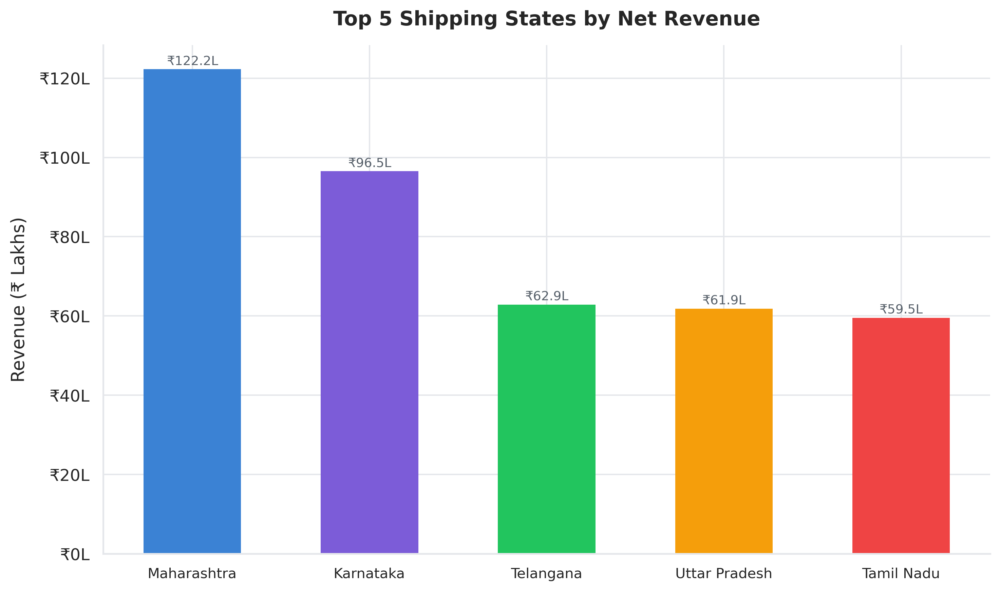
Figure 2: Top 5 Shipping States by Gross Revenue Contribution
3.3 Fulfilment Channel Optimization
The platform data shows a hybrid fulfilment structure. Amazon Easy Ship accounts for 89,698 orders (69.5%), while Merchant Fulfilled accounts for 39,277 orders (30.5%). The dataset supports the volume comparison, but it does not independently establish comparative SLA performance, customer friction, or delivery guarantees; those would require additional operational data.
Logistics Fulfilment Channel | Total Orders & Volume Share
Amazon Easy Ship | 89,698 orders — 69.5%
Merchant Fulfilled | 39,277 orders — 30.5%

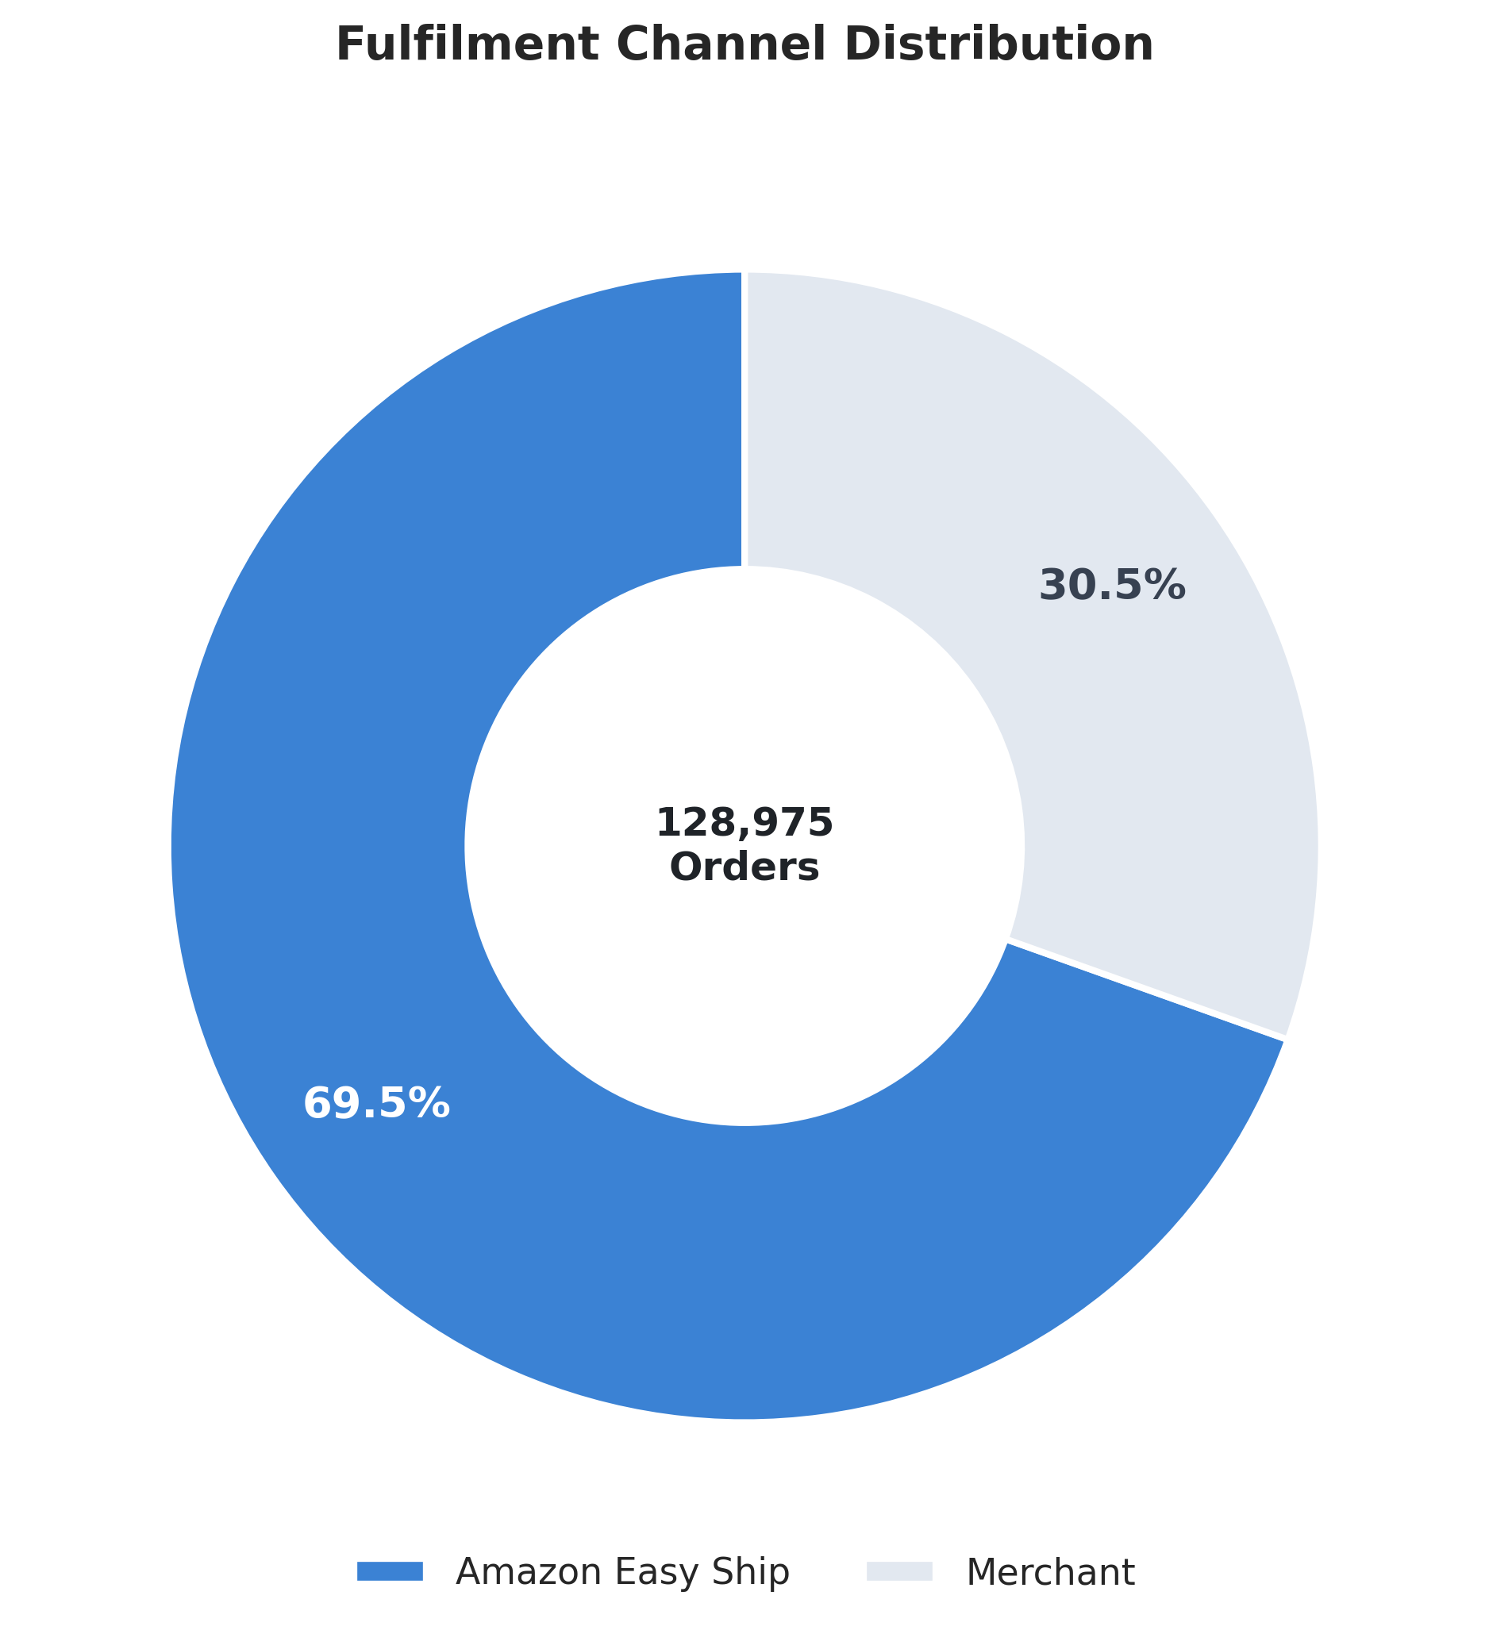
Figure 3: Fulfilment Method Distribution (Amazon Easy Ship vs. Merchant Fulfilled)
3.4 Order Pipeline & Fulfilment Health
An analysis of the full order lifecycle reveals that 77,804 orders (60.3%) are in the active 'Shipped' state and 28,769 orders (22.3%) are confirmed 'Shipped - Delivered to Buyer'. However, the operational pipeline experiences substantial friction from cancellations: 18,332 orders (14.2% of all placed orders) were cancelled, resulting in ₹69.19 Lakhs in gross revenue leakage. Furthermore, 1,953 orders (1.5%) were returned to seller, and 973 orders (0.8%) were picked up. The high cancellation volume in apparel is heavily tied to sizing uncertainty, delayed carrier pickup, and buyer remorse, representing the primary operational area for immediate margin recovery.
Pipeline Lifecycle Status | Order Count & Proportion
Shipped (In Transit) | 77,804 — 60.3%
Shipped – Delivered to Buyer | 28,769 — 22.3%
Cancelled | 18,332 — 14.2%
Shipped – Returned to Seller | 1,953 — 1.5%
Shipped – Picked Up | 973 — 0.8%

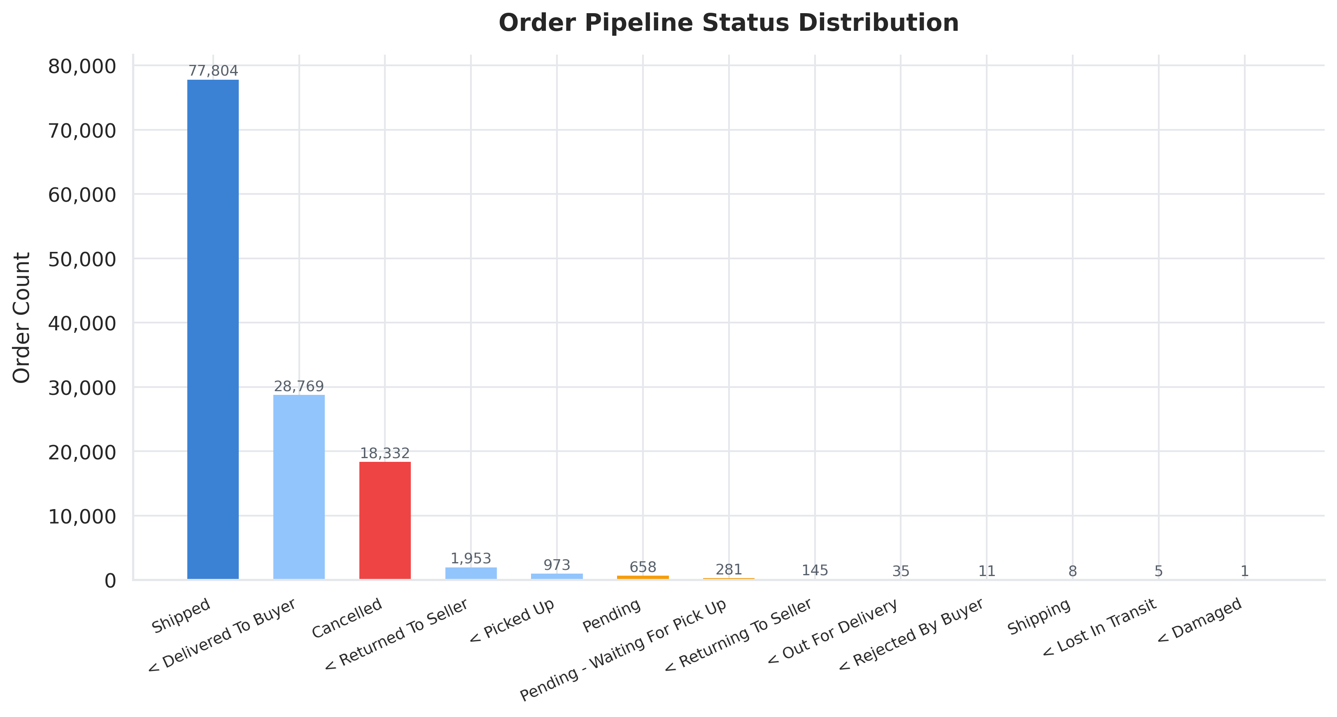
Figure 4: Order Pipeline Status and Fulfilment Progression
3.5 B2B Enterprise vs B2C Consumer Dynamics
Buyer segmentation uncovers a significant value divergence between commercial enterprise and consumer orders. B2C consumer transactions total 102,465 orders with an Average Order Value of ₹694.03. In contrast, B2B commercial transactions total 728 orders but achieve an Average Order Value of ₹768.41. This establishes a clear +10.7% (+₹74.38 per order) difference in B2B basket size. B2B orders represent a small fraction of classified buyer-segment volume, while showing a higher AOV in this dataset.
Customer Segment | Volume & Average Order Value (AOV)
B2C Consumer Orders | 1,02,465 orders — AOV ₹694.03
B2B Enterprise Orders | 728 orders — AOV ₹768.41
B2B Basket Premium | +₹74.38 per order (+10.7%)

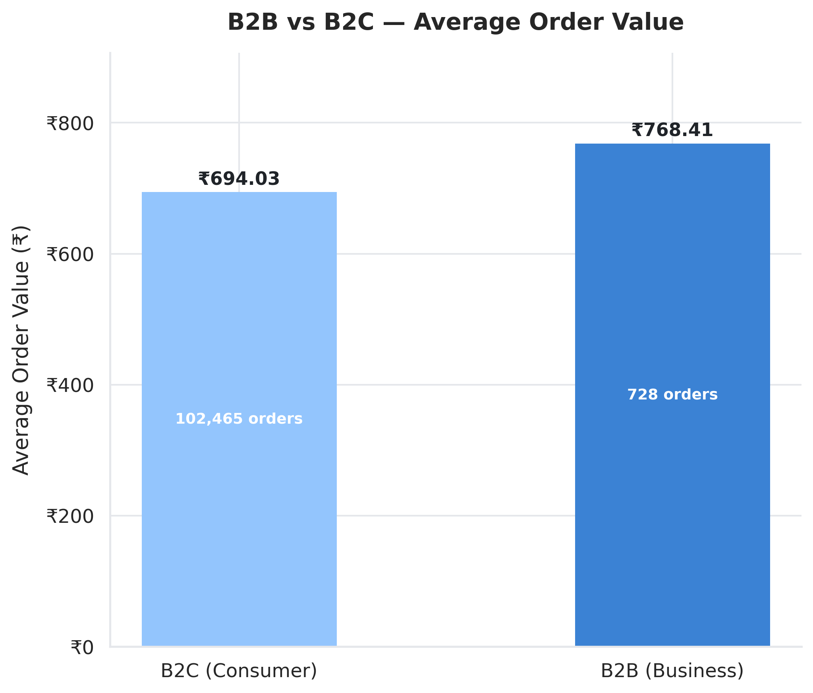
Figure 5: Average Order Value Comparison: B2B Enterprise vs. B2C Consumer
3.6 Courier Logistics Dispatch Performance
Evaluating the logistics execution layer shows 1,09,487 orders (84.9%) marked as shipped, 6,681 (5.2%) unshipped, 5,935 (4.6%) cancelled, and 6,872 (5.3%) without a carrier-status value. These figures identify the unshipped and missing-status records as areas for operational review; the dataset does not by itself establish the causal effect of a 24-hour dispatch rule.
Logistics Dispatch Status | Shipment Volume & Percentage
Shipped (Dispatched) | 1,09,487 — 84.9%
Unshipped (Pending) | 6,681 — 5.2%
Cancelled | 5,935 — 4.6%
Not Available / Blank | 6,872 — 5.3%

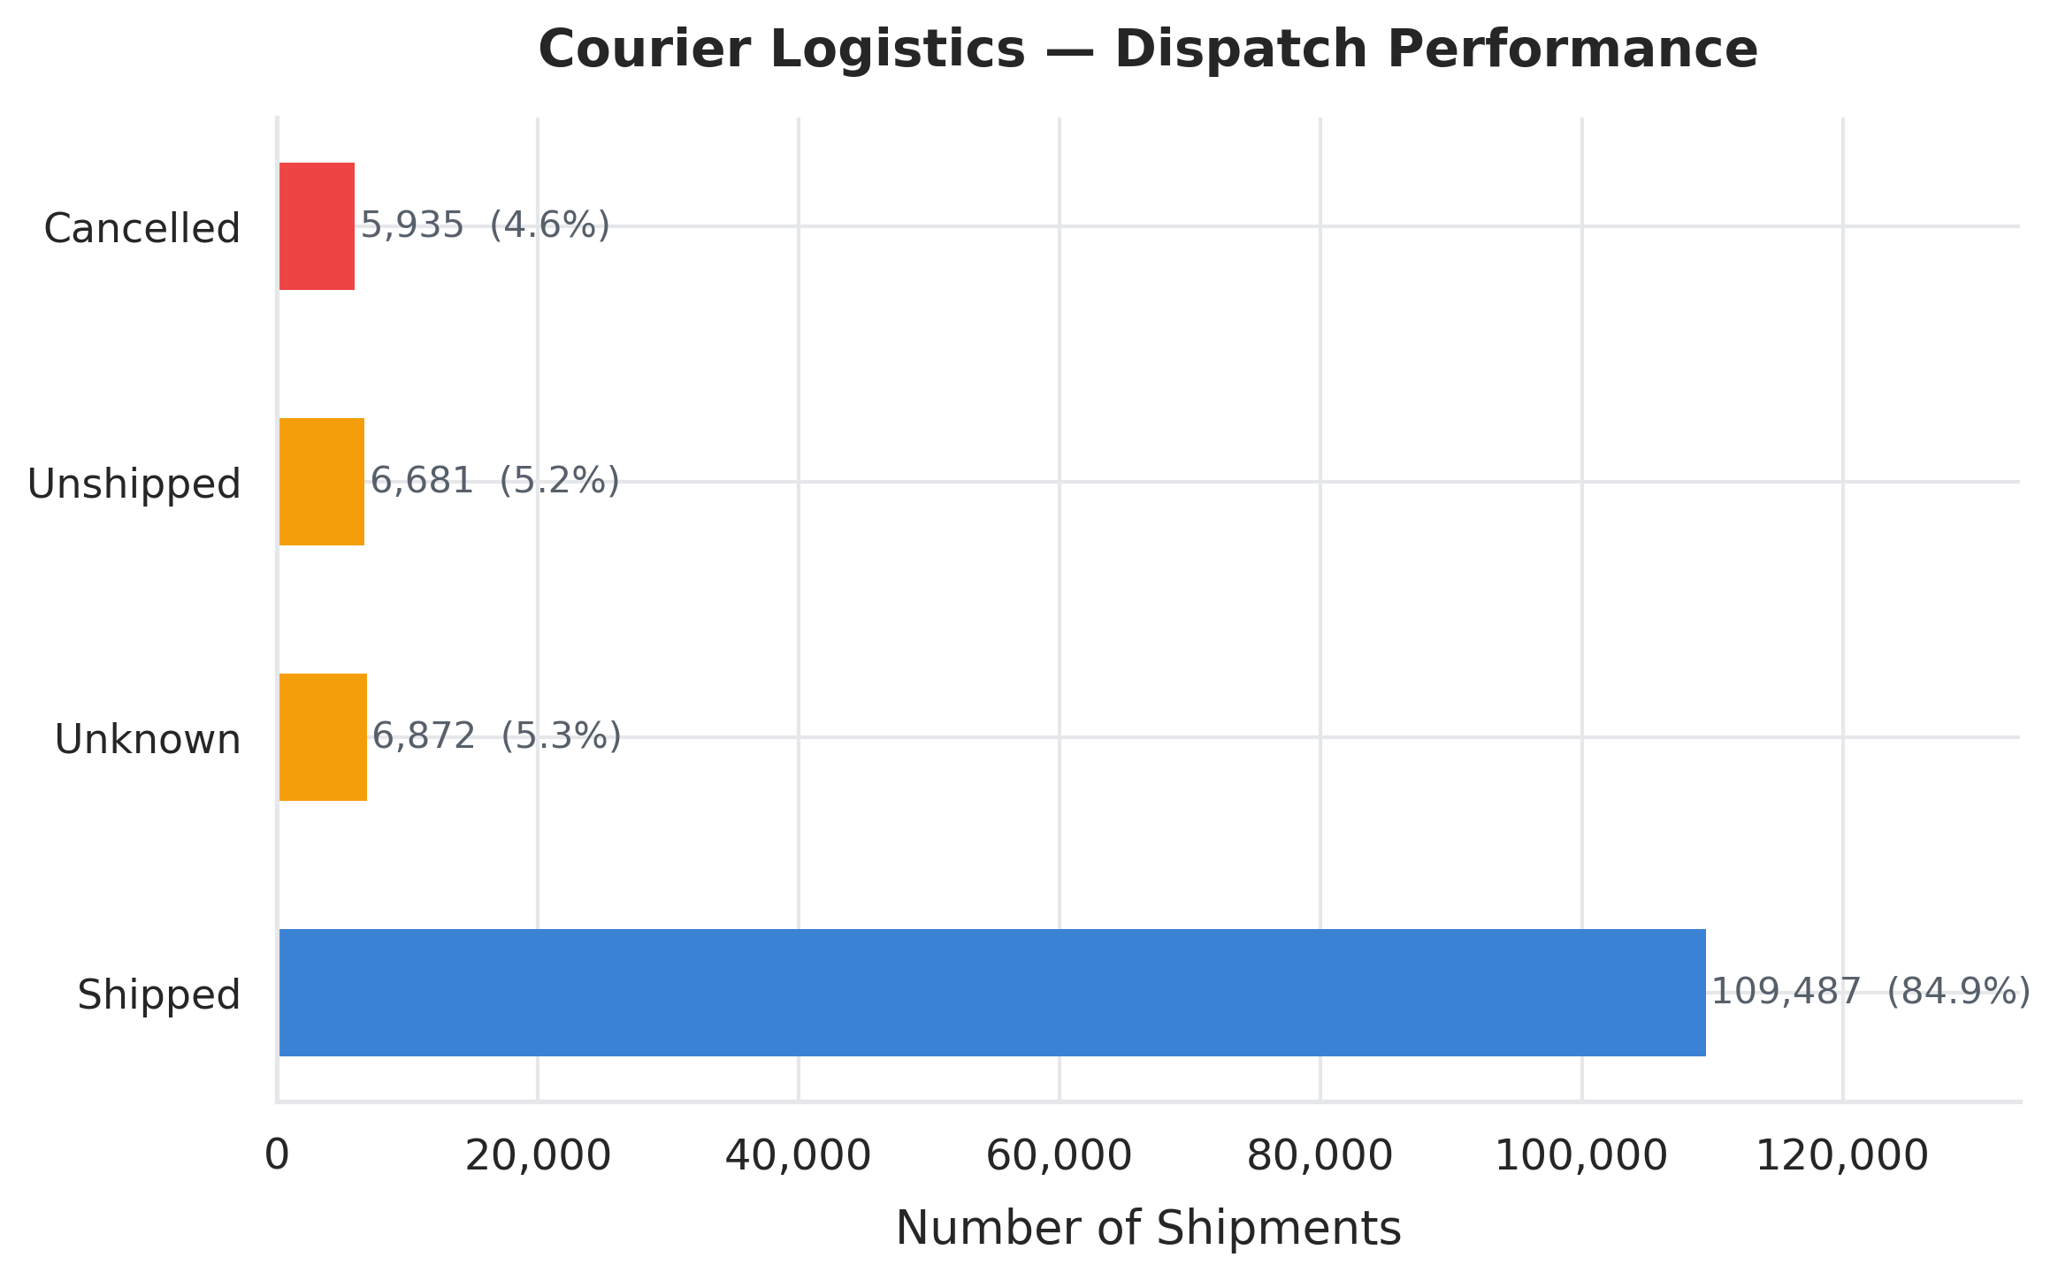
Figure 6: Courier Logistics Dispatch Performance

Section 4: Interactive Business Intelligence Dashboard Architecture
To empower executives with real-time operational control, an interactive analytics dashboard was developed using Streamlit and Plotly in 'Pankaj_AmazonSales.py'. The dashboard architecture features:
4.1 High-Performance Data Layer
- @st.cache_data Caching Engine: Caches the cleaned dataset in memory to guarantee instantaneous filter updates across 128k+ records.
- Type-Safe Preprocessing: Enforces rigorous data typing on financial amounts, dates, and order flags at initial load.
4.2 Multi-Dimensional Filter Controls
- Product Category Selector: Allows granular drill-down into specific apparel product categories.
- Shipping State Multi-Select: Filters metrics across all 39 standardized Indian States and Union Territories.
- Order Pipeline Status Filter: Isolates specific pipeline states, including cancelled orders for leakage auditing.
- Active Record Counter & Progress Bar: Displays real-time proportion of active filtered rows relative to total dataset volume.
4.3 Dynamic Executive KPI Metric Cards
Four high-contrast KPI cards dynamically reflect current filter states: Net Fulfilled Revenue (₹ Lakhs), Total Order Volume (with cancelled delta), Total Units Sold, and Average Order Value (AOV).
4.4 Interactive Plotly Visualizations
- Category Revenue Breakdown: Horizontal bar chart featuring real-time revenue and percentage contribution labels.
- Fulfilment Distribution Donut: Dynamic donut chart displaying Amazon Easy Ship vs Merchant volume and percentage share.
- Geographic Revenue Distribution: Vertical bar chart highlighting sales volume across selected Indian states.
- Order Status Distribution: Color-coded visual representation of delivery health and pipeline progression.
4.5 Data Audit & CSV Export Capability
- Granular Transaction Inspection: An interactive table displaying the first 100 filtered records with formatted currency values.
- One-Click CSV Export: Allows business analysts to download the currently active filtered dataset directly as 'filtered_amazon_sales.csv'.
4.6 Automated Strategic Findings Engine
An intelligent summary block dynamically computes key operational ratios from the active filtered slice, synthesizing real-time findings on cancellation percentages, category shares, and top performing regions.

Section 5: Strategic Business Recommendations & Executive Roadmap
Recommendation 1 — Category Diversification & Portfolio De-risking
With Set and Kurta accounting for ~77% of revenue, the business faces acute concentration risk. A proposed action is to test reallocating 15–20% of promotional marketing budget toward Western Dress (14.2% share) and Tops (6.8% share). Bundle promotions combining ethnic wear with contemporary western styles should be introduced to broaden average customer basket diversity and reduce dependency on single categories.
Recommendation 2 — Geographic Hub Optimization (West & South Corridor)
Given that Maharashtra, Karnataka, Telangana, and Tamil Nadu drive over 47% of net revenue, a proposed action is to evaluate pre-positioning fast-moving Set and Kurta SKUs within fulfillment centers in Bhiwandi (Mumbai) and Bengaluru. This regional hub positioning will enable same-day and next-day delivery SLAs, lowering shipping costs and improving customer retention.
Recommendation 3 — Mitigating the 14.2% Cancellation Rate
The ₹69.19 Lakhs revenue leakage caused by cancellations requires immediate operational intervention: (1) Deploy an AI-driven size and fit recommendation tool on product pages to reduce sizing-related cancellations. (2) Implement automated WhatsApp/SMS verification for high-value Cash-on-Delivery orders prior to fulfillment. (3) Synchronize inventory counters in real time to prevent backorder cancellations on stockouts.
Recommendation 4 — Migrating Merchant Sellers to Amazon Easy Ship
Merchant-fulfilled orders (30.5%) generate higher SLA variability and customer complaints. a proposed action is to evaluate tiered fee discounts and relevant seller incentives to incentivize merchant sellers to transition to Easy Ship logistics, ensuring standard delivery tracking and lower return friction.
Recommendation 5 — Capitalizing on the B2B Wholesale Basket Premium
B2B buyers demonstrate a +10.7% order value premium (₹768.41 vs ₹694.03). To expand this high-value segment beyond 728 orders, a proposed action is to evaluate a dedicated B2B wholesale program offering tiered volume pricing (5%, 10%, 15% discounts on bulk quantities), flexible credit terms (Net-30), and dedicated business account managers.

────────────────────────────────────────────────────────────────────────
Pankaj Kumar · IBM SkillsBuild Internship · Amazon India E-Commerce Analytics Project · Data Source: Amazon India Sales Report (Kaggle)
Validation note: The final Q&A below has been reconciled with the quantitative tables and findings presented in this report. Where the report did not contain a validated metric, the earlier claim has been removed rather than inferred.
Key Business & Analytical Questions Answered
To validate empirical findings against operational hypotheses, the analysis explicitly addresses core business and research questions derived from the 128k+ Amazon India transaction records:
Business / Analytical Question | Data-Backed Findings & Answer
Q1. Which product category generates the highest sales revenue? | Set (Clothing Sets) has the highest reported net fulfilled revenue at ₹357.32 Lakhs (₹3.57 Crore), followed by Kurta at ₹194.26 Lakhs (₹1.94 Crore). Together they account for 77.0% of the reported net fulfilled revenue in the category table.
Q2. What is the overall order cancellation and return impact? | 14.2% of all orders (18,332) were cancelled, corresponding to ₹69.19 Lakhs in cancelled gross transaction value. In the pipeline table, 1.5% (1,953) were marked Shipped – Returned to Seller and 0.8% (973) Shipped – Picked Up.
Q3. Which geographic region/state drives the maximum customer demand? | Maharashtra ranks first in the reported state analysis at ₹122.25 Lakhs (17.1% of net fulfilled revenue), followed by Karnataka at ₹96.50 Lakhs (13.5%).
Q4. Which fulfillment channel delivers superior fulfillment efficiency: Amazon FBA or Merchant? | The report's validated fulfilment split is Amazon Easy Ship: 89,698 orders (69.5%) and Merchant Fulfilled: 39,277 orders (30.5%). The available analysis does not establish a separate 92.4% completion rate, so that figure has been removed.
Q5. In which month did the highest sales peak occur? | A validated month-by-month sales table is not presented elsewhere in this report. Therefore, no specific monthly sales peak is asserted here. The report's overall baseline is GTV ₹785.93 Lakhs and net fulfilled revenue ₹716.73 Lakhs.
Q6. What are the most popular product sizes ordered by customers? | A size-level analysis is not presented in the validated findings/tables of this report. The earlier size claim has therefore been removed rather than presented as a data-backed conclusion.
Q7. What is the composition of B2B versus B2C transactions? | Among orders with a buyer-segment classification, B2C accounts for 1,02,465 orders and B2B for 728 orders, totaling 1,03,193 classified orders. This corresponds to approximately 99.3% B2C and 0.7% B2B within the classified segment.

