DEPARTMENTOF

COMPUTERSCIENCE&ENGINEERING
EXPERIMENT- 09

Student Name: Ashutosh Yadav UID: 23BCS11023
Branch: BE-CSE Section/Group: KRG-1-B
Semester: 05 | Date of Performance: 28/10/25
Subject Name:ADBMS | Subject Code: 23CSP-333

- Aim: To create and connect a PostgreSQL database instance on Amazon RDS (Relational Database Service)
- Objective:
To understand the steps involved in launching a database instance using Amazon RDS.

To configure a database for public access and connect it with a local client (pgAdmin). To perform basic SQL operations (CREATE, INSERT, SELECT).
- Tools / Software

AmazonWeb Services (AWS) PostgreSQL

pgAdmin 4
RDS (Relational Database Service)
- Program:
Step 1: Create and Configure Database Instance
  - Login to AWS Console → RDS → Create database, select Standard create and PostgreSQL under the Free Tier template.
  - Set DB identifier: ruchi-db, Username: postgre, choose db.t3.micro, 20 GB gp2 storage,

and enable Public access.
  - Click Create database and wait until the status shows Available in the RDS dashboard.
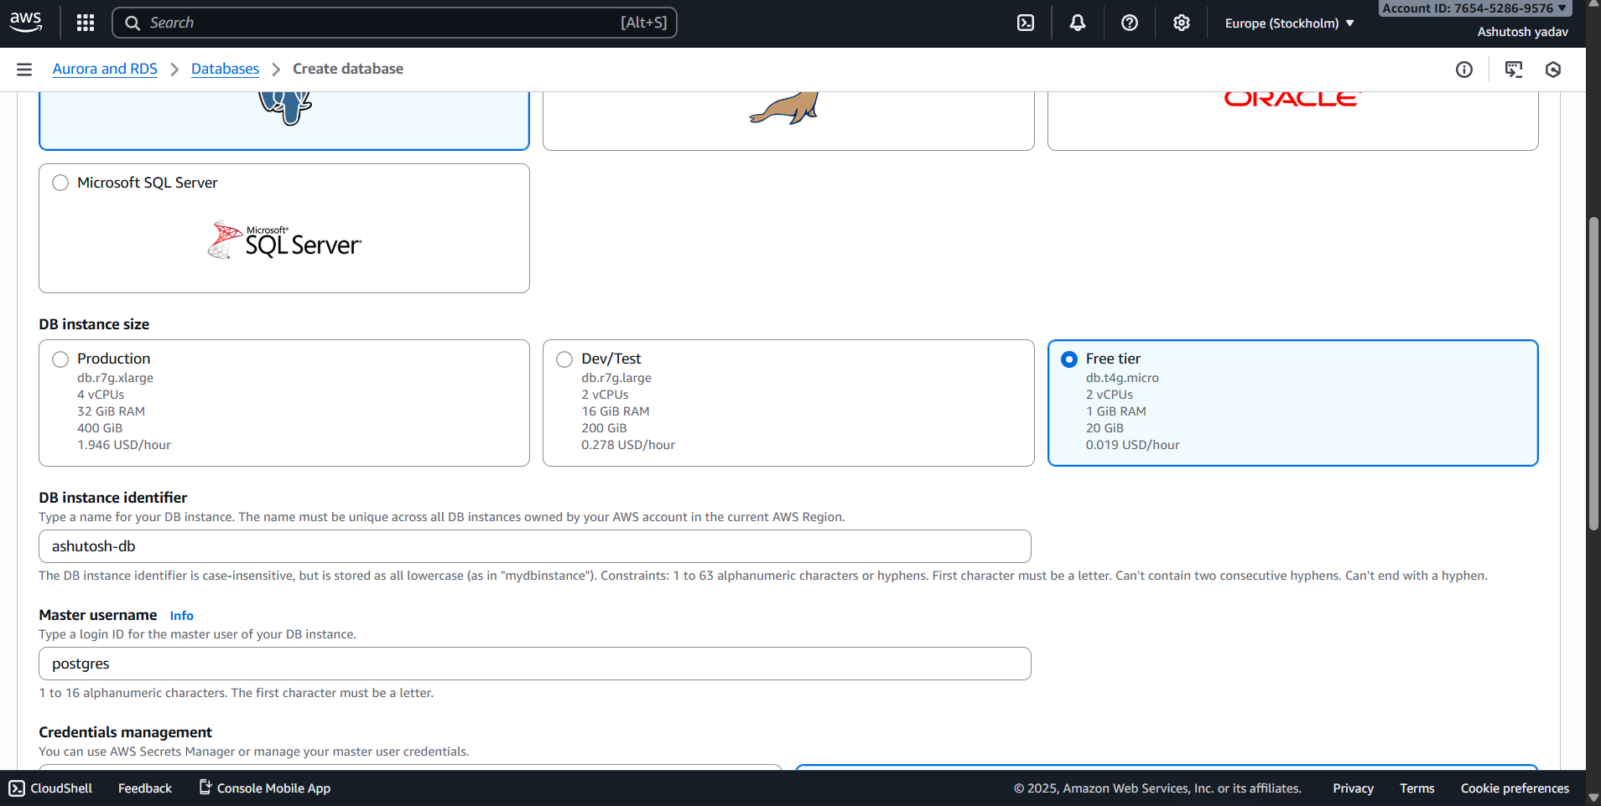
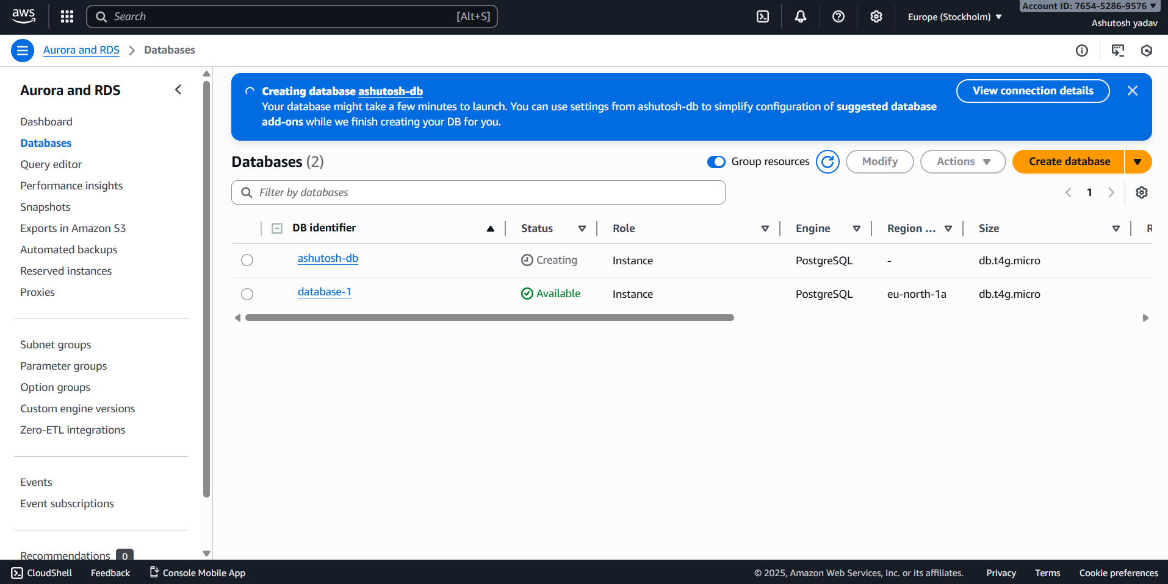
DEPARTMENTOF
COMPUTERSCIENCE&ENGINEERING
Step 2: Configure Security Group (Allow Local Access Only)
  - In AWS Console → go to RDS → Databases → click your DB .
  - Open the Connectivity & Security tab.
  - Under VPC security groups, click the linked group name (it opens EC2 security groups).
  - Click Edit inbound rules → Add rule
Type: PostgreSQL

Protocol: TCP
Port: 5432

Source: My IP
  - .ClickSaverules.

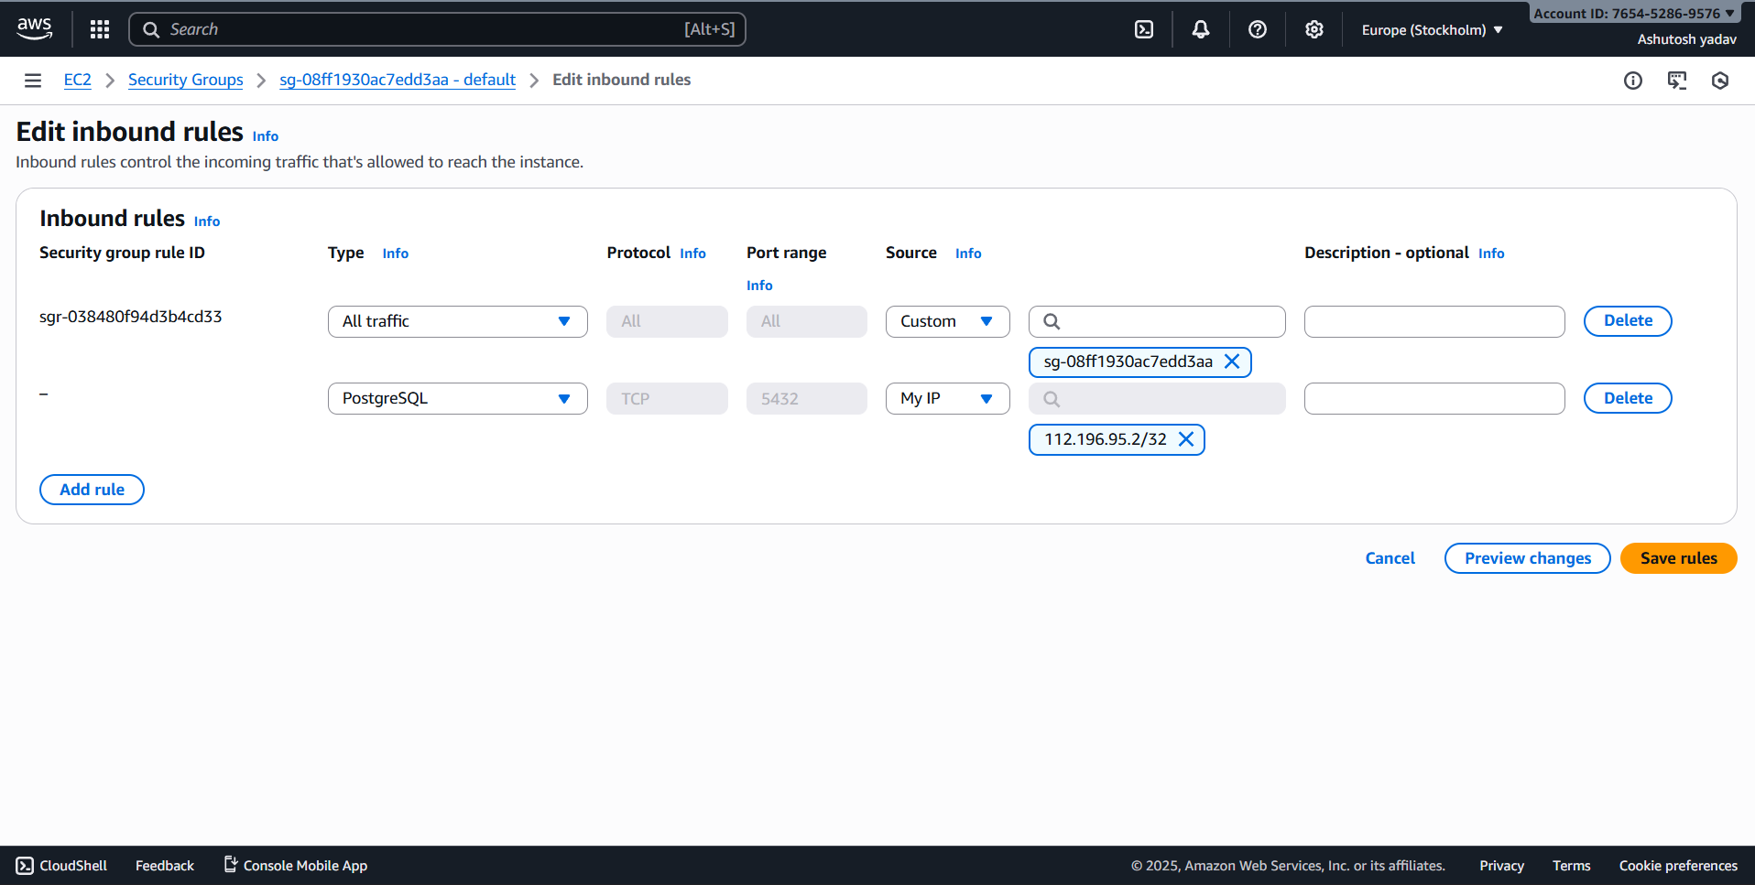
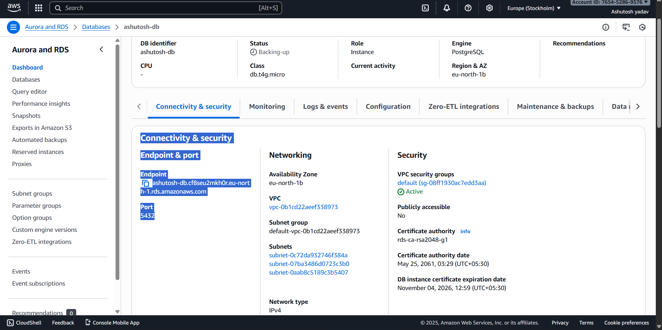
Step3:ConnectDatabaseUsingpgAdmin
  - Open pgAdmin 4 on your local system.
  - Right-click Servers → Create → Server.
  - Under the General tab, enter the name: postgres.
  - Under the Connection tab, fill in the following details:
    - Host name/address from instance connectivity & security
    - Port: 5432 Username and password as while creating the instance.
- Click Save to connect your RDS PostgreSQL database.
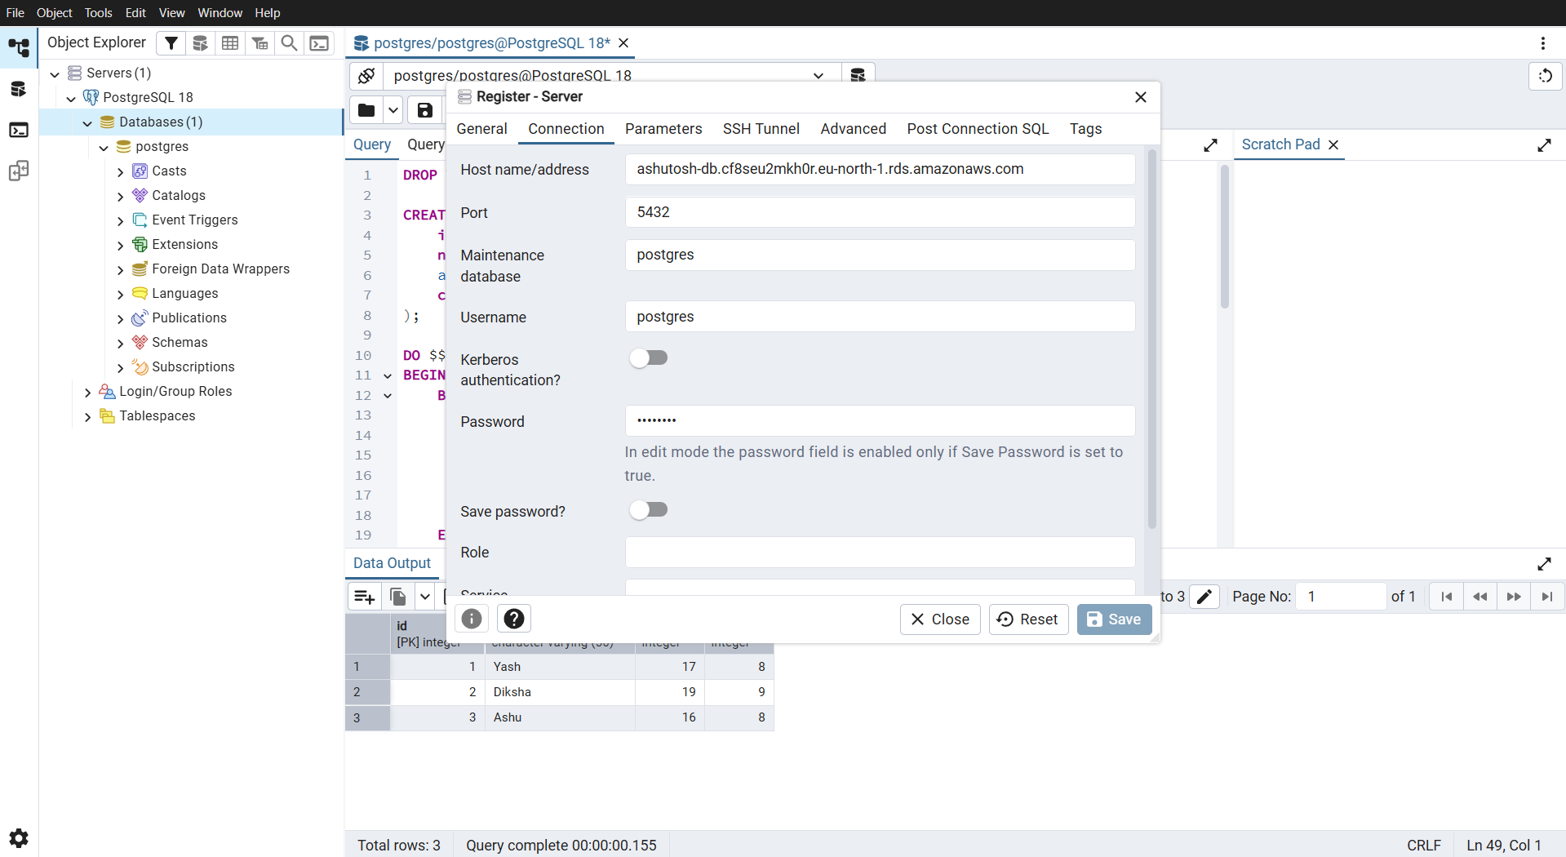

Learning Outcomes:
- Understand and configure RDS instances:
Learners will be able to create and configure a PostgreSQL database instance on Amazon RDS by selecting appropriate instance types, storage options, and security groups.
- Establish secure database connections:
Learners will be able to connect to the PostgreSQL RDS instance using database clients or application code through proper authentication, networking, and endpoint management.
- Manage and monitor RDS resources:
Learners will be able to manage database parameters, perform basic maintenance tasks, and use AWS monitoring tools (like CloudWatch) to ensure database performance and availability.

