📄 Wireframe Document

Project: Chicken Disease Detection System (Deep Learning Powered)
Version: v1.0 (Final UI)
Designed & Implemented By: Pankaj Kumar Pramanik

1. Overview
This document represents the final UI wireframe and developer handoff for the Chicken Disease Detection System, a deep learning–powered web application.
The system allows users to:
- Upload a chicken image
- Run CNN-based inference
- View predicted disease results instantly
This wireframe reflects the actual implemented UI, validated against the production deployment.

2. Application Layout (Final)

Overall Layout Structure
--------------------------------------------------
| Application Header |
--------------------------------------------------
| |
| Image Upload Panel | Prediction Results |
| | |
| | |
--------------------------------------------------

3. Header Section

Title
Chicken Disease Detection System

Characteristics
- Center-aligned
- Large, bold typography
- Clear medical / AI system identity

4. Image Upload Panel (Left Section)

Purpose
Allows the user to upload and preview a chicken image before prediction.

Components

4.1 Image Preview Area
- Displays the uploaded image
- Auto-resizes while maintaining aspect ratio
- Placeholder state before upload

4.2 Action Buttons
Button | Action
Upload | Opens file picker
Predict | Sends image to backend for inference
Button Behavior:
- Upload → Enables image preview
- Predict → Calls /predict API

Validation Rules
- Accepts image formats: .jpg, .png
- Prevents prediction without image upload
- Displays inline error (if required)

5. Prediction Results Panel (Right Section)

Purpose
Displays the inference output returned from the deep learning model.

Components

5.1 Results Container
- Card-based UI
- Soft background with rounded corners

5.2 Prediction Output
Label:
Prediction Results
Response Format (JSON-style):
{
"image": "Coccidiosis"
}

Interpretation
- "image" → Predicted disease class
- Result is deterministic based on trained CNN model

Visual Characteristics
- Monospace font for JSON output
- High contrast for readability
- Scroll-safe container (future-ready)

6. User Interaction Flow (Final)
User opens application
↓
Clicks Upload
↓
Selects chicken image
↓
Image preview displayed
↓
Clicks Predict
↓
Image sent to Flask API
↓
CNN model inference
↓
Prediction displayed in Results panel

7. Backend Integration Notes

API Endpoint
POST /predict

Request
- Multipart form-data
- Key: image

Response
{
"image": "Coccidiosis"
}

8. UI / UX Principles Followed
✔ Minimal & clean layout
✔ Clear separation of input and output
✔ Instant feedback after prediction
✔ No unnecessary user actions
✔ Production-friendly design

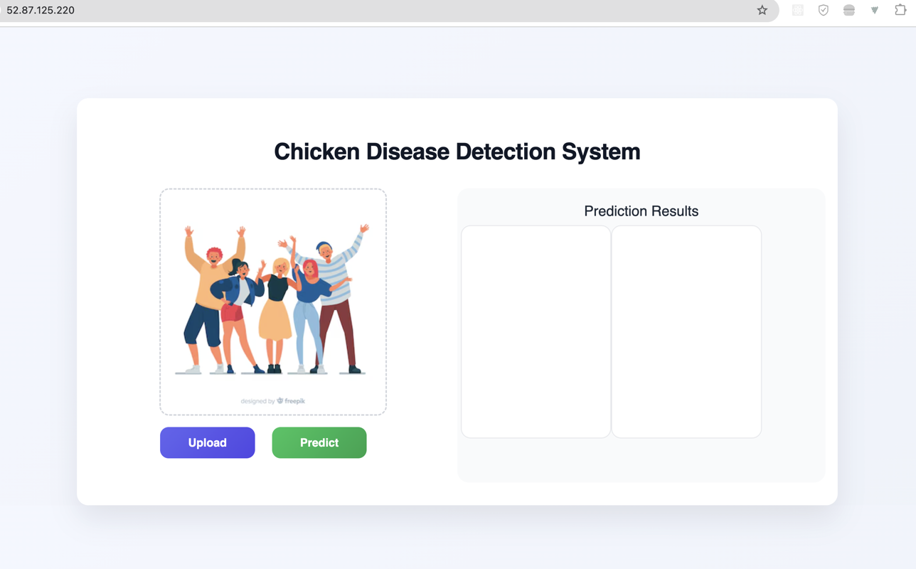

9. Non-Functional Requirements
Requirement | Status
Responsive UI | ✅
Fast Inference Display | ✅
Error-safe Flow | ✅
Cloud Deployed | ✅
Production Ready | ✅

10. Future UI Enhancements (Optional)
- Confidence score (%)
- Disease description panel
- Severity indicator (color-coded)
- History of predictions
- Batch image upload

11. Conclusion
This wireframe document captures the final, implemented UI of the Chicken Disease Detection System.

