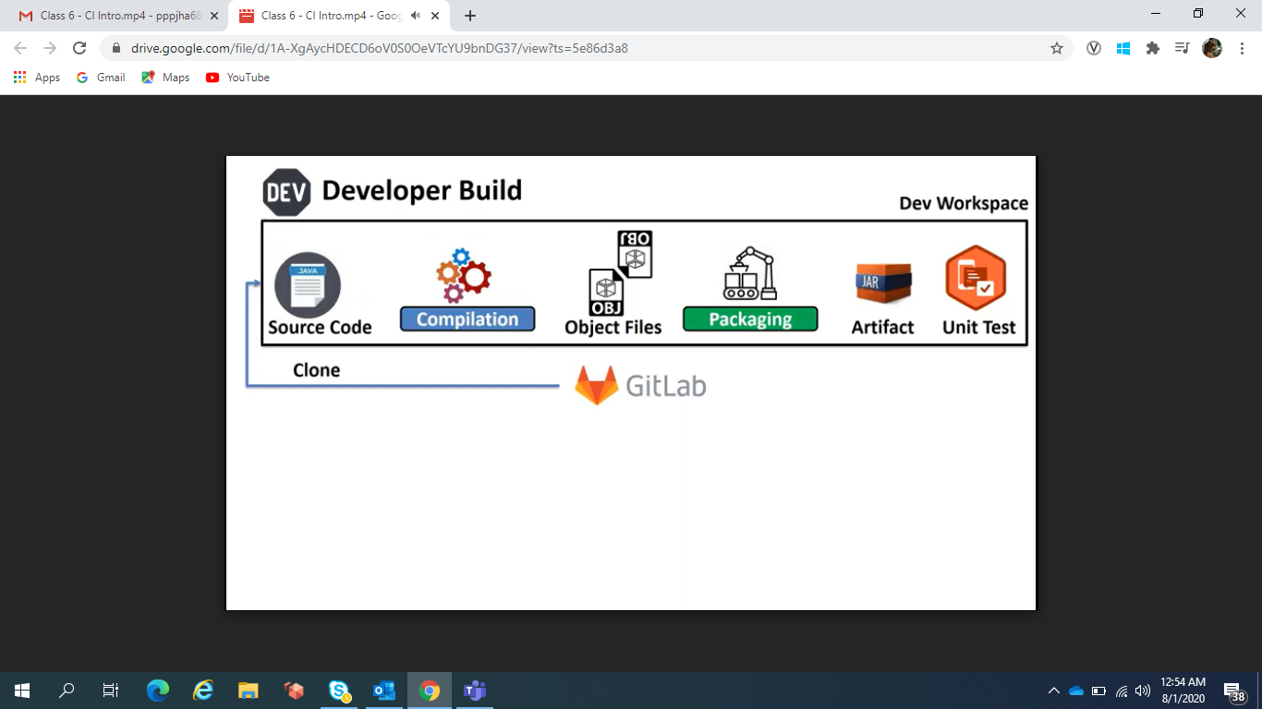

Build is nothing but Converting Source code into Object files and combining several object file together and creating a singl deliverables.

Nightly Build is a full build

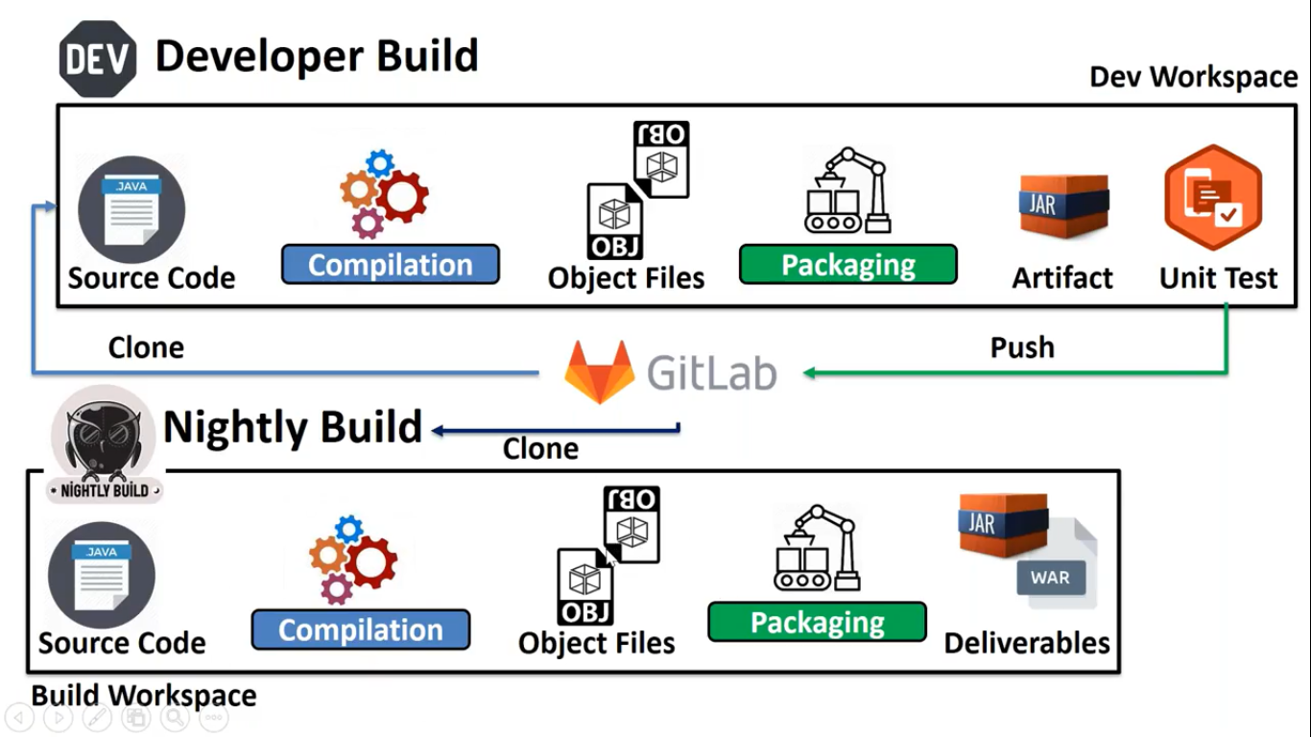

Developer Build is done by developer and it contains only developer files only.

Nightly Build is happening on regular intervals, it will happened with full build.

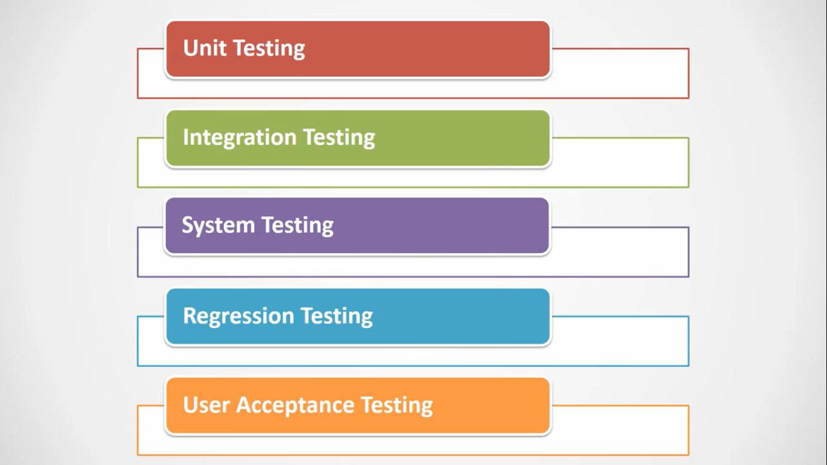

Integration Testing is done before giving it to QA

It is done during Nightly Build at the last

System Testing is done by QA

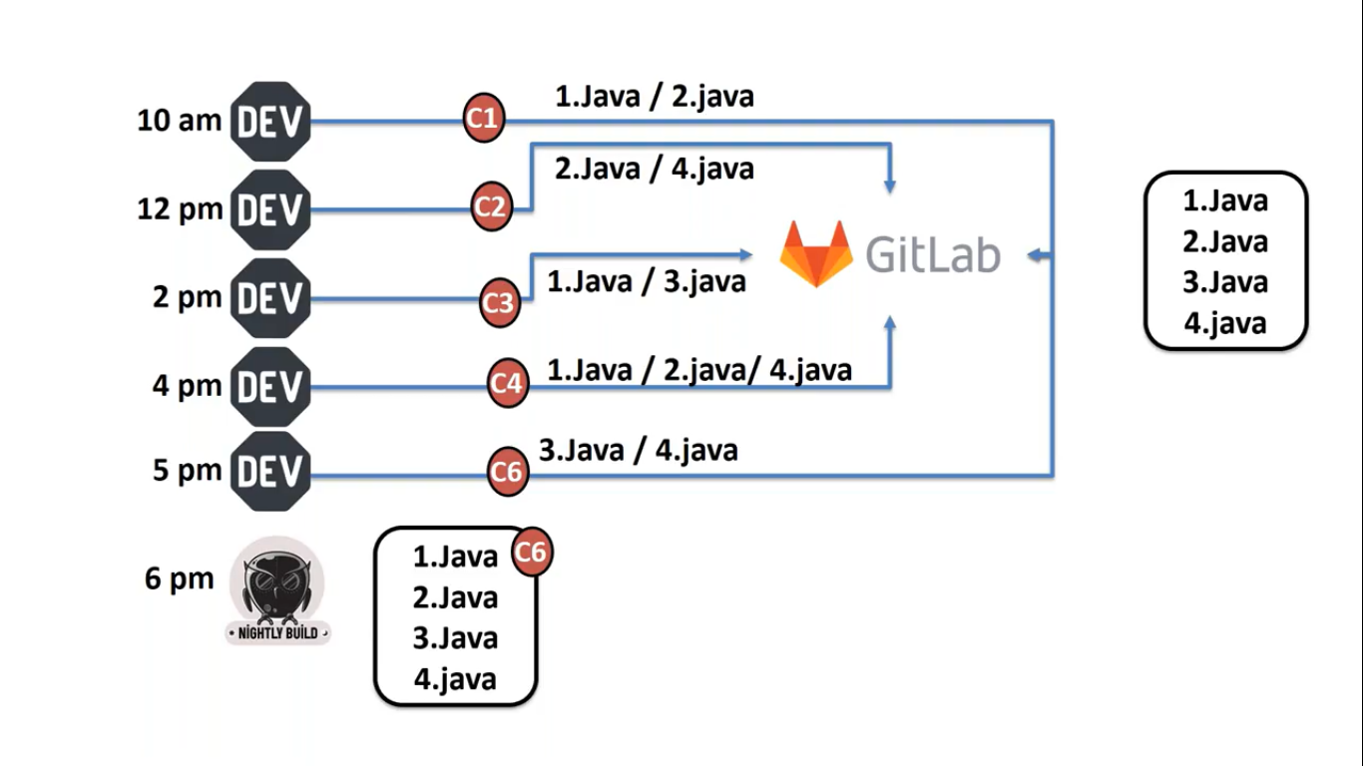

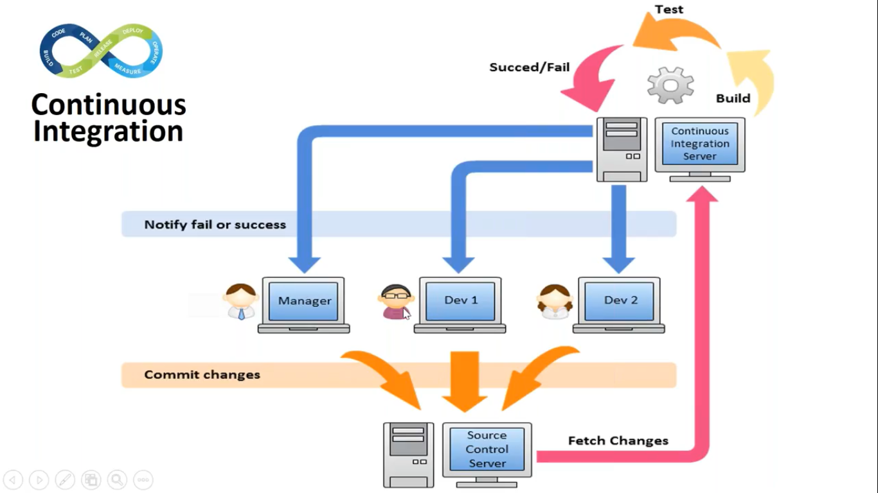

CI is a automated process i.e. whenever developer checkin the code we have to take that code and integrate with the existing code.

Here we will continuously monitor whether new code is getting check in.

We have to continuously poll in.

For doing CI job we will use a tool called as Jenkins.

Jenkins is a web application which can be used for automation.

We can say Jenkins is a dumb tool which will not do anything by its own but needs to specify what to do when to do and where to do.

For any kind of work we have plugins in Jenkins.

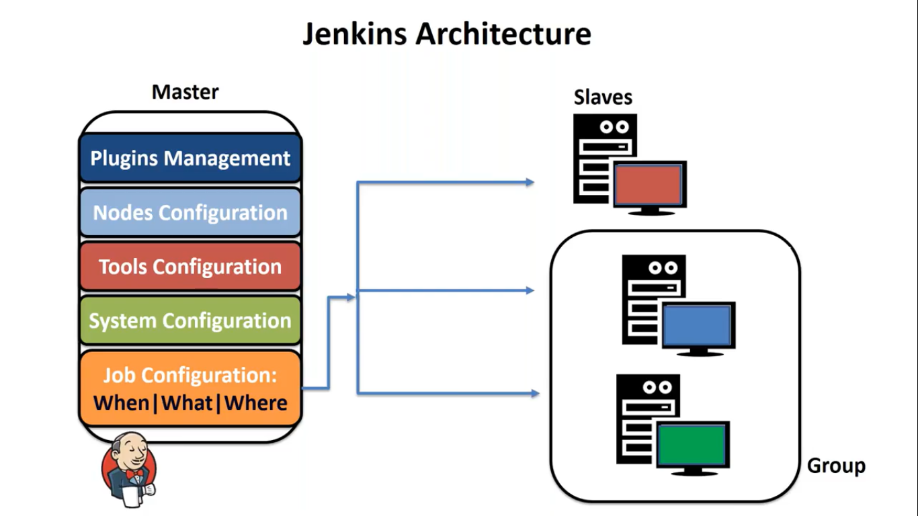

In Jenkins we can create a group, Advantage of group is that if one machine is not available in group it will look for other machine in the group.