AgentOps Dashboard
Databricks partner accelerator — internal management pitch
(Editable Word document — replace figures with product screenshots when available.)
Version 1.0 · April 2026

Executive summary
Organizations are moving AI agents into production on Databricks, but operations teams still lack a single place to answer four critical questions: Are agents healthy and reliable? What are they costing? Is output quality and safety regressing? What data did they touch for governance and audit?
Databricks already provides the underlying telemetry and governance primitives (Inference Tables, MLflow tracing and evaluation, Unity Catalog, system billing data, and Lakebase for operational storage). The gap is packaging: there is no first-class, Databricks-native “control tower” that unifies these signals for executives and operators.
AgentOps Dashboard is a partner accelerator project: a professional web application deployed as a Databricks App, with a FastAPI backend and a React user interface. It is intentionally designed to showcase multiple Databricks capabilities in one coherent story while solving a real observability problem that affects agent proof-of-concepts and production rollouts.

Why this initiative exists
Databricks encourages partners to build focused accelerators that demonstrate new platform capabilities. Several high-profile partner demos already exist in adjacent spaces (for example, Genie and governance storytelling, or Lakebase-powered tooling). Our opportunity is to deliver a differentiated accelerator that is credible with buyers and technically impressive with Databricks field teams—without duplicating those narratives.

The business problem
AI agents are not “just a chatbot.” They plan, call tools, read governed data, and take actions. When something fails—latency spikes, cost runaway, hallucinations, unsafe outputs, or unauthorized data access—teams today stitch together notebooks, SQL, and ad-hoc reports. That operational gap slows adoption and increases risk.
- Many agent pilots fail when monitoring and ownership are unclear (industry reporting commonly cites high failure rates linked to operational maturity).
- Finance and product leadership cannot attribute model spend to agents, features, or business lines.
- Risk and compliance teams cannot produce a defensible audit narrative without manual effort.

What we are building
AgentOps Dashboard is a Databricks-native operations console: one application with four primary panels, backed by governed platform data and Lakebase for application state.
Panel | What it delivers (customer value)
Agent health | Throughput, latency, error rates, and availability signals sourced from inference logging.
Cost & tokens | Spend drivers, token burn trends, and attribution using inference telemetry and billing/system data (subject to access grants).
Quality & safety | Automated evaluation signals and trace drill-down using MLflow Agent Evaluation and MLflow tracing.
Governance & audit | What governed assets were touched, lineage context, and audit-friendly summaries using Unity Catalog.

Differentiation (why this accelerator stands out)
- Unifies multiple Databricks strengths into one product-shaped experience (not a single-feature demo).
- Targets a clear enterprise pain: production agent observability and governance readiness.
- Technically achievable: primarily integration, UX, and governed access patterns—not bespoke model training.

Databricks components we showcase
Capability | Role in AgentOps Dashboard
Lakebase | Operational datastore for configuration, thresholds, alerts, and cached aggregates.
Databricks Apps | Managed deployment and secure runtime integration for the web application.
Inference Tables | Primary telemetry for requests, responses, latency, tokens, and errors.
MLflow tracing | Step-by-step debugging narrative for agent runs.
MLflow Agent Evaluation | Automated quality scoring (groundedness, relevance, safety, correctness).
Unity Catalog | Governance: permissions, lineage, and audit-oriented presentation.

Figures

Figure A — Reference data flow (conceptual)
Illustrative architecture showing how user traffic flows through AI Gateway and agents into Inference Tables, while MLflow, system telemetry, and Unity Catalog provide parallel signals consumed by the dashboard. Lakebase stores application-owned operational data.
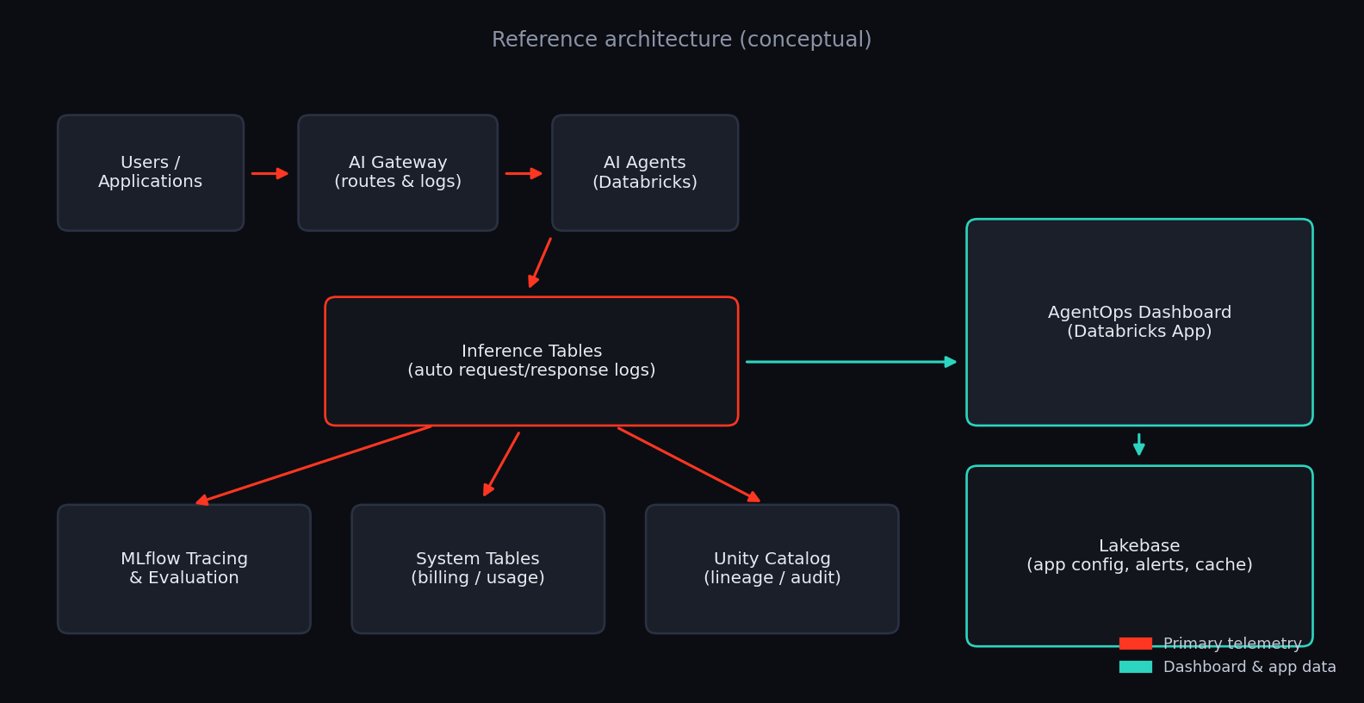

Figure B — Product UI direction (illustrative)
Concept rendering of the four-panel operational console. Replace with screenshots of the production UI when available for customer-facing decks.
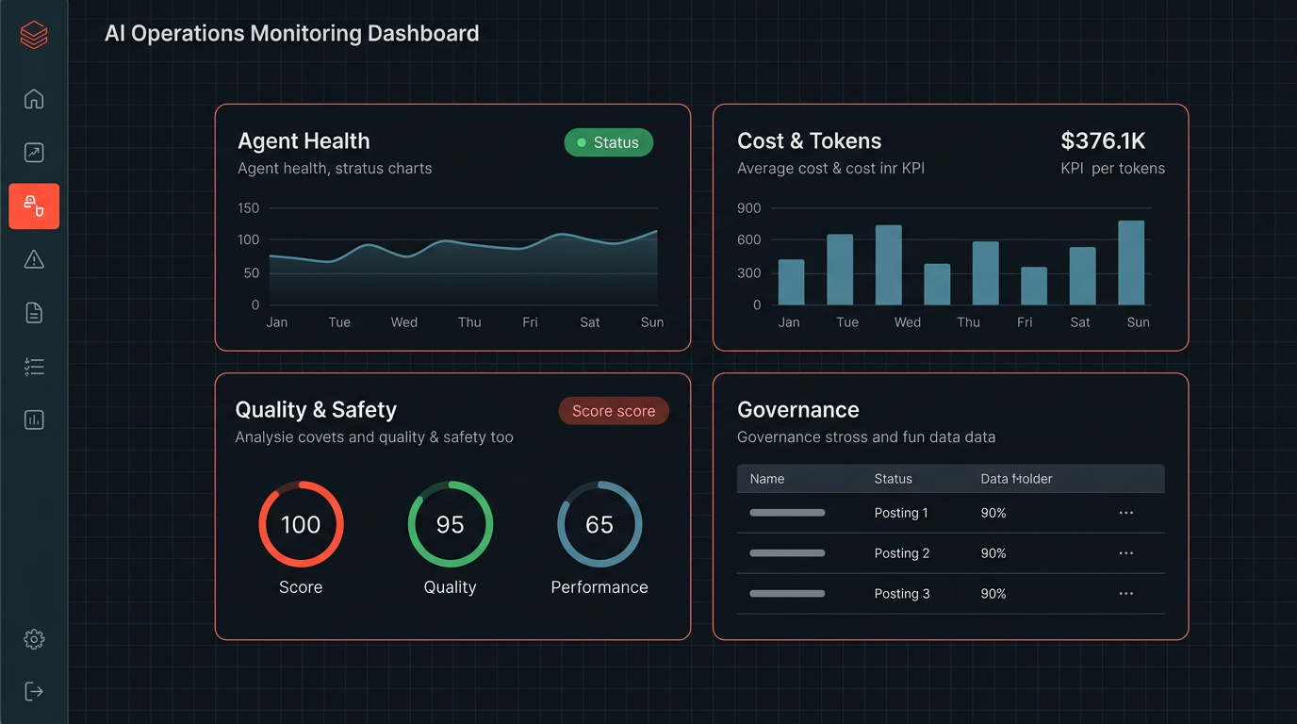

Outcome we want from Databricks
- Field recognition: a repeatable demo that solution architects can show to customers.
- Partner marketing alignment: a credible “agent operations” story anchored in GA platform features.
- Pipeline acceleration: prospects already running agents can visualize value in minutes.

What we need from management
- Sponsorship and prioritization for a focused accelerator timeline (engineering + design + demo prep).
- Access to a Databricks workspace suitable for integration testing (SQL warehouse, UC, optional Lakebase).
- A decision on customer-facing positioning: internal enablement vs external launch packaging.

One-line pitch (talk track)
We are building AgentOps Dashboard — a Databricks-native control tower that unifies inference telemetry, MLflow tracing and evaluation, billing signals, and Unity Catalog governance into one operations console for production AI agents.

Supporting detail: see repository file agentops-explainer.html and DEVELOPMENT_PROGRESS.md.

