AgentOps Dashboard
Databricks partner accelerator | Unified production observability for AI agents
Internal pitch document — concept overview (editable in Microsoft Word)

Executive summary
AgentOps is a Databricks-native web application that gives teams a single “control tower” for AI agents in production. It unifies data that already exists in a modern Lakehouse—without standing up a separate stack—by combining health metrics, cost and token attribution, quality and safety scorecards, and governance-oriented audit views. The goal is a credible partner accelerator: showcase multiple Databricks capabilities in one compelling, demo-ready product story.

Strategic context: why this project
Databricks values partner accelerators: small, reference-grade solutions that show how to apply new platform capabilities in a realistic scenario. A strong accelerator improves market visibility, partnership positioning, and follow-on project opportunities. This initiative explicitly targets a differentiated story rather than recreating an example another partner has already taken to market (for example, alternatives focused on a single feature such as a migration tool or a narrow governance demo).

The business problem (plain language)

What is changing
Organizations are deploying AI agents (systems that use models, tools, and data to act on behalf of users) directly on the data platform. In production, teams must answer: Is the system reliable? How much is it costing? Is output accurate and safe? And can we show regulators and security stakeholders what the agent did?

Why it hurts today
- Operational visibility is scattered across logs, ad hoc SQL, and separate monitoring tools.
- Cost and token growth are hard to attribute to individual agents, features, or teams until invoices arrive.
- Quality and safety need continuous evaluation, not a one-time benchmark.
- Governance and audit need a clear line from agent behavior to the underlying tables and models.

One sentence problem statement
There is no single Databricks screen today that assembles health, cost, quality, and governed audit together for production agent workloads.

Our product concept: AgentOps Dashboard
AgentOps is a control tower implemented as a Databricks App, with a modern user interface and a Python API. It reads from governed Lakehouse data sources the customer already has (inference and usage logging, system tables, MLflow traces and evaluation outputs, and Unity Catalog metadata), and it stores app-specific configuration in Lakebase, Databricks' operational database inside the platform.

The four product panels (at a glance)
Panel | What the business user gets
Agent health | Service status, request volume, latency, error rate, and clear alerts for regressions.
Cost and tokens | Token and spend visibility by agent and time period; burn and forecast style insights.
Quality and safety | Signals such as groundedness, relevance, and safety trends; drill into traces when scores drop.
Governance and audit | Which assets agents touched, lineage and policy posture at a high level, audit friendly summaries.

How it is built on Databricks (credible, not bolt-on)
- Lakebase: operational data for the app itself (alerts, saved views, cached rollups) alongside analytics.
- Inference Tables: automatic, governed capture of model traffic for performance and cost analytics.
- MLflow: tracing and Agent Evaluation to explain behavior and show quality in production over time.
- Unity Catalog: access control, lineage, and discoverability to support a governance narrative.
- System tables: where permitted, use platform billing and usage to strengthen cost models.

End-to-end architecture (conceptual)
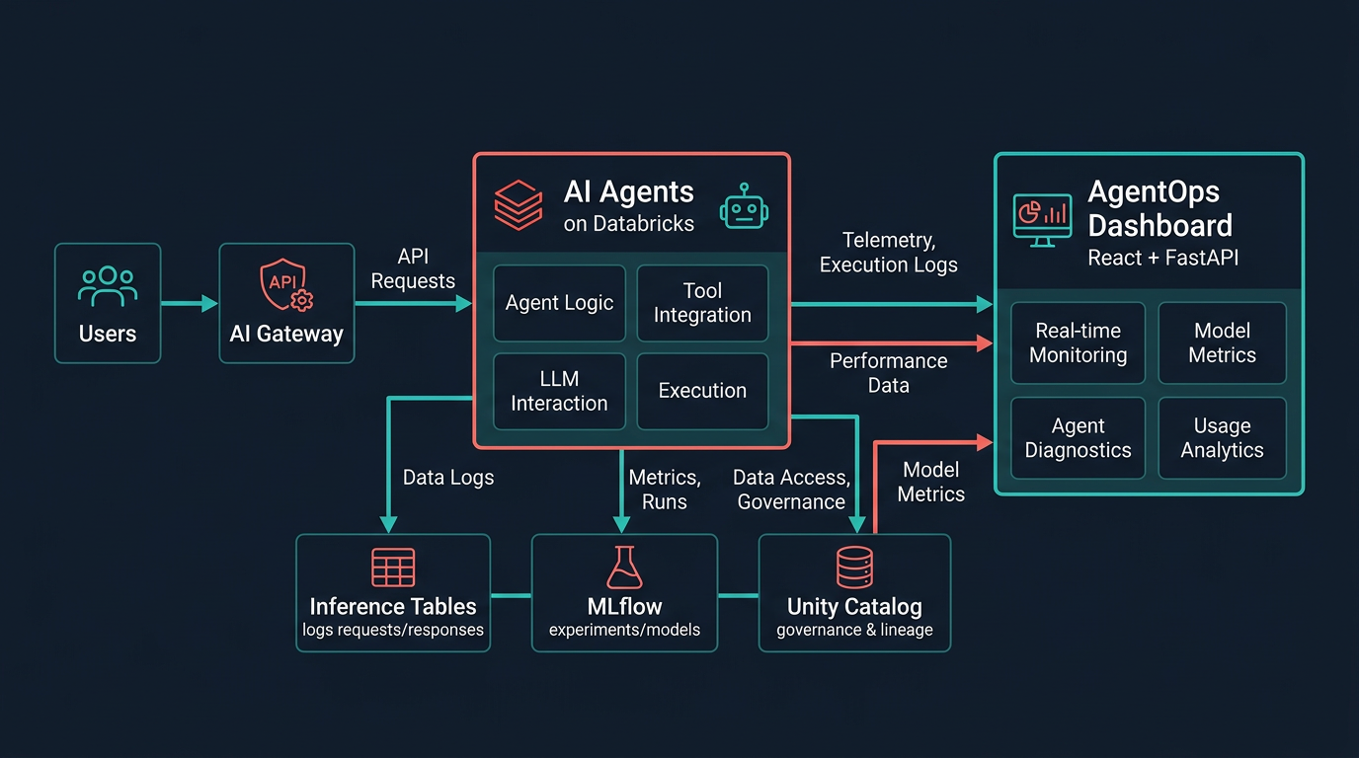
Figure 1 — Data flows from AI traffic through Databricks into AgentOps, without a separate off-platform warehouse.

End-user experience (conceptual)
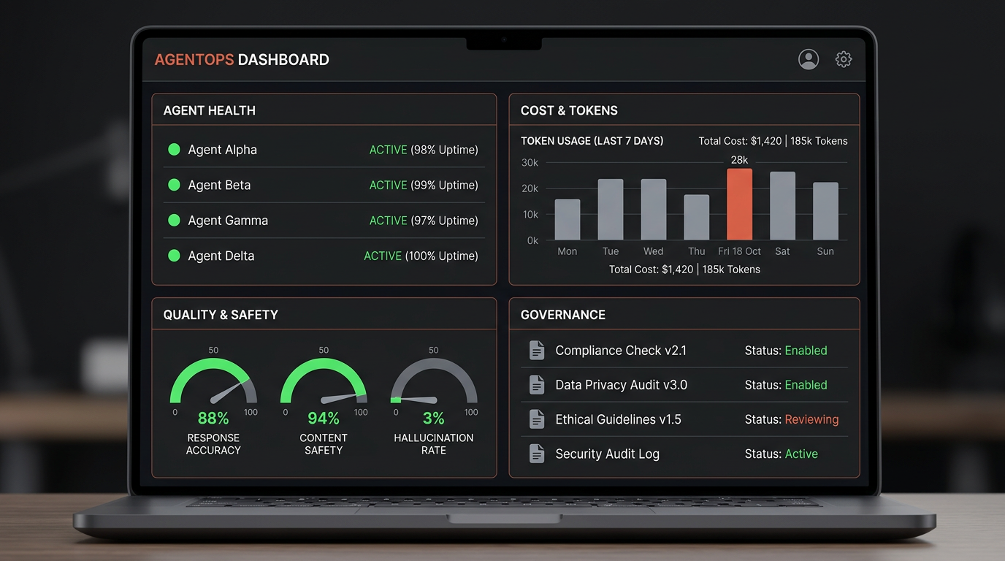
Figure 2 — Concept of the four-panel “single pane of glass” experience (stylized mock, not a live product screenshot).

What we are implementing (current engineering direction)
The implementation uses a professional web stack: React and TypeScript for a responsive, branded user interface, FastAPI for API services, and a path to Databricks SQL and SDK integration. Deployment is aligned with Databricks Apps. Development progress is tracked in a living engineering checklist so the initiative stays on message as features land.

What makes this pitch strong for Databricks + our firm
- Complements, not competes, with a broad GenAI program: the story is about responsible production operations.
- Assembles many Databricks product names in a single coherent use case, which maps well to partner reviews.
- Fills a practical gap: teams are tired of one-off SQL and notebooks to answer the same four questions every week.

One line pitch (ready for a slide or email header)
"We are building a Databricks-native control tower that unifies inference and usage data, MLflow quality signals, and Unity Catalog governance into one place for health, cost, quality, and audit of AI agents in production—without adding a separate vendor stack."

Delivery expectations (realistic for leadership)
- A demo-ready v1: four panels, live or semi live data, clear narrative, deployable in Databricks.
- Integration depth depends on workspace entitlements, including access to system tables, UC lineage outputs, and MLflow experiments, which the delivery team will validate with the platform team.
- A crisp accelerator story: fast to explain, defensible, and extensible to customer workshops.

Call to action
Sponsor a focused delivery window, assign a workspace with Unity Catalog, confirm Lakebase and governance entitlements, and back the partner positioning narrative with one executive sponsor and one platform owner. This document can be updated as screenshots from the live app replace the concept art.

Prepared for internal management use. For questions or updates, align with the AgentOps product owner and delivery lead.

