How to run the Blood Bank Donor Management System Django Python

1. Download the zip file
2. Extract the file, copy bbdms folder, and paste it on the desktop
3. Open MySQL Create a database bbdmspythondb then import the SQL File available in the SQL File Folder (For MySQL we used the XAMPP server)
4. Open PyCharm and click on the terminal
5. Navigate the project folder using the cd command
cd project_path
For ex: cd C:\Users\ANUJ\OneDrive\Desktop\bbdms\
6. Now Navigate to the bloodbanksystem folder
cd bloodbanksystem
7. Run the Project using the following command
python manage.py runserver
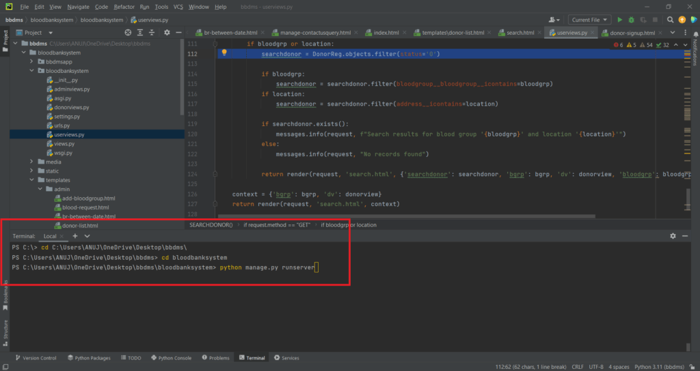
Now click the URL http://127.0.0.1:8000 and the Project will run
Login Details
*************admin************
Username: admin
Password: Test@123
*************Donor************
Username: test123
Password: Test@123 OR Register new donor

For More Detail visit:
https://phpgurukul.com/python-projects-free-download/

