TASK SNAP’s

Source env activated

Port 5002

https response code 200

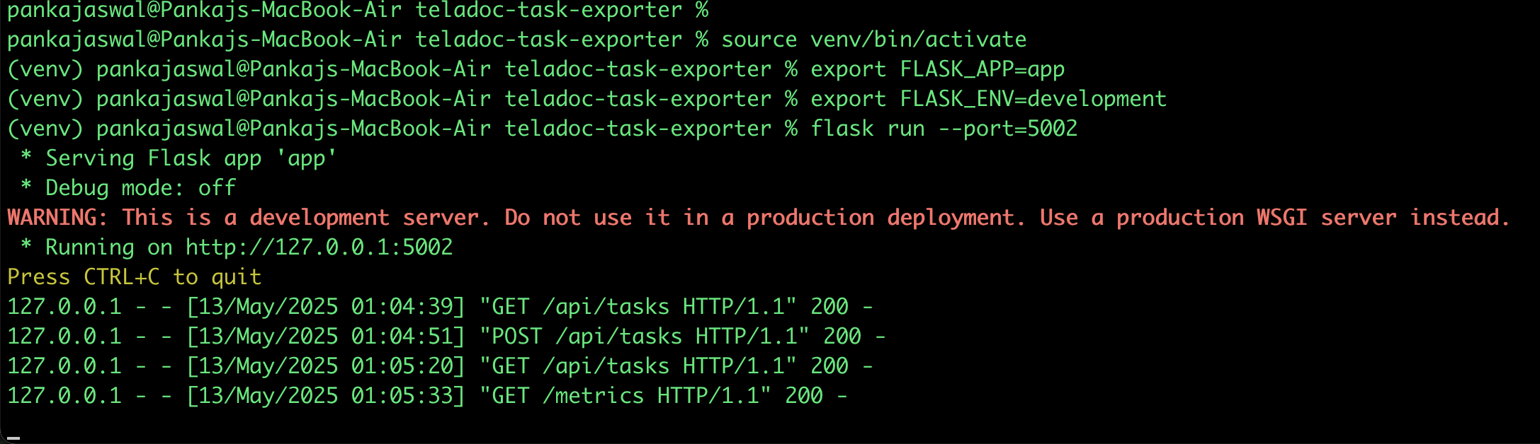

Curl to hit from terminal:-

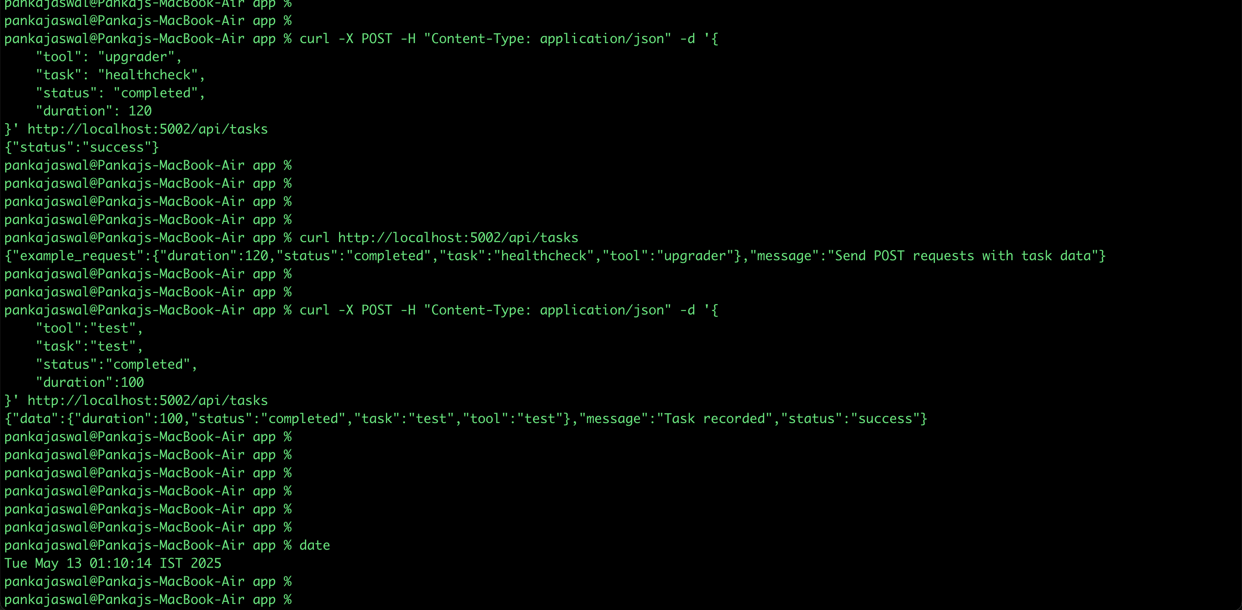

/metrics output:-

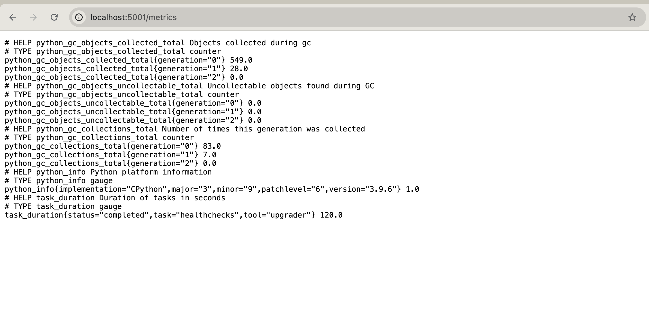

/api/tasks output :-

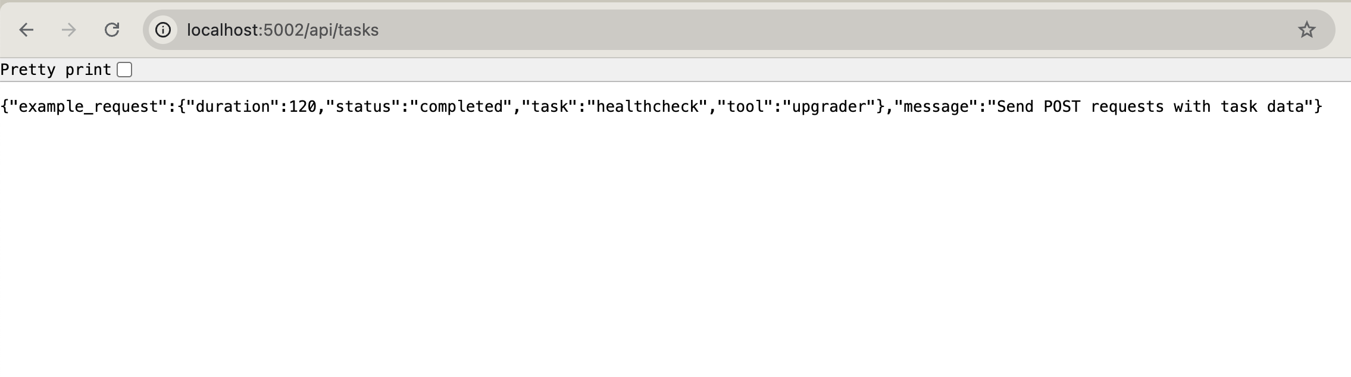

Prometheus logs data :-

