Computational Lab - Assignment 4: Directed Acyclic Graph (DAG) with STL-Plus Lib

By: Pankaj Azad, Roll Number - 14M517, M.Tech Ist Sem

Enter number of vertices...13

Enter the edges (E.g. 4 3 means a directed edge from 4 to 3). -1 -1 as input stops the process

0 5

0 1

0 6

2 0

2 3

3 5

5 4

6 4

6 9

7 6

8 7

9 11

9 12

9 10

11 12

-1 -1

Enter any of the following available choices

1 - Add Edge(s)

2 - Delete Edge(s)

3 - Print Adjacency list and draw graph (generates a png image)

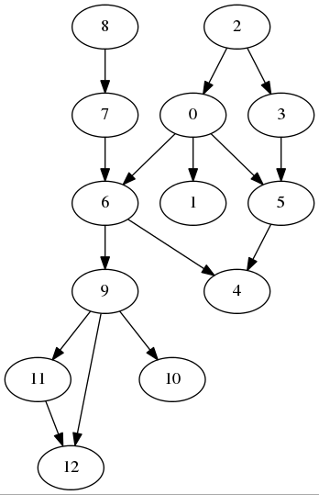4 - Depth First Search (DFS)

5 - Detect existence of cycle

9 - Exit

3

DAG: 13 Vertices and 15 Edges

[0] => 5 1 6

[1] =>

[2] => 0 3

[3] => 5

[4] =>

[5] => 4

[6] => 4 9

[7] => 6

[8] => 7

[9] => 11 12 10

[10] =>

[11] => 12

[12] =>

Enter any of the following available choices

1 - Add Edge(s)

2 - Delete Edge(s)

3 - Print Adjacency list and draw graph (generates a png image)

4 - Depth First Search (DFS)

5 - Detect existence of cycle

9 - Exit

5

No Cycle found!!

Enter any of the following available choices

1 - Add Edge(s)

2 - Delete Edge(s)

3 - Print Adjacency list and draw graph (generates a png image)

4 - Depth First Search (DFS)

5 - Detect existence of cycle

9 - Exit

1

Enter the edges (E.g. 4 3 means a directed edge from 4 to 3). -1 -1 as input stops the process

4 2

-1 -1

Enter any of the following available choices

1 - Add Edge(s)

2 - Delete Edge(s)

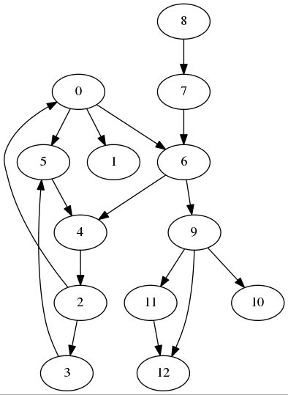3 - Print Adjacency list and draw graph (generates a png image)

4 - Depth First Search (DFS)

5 - Detect existence of cycle

9 - Exit

3

DAG: 13 Vertices and 16 Edges

[0] => 5 1 6

[1] =>

[2] => 0 3

[3] => 5

[4] => 2

[5] => 4

[6] => 4 9

[7] => 6

[8] => 7

[9] => 11 12 10

[10] =>

[11] => 12

[12] =>

Enter any of the following available choices

1 - Add Edge(s)

2 - Delete Edge(s)

3 - Print Adjacency list and draw graph (generates a png image)

4 - Depth First Search (DFS)

5 - Detect existence of cycle

9 - Exit

5

Cycle Exits!!

Enter any of the following available choices

1 - Add Edge(s)

2 - Delete Edge(s)

3 - Print Adjacency list and draw graph (generates a png image)

4 - Depth First Search (DFS)

5 - Detect existence of cycle

9 - Exit

2

Enter the edges (E.g. 4 3 means a directed edge from 4 to 3). -1 -1 as input stops the process

3 5

-1 -1

Enter any of the following available choices

1 - Add Edge(s)

2 - Delete Edge(s)

3 - Print Adjacency list and draw graph (generates a png image)

4 - Depth First Search (DFS)

5 - Detect existence of cycle

9 - Exit

5

Cycle Exits!!

Enter any of the following available choices

1 - Add Edge(s)

2 - Delete Edge(s)

3 - Print Adjacency list and draw graph (generates a png image)

4 - Depth First Search (DFS)

5 - Detect existence of cycle

9 - Exit

2

Enter the edges (E.g. 4 3 means a directed edge from 4 to 3). -1 -1 as input stops the process

2 0

-1 -1

Enter any of the following available choices

1 - Add Edge(s)

2 - Delete Edge(s)

3 - Print Adjacency list and draw graph (generates a png image)

4 - Depth First Search (DFS)

5 - Detect existence of cycle

9 - Exit

5

No Cycle found!!

Enter any of the following available choices

1 - Add Edge(s)

2 - Delete Edge(s)

3 - Print Adjacency list and draw graph (generates a png image)

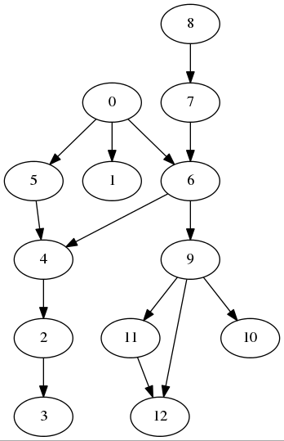4 - Depth First Search (DFS)

5 - Detect existence of cycle

9 - Exit

3

DAG: 13 Vertices and 14 Edges

[0] => 5 1 6

[1] =>

[2] => 3

[3] =>

[4] => 2

[5] => 4

[6] => 4 9

[7] => 6

[8] => 7

[9] => 11 12 10

[10] =>

[11] => 12

[12] =>

Enter any of the following available choices

1 - Add Edge(s)

2 - Delete Edge(s)

3 - Print Adjacency list and draw graph (generates a png image)

4 - Depth First Search (DFS)

5 - Detect existence of cycle

9 - Exit

4

Enter the source node for DFS...0

DFS from 0 : 0, 5, 4, 2, 3, 1, 6, 9, 11, 12, 10,

Enter any of the following available choices

1 - Add Edge(s)

2 - Delete Edge(s)

3 - Print Adjacency list and draw graph (generates a png image)

4 - Depth First Search (DFS)

5 - Detect existence of cycle

9 - Exit

9

SOURCE CODE

dag.h

#include <iostream>

#include <list>

#include <vector>

#include "digraph.hpp"

**using** **namespace** std**;**

enum Color **{** WHITE**,** GREY**,** BLACK **};**

**typedef** stlplus**::**digraph**<**int**,**bool**>** IntBoolGraph**;** // int Node Type & bool arc type

**typedef** std**::**vector**<**IntBoolGraph**::**iterator**>** NodeVector **;**

**typedef** std**::**vector**<**IntBoolGraph**::**arc_iterator**>** ArcVector **;**

class Dag

**{**

public**:**

Dag**(**int vertices**);**

**~**Dag**();**

int vertices**()** **{** **return** numberOfVertices**;** **}**

int edges**()** **{** **return** numberOfEdges**;** **}**

bool addEdge**(**int src**,** int dst**);**

void addEdges**();**

bool deleteEdge**(**int src**,** int dst**);**

void deleteEdges**();**

vector**<**int**>&** performDfsFromGivenSource**();**

void dfs**(**int sourceVertex**);**

bool doesCycleExist**();**

bool visit**(**int vertex**);**

void print**(**ostream **&**out**);**

private**:**

int numberOfEdges**;**

int numberOfVertices**;**

list**<**int**>\*** adjList**;**

char**\*** colorList**;**

vector**<**int**>** dfsOutputList**;**

IntBoolGraph graph**;**

NodeVector nodes**;**

ArcVector arcs**;**

**};**

dag.cpp

#include "dag.h"

#include <fstream>

#include <cstdlib>

#include <string>

#include <sstream>

**using** **namespace** std**;**

Dag**::**Dag**(**int vertices**)**

**{**

numberOfVertices **=** vertices**;**

// Add nodes/vertices

IntBoolGraph**::**iterator node**;**

**for** **(**int i**=**0**;**i**<**numberOfVertices**;**i**++)**

**{**

IntBoolGraph**::**iterator node **=** graph**.**insert**(**i**);**

nodes**.**push_back**(**node**);**

**}**

numberOfEdges **=** 0**;**

// adjList = new list<int>[numberOfVertices];

colorList **=** **new** char**[**numberOfVertices**];**

**}**

Dag**::~**Dag**()**

**{**

// delete adjList;

**delete** colorList**;**

**}**

bool Dag**::**addEdge**(**int src**,** int dst**)**

**{**

bool ret **=** **false;**

**if(** src **<** numberOfVertices **&&** dst **<** numberOfVertices**)**

**{**

IntBoolGraph**::**arc_iterator edge **=** graph**.**arc_insert**(**nodes**[**src**],**nodes**[**dst**],true);**

arcs**.**push_back**(**edge**);**

numberOfEdges**++;**

ret **=** **true;**

**}**

**return** ret**;**

**}**

bool Dag**::**deleteEdge**(**int src**,** int dst**)**

**{**

bool ret **=** **false;**

**if(** src **<** numberOfVertices **&&** dst **<** numberOfVertices**)**

**{**

//locate and remove the edge

IntBoolGraph**::**arc_iterator edge**;**

IntBoolGraph**::**iterator from**;**

IntBoolGraph**::**iterator to**;**

**for** **(**int i**=**0**;**i**<**numberOfEdges**;** i**++)**

**{**

from **=** graph**.**arc_from**(**arcs**[**i**]);**

to **=** graph**.**arc_to**(**arcs**[**i**]);**

**if** **(\***from **==** src **&&** **\***to **==** dst**)**

**{**

graph**.**arc_erase**(**arcs**[**i**]);**

numberOfEdges**--;**

ret **=** **true;**

**break;**

**}**

**}**

**}**

**return** ret**;**

**}**

void Dag**::**print**(**ostream **&**out**)**

**{**

static int dotfileNumber**=**0**;**

dotfileNumber**++;**

out **<<** "DAG: " **<<** numberOfVertices **<<** " Vertices and " **<<** numberOfEdges **<<** " Edges " **<<** endl**;**

ofstream dotfile**;**

ostringstream dotfileName**;**

dotfileName **<<**"dag" **<<** dotfileNumber **<<** ".dot"**;**

dotfile**.**open**(**dotfileName**.**str**().**c_str**(),**ofstream**::**out**);**

dotfile **<<** "digraph G {" **<<** endl**;**

**for** **(**int index **=** 0**;** index **<** numberOfVertices**;** index**++)**

**{**

out **<<** "["**<<** index **<<** "] => " **;**

**for(**int j **=** 0**;** j**<** graph**.**fanout**(**nodes**[**index**]);** j**++)**

**{**

IntBoolGraph**::**arc_iterator edge **=** graph**.**output**(**nodes**[**index**],**j**);**

IntBoolGraph**::**iterator toNode **=** graph**.**arc_to**(**edge**);**

out **<<** **\***toNode **<<** " " **;**

dotfile **<<** "\t "**<<** index **<<** " -> " **<<** **\***toNode **<<** ";" **<<** endl**;**

**}**

cout **<<** endl**;**

**}**

dotfile **<<** "}" **<<** endl**;**

dotfile**.**close**();**

ostringstream dagGenerationCommand**;**

dagGenerationCommand **<<** "dot -Tpng dag" **<<** dotfileNumber **<<** ".dot -o dag" **<<** dotfileNumber **<<** ".png"**;**

system**(**dagGenerationCommand**.**str**().**c_str**());**

ostringstream imageOpeningCommand**;**

imageOpeningCommand **<<** "ristretto dag" **<<** dotfileNumber **<<** ".png" **<<** "&"**;**

system**(**imageOpeningCommand**.**str**().**c_str**());**

**}**

void Dag**::**addEdges**()**

**{**

int src**,** dst**;**

cout **<<** "Enter the edges (E.g. 4 3 means a directed edge from 4 to 3). -1 -1 as input stops the process" **<<** endl**;**

**do**

**{**

cin **>>** src **>>** dst**;**

**if(**src**!=-**1 **&&** **!**addEdge**(**src**,**dst**))**

cout **<<**"Failed to add this edge, (Try again with vertex numbers between range (0,TotalVertices -1))" **<<** endl**;**

**}while(**src**!=-**1**);**

**}**

void Dag**::**deleteEdges**()**

**{**

int src**,** dst**;**

cout **<<** "Enter the edges (E.g. 4 3 means a directed edge from 4 to 3). -1 -1 as input stops the process" **<<** endl**;**

**do**

**{**

cin **>>** src **>>** dst**;**

**if(**src**!=-**1 **&&** **!**deleteEdge**(**src**,**dst**))**

cout **<<**"Failed to add this edge, (Try again with vertex numbers between range (0,TotalVertices -1))" **<<** endl**;**

**}while(**src**!=-**1**);**

**}**

vector**<**int**>&** Dag**::**performDfsFromGivenSource**()**

**{**

int src**;**

cout **<<** "Enter the source node for DFS..."**;**

cin **>>** src**;**

dfsOutputList**.**clear**();**

**for(**int i**=**0**;**i**<**numberOfVertices**;**i**++)**

**{**

colorList**[**i**]** **=** WHITE**;**

**}**

dfs**(**src**);**

cout **<<** "DFS from " **<<** src **<<** " : "**;**

**for(**int i**=**0**;**i**<**dfsOutputList**.**size**();**i**++)**

cout **<<** dfsOutputList**[**i**]** **<<** ", "**;**

cout **<<** endl**;**

**return** dfsOutputList**;**

**}**

void Dag**::**dfs**(**int sourceVertex**)**

**{**

colorList**[**sourceVertex**]** **=** BLACK**;**

dfsOutputList**.**push_back**(**sourceVertex**);**

**for(**int j **=** 0**;** j**<** graph**.**fanout**(**nodes**[**sourceVertex**]);** j**++)**

**{**

IntBoolGraph**::**arc_iterator edge **=** graph**.**output**(**nodes**[**sourceVertex**],**j**);**

IntBoolGraph**::**iterator toNode **=** graph**.**arc_to**(**edge**);**

**if** **(** colorList**[\***toNode**]** **!=** BLACK **)**

dfs**(\***toNode**);**

**}**

cout **<<** endl**;**

**}**

bool Dag**::**doesCycleExist**()**

**{**

NodeVector topo **=** graph**.**dag_sort**();**

**return** topo**.**empty**();**

**}**

main.cpp

// build command

// g++ -g -Istlplus3-03-11/containers -Istlplus3-03-11/persistence -Istlplus3-03-11/portability -Lstlplus3-03-11 -lstlplus3-03-11 dag.cpp main.cpp -o dag

#include <iostream>

#include <cstdlib>

#include <cstdio>

#include "dag.h"

#ifdef __linux__

#define CLEAR_SCREEN system("clear")

#elif _WIN32

#define CLEAR_SCREEN system("cls")

#endif

**using** **namespace** std**;**

int main**()**

**{**

int input**=**0**,**vertices**=**0**;**

CLEAR_SCREEN**;**

cout **<<** "\nComputational Lab - Assignment 4: Directed Acyclic Graph (DAG) with STL-Plus Lib"**;**

cout **<<** "\nBy: Pankaj Azad, Roll Number - 14M517, M.Tech Ist Sem\n\n\n" **<<** endl**;**

cout **<<** "Enter number of vertices..."**;**

cin **>>** vertices**;**

Dag dag**(**vertices**);**

dag**.**addEdges**();**

**do**

**{**

cout **<<** "\n\n\n"**;**

cout **<<** "Enter any of the following available choices" **<<** endl**;**

cout **<<** "1 - Add Edge(s)" **<<** endl**;**

cout **<<** "2 - Delete Edge(s)" **<<** endl**;**

cout **<<** "3 - Print Adjacency list and draw graph (generates a png image)" **<<** endl**;**

cout **<<** "4 - Depth First Search (DFS)" **<<** endl**;**

cout **<<** "5 - Detect existence of cycle" **<<** endl**;**

cout **<<** "9 - Exit" **<<** endl**;**

cin **>>** input**;**

**switch(**input**)**

**{**

**case** 1**:**

dag**.**addEdges**();**

**break;**

**case** 2**:**

dag**.**deleteEdges**();**

**break;**

**case** 3**:**

dag**.**print**(**cout**);**

**break;**

**case** 4**:**

dag**.**performDfsFromGivenSource**();**

**break;**

**case** 5**:** cout **<<** **(** dag**.**doesCycleExist**()?** "\nCycle Exits!!\n"**:** "\nNo Cycle found!!\n"**)** **<<** endl**;**

**break;**

**case** 9**:** exit**(**0**);**

**break;**

**}**

**}while(**input**!=**9**);**

**return** 0**;**

**}**