ExamOnline v3.0 – Testing On The Net





Abstract

By: -
Pankaj Batra
Vipul Jhawar
Jind Institute Of Engineering & Technology.

About ExamOnline – ExamOnline is an online testing solution that can be used to conduct any kind of multiple-choice test on the Internet. The software once deployed is easy to maintain and is scalable too. As the solution has been developed using the tried and tested Java technology it supports multiple platforms and databases.

Features of ExamOnline – The main features of ExamOnline are:-
- Support multiple tests, where each test can have different attributes.
- Support multiple administrators at the same time for configuring and maintaining different tests.
- Support multiple test takers at the same time.
- Secure, economical to host and maintain.
- Requires only a PC with an Internet connection to administer a test. Does not require the installation of any specialized software or components at the user site.
- Separate control panel for each and every administrator and user.
- User can switch over between the subjects of the test.
- On the fly computation of the score.
- Lightening fast.
10. The solution is very secure as it is based on proper session-management and also supports the well known username-password combo for security.

It is a complete online testing solution that can be used to conduct any kind of test round the year e.g. evaluation tests for different technologies, mock tests for different entrance exams such as I.I.T., D.C.E. etc.

Although the current version supports the most basic features of any multiple choice question tests. But the flexible architecture of the solution can be easily modified to incorporate specialized features for a test and the solution be deployed in much less time.

Technologies Involved - Java TM technology to support business logic.
Tomcat 4.0 server to host the solution.
MySql database.
Platforms supported – Windows 2000, Linux.

Environment Characteristics

Hardware
Minimum Pentium III or equivalent Processor with minimum 128MB RAM.

Software
Microsoft’s Windows 2000 Professional Edition.
MySql database server and clients.
Allaire’s Jrun 3.0 Enterprise Edition or Tomcat 4.0 server.
Sun Microsystems’s Java Development kit 1.3.
Sun Microsystems’s Java Servlet Development Kit 2.1.
Any Internet Browser such as Microsoft’s Internet Explorer.

System Architecture

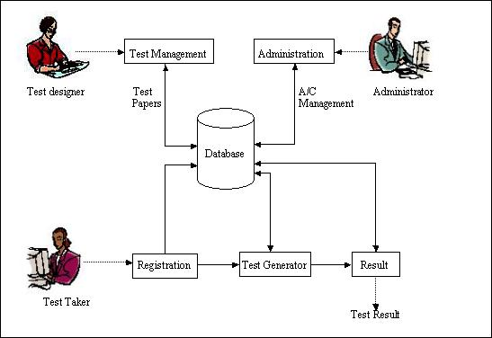

Getting Started With ExamOnline

ExamOnline Login Screen– Both the users and the administrator have to login to their respective control panels. New users have to first register to get a valid username and password. | 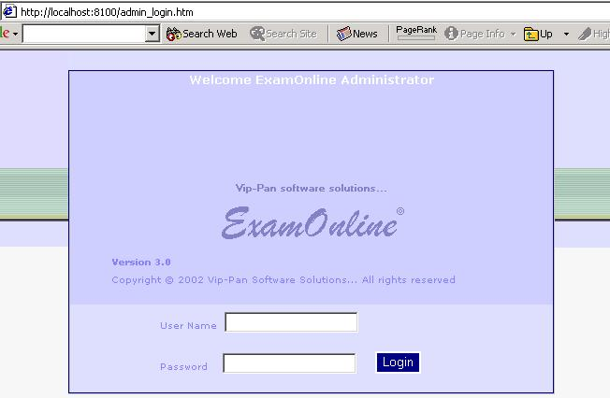

Separate control panel for each administrator to configure and manage his tests. The administrator can start, stop, delete and manage the tests. He can Add, Edit, View and Delete questions. He can also configure a new test. | 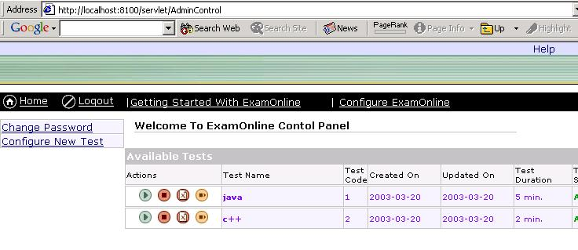
The administrator configures a new test by simply filling up the forms and then adding the desired number of questions to each and every subject. |  | 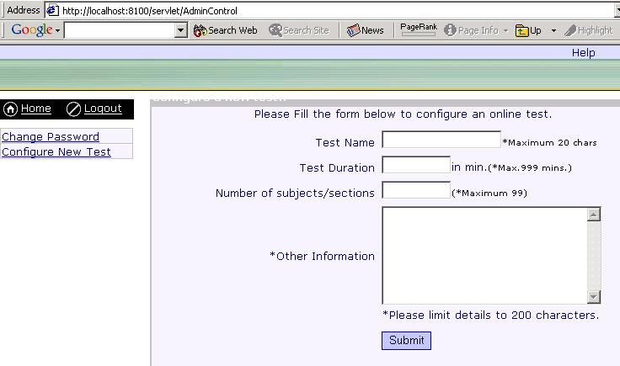

Each user has his own control panel from where he can choose the following links – My Test Center, My Score Card, Change Password and Change Account Information. | 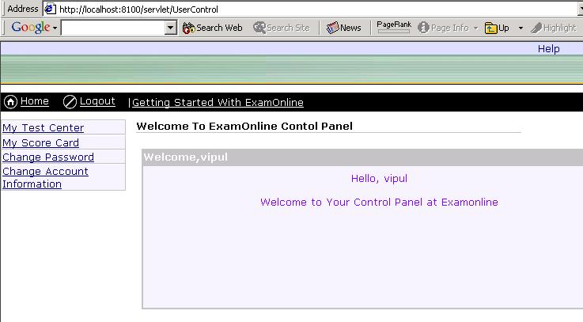

The test taker can choose from all the available tests the test he wishes to appear for from the My Test Center link. | 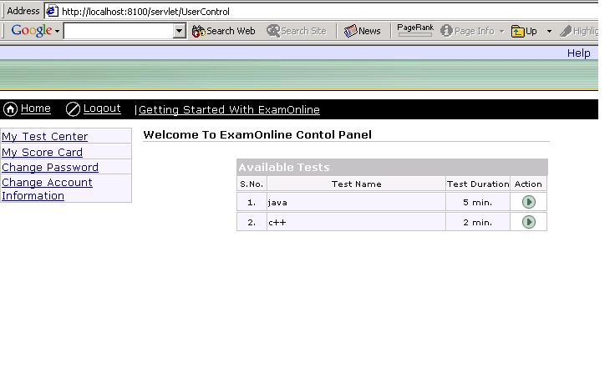

The user can rate his performance by viewing the detail result card using the My Score Card link. | 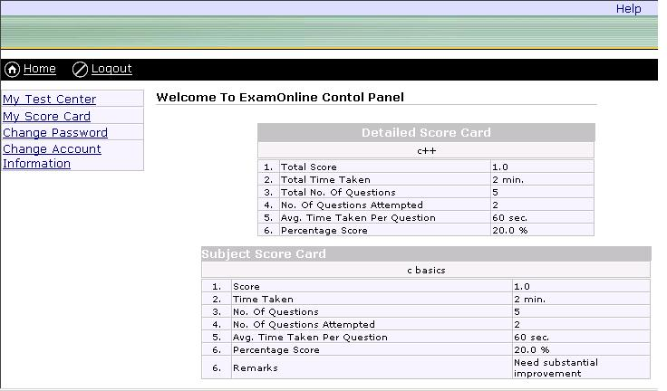

The user can change his account information using the Change Account Information link. | 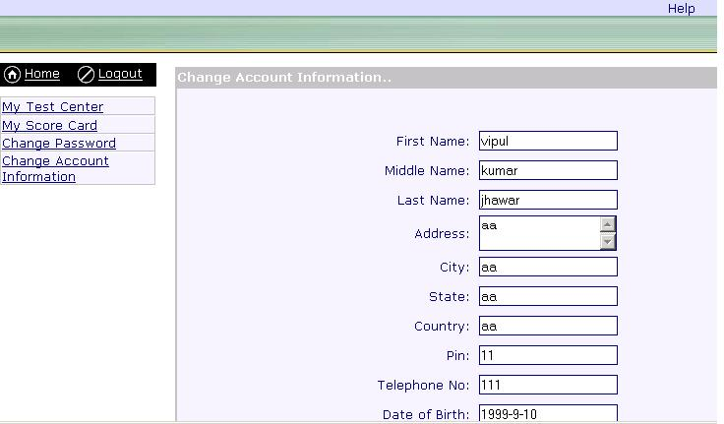

Note:- The solution has already been tested and installed by us on our server. As the installation is very complex and typical we request you to refer to the link mentioned below to see the proper working of the software.
The solution has been hosted at http://examonline.net4engineers.com and a test in ‘c language ‘ is being conducted. However, we have created a special administrator account for you so that you can administer the tests also.The details of the account are as follows
Adminstrator username:- mystica
Administrator password:- mystica
If you want to administer the test at the above mentioned link then please follow the following steps:-
1.log onto http://examonline.net4engineers.com and then click on administrator.
2.The fill the above mentioned username and password.
3.your control panel will appear in front of you. From here you can create a new test.
4.Then add questions to this test.
5.After required number of questions have been added then click on the ‘Start Test’ link on the main control panel.
6.After this is done the test configured by you will be served to the test takers.
7.Please refer to ‘Getting started with examonline’ on the control panel for any kind of help.

After this if u want to give the test then follow the following steps.
1.log onto http://examonline.net4engineers.com and then click on test taker.
2.Click on new user if u have not registered before.
3.Fill up the form and then login to the test takers control panel .
4.Choose the test you want to give and then after giving the test view the result.

Installation Manual

To run ExamOnline (an online testing Web Application) following steps must be followed :
1.On a Windows 2000/Linux system 1st install Sun's Java Development Kit (minimum 1.3 version)
2.Install Apache Tomcat(minimum 4.0 version) & edit server.xml file in <Apache-tomcat-root>/conf
(e.g. C:\Program Files\Apache Tomcat 4.0\conf in windows) as follows:
Find following entry in server.xml file
<!-- Tomcat Root Context -->
<!--
<Context path="" docBase="ROOT" debug="0" >
-->
Now change this to
<!-- Tomcat Root Context -->
<Context path="" docBase="ROOT" debug="0" reloadable="true">
</Context>
And save this file.
3.Install Mysql database server Make a user with username:net4engineers & password: database
4.Make a new database in mysql with name net4engineers_com
5.copy all contents of ExamOnline folder given in package to <Apache-tomcat-root>/webapps/ROOT directory (e.g. C:\Program Files\Apache Tomcat 4.0\webapps\ROOT in windows).
6.Now start Apache tomact server by starting startup.bat on windows or startup.sh on linux found in <Apache-tomcat-root>/bin directory.
7.Open any internet browser & open a url http://127.0.0.1:8080 in it. U will see Examonline Homepage.
8. Now create database tables for application by accessing url: http://127.0.0.1:8080/database/CreateTables.jsp
9.Now the Web Application is ready to run.
10.In the web browser type http://127.0.0.1:8080 and then choose the administrator part to administer the test otherwise as a test taker to give a test.
11.However please note that you have to configure a test before it can be served.So, first login as administrator and configure a new test.
12.For further instructions on administering test please see ‘getting started with examonline’ on the administrator control panel.

Note :-** Although we are sending you the codes of the software to abide by the rules of the contest but please be sure to maintain the secrecy of the classes as the solution may be commercial in future and any illegal use by anyone will mean commercial losses to us.

