PROJECT REPORT

Data Science Future Scope Analysis (2025–2030)

Name-Pankaj Sanjay Borate
Date=28-01-2026

1. Introduction
Data Science is one of the fastest-growing and most impactful fields in the modern digital era. With the explosion of data from industries such as healthcare, finance, e-commerce, and artificial intelligence, the demand for skilled data scientists continues to rise.
This project, “Data Science Future Scope Analysis”, focuses on analyzing future trends related to:
- Salary growth
- Job opportunities
- Industry demand
- Market growth rate
The analysis is presented using Power BI dashboards, providing a clear and visual understanding of how Data Science will evolve in the coming years.

2. Objectives of the Project
The main objectives of this project are:
- To analyze the future salary trends of Data Science professionals
- To study job growth and employment opportunities
- To identify high-demand industries for Data Scientists
- To visualize data using Power BI dashboards
- To help students and professionals understand career scope in Data Science

3. Tools & Technologies Used
- Power BI – Data visualization and dashboard creation
- CSV Dataset – Source of structured data
- Microsoft Excel – Data cleaning (optional)
- Data Analysis Techniques – Aggregation, averages, trends

4. Dataset Description
The dataset used in this project contains future-oriented data related to Data Science careers.
Key columns include:
- Year – Timeline from 2025 to 2030
- Average_Salary_USD – Average annual salary in USD
- Growth_Rate_Percent – Industry growth rate
- Jobs_Millions – Number of jobs in millions
- Industry – High-demand sectors
This dataset helps in forecasting future opportunities in the Data Science field.

5. Dashboard Overview
The Power BI dashboard titled “Data Science Future Scope” includes the following visualizations:
- Sum of Average Salary by Year
- Average Number of Jobs by Year
- Growth Rate Percentage Trend
- High-Demand Industries for Data Scientists
- Minimum Salary Insights
- KPI Cards showing key metrics
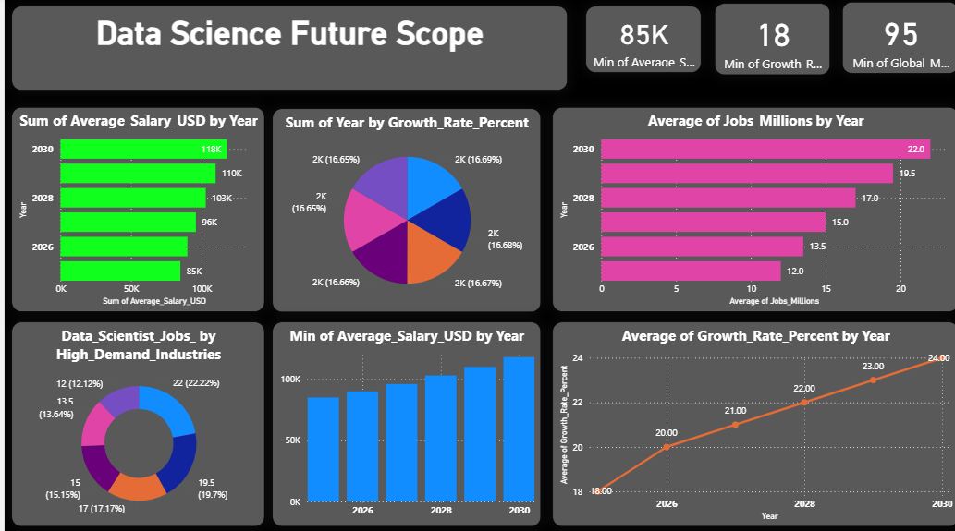

6. Key Insights and Analysis
Salary Analysis:
The average salary of Data Scientists shows a steady increase from 2025 to 2030. By 2030, salaries are expected to reach up to $118,000 annually, indicating strong financial growth in this career.
Job Market Growth:
The number of Data Science jobs is expected to grow from approximately 12 million to 22 million globally by 2030, highlighting massive employment opportunities.
Growth Rate:
The industry growth rate increases consistently from 18% to 24%, showing that Data Science is expanding faster than many traditional career fields.
Industry Demand:
Industries such as IT, Finance, Healthcare, E-commerce, and Artificial Intelligence are the top recruiters of Data Science professionals.

7. Advantages of Data Science as a Career
• High salary packages
• Strong global demand
• Opportunities across multiple industries
• Career growth and job security
• Continuous learning and innovation

8. Limitations of the Project
• Data is predictive and may vary with market conditions
• Limited time range (2025–2030)
• External factors such as economic changes are not included

9. Future Scope of the Project
• Integration of real-time job market data
• Country-wise salary and demand comparison
• Skill-based demand analysis
• Use of machine learning models for prediction

10. Conclusion
The Data Science Future Scope Analysis clearly shows that Data Science will remain one of the most promising and high-growth career options in the future. With rising salaries, increasing job opportunities, and strong industry demand, Data Science offers excellent prospects for students and professionals alike. Power BI plays a vital role in visualizing and understanding these trends.

11. References
• Industry Research Reports
• Online Job Portals
• Data Science Career Articles
• Power BI Documentation

