Unit I: Introduction

- Introduction to Programming,
- Introduction to components of a computer system (disks, memory, processor,
- where a program is stored and executed,
- operating system,
- compilers
- Idea of Algorithm: steps to solve logical and numerical problems. Representation of Algorithm:
- Flowchart,
- Pseudo code and Source code with examples.

1.Introduction to Programming,
COMPUTER PROGRAMMING is a step by step process of designing and developing various sets of computer programs to accomplish a specific computing outcome.
The process comprises several tasks like
- analysis,
- coding,
- algorithm generation,
- checking accuracy
- and resource consumption of algorithms, etc.
The purpose of computer programming is to find a sequence of instructions that solve a specific problem on a computer.
Computer Programming is very easy if it is appropriately managed. There are many computer programming languages available so finalizing the right programming language is not an easy task.
Most important basic elements for programming languages are:
- Programming Environment
- Data Types
- Variables
- Keywords
- Logical and Arithmetical Operators
- If else conditions
- Loops
- Numbers, Characters and Arrays
- Functions
- Input and Output Operations

Types of programming language

1. Low-level programming language

Low-level language is machine-dependent (0s and 1s) programming language. The processor runs low- level programs directly without the need of a compiler or interpreter, so the programs written in low-level language can be run very fast.
Low-level language is further divided into two parts -
i. Machine Language
Machine language is a type of low-level programming language. It is also called as machine code or object code. Machine language is easier to read because it is normally displayed in binary or hexadecimal form (base 16) form. It does not require a translator to convert the programs because computers directly understand the machine language programs.
The advantage of machine language is that it helps the programmer to execute the programs faster than the high-level programming language.

ii. Assembly Language
Assembly language (ASM) is also a type of low-level programming language that is designed for specific processors. It represents the set of instructions in a symbolic and human-understandable form. It uses an assembler to convert the assembly language to machine language.
The advantage of assembly language is that it requires less memory and less execution time to execute a program.

2. High-level programming language
High-level programming language (HLL) is designed for developing user-friendly software programs and websites. This programming language requires a compiler or interpreter to translate the program into machine language (execute the program).
The main advantage of a high-level language is that it is easy to read, write, and maintain.
High-level programming language includes Python, Java, JavaScript, PHP, C#, C++, Objective C, Cobol, Perl, Pascal, LISP, FORTRAN, and Swift programming language.
A high-level language is further divided into three parts -
i. Procedural Oriented programming language
Procedural Oriented Programming (POP) language is derived from structured programming and based upon the procedure call concept. It divides a program into small procedures called routines or functions.
Procedural Oriented programming language is used by a software programmer to create a program that can be accomplished by using a programming editor like IDE, Adobe Dreamweaver, or Microsoft Visual Studio.
The advantage of POP language is that it helps programmers to easily track the program flow and code can be reused in different parts of the program.

The advantage of POP language is that it helps programmers to easily track the program flow and code can be reused in different parts of the program.
Example: C, FORTRAN, Basic, Pascal, etc.

ii. Object-Oriented Programming language
Object-Oriented Programming (OOP) language is based upon the objects. In this programming language, programs are divided into small parts called objects. It is used to implement real-world entities like inheritance, polymorphism, abstraction, etc in the program to makes the program reusable, efficient, and easy-to-use.
The main advantage of object-oriented programming is that OOP is faster and easier to execute, maintain, modify, as well as debug.

Note: Object-Oriented Programming language follows a bottom-up approach.
Example: C++, Java, Python, C#, etc.

iii. Natural language
Natural language is a part of human languages such as English, Russian, German, and Japanese. It is used by machines to understand, manipulate, and interpret human's language. It is used by developers to perform tasks such as translation, automatic summarization, Named Entity Recognition (NER), relationship extraction, and topic segmentation.
The main advantage of natural language is that it helps users to ask questions in any subject and directly respond within seconds.

3. Middle-level programming language
Middle-level programming language lies between the low-level programming language and high-level programming language. It is also known as the intermediate programming language and pseudo-language.
A middle-level programming language's advantages are that it supports the features of high-level programming, it is a user-friendly language, and closely related to machine language and human language.
Example: C, C++, language

Most commonly used Programming Language

Programming Language
As we know, to communicate with a person, we need a specific language, similarly to communicate with computers, programmers also need a language is called Programming language.
Before learning the programming language, let's understand what is language?

What is Language?
Language is a mode of communication that is used to share ideas, opinions with each other. For example, if we want to teach someone, we need a language that is understandable by both communicators.

What is a Programming Language?
A programming language is a computer language that is used by programmers (developers) to communicate with computers. It is a set of instructions written in any specific language ( C, C++, Java, Python) to perform a specific task.
A programming language is mainly used to develop desktop applications, websites, and mobile applications.

Types of programming language

1. Low-level programming language
Low-level language is machine-dependent (0s and 1s) programming language. The processor runs low- level programs directly without the need of a compiler or interpreter, so the programs written in low-level language can be run very fast.
Low-level language is further divided into two parts -
i. Machine Language
Machine language is a type of low-level programming language. It is also called as machine code or object code. Machine language is easier to read because it is normally displayed in binary or hexadecimal form (base 16) form. It does not require a translator to convert the programs because computers directly understand the machine language programs.
The advantage of machine language is that it helps the programmer to execute the programs faster than the high-level programming language.
ii. Assembly Language
Assembly language (ASM) is also a type of low-level programming language that is designed for specific processors. It represents the set of instructions in a symbolic and human-understandable form. It uses an assembler to convert the assembly language to machine language.
The advantage of assembly language is that it requires less memory and less execution time to execute a program.

2. High-level programming language
High-level programming language (HLL) is designed for developing user-friendly software programs and websites. This programming language requires a compiler or interpreter to translate the program into machine language (execute the program).
The main advantage of a high-level language is that it is easy to read, write, and maintain.
High-level programming language includes Python, Java, JavaScript, PHP, C#, C++, Objective C, Cobol, Perl, Pascal, LISP, FORTRAN, and Swift programming language.
A high-level language is further divided into three parts -
i. Procedural Oriented programming language
Procedural Oriented Programming (POP) language is derived from structured programming and based upon the procedure call concept. It divides a program into small procedures called routines or functions.
Procedural Oriented programming language is used by a software programmer to create a program that can be accomplished by using a programming editor like IDE, Adobe Dreamweaver, or Microsoft Visual Studio.
The advantage of POP language is that it helps programmers to easily track the program flow and code can be reused in different parts of the program.

The advantage of POP language is that it helps programmers to easily track the program flow and code can be reused in different parts of the program.
Example: C, FORTRAN, Basic, Pascal, etc.
ii. Object-Oriented Programming language
Object-Oriented Programming (OOP) language is based upon the objects. In this programming language, programs are divided into small parts called objects. It is used to implement real-world entities like inheritance, polymorphism, abstraction, etc in the program to makes the program resusable, efficient, and easy-to-use.
The main advantage of object-oriented programming is that OOP is faster and easier to execute, maintain, modify, as well as debug.

Note: Object-Oriented Programming language follows a bottom-up approach.
Example: C++, Java, Python, C#, etc.
iii. Natural language
Natural language is a part of human languages such as English, Russian, German, and Japanese. It is used by machines to understand, manipulate, and interpret human's language. It is used by developers to perform tasks such as translation, automatic summarization, Named Entity Recognition (NER), relationship extraction, and topic segmentation.
The main advantage of natural language is that it helps users to ask questions in any subject and directly respond within seconds.

3. Middle-level programming language
Middle-level programming language lies between the low-level programming language and high-level programming language. It is also known as the intermediate programming language and pseudo-language.
A middle-level programming language's advantages are that it supports the features of high-level programming, it is a user-friendly language, and closely related to machine language and human language.
Example: C, C++, language

Most commonly used Programming Language
As we all know, the programming language makes our life simpler. Currently, all sectors (like education, hospitals, banks, automobiles, and more ) completely depend upon the programming language.
There are dozens of programming languages used by the industries. Some most widely used programming languages are given below -
- Python is one of the most widely used user-friendly programming languages. It is an open-source and easy to learn programming language developed in the 1990s. It is mostly used in Machine learning, Artificial intelligence, Big Data, GUI based desktop applications, and Robotics.
- Java is a simple, secure, platform-independent, reliable, architecture-neutral high-level programming language developed by Sun Microsystems in 1995. Now, Java is owned by Oracle. It is mainly used to develop bank, retail, information technology, android, big data, research community, web, and desktop applications.
- C is a popular, simple, and flexible general-purpose computer programming language. Dennis M Ritchie develops it in 1972 at AT&T. It is a combination of both low-level programming language as well as a high-level programming language. It is used to design applications like Text Editors, Compilers, Network devices, and many more.
- C++ is one of the thousands of programming languages that we use to develop software. C++ programming language is developed by Bjarne Stroustrup in 1980. It is similar to the C programming language but also includes some additional features such as exception handling, object-oriented programming, type checking, etc.
- JavaScript is a type of scripting language that is used on both client-side as well as a server-side. It is developed in the 1990s for the Netscape Navigator web browser. It allows programmers to implement complex features to make web pages alive. It helps programmers to create dynamic websites, servers, mobile applications, animated graphics, games, and more.

+++++++++++++++++++++++++++++++++++++++++++++++++++

2.Introduction to components of a computer system (disks, memory, processor,
There are 5 main computer components that are given below:
- Input Devices
- CPU
- Output Devices
- Primary Memory
- Secondary Memory
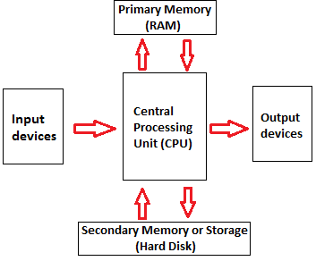
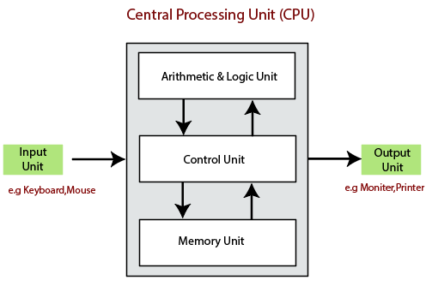

The operations of computer components are given below:
1) Inputting: It is the process of entering raw data, instructions and information into the computer. It is performed with the help of input devices.
2) Storing: The computer has primary memory and secondary storage to store data and instructions. It stores the data before sending it to CPU for processing and also stores the processed data before displaying it as output.
3) Processing: It is the process of converting the raw data into useful information. This process is performed by the CPU of the computer. It takes the raw data from storage, processes it and then sends back the processed data to storage.
4) Outputting: It is the process of presenting the processed data through output devices like monitor, printer and speakers.
5) Controlling: This operation is performed by the control unit that is part of CPU. The control unit ensures that all basic operations are executed in a right manner and sequence.

Computer Memory
The computer memory holds the data and instructions needed to process raw data and produce output. The computer memory is divided into large number of small parts known as cells. Each cell has a unique address which varies from 0 to memory size minus one.
Computer memory is of two types: Volatile (RAM) and Non-volatile (ROM).
The secondary memory (hard disk) is referred as storage not memory.
- Register memory
- Cache memory
- Primary memory
- Secondary memory

Register Memory
Register memory is the smallest and fastest memory in a computer. It is not a part of the main memory and is located in the CPU in the form of registers, which are the smallest data holding elements. A register temporarily holds frequently used data, instructions, and memory address that are to be used by CPU. They hold instructions that are currently processed by the CPU. All data is required to pass through registers before it can be processed. So, they are used by CPU to process the data entered by the users.

Cache Memory
Cache memory is a high-speed memory, which is small in size but faster than the main memory (RAM). The CPU can access it more quickly than the primary memory. So, it is used to synchronize with high-speed CPU and to improve its performance.
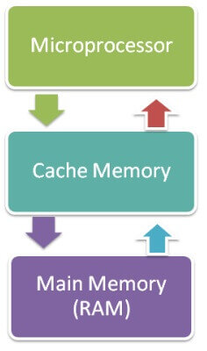
Cache memory can only be accessed by CPU. It can be a reserved part of the main memory or a storage device outside the CPU. It holds the data and programs which are frequently used by the CPU. So, it makes sure that the data is instantly available for CPU whenever the CPU needs this data. In other words, if the CPU finds the required data or instructions in the cache memory, it doesn't need to access the primary memory (RAM). Thus, by acting as a buffer between RAM and CPU, it speeds up the system performance.

Primary Memory
Primary Memory is of two types: RAM and ROM.

RAM (Volatile Memory)
It is a volatile memory. It means it does not store data or instructions permanently. When you switch on the computer the data and instructions from the hard disk are stored in RAM.
CPU utilizes this data to perform the required tasks. As soon as you shut down the computer the RAM loses all the data.

ROM (Non-volatile Memory)
It is a non-volatile memory. It means it does not lose its data or programs that are written on it at the time of manufacture. So it is a permanent memory that contains all important data and instructions needed to perform important tasks like the boot process.

Secondary Memory
The secondary storage devices which are built into the computer or connected to the computer are known as a secondary memory of the computer. It is also known as external memory or auxiliary storage.
The secondary memory is accessed indirectly via input/output operations. It is non-volatile, so permanently stores the data even when the computer is turned off or until this data is overwritten or deleted. The CPU can't directly access the secondary memory. First, the secondary memory data is transferred to primary memory then the CPU can access it.
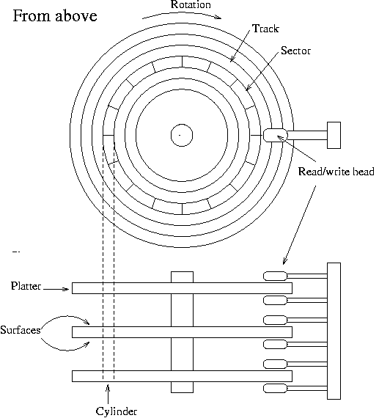
A disk is divided into tracks, cylinders, and sectors. A track is that portion of a disk which passes under a single stationary head during a disk rotation, a ring 1 bit wide. A cylinder is comprised of the set of tracks described by all the heads (on separate platters) at a single seek position. Each cylinder is equidistant from the center of the disk. A track is divided into segments of sectors, which is the basic unit of storage.
On Sun systems a sector is 512 bytes (1 disk block) of data, with header and trailer information. The latter make it possible for the controller to identify sectors, detect data errors, and perform error corrections when necessary.

3. where a program is stored and executed,
Programs are stored on secondary storage devices such as hard disks. When you install a program on your computer, the program is actually copied to your hard disk. But when you execute a program, the program is copied (loaded) from your hard disk to the main memory, and that copy of the program is executed.
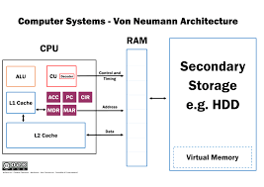

4. operating system,
An Operating System (OS) is an interface between a computer user and computer hardware. An operating system is a software which performs all the basic tasks like file management, memory management, process management, handling input and output, and controlling peripheral devices such as disk drives and printers.
Some popular Operating Systems include Linux Operating System, Windows Operating System, VMS, OS/400, AIX, z/OS, etc.

Definition
An operating system is a program that acts as an interface between the user and the computer hardware and controls the execution of all kinds of programs.
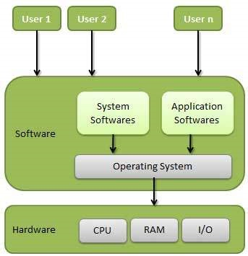
Following are some of important functions of an operating System.
- Memory Management
- Processor Management
- Device Management
- File Management
- Security
- Control over system performance
- Job accounting
- Error detecting aids
- Coordination between other software and users

Memory Management
Memory management refers to management of Primary Memory or Main Memory. Main memory is a large array of words or bytes where each word or byte has its own address.
Main memory provides a fast storage that can be accessed directly by the CPU. For a program to be executed, it must in the main memory. An Operating System does the following activities for memory management −
- Keeps tracks of primary memory, i.e., what part of it are in use by whom, what part are not in use.
- In multiprogramming, the OS decides which process will get memory when and how much.
- Allocates the memory when a process requests it to do so.
- De-allocates the memory when a process no longer needs it or has been terminated.

Processor Management
In multiprogramming environment, the OS decides which process gets the processor when and for how much time. This function is called process scheduling. An Operating System does the following activities for processor management −
- Keeps tracks of processor and status of process. The program responsible for this task is known as traffic controller.
- Allocates the processor (CPU) to a process.
- De-allocates processor when a process is no longer required.

Device Management
An Operating System manages device communication via their respective drivers. It does the following activities for device management −
- Keeps tracks of all devices. Program responsible for this task is known as the I/O controller.
- Decides which process gets the device when and for how much time.
- Allocates the device in the efficient way.
- De-allocates devices.

File Management
A file system is normally organized into directories for easy navigation and usage. These directories may contain files and other directions.
An Operating System does the following activities for file management −
- Keeps track of information, location, uses, status etc. The collective facilities are often known as file system.
- Decides who gets the resources.
- Allocates the resources.
- De-allocates the resources.

Types of Operating Systems
An Operating System performs all the basic tasks like managing file,process, and memory. Thus operating system acts as manager of all the resources, i.e. resource manager. Thus operating system becomes an interface between user and machine.
Types of Operating Systems: Some of the widely used operating systems are as follows-
1. Batch Operating System –
This type of operating system does not interact with the computer directly. There is an operator which takes similar jobs having same requirement and group them into batches. It is the responsibility of operator to sort the jobs with similar needs.
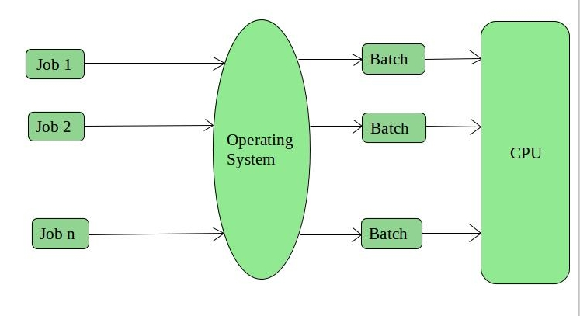

Time-Sharing Operating Systems –
Each task is given some time to execute, so that all the tasks work smoothly. Each user gets time of CPU as they use single system. These systems are also known as Multitasking Systems. The task can be from single user or from different users also. The time that each task gets to execute is called quantum. After this time interval is over OS switches over to next task.
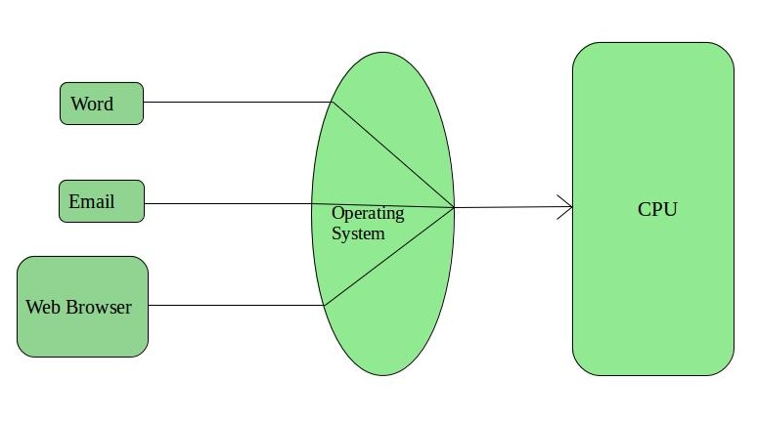
Distributed Operating System –
These types of operating system is a recent advancement in the world of computer technology and are being widely accepted all-over the world and, that too, with a great pace. Various autonomous interconnected computers communicate each other using a shared communication network. Independent systems possess their own memory unit and CPU.
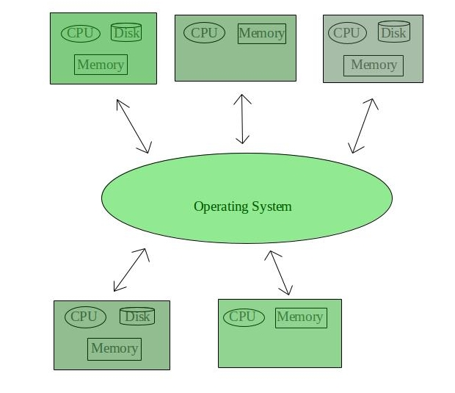

Network Operating System –
These systems run on a server and provide the capability to manage data, users, groups, security, applications, and other networking functions. These type of operating systems allow shared access of files, printers, security, applications, and other networking functions over a small private network. One more important aspect of Network Operating Systems is that all the users are well aware of the underlying configuration, of all other users within the network, their individual connections etc. and that’s why these computers are popularly known as tightly coupled systems.
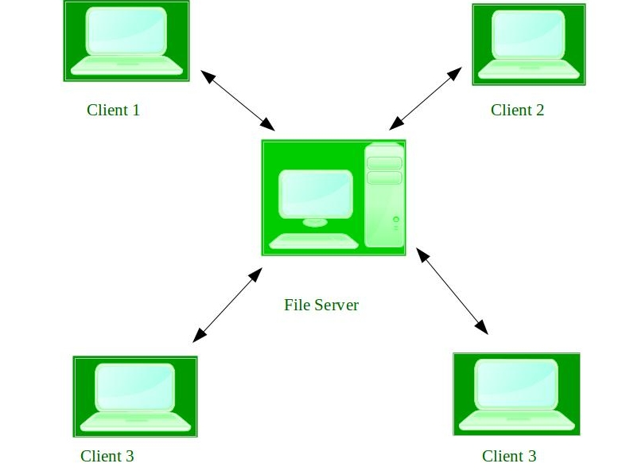

- compilers
A compiler is a special program that processes statements written in a particular programming language and turns them into machine language or "code" that a computer's processor uses.

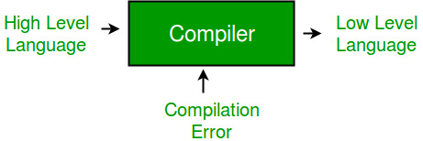
Compiler, Computer software that translates (compiles) source code written in a high-level language (e.g., C++) into a set of machine-language instructions that can be understood by a digital computer's CPU. .
- A compiler is a translator that converts the high-level language into the machine language.
- High-level language is written by a developer and machine language can be understood by the processor.
- Compiler is used to show errors to the programmer.
- The main purpose of compiler is to change the code written in one language without changing the meaning of the program.
- When you execute a program which is written in HLL programming language then it executes into two parts.
- In the first part, the source program compiled and translated into the object program (low level language).
- In the second part, object program translated into the target program through the assembler.

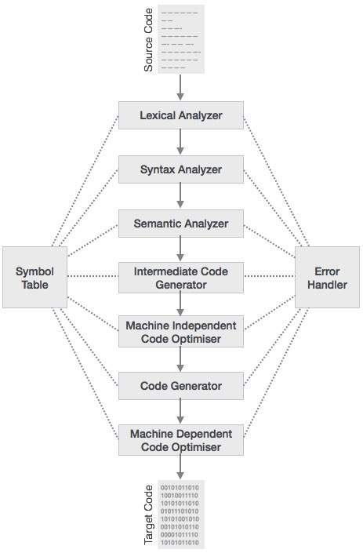

Lexical Analysis
The first phase of scanner works as a text scanner. This phase scans the source code as a stream of characters and converts it into meaningful lexemes. Lexical analyzer represents these lexemes in the form of tokens as:
<token-name, attribute-value>

Syntax Analysis
The next phase is called the syntax analysis or parsing. It takes the token produced by lexical analysis as input and generates a parse tree (or syntax tree). In this phase, token arrangements are checked against the source code grammar, i.e. the parser checks if the expression made by the tokens is syntactically correct.

Semantic Analysis
Semantic analysis checks whether the parse tree constructed follows the rules of language. For example, assignment of values is between compatible data types, and adding string to an integer. Also, the semantic analyzer keeps track of identifiers, their types and expressions; whether identifiers are declared before use or not etc. The semantic analyzer produces an annotated syntax tree as an output.

Intermediate Code Generation
After semantic analysis the compiler generates an intermediate code of the source code for the target machine. It represents a program for some abstract machine. It is in between the high-level language and the machine language. This intermediate code should be generated in such a way that it makes it easier to be translated into the target machine code.

Code Optimization
The next phase does code optimization of the intermediate code. Optimization can be assumed as something that removes unnecessary code lines, and arranges the sequence of statements in order to speed up the program execution without wasting resources (CPU, memory).

Code Generation
In this phase, the code generator takes the optimized representation of the intermediate code and maps it to the target machine language. The code generator translates the intermediate code into a sequence of (generally) re-locatable machine code. Sequence of instructions of machine code performs the task as the intermediate code would do.

7. Idea of Algorithm: steps to solve logical and numerical problems. Representation of Algorithm:

What is an Algorithm?
An algorithm is a process or a set of rules required to perform calculations or some other problem-solving operations especially by a computer. The formal definition of an algorithm is that it contains the finite set of instructions which are being carried in a specific order to perform the specific task. It is not the complete program or code; it is just a solution (logic) of a problem, which can be represented either as an informal description using a Flowchart or Pseudocode.

Characteristics of an Algorithm
The following are the characteristics of an algorithm:
- Input: An algorithm has some input values. We can pass 0 or some input value to an algorithm.
- Output: We will get 1 or more output at the end of an algorithm.
- Unambiguity: An algorithm should be unambiguous which means that the instructions in an algorithm should be clear and simple.
- Finiteness: An algorithm should have finiteness. Here, finiteness means that the algorithm should contain a limited number of instructions, i.e., the instructions should be countable.
- Effectiveness: An algorithm should be effective as each instruction in an algorithm affects the overall process.
- Language independent: An algorithm must be language-independent so that the instructions in an algorithm can be implemented in any of the languages with the same output.

Dataflow of an Algorithm
- Problem: A problem can be a real-world problem or any instance from the real-world problem for which we need to create a program or the set of instructions. The set of instructions is known as an algorithm.
- Algorithm: An algorithm will be designed for a problem which is a step by step procedure.
- Input: After designing an algorithm, the required and the desired inputs are provided to the algorithm.
- Processing unit: The input will be given to the processing unit, and the processing unit will produce the desired output.
- Output: The output is the outcome or the result of the program.

Why do we need Algorithms?
- Scalability: It helps us to understand the scalability. When we have a big real-world problem, we need to scale it down into small-small steps to easily analyze the problem.
- Performance: The real-world is not easily broken down into smaller steps. If the problem can be easily broken into smaller steps means that the problem is feasible.

Let's understand the algorithm through a real-world example. Suppose we want to make a lemon juice, so following are the steps required to make a lemon juice:
Step 1: First, we will cut the lemon into half.
Step 2: Squeeze the lemon as much you can and take out its juice in a container.
Step 3: Add two tablespoon sugar in it.
Step 4: Stir the container until the sugar gets dissolved.
Step 5: When sugar gets dissolved, add some water and ice in it.
Step 6: Store the juice in a fridge for 5 to minutes.
Step 7: Now, it's ready to drink.

Factors of an Algorithm
The following are the factors that we need to consider for designing an algorithm:
- Modularity: If any problem is given and we can break that problem into small-small modules or small-small steps, which is a basic definition of an algorithm, it means that this feature has been perfectly designed for the algorithm.
- Correctness: The correctness of an algorithm is defined as when the given inputs produce the desired output, which means that the algorithm has been designed algorithm. The analysis of an algorithm has been done correctly.
- Maintainability: Here, maintainability means that the algorithm should be designed in a very simple structured way so that when we redefine the algorithm, no major change will be done in the algorithm.
- Functionality: It considers various logical steps to solve the real-world problem.
- Robustness: Robustness means that how an algorithm can clearly define our problem.
- User-friendly: If the algorithm is not user-friendly, then the designer will not be able to explain it to the programmer.
- Simplicity: If the algorithm is simple then it is easy to understand.
- Extensibility: If any other algorithm designer or programmer wants to use your algorithm then it should be extensible.
Example

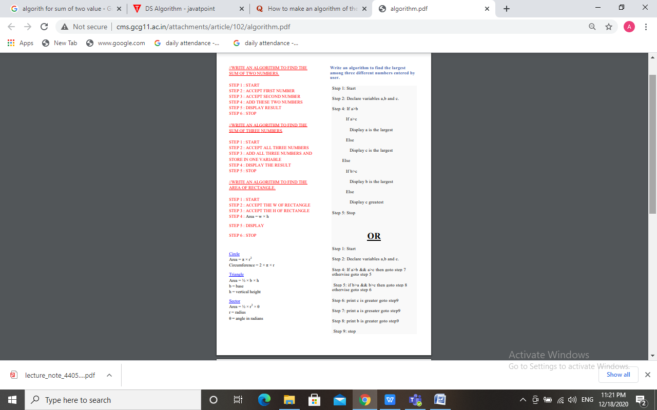

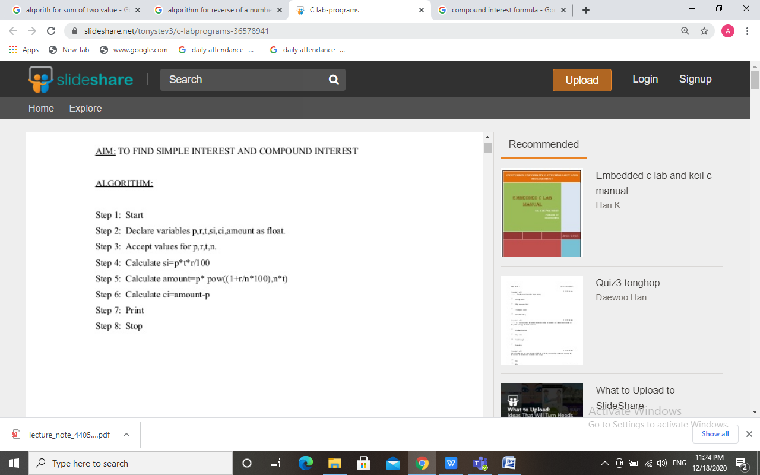

- FLOW CHART
FLOW CHART
A flowchart is a graphical representation of steps. It was originated from computer science as a tool for representing algorithms and programming logic but had extended to use in all other kinds of processes.

Flowchart Symbols
Different flowchart shapes have different conventional meanings. The meanings of some of the more common shapes are as follows:

- Terminator (START and END)
The terminator symbol represents the starting or ending point of the system.


- Process
A box indicates some particular operation.


Document
This represents a printout, such as a document or a report.


Decision
A diamond represents a decision or branching point. Lines coming out from the diamond indicates different possible situations, leading to different sub-processes.


5.Data
It represents information entering or leaving the system. An input might be an order from a customer. Output can be a product to be delivered.


6.On-Page Reference
This symbol would contain a letter inside. It indicates that the flow continues on a matching symbol containing the same letter somewhere else on the same page.


7.Flow
Lines represent the flow of the sequence and direction of a process.

When to Draw Flowchart?
Using a flowchart has a variety of benefits:
- It helps to clarify complex processes.
- It identifies steps that do not add value to the internal or external customer, including delays; needless storage and transportation; unnecessary work, duplication, and added expense; breakdowns in communication.
- It helps team members gain a shared understanding of the process and use this knowledge to collect data, identify problems, focus discussions, and identify resources.
- It serves as a basis for designing new processes.

Example 1 :- DRAW A FLOW CHART FOR SUM OF TWO VALUES

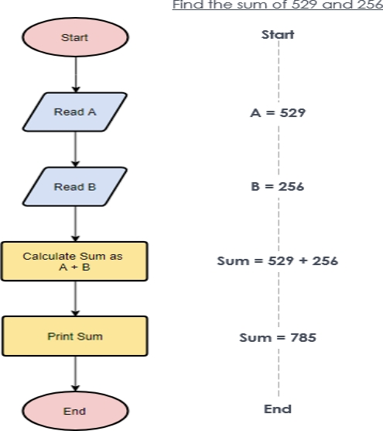

EXAMPLE 2:- Calculate profit and loss
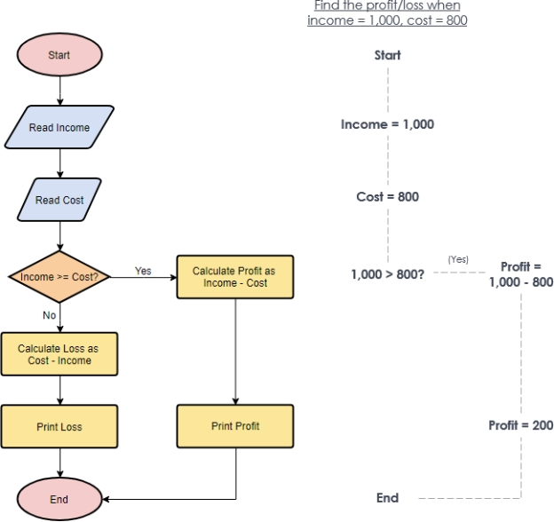

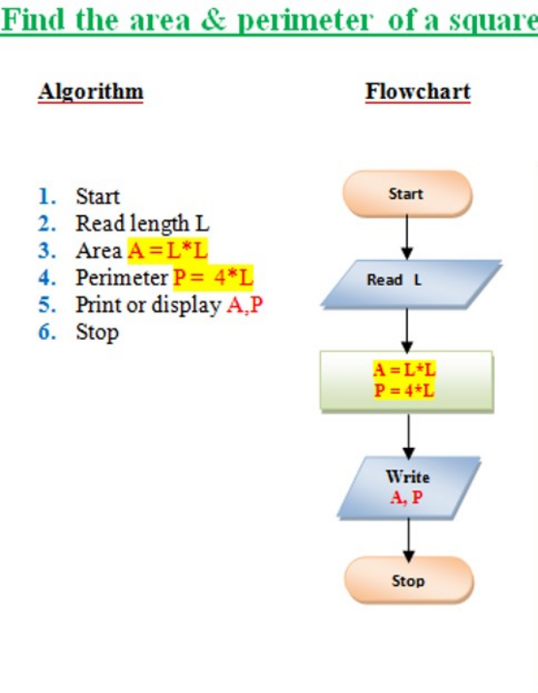

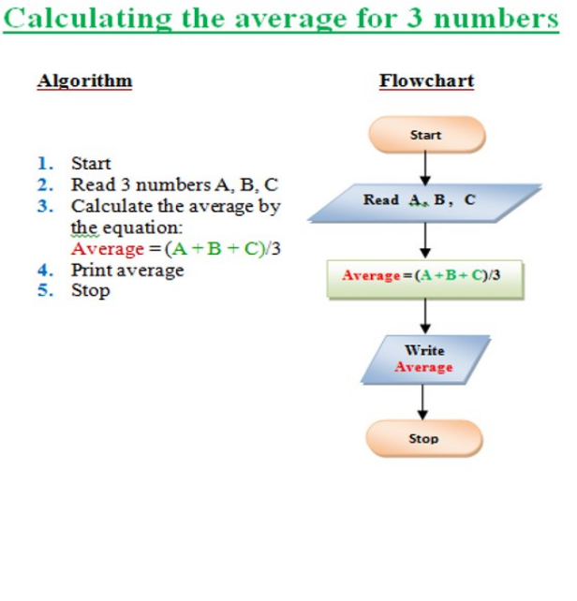

Advantages Of Using FLOWCHARTS:
• Communication: Flowcharts are better way of communicating the logic of a system to all concerned or involved.• Effective analysis: With the help of flowchart, problem can be analysed in more effective way therefore reducing cost and wastage of time.• Proper documentation: Program flowcharts serve as a good program documentation, which is needed for various purposes, making things more efficient.• Efficient Coding: The flowcharts act as a guide or blueprint during the systems analysis and program development phase.• Proper Debugging: The flowchart helps in debugging process.• Efficient Program Maintenance: The maintenance of operating program becomes easy with the help of flowchart. It helps the programmer to put efforts more efficiently on that part
Disadvantages Of Using FLOWCHARTS:• Complex logic: Sometimes, the program logic is quite complicated. In that case, flowchart becomes complex and clumsy. This will become a pain for the user, resulting in a waste of time and money trying to correct the problem• Alterations and Modifications: If alterations are required the flowchart may require re-drawing completely. This will usually waste valuable time.• Reproduction: As the flowchart symbols cannot be typed, reproduction of flowchart becomes a problem.

- Pseudo code with examples.

Pseudocode
Pseudocode refers to an informal high-level description of the operating principle of a computer program or other algorithm. It uses structural conventions of a standard programming language intended for human reading rather than the machine reading.

Advantages of Pseudocode
- Since it is similar to a programming language, it can be quickly transformed into the actual programming language than a flowchart.
- The layman can easily understand it.
- Easily modifiable as compared to the flowcharts.
- Its implementation is beneficial for structured, designed elements.
- It can easily detect an error before transforming it into a code.

Disadvantages of Pseudocode
- Since it does not incorporate any standardized style or format, it can vary from one company to another.
- Error possibility is higher while transforming into a code.
- It may require a tool for extracting out the Pseudocode and facilitate drawing flowcharts.
- It does not depict the design.

Difference between Algorithm and the Pseudocode
An algorithm is simply a problem-solving process, which is used not only in computer science to write a program but also in our day to day life. It is nothing but a series of instructions to solve a problem or get to the problem's solution. It not only helps in simplifying the problem but also to have a better understanding of it.
However, Pseudocode is a way of writing an algorithm. Programmers can use informal, simple language to write pseudocode without following any strict syntax. It encompasses semi-mathematical statements.

Ex- 1 Pseudocode to Add Two Numbers
- BEGIN.
- NUMBER s1, s2, sum.
- OUTPUT("Input number1:")
- INPUT s1.
- OUTPUT("Input number2:")
- INPUT s2.
- sum=s1+s2.
- OUTPUT sum.
- 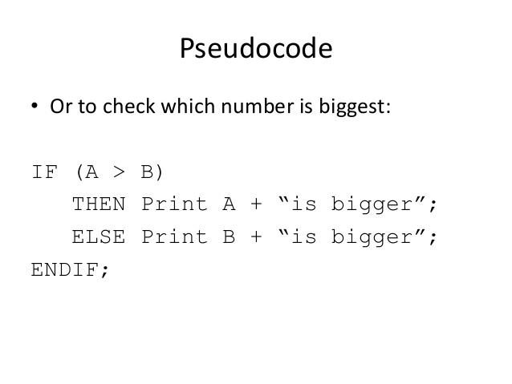

10 Source Code
Programming statements and instructions that are written by the developer. Source code is what a programmer writes, but it is not directly executable by the computer. It must be converted into machine language by compilers, assemblers or interpreters.
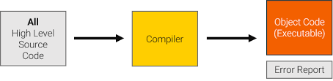
Object code:- Object code is a set of instruction codes that is understood by a computer at the lowest hardware level. Object code is usually produced by a compiler that reads some higher level computer language source instructions and translates them into equivalent machine language instructions.

Different programming languages
There are hundreds of different programming languages. It’s impossible to say for certain which are better or worse, as it depends on the context of the project and the application for which the source code is used. Some of the most popular programming languages are:
- BASIC
- Java
- C
- C++
- Pascal
- Python
- PHP
- JavaScript
For the computer to understand these languages, however, they need to first be translated into machine code.

Compiler & Interpreter
For the computer to be able to further process the source code written by the programmer, there needs to be a translation into low level language.
- Compiler: This application type translates (compiles) the source code into a code that the process understands and can execute. This machine code is saved in the form of an executable file.
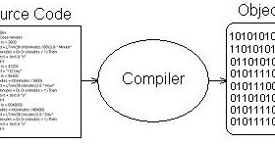

- Interpreter: An interpreter translates the source code line for line and executes it directly. The translation process is much faster than a compiler but the execution is slower and requires a large amount of memory.

Structure of a source text
Depending on the programming language in question, you’re limited to certain conventions when writing a program. Very few programming languages appear out of nowhere, though, and most of them build on one another. For this reason, certain elements come into use in various different program codes:
- Commands: Instructions are as a rule the basis for all applications. Here, the programmer makes it clear for their future program what needs to be done. Such commands can, for example, trigger certain calculations or display a text.
- Variables: Variables are vacancies that can be filled with information. These are referred to within the source code again and again with an assigned name.
- Comparisons: The structure of most programs is built by queries that function on the if-then scheme, i.e. the principle of propositional logic. If a particular truth value is entered, then one solution is triggered instead of another.
- Loop: Queries can also be the foundation for loops in a source code. A command is repeated until a certain value is reached. When the program ends the loop and runs the rest of the code.

- Comments: In all common programming languages, you can comment on lines within the code. This makes it possible to write text in the source code that isn’t taken into account by the program. Comments are entered into the source code, for example, so that you or another developer can continue to understand parts of the code in the future.

- Difference between Source Code and Object Code :
 | Source CODE | OBJECT CODE
01. | Source code is generated by human or programmer. | Object code is generated by compiler or other translator.
02. | Source code is high level code. | Object code is low level code.
03. | Source code is written in plain text by using some high level programming language. | Object code is translated code of source code. It is in binary format.
04. | Source code is human understandable. | Object code is not human understandable.
05. | Source code is not directly understandable by machine. | Object code is machine understandable and executable.
06. | It is written in high level language like C, C++, Java, Python etc or assembly language. | It is written in machine language through compiler or assembler or other translator.
07. | It can be easily modified. | It can not be modified.
===========================================================

