Deogiri Institute of Engineering and Management Studies, Aurangabad
Department of Computer Science Engineering

Report on
Computer Architecture and Organization
Redmi note 7 pro

Submitted By
Roshni Mahajan (26040)

Under the Guidance of
Prof. P. H. Durole
Department of Computer Science Engineering
(Deogiri Institute of Engineering and Management Studies)
2018-2019
Redmi Note 7 Pro Review
HIGHLIGHTS
- Xiaomi Redmi Note 7 Pro is available in two storage configurations
- Redmi Note 7 Pro camera setup includes a 48-megapixel sensor
- Redmi Note 7 Pro is powered by Qualcomm Snapdragon 675 processo
- 16.0 cm (6.3 inch) FHD+ Display | Rear Fingerprint Scanner
- 4 GB RAM | 64 GB ROM | Expandable Upto 256 GB
- 48MP + 5MP Dual Rear Camera | 13MP Front Camera
- 4000 mAh Li-polymer Battery
- Android v9.0 (Pie) OS
- Qualcomm Snapdragon 675 2.0 GHz + 1.7 GHz Octa Core Processor
- 1 Year Manufactufrer Warranty
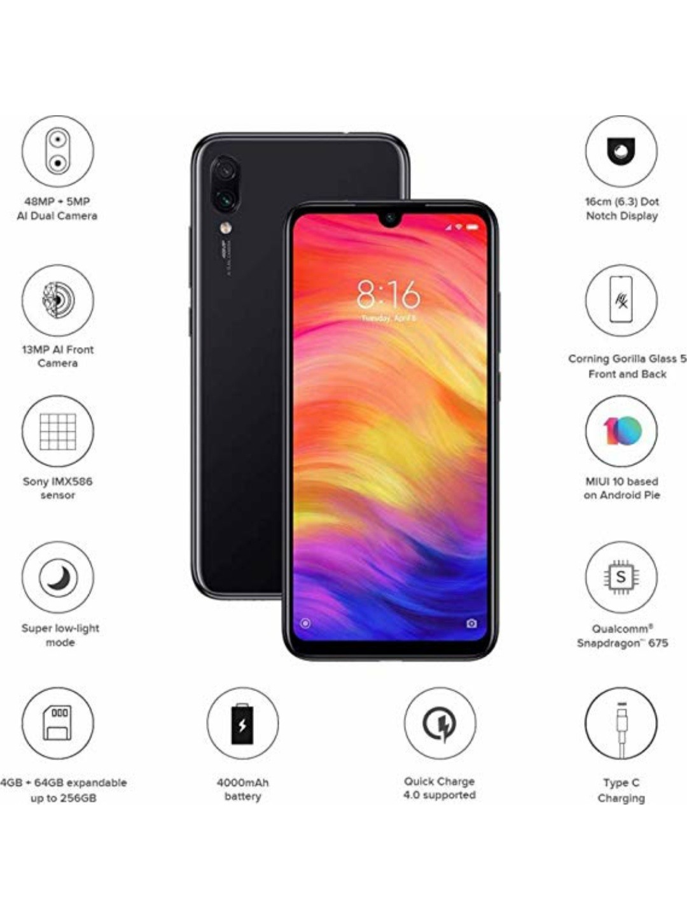

Xiaomi has yet again managed to send ripples throughout the Indian smartphone industry with the launch of the Redmi Note 7 ₹ 10,400 and Redmi Note 7 Pro ₹ 14,090. The more feature-packed offering of the duo, the Redmi Note 7 Pro, packs some incredible hardware for its asking price, including a 48-megapixel rear camera, an octa-core Qualcomm Snapdragon 675 processor, and a large 4,000mAh battery, all encased in an attention-grabbing chassis. At its price, there is hardly any other smartphone in the market that can match the hardware prowess of the Redmi Note 7 Pro, at least on paper. Does that translate to a smartphone experience that can outshine offerings from other brands? Let's find out in our in-depth Redmi Note 7 Pro review.

Redmi Note 7 Pro Summary
The Redmi Note 7 Pro is one of the most feature packed phones in its price bracket, bringing a premium design, capable octa-core processor, 48-megapixel camera, and fast charging support to the table. The phone packs a 6.3-inch full-HD+ (1080x2340 pixels) LTPS In-Cell display protected by a layer of Gorilla Glass 5. Content on the display looks sharp with crisp colours, but at the same time, it is also quite reflective.

The phone is powered by the Snapdragon 675 processor ticking alongside up to 6GB of RAM. Be it heavy multitasking or games like PUBG Mobile and Asphalt 9, the phone barely struggles at all. The Redmi Note 7 Pro runs MIUI 10 based on Android 9 Pie, and even though it is rich in features, you will also have to see pesky ads.

The phone’s 48-megapixel main camera captures beautiful images with ample detail, high dynamic range, and good vibrancy. The night mode also performs well, while selfies captured by the 32-megapixel front camera also look sharp with natural colours and edge detection in bokeh mode. The 4,000mAh battery ensures that the Redmi Note 7 Pro easily sails past a full day of usage, while support for Qualcomm's Quick Charge 4.0 fast charging technology helps to quickly top up the battery.
Redmi Note 7 Pro Full Specifications
General
Brand : Xiaomi
Model : Redmi Note 7 Pro
Release date : February 2019
Launched in India : Yes
Form factor : Touchscreen
Body type : Glass
Dimensions (mm) : 159.21 x 75.21 x 8.10
Weight (g) : 186.00
Battery capacity (mAh) : 4000
Removable battery : No
Fast charging : Quick Charge 4+
Colours : Classic Space Black, Nebula Red, Neptune Blue
Display
Screen size (inches) : 6.30
Touchscreen : Yes
Resolution : 1080x2340 pixels
Protection type : Gorilla Glass
Aspect ratio : 19.5:9
Pixels per inch (PPI) : 409
Hardware
Processor : 2GHz octa-core
Processor make : Qualcomm Snapdragon 675
RAM : 4GB
Internal storage : 64GB
Expandable storage : Yes
Expandable storage type : microSD
Camera
Rear camera : 48-megapixel (f/1.79, 1.6-micron) + 5-megapixel
Rear autofocu : Yes
Rear flash : LED
Front camera : 13-megapixel
Software
Operating system : Android Pie
Skin : MIUI 10
Connectivity
Wi-Fi : Yes
Wi-Fi standards supported : 802.11 a/b/g/n/ac
GPS : Yes
Bluetooth : Yes, v 5.00
Infrared : Yes
USB OTG : Yes
USB Type-C : Yes
Headphones : 3.5mm
Number of SIMs : 2
Active 4G on both SIM cards : Yes
SIM 1
SIM Type : Nano-SIM
GSM/CDMA : GSM
3G : Yes
4G/ LTE : Yes
Supports 4G in India (Band 40) : Yes
SIM 2
SIM Type : Nano-SIM
GSM/CDMA : GSM
3G : Yes
4G/ LTE : Yes
Supports 4G in India (Band 40) : Yes
Sensors
Face unlock : Yes
Fingerprint sensor : Yes
Compass/ Magnetometer : Yes
Proximity sensor : Yes
XIAOMI REDMI NOTE 7 PRO VERDICT
The Xiaomi Redmi Note 7 Pro will go down in history for being the first to offer a whopping 48MP camera for under Rs 15,000. But while the camera isn't all that good when shooting in native 48MP, the Note 7 Pro does an excellent job in taking sharp and details photos at 12MP resolution thanks to the half-inch sensor. But leave the camera aside, and there's still a lot to talk about the Redmi Note 7 Pro, with the performance setting a new benchmark and the phone itself getting a much-needed design makeover. Read the detailed review to learn more about how the Redmi Note 7 Pro fares among its peers.

XIAOMI REDMI NOTE 7 PRO DESCRIPTION
Overview

The Xiaomi Redmi Note 7 Pro is a mid-range budget smartphone. The phone has good performance well. The smartphone comes with a huge storage space for storing large amount of data or files. It is very good for clicking good images and videos. But the phone comes with a hybrid slot, which is not preferred by many users. The phone offers a truly immersive and enriched smartphone experience. Powered by a 2.0 GHz Qualcomm Snapdragon 675 processor and a dual (48 MP + 5 MP) rear camera the phone has everything you need. It also has Face Unlock feature which makes unlocking the phone a piece of cake, and provides additional security.The phone has a 13 MP front camera comes with features such as AI Beautify 4.0 and AI Portrait mode which let you take beautiful bokeh selfies easily.

Design

The Xiaomi Redmi Note 7 Pro has a 6.3-inch full HD bezel-less display with a stylish waterdrop notch and 1,080 x 2,340 pixels resolution. It has a pixel density of 409 PPI for a good viewing experience and comes with Corning Gorilla glass 5 protection against scratches and marks. It comes with an Aura Design, which provides an immersive experience to the users. It is available in stylish Space Black, Nebula Red and Neptune Blue colours. It comes with P2i Nano-coating that repels accidental liquid spills and light rain. A custom rubberized material keeps any liquid from seeping in.It has sleek dimensions of 159.2 x 75.2 x 8.1 mm and weighs 186 grams. The phone has a Hybrid Dual SIM (Nano-SIM, dual stand-by). It has a front/back glass which gives it a sleek look.

Camera

The Redmi Note 7 Pro has a dual 48MP + 5MP rear camera set up with Exmor-RS CMOS Sensor lenses along with a LED flash. It can click HD pictures and record videos. The phone has a 13MP front camera for clicking excellent selfies and making video calls.The phone has a 48 MP primary rear camera with f/1.8, (wide), 1/2", 0.8µm, PDAF, and a second 5 MP sensor with f/2.4 and depth sensor. The smartphone has a 13MP front selfie camera and also supports HDR.

Performance

The Xiaomi Redmi Note 7 Pro is powered by an octa-core (2GHz dual-core Kryo 460 + 1.7GHz hexa-core Kryo 460) processor with Qualcomm Snapdragon 675 chipset. It has 4GB of RAM, which helps the device for multitasking and Adreno 612 GPU which can easily handle most games, and offers an immersive experience to users.

Xiaomi Redmi Note 7 Pro offers 4G connectivity, Wi-Fi, Mobile Hotspot, Bluetooth v5.0, A-GPS and USB type-c connectivity. The smartphone runs on Android 9.0 out of the box with MIUI 10 on top which gives an enhanced user experience.

Battery and Storage

The device comes with a mammoth 4,000mAh Li-Po battery with Qualcomm’s quick charge technology. The phone is a good option for heavy users since it does not require to be charged frequently. The Xiaomi Redmi Note 7 Pro comes with 64GB internal memory expandable up to 256GB with a memory card slot, that provides enough space for all your music, videos, etc. The phone has a Non-removable Li-Po 4000 mAh battery with Fast battery charging 18W (Quick Charge 4).

Configuration:

The phone is powered by a Qualcomm SDM675 Snapdragon 675 (11 nm) chipset with an octa-core (2x2.0 GHz Kryo 460 Gold & 6x1.7 GHz Kryo 460 Silver) processor. It has Adreno 612 GPU which can handle most tasks with ease. The phone runs on Android 9.0 (Pie) with MIUI 10 UI on top.

Connectivity:

Connectivity options included in the phone are Wi-Fi 802.11 a/b/g/n/ac, dual-band, Wi-Fi Direct, hotspot, Bluetooth 5.0, A2DP, LE, GPS, Infrared port, FM radio, USB 2.0, and USB Type-C 1.0 reversible connector.

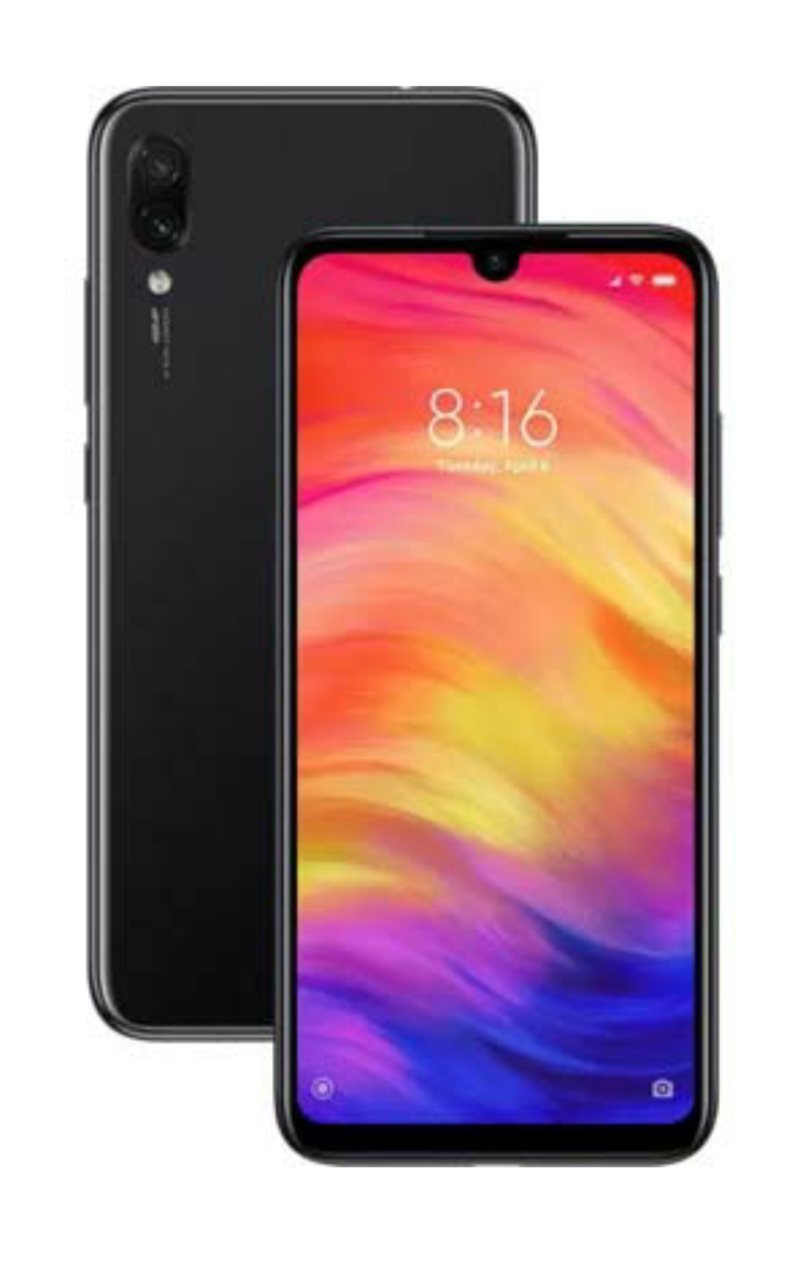
Xiaomi Redmi Note 7 Pro Review: Design and Build
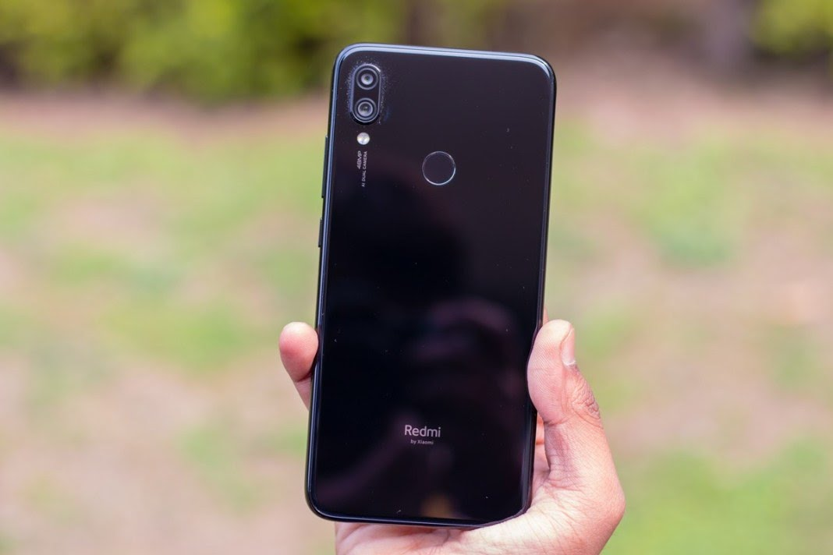
There are some major design changes with this Note iteration. And perhaps for the first time, Xiaomi’s Note is up with the latest design trends. The Redmi Note 7 Pro offers Gorilla Glass 5 on front and back, a semi-circular ‘Dot’ notch at the front, and gradient patterns that are currently in. The handset retains the IR Blaster (something MI fans value), and switch to a reversible USB Type-C port at the bottom is a much welcome change.

Another bonus is splash resistance. The Note 7 Pro is not waterproof or water-resistant but has a higher probability of emerging unscathed after a spillage or being accidentally caught up in rain.
On the downside, the phone feels thick since the back is flat, the microSD card slot is hybrid, buttons are slightly clicky, and the side frame in still plastic. Bezels around the screen are reasonably slim.
Unlike the low-end Note 7, the Pro variant has a bigger camera hump (understandable considering the bigger sensor), and unfortunately, the bundled case doesn’t even it out.

Speaking of back covers, Xiaomi will also sell its own perforated case covers for Redmi Note 7 Pro, and those don’t even out the camera hump either. I am guessing Xiaomi isn’t using sapphire glass over the camera assembly, and users could end up scratching the camera glass after a period of usage.

Xiaomi Redmi Note 7 Pro Review: Display
The Redmi Note 7 Pro has a 6.3-inch LTPS display with Full HD+ resolution. The display is extremely crisp and sharp. Contrast and dynamic range are pretty good, and colors are punchy without being oversaturated.
Whites are marred by cold bluish tones, but that’s shouldn’t be a big concern as MIUI 10 offers enough customization options that should let you tune the display according to your preferences.
It must also be mentioned that AMOLED displays on Galaxy M30, A30, and A50 are so much better.

Xiaomi Redmi Note 7 Pro Review: Software
As for the software, there is familiar MIUI 10 software and this time Xiaomi is backing it with the latest Android 9 Pie right at launch. The interface is generously laden with ads but other than that there are ample customization options and plenty to like.

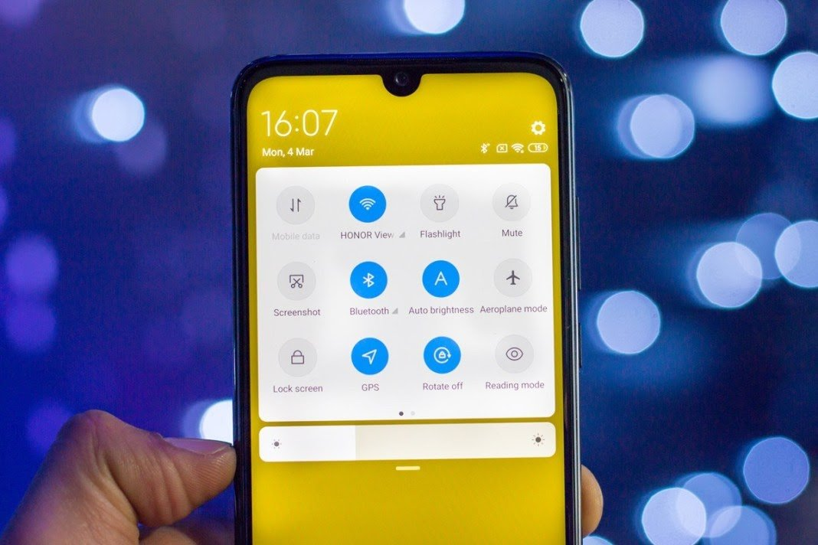
We wouldn’t prefer MIUI over One UI on Samsung A-series or over stock Android on Nokia phones (which many common folks are likely to find bland), but in our books, it ranks better than Color OS (Oppo, Realme), EMUI (Honor) or Funtouch OS (Vivo).
In the long term that we have been using the Redmi Note 7 Pro, we did run into unexpected app crashes and erratic behavior at times, but these weren’t as prominent.
The handset doesn’t yet support HD streaming on apps like Netflix and Amazon Prime. It’s DRM L1 certified, though.

Xiaomi Redmi Note 7 Pro Performance Review
The performance is the very essence of the new Redmi Note 7 Pro. Xiaomi was the first to give due importance to chipsets on their affordable phones and this year, with the Redmi Note 7 Pro, it takes a massive lead. Other OEMs have been playing catch up for a while, but the Note 7 Pro now has some solid competition.

In terms of hardware, it’s now challenged by Realme 3 Pro that’s powered by Snapdragon 710, Vivo Z1Pro that employs Snapdragon 712, and Samsung Galaxy M40 that now has Snapdragon 675 and 128GB storage for under 20k.
I won’t go harping about the details of the chipset (which you may read in our separate article on SD 675), but suffice to say, the performance is very smooth. We didn’t face any issue with day-to-day usage or with multitasking.
The phone doesn’t heat with day-to-day usage but gets pretty warm with long bouts of gaming.
The SoC is further backed by LPDDR4X RAM (up to 6GB). There is no dedicated microSD card slot, but the reasonably priced 128GB storage variant makes up for it. On our 64GB storage variant, around 50GB is free at the user end.

ALSO READ: Realme 3 Pro vs Redmi Note 7 Pro comparison

Xiaomi Redmi Note 7 Pro Camera Review
Camera performance has always been a strength of Xiaomi’s affordable phones. Even the last generation Redmi Note 6 is better than most currently available options, so the 48MP Sony IMX576 sensor on the affordable Note 7 Pro takes the game to a whole new level.
The IMX586 is designed to give the best shots in the 12MP mode, where four adjoining pixels are clubbed as one, but you may also shoot in full 48MP resolution using the pro mode or changing camera settings. The 48MP shots aren’t as crisp though, so you’d be better off with 12MP images.
The images shot on the Note 7 Pro in proper lighting look amazing. In tricky lighting, the phone tends to suppress details in the shadow region. The HDR Mode can be a hit or a miss.

The portrait mode is very good, but like portrait modes on other phones, it isn’t perfect. There are a few portrait effects in the software and mre like studio lighting are on their way.

Portrait Mode
Xiaomi has also added a night mode, and it can really improve night time shots. The processing takes a couple of seconds, but the night mode can radically enhance sharpness and dynamic range. It can also remove flares around hard light sources. This is really good!

Normal Photo Mode
Night Mode subtly enhances dynamic range and sharpness without going overboard
The 13MP selfie camera clicks detailed and well-metered shots, but only in good lighting conditions. In low light, selfie camera performance steeply deteriorates.

Xiaomi Redmi Note 7 Pro Review: Battery
As expected, the 4000mAh battery on the Note 7 Pro easily lasts for a day, and more. Xiaomi bundles a 5V 2A charger in the box, which takes more than 2 hours and 30 minutes to fully charge the battery.

You can separately buy a QC 4.0 charger for faster charging, but those aren’t cheap or easy to come by. The next best option is 15W QuickCharge 3.0 adapter that Xiaomi’s sells on its online store for Rs. 449.

Pros
- Excellent performance
- Excellent rear camera
- Elegant glass finish
- USB Type-C and QuickCharge 4.0 support
- Decent battery backup
- Aggressive price

Cons
- Ads in the UI (can be mostly turned off)
- Hybrid card slot
- No HD streaming on Netflix and Prime
- Fast charger not bundled in the box
- Gets hot with extended gaming
- That camera hump isn’t easy to even
Xiaomi Redmi Note 7 Pro advantages
Xiaomi Redmi Note 7 Pro comes with the latest operating system of Android 9.0 (Pie), MIUI 10, It has Qualcomm SDM675 Snapdragon 675 (11 nm), It offers a fast CPU, It supports Octa-core (2×2.0 GHz Kryo 460 Gold & 6×1.7 GHz Kryo 460 Silver), It includes Adreno 612 and it gives you superb performance without any lags.

Xiaomi Redmi Note 7 Pro has superb expandable memory via card slot, microSD, up to 256 GB (uses SIM 2 slot), It offers high internal memory of 128 GB, 6 GB RAM or it presents superb internal memory of 64 GB, it has 4 GB RAM that is very useful in multitasking performance, It offers lots of RAM & large memory.

Xiaomi Redmi Note 7 Pro has the main camera of Dual 48 MP, f/1.8, 1/2″, 0.8µm, PDAF, it has 5 MP, f/2.4, depth sensor, It offers features such as Dual-LED flash, HDR, panorama, It takes amazing photos with high quality, and it provides you with a flash that enables you to take superb photos in low light conditions.

Xiaomi Redmi Note 7 Pro

Xiaomi Redmi Note 7 Pro has video of 2160p@30fps, 1080p@30/60/120fps, (gyro-EIS), It offers 4K video recording, It presents a selfie camera of Single 13 MP, It has features such as HDR, It contains video of 1080p@30fps and it gives you amazing selfies.

Xiaomi Redmi Note 7 Pro has 2G bands GSM 850 / 900 / 1800 / 1900 – SIM 1 & SIM 2, It presents 3G bands HSDPA 850 / 900 / 1900 / 2100, It presents 4G bands LTE band 1(2100), 3(1800), 5(850), 7(2600), 8(900), 40(2300), 41(2500), Speed is HSPA 42.2/5.76 Mbps, LTE-A (3CA) Cat9 450/50 Mbps, It offers GPRS and it presents EDGE.

Xiaomi Redmi Note 7 Pro is announced in 2019, February, It will be released in 2019, March, The body dimensions are 159.2 x 75.2 x 8.1 mm (6.27 x 2.96 x 0.32 in), It has front/back glass (Gorilla Glass 5), It comes with Hybrid Dual SIM (Nano-SIM, dual stand-by), It offers a premium & impressive design.

Xiaomi Redmi Note 7 Pro has a loudspeaker, It comes with 3.5mm jack, It contains active noise cancellation with dedicated mic, It has Comms WLAN such as Wi-Fi 802.11 a/b/g/n/ac, dual-band, Wi-Fi Direct, hotspot, It presents Bluetooth 5.0, A2DP, LE and it offers high build quality.

Xiaomi Redmi Note 7 Pro has GPS, with A-GPS, GLONASS, BDS, It supports Infrared port, It has FM radio, recording, It offers USB 2.0, Type-C 1.0 reversible connector, It comes with a rich number of sensors such as fingerprint (rear-mounted), accelerometer, gyro, ambient light sensor, proximity & compass.

Xiaomi Redmi Note 7 Pro comes with a non-removable Li-Po 4000 mAh battery that lasts for a long time, It presents fast battery charging 18W (Quick Charge 4), It has misc colors such as Nebula Red, Neptune Blue, Space Black and its price is About 200 EUR.

Xiaomi Redmi Note 7 Pro comes with premium design, It contains a long battery life, It offers smooth performance, It supports 4G in India (Band 40), It looks very premium in the hands, It offers a high pixel density, It has a high resolution that makes the display very clear & bright.

Xiaomi Redmi Note 7 Pro offers a high-end processor & graphics processor, It has excellent & up-to-date software, It supports superb cameras with many features, It has a big & vibrant screen, It provides you with better viewing angles & lower power consumption, It offers nearly every connectivity like Wi-Fi, Bluetooth, GPS, USB, 3G & 4G.
Xiaomi Redmi Note 7 Pro disadvantages
Xiaomi Redmi Note 7 Pro comes with a bit heavy weight of 186 g (6.56 oz), It comes with a non-removable battery, It heats up quickly, It does not have an NFC feature, it does not offer a water & dust resistant, It does not have wireless charging, It does not have Barometer or Temperature

