

**MSPM’S**

**Deogiri Institute of Engineering and Management Studies, Aurangabad**

**Department of Computer Science and Engineering**

Report on

**VIVO Y71 and HUAWEI P20 PRO**

Submitted By

**1) Nutan Pundlik(26017)**

**2)Saurabh Pawar(26018)**

Under the Guidance of

**Prof. P.N. Durole**

Department of Computer Science and Engineering

2019-2020

**VIVO Y71 SPECIFICATION**

The Vivo Y71 mobile features a 6.0" (15.24 cm) display with a screen resolution of 720 x 1440 pixels and runs on Android v8.1 (Oreo) operating system. The device is powered by Quad core, 1.4 GHz, Cortex A53 processor paired with 3 GB of RAM. As far as the battery is concerned it has 3360 mAh. Over that, as far as the rear camera is concerned this mobile has a 13 MP camera . Other sensors include Light sensor, Proximity sensor, Accelerometer, Compass, Gyroscope. So, does it have a fingerprint sensor? No, it doesn't. For graphical performance that can make games run smoothly, this phone has got a Adreno 308 GPU. On board storage is at 16 GB with the option to expand the memory by Yes Up to 256 GB. Design is one of the most important factors when it comes to mobiles. This phone is 7.8 mm slim and weighs 150 grams.

**Processor**

**Snapdragon 425 quad-core**

The Qualcomm Snapdragon 425 (8917) is an ARM-based entry level SoC for tablets and smartphones (mostly Android based). It was announced in February 2016 and integrates four 64-Bit Cortex-A53 CPU cores (quad-core) that clock with up to 1.4 GHz. Furthermore, there is a Adreno 308 graphics card, a LPDDR3 memory controller (max. 667 MHz) and wireless radios for WiFi and 4G/LTE included in the chip.

The Cortex-A53 is the successor of the entry level Cortex-A7 CPU cores. The A53 is now capable of 64 Bit (ARMv8-ISA) and addressing more than 4 GB RAM. According to ARM the performance per MHz is a lot better and even surpasses a Cortex-A9 core.

The integrated [Adreno 308](https://www.notebookcheck.net/Qualcomm-Adreno-308-GPU.215368.0.html" \t "_self) is the integrated graphics card that supports OpenGL ES 3.0.

The integrated wireless radios support WiFi 802.11ac Wave 2, Bluetooth 4.1, GPS/GLONASS/Baidou, 2G, 3G and 4G (LTE Cat.4) standards. Furthermore, the SoC is able to decode 1080p videos in H.265 (encode only in H.264) and cameras with up to 13 MP.

The power consumption of the chip is ranging in the lower range, and therefore it is also suited for smaller smartphones. It is manufactured in 28 nm LP at TSMC.

**CPU SPECIFICATION**

**CPU real -time data**

CPU time (or process time) is the amount of [time](https://en.m.wikipedia.org/wiki/Time" \o "Time) for which a [central processing unit](https://en.m.wikipedia.org/wiki/Central_processing_unit" \o "Central processing unit) (CPU) was used for processing [instructions](https://en.m.wikipedia.org/wiki/Instruction_(computer_science)" \o "Instruction (computer science)) of a [computer program](https://en.m.wikipedia.org/wiki/Computer_program" \o "Computer program) or [operating system](https://en.m.wikipedia.org/wiki/Operating_system" \o "Operating system), as opposed to elapsed time, which includes for example, waiting for [input/output](https://en.m.wikipedia.org/wiki/Input/output" \o "Input/output) (I/O) operations or entering low-power (idle) mode. The CPU time is measured in [clock ticks](https://en.m.wikipedia.org/wiki/System_Time" \o "System Time) or seconds. Often, it is useful to measure CPU time as a percentage of the CPU's capacity, which is called the CPU usage.

CPU time and CPU usage have two main uses. The first use is to quantify the overall busyness of the system. When the CPU usage is high, the user may experience [lag](https://en.m.wikipedia.org/wiki/Lag" \o "Lag). Such high CPU usage indicates insufficient processing power. Either the CPU needs to be upgraded, or the user experience reduced, for example, by switching to lower resolution graphics or reducing animations.

The second use, with the advent of [multi-tasking](https://en.m.wikipedia.org/wiki/Multi-tasking" \o "Multi-tasking), is to quantify how the processor is shared between computer programs. High CPU usage by a single program may indicate that it is highly demanding of processing power or that it may malfunction; for example, it has entered an [infinite loop](https://en.m.wikipedia.org/wiki/Infinite_loop" \o "Infinite loop). CPU time allows measurement of the processing power a single program requires, eliminating interference, such as time executed waiting for input or being suspended to allow other programs to run.

In contrast, [elapsed real time](https://en.m.wikipedia.org/wiki/Elapsed_real_time" \o "Elapsed real time) (or simply real time, or [wall-clock time](https://en.m.wikipedia.org/wiki/Wall-clock_time" \o "Wall-clock time)) is the time taken from the start of a computer program until the end as measured by an ordinary clock. Elapsed real time includes I/O time, any multitasking delays, and all other types of waits incurred by the program.

**VIVO ROM**

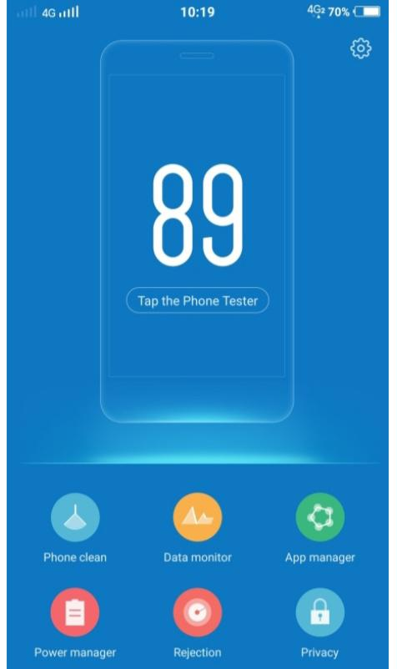**Funtouch os\_4.0**

Vivo Mobile highlights its unique approach to the Android operating system with its custom ROM named Funtouch OS, it’s customized operating system exclusive for Vivo smartphones. Funtouch OS was first launched on December 28, 2013. Now its in more than 50 million Vivo smartphone users.

The Funtouch OS was developed around the idea of a simple user interface (UI) that places intuitive controls within easy reach of its users. At present, Vivo’s V3Max, V3, and Y51 ,Y71 smartphones use Funtouch OS 2.5—Vivo’s most powerful smartphone OS yet.

## **FUNTOUCH OS FEATURES**

One of the strengths of the Android operating system is its high customizability. Vivo’s Funtouch OS preserves this feature with the **iTheme application**. This enables users to download various themes online that match their preferences, and even create their own by changing the wallpapers, fonts, and lock screen set-ups.

With Funtouch OS, Vivo decided to do away with the traditional Android OS app drawer, which is now replaced by a desktop that can easily be organized with app folders. Vivo’s Funtouch OS also introduces the Quick Control Center, accessible with a swipe up from the bottom of the screen, which contains quick shortcuts including sound levels, brightness control, recent apps, and toggles for Wi-Fi, Mobile Data, Flashlight, and more.

**TYPES OF MEMORY IN PHONES**

1. volatile memory.
2. non-volatile memory.

So what are they and which one serves which purpose on our smartphone? lets check it out.

**volatile memory**

Volatile memory is memory which lose it's content  when the device is powered off. Mainly it comes in the form of RAM. RAM stands for **R**andom **A**ccess **M**emory (meaning that each memory location has a direct and unique address that can be read or written to independently of any other location/address).  
  
RAM is very fast to access, and it is used for primarily one thing: the run-time memory of software applications (including the device's operating system and any applications).  
  
There is also a secondary use for RAM, where a part of it is allocated/reserved and used as if it was a storage drive. This is known as a RAM disk. On smartphones this is generally visible to some applications (such as file managers) as the D-drive. As it is volatile memory, only small temporary items/files should be stored there as its contents disappear when the device is powered off.

**Non-Volatile memory**

Non-volatile memory is memory that retains it's state even if the device is powered off. In other words, what's in non-volatile memory survives a device reboot.

Basically there are two types or non-volatile memory. The first one is ROM and the second one is  Flash-RAM.

Most of you know this memory type by it's PC name, ROM. ROM stands for Read Only Memory and it is usually based on a flash memory. what does it mean flash memory? simple. That means we can re-program this memory to hold new data.

So what data is stored in the Flash ROM? it usually stores the OS and some other application related parts that we do not want to be erased.

On smartphones some applications will see/show the ROM as the Z-drive. It can be viewed/read, but not written to. And on newer devices based on Symbian 9.1/S60 3rd Edition, access to specific directories (or "folders", if you prefer that term) is also protected from unprivileged applications.

**Feature of VIVO Y71**

### **Your World in One Hand**

The new 18:9 Full View™ Display has super narrow bezels, achieving an impressive screen-to-body ratio of 84.4%. The result? An immersive display that pushes your mobile viewing experience to the limits. Compared with standard 16:9 aspect ratio phones, the 6.0‑inch Y71 displays 12.5% more content, while still being compact and lightweight enough to carry and operate with one hand.

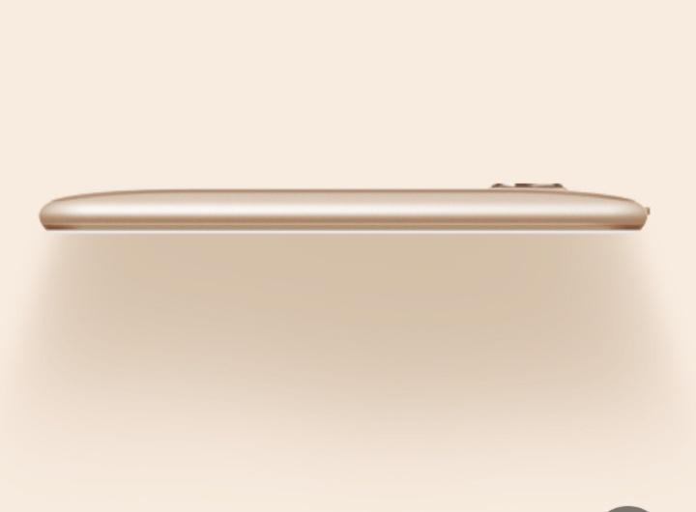

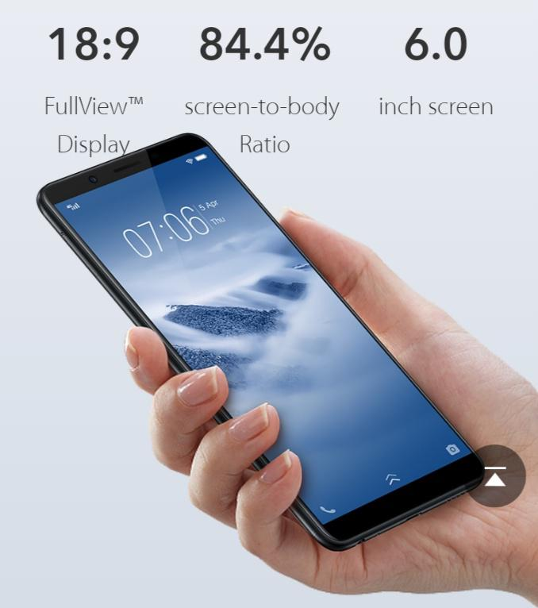

### **Beauty Comes in Curves**

Lightweight and slim, the Y71’s body features a slight curve, which sits snugly in your palm. Smoothed by the new high polymer Nano-blasting technique, it’s elegant and designed to be touched.

### **AI Face Beauty**

We don’t believe in a ‘one-size-fits all’ approach to portrait photography. Your Y71 identifies your gender, age, skin tone and texture, and then applies a range of beauty effects, while highlighting your natural beauty. Over time, it learns more about your face and photographic habits, and adapts to enhance your selfies even further.

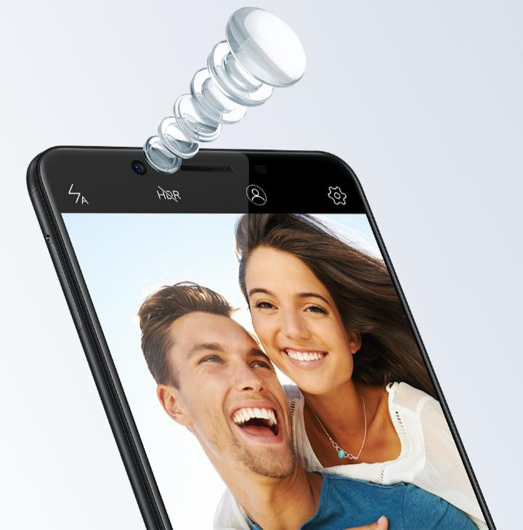

### **Smooth User Experience**

Open apps instantly with the Y71’s 3GB RAM and powerful Qualcomm processor. You’ll enjoy seamless performance, whether you’re watching videos or checking social media. To maintain smooth operation over time, your Y71 smartly performs defragmentation and memory optimization tasks, leaving you free to focus on having fun.

### 

**Extended Battery Life**

The Y71 boasts a large capacity 3360mAh battery and advanced Android 8.1 OS optimization, making it even more energy efficient. The latest Vivo Smart Engine also provides additional power management, so your longer lasting battery gives you the freedom to stay outside longer.

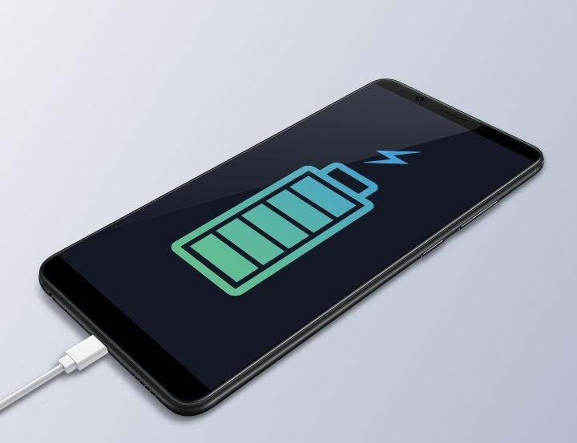

### **Smart Split with Bigger View**

Vivo’s Smart Split feature, combined with the 6.0‑inch 18:9 Full View™ Display, improves your ability to multi-task. You can still watch videos and chat simultaneously, but with a much bigger viewing space. So you enjoy even more impressive video quality, and more space to display your messages.

\* Currently supports Facebook, Line, Messages, Viber, WeChat, WhatsApp, BBM, Play Movies & TV, YouTube, Video, MX Player, VLC for Android, Chrome, Gmail and more.

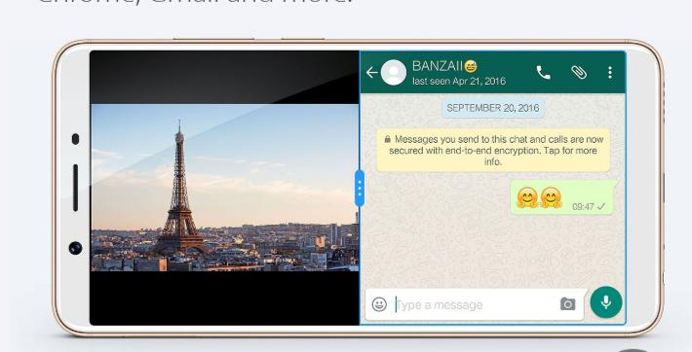

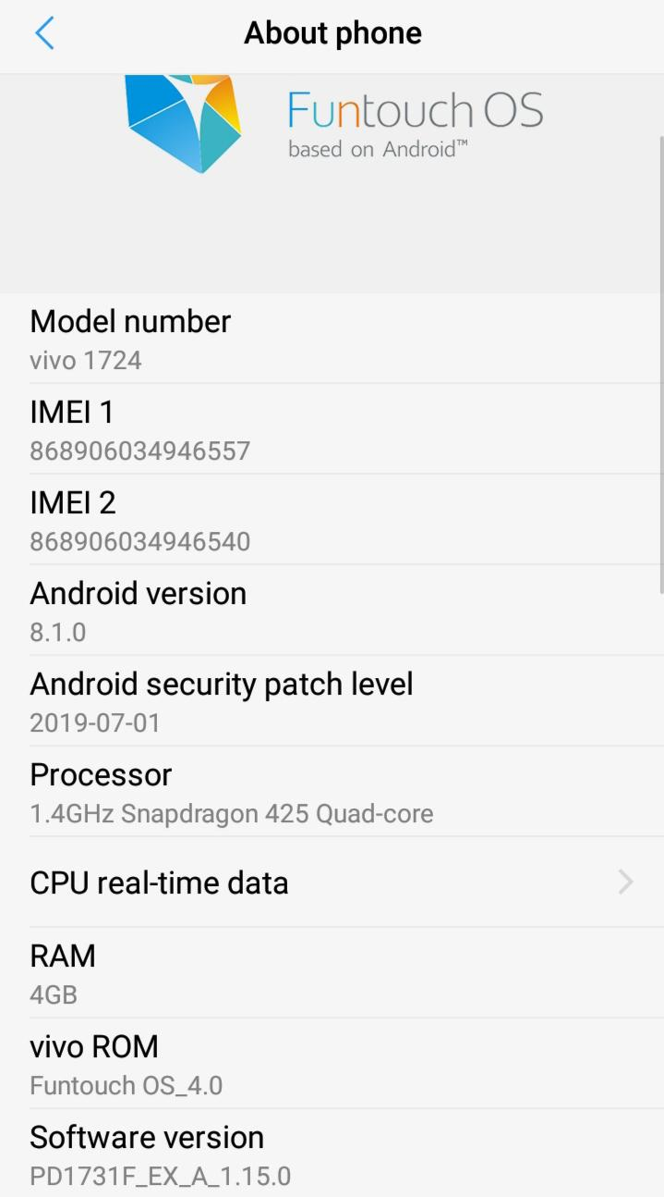

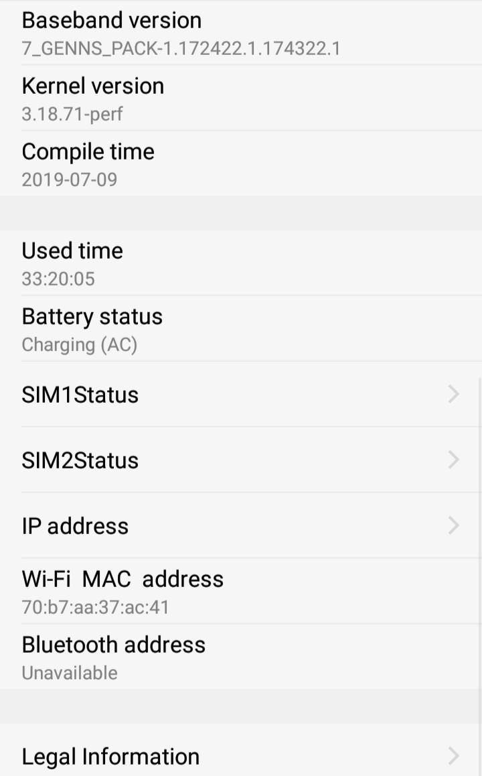

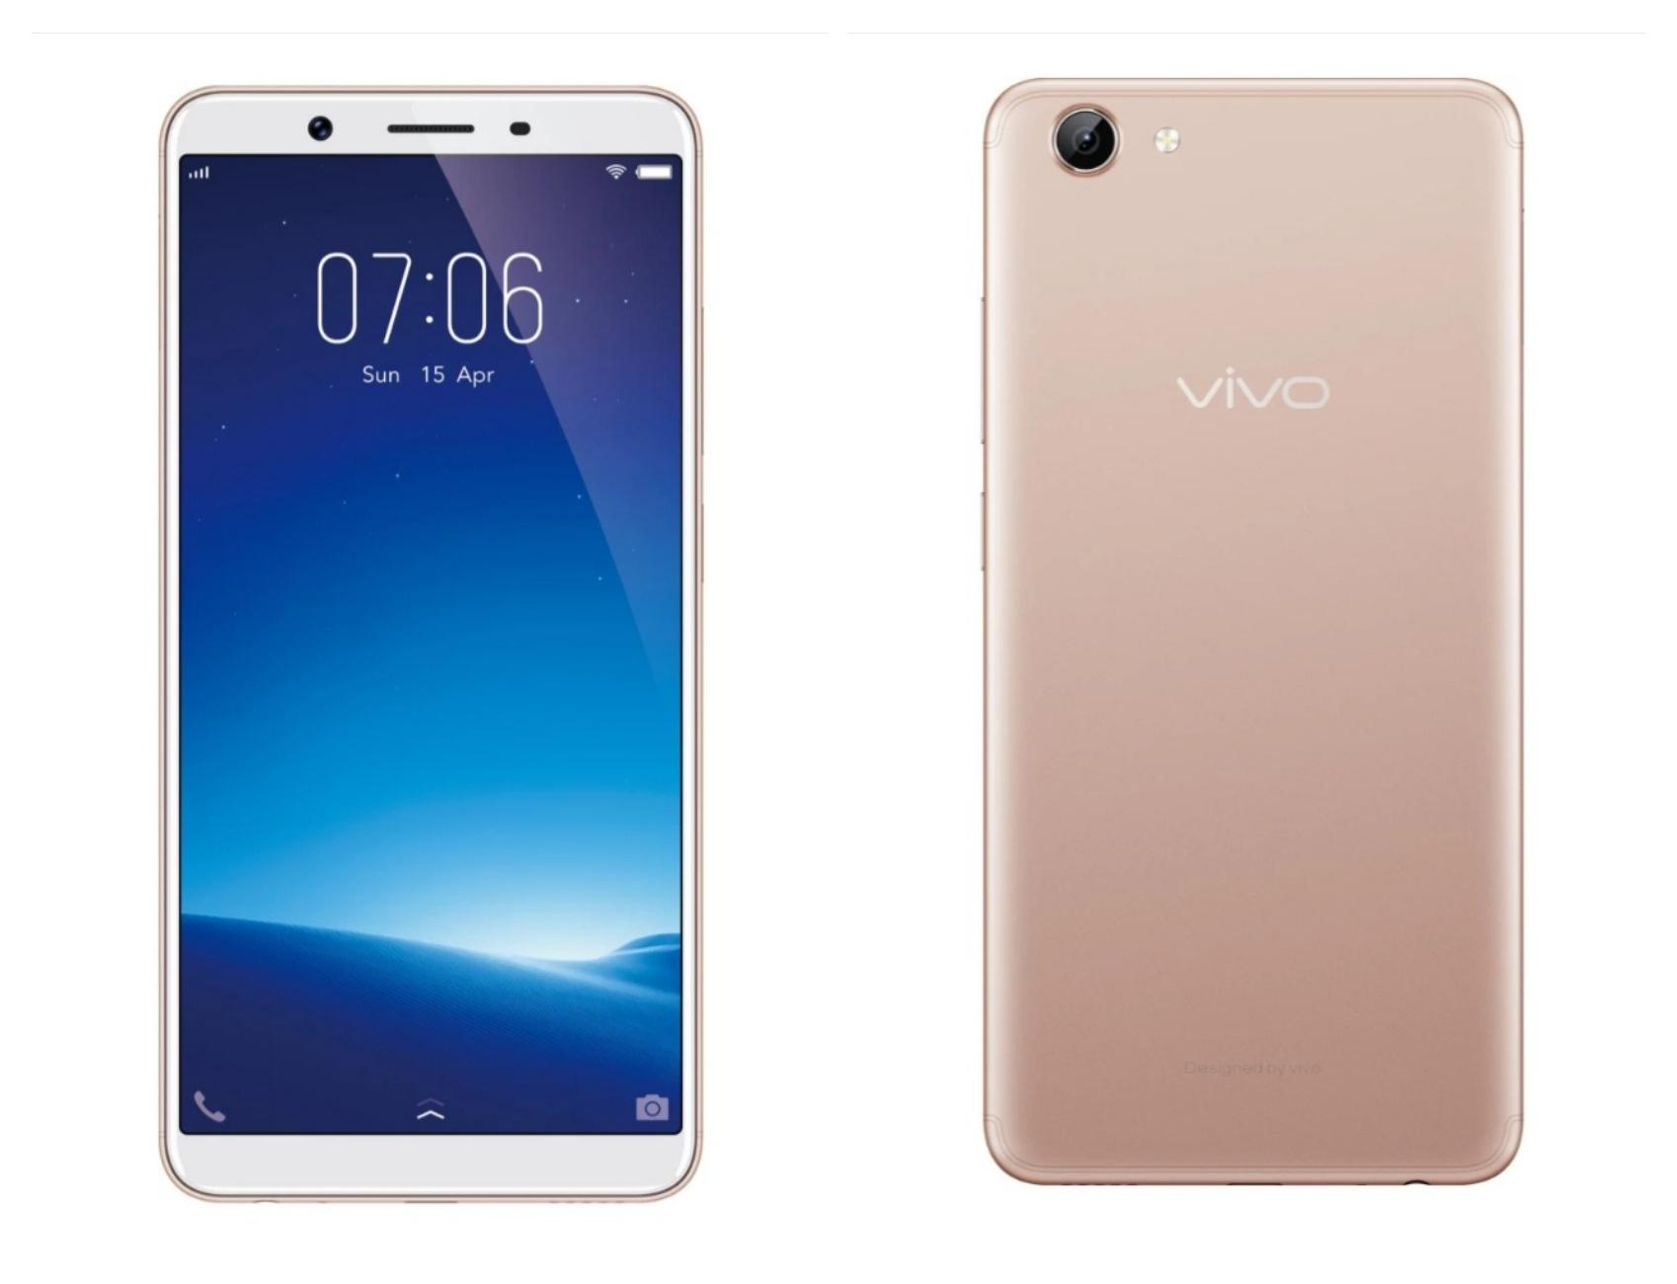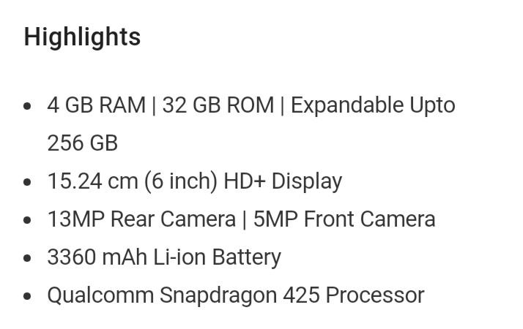

* **Function of Memory**
* Phone's memory includes RAM and ROM. RAM equals the memory (or memory bar) of the computer, while ROM is the device's internal storage, equaling the hard disk of the computer.

* The bigger the RAM, the more software the phone runs smoothly; While the bigger the ROM, the more data it can store. Usually, a phone with big RAM is not easy to get stuck. So far, the RAM of the smartphones generally reaches above 2G, the major phones are equipped with 3GB / 4GB, even 6GB and 8GB this year.

ROM (Read Only Memory) is a form of data storage. This type of memory keeps the saved data even if the device power is off. The word Read-only identifies it as "read-only memory", since the reprogramming process is generally infrequent, comparatively slow, and often does not permit random access writes to individual memory locations. It equals a hard disk in a computer, storing various of files, including videos, songs, photos, and system software, etc. At present, most smartphones are equipped with 16GB, 32GB, 64GB, or even 128GB, 256GB large ROM. But we have to pay attention that in phones the ROM is not described with ROM but with storage.

------------------------\*\*\*\*\*\*\*\*\*\*\*\*\*\*\*\*\*----------------------------------

**[Huawei P20 Pro](javascript:;" \o "HUAWEI P20 Pro)**

**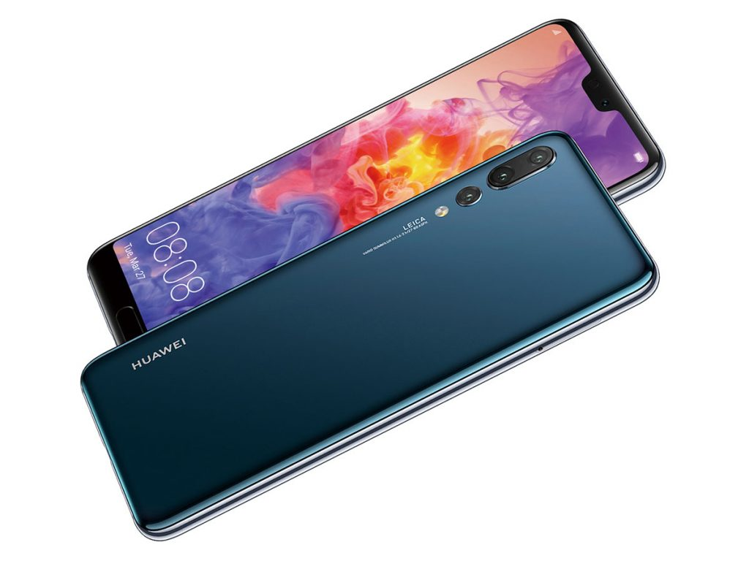 **

****

****







 

      

 

 



****

Type : OLED capacitive touchscreen, 16M colors





 

 

****

 

 

Chipset : Hisilicon Kirin 970 (10 nm)

GPU : Mali-G72 MP12

  



****

 

 



Selfie camera : Single 24 MP, f/2.0, 26mm (wide)

Main Camera : Triple 40 MP, f/1.8, 27mm (wide), 1/1.7", PDAF, Laser AF, OIS

Laser AF, OIS

Features : Leica optics, LED flash, HDR, panorama

****





****

Network Technology

GSM / HSPA / LTE

NFC Yes

Infrared port Yes

Radio No

USB 3.1, Type-C 1.0 reversible connector

   



  



   

 

** **

 



 ☹   



** **



 

 ☹  



****









 

Fingerprint (front-mounted) : 

Color spectrum : 

**Sound**

Loudspeaker Yes, with stereo speakers

Loudspeaker Voice 71dB / Noise 69dB / Ring 91dB

Audio quality Noise -92.1dB / Crosstalk -92.1dB

**Battery**

Type : Non-removable Li-Po 4000 mAh battery

Charging : Fast battery charging 22.5W (58% in 30 min)

Battery life : Endurance rating 89h

**Processor architecture**

**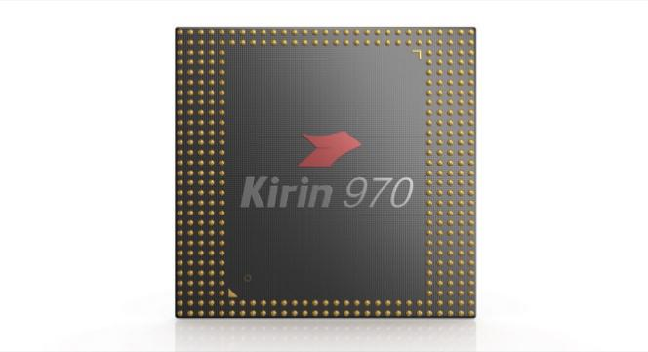**

**Kirin 970** is a [64-bit](https://en.wikichip.org/wiki/64-bit_architecture" \o "64-bit architecture) [octa-core](https://en.wikichip.org/wiki/octa-core" \o "octa-core) high-performance mobile [ARM](https://en.wikichip.org/wiki/ARM" \o "ARM) [LTE](https://en.wikichip.org/wiki/LTE" \o "LTE) SoC introduced by [HiSilicon](https://en.wikichip.org/wiki/HiSilicon" \o "HiSilicon) in mid-2017 at the [2017 IFA](https://en.wikichip.org/w/index.php?title=2017_IFA&action=edit&redlink=1" \o "2017 IFA (page does not exist)). This chip, which is fabricated on a [10 nm process](https://en.wikichip.org/wiki/10_nm_process" \o "10 nm process), features four [Cortex-A73](https://en.wikichip.org/wiki/arm_holdings/microarchitectures/cortex-a73" \o "arm holdings/microarchitectures/cortex-a73) [big cores](https://en.wikichip.org/wiki/big_cores" \o "big cores) operating at up to 2.36 GHz along with four [Cortex-A53](https://en.wikichip.org/wiki/arm_holdings/cortex-a53" \o "arm holdings/cortex-a53) [little cores](https://en.wikichip.org/wiki/little_cores" \o "little cores) operating at up to 1.8 GHz. The 970 incorporates [ARM](https://en.wikichip.org/wiki/ARM_Holdings" \o "ARM Holdings)'s [Mali G72](https://en.wikichip.org/w/index.php?title=arm_holdings/mali_g72&action=edit&redlink=1" \o "arm holdings/mali g72 (page does not exist)) (12 core) IGP operating at 850 MHz and supports up to 8 GiB of quad-channel LPDDR4X-3732 memory.

                                                                                

|  |  |
| --- | --- |
| **General Specs** | |
| Family | [Kirin](https://en.wikichip.org/wiki/hisilicon/kirin" \o "hisilicon/kirin) |
| Series | 900 |
| Frequency | 1,800 MHz, 2,360 MHz |
| **Microarchitecture** | |
| ISA | ARMv8 (ARM) |
| Microarchitecture | [Cortex-A53](https://en.wikichip.org/wiki/hisilicon/microarchitectures/cortex-a53" \o "hisilicon/microarchitectures/cortex-a53), [Cortex-A73](https://en.wikichip.org/wiki/hisilicon/microarchitectures/cortex-a73" \o "hisilicon/microarchitectures/cortex-a73) |
| Core Name | [Cortex-A53](https://en.wikichip.org/wiki/hisilicon/cores/cortex-a53" \o "hisilicon/cores/cortex-a53), [Cortex-A73](https://en.wikichip.org/wiki/hisilicon/cores/cortex-a73" \o "hisilicon/cores/cortex-a73) |
| Process | [10 nm](https://en.wikichip.org/wiki/10_nm_process" \o "10 nm process) |
| Transistors | 5,500,000,000 |
| Technology | CMOS |
| Die | 96.72 mm² 9.75 mm × 9.92 mm |
| Word Size | 64 bit |
| Cores | 8 |
| Threads | 8 |
| Max CPUs | 1 (Uniprocessor) |
| Max Memory | 8 GiB |

        

# Android 8.1 oreo

# IMG_256

Android "Oreo" ([codenamed](https://en.wikipedia.org/wiki/Code_name" \o "Code name) Android O during development) is the eighth major release and the 15th version of the [Android](https://en.wikipedia.org/wiki/Android_(operating_system)" \o "Android (operating system)) [mobile operating system](https://en.wikipedia.org/wiki/Mobile_operating_system" \o "Mobile operating system).

It contains a number of major features, including notification grouping, [picture-in-picture](https://en.wikipedia.org/wiki/Picture-in-picture" \o "Picture-in-picture) support for video, performance improvements and battery usage optimization, and support for [autofillers](https://en.wikipedia.org/wiki/Autofill" \o "Autofill), [Bluetooth 5](https://en.wikipedia.org/wiki/Bluetooth_5" \o "Bluetooth 5), system-level integration with [VoIP](https://en.wikipedia.org/wiki/VoIP" \o "VoIP) apps, wide [color gamuts](https://en.wikipedia.org/wiki/Color_gamut" \o "Color gamut), and [Wi-Fi Aware](https://en.wikipedia.org/wiki/Wi-Fi_Aware" \o "Wi-Fi Aware). Android Oreo also introduces two major platform features: [Android Go](https://en.wikipedia.org/wiki/Android_Go" \o "Android Go) – a software distribution of the operating system for low-end devices – and support for implementing a [hardware abstraction layer](https://en.wikipedia.org/wiki/Hardware_abstraction_layer" \o "Hardware abstraction layer).

# Features

Starting with Android 8.1, we’re making Android a great platform for entry-level devices. Features in the Android Oreo (Go edition) configuration include:

* Memory optimizations. Improved memory usage across the platform to ensure that apps can run efficiently on devices with 1GB or less RAM.
* Flexible targeting options. New [hardware feature constants](https://developer.android.com/reference/android/content/pm/PackageManager.html" \l "FEATURE_RAM_LOW) to let you target the distribution of your apps to normal or low-RAM devices through Google Play.
* Google Play.While all apps will be available on devices running Android Oreo (Go edition), Google Play will give visibility to apps specifically optimized by developers to provide a great experience for billions of people with the building for billions [guidelines.](https://developer.android.com/develop/quality-guidelines/building-for-billions.html)

   

Notifications can be snoozed, and batched into topic-based groups known as "channels".[[19]](https://en.wikipedia.org/wiki/Android_Oreo" \l "cite_note-19)[[20]](https://en.wikipedia.org/wiki/Android_Oreo" \l "cite_note-20) The 'Major Ongoing' feature orders the alerts by priority, pinning the most important application to the top slot.

The Android 8.1 update supports the display of battery percentages for connected [Bluetooth](https://en.wikipedia.org/wiki/Bluetooth" \o "Bluetooth) devices, makes the notification shade slightly translucent, and dims the on-screen navigation keys in order to reduce the possibility of [burn-in](https://en.wikipedia.org/wiki/Screen_burn-in" \o "Screen burn-in).

## **Triple Camera**

The Huawei P20 Pro is the first smartphone on the market to offer a triple camera setup: a whopping 40-megapixel primary 'Light Fusion' RGB sensor (with an f/1.8 aperture), a 20-megapixel monochrome sensor (with an f/1.6 aperture) and an 8-megapixel telephoto sensor (with an f/2.4 aperture)

HUAWEI's P series has always been a pioneer of smartphone photography. Now the HUAWEI P20 Pro is once again leading the way with the revolutionary Leica Triple Camera, where aesthetic vision meets an advanced camera system that shines a light on intelligent photography.                 **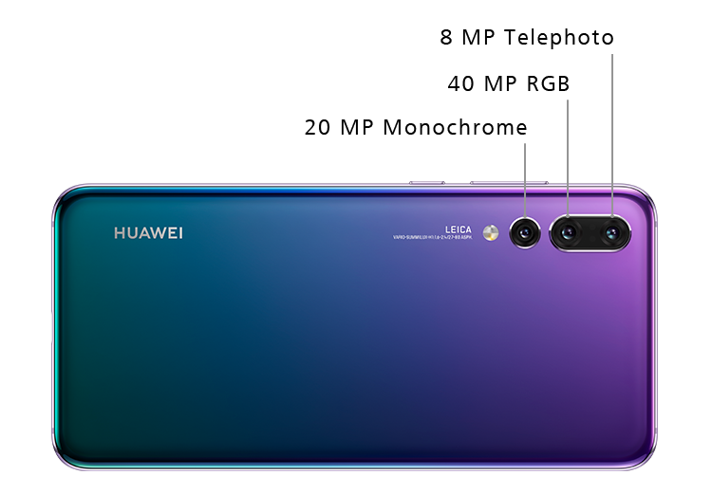**

## **More Power, For Longer**

The HUAWEI P20 Pro houses a hugely powerful battery that charges safely and swiftly, and keeps its power for much longer. With HUAWEI FastCharge\* the mighty 4000 mAh\*\* battery can fast-charge at speed for maximum convenience.

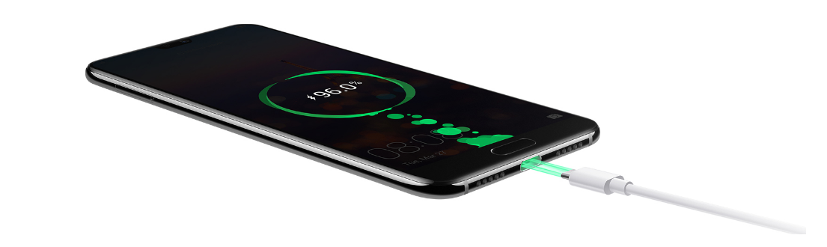

## **AI Image Stabilisation**

Image stabilization (IS) is a family of techniques that reduce [blurring](https://en.wikipedia.org/wiki/Motion_blur" \o "Motion blur) associated with the motion of a [camera](https://en.wikipedia.org/wiki/Camera" \o "Camera) or other imaging device during [exposure](https://en.wikipedia.org/wiki/Exposure_(photography)" \o "Exposure (photography)).

HUAWEI AI Image Stabilisation allows you to capture incredible blur-free, handheld shots in low-light using Night Mode. No more tripod. Night Mode also balances high-contrast scenes for effortlessly clear, light-balanced snaps in any setting.

Image stabilization (IS) is a family of techniques that reduce blurring associated with the motion of a camera or other imaging device during exposure. ... It is used in image-stabilized binoculars, still and video cameras, astronomical telescopes, and also smartphones, mainly the high-end.

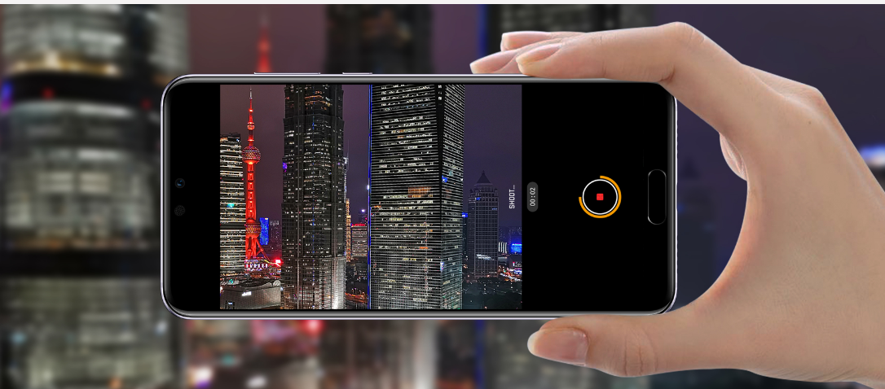

**Master AI**

With the support of Master AI, the HUAWEI P20 Pro is able to identify, in real-time, 19 different categories\*. Professional photography skills like lighting and other settings are then automatically adjusted by AI so your photo is the absolute best it can be.

**GPU Turbo Technology**

A graphics processing unit (GPU) is a specialized [electronic circuit](https://en.wikipedia.org/wiki/Electronic_circuit" \o "Electronic circuit) designed to rapidly manipulate and alter [memory](https://en.wikipedia.org/wiki/Memory_(computing)" \o "Memory (computing)) to accelerate the creation of [images](https://en.wikipedia.org/wiki/Image" \o "Image) in a [frame buffer](https://en.wikipedia.org/wiki/Frame_buffer" \o "Frame buffer) intended for output to a [display device](https://en.wikipedia.org/wiki/Display_device" \o "Display device).

Their highly parallel structure makes them more efficient than general-purpose [central processing units](https://en.wikipedia.org/wiki/Central_processing_unit" \o "Central processing unit) (CPUs) for [algorithms](https://en.wikipedia.org/wiki/Algorithm" \o "Algorithm) that process large blocks of data in parallel.

## Unleash the Power At Full Speed

With revolutionary image processing acceleration powered by GPU Turbo Technology, HUAWEI P20 Pro offers you smooth and flowing gaming experience.GPU Turbo is a hardware-software integrated graphics processing acceleration technology that reconstructs the traditional graphics processing framework at the lower layer system, thus aiming to improve the user experience. ... As such, the new GPU Turbo by Huawei and Honor aims to cater to these problems.

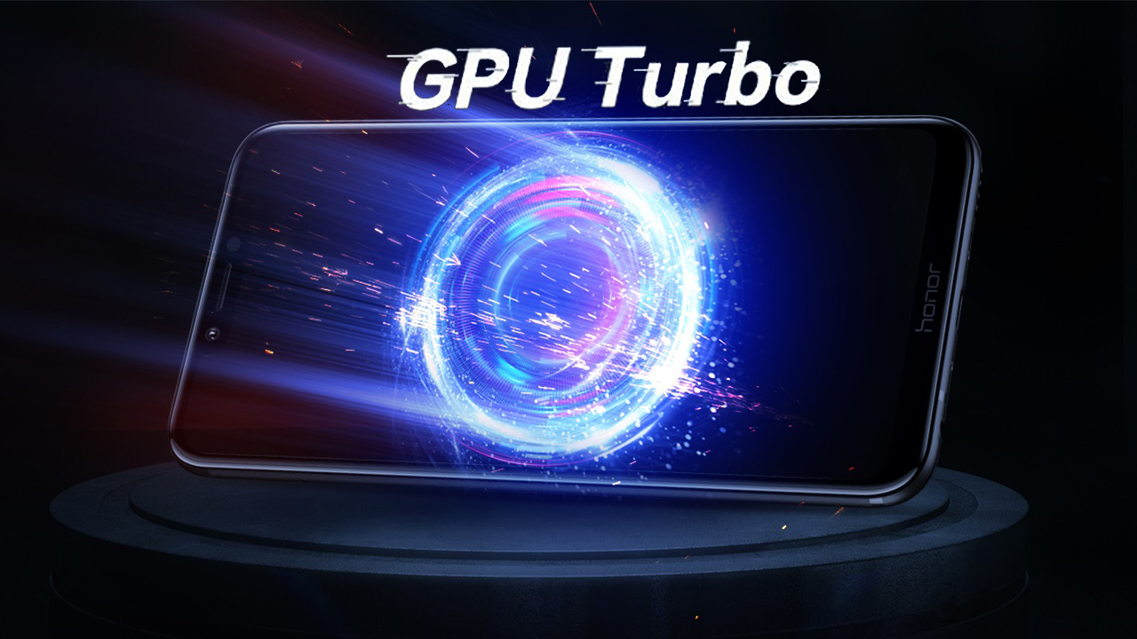

Powerful graphics processors result in smoother gameplay and the ability to render more detailed textures in a smartphone. Often times, there is a talk about not just the right amount of GPU power but also about how efficient is the GPU since a balance is necessary to provide the user with adequate battery life while gaming. Huawei states that this balanced is going to be improved or disturbed, depending on how you look at things.

Modern GPUs use most of their [transistors](https://en.wikipedia.org/wiki/Transistor" \o "Transistor) to do calculations related to [3D computer graphics](https://en.wikipedia.org/wiki/3D_computer_graphics" \o "3D computer graphics)GPUs were initially used to accelerate the memory-intensive work of [texture mapping](https://en.wikipedia.org/wiki/Texture_mapping" \o "Texture mapping) and [rendering](https://en.wikipedia.org/wiki/Rendering_(computer_graphics)" \o "Rendering (computer graphics)) polygons, later adding units to accelerate [geometric](https://en.wikipedia.org/wiki/Geometry" \o "Geometry) calculations Recent developments in GPUs include support for [programmable shaders](https://en.wikipedia.org/wiki/Programmable_shader" \o "Programmable shader) which can manipulate vertices and textures with many of the same operations supported by [CPUs](https://en.wikipedia.org/wiki/Central_processing_unit" \o "Central processing unit)Because most of these computations involve [matrix](https://en.wikipedia.org/wiki/Matrix_(mathematics)" \o "Matrix (mathematics)) and [vector](https://en.wikipedia.org/wiki/Vector_calculus" \o "Vector calculus) operations, engineers and scientists have increasingly studied the use of GPUs for non-graphical calculations; they are especially suited to other [embarrassingly parallel](https://en.wikipedia.org/wiki/Embarrassingly_parallel" \o "Embarrassingly parallel) problems.

**Control unit**

A control unit (CU) handles all processor control signals. It directs all input and output flow, fetches code for instructions from microprograms and directs other units and models by providing control and timing signals. A CU component is considered the processor brain because it issues orders to just about everything and ensures correct instruction execution.

**CU functions are as follows:**

* Controls sequential instruction execution
* Interprets instructions
* Guides data flow through different computer areas
* Regulates and controls processor timing
* Sends and receives control signals from other computer devices
* Handles multiple tasks, such as fetching, decoding, execution handling and storing results

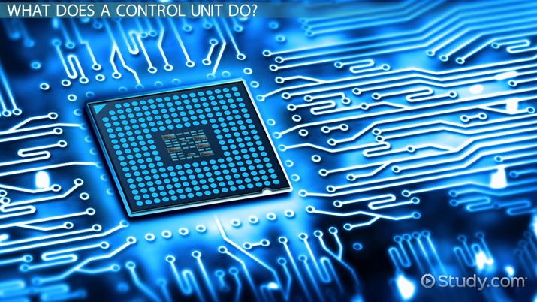

**CUs are designed in two ways:**

* **Hardwired control:**

Design is based on a fixed architecture. The CU is made up of flip-flops, logic gates, digital circuits and encoder and decoder circuits that are wired in a specific and fixed way. When instruction set changes are required, wiring and circuit changes must be made. This is preferred in a reduced instruction set computing (RISC) architecture, which only has a small number of instructions.

* **Microprogram control:**

Microprograms are stored in a special control memory and are based on flowcharts. They are replaceable and ideal because of their simplicity.

**Input & output mechanism**

**USB Type C**

Type-C over other existing variants is that it allows for ‘reverse plug orientation’. It can be also be used to share data, charging device.

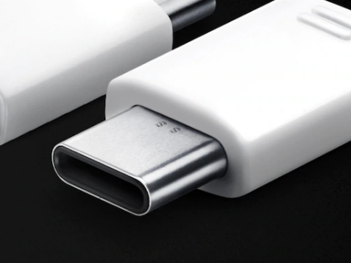

      

  

 **Stereo Speakers**

Two separate speakers built directly into the phone: one for the left sound channel, and one for the right. The separate left and right sound channels of stereo music or ringtones produces a stereo effect where slightly different sound is heard by the left and right ears, making it sound more "real". 

**OLED**

OLED displays means just what it does in LCDs - there is an array of thin-film transistors (TFTs) on one substrate of the display, and these control each pixel/subpixel.   

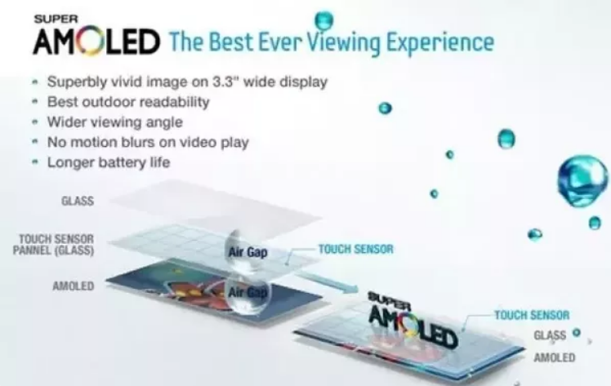

# MEMORY

# Random-access memory

Random-access memory (RAM [/ræm/](https://en.wikipedia.org/wiki/Help:IPA/English" \o "Help:IPA/English)) is a form of [computer memory](https://en.wikipedia.org/wiki/Computer_memory" \o "Computer memory) that can be read and changed in any order, typically used to store working [data](https://en.wikipedia.org/wiki/Data" \o "Data) and [machine code](https://en.wikipedia.org/wiki/Machine_code" \o "Machine code).In today's technology, random-access memory takes the form of [integrated circuit](https://en.wikipedia.org/wiki/Integrated_circuit" \o "Integrated circuit) (IC) chips with [MOS](https://en.wikipedia.org/wiki/MOSFET" \o "MOSFET) (metal-oxide-semiconductor) [memory cells](https://en.wikipedia.org/wiki/Memory_cell_(computing)" \o "Memory cell (computing)). RAM is normally associated with [volatile](https://en.wikipedia.org/wiki/Volatile_memory" \o "Volatile memory) types of memory (such as [DRAM](https://en.wikipedia.org/wiki/DRAM" \o "DRAM) [modules](https://en.wikipedia.org/wiki/DIMM" \o "DIMM)), where stored information is lost if power is removed, although non-volatile RAM has also been developed.

The two main types of volatile random-access [semiconductor memory](https://en.wikipedia.org/wiki/Semiconductor_memory" \o "Semiconductor memory) are [static random-access memory](https://en.wikipedia.org/wiki/Static_random-access_memory" \o "Static random-access memory) (SRAM) and [dynamic random-access memory](https://en.wikipedia.org/wiki/Dynamic_random-access_memory" \o "Dynamic random-access memory) (DRAM).

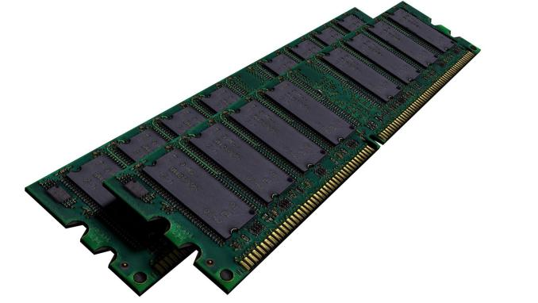

**Secure Digital Card**

An SD Card (Secure Digital Card) is an ultra small flash memory card designed to provide high-capacity memory in a small size. SD cards are used in many small portable devices such as digital video camcorders, digital cameras, handheld computers, audio players and mobile phones.

How Does an SD Card Work? Secure Digital (SD) cards are a form of flash memory used to store data from many modern digital devices. They differ from other storage media in that they can be written to thousands of times and do not require power to retain their contents.

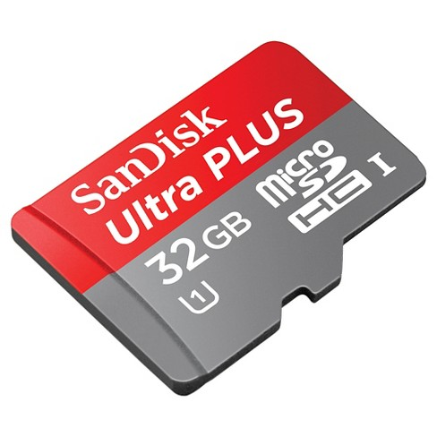

**Comparison**

|  |  |  |
| --- | --- | --- |
| **Feature** | ** VIVO Y71** | **** |
| Processor | Quad core, 1.4 GHz  Cortex A53 processor | 1.8GHz octa-core  Kirin 970 |
| Display | 6.0" (15.24 cm) |   6.10 |
| Screen resolution | 720 x 1440 pixels | 1080x2240 pixels |
| Operating system | Android v8.1 (Oreo) | Android v8.1 (Oreo) |
| Battery capacity | 3360 mAh | 4000 mAh |
| Camera | 13 MP | 40+24 MP |
| RAM | 3 GB | 6GB |