Marathwada Shikshan Prasarak Mandal’s

**Deogiri Institute Of Engineering and Management Studies**

**Aurangabad**

**Seminar Report**

**On**

**Automatic and real-time Pothole detection and Traffic monitoring system using Smartphone Technology**

Submitted By

**Nikita N. Muthal (36119)**

**Siddhi M. Gaud (36128)**

**Dr. Babasaheb Ambedkar Technological University**

**Lonere (M.S.)**



Department of Computer Science and Engineering

**Deogiri Institute of Engineering and Management Studies,**

**Aurangabad**

(2019- 2020)

**Seminar Report**

**On**

**Automatic and real-time Pothole detection and Traffic monitoring system using Smartphone Technology**

Submitted By

**Nikita N. Muthal(36119)**

**Siddhi M. Gaud(36128)**

**In partial fulfillment of**

**Bachelor of Technology**

**(Computer Science & Engineering)**

Guided By

**Mr .P.H.Durole**

Department of Computer Science & Engineering

**Deogiri Institute of Engineering and Management Studies,**

**Aurangabad** (2019- 2020)

**CERTIFICATE**

This is to certify that, the Seminar entitled “ **Automatic and real-time Pothole and detection and Traffic monitoring system using Smartphone Technology “**  submitted by **(Nikita Muthal, Siddhi Gaud)** is a bonafide work completed under my supervision and guidance in partial fulfillment for award of Bachelor of Technology (Computer Science and Engineering) Degree of Dr. Babasaheb Ambedkar Technological University, Lonere.

Place: Aurangabad

Date:4/9/2019

**Mr.P.H.Durole Mr. S.B. Kalyankar**

**Guide Head**

**Dr. Ulhas D. Shiurkar**

**Director,**

**Deogiri Institute of Engineering and Management Studies,**

**Aurangabad**

**ABSTRACT**

With widespread adoption of smartphones, some of human’s tough problems are being tackled with mobile applications. One of many such problems is road traffic accidents, and congested traffic in metropolitan cities. According to the World Health Organization (WHO), road accidents accounted for 53,339 fatalities in Nigeria in the year 2010 and with growing number of vehicle users, trafﬁc is growing day by day. Technology, more specifically, mobile phone technology has evolved to enable miniature devices the capability of containing powerful sensors. The functionalities of these sensors, such as accelerometers, present in smartphones is what this study exploits to develop a system capable of automatically detecting potholes in real-time and monitoring road traffic conditions. Machine learning techniques; Support vector machines based on K-means clustering, are applied to the data obtained from such sensors to estimate road/traffic conditions. Previous work in this area puts the onus on the user, and pays little attention to giving incentives for the tedious, and mundane task of cataloging potholes, or any other road anomalies. As such, this study goes beyond simply detecting or estimating road/traffic conditions and derives utility for the user by making use of the data collected to enable prevention of potholes while driving, and visualizing roads traffic which would inform decisions on alternate routes. The developed system is evaluated using data obtained from the crawdad.org database and a test drive on Ilorin roads shows promising results.

**Keywords:**

Road condition, traffic, potholes, real-time, machine learning, mobile, sensors, visualization

**INTRODUCTION**

The importance of good road infrastructure in any society cannot be overemphasized, as it is a vital part of people’s day-to-day activities. Road traffic accidents account for a major percentage of deaths worldwide and according to the World Health Organization; they have a degree of effect on the GDP of any nation causing a 4% decrease in Nigeria’s during the year 2010 . Ministries, departments and agencies in cities across the world concerned with road and traffic maintenance, spend huge amounts of money yearly in maintaining and repairing road anomalies including potholes. Potholes are shallow pits on a road’s surface, caused by activities like erosion, weather, trafﬁc and some other factors. These anomalies when accumulated in the transportation system, constitutes to major problems. These problems, even though appear to be less signiﬁcant at an individual level, constitute to major problems when taken in cumulative, collective and large-scale manner. The problems constituted by these potholes result in low fuel economy, accidents, trafﬁc coagulations and so on, which have an adverse impact on the economy of a country and day to day life of citizens. With growing number of vehicle users, trafﬁc is growing day by day. It is desirable to have a mechanism, by which people can know, in real-time, about the trafﬁc condition in the routes on which they wish to travel. As a result, working on trafﬁc monitoring has gained signiﬁcant attention. Detection of potholes and traffic monitoring is a problem widely studied in recent times, and the approaches often employ the usage of dedicated sensors such as GPS, accelerometers, and traffic cameras. Thus, the smartphone based pothole detection and trafﬁc estimation methods obviate the need for specialized hardware installed in vehicles or on the roadside. Being crowd-sourced - using distributed participatory data collection - the approach has the advantage of high scalability considering that the number of smartphone users is growing quite rapidly. Automated embedded sensing systems, including smartphones, generally, have two classes of sensors to be used for pothole detection: microphone and accelerometers. This study employs accelerometer data processing for pothole detection and traffic monitoring. This solution extends the methodology and is implemented on Android OS. To create a successful road surface monitoring system accepted by wide user community, it is important to make it attractive for the users - to provide added value without a signiﬁcant process overhead. Therefore, the ability for the system to carry out traffic monitoring would serve as an incentive by providing real-time trafﬁc information collected by participatory sensing approach to participants. Furthermore, several researches with high positive results in pothole detection have been carried out. For instance, achieved 90% true positives with real life data and described methods to more efficiently monitor road traffic conditions using machine learning techniques in place of threshold based heuristics. Despite this, disturbingly few studies has been done around utilizing the processed data for social or economic benefit. Thus, as an added incentive for citizens this research makes use of processed accelerometer data to enable road users prevent potholes while driving coupled with giving real-time information on road traffic in the development of an automatic and real-time pothole detection and traffic monitoring system using smartphone technology by applying artificial intelligence.

**LITERATURE SURVEY**

**Methods Using Specialized Sensors**

Proposed in is a distributed mobile sensor computing system called CarTel. This system includes a set of sensors installed in vehicles to collect and process data and send it to portal based upon the continuous queries which are processed by continuous query processor on remote nodes. It uses sensors like GPS for monitoring the movements of vehicles. CarTel includes, CafNet, a networking stack that uses opportunistic connection (e.g. Wi-Fi, Bluetooth) to transfer information between portal and remote nodes. These information can be used for various applications such as time of travel, route planning. CarTel currently does not offer a way to aggregate information gathered across different users and it does not include machine learning; it just replies to the queries based upon the data stored in relational database. Pothole Patrol system as described in uses 3-axis accelerometer and GPS mounted on the dashboard to monitor

road surface. It not only identifies potholes but also differentiate potholes from other road anomalies. It collects the signals using accelerometer. It uses machine-learning algorithms to identify potholes. These signals are then passed through a series of signal processing filters, where each filter is designed in such a way that it will reject one or more non-pothole events (manholes, expansion joints, railroad crossing). For training the machine, it uses a threshold value to classify potholes based upon search over values of each parameter and computes a detector score, which is to be maximized. It also classifies the data by location to filter out misclassified events. It uses an external GPS to detect the location of potholes. This system gives a false positive rate of less than 0.2% in controlled experiments. RCM-TAGPS system as discussed in collects the sensor data using three-axis accelerometer and GPS. The sensor data has 4-tuples: current time, location, velocity and three direction accelerations. This system also does the data cleaning before processing or analyzing it to deal with technical challenges like

GPS error, and transmission error. This system analyses the Power Spectral Density (PSD) to detect pavement roughness using Fourier transform. The International Roughness Index (IRI) is calculated based upon PSD. The pavement roughness is then classified in four levels (excellent, good, qualified and unqualified) according to, the Technical Code of Maintenance for Urban Road CJJ36-2006, one of the industry standards in the People’s Republic of China. This standard evaluates the pavement roughness by Riding Quality Index (RQI). Based upon the value of RQI, the pavement roughness is classified. The system provides the evaluation of a section of road based upon its roughness. However, this system does not provide the proper location of pothole, bump or manhole.

**Methods Using Smartphone Sensors**

The methodology described in [11] uses mobile smartphone to monitor road and traffic conditions. It detects potholes, braking, bumps and honks using accelerometer, microphone, GSM radio and GPS sensors present in smartphones. It uses triggered sensing where a high energy-consuming sensor e.g. GPS, microphone, is activated by a low energy-consuming sensor e.g. accelerometer, or cellular radio making the system energy-efficient. The strongest signal (SS)-based localization algorithm was used in this research so that the relevant location can be tagged with sensed information such as honking or bump, and the researchers employed GSM radios for energy-efficient localization. This system uses smartphone and its embedded accelerometer to detect the various events. The phone can lie at any arbitrary orientation and, hence, it’s embedded accelerometer. Therefore, it must be oriented along the vehicle’s axis before analyzing the signals. This system uses an algorithm based upon Euler angles for reorientation. The sensor is virtually rotated along the vehicle’s axis using pre-rotation, tilt and post-rotation angles (Euler angles). The post-rotation angle is calculated using GPS, so to avoid extra energy consumption the pre-rotation and tilt angles are monitored continuously and whenever there is any significant change in these angles, GPS is turned on and reorientation process is done again. It detects the braking event by analyzing the y-value of accelerometer. If the value is above a certain threshold value then, it will show as a braking event. Furthermore, after evaluation, Mohan, P et.al in [11] report a false negative rate of 4-11% for braking event, having developed the system to differentiate between stop-and-go traffic and pedestrians based upon the magnitude and frequency of the values of accelerometer. It detects bump based upon the z-value of accelerometer. It provides two heuristics based upon the speed of the vehicle. If speed is greater than 25kmph, it uses z-peak heuristic where a spike along z-value above a specific threshold is classified as a bump. At low speed, z-sus heuristic is used which detects a sustained dip in z-value for at least 20ms. It gives a false positive rate of less than 10% and false negative rate between 20-30%. It also detects the honks using the microphone present in smartphone. The number of honks detected is sent to the server. The honk detector performs a discrete Fourier transform and detects the frequency domain spikes. It detects a honk if the spike is between 2.5 kHz to 4 kHz.

[10], proposed a system which uses Android OS base smartphones having accelerometer sensor for detection of potholes in real-time. This system detects events in real-time and collects the data for off-line post-processing. The data is collected using 3-axis accelerometer sensor present in Smart-phones. They have proposed four algorithms for detection of potholes. The first two algorithms (ZTHRESH and Z-DIFF) are for real-time detection and the other two (STDEV (Z) and G-ZERO) are used for off-line post-processing of data. Z-THRESH algorithm classifies the measurements based upon the values above specific threshold level for identifying the type of pothole (small pothole, cluster of potholes, large potholes).

ZDIFF algorithm calculates the difference between two consecutive values and searches for the difference exceeding specific threshold. This algorithm detects fast changes in acceleration data in vertical direction. STDEV (Z) algorithm calculates standard deviation of accelerometer data in vertical direction over a specified window size. This algorithm classifies the events based upon the standard deviation value exceeding a specific threshold level. G-ZERO algorithm uses specific measurement tuple to detect the event. This algorithm searches for the tuple where all the three-axis data values are near to 0g.

This data tuple indicates vehicle is either entering or exiting a pothole i.e. it is in a temporary free fall. Z-THRESH, Z-DIFF,and STDEV (Z) algorithms assume that the position of accelerometer’s Z-axis is known. G-ZERO algorithm can analyze the tuple without information about z-axis position. This system gives a true positive result of 90% (approx.).

[1], developed a system called Wolverine that uses smartphone sensors for traffic state monitoring and detection of bumps. It uses accelerometer sensor to collect the data. The device (phone)is to be reoriented as it can have any arbitrary orientation when kept inside the vehicle. This system reorients the phone in two steps using accelerometer and magnetometer. In first step, phone’s axes are aligned with geometric axes. A rotation matrix

is formed using Gravity Vector given by accelerometer and Magnetic Vector given by magnetometer. This rotation matrix represents the angles of rotation of device’s axes to align with geometric axes. In second step, the new device’s axes are aligned with vehicle’s axes. The direction of motion of vehicle is located using GPS to find the angle of motion of vehicle with magnetic north to transform the device’s axes towards vehicle’s axes. This system detects two events i.e. braking and bump. The bump event is detected by the standard deviation on window of one-second duration with sampling rate of 50 readings per second over the z-axis value. The braking event is detected by using the difference between the maximum and minimum value within a window for y-axis value. The sensor data is classified using k-means clustering algorithm into two classes which is labeled manually as either smooth or bumpy (for bump detection) and brake or not (for braking detection). This labeled data is used to train Support Vector Machine (SVM) for classification of data points during test phase for vehicle state prediction. This system gives 10% false negative rate for bump detection and 21.6% false negative rate and 2.7% false positive rate for braking detection.

[15], proposed a mobile phone application that uses GPS,accelerometer and microphone to collect r data. This application detects road and traffic conditions along with driving

* **Findings :**

Most of the above-described methods have used accelerometer and GPS for data collection. Some of these methods have also used machine-learning algorithms to include self-calibration functionality in the system. Hull, B et.al in [7], first employed smartphone sensors to get the tri-axial acceleration, and geocoordinates of the vehicle, and used calculus in detecting road conditions where the others either employed machine learning or threshold based heuristics.

Mohan, P. et.al in [11], was the first documented system using smartphone sensors to implement a virtual re-orientation but did so using Euler’s angles with data from the accelerometer alone whereas [1], in addition made use of the magnetic vector values obtained from the magnetometer sensor. [10], was the documented pioneer in real-time detection of road conditions and this was made possible and effective with their classification algorithms: Z-Diff and Z-Tresh.

Looking closely, one would not but notice the trend in this research area; the evolution from installed sensors in vehicles to using sensors in smartphones, threshold based detection to using machine learning approaches, post processing to real-time detection. All these have been inspired by the rise of mobile and sensor technology and this research aims to maximize the potential in this technologies to develop a system using a hybrid mix of the best approaches employed in previous research, and introduces improved techniques to reach the research goal behavior.This application is used to detect various events based upon the patterns observed. This application does not use machine learning. It is completely based upon the patterns obtained from the sensor data.

**METHODOLOGY**

**Software Development Methodology**

The Software development approach used in the research was the Feature driven development (FDD), which is a client-centric, architecture-centric, and pragmatic software process. Features, as the name implies, are an important aspect of FDD. A feature is a small, client-valued function expressed in the form <action><result><object>, and the various features of the proposed system are highlighted and discussed in the following section.

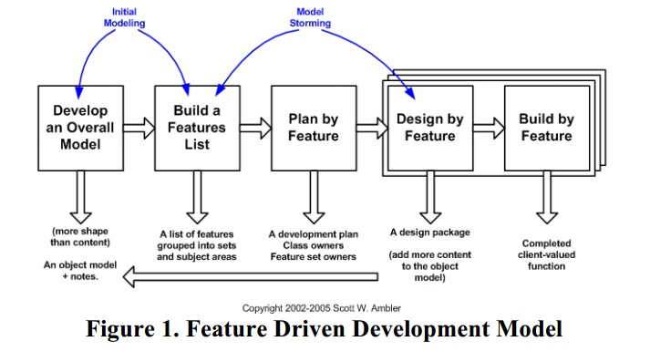

**Features:**

1. Learn to identify potholes & detect road conditions.

2. Infer when the user is driving.

3. Determine the 3-axis acceleration(how fast & in what direction is an object moving), and magnetic vectors using the accelerometer and magnetometer sensors in device.

4. Determine the geo-location of the user in real-time while driving using GPS.

5. Detect a braking event from sensed tri-axial (provides simultaneous measurements in three orthogonal directions)data obtained while the user was driving.

6. Detect a speed breaker from sensed tri-axial data obtained while the user was driving.

7. Use triggered sensing to save the users power

8. Send pothole, sensor data, and braking event data to a central web server.

9. Re-orient virtually, the device to minimize error in sensor data.

**Analysis of the Various Modules Involved**

**1. Sensing Module**

The Sensing module is central to the entire system, as its output is what the rest of the system acts on. This module is responsible for getting the needed parameters from the various sensors being used in the smart phone by the system such as the GPS coordinates from the GPS, the 3-axis acceleration values from the accelerometer.The magnetic vector from the magnetometer, Network information from radio sensors. The module is also for triggered sensing where the high power sensors are triggered only when the low power sensors needs to be complemented or when needed.

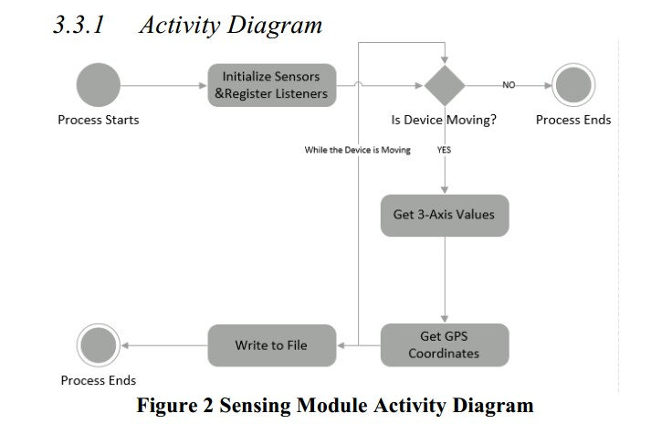

**2.** **Road Condition Detection Module**

The road condition detection module is where the actual prediction of the vehicle state is performed based on the real time sensor information that is passed to the learning module. The module is also responsible for providing input for the data aggregation module where all the data is stored, and works with the sensing module to enable geo-spatial information attached to the data.

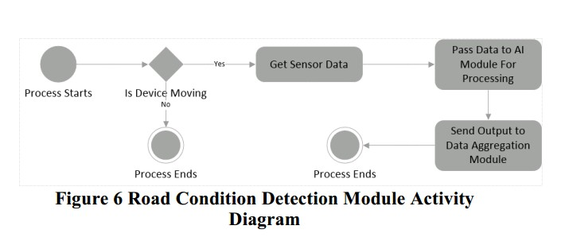

**3. Traffic Visualization Module**

Traffic Information Module Similar to the visualization module, the traffic information module gets data relating to traffic information (braking event data) from the road condition detection module and provides the user with information on real-time traffic using a heat map visualization(is a graphical representation of data where values are represented as colours)tool on the web app. The module also exposes an interface using REST for other applications to consume the data.

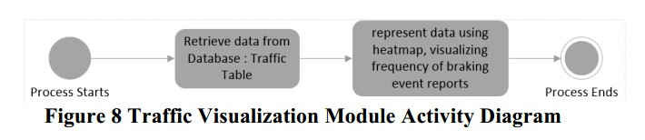

**4. Pothole Visualization Module**

The pothole prevention module is responsible for deriving value for the user that is, using the aggregated road condition data to visualize the state of road networks the user is interested in. This module controls the crowd map on the mobile and web applications using pothole data, and provides an interface for other exposing the data to other developers as well.

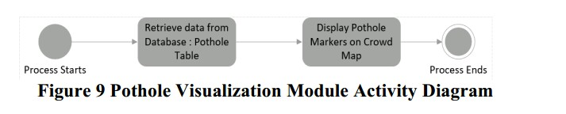

**5. Virtual Re-orientation Module**

The 3-axis parameters obtained from the accelerometer are largely affected by the angle of inclination or position of the device. As such, this can lead to errors in the values especially because users cannot be controlled over how or where to place their phones. Introducing the magnetometer, we would get the magnetic gravity vectors, which is then combined with the 3axis values and used to compute the correct orientation of the device, hence, the name “virtual” re-orientation. This module is responsible for carrying out the virtual re-orientation operation using the algorithm in the following subsection.

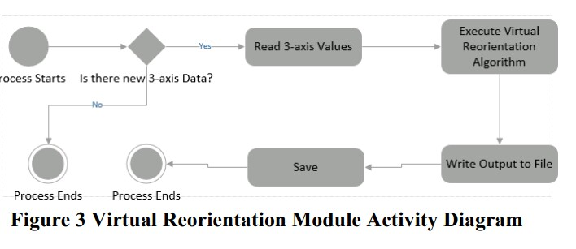

**Virtual Re-orientation Algorithm**

1. Get Rotation Matrix based on the gravity and magnetic vectors

2. Invert Rotation Matrix

3. Get Linear acceleration Vectors in Device coordinate system

4. Multiply Rotation Matrix by linear acceleration vector

**Threshold Computing Module**: The characteristic of the accelerometer data changes with environment configuration. In particular, the vehicle, the mobile device and the nature of the road affect the characteristics of the sensor data. Due to this variation in characteristic, the accuracy of the system with fixed thresholds would be lower when tested under different conditions. The threshold-computing module is responsible for determining the values that serves as boundary for the vehicle state being classified as a bump, pothole, braking event, or anomaly. As opposed to heuristics based approaches used in some previous research, the module uses K-means clustering algorithm to classify the incoming stream of accelerometer data into classes based upon the features present in the data itself, and produces an output that serves as an input for the Artificial learning module. This will make the classification more robust to changes in the environment.

**Artificial Learning Module**

This module is central to entire system as it is responsible for “learning” to identify road conditions using a supervised learning approach. The labeled data resulted from the threshold computing module, merged with the data from the sensing module is used train a SVM classifier. This trained SVM, in turn, is used to classify the data points that are generated during the test phase, and hence to predict the vehicle state in real-time while the user is driving. SVMs are supervised learning models that analyze data and recognize patterns. A special property is that they simultaneously minimize the empirical classification error and maximize the geometric margin; hence they are also known as maximum margin classifiers.

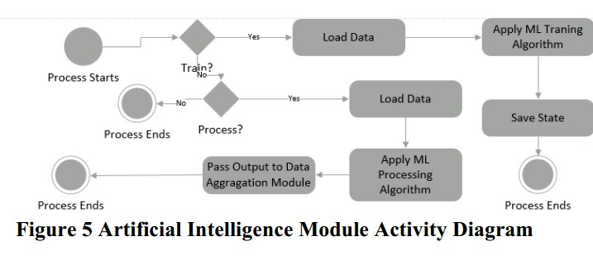

**6. Road Condition Detection Module**

The road condition detection module is where the actual prediction of the vehicle state is performed based on the realtime sensor information that is passed to the learning module. The module is also responsible for providing input for data aggregation module where all the data is stored, and works with the sensing module to enable geo-spatial information attached to data. 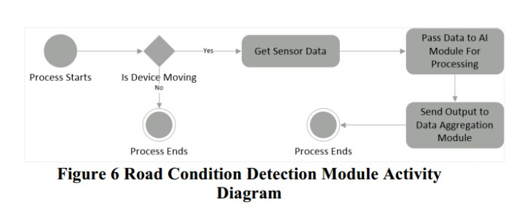

**7. Pothole Visualization/Prevention Module**

The pothole prevention module is responsible for deriving value for the user that is, using the aggregated road condition data to visualize the state of road networks the user is interested in. This module controls the crowd map on the mobile and web applications using pothole data, and provides an interface for other exposing the data to other developers as well.

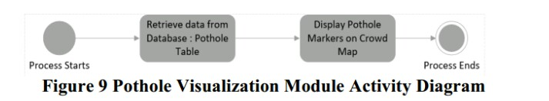

**8. Traffic Information Module**

Similar to the visualization module, the traffic information module gets data relating to traffic information (braking event data) from the road condition detection module and provides the user with information on real-time traffic using a heatmap visualization tool on the web app. The module also exposes an interface using REST for other applications to consume the data.

**9. Data Aggregation Module**

As the name implies, the data aggregation module serves as a warehouse for all the relevant data aggregated from various components of the system. Pothole, and Traffic, data are stored in a data store for easy retrieval. The data aggregation module. uses a backend service known as parse, which is an online data store accessed using REST API calls. 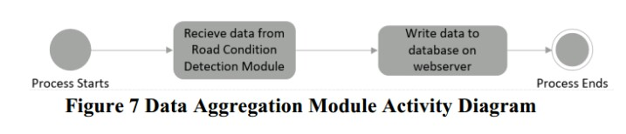

**CONCLUSIONS**

This project describes and implements a real-time pothole detection and traffic monitoring system, and has been able to harness Smartphone sensors to solve a global challenge, apply Machine learning to a real world problem and develop a scalable, reliable system driven by the power of crowdsourcing. The challenge embedded in transportation as detailed in the introduction leading to this research, has been shown to be significant. However as technology advances, and penetration. rises, such challenges are solvable with easily accessible tools as shown with the development of this system.

Recommendations for Future Work

Based on the work carried out in implementation of the real-automatic pothole detection and traffic monitoring system, the following recommendations are made:

• A larger and more representative test data must be collected to concretely evaluate such a system as this.

• It is needful to obtain traffic exposure data to accurately assess the current challenge of road traffic anomalies accidents.

• There is need to obtain correlation data between the transport sector and other sectors of the economy so as to accurately and figuratively describe the impact of road traffic anomalies and congestion has on the economy in general.

• A more efficient tool for representing traffic flow that could visualize traffic accurately on specific routes as opposed to the radial approach applied in this project should be developed. As with any body of work, a room for improvement does not cease to exist therefore, the researcher wishes that these recommendations would serve as a basis for further research especially in the area of road condition detection and traffic monitoring towards much improved techniques.

**REFERENCES**

**[1]**Bhoraskar, R., Vankadhara, N., Raman, B., & Kulkarni, P. (2012, January). Wolverine: Traffic and road condition estimation using smartphone sensors. InCOMSNETS (pp. 1-6).

**[2]** Chugh, G., Bansal, D., & Sofat, S. Road Condition Detection Using Smartphone Sensors: A Survey.

**[3]** Chen, K., Lu, M., Fan, X., Wei, M., & Wu, J. (2011, August). Road condition monitoring using on-board Three-axis Accelerometer and GPS Sensor. InCommunications and Networking in China (CHINACOM), 2011 6th International ICST Conference on (pp. 1032-1037). IEEE.

**[4]** Eriksson, J., Girod, L., Hull, B., Newton, R., Madden, S., & Balakrishnan, H. (2008, June). The pothole patrol: using a mobile sensor network for road surface monitoring. In Proceedings of the 6th international conference on Mobile systems, applications, and services (pp. 29-39).ACM.

**[5]** Feature Driven Development (FDD) and Agile Modeling. (n.d). In http://agilemodeling.com/

Retrieved January 13, 2015 from http://agilemodeling.com/essays/fdd.htm

**[6]** Gosling, J. (2000). The Java language specification. Addison-Wesley Professional.

**[7]** Hull, B., Bychkovsky, V., Zhang, Y., Chen, K., Goraczko, M., Miu, A., & Madden, S. (2006,

October). CarTel: a distributed mobile sensor computing system. In Proceedings of the 4th

international conference on Embedded networked sensor systems (pp. 125-138). ACM.

**[8]** K-means Clustering. (n.d.). In Wikipedia. Retrieved January 12, 2015, from http://en.wikipedia.org/wiki/K-means_clustering

**ACKNOWLEDGEMENT**

We would like to place on record our deep sense of gratitude to Prof. P.H.Durole, HOD-S.B.Kalyankar Sir Dept. of Computer Science and Engineering, Deogiri Institute of Engineering and management Studies Aurangabad, for his generous guidance, help and useful suggestions.

We express our sincere gratitude to Prof. P.H.Durole, Dept. of Computer Science and Engineering, Deogiri Institute of Engineering and management Studies Aurangabad, for his stimulating guidance, continuous encouragement and supervision throughout the course of present work.

We are extremely thankful to Dr.Ulhas Shiurkar Sir Director, Deogiri Institute of Engineering and management Studies Aurangabad, for providing us infrastructural facilities to work in, without which this work would not have been possible.

**Signature of Student**

Name of Student

Nikita Muthal (36119) Sign

Siddhi Gaud (36128) Sign