Marathwada Shikshan Prasarak Mandal’s

**Deogiri Institute of Engineering and Management Studies,**

**Aurangabad**

**Seminar Report**

**Motion Detection And Instant Alerter**

Submitted By **Kajal ramdas sandalse(36142)**

**Dr. BabasahebAmbedkar Technological University**

**Lonere (M.S.)**



Department of Computer Science and Engineering **(TNR-16)**

**Deogiri Institute of Engineering and Management Studies,**

**Aurangabad**

(2019- 2020)

**Seminar Report**

**On**

**Motion Detection And Instant Alerter**

Submitted By

**Kajal ramdas sandalse(36142)**

**In partial fulfillment of**

**Bachelor of Technology**

**(Computer Science & Engineering)**

Guided By

**Mr. Sanjay.P.Kalyankar**

Department of Computer Science & Engineering

**Deogiri Institute of Engineering and Management Studies,**

**Aurangabad**

(2019- 2020)

**CERTIFICATE**

This is to certify that, the Seminar entitled “**Motion Detection And Instant alerter**” submitted by Kajal Ramdas Sandalseis a bonafide work completed under my supervision and guidance in partial fulfillment for award of Bachelor of Technology (Computer Science and Engineering) Degree of Dr. BabasahebAmbedkar Technological University, Lonere.

Place: Aurangabad

Date:17-10-19

**Mr S.B. Kalyankar Mr. S.B Kalyankar**

**Guide Head**

**Dr. Ulhas D. Shiurkar**

**Director,**

**Deogiri Institute of Engineering and Management Studies,**

**Aurangabad**

###### Contents

1. **INTRODUCTION** 
   1. Introduction

1. **LITERATURE SURVEY**

1. **Brief on System**

3.1 Existing System

3.2 Proposed System

**4. CONCLUSIONS**

4.1 Conclusion

4.2 Application

1. **REFERENCES**

1. **ACKNOWLEDGEMENT**

**Motion Detection And Instant Alerter**

***Abstract***

In surveillance, CCTV camera is costly because of the use of computer. It reserves too much space for continues recording and also require manpower to detect the unauthorized Activity. But compared to the existing system Raspberry pi system is much cheaper with better resolution and low power consumption feature. Here pyroelectric infrared (PIR) sensors are used as a simple but powerful people presence triggers. This system is suitable for small personal area surveillance. i.e. personal office cabin, bank locker room, parking entrance. Whenever the motion is detected through PIR sensor inside the room the image is captured through camera and temporarily stored in the raspberry pi module. Internet of things based application can be used remotely to view the activity and get notifications when motion is detected. System works standalone without the PC once programmed. One android Application is used to get the notification on motion detection.

**Introduction**

Starting from small houses to huge industries, surveillance plays very vital role to fulfill our safety aspects as Burglary and theft have always been a problem. In big industries personal security means monitoring the people’s changing information like activities, behavior for the purpose of protecting, managing and influencing confidential details. Surveillance means watching over from a distance by means of electronic equipment such as CCTV cameras but it is costly for normal residents to set up such kind of system and also it does not inform the user immediately when the burglary happens.

Internet of things (IOT) is a concept that is a going development of the internet by which everyday 'things' objects have communication capabilities which allow them to send and receive data through connections wireless or wired and unique addressing schemes to create new applications/services and reach common goal. In particular, IOT is a new paradigm in computer science that aims at exploiting the information about the environment state in order to personalize it, that is to adapt the environment to the user preferences. The goal of the IOT is to enable everything to be connected at anytime, anyplace, with anything ideally using network. IOT technology can be created a new idea and wide development space for smart houses to provide intelligence and to improve the quality of life IOT based application can be used remotely to view the activity and get notification when motion is detected. Several applications will be presented, which are important to envisage some of the potential IOT. Some of these applications are: smart cities, smart energy, smart grid, agriculture and breeding, and pharmaceutical industry To integrate IOT in security systems to detect motion, for example every day when we are at work you will be able to monitor and get notifications if any activity happens at your home. There is no need to have machines at both ends to get the desired output thus, for home users this project will prove to be of great use as it has low energy consumption and also comes at a low cost. Also, enhancing the capabilities of these technologies and integrating them, by introducing the 'Motion Detection' system and to contribute to the current security system

In literature [4] an IOT based system and its advantages are explained which uses email notification and cloud to store data, literature [5] discussed about remote image data transfer to android device with wireless LAN but with limited distance constrain.

The limitation of CCTV cameras is discussed in [6] while the real time systems provide an immediate response for crime detection and the prevention. The main principle of network remote video surveillance system based on embedded system as discussed in literature [7] is to set an embedded web server at the video surveillance terminal. The video signal should be

**USB Camera** digitized first, then compressed by the high compression chip and finally is sent to the built-in web server.

In literature [8] power management is explained in sensor base system. The continuous monitoring of the videos is not required as discussed in [9] where the video frames were compared with a template image. While comparing if any intrusion is detected then the authorized person is notified via GSM which include one extra hardware in system and make is costlier.[10] talks about performance evolution of PIR sensor of deployment schemes, evaluated in a Java based simulation environment. They operate autonomously in unattended environments. And literature [11] suggests system, captures video, shares among networked systems and also alerts the controlling person with short message service. This [12] considers visual transporting, storing, raising, using and connecting object with internet.

**3. PROPOSED WORK**

The aim is to make a smart surveillance system which can be monitored by owner remotely through android application. As it is connected with the system with IOT, system will send the push notification to android device when an intrusion is detected inside the room. It is required to develop and implement and affordable low cost web-camera based surveillance system for remote security monitoring. Authorized user can access to their monitoring system remotely via internet with the use a mobile phone and monitor the situation on application. This entire work is done on raspberry pi with Raspbian operating system ported on it.

Surveillance System consists of mainly two parts:

A. Hard-wired surveillance systems: These systems use wires to connect the cameras, motion detectors, power supply and LAN cable with the pi.

B. Remote Access Systems: These systems have the capability to monitor and control a security system from a location away from the surveillance area through android device.

**System Development :-**

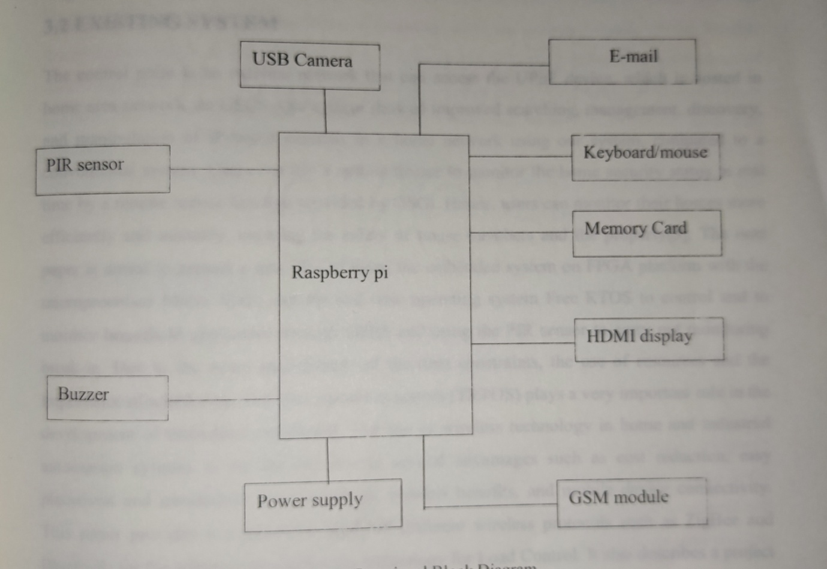

**Existing system :-**

The control point is an extrernal network that can access the UPnP device, which is hosted in home area network via USCS. Our system showed improved searching,management,discovery, and manipulation of IP-based cameras in a home network using our system, compared to a conventional system Users can use a mobile device to a monitor the home security status in real time by remote access function provided by OSGi.Hence,users can monitor their homes more efficiently and instantly,ensuring the safety of house members and the property. The next paper is aimed to present a new idea of using the embedded system on FGPA platform with the microprocessor Micro Blaze and the real time operating system (TRTOS)plays a very important role in the development of embedded systems.

**Hardware rwquirements:-**

* **Rasberry pi**
* **PIR Sensor**
* **Buzzer**
* **GSM**

**Raspberrypi:-**   
The Raspberry Pi just got juicer! Now with a Quad-Core 64bit CPU, WiFi & Bluetooth!

The Raspberry Pi 3 Model B is the third generation Raspberry Pi. This powerful credit-card sized single board computer can be used for many applications and supersedes the original Raspberry Pi Model B+ and Raspberry Pi 2 Model B.

Whilst maintaining the popular board format the Raspberry Pi 3 Model B brings you a more powerful processor, 10x faster than the first generation Raspberry Pi.

Additionally it adds wireless LAN & Bluetooth connectivity making it the ideal solution for powerful connected designs.

**Raspberry Pi 3 - Model B Technical Specification**

* Broadcom BCM2387 chipset
* **1.2GHz Quad-Core ARM Cortex-A53**
* **802.11 bgn Wireless LAN and Bluetooth 4.1** (Bluetooth Classic and LE)
* **1GB RAM**
* **64 Bit CPU**
* 4 x USB ports
* 4 pole Stereo output and Composite video port
* Full size HDMI
* 10/100 BaseT Ethernet socketbr
* CSI camera port for connecting the Raspberry Pi camera
* DSI display port for connecting the Raspberry Pi touch screen display
* Micro SD port for loading your operating system and storing data
* Micro USB power source

**Raspberry Pi 3 - Model B Features**

* + Now **10x Faster** - Broadcom BCM2387 ARM Cortex-A53 Quad Core Processor powered Single Board Computer running at 1.2GHz!
  + 1GB RAM so you can now run bigger and more powerful applications
  + Fully HAT compatible
  + 40pin extended GPIO to enhance your “real world” projects.
  + Connect a Raspberry Pi camera and touch screen display (each sold separately)
  + Stream and watch Hi-definition video output at 1080
  + Micro SD slot for storing information and loading your operating systems.
  + 10/100 BaseT Ethernet socket to quickly connect the Raspberry Pi to the Internet

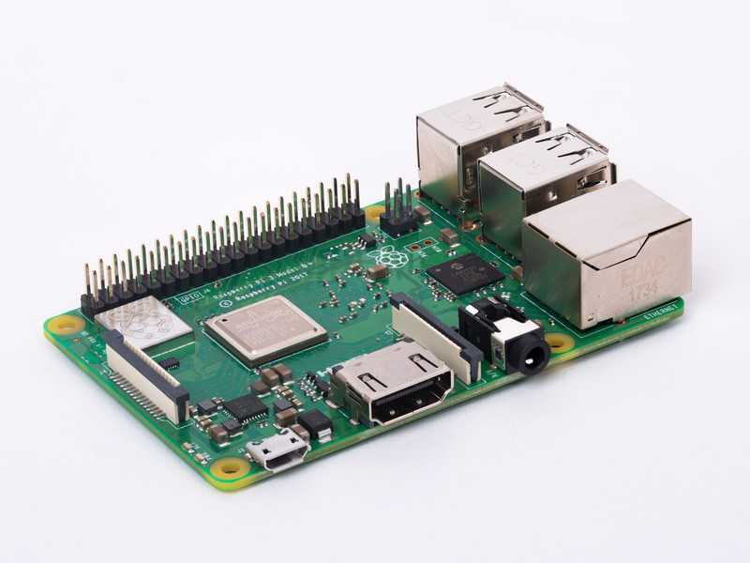

**Pir sensor:-**

PIR sensor detects a human being moving around within approximately 10m from the sensor. This is an average value, as the actual detection range is between 5m and 12m.PIR are fundamentally made of a pyro electric sensor, which can detect levels of infrared radiation. For [numerous essential projects](http://www.efxkits.com/) or items that need to discover when an individual has left or entered the area. PIR sensors are incredible, they are flat control and minimal effort, have a wide lens range, and are simple to interface with.

Most PIR sensors have a 3-pin connection at the side or bottom. One pin will be ground, another will be signal and the last pin will be power. Power is usually up to 5V. Sometimes bigger modules don’t have direct output and instead just operate a relay which case there is ground, power and the two switch associations. Interfacing PIR with microcontroller is very easy and simple. The PIR acts as a digital output so all you need to do is listening for the pin to flip high or low. The motion can be detected by checking for a high signal on a single I/O pin. Once the sensor warms up the output will remain low until there is motion, at which time the output will swing high for a couple of seconds, then return low. If motion continues the output will cycle in this manner until the sensors line of sight of still again. The PIR sensor needs a warm-up time with a specific end goal to capacity fittingly. This is because of the settling time included in studying nature’s domain. This could be anyplace from 10-60 seconds.

**USB Camera:-**

USB Cameras is a camera that feeds or streams its image in real time to or through a computer to a computer network. It’s imaging cameras that use USB technology (USB 2.0 or 3.0) to transfer image data. It designed to easily interface with computer systems by using the same USB technology that is found on most computers. Fig. 3 shows USB camera that low manufacturing cost and their high flexibility, making them the lowest-cost. Used a standard USB webcam to take pictures and video on the raspberry pi connected by a USB cable, or similar cable, when "captured" by the raspberry pi, the pictures and video are saved or sent to other networks via systems such as the internet, and emailed as an attachment.



**Buzzer:-**

The **piezo buzzer** produces sound based on reverse of the piezoelectric effect. The generation of pressure variation or strain by the application of electric potential across a piezoelectric material is the underlying principle. These buzzers can be used alert a user of an event corresponding to a switching action, counter signal or sensor input. They are also used in alarm circuits.

The buzzer produces a same noisy sound irrespective of the voltage variation applied to it. It consists of piezo crystals between two conductors. When a potential is applied across these crystals, they push on one conductor and pull on the other. This, push and pull action, results in a sound wave. Most buzzers produce sound in the range of 2 to 4 kHz.

The Red lead is connected to the Input and the Black lead is connected to Ground.

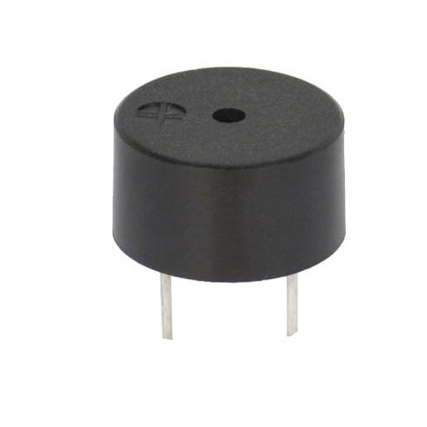

**Gsm:-**

GSM is a mobile communication modem; it is stands for global system for mobile communication (GSM). The idea of GSM was developed at Bell Laboratories in 1970.  It is widely used mobile communication system in the world. GSM is an open and digital cellular technology used for transmitting mobile voice and data services operates at the 850MHz, 900MHz, 1800MHz and 1900MHz frequency bands.

GSM system was developed as a digital system using time division multiple access (TDMA) technique for communication purpose. A GSM digitizes and reduces the data, then sends it down through a channel with two different streams of client data, each in its own particular time slot. The digital system has an ability to carry 64 kbps to 120 Mbps of data rates.

There are various cell sizes in a GSM system such as macro, micro, pico and umbrella cells. Each cell varies as per the implementation domain. There are five different cell sizes in a GSM network macro, micro, pico and umbrella cells. The coverage area of each cell varies according to the implementation environment.

**Time Division Multiple Access**

TDMA technique relies on assigning different time slots to each user on the same frequency. It can easily adapt to data transmission and voice communication and can carry 64kbps to 120Mbps of data rate.

**GSM Architecture**

A GSM network consists of the following components:

* **A Mobile Station:**  It is the mobile phone which consists of the transceiver, the display and the processor and is controlled by a SIM card operating over the network.
* **Base Station Subsystem:** It acts as an interface between the mobile station and the network subsystem. It consists of the Base Transceiver Station which contains the radio transceivers and handles the protocols for communication with mobiles. It also consists of the Base Station Controller which controls the Base Transceiver station and acts as a interface between the mobile station and mobile switching centre.
* **Network Subsystem:** It provides the basic network connection to the mobile stations. The basic part of the Network Subsystem is the Mobile Service Switching Centre which provides access to different networks like ISDN, PSTN etc. It also consists of the Home Location Register and the Visitor Location Register which provides the call routing and roaming capabilities of GSM. It also contains the Equipment Identity Register which maintains an account of all the mobile equipments wherein each mobile is identified by its own IMEI number. IMEI stands for International Mobile Equipment Identity.

**Features of GSM Module:**

* Improved spectrum efficiency
* International roaming
* Compatibility with integrated services digital network (ISDN)
* Support for new services.
* SIM phonebook management
* Fixed dialing number (FDN)
* Real time clock with alarm management
* High-quality speech
* Uses encryption to make phone calls more secure
* Short message service (SMS)

The security strategies standardized for the GSM system make it the most secure telecommunications standard currently accessible. Although the confidentiality of a call and secrecy of the GSM subscriber is just ensured on the radio channel, this is a major step in achieving end-to- end security.

**Software requirement :-**

**Programming language :** python

**SYSTEM WORKING :-**

The raspberry pi is powered by a 5V micro USB supply after the installation of rasberian. When all the hardware which is PIR sensor , camera , module, LED , buzzer have been attached to the raspberry pi and camera module has been activated. Python will be run. The system is tested when there is any motion or change in infrared radiation sensor will bw triggered camera module captured the image, the LED will be “ON” and the buzzer will be produce an alarm sound the system then started sending an EMAIL to the user to notify when the Email has been successfully sent, the LED and buzzer will “off” and stop producing alarm sound .

**Advantages:-**

It offers privacy on both sides since it is being viewed by only one person

It is a simple circuit. The operating system used here is Raspbian OS.

systems. It is simple to implement, small size portable stand-alone device with its own power source, energy capable with instantaneous alert, truly cheap for residential and personal use.

this can be used or can prove useful to a project targeting security setup which is limited to specific location to monitor properties and assets from a separate location.

**Disadvantages:-**

Radio frequency at high power is harmful for humans

Any kind of moving object can trigger the PIR sensor type.

It requires lot of memory.

Application :-

Internet of household where we can attach other devices of house with internet

Industrial automation and control through internet

Improvement in the security issues in highly re-stricted area

**Future Scope:-**

There will be remote for the controlling

Power on facility will be through the remote

Power saving facility will be available

In the fiture the user can be provided a remote access to this software from some remote pc through internet.

Conclusion:

The smart surveillance system has been aimed to design in such a way that it can fulfil the needs of the user for particular surveillance area. It has countless applications and can be used in different environments and scenarios. For instance, at one scenario it can be used by any person working in industry to be aware of the activity being happened at their own working places, in their absence, while at another instance it can be used for spy purposes at bank lockers, storage houses. Another application is to provide information to the user about what is happening in surveillance area by notification.

**References:-**

[1][***www.ijais.org***](http://www.ijais.org)

[***www.iosr.org***](http://www.iosr.org)

[***www.ijoar.org***](http://www.ijoar.org)

**ACKNOWLEDGEMENT**

I would like to place on record my deep sense of gratitude to Prof. SB kalynkar sir, HOD-Dept. of Computer Science and Engineering, Deogiri Institute of Engineering and management Studies Aurangabad ,for his generous guidance, help and useful suggestions.

I express my sincere gratitude to Prof. P.H.Durole, Dept. of Computer Science and Engineering, Deogiri Institute of Engineering and management Studies Aurangabad, for his stimulating guidance, continuous encouragement and supervision throughout the course of present work.

I am extremely thankful to Dr Ulhas Shiurkar, Director, Deogiri Institute of Engineering and management Studies Aurangabad, for providing me infrastructural facilities to work in, without which this work would not have been possible.