TEACHING MANUAL: BASICS OF MANAGEMENT (EEVOE 303)
Unit 1: Introduction to Management Target Audience: Final Semester Diploma Students (Himachal Pradesh) Instructor Profile: Expert Management Faculty (10+ Years Experience)

UNIT 1 OVERVIEW
- Duration: 16 Lectures
- Focus: Core definitions, functions, and structures of management.
- Context: Tailored for future Junior Engineers (JEs), Supervisors, and Entrepreneurs in HP.

LECTURE 1: Course Orientation & Overview
Topic: Course Orientation and Overview of Management

1. Learning Outcomes
- Explain the course structure and assessment scheme.
- Articulate why management skills are critical for diploma engineers in workplaces like PWD, IPH, or industry hubs (Baddi/Nalagarh).

2. Teacher’s PPT Outline
- Slide 1: Title: Basics of Management. Quote: "Technical skill gets you the job; Management skill gets you promoted."
- Slide 2: Syllabus Overview (5 Units).
- Slide 3: The "Himachal Engineer" Context – Why do JEs need management?
- Slide 4: Assessment: Internal Exams, Quizzes, Final Board Exam.

3. Detailed Lecture Notes
Introduction to the Subject: Welcome to your final semester. You are all skilled in your technical trades—whether Electrical, Civil, or Mechanical. But imagine this scenario:
- You are appointed as a Junior Engineer (JE) in the PWD in a remote area like Kaza or Pangi.
- A landslide has blocked the road.
- Technical Skill: You know how to repair the road.
- Management Skill: You need to arrange the JCB machine, manage 20 laborers, ensure they have food and safety gear, and report progress to the SDO. Without management, your technical knowledge cannot be applied.
Why this Course? For diploma students, the career path usually starts at the Supervisory Level. You are the bridge between the workforce (labor/technicians) and the management (XEN/Managers). This course teaches you how to cross that bridge effectively.

4. Assessment Bank
- Short Question: Why is management considered a "life skill" rather than just a "business skill"?

LECTURE 2: Meaning and Definitions of Management
Topic: Meaning and Definitions of Management

1. Learning Outcomes
- Define management using standard definitions.
- Identify goals, people, and resources as key elements.
- Distinguish Management from Administration.

2. Detailed Lecture Notes
Definition: Management is "The art of getting things done through others." It is the process of planning, organizing, staffing, directing, and controlling resources to achieve organizational goals.
Key Elements:
- Goals: Every management effort has a target. (e.g., A Gram Panchayat aims to build a concrete path in 3 months).
- Resources: Men (Workforce), Money (Budget), Material (Cement/Sand), Machine (Mixers), Methods.
- Process: It is continuous, not a one-time act.
Management vs. Administration:
- Administration (The Brain): Sets the policies and objectives.
  - Example: The HP State Government decides to build a new medical college in Hamirpur. This is Administration.
- Management (The Hands): Executes the policy.
  - Example: The Project Manager and engineers at the construction site ensuring the college is built on time. This is Management.

3. Activity: "The Village Fair"
- Scenario: Your village is organizing a "Devta Mela".
- Discussion: Who is the Administrator? (The Temple Committee/Panchayat deciding the date). Who is the Manager? (The youth club head organizing the stalls and traffic).

4. Assessment Bank
- MCQ: Administration is primarily concerned with: a) Doing the work b) Formulating policy [Correct] c) Supervising workers d) Repairing machines

LECTURE 3: Nature and Characteristics of Management
Topic: Nature and Characteristics of Management

1. Learning Outcomes
- Describe management as a process, art, and science.
- List characteristics: Goal-oriented, Universal, Continuous.

2. Detailed Lecture Notes
Nature of Management:
- As a Science: It has fixed principles. (e.g., If you pay workers fair wages, motivation increases. This is a tested principle).
- As an Art: It requires personal skill. (e.g., Handling a strike in the Barmana Cement Plant requires negotiation skills that come from experience, not just books).
Characteristics:
- Universal: Management applies everywhere—from a shop in Mall Road Shimla to the HRTC Bus Depot.
- Goal-Oriented: Without a goal, management is useless.
- Continuous: It never stops. Once the apple harvest is managed, the pruning management begins.
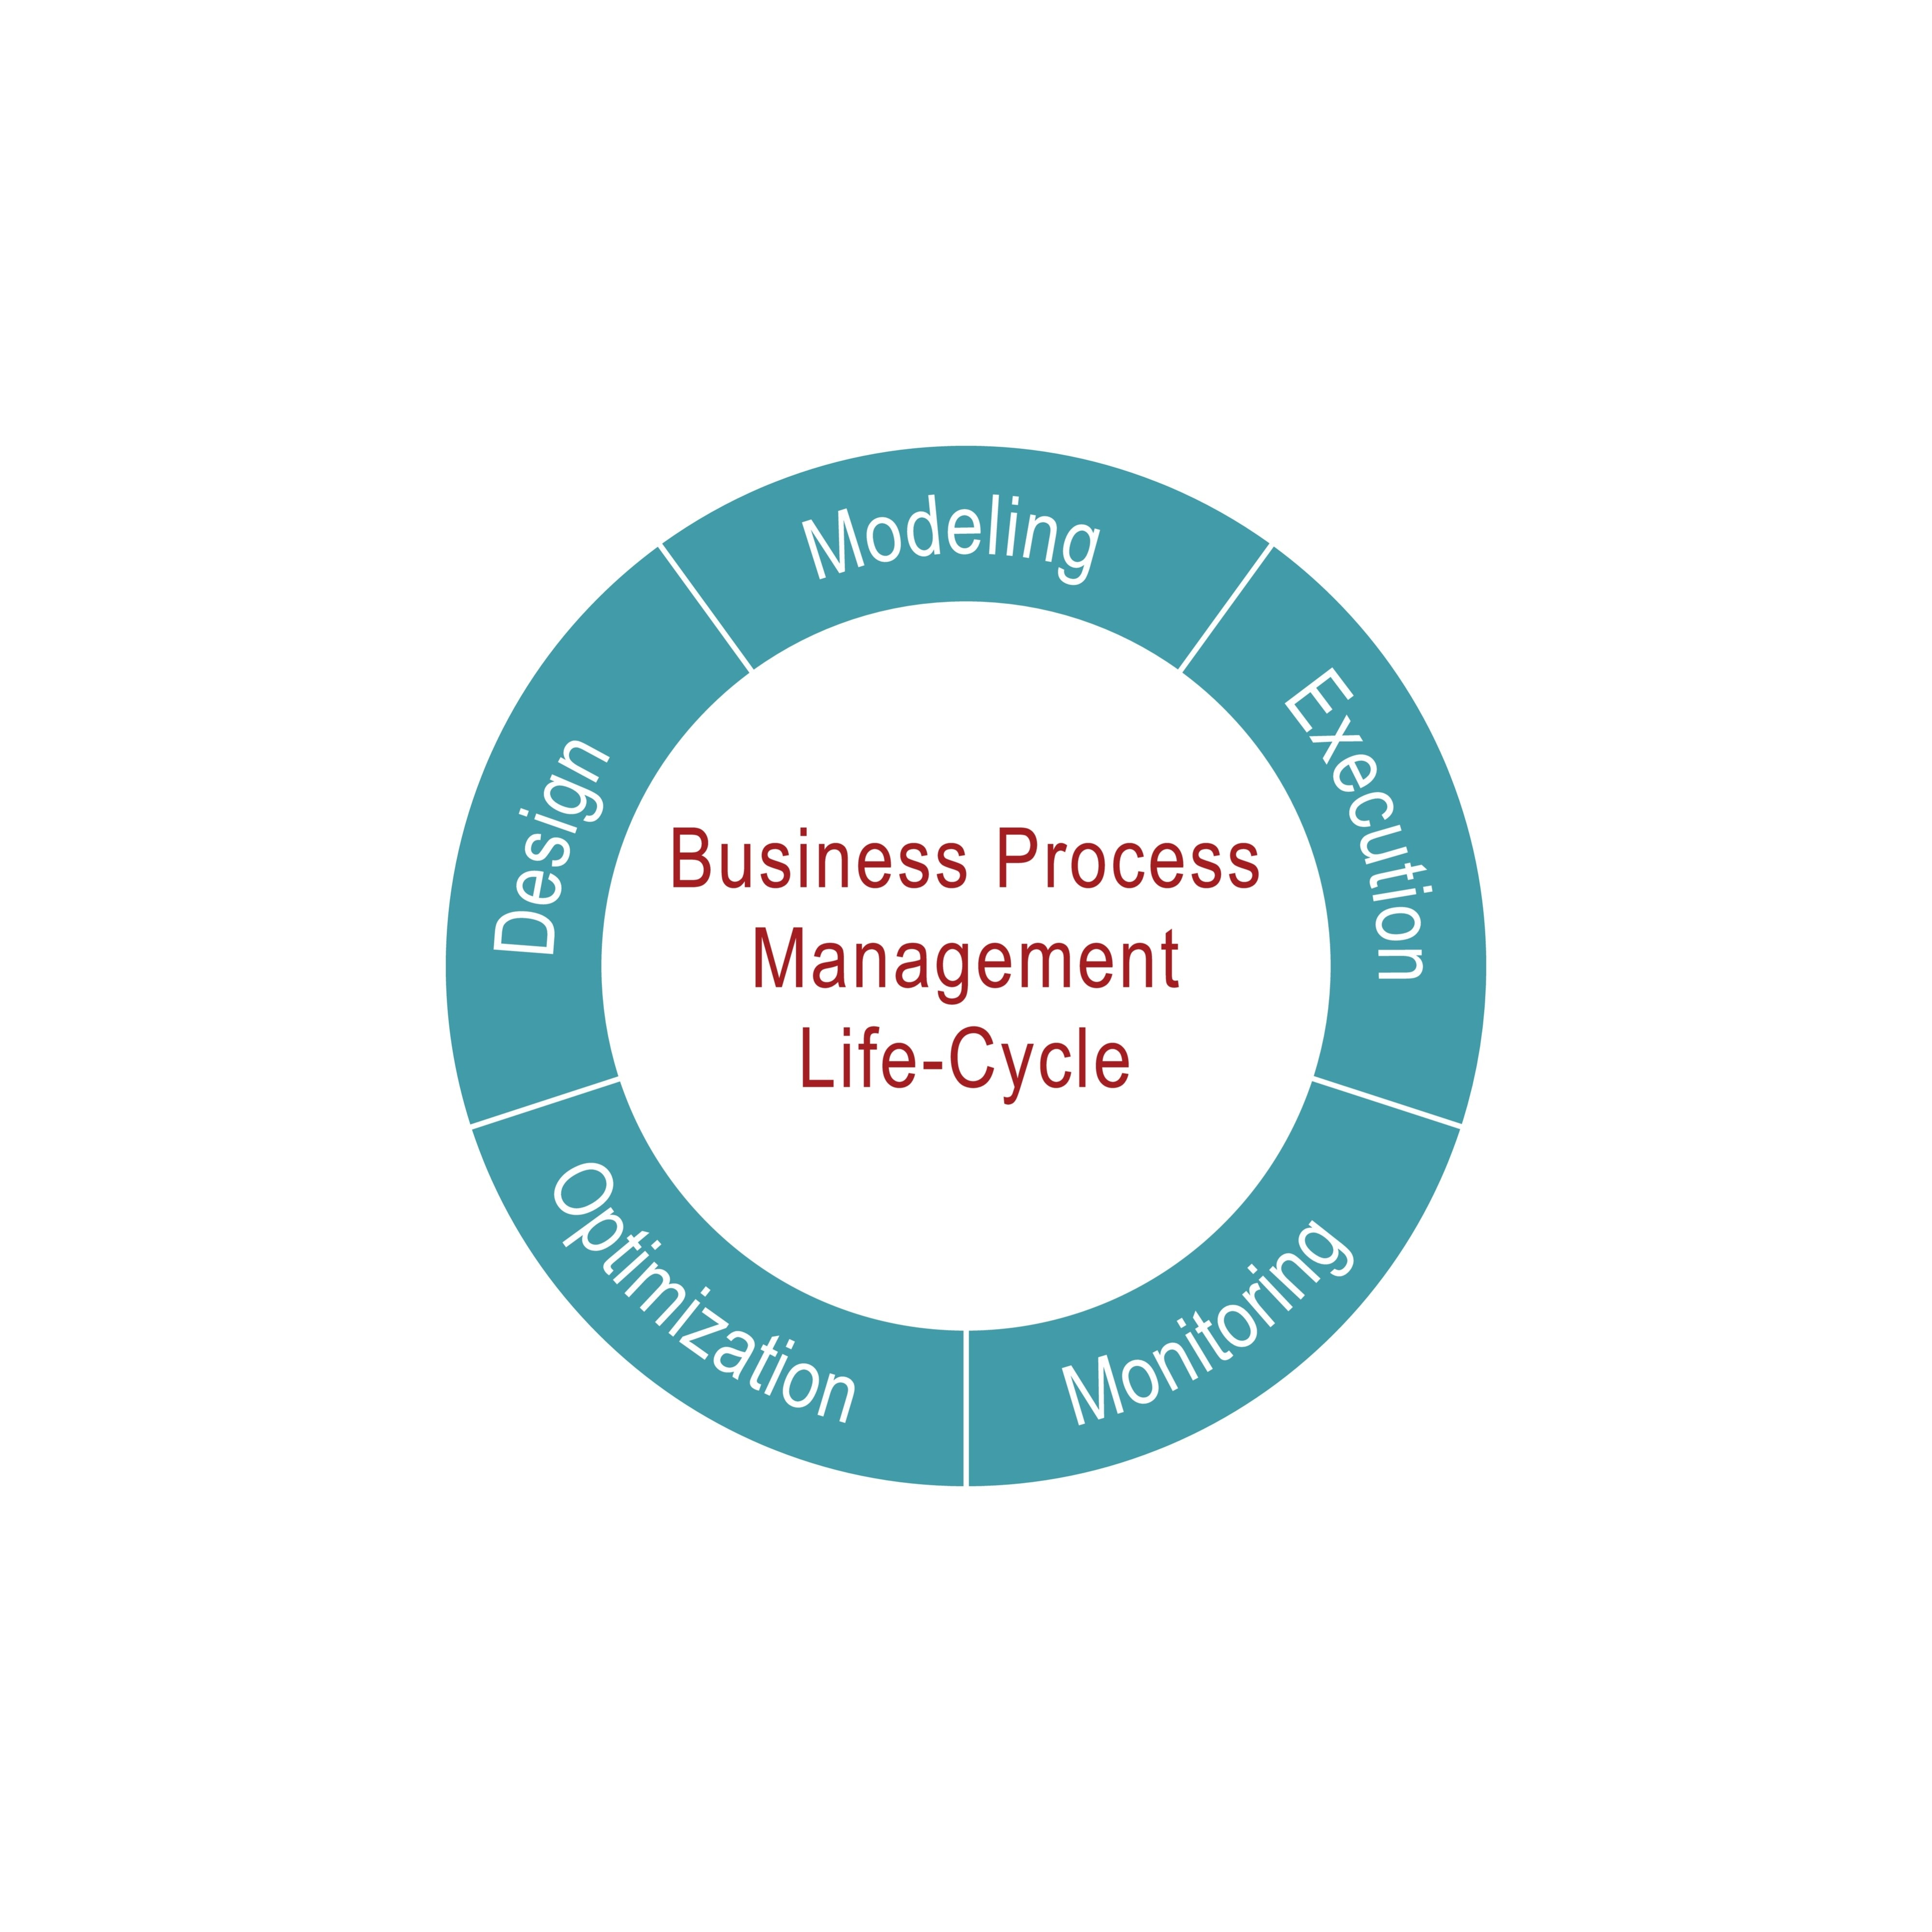
Shutterstock

3. Assessment Bank
- Short Question: Explain why management is called "Universal".

LECTURE 4: Levels and Roles of Management
Topic: Levels and Roles of Management

1. Learning Outcomes
- Differentiate top, middle, and lower-level management.
- Discuss skill requirements (Conceptual, Human, Technical).

2. Teacher’s PPT Outline
- Slide 1: Pyramid Diagram of Levels.
- Slide 2: Top Level (Strategic).
- Slide 3: Middle Level (Tactical).
- Slide 4: Lower Level (Operational).
- Slide 5: Skills required at each level.

3. Detailed Lecture Notes
The Hierarchy (The Pyramid):
- Top Level: Board of Directors, CEO, MD.
  - Role: Vision and Policy.
  - HP Context: The Managing Director of HPSEB (Electricity Board) sitting in Shimla. He decides "We will electrify 100% of remote villages."
- Middle Level: Department Heads, XEN (Executive Engineers).
  - Role: Execution and Coordination.
  - HP Context: The XEN in Mandi district. He receives the order and instructs the SDOs.
- Lower Level: Supervisors, Junior Engineers (JE), Foremen.
  - Role: Direct supervision of work.
  - HP Context: You (The JE) standing in the village ensuring the poles are erected correctly.
Skills Required:
- Technical Skills: High for Lower Level (You need to know how the transformer works).
- Human Skills: Essential for ALL levels (Dealing with people).
- Conceptual Skills: High for Top Level (Seeing the big picture).

4. Assessment Bank
- MCQ: Junior Engineers belong to which level of management? a) Top b) Middle c) Lower/Operational [Correct] d) Administrative

LECTURE 5: Principles of Management (Classical Views)
Topic: Principles of Management

1. Learning Outcomes
- Explain Fayol’s Principles (Division of Work, Authority, Unity of Command).
- Relevance in modern organizations.

2. Detailed Lecture Notes
Henry Fayol’s 14 Principles (Focus on Key 5):
- Division of Work: Specialization increases efficiency.
  - Example: In an apple orchard, one group picks apples, another grades them, and the third packs them. If one person does all three, speed drops.
- Unity of Command: One employee should have only one boss.
  - Example: If a worker gets orders from the Contractor and the JE simultaneously, and the orders conflict, the work stops.
- Authority & Responsibility: If you give a person responsibility, you must give them authority.
  - Example: You are responsible for fixing a fault, but you don't have the authority to issue spare parts from the store. You cannot succeed.
- Discipline: Essential for safety, especially in industries like Hydro Projects.
- Esprit de Corps: Team Spirit. "Union is Strength."

3. Assessment Bank
- Long Question: Explain the principle of "Unity of Command" with a diagram. What happens if this principle is violated?

LECTURE 6: Management Process and Functions: Overview
Topic: Management Process and Functions

1. Learning Outcomes
- Draw the management process cycle.
- Briefly explain P-O-S-C-C (Planning, Organizing, Staffing, Coordinating, Controlling).

2. Detailed Lecture Notes
The Management Cycle (P-O-S-C-C):
- Planning: Deciding in advance what to do. (The Blueprint).
- Organizing: Arranging resources to do it. (The Structure).
- Staffing: Putting people in the structure. (The Hiring).
- Coordinating: Ensuring everyone works together. (The Harmony).
- Controlling: Checking if things went according to plan. (The Check).
Analogy: Building a House in Kangra.
- Plan: The architect's map.
- Organize: Ordering bricks, sand, slate for the roof.
- Staff: Hiring the mason (mistri) and laborers.
- Coordinate: Ensuring the electrician comes only after the walls are ready.
- Control: Checking if the walls are straight and within budget.

LECTURE 7-8: Planning & Types of Plans
Topic: Planning: Concept, Importance, Types, and Steps

1. Learning Outcomes
- Define planning and types (Strategic, Tactical, Operational).
- Types of plans: Rules, Budgets, Strategies.
- Steps in Planning.

2. Detailed Lecture Notes
What is Planning? "Thinking before doing." It bridges the gap between where we are and where we want to go.
Types of Plans:
- Rule: Strict guide. Ex: "No Smoking in the Transformer Room."
- Procedure: Chronological steps. Ex: Procedure to apply for a Driving License in HP.
- Budget: Statement of expected results in numbers/rupees. Ex: Cost estimation for a college trip to Manali.
- Policy: General guide. Ex: "We hire local youth first."
Steps in Planning:
- Define Objective.
- Gather Information (Premising).
- Identify Alternatives (Option A, B, C).
- Evaluate and Select the Best Option.
- Implement and Follow-up.

3. Activity: "Plan a Trip"
- Task: Students work in groups to plan a class trip to Dharamshala.
- Deliverable: They must produce a "Budget Plan" and a "Schedule/Procedure".

4. Assessment Bank
- MCQ: A budget is a plan expressed in: a) Words b) Numerical terms [Correct] c) Pictures d) Legal terms

LECTURE 9-11: Organizing & Structures
Topic: Organizing Concept, Structures (Line, Functional), Span of Control

1. Learning Outcomes
- Explain organizing and division of labor.
- Distinguish Line, Functional, and Line & Staff structures.
- Span of Control.

2. Detailed Lecture Notes
Concept: Organizing is creating a structure of roles. Who reports to whom?
Types of Structures:
- Line Organization: Oldest, simplest. Direct vertical flow of authority.
  - Structure: GM -> Manager -> Supervisor -> Worker.
  - Usage: Small workshops, Military.
- Functional Organization: Based on specialization.
  - Structure: Works Manager -> Production Boss / Quality Boss / Maintenance Boss -> Worker.
  - Usage: Modern factories in Baddi.
- Line and Staff:
  - Line: Doers (Production).
  - Staff: Advisors (Legal, HR).
Span of Control: How many subordinates can a superior effectively manage?
- Narrow Span: Strict control (e.g., 1 JE managing 5 specialized technicians).
- Wide Span: Loose control (e.g., 1 Supervisor managing 40 unskilled laborers carrying soil).

LECTURE 12: Staffing
Topic: Staffing: Concept and HR Activities

1. Learning Outcomes
- Define staffing.
- List HR activities: Recruitment, Selection, Training.

2. Detailed Lecture Notes
Definition: "Filling and keeping filled the positions in the organization structure."
The Staffing Process:
- Manpower Planning: Estimating how many people are needed. (e.g., "We need 50 extra workers for the apple season").
- Recruitment: Searching for candidates. (e.g., Advertising in 'The Tribune' or local WhatsApp groups).
- Selection: Choosing the best. (Interview/Test).
- Training: Teaching them skills. (e.g., Training a new driver on hill roads).
- Performance Appraisal: Checking their work at year-end.

LECTURE 13: Coordinating
Topic: Coordinating: Concept and Techniques

1. Learning Outcomes
- Explain coordination as synchronization.
- Techniques: Meetings, Committees, Communication.

2. Detailed Lecture Notes
Analogy: An Orchestra. The drummer, guitarist, and singer must coordinate. If they play at different speeds, it’s noise, not music. Relevance: In a project, the Civil team must finish the foundation before the Mechanical team installs the machine. Techniques:
- Weekly Review Meetings.
- Standard Operating Procedures (SOPs).
- Clear Communication channels.

LECTURE 14: Controlling
Topic: Controlling: Meaning, Steps and Application

1. Learning Outcomes
- Define controlling.
- Steps: Standards -> Actuals -> Comparison -> Correction.

2. Detailed Lecture Notes
Definition: Compelling events to conform to plans. It is looking back to ensure the future is on track.
The Control Process (Example: Road Construction):
- Set Standard: "We must lay 1km of road per week."
- Measure Actual: "This week we did only 600m."
- Compare: "Deviation of -400m."
- Analyze Cause: "Heavy rain stopped work for 2 days."
- Corrective Action: "Work overtime next week to catch up."

LECTURE 15: Areas/Functions of Management
Topic: Marketing, Finance, HR, Production

1. Learning Outcomes
- Briefly describe the 4 pillars of management.

2. Detailed Lecture Notes
- Production Management: Converting raw material to finished goods. (Factory floor).
- Financial Management: Managing money. (Sources of funds, profit usage).
- Marketing Management: Selling the product. (Advertising, Sales).
  - Example: HPMC marketing apple juice to tourists.
- Human Resource (HR) Management: Managing people. (Hiring, Welfare).

LECTURE 16: Unit 1 Recap and Integrated Case Study
Topic: Integrated Case Study

1. Case Study: "The Delayed Bridge"
Context: A small bridge project in a village near Chamba. Scenario: The project is delayed by 6 months.
- Observation 1: Materials often run out because they are ordered late. (Failure of Planning).
- Observation 2: The Site Engineer fights with the Contractor openly. (Failure of Coordinating).
- Observation 3: 50 workers are supervised by one inexperienced trainee. (Failure of Organizing/Span of Control).
Student Questions:
- Identify the management functions that have failed in this project.
- As a new Project Manager, what is your first step to fix the "Material Shortage" issue? (Answer: Better Planning/Inventory Control).
- Suggest a better organizational structure for the site.

2. Unit 1 Assessment (Sample)
- Q1: Define Management. (2 Marks)
- Q2: List the 5 functions of management. (5 Marks)
- Q3: Explain the difference between "Line" and "Functional" organization with a diagram. (10 Marks)

