WEEK 1 PROJECT REPORT
Data Cleaning and Preliminary Analysis with R
Virtual R Data Analyst Internship | Week 1

1. Introduction
This report demonstrates a complete beginner-friendly data-cleaning and exploratory-analysis workflow using R. The Iris dataset is a well-known publicly available dataset originally collected by Ronald Fisher and distributed with R in the datasets package. It contains 150 observations across three iris species (setosa, versicolor, virginica) and four numeric flower measurements: sepal length, sepal width, petal length and petal width.

2. Dataset and preparation
The original Iris dataset contains 150 rows, five columns (four numeric measurements and one categorical species label), and no missing values. To demonstrate the task requirement for missing-data handling, five numeric cells were intentionally changed to NA at fixed row/column positions. This is a transparent teaching modification; it is not a claim that the original public dataset contained missing values. The modified input is provided as iris_with_missing.csv.
Dataset dimensions: 150 rows × 5 columns. Species counts: 50 setosa, 50 versicolor and 50 virginica. Variables are measured in centimetres.

3. Data cleaning methodology
- Missing values: counted with is.na() and colSums(is.na()). Five intentionally introduced NA cells were found.
- Imputation: each missing numeric value was replaced with the median of its own species for that variable. Group-wise median imputation preserves species-specific distributions and is robust to extreme values.
- Duplicates: checked using duplicated(); duplicate rows are inspected rather than blindly removed.
- Outliers: the 1.5 × IQR rule was used to flag potential outliers. Flags are reviewed; values are not automatically deleted because unusual measurements can be valid.
- Categorical encoding: species was retained as a factor; model.matrix(~ species - 1) creates one-hot/dummy columns for modeling.
- Normalization: a separate min–max normalized copy was created using (x − min)/(max − min). The cleaned measurements remain in centimetres for interpretation.

4. R code and reproducibility
The accompanying task1_iris_analysis.R script reproduces the dataset modification, inspection, cleaning, encoding, outlier checks, normalization, summary statistics, correlation, plots and CSV export. Run it in R or RStudio. The dataset iris_with_missing.csv is supplied for reference; the script also recreates the same missing values from built-in iris.

5. Preliminary analysis and findings
The species-wise mean measurements after median imputation are shown below (rounded to two decimals).
Species | Sepal length | Sepal width | Petal length | Petal width
setosa | 5.01 | 3.42 | 1.46 | 0.25
versicolor | 5.92 | 2.77 | 4.26 | 1.33
virginica | 6.59 | 2.97 | 5.55 | 2.03
The scatter plot shows a strong positive relationship between petal length and sepal length overall, with species forming distinct clusters. Setosa has notably smaller petals, while virginica generally has the largest petal measurements. The box plot highlights differences in petal length distributions among the three species.
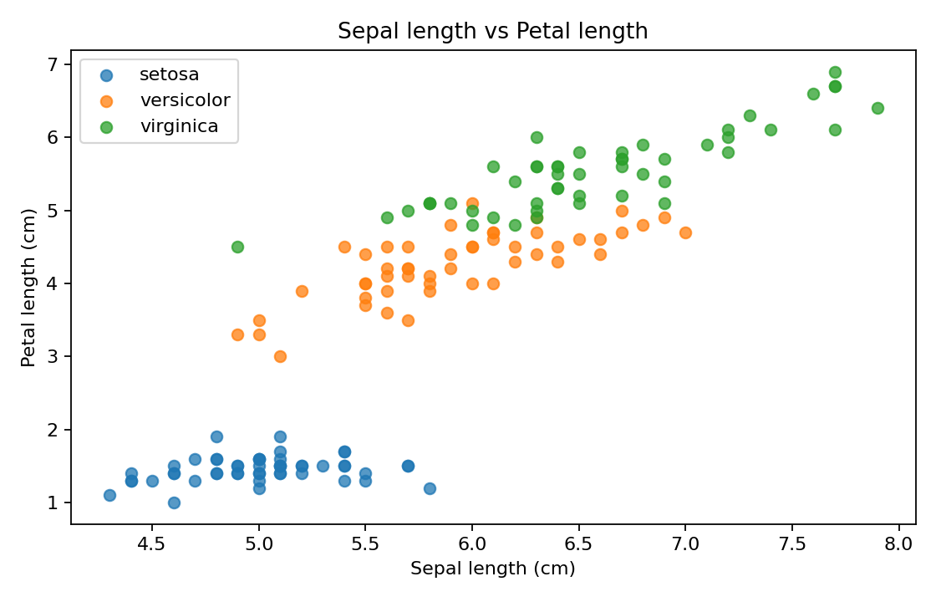
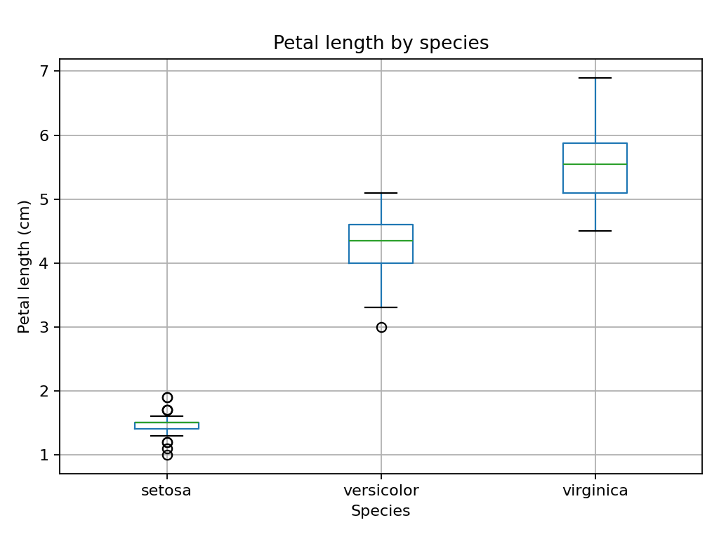

6. Correlation and interpretation
Pearson correlations among the four numeric variables are calculated with cor(). Petal length and petal width are strongly positively associated; these variables are useful for distinguishing species. Correlation indicates association and does not establish causation. The complete correlation matrix and R console outputs can be generated by running the script.

7. Conclusion
This exercise demonstrates dataset inspection, missing-value treatment, duplicate checks, IQR-based outlier flagging, categorical encoding, normalization and exploratory analysis in R. The workflow is reproducible and keeps the original measurement units in the cleaned dataset. For a real research or business dataset, imputation choices and outlier treatment should be justified by domain context and validated before modeling.

8. Deliverables
Included files: (1) this Word report, (2) task1_iris_analysis.R R script, and (3) iris_with_missing.csv input dataset. Charts are embedded in this report.
Dataset reference: Fisher, R.A. (1936), The use of multiple measurements in taxonomic problems; Iris dataset distributed in R (datasets::iris).

