Week 2 Task: Data Visualization and Insight Communication using R
Virtual R Data Analyst Internship | Dataset: Iris

1. Dataset Overview
The Iris dataset contains 150 observations from three flower species (setosa, versicolor, and virginica). Four numeric measurements are included: sepal length, sepal width, petal length, and petal width (in centimetres). The species column is categorical.

2. Visualization Design and Findings
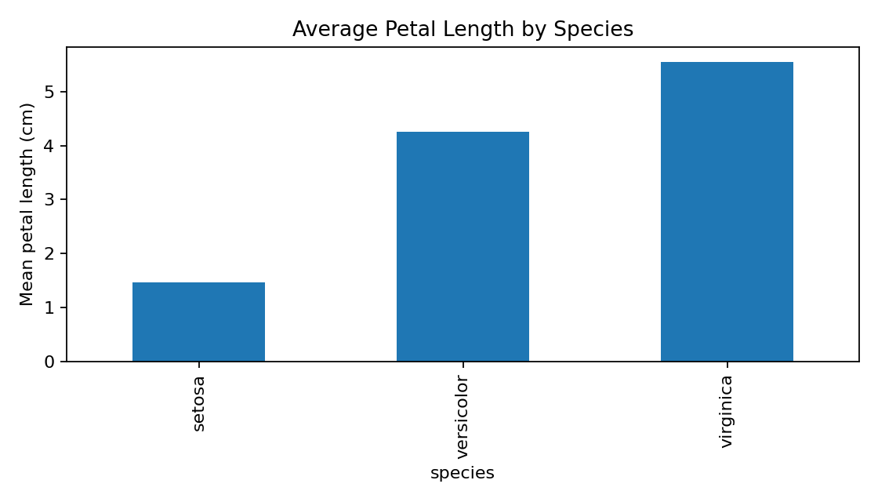
Bar chart compares average petal length among the three species. Setosa has the smallest average, while virginica has the largest.
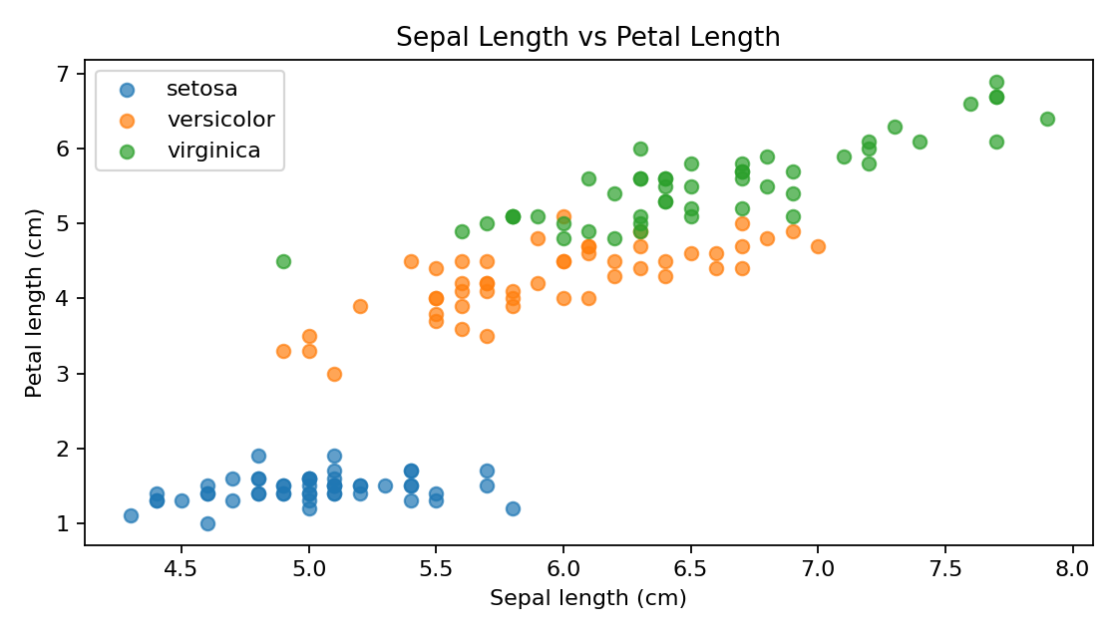
The scatter plot shows a positive relationship: longer sepals generally accompany longer petals. Species form distinguishable clusters, especially Setosa.
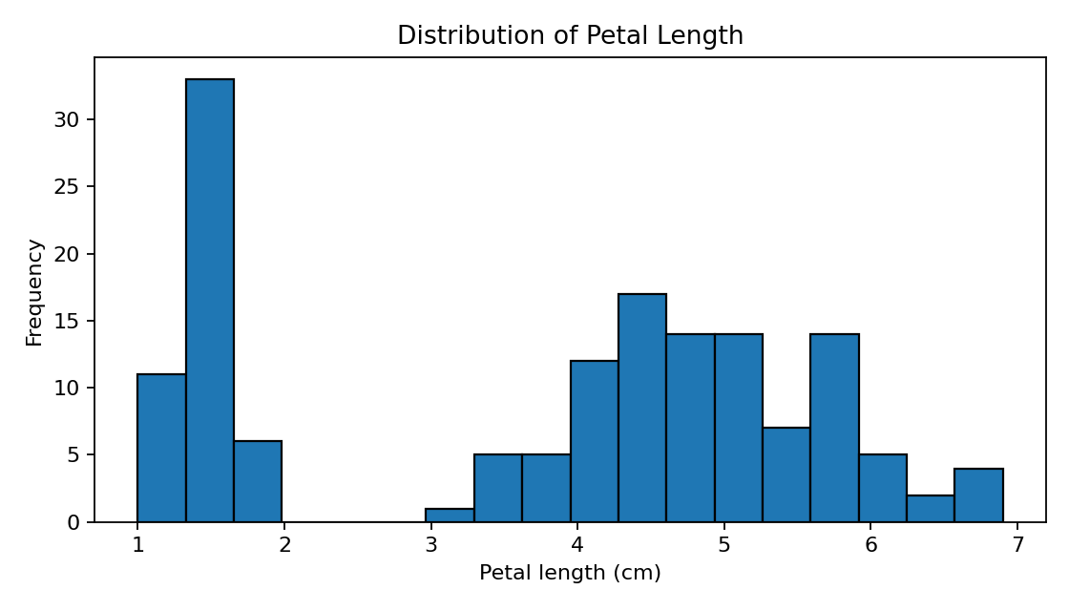
The histogram is not a single smooth group; it shows clusters/ranges reflecting differences between species.
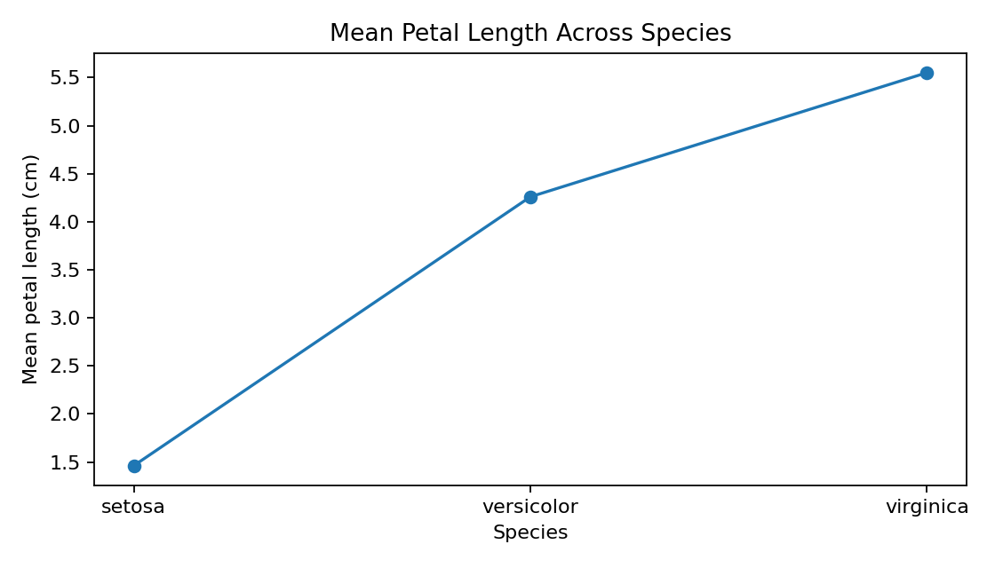
The line chart connects species-level means for a compact comparison. Virginica has the highest mean petal length and Setosa the lowest.

3. Key Insights
• Setosa has distinctly shorter petals than the other species.
• Virginica has the largest average petal length, followed by versicolor.
• Sepal length and petal length show a positive association overall.
• Petal length distribution contains separate clusters, indicating that species differ in flower measurements.

4. Code and Reproducibility
The accompanying week2_visualization.R script uses ggplot2 to create the four visualizations and saves each chart as a PNG. Keep iris_week2.csv and the R script in the same folder before running the script.
Run in R/RStudio: install.packages('ggplot2') (once), then source('week2_visualization.R').

5. Conclusion
Visualizations make species differences easier to understand than a table alone. The bar and line charts summarize average petal length, the scatter plot displays the relationship between measurements and species clusters, and the histogram shows the distribution of petal lengths. These plots communicate the main patterns clearly to a non-technical audience.

