**Crontab**

<https://crontab.guru/every-week>

<http://www.computerhope.com/unix/ucrontab.htm>

<https://kb.iu.edu/d/afiz>

<http://www.thegeekstuff.com/2009/06/15-practical-crontab-examples>

<http://www.tecmint.com/11-cron-scheduling-task-examples-in-linux/>

Cron" is a time-based job scheduler in Unix-like operating systems.The **crontab** is a list of commands that you want to run on a regular schedule, **cron** is the system process which will automatically perform tasks for you according to a set schedule. Cron Jobs are used for scheduling tasks to run on the server. They're most commonly used for automating system maintenance or administration. The schedule is called the **crontab**, which is also the name of the program used to edit that schedule.

# yum install crotab*

# service crond restart

# crontab -e

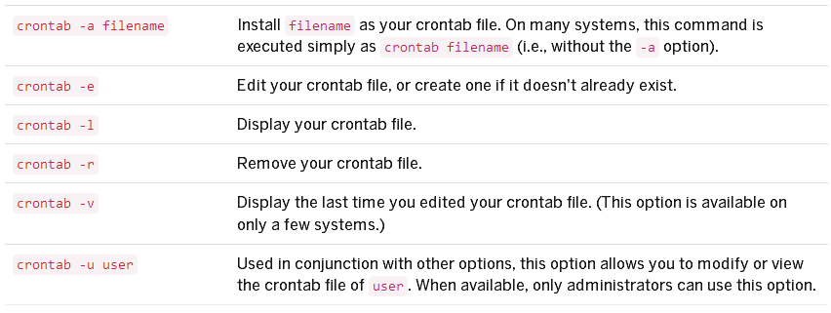

**Crontab Table Format :-**

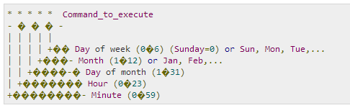

Each entry in a crontab file consists of six fields, specifying in the following order:

minute(s) hour(s) day(s) month(s) weekday(s) command(s)

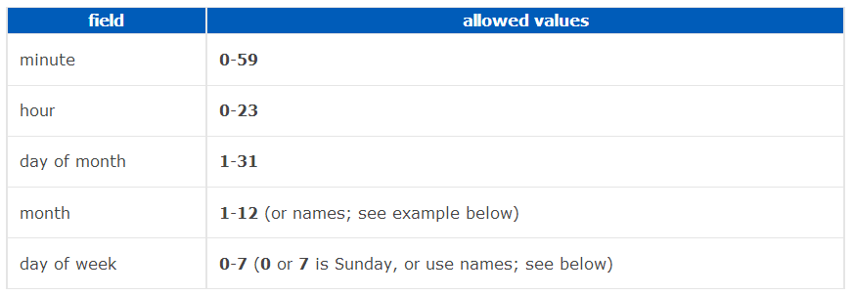

**Specifying multiple values in a field**

* The asterisk (*) operator specifies all possible values for a field. e.g. every hour or every day.
* The comma (,) operator specifies a list of values, for example: "1,3,4,7,8".
* The dash (-) operator specifies a range of values, for example: "1-6", which is equivalent to "1,2,3,4,5,6".
* The slash (/) operator, can be used to skip a given number of values. For example, "*/3" in the hour time field is equivalent to "0,3,6,9,12,15,18,21"; "*" specifies 'every hour' but the "/3" means that only the first, fourth, seventh...and such values given by "*" are used.

**EXAMPLES**

This cron job will run every minute, all the time:

* * * * * [command]

This will run on Mondays, every hour (i.e. 24 times in one day, but only on Mondays):

0 * * * 1 [command]

Division operator is also used. This will run 12 times per hour, i.e. every 5 minutes:

*/5 * * * * [command]

To run Script sample.sh at 12.59 every day and supress the output

59 12 * * * sh /usr/bin/sample.sh

To run sample.sh everyday at 9pm (21:00)

0 21 * * * sh /usr/bin/sample.sh

To run sample.sh every Tuesday to Saturday at 1am (01:00)

0 1 * * 2-7 sh /usr/bin/sample.sh

To run sample.sh at 07:30, 09:30 13:30 and 15:30

30 07,09,13,15 * * * sh sample.sh

What if you'd want to run something every 10 minutes? Well you could do this:

0,10,20,30,40,50 * * * * sh /usr/bin/sample.sh

But crontab allows you to do this as well:

*/10 * * * * sh /usr/bin/sample.sh

Disable Email Notification.

* * * * * >/dev/null 2>&1

To run /path/to/command five minutes after midnight, every day, enter:  
5 0 * * * /path/to/command

Run script.sh at 2:15pm on the first of every month, enter:  
15 14 1 * * sh /usr/bin/sample.sh

Run script.php at 10 pm on weekdays, enter:  
0 22 * * 1-5 sh /usr/bin/sample.sh

Schedule a cron to execute at 2am daily.

0 2 * * * sh /usr/bin/sample.sh

##### Schedule a cron to execute on every Sunday at 5 PM.

0 17 * * sun sh /usr/bin/sample.sh

Schedule a cron to execute on selected months.

* * * jan,may,aug * sh /usr/bin/sample.sh

***Multiple Commands with Double amper-sand(&&)***

@daily <command1> && <command2>

View the crontab of user

# crontab -u username -l

Remove the crontab of user **sandy**.

# crontab -u sandy -r

Edit the crontab of the Other user name

# crontab -u username -e

**Some entries in Crontab -e file :-**

# 57 12 * * * mkdir /home/amit/Desktop/bb123

# 26 12 * * * rmdir /home/amit/Desktop/bb123

# 09 14 * * * mysqldump -u root -p dada123 --all-databases > /home/amit/Desktop/all-databases.sql

# 21 14 * * * sh /home/amit/Desktop/fc.sh

# 53 18 * * * mkdir /root/Desktop/cron123 | mail -s "cron mail" [soni@mangesh.di.com](mailto:soni@mangesh.di.com) ( schedule for mail)

**tar** -cvf output.tar **/dirname (to convert in tar file)**

**Cron Allow and Deny :-**

The /etc/cron.allow and /etc/cron.deny files are used to restrict access to cron. The format of both access control files is one username on each line. Whitespace is not permitted in either file. The cron daemon (crond) does not have to be restarted if the access control files are modified.By Default all user access Crontab. But if you want to Restricted some user then add the user in /etc/cron.deny

If the file **cron.allow** exists, only users listed in it **allowed to use cron**.

If the file the **cron.deny** exists, those users **Not allowed to use cron.**

* **Edit the /etc/cron.d/cron.deny file and add user names, one user per line. Include users who will be denied access to the crontab commands.**

**# vim /etc/cron.d/cron.deny**

vivek

shri

krish

* **Edit the /etc/cron.d/cron.allow file and add user names, one user per line Include users** that will be allowed to use the crontab command**.**

**# vim /etc/cron.d/cron.allow**

amit

nanhe

komal