**Samba on RHEL 6**

• Samba allows File and Print sharing bet the Heterogeneous Environment (Like linux to Windows).

• Samba is a open source software.

• Samba uses TCP/IP protocol.

• Samba is Linux implementation of SMB(Server Msg Block)/CIFS protocols.

• Samba support Microsoft Access Control Lists.

• Main configuration file of Samba server is **/etc/samba/smb.conf**

* In Linux SAMBA provides the following services:

* User Authentication and authorization
* File and printer sharing
* Name resolution
* Browsing

**RPM required for Samba Server :-**

# yum install samba*

samba-common-3.6.9-151.el6.i686

samba-winbind-clients-3.6.9-151.el6.i686

samba-client-3.6.9-151.el6.i686

samba-3.6.9-151.el6.i686

samba-winbind-3.6.9-151.el6.i686

# yum install rdesktop* (Not neccesary, It is used to Remote access for windows System)

### Samba Daemons are :-

For Samba we need three services to run, one optional and two required

|  |  |  |  |
| --- | --- | --- | --- |
|  | Service | Daemons | Description |
| Required | smb | smbd | (SMB/CIFS Server) main samba service which provide user authentication and authorization and file and printer sharing |
| Required | nmb | nmbd | (NetBIOS name server) Resources browsing |
| Optional | winbind | winbindd | For host and user name resolution |

**Configuration Samba Server:-**

1. # yum install samba*
2. # service smb restart
3. You can create a new Samba user only from valid accounts on a Linux computer

#useradd sambauser1

#passwd sambauser1

#useradd sambauser2

#passwd sambauser2

1. Create a samba Passward for user

# smbpasswd -a sambauser1

1. Create samba share Folde

# mkdir sambafolder

# chmod 777 sambafolder

1. Now open main configuration file of Samba “ /etc/samba/smb.conf ”

#vim /etc/samba/smb.conf

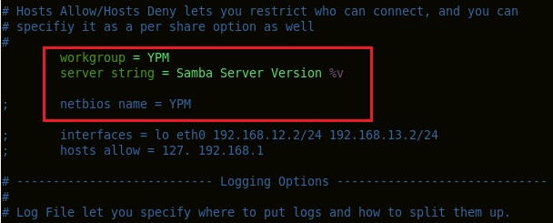

In that, Enter your Workgroup name

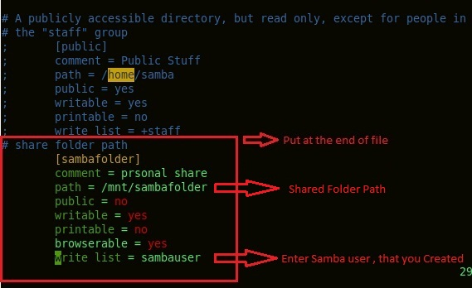

Enter the share folder path and Permission in the end of file

### Configure Samba client on Linux system :-

1. # Yum install samba*

samba-client

samba-common

samba-winbind-client

1. Try to list share from Samba server with smbuser1

# smbclient -L <samba server ip> -U smbuserName

### Configure window 7 as Samba client system :-

1. Open computer properties

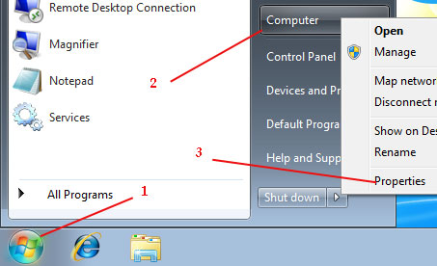

1. Click on change setting

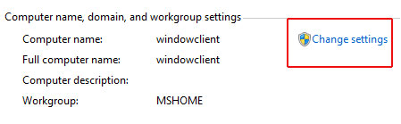

1. Click on change

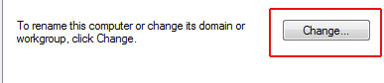

1. Change workgroup
2. Start -> in search box type samba server IP

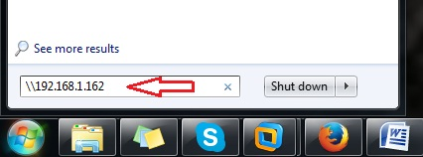

1. Log on with samba user and samba Passwards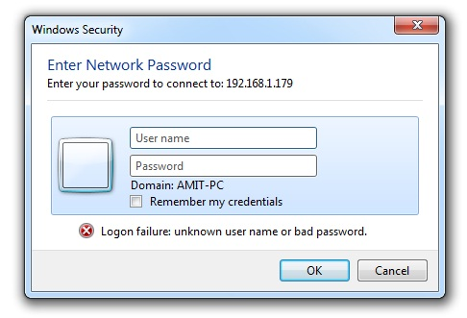
2. After enter username and passwards , it show your linux share folder list

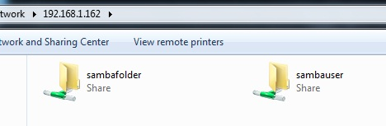

1. Suppose you want map the sharefolder Permanently as map network .then

Rigt click on sharefolder -> Map network divice -> Finish

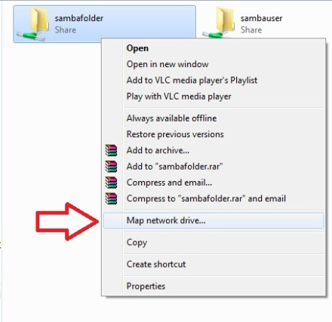 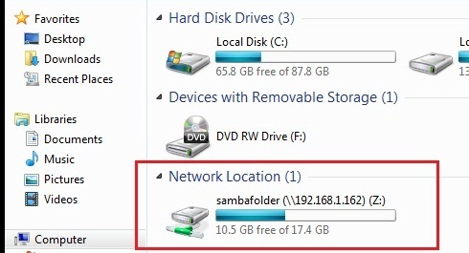

*************************************************************************************

Suppose we face following type of permission Problem then Execute the following Command

# setsebool -p samba_enable_home_dirs on

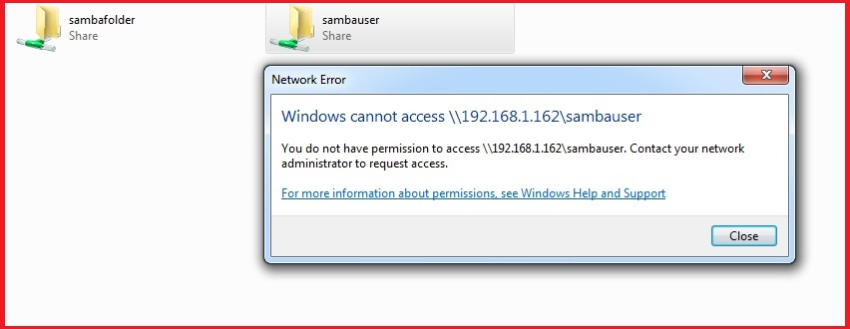

Suppose samba share Folder not open then Execute the following Command

# chcon -t samba_share_t -R /<Shared Folder Path>

*************************************************************************************

# [configure samba access using groups](http://unix.stackexchange.com/questions/197175/how-to-properly-configure-samba-access-using-groups) :-

1. Create samba Group

# groupadd smbgroup (like testgroup)

# usermod -G smbgroup smbuser

1. Create samba share Folde

# mkdir data

# chmod 777 data

1. Now open main configuration file of Samba “ /etc/samba/smb.conf ”

#vim /etc/samba/smb.conf



In that, Enter your Workgroup name

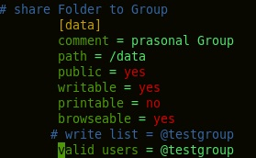

Enter the share folder path and Permission in the end of file

**Some Important Command :-**

1. # findsmb :- Shows the samba Server in currant Network.
2. # smbtree :- Shows the Connected PC in Network (Both Windows and Linux).
3. #smbstatus :- Server Status
4. Suppose we want to Access Directory or Drive From Windows System

# smbclient -U Administrator //192.168.1.162/D$

Administrator Passward :

Smb:\>

(use command under Smb:\> like ls,cd,cd .., mget,quit)

1. Smbget : - wget-like utility for download files over SMB

# smbget --help :- information about smbget option

# smbget -u Administrator smb://192.168.1.162/javaFIie/a.txt

Above Command used to Download a file from another System directely, and file Download in the Current Present Directory.

# smbclient -L [IP] -U [UserName]

Above Command used to Find Shared Folder in Particular System.

1. Smbtar :- For **Backup**

# smbtar -s [IP] -x [Fname] -u [Uname] -t [Fname.tar] -p <UserPassward> -V

# tar -tvf [Fname.tar] .... for Open tar File

**Remote access Windows System From Linux System :-**

1. # yum install rdesktop*
2. In Windows System, go to MyComp -> R.click Properties -> Remote Setting -> in remote tab -> click on second option ie. “Allow Connection from ..” -> apply ->ok
3. # rdesktop -f -a 16 [Windows IP]

Suppose command not run and it throws the Error

“Error : Unable to Connet” , that time use following Command

# service smb restart