**Zabbix is an open source enterprise-class monitoring software for servers, network devices, and applications. Zabbix uses Zabbix Agent installed on monitored hosts to collect the data. Also, it can monitor standard services such as SMTP or HTTP web services without having a client on the monitored host.**

**Zabbix uses several options for collecting metrics, including agentless monitoring of user services and client-server architecture. To collect server metrics, it uses a small agent on the monitored client to gather data and send it to the Zabbix server. Zabbix supports encrypted communication between the server and connected clients, so your data is protected while it travels over insecure networks.**

**The Zabbix server stores its data in a relational database powered by MySQL, PostgreSQL, or Oracle. You can also store historical data in nosql databases like Elasticsearch and TimescaleDB. Zabbix provides a web interface so you can view data and configure system settings.**

**Configure Zabbix repository**

**Zabbix is not included in Ubuntu repositories. So, to install Zabbix, we will need to set up the Zabbix repository on the system by installing the Zabbix repository configuration package.**

wget https://repo.zabbix.com/zabbix/4.2/ubuntu/pool/main/z/zabbix-release/zabbix-release_4.2-1+bionic_all.deb

dpkg -i zabbix-release_4.2-1+bionic_all.deb

apt update

**Then install the Zabbix server and web frontend with MySQL database support:**

**Also, install the Zabbix agent, which will let you collect data about the Zabbix server status itself.**

apt install zabbix-server-mysql zabbix-frontend-php

apt install zabbix-agent

**Login to the MariaDB server and create a database for our Zabbix installation.**

mysql -u root -p

mysql> create database zabbix;

mysql> grant all privileges on zabbix.* to zabbixuser@localhost identified by 'temp123';

mysql> quit;

**Next you have to import the initial schema and data. The Zabbix installation provided you with a file that sets this up.**

cd /usr/share/doc/zabbix-server-mysql

gunzip create.sql.gz

mysql -u zabbixuser -p zabbix < create.sql.gz

**(put the zabbixuser password)**

**Edit the Zabbix configuration file to update with your timezone.**

**(Uncomment the timezone line)**

vi /etc/zabbix/apache.conf

php_value date.timezone Asia/Kolkata

**In order for the Zabbix server to use this database, you need to set the database password in the Zabbix server configuration file. Open the configuration file**

vi /etc/zabbix/zabbix_server.conf

**(Look for the following section of the file:)**

DBHost=localhost

DBName=zabbix

DBUser=zabbixuser

DBPassword=temp123

**Now restart Apache & Zabbix server to apply these new settings**.

systemctl restart apache2

systemctl start zabbix-server

systemctl enable zabbix-server

**Configuring Settings for the Zabbix Web Interface**

**Open a web browser and point it to the following URL.**

http://192.168.72.91/zabbix/

**On the next screen, you will see the table that lists all of the prerequisites to run Zabbix.**

**Click Next Step on Zabbix welcome page.**

**The next screen asks for database connection information.**

**If everything is OK, click the Next Step.**

**On the next screen, you can leave the options at their default values.**

**Click Next Step to go to the next page.**

**Now, you have completed the installation of Zabbix. Click Finish.**

**Access Zabbix Server**

**Log in to Zabbix Server with the default username and password.**

Username: “Admin”

Password: “zabbix”

**Installing and Configuring the Zabbix Agent**

**Then, just like on the Zabbix server, run the following commands to install the repository configuration package:**

**Ubuntu:**

wget https://repo.zabbix.com/zabbix/4.2/ubuntu/pool/main/z/zabbix-release/zabbix-release_4.2-1+bionic_all.deb

sudo dpkg -i zabbix-release_4.2-1+bionic_all.deb

**Then install the Zabbix agent:**

apt update

apt install zabbix-agent

**CentOs:**

rpm -Uvh https://repo.zabbix.com/zabbix/4.2/rhel/6/x86_64/zabbix-release-4.2-1.el6.noarch.rpm

yum clean all

yum install zabbix-agent -y

**Now edit the Zabbix agent settings to set up its secure connection to the Zabbix server. Open the agent configuration file**

**First you have to edit the IP address of the Zabbix server.**

vi /etc/zabbix/zabbix_agentd.conf

### Zabbix Server IP Address or Hostname ###

Server=192.168.72.91

### Client Hostname ###

Hostname=client.mit.com

**Save and close the file. Now you can restart the Zabbix agent**

**ubuntu:**

systemctl restart zabbix-agent

systemctl enable zabbix-agent

ufw allow 10050/tcp

**CentOs:**

systemctl restart zabbix-agent

systemctl enable zabbix-agent

systemctl disable firewalld

**zabbix Agent On Windows**

**You have download zabbix agent for windows from:**

<https://www.zabbix.com/download.php>

**(Make sure Package should be 4.2 version)**

**now just install and put the servers IP addres while installation**

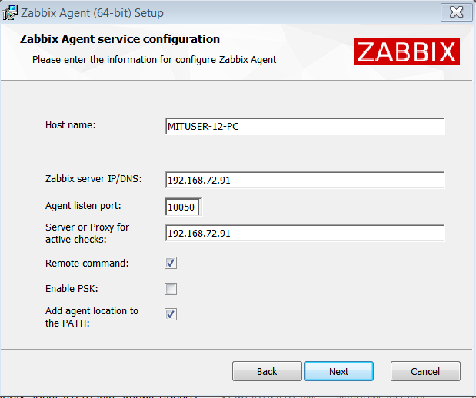

**Add Remote Linux Host to Zabbix Server for Monitoring**

Login to Zabbix Web console using the admin account. Then, go to

**Configuration >> Hosts >> Create Host.**

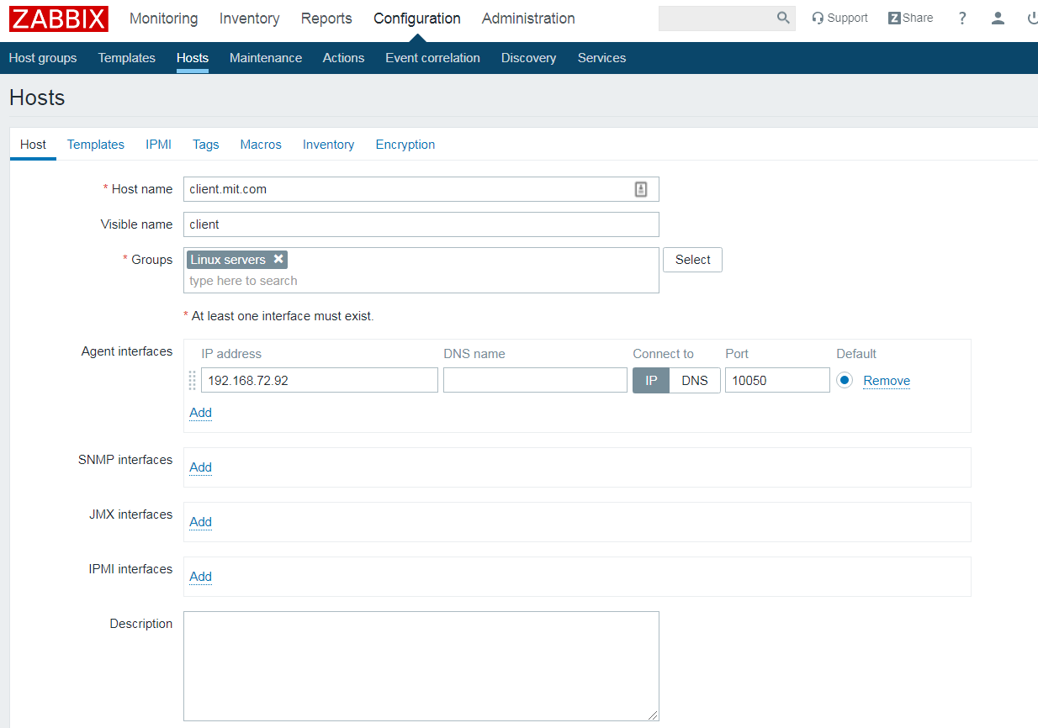

**Hostname**: Hostname of the remote node

**Visible name:** Name of the remote node

**Group:** Select host groups the node belongs to.

**Agent Interface:** Enter IP Address of node or DNS name

**Go to Templates >> Link new templates.** You either type to search a template or click on the **Select** to choose from a list of templates**. Tick** mark the template you want to link to the new host.

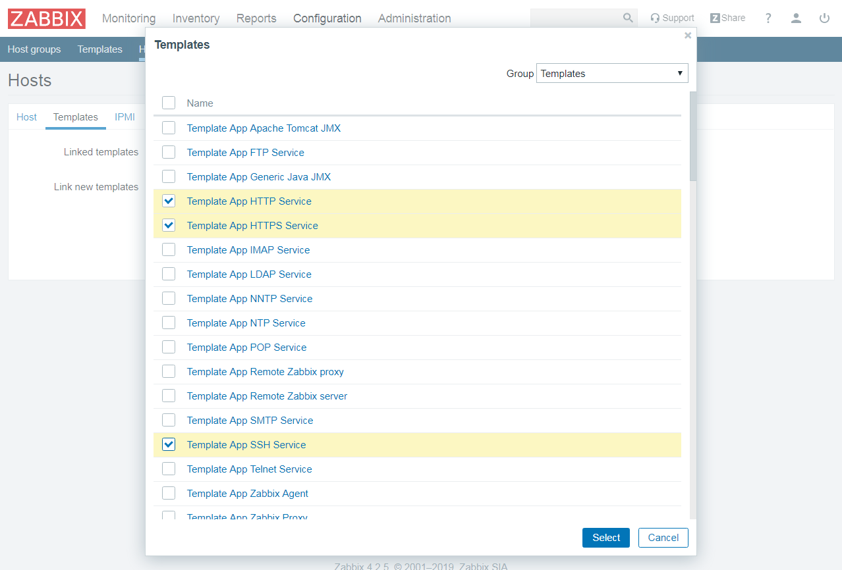

**Then, click on Add.**

**Finally, click on Add to complete the addition of the host.**

**useful links**

<https://www.digitalocean.com/community/tutorials/how-to-install-and-configure-zabbix-to-securely-monitor-remote-servers-on-ubuntu-18-04>

<https://www.itzgeek.com/how-tos/linux/how-to-add-a-node-to-zabbix-server-for-monitoring.html>

<https://tecadmin.net/install-zabbix-on-ubuntu/>