1. ***Seafile****is an open source, cross-platform high-performance file syncing and sharing and*[*cloud storage system*](https://www.tecmint.com/free-open-source-cloud-storage-tools-for-linux/)*with privacy protection and teamwork features.*
2. *It allows users to create groups and easily share files into groups.*

***Now install Seafiles from wget***

***yum install wget***

wget --no-check-certificate https://raw.githubusercontent.com/haiwen/seafile-server-installer/master/seafile_centos

bash seafile_centos 6.1.2

*Run the script, select option****1****to install****Community Edition (CE)***

*Once the installation process is complete, you will see the message in the screenshot. Read through it to proceed.*

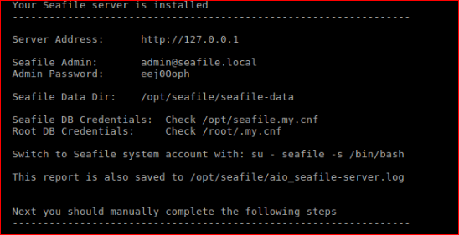

*access the****Seafile****web admin dashboard, open a web browser and type in your server IP address to navigate*  *http://SERVER_IP*