**Launce EC2 instance step by step**

**Click on 'Launch Instance' button in the section of Create Instance (as shown below).**

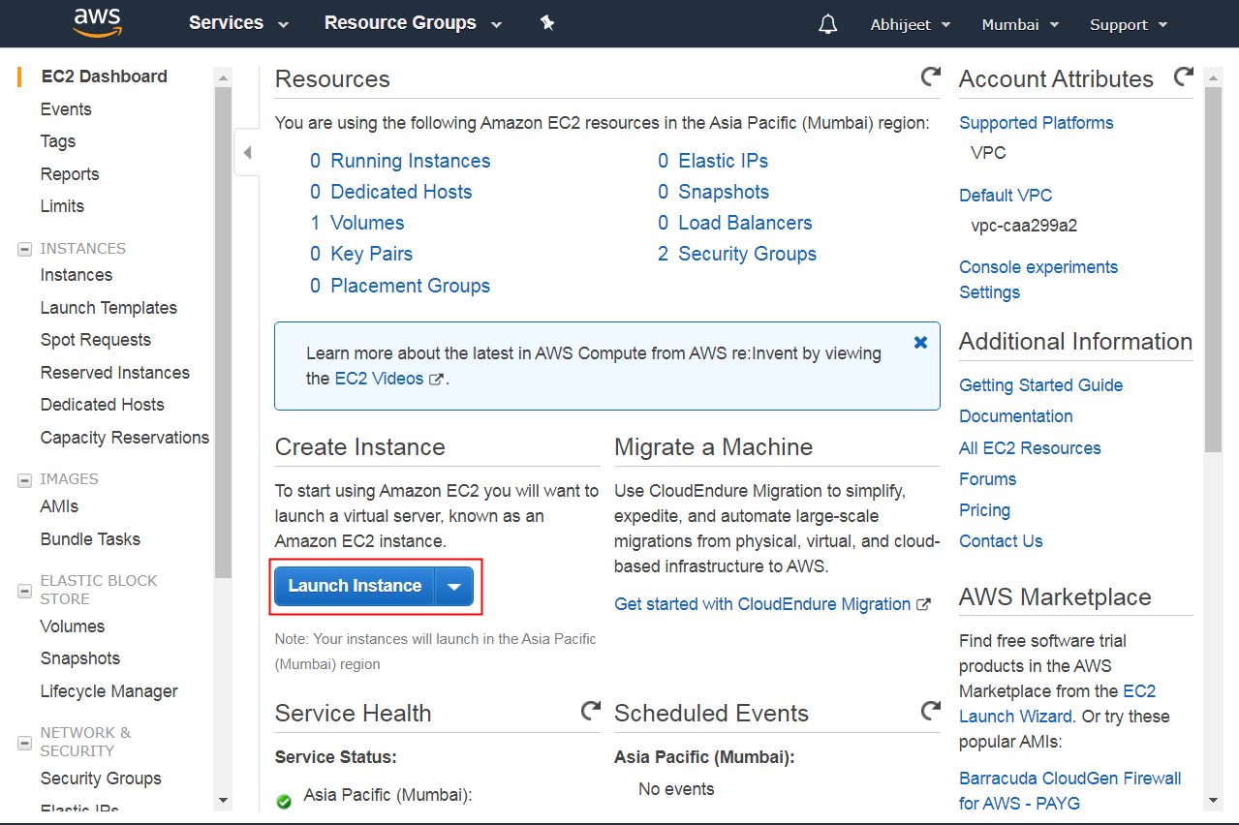

**Here we are choosing the Ubuntu 18.04 server.**

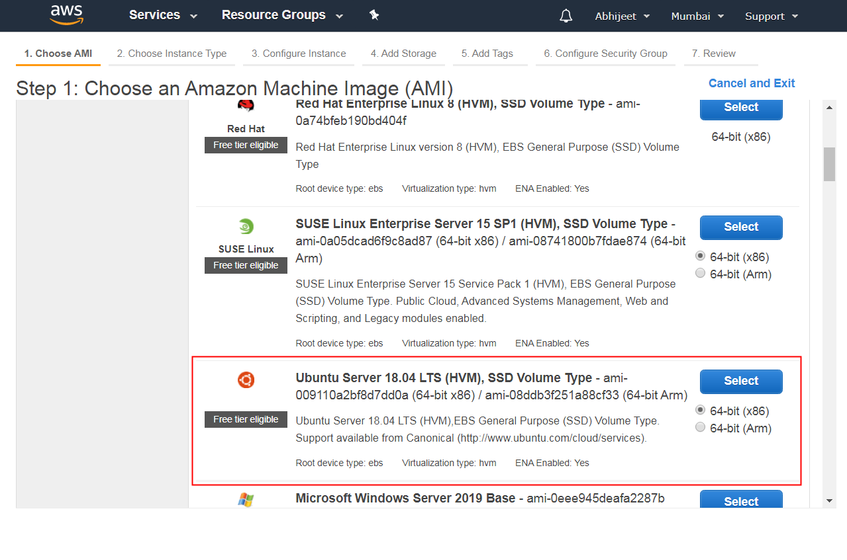

**We will choose t2.micro instance type, which is a 1vCPU and 1GB memory server offered by AWS.**

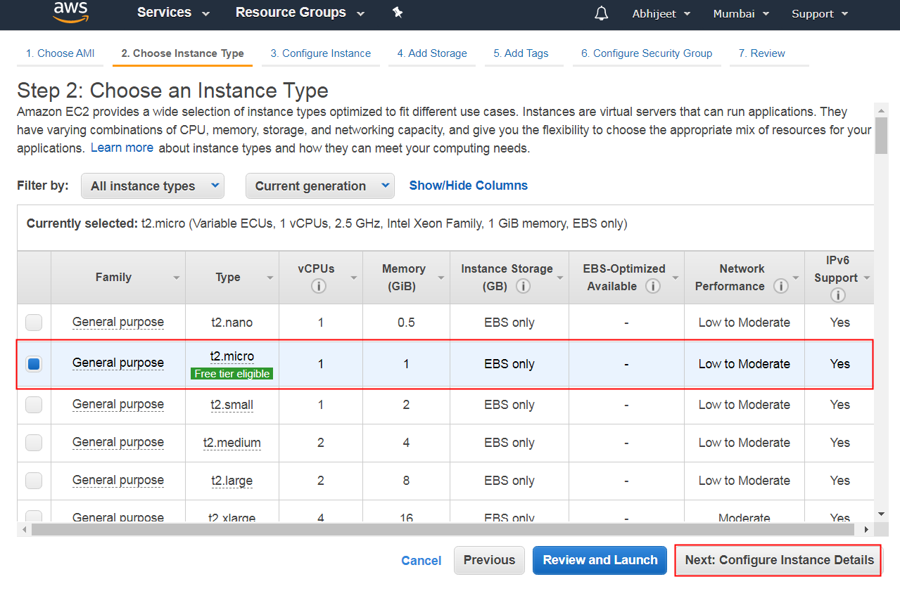

**you can leave this setting by default**

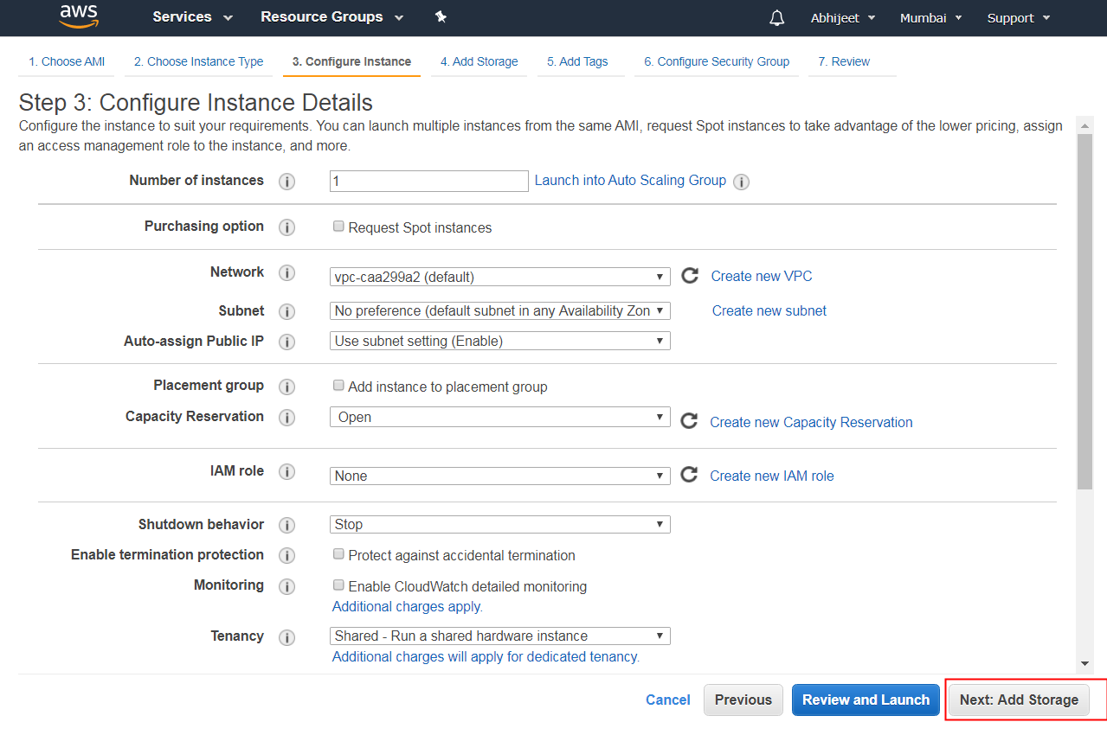

**In the Add Storage step, you'll see that the instance has been automatically provisioned a General Purpose SSD root volume of 8GB. You can change your volume size, add new volumes, change the volume type, etc.**

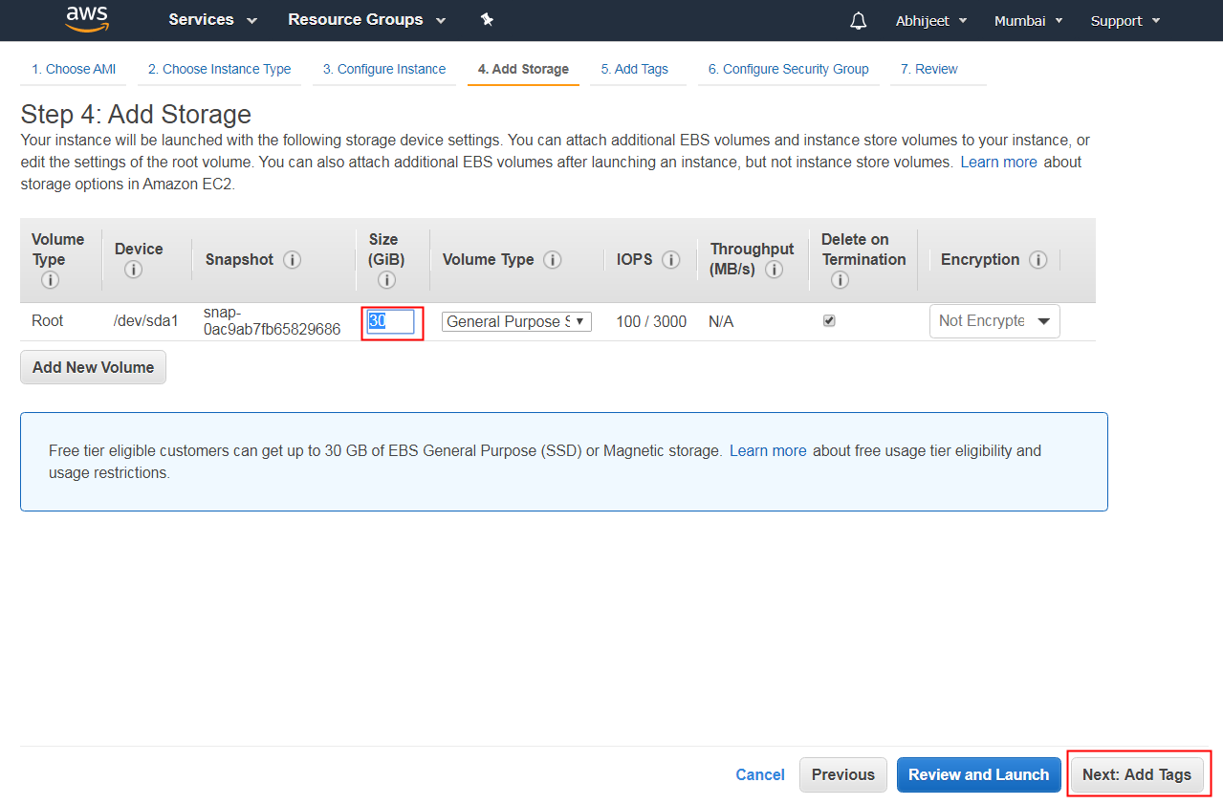

**you can tag your instance with a key-value pair. This gives visibility to the AWS account administrator when there are lot number of instances. OR you cane leave this.**

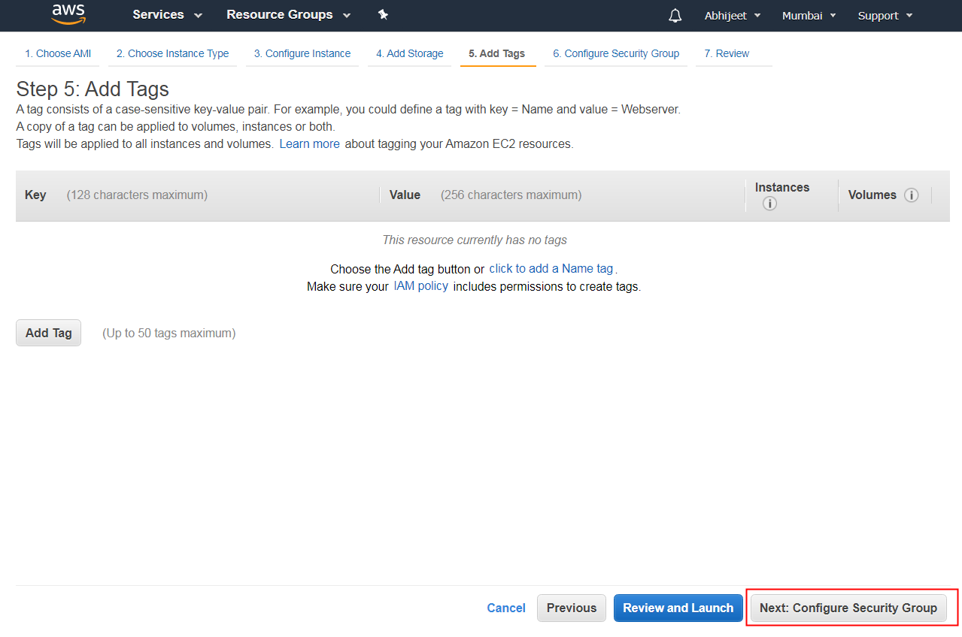

**In this next step of configuring Security Groups, you can restrict traffic on your instance ports. This is an added firewall mechanism provided by AWS apart from your instance's OS firewall.**

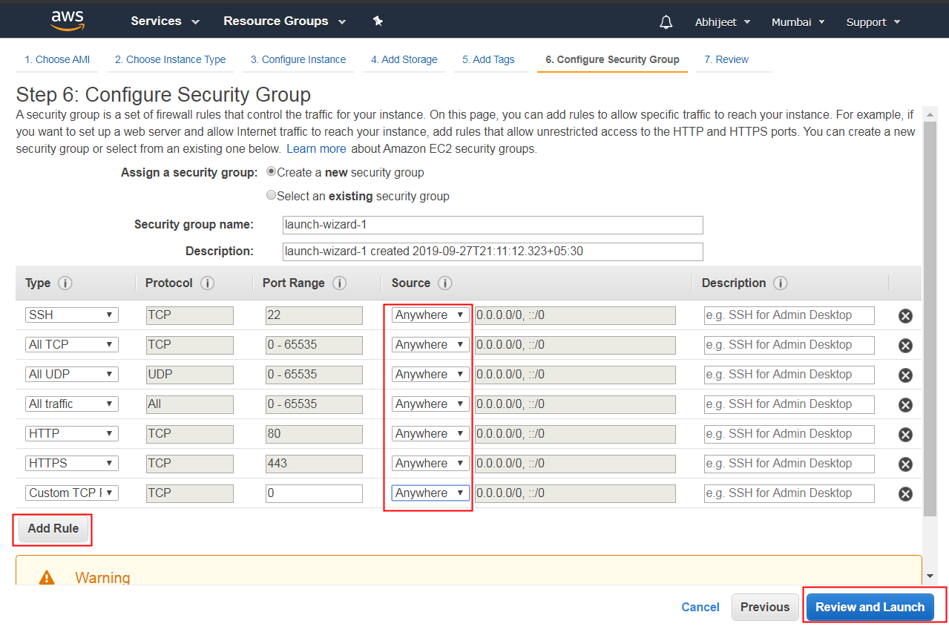

**In this step, we will review all our choices and parameters and go ahead to launch our instance.**

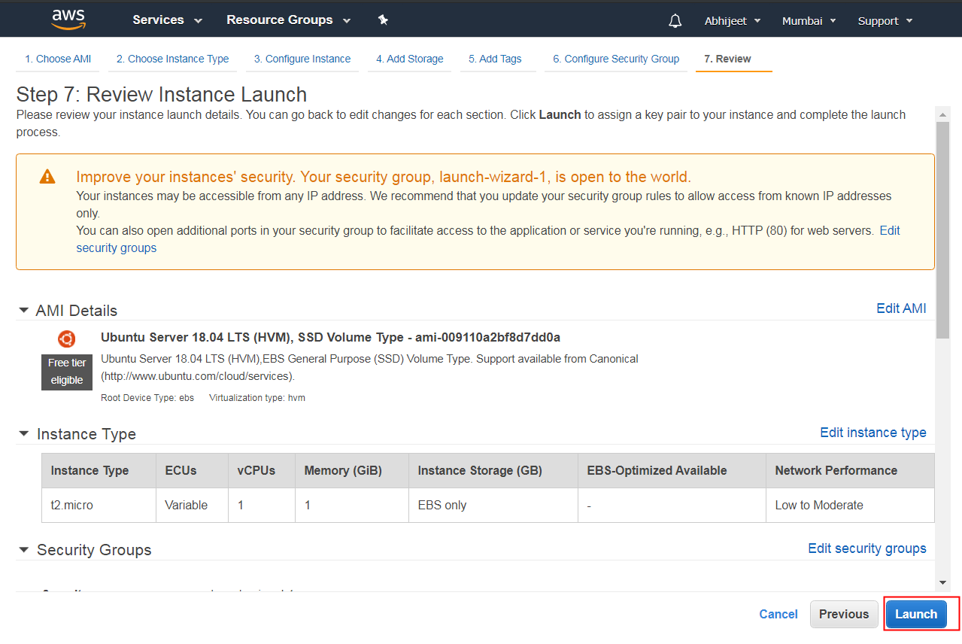

**In the next step you will be asked to create a key pair to login to you an instance. A key pair is a set of public-private keys.**

**1.Create a new key pair**

**2.Give a name to your key**

**3.Download and save it in your secured folder**

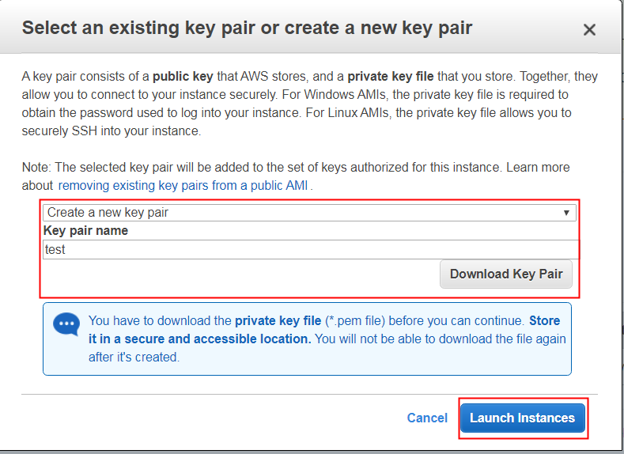

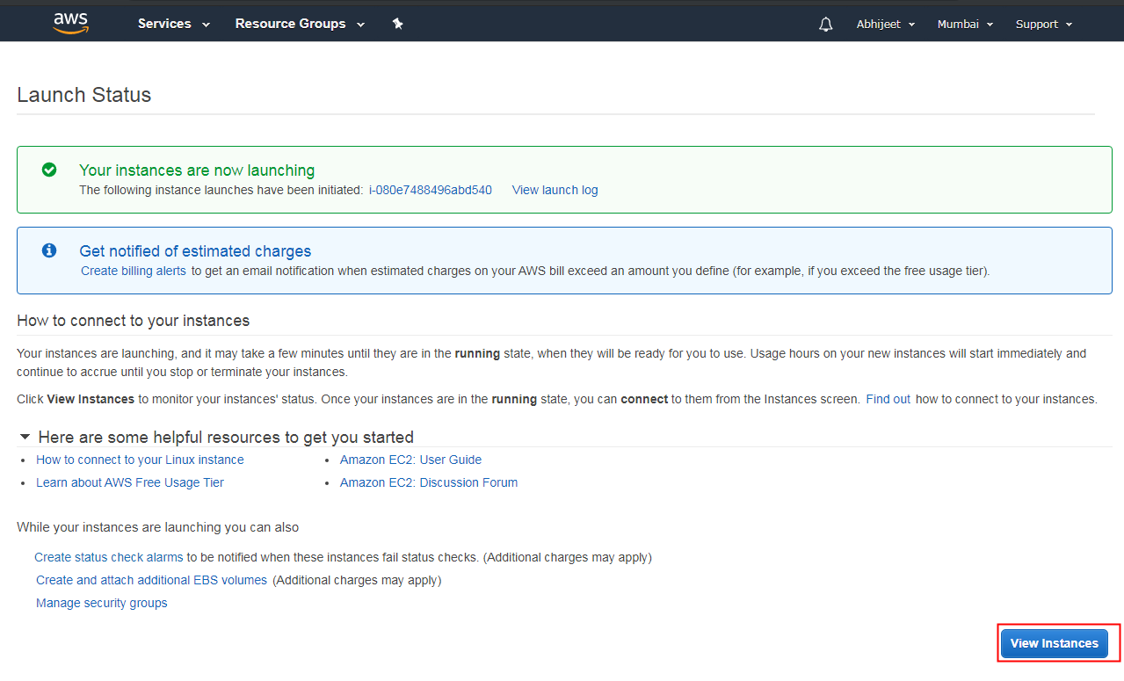

**Once your instance is up and running, you can see its status as 'Running' now.**

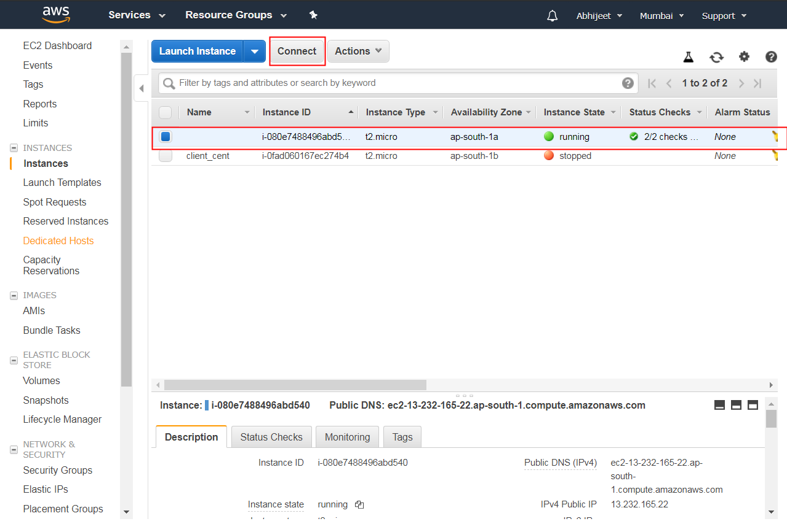

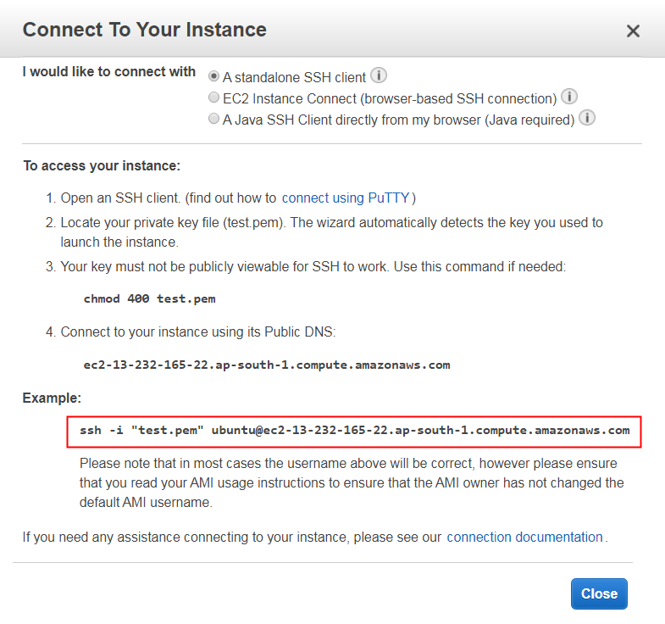

useful links

<https://docs.aws.amazon.com/quickstarts/latest/vmlaunch/step-1-launch-instance.html>

<https://hackernoon.com/launching-an-ec2-instance-fbfd50894aac>