**WordPress is the world’s leading content management system. Used by tens of millions of webpages and internet creators alike, WordPress is the backbone of most blogs and news outlets. Webpage performance with WordPress is also typically one of the fastest available**.

**WordPress is undoubtedly one of the most popular Content Management Systems (CMS) available in the market.WordPress can be installed in multiple ways – one of them is using LAMP. With this method you can host yourvery own WordPress website on a VPS. That’s why in this tutorial, we’ll show you how to install WordPres on Ubuntu**

**______________Install Lamp With Wordpress ___________________**

**Step 1: Apache Web Server Installation**

**To install the Apache web server, run the following command:**

# apt-get install apache2 -y

# systemctl enable apache2

# systemctl restart apache2

**Step 2: Install PHP**

**The next step of our LAMP stack setup is to install PHP**.

# apt install php php-curl php-gd php-mbstring php-xml php-xmlrpc php-soap php-intl php-zip -y

# apt install php-mysql -y

# php -v

**Step 3: Install the MySQL Database server**

**To install the default package, run the following command:**

# apt install mysql-server -y

# mysql_secure_installation

**Step 4: Create a Database for WordPress**

# mysql -u root -p

mysql> CREATE DATABASE wordpress;

mysql> GRANT ALL PRIVILEGES ON wordpress.* TO 'abhi'@'localhost' IDENTIFIED BY 'temp123';

mysql> FLUSH PRIVILEGES;

mysql> exit;

**Step 5: Install WordPress**

**Now we can proceed with the actual installation of WordPress.**

**download and extract the latest WordPress installation files in**

**document root directory (/var/www/html).**

# cd /var/www/html

# wget -c http://wordpress.org/latest.zip

# apt install unzip -y

# unzip latest.zip

# chown -R www-data:www-data wordpress

# rm latest.zip

**All the WordPress files will be now placed in the wordpress directory in /var/www/html/wordpress**

# cd /var/www/html/wordpress

# mv wp-config-sample.php wp-config.php

# vi wp-config.php

**( replacing database_name_here, username_here and password_here with your own details)**

**It will look like this >**

// ** MySQL settings - You can get this info from your web host ** //

/** The name of the database for WordPress */

define('DB_NAME', '**wordpress**');

/** MySQL database username */

define('DB_USER', '**Abhi**');

/** MySQL database password */

define('DB_PASSWORD', '**temp123**');

/** MySQL hostname */

define('DB_HOST', 'localhost');

/** Database Charset to use in creating database tables. */

define('DB_CHARSET', 'utf8');

/** The Database Collate type. Don't change this if in doubt. */

define('DB_COLLATE', '');

**Step 5: Create the Virtual Host Files**

**We can now create our virtual host files.**

**create the virtual host configuration file for your domain like sam.com.conf**

# vi /etc/apache2/sites-available/your_domain.com.conf

<VirtualHost *:80>

ServerAdmin admin@sam.com

ServerName sam.com

ServerAlias www.sam.com

DocumentRoot /var/www/html/wordpress

<Directory /var/www/html/wordpress>

Options Indexes FollowSymLinks

AllowOverride All

Require all granted

</Directory>

</VirtualHost>

# a2ensite sam.com

# systemctl configtest

# systemctl restart apache2

**Step 6: Configure WordPress**

**we need to access the WordPress Web Interface and finish the installation.**

**open your browser and navigate to:**

http://www.sam.com/

**>Choose your language and click “Continue”.**

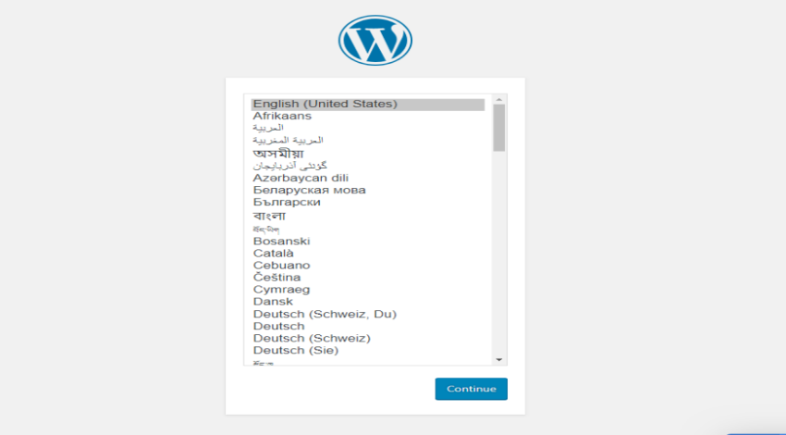

**>Enter your preferred information at the main installation screen, such as the site title, and your username, password, and email, and click on “Install WordPress”:**

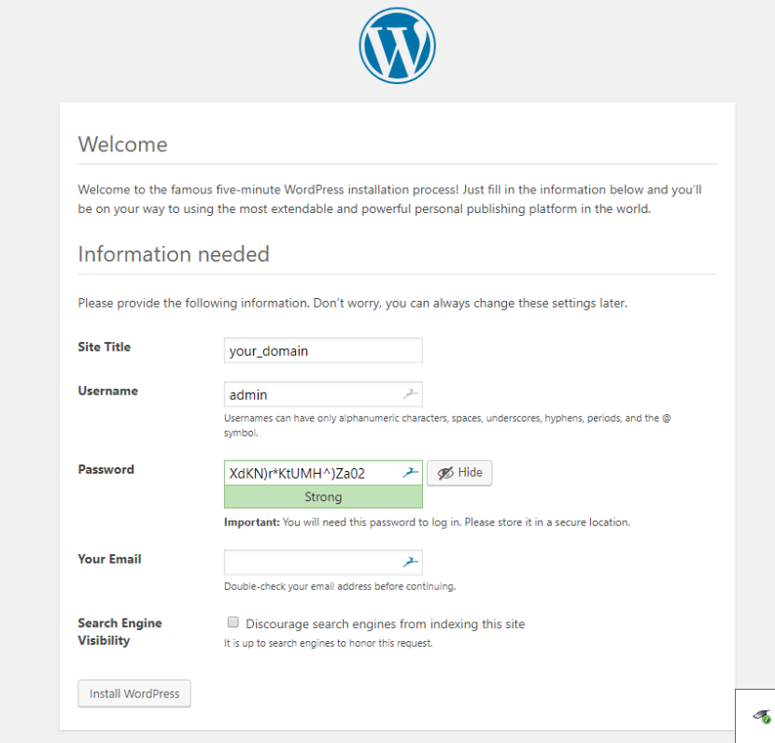

**You will be informed that WordPress has been successfully installed and you can now log in to your administration dashboard using the information you have set up previously**.

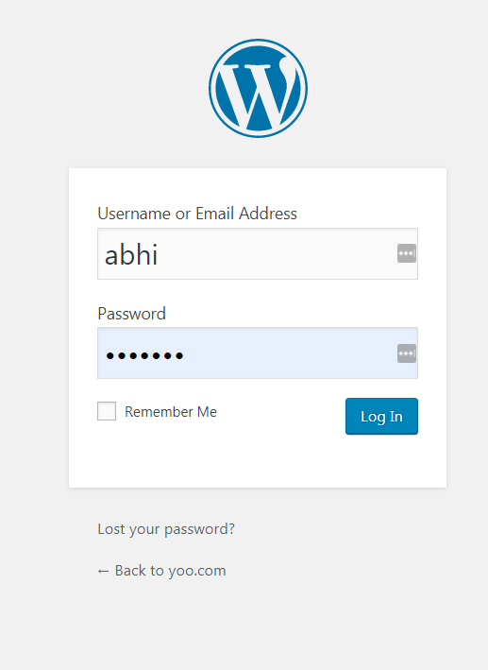

**Congratulations! WordPress has been successfully installed on your server. You can now start building and customize your site according to your needs.**

**helpful links**

<https://www.rosehosting.com/blog/how-to-install-wordpress-with-lamp-stack-on-ubuntu-18-04/>

<https://www.hostinger.in/tutorials/how-to-install-wordpress-on-ubuntu-using-lamp-stack/>

<https://linuxconfig.org/how-to-install-wordpress-on-ubuntu-18-04-bionic-beaver-linux>