**Monitor Linux Server Using Nagios Core And NRPE**

**Nagios is one of the most widely used open source monitoring tool for monitoring the services and application that run's on Windows and Linux. It also has the capability to monitor routers and other network devices.**

**With the help of Nagios, you can monitor basic services and attributes. We can access the Nagios using web interface coming with the bundle, but the configurations need to be done on the file level.**

**Nagios Core is a free and open source tool that allows you to monitor your entire IT infrastructure to ensure hosts, services and applications are functioning properly. For more information, you can visit the website of Nagios. This article is intended for use by Nagios Administrators who wish to monitor Linux servers with Nagios Core using the linux NRPE agent.**

192.168.72.91 server.mit.com (nagios server)

192.168.72.92 client.mit.com (client-ubuntu)

192.168.72.94 agent.mit.com(client-centos)

**Install Nagios Core**

**Before compiling the Nagios from the source, you would need to install dependent packages for Nagios. Update the repository cache and install the dependencies for Nagios.**

apt-get update

apt-get install build-essential apache2 php openssl perl make php-gd libgd-dev libapache2-mod-php libperl-dev libssl-dev daemon wget apache2-utils unzip

**Create nagios user and nagcmd group , add the nagios and apache user to the part of the nagcmd group.**

useradd nagios

groupadd nagcmd

usermod -a -G nagcmd nagios

usermod -a -G nagcmd www-data

**You can use below commands to download Nagios core (v4.4.3). Else, you can visit the official website to download the latest version of Nagios core.**

wget https://assets.nagios.com/downloads/nagioscore/releases/nagios-4.4.3.tar.gz

tar -zxvf nagios-4.4.3.tar.gz

cd nagios-4.4.3/

**Perform the below steps to compile the Nagios from the source code.**

./configure --with-nagios-group=nagios --with-command-group=nagcmd --with-httpd_conf=/etc/apache2/sites-enabled/

make all

make install

make install-init

make install-config

make install-commandmode

**Execute the below command in the terminal to install Nagios web interface.**

make install-webconf

**Configure Nagios**

**Edit the /usr/local/nagios/etc/objects/contacts.cfg file and change the email address associated with the nagiosadmin contact definition to the address you’d like to use for receiving alerts.**

vi /usr/local/nagios/etc/objects/contacts.cfg

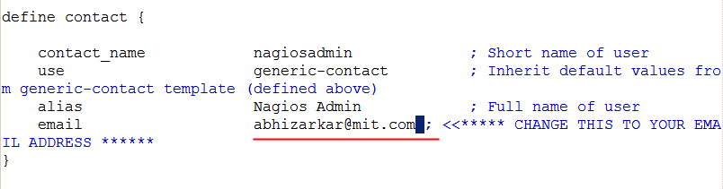

**Create a user account (nagiosadmin) for logging into the Nagios web interface. Remember the password you assign to this account – you’ll need it later.**

htpasswd -c /usr/local/nagios/etc/htpasswd.users nagiosadmin

password:

**Run the following command.**

a2enmod cgi

**Restart Apache to make the new settings take effect.**

systemctl restart apache2

**Install Nagios Plugins**

**Now, it’s time to download Nagios plugins for monitoring the services.**

wget https://nagios-plugins.org/download/nagios-plugins-2.2.1.tar.gz

tar -zxvf nagios-plugins-2.2.1.tar.gz

cd nagios-plugins-2.2.1/

**Compile and install the plugins.**

./configure --with-nagios-user=nagios --with-nagios-group=nagios

make

make install

**Start Nagios**

**Verify the sample Nagios configuration files.**

### /usr/local/nagios/bin/nagios -v /usr/local/nagios/etc/nagios.cfg

**Now, start the Nagios service.**

systemctl enable nagios

systemctl start nagios

**Access Nagios Web Interface**

**Now access the Nagios web interface using the following URL.**

http://192.168.72.91/nagios/

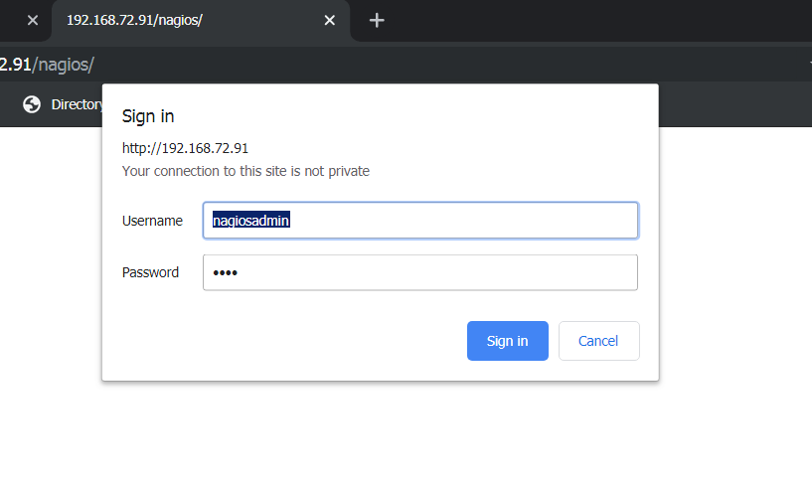

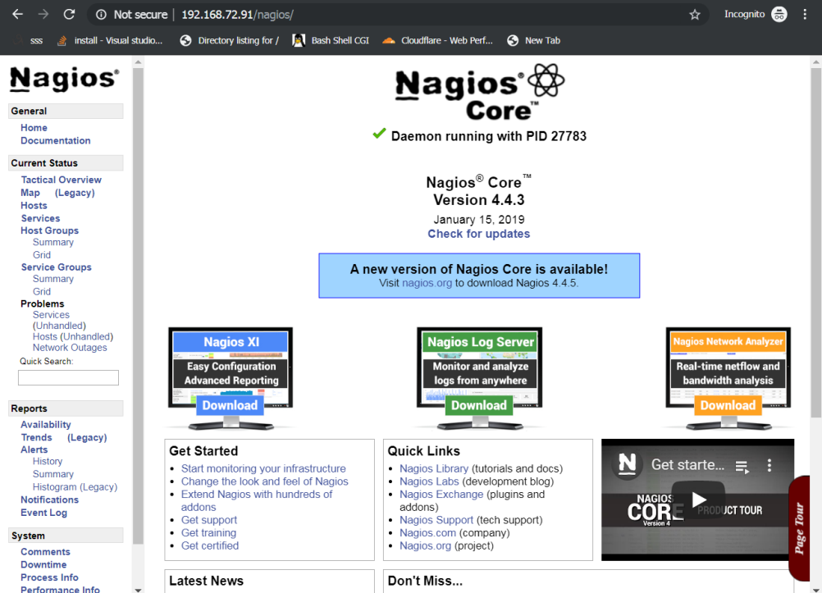

**Installing and Configuring NRPE On The Remote Linux Machine**

**NRPE Plugin**

**Nagios Remote Plugin Executor (abbreviated as NRPE) plugin allows you to monitor applications and services running on remote Linux / Windows hosts. This NRPE Add-on helps Nagios to monitor local resources like CPU, Memory, Disk, Swap, etc. of the remote host.**

**On Remote Linux System**

**Install NRPE Add-on & Nagios Plugins**

**NRPE and Nagios plugins are not available in the base repository of CentOS 7. So, you need configure EPEL repository on CentOS 7.**

**### CentOS 7 / RHEL 7 ###**

yum install -y epel-release

rpm -ivh https://dl.fedoraproject.org/pub/epel/epel-release-latest-7.noarch.rpm

yum install -y nrpe nagios-plugins-all

**### Ubuntu 18.04 / 16.04 & Debian 9 ###**

apt update

apt install -y nagios-nrpe-server nagios-plugins

**Modify the NRPE configuration file to accept the connection from the Nagios server, Edit the /etc/nagios/nrpe.cfg file.**

vi /etc/nagios/nrpe.cfg

Add the Nagios servers IP address, like below.

## 

**Configure Nagios Checks**

**The /etc/nagios/nrpe.cfg file contains the basic commands to check the attributes (CPU, Memory, Disk, etc.architecure) and services (HTTP, FTP, etc.) on remote hosts. Below command lines let you monitor attributes with the help of Nagios plugins.**

vi /etc/nagios/nrpe.cfg

***add this commad in bottom of the file***

**CentOS 7 / RHEL 7**

*command[check_users]=/usr/lib64/nagios/plugins/check_users -w 5 -c 10command[check_load]=/usr/lib64/nagios/plugins/check_load -w 15,10,5 -c 30,25,20command[check_root]=/usr/lib64/nagios/plugins/check_disk -w 20% -c 10% -p /dev/mapper/centos-root*

*command[check_swap]=/usr/lib64/nagios/plugins/check_swap -w 20% -c 10%command[check_total_procs]=/usr/lib64/nagios/plugins/check_procs -w 150 -c 200*

**Ubuntu 18.04 / Ubuntu 16.04 & Debian 9**

*command[check_users]=/usr/lib/nagios/plugins/check_users -w 5 -c 10command[check_load]=/usr/lib/nagios/plugins/check_load -w 15,10,5 -c 30,25,20*

*command[check_root]=/usr/lib/nagios/plugins/check_disk -w 20% -c 10% -p /dev/mapper/server--vg-root*

*command[check_swap]=/usr/lib/nagios/plugins/check_swap -w 20% -c 10%*

*command[check_total_procs]=/usr/lib/nagios/plugins/check_procs -w 150 -c 200*

**In the above command definition -w stands for warning and -c stands for critical.**

**You can adjust the alert level as per your requirements. Change warning to 200 and critical to 250 for testing purpose.**

Restart the NRPE service.

**### CentOS 7 / RHEL 7 ###**

systemctl start nrpe

systemctl enable nrpe

**### Ubuntu 18.04 / 18.04 & Debian 9 ###**

systemctl restart nagios-nrpe-server

**On Nagios Server**

**Use the following command to install the check_nrpe plugin on your machine.**

apt -y install nagios-nrpe-plugin

**Edit the Nagios configuration file to include all .cfg files inside the /usr/local/nagios/etc/servers directory.**

vi /usr/local/nagios/etc/nagios.cfg

**Add or uncomment the following line.**

*cfg_dir=/usr/local/nagios/etc/servers*

**Create a configuration directory.**

mkdir /usr/local/nagios/etc/servers

**Configure Nagios Server**

**Now it’s time to configure the Nagios server to monitor the remote client machine, and You’ll need to create a command definition in Nagios object configuration file to use the check_nrpe plugin. Open the commands.cfg file.**

vi /usr/local/nagios/etc/objects/commands.cfg

**Add the following Nagios command definition to the file.**

*# .check_nrpe. command definition*

*define command{*

*command_name check_nrpe*

*command_line /usr/lib/nagios/plugins/check_nrpe -H $HOSTADDRESS$ -t 30 -c $ARG1$*

*}*

**Add a Linux host to Nagios server**

**Create a client configuration file /usr/local/nagios/etc/servers/client.mit.com.cfg and agent.mit.com to define the host and service definitions of remote Linux host.**

vi /usr/local/nagios/etc/servers/client.mit.com.cfg

*define host{*

*use linux-server*

*host_name client.mit.com*

*alias client.mit.com*

*address 192.168.72.92*

*}*

*define hostgroup{*

*hostgroup_name linux-server*

*alias Linux Servers*

*members client.mit.com*

*}*

*define service{*

*use local-service*

*host_name client.mit.com*

*service_description SWAP Uasge*

*check_command check_nrpe!check_swap*

*}*

*define service{*

*use local-service*

*host_name client.mit.com*

*service_description Root / Partition*

*check_command check_nrpe!check_root*

*}*

*define service{*

*use local-service*

*host_name client.mit.com*

*service_descriptio Current Users*

*check_command check_nrpe!check_users*

*}*

*define service{*

*use local-service*

*host_name client.mit.com*

*service_description Total Processes*

*check_command check_nrpe!check_total_procs*

*}*

*define service{*

*use local-service*

*host_name client.mit.com*

*service_description Current Load*

*check_command check_nrpe!check_load*

**you have to do same for agent.mit.com**

vi /usr/local/nagios/etc/servers/agent.mit.com.cfg

put the same entry as client

**Verify Nagios for any errors.**

/usr/local/nagios/bin/nagios -v /usr/local/nagios/etc/nagios.cfg

**Restart the Nagios server.**

systemctl restart nagios

if you want monitor http , ftp, smtp, pop3 etc services the you have to add this line

*define service{*

*use local-service*

*host_name client.mit.com*

*service_description Current Load*

*check_command check_http*

**Go and check the Nagios web interface to view the new services**

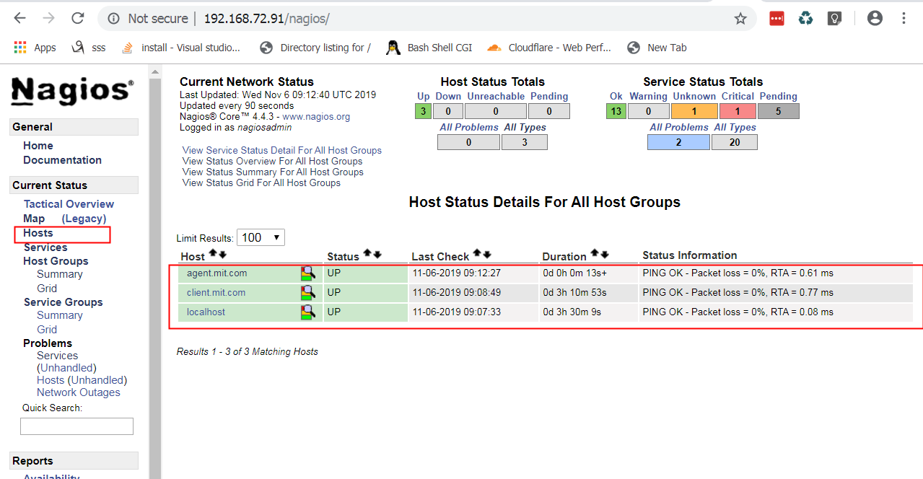

**Within a minute, you should start seeing status in services page.**

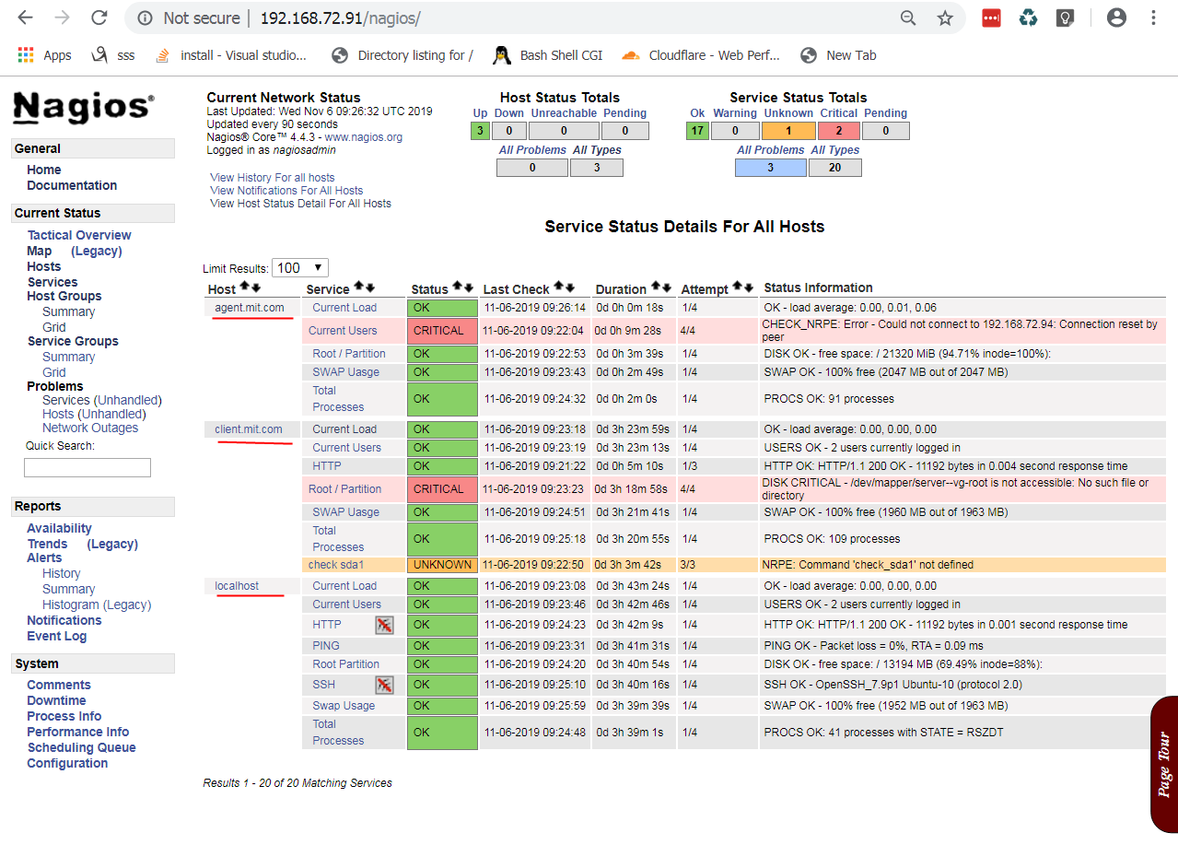

**links:**

<https://www.itzgeek.com/how-tos/linux/ubuntu-how-tos/install-nagios-4-1-1-ubuntu-16-04.html>

<https://www.itzgeek.com/how-tos/linux/centos-how-tos/monitor-remote-linux-system-with-nagios-3.html>