**Installing and Configuring ProFTPD Server**

**FTP servers are the piece of software that allows you to create a FTP connection between your local computer and a web server. ProFTPD is a FTP server for Unix/Linux servers, very configurable and very effective, it is free & open-sourced, released under the GPL license.**

sudo apt-get update

apt-get install proftpd

**Configure ProFTPD Server**

vi /etc/proftpd/proftpd.conf

1. **ServerName**: Make it your default server name.
2. **UseIPV6:** You may switch it to “Off“, if you don’t use it.
3. **DefaultRoot** : Uncomment this line to restrict users with their home folders.
4. **RequireValidShell**: Uncomment this line and make it “On” to enable logging in for users, even for those who doesn’t have a valid shell in /etc/shells to log in.
5. **AuthOrder**: Uncomment the line to enable the using of local passwords.
6. **Port**: This line defines the default port for the FTP server, it is 21 by default. If you want, you can define any custom port here.

service proftpd restart

**create a FTP users**

useradd -m abhishek

***m=> create home directory***

passwd abhishek

**If you want to give limited access then you have to uncomment defualtRoot in /etc/proftpd/proftpd.conf .**

*DefaultRoot ~*

touch /home/abhishek/test

**then you have to mention this user in /etc/proftpd/proftpd.conf**

*User abhishek*

service proftpd restart

**That’s it!. You can now go to following addresses on the browser, it will be up and running, it will ask you about the user name and the password.**

ftp://192.168.72.91 **OR** ftp://your_domain_name

**OR**

**you can access with Win_Scp**

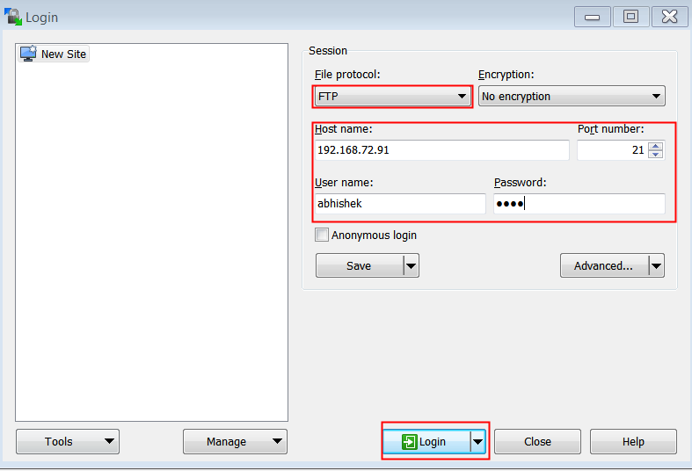

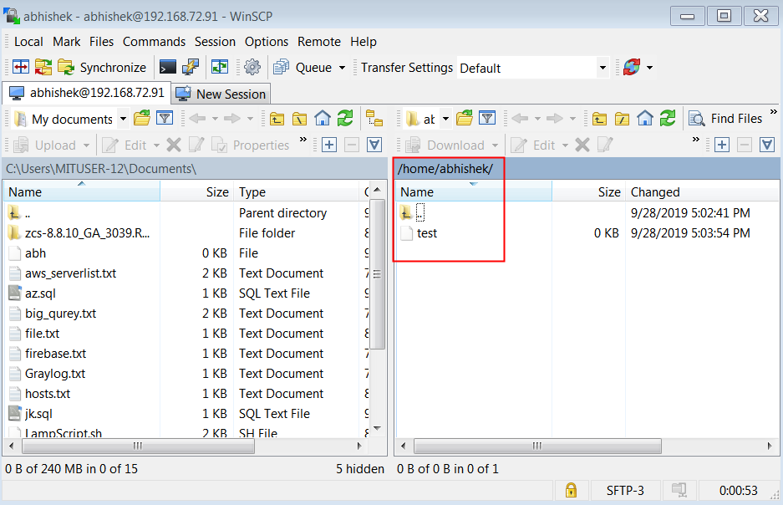

**If you want to add multiple user then you have create group and put users in this group.**

groupadd sysadmin

useradd -m hp dell lenovo

**assign passwords for above users.**

usermod -G sysadmin hp dell lenovo

**you can change home directory,**

**for example**

mkdir /opt/public

usermod -d /opt/public hp

**then you can access only this directory.**

**then you have to mention this group in /etc/proftpd/proftpd.conf**

*group sysadmin*

service proftpd restart

useful links

<https://www.tecmint.com/install-proftpd-in-ubuntu-and-debian/>

<https://websiteforstudents.com/setup-proftpd-ubuntu-17-04-17-10/>