**How to Reset the Root Password in Linux (ubuntu)**

**Reset Lost Root Password from the Grub Menu**

1. First and foremost, to recover a lost root password, we need to restart the Linux host, assuming you can’t remember the password for root (or superuser).

2 . Once the GRUB page appears, quickly select the “*Advanced options for GNU/Linux” option by pressing the down arrow key and Enter button.

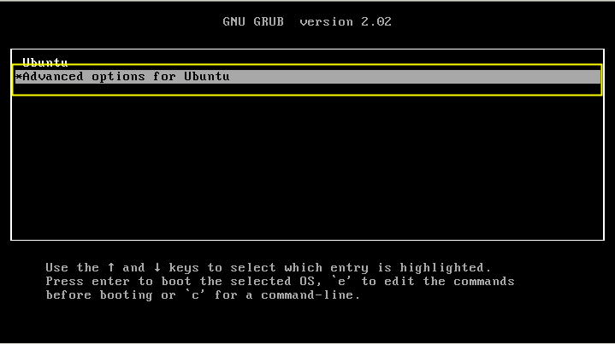

3. Now press e to edit the commands.

You need to modify it or change it from “read-only” mode to “read-write” mode. Find the line beginning with “Linux.” After, look for “ro,” and change it “rw.” Add init=/bin/bash at the end of the line

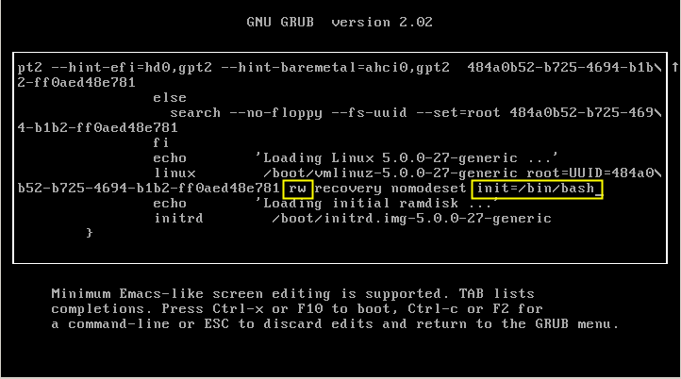

4. Press F10. This will display a screen with a prompt.

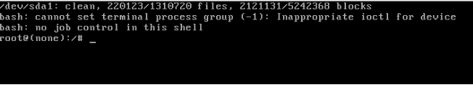

6. You can now reset your lost root password by using the following command:

passwd root

Alternatively, you can change the password of the super user with the command:

passwd abhi

Once you are done, type:

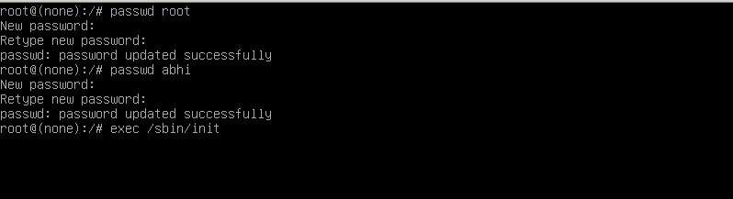

exec /sbin/init

to exit the prompt and reboot the computer.

**Recover a forgotten root password on Redhat 7/centOs 7 Linux**

Start your system and once you see your GRUB2 boot menu use e key to edit your default boot item. Usually it is the first line:

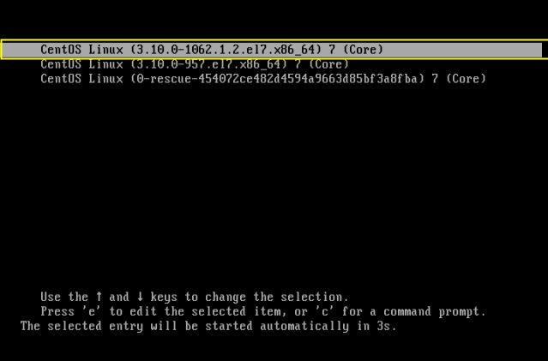

Once you hit e key you will see a screen similar to the one below:

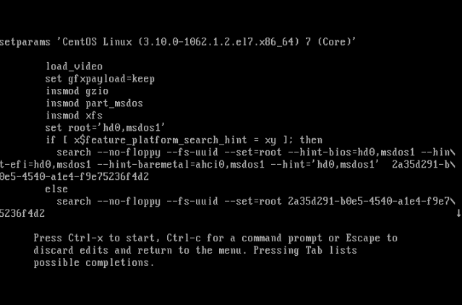

press down arrow key and Find the line beginning with linux. In this example the line begins linux16.

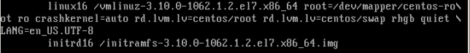

Using the arrow keys and the delete key, manually delete the following entries **rhgb** and **quiet** from the line.

Next, append the following statement to the end of the line init=/bin/bash

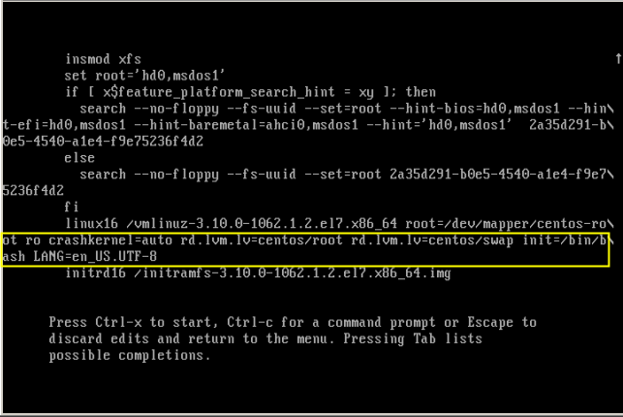

Once you edit the boot line as show above press CTRL + x to start booting your RHEL 7 system into a single mode. At the end of the system boot you will enter a single mode:

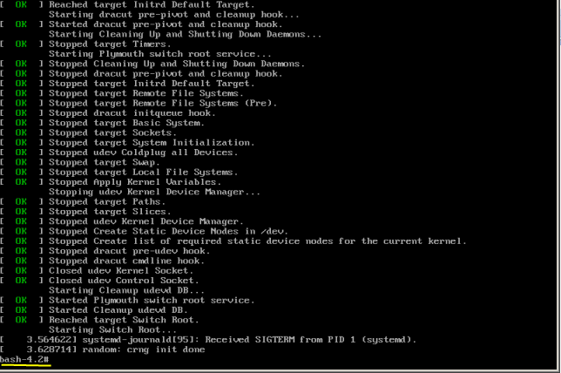

Once you enter a single your root partition is mounted as Read Only ro. You ca confirm it with the following linux command:

# mount | grep root

In order to mount our partition with Read/Write flag we use mount with a remount option as follows:

# mount -o remount,rw /

**Change root's password**

Still in the single mode we can proceed with the actual root password recovery. To do this we use passwd command:

# passwd

All the above steps are show below:

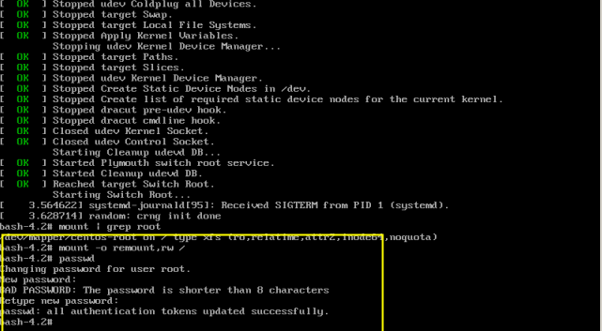

exec /sbin/init

to exit the prompt and reboot the computer.